The off-the-shelf Bayesian Optimization solver was obtained from:

https://github.com/thuijskens/bayesian-optimization/blob/master/python/gp.py

This code was copy/pasted into P2.py, the objective function was written, the variable bounds were defined, and the number of iterations was set to 100.

The results of the Bayesian Optimization are as follows:

1st run:

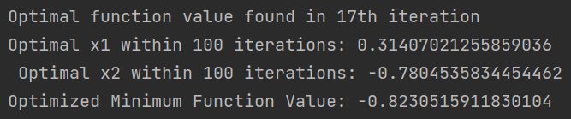

2nd run:

3rd run:

4th run:

The results from the 4th run are taken as the optimal since it resulted in the minimum function value.