
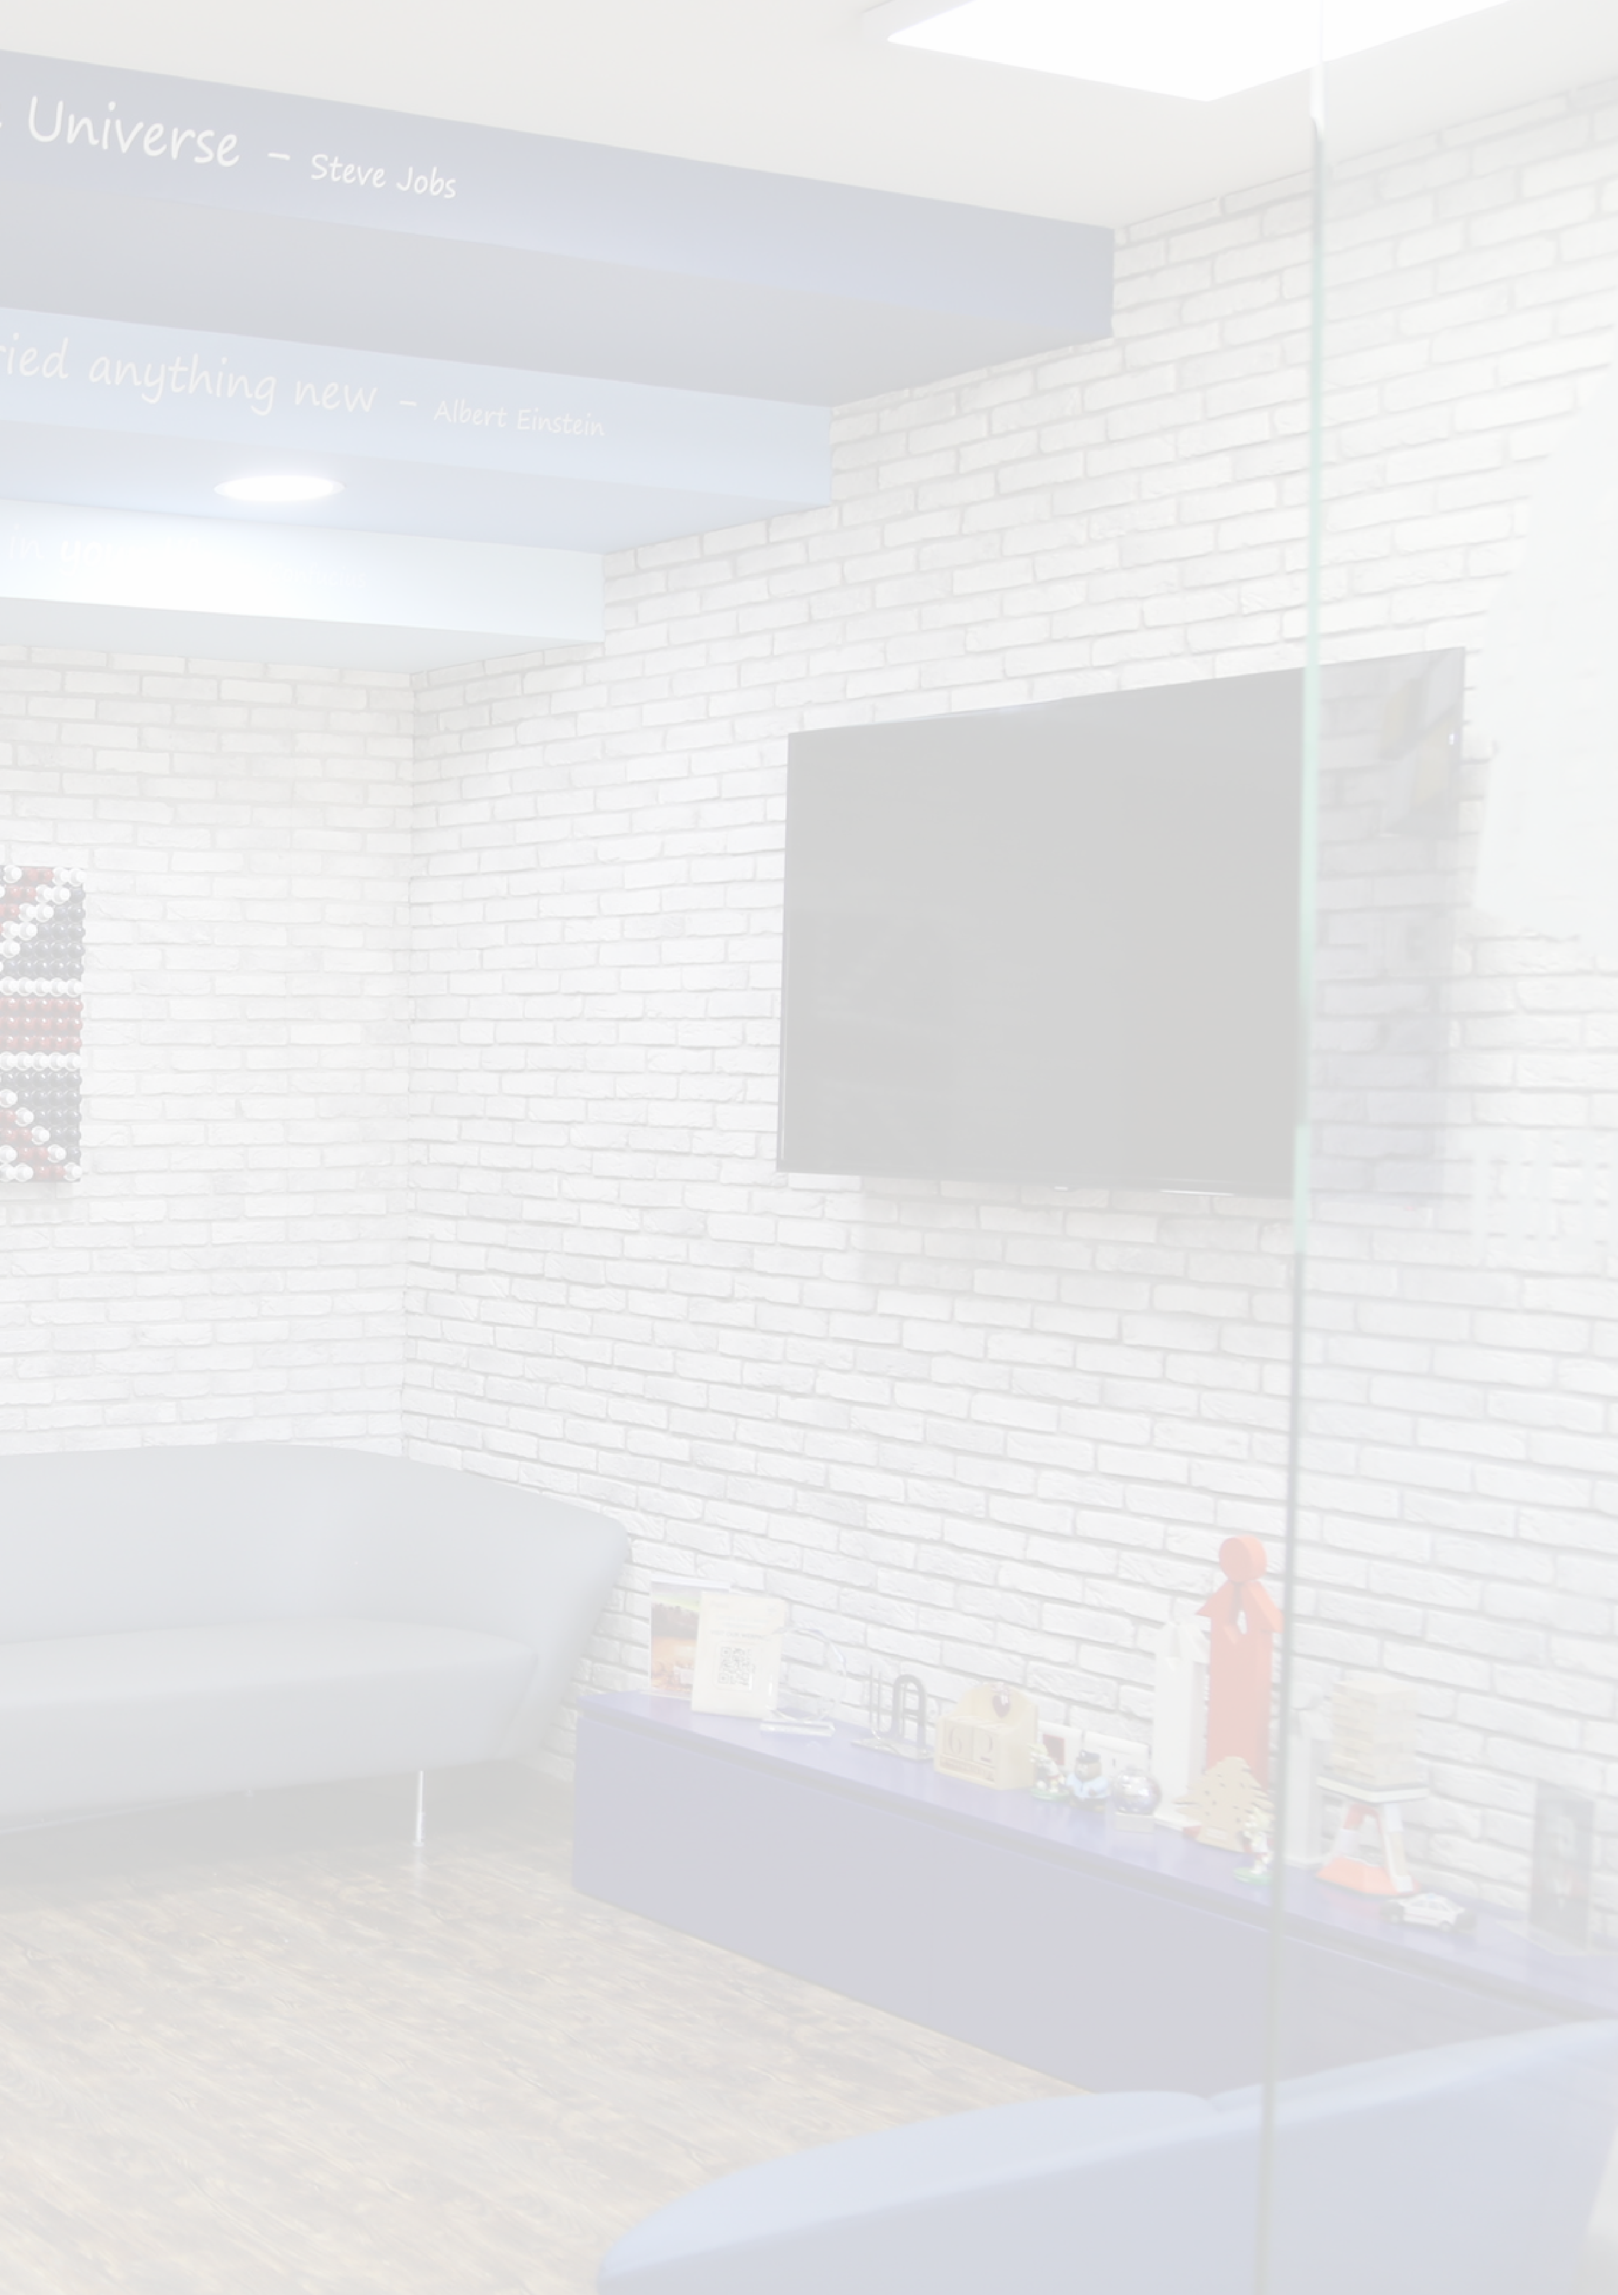


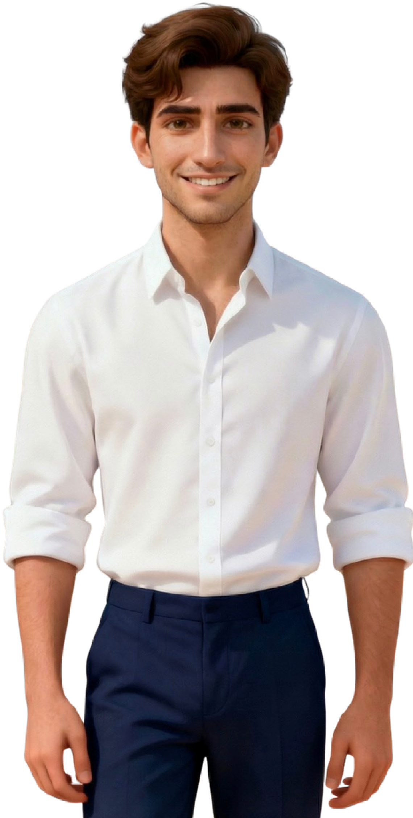
MOCK INTERVIEW
FEEDBACK
REPORT

Name: | {{CandidateName}} | ID: | {{CandidateId}}
Date: | {{InterviewDate}} | Evaluator: | {{EvaluatorName}}

A. Common Questions Feedback
{{#CommonQuestions}}
{{.QuestionTitle}} | Rating: {{.Rating}}/5
Feedback

{{.Comment}}
Tips

{{.Tips}}

{{/CommonQuestions}}

B. Technical Questions Feedback
{{#TechnicalQuestions}}
{{.QuestionTitle}} | Rating: {{.Rating}}/5
Feedback

{{.Comment}}
Tips

{{.Tips}}

{{/TechnicalQuestions}}

C. Candidate Questions Feedback
{{#CandidateQuestions}}
{{.QuestionTitle}} | Rating: {{.Rating}}/5
Feedback

{{.Comment}}
Tips

{{.Tips}}

{{/CandidateQuestions}}

3. Soft Skills Feedback
Category | Grade
A.1 Verbal Communication: Communication Clarity | {{SkillA1}}/5
A.2 Verbal Communication: Confidence / Tone of Voice | {{SkillA2}}/5
B.1 Non Verbal Communication: Posture | {{SkillB1}}/5
B.2 Non Verbal Communication: Body Language | {{SkillB2}}/5
C. Engagement & Enthusiasm | {{SkillC}}/5
D. Time Management | {{SkillD}}/5
E. Critical Thinking | {{SkillE}}/5

4. Overall Feedback & Recommendation
Overall Rating: {{OverallRating}}/5  {{SummaryComment}} | In my opinion  
For more information and insights, please contact the CCD team at ccd@ua.edu.lb or call 05 927 000 (extensions 1130, 1131, or 1133).

