**México Solidarity Project**

**Thanks for coming to hear José Luis Granados Ceja and for your interest in México. Want to get to know other Mexican activists? You’ll hear their voices in our weekly bilingual Bulletin. Subscribe below, or use the QR code.**

**https://mexicosolidarityproject.org/subscribe/**

History was made on December 1, 2018:  progressive Andrés Manuel López Obrador, affectionately called AMLO, became President of México in a landslide. Today, his approval rating remains at around 65%. Why? He has made good on his promise “for the good of all, but first the poor.” México has embarked on a project for transformational change.

But we know the drill. As usual, the US exerts enormous pressure to undermine this victory - including threats of invasion by Republicans. This affects not just Mexican@s, but US Chican@s, Central Americans, with reverberations for the left around the globe.

México, more than any other country of the world, will influence our struggle in the US for to end the system   Will the US succeed in maintaining Mexico as a vassal state? Will México point the way for US social movements to gain governing power? Better futures are possible!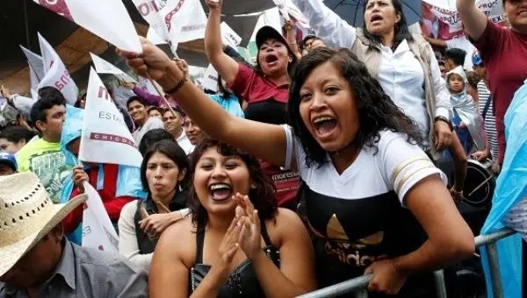

**Name Email Organization (if any) Phone #**

**______________________________________________________________________________**

**______________________________________________________________________________**

**______________________________________________________________________________**

**______________________________________________________________________________**

**______________________________________________________________________________**

**______________________________________________________________________________**

**______________________________________________________________________________**

**______________________________________________________________________________**

**______________________________________________________________________________**