**México Solidarity Project**

**A turning point in Mexican History:**  In 2018, Andrés Manuel López Obrador, AMLO, became President of México in a landslide. During his 6 year term, Mexico has been on the road to a profound transformation, finally fulfilling the promise of previous revolutions to serve the needs of farmers and laborers, but “first, the poor.” Support for Morena has continued to grow, and in 2024, Claudia Sheinbaum is poised to become México’s next president.

But we know the drill. México’s financial, corporate, and narco-interests resist reform. Most importantly, as usual, **the US will exert enormous pressure to undermine this victory** that affects not just Mexicans, but US Mexicanos/Chicanos, Latin Americans, with reverberations for the left around the globe.

We share a long history of cross-border organizing. **In the US, we must insist that our government stop its interference. México has a right to sovereignty**: to dismantle policies serving foreign corporations, and to control its own resources. Our support includes other social movements such as the Zapatistas, other indigenous groups and feminists. **A better future is possible!**



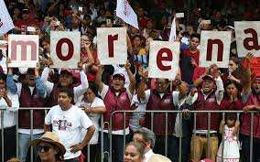

**Subscribe to the MSP bilingual weekly Bulletin**

**https://mexicosolidarityproject.org/subscribe/**

**SUBSCRIBE/WANT TO KNOW MORE/Participate**

**Name Email Phone Organization (if any)**

**______________________________________________________________________________**

**______________________________________________________________________________**

**______________________________________________________________________________**

**_____________________________________________________________**

**____________________________________________________________**

**_____________________________________________________________**

**_____________________________________________________________**

**_____________________________________________________________**

**_____________________________________________________________**

***Local organization and contact information:***