Lab1 Readme

John Ellis

1/31/2022

## R Markdown

This is an R Markdown document. Markdown is a simple formatting syntax for authoring HTML, PDF, and MS Word documents. For more details on using R Markdown see <http://rmarkdown.rstudio.com>.

When you click the **Knit** button a document will be generated that includes both content as well as the output of any embedded R code chunks within the document. You can embed an R code chunk like this:

summary(cars)

## speed dist   
## Min. : 4.0 Min. : 2.00   
## 1st Qu.:12.0 1st Qu.: 26.00   
## Median :15.0 Median : 36.00   
## Mean :15.4 Mean : 42.98   
## 3rd Qu.:19.0 3rd Qu.: 56.00   
## Max. :25.0 Max. :120.00

## Including Plots

You can also embed plots, for example:

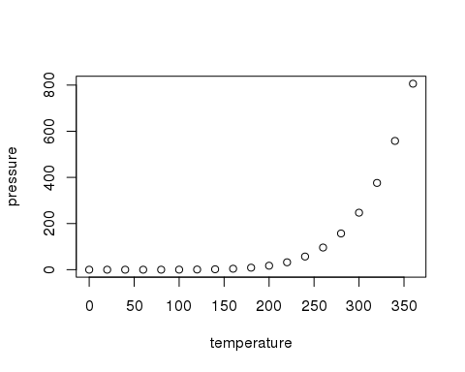

Note that the echo = FALSE parameter was added to the code chunk to prevent printing of the R code that generated the plot.

*What happens when you surround text with one-star pairs?*

**What happens when you surround text with two-star pairs?**

***What happens when you surround text with three-star pairs?***

1. Start typing this list. Note there are two spaces between the period and the word "Start".
2. Type the second line of the list
3. What happens if I type step 3 as another step 1?

It becomes "Step 3"

* What does this star at the beginning do? "It creates a bullet point"
* Visually, it's similar to the numbered list.

1. What happens if we nest a list? "it creates a sub-list"
   1. Type four spaces, then type the number
   2. Did this do what you expected?
2. What if we contine the numbers this way? "Bullet points then become Dashes"
   * What happens if we indent using stars?
   * Let's add another one for good measure.
     + Can we get another level of nesting? "yes"

[What does this do?](https://google.com) "This links a website"

How is this different from the above?

How is this different from the above?

"The link here is embedded as text, instead of as a plain URL"

Two things about committing. 1) You should commit somewhat frequently. At minimum, you should try and make a commit each time that you've finished a lab exercise. 2) Leave informative commit messages. "Added stuff" will not help you if you're looking at your commit history in a year. A message like "Typed in Lab 1 RMarkdown examples" will be more useful.

The synchronizing can go in the opposite direction as well, which is called a "Pull". One reason you would use "Pull" is if you are working on the lab report from more than one computer throughout the day. You would push your commits from the first computer, move to the second computer, and then use pull to get all the changes you made and synchronized.

The table with poor spacing

|  |  |  |  |
| --- | --- | --- | --- |
| Column 1 | Column 2 | Column 3 | Column 4 |
| Notice | what | the | colons |
| are | doing? |  |  |

The table with good spacing

|  |  |  |  |
| --- | --- | --- | --- |
| Column 1 | Column 2 | Column 3 | Column 4 |
| Notice | what | the | colons |
| are | doing? |  |  |