 const checkButton = document.getElementById("checkButton");

checkButton.addEventListener("click", checkWord);     typingInput.addEventListener("keydown", function(e) {

            if (e.key === "Enter") {

                checkWord();

            }

        });

 const typingInput = document.getElementById("typingInput"); const wordList = ["hello", "world", "javascript", "typing", "test"]; typingInput.value = ""; typingInput.focus(); const typingInput = document.getElementById("typingInput"); const typed = typingInput.value.trim().toLowerCase(); const currentWord = wordList[currentIndex].toLowerCase(); const isCorrect = typed === currentWord;

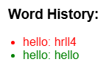 feedback.textContent = isCorrect ? `✔ Correct! You typed "${typed}"` : `✘ Incorrect. You typed "${typed}"`; feedback.className = isCorrect ? "result correct" : "result incorrect";

const li = document.createElement("li");  li.textContent = `${wordList[currentIndex]}: ${typed}`; li.className = isCorrect ? "correct" : "incorrect"; wordHistory.appendChild(li);

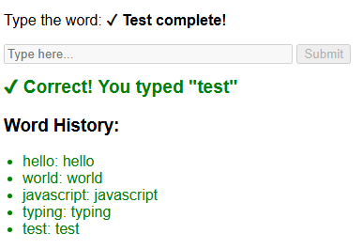 if (isCorrect) {

currentIndex++;

if (currentIndex < wordList.length) {

targetWordDisplay.textContent = wordList[currentIndex];

} else {

targetWordDisplay.textContent = "✓ Test complete!";

typingInput.disabled = true;

checkButton.disabled = true;

}

}