(b) Oriented signed FDG representation learning
- Multi-scale dental conditioner
$$L_{VAE}$$
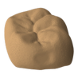
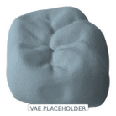
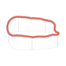
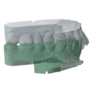
CAD
Oriented
signed FDG
\
Recon.
FDG
\
Reconstructed
mesh
VAE p laceholder
Z = ( O, F )
VAE
Enc.
VAEDec.
Scans
Margin
Inputs

FDI
Structure
condition
G
V
Feature
condition
G
V
Align &
Sample

(c) Case-conditioned crown generation

d

Frozen
S-Dec
Structure Flow
Sparse structure
Structure Flow
Noise



Scans
Margin
Inputs

FDI
\

