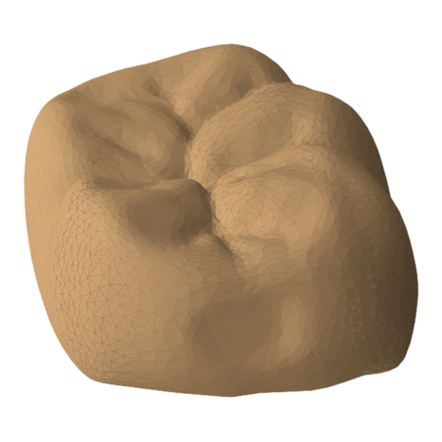
(a) Sparse surface support
(c) Geometry code and sparse latent

Sparse Geometric VAE
Z = ( O, F )
c
c
c
c
c
c
c
c
c
geometry, local sign, and orientation are compressd jointly
$$b_{j}$$
axis flags
$$v_{j}$$
offset
$$d_{j}$$
sign d.
$$n_{j}$$
normal
(b) Local oriented signed FDG
inactive
active
Surface-neighborhood activate set
$$n_{j}$$

