EXECUTIVE SUMMARY – BANK CUSTOMERS SATISFACTION
Bank Customer Segmentation & Satisfaction
Unsupervised analysis of 1,000 customers of Chase, Bank of America and Wells Fargo · Juan Esteban Londoño-Marín · October 2026
1,000  customers analyzed | 4.17★  average satisfaction | 19%  passive customers | 5  segments with an offer

Key Insights
- “Most customers are happy, but one in five is not” — and another one in five is quietly at risk. 60% are very satisfied (5★), 21% dissatisfied (2★) and 19% satisfied but unenthusiastic (4★, ‘passive’), the group most exposed to competitors.
- The mobile app decides the experience. Digital & mobile is the top reason at every satisfaction level: it explains 40% of delight and 24% of dissatisfaction (crashes during payment, unreliable app).
- Satisfaction depends on service touchpoints, not on who the customer is. Age, income, debt, tenure, products, channels and bank show no significant link to satisfaction (all p > 0.10). The three banks score between 4.14★ and 4.20★.
- Five customer segments, each with a clear offer. From young professionals ready for a first mortgage to highly leveraged earners who need debt relief rather than new credit.
- A trained model assigns new customers automatically to a segment and returns its recommended offer.

Context and approach
The dataset contains 1,000 customers, their products, income, debt, channel use and a free-text opinion about their bank. The work followed four stages: data cleaning with a documented audit log (the raw file was never modified), exploratory analysis, natural-language processing of the opinions, and customer segmentation. All models are unsupervised or pre-trained; no model was trained on labeled data.
Stage | What was done | Result
Cleaning | Type scan of every cell, logic rules, outlier checks | 5 corrupted debts imputed, 138 product totals fixed, 141 rows flagged, 0 removed
Exploration | Distributions, bank profiles, associations, text structure | Uniform, independent variables; banks serve the same customer type
Satisfaction (NLP) | 3 sentiment models compared; topic phrase extracted and grouped | 5-star model selected; 9 reason categories
Segmentation | K-Means, hierarchical clustering and DBSCAN; stability and outlier checks | K-Means, 5 segments, saved pipeline

Part 1 · Customer satisfaction

How satisfied are customers?
Three pre-trained sentiment models were compared. All three rank the messages in the correct order, but the 5-star review model separates the levels with the widest margin and uses an intuitive business scale, so it defines the satisfaction level.
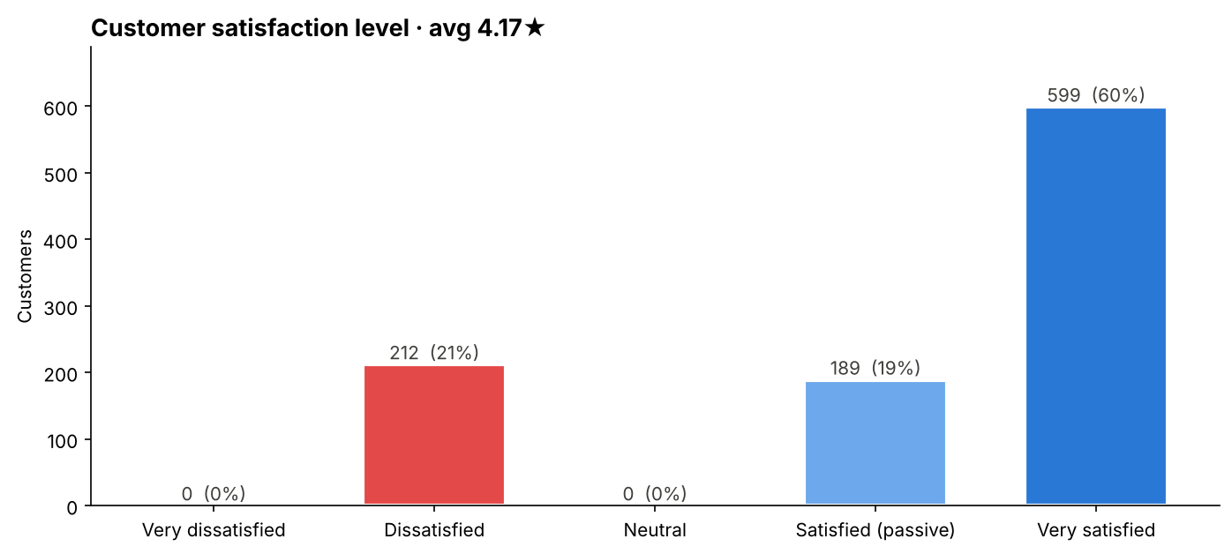
Figure 1. Satisfaction level of the 1,000 customers (5-star model).
The passive 19%. Their messages read ‘generally fine… meets most of my banking needs’: no complaint, but no enthusiasm. In Net Promoter terms they are Passives — content today, easy to lose tomorrow.

Why are they satisfied or dissatisfied?
Each message contains a short topic phrase (e.g. ‘hidden banking fees’). The 30 distinct topics were grouped into 9 business categories, and the grouping was checked with unsupervised clustering of sentence embeddings.
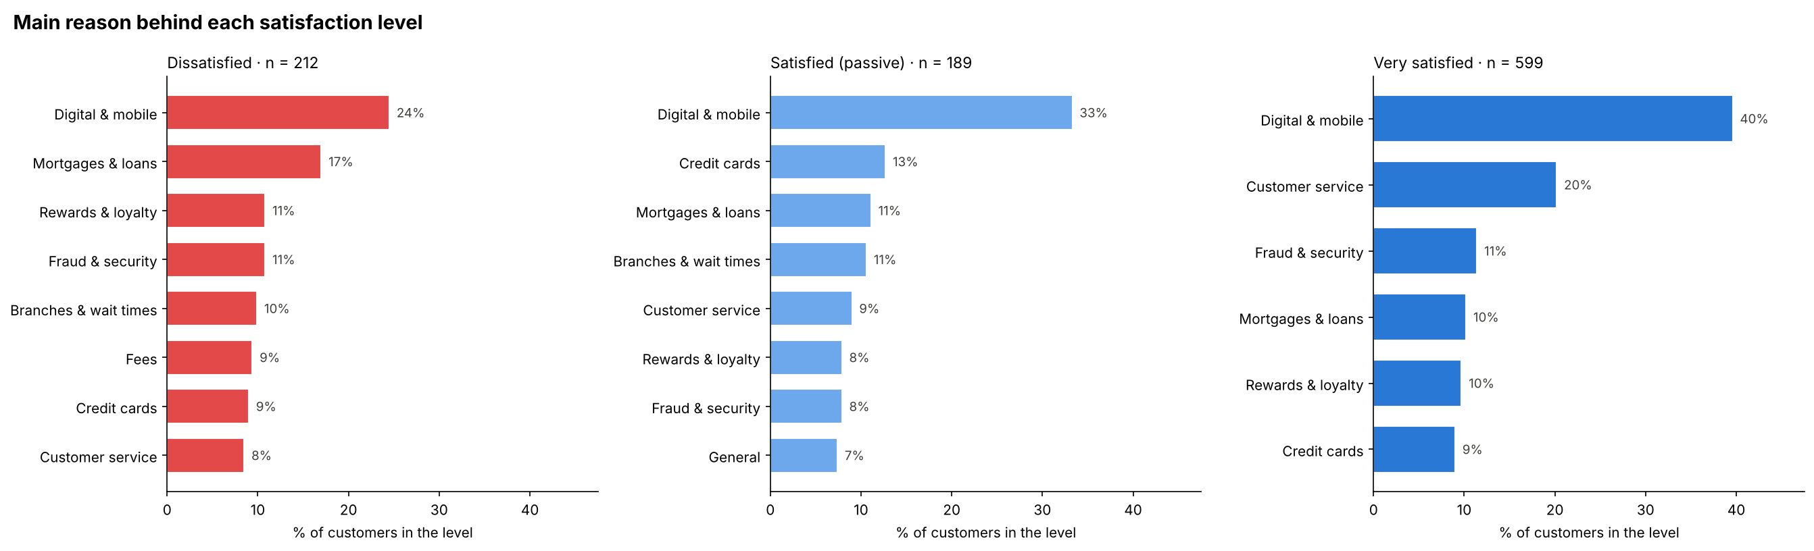
Figure 2. Main reasons within each satisfaction level.
- Delight: digital convenience (40%), helpful financial advice (20%) and efficient fraud protection (11%).
- Dissatisfaction: unreliable app and crashes during payment (24%), confusing mortgage and loan processes (17%), poor loyalty offers and slow fraud resolution (11% each).
- Passive: an app that works but glitches (33%), standard credit card offers and an ordinary mortgage process.
- Pure friction: hidden fees and long branch lines never appear among very satisfied customers.

Does satisfaction vary across customers or banks?
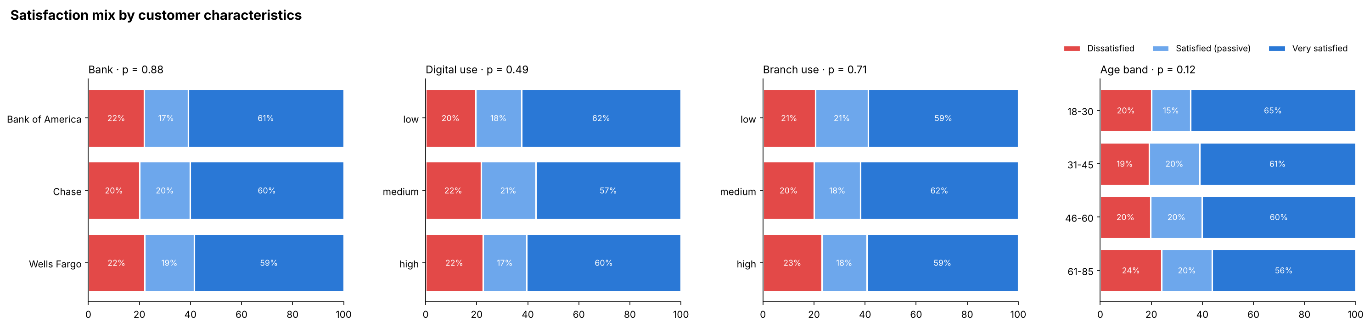
Figure 3. Satisfaction mix by bank, channel use and age — no significant differences.
No. The satisfaction mix is practically the same across banks (p = 0.88), channels and age bands. What changes is what dissatisfied customers complain about: Bank of America concentrates fees and mortgages, Wells Fargo credit cards, and Chase the digital experience.

Part 2 · Customer segments and offers
Ten variables describing life stage, financial capacity, products held and channel use were standardized and clustered. Three methods were compared. DBSCAN found no dense groups — it either labelled most customers as noise or merged them into one cluster — confirming that customers are spread evenly. Hierarchical clustering (Ward) and K-Means produced similar quality, and K-Means with five segments was selected for its slightly better metrics, interpretability, robustness (97% agreement when refitted without outliers) and its ability to assign new customers.
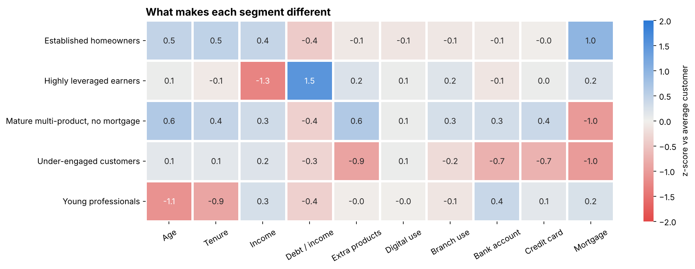
Figure 4. How each segment differs from the average customer (blue = above, red = below).
Segment | Customers | Profile | Recommended offer
Established homeowners | 241 | Age 59, 20 years with the bank, all with a mortgage, $172k income | Refinancing, home insurance, home-equity line
Young professionals | 231 | Age 27, 5 years with the bank, $152k income, low debt | Rewards card, first-home mortgage pre-approval, automated investing
Highly leveraged earners | 201 | $44k income, debt 7.6× income | Debt consolidation and financial coaching — no new credit
Mature multi-product, no mortgage | 184 | Age 64, most extra products, no mortgage | Wealth management, retirement planning, premium card
Under-engaged customers | 143 | Almost no products; 100 of the 111 zero-product customers | Starter bundle: checking + entry card, digital onboarding

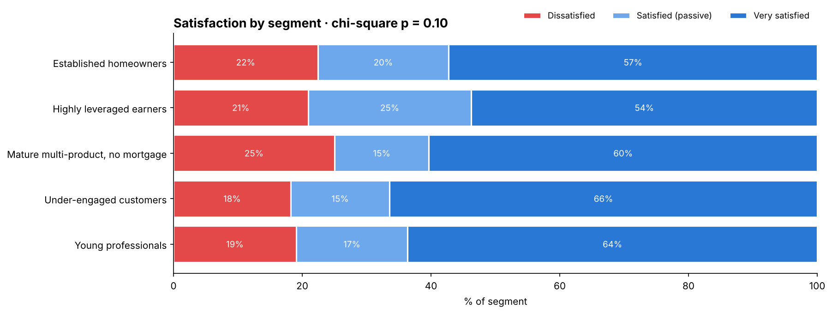
Figure 5. Satisfaction inside each segment.
Satisfaction does not differ significantly between segments (p = 0.10). Under-engaged customers and young professionals are the happiest (66% and 64% very satisfied); the mature multi-product segment has the most dissatisfied customers (25%) and highly leveraged earners the most passives (25%). Digital & mobile is the main complaint in four of the five segments.

Recommendations
- Fix app reliability first. Payment crashes are the largest single complaint, and the app is also the largest source of delight; every campaign will run through it.
- Convert the passive 19%. Replace generic card offers and simplify the mortgage journey before competitors reach these customers.
- Remove pure friction. Transparent fees and branch queue management are quick wins: they only ever generate dissatisfaction.
- Launch segment offers in order of value and risk: young professionals (growth), established homeowners (retention), under-engaged customers (easiest cross-sell), mature customers (wealth). Offer relief, not credit, to highly leveraged earners.
- Monitor continuously. Score new opinions with the same pipeline and track the share of passive customers as an early churn signal; assign new customers to segments with the saved model.

Limitations
- The customer variables are uniform and independent and the opinions follow three templates, which suggests a synthetic dataset; results demonstrate the method more than they describe a real market.
- Segments are a useful partition rather than naturally separated groups (silhouette ≈ 0.10, moderate stability).
- With real free-text reviews, sentiment accuracy would be lower and the rule-based topic extraction would be replaced by the embedding clustering already

