Suggest text section:

Consistent with results from the PGW experiment, an analysis of official tornado reports from the Storm Prediction Center (SPC) archive (2007-2020) finds an upward trend of 7% per year in the intensity of the strongest tornado (as defined using damage path characteristics, Fricker et al. 2017) occurring in Mississippi (corresponding to the cool season box) during the cool season (November through February) and a downward trend of 10% per year in the intensity of the strongest tornado occurring in Oklahoma (corresponding to the warm season box) during the warm season (May through July) although year-to-year variations are large due to the small sample sizes each season (**Fig. X**).

Methods section:

The empirical analysis uses the *1950-2020-torn-inipoint* shapefiles from the SPC. Data are filtered to include only tornadoes in Oklahoma during the warm season (May-July) and separately only tornadoes in Mississippi during the cool season (November through February) over the period 2007-2020. The EF rating scale was first implemented in 2007 and the last year available to the authors at the time of analysis is 2020. The average number of Oklahoma warm-season tornadoes over this period is 47 (with a range between 3 and 118) and the average number of Mississippi cool-season tornadoes over this same period is 24 (with a range between 5 and 47). Per tornado intensity (energy dissipation) is computed using the formula in Fricker et al. (2017). For each region/season, the highest per-tornado intensity is plotted and the best-fit line on the semi-log (base 10) scale is shown. Regressing the natural logarithm of per season highest intensity onto year weighted by the number of tornadoes, there is an increase of 7% in tornado intensity per year during the cool season over Mississippi and a decrease of 10% in tornado intensity per year during the warm season over Oklahoma. For replicating the analysis, all the code and data are available on GitHub <https://github.com/jelsner/tor-pwr-up> in the file “CoolVsWarmSeasonTrends.Rmd.”

**Figure X caption**: A recent increase in the intensity of the strongest tornadoes in Mississippi during the cool season. Seasonal highest tornado intensity (GW) for Mississippi during the cool season (blue) and for Oklahoma during the warm season (red). The horizontal axis marks the year of the first month of the season. The corresponding trend line is based on a log-linear regression.

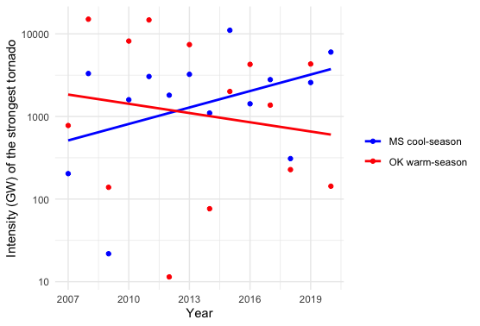

James B. Elsner, Florida State University, Tallahassee, FL, 32306, ORCID 0000-0001-6805-7431