<https://azure.microsoft.com/en-in/overview/what-is-cloud-computing>

<https://www.youtube.com/watch?v=X43KVeWVkSY> Cloud Computing – Intro, Architecture

# **What is Cloud Computing?**

Simply put, cloud computing is the delivery of computing services—including servers, storage, databases, networking, software, analytics, and intelligence—over the Internet (“the cloud”) to offer faster innovation, flexible resources, and economies of scale. You typically pay only for cloud services you use, helping lower your operating costs, run your infrastructure more efficiently and scale as your business needs change.

# **Cloud Computing Service Providers**

A few of the most popular cloud computing service providers include:

* Microsoft Azure
* Google Cloud
* Alibaba Cloud
* IBM Cloud
* Oracle
* Amazon Web Services (AWS)
* Salesforce
* SAP
* Rackspace Cloud
* VMWare

# **Top Benefits of Cloud Computing**

Cloud computing is a big shift from the traditional way businesses think about IT resources. Here are seven common reasons organisations are turning to cloud computing services:

**Cost**

Cloud computing eliminates the capital expense of buying hardware and software and setting up and running on-site datacenters—the racks of servers, the round-the-clock electricity for power and cooling, the IT experts for managing the infrastructure. It adds up fast.

**Speed**

Most cloud computing services are provided self service and on demand, so even vast amounts of computing resources can be provisioned in minutes, typically with just a few mouse clicks, giving businesses a lot of flexibility and taking the pressure off capacity planning.

**Global scale**

The benefits of cloud computing services include the ability to scale elastically. In cloud speak, that means delivering the right amount of IT resources—for example, more or less computing power, storage, bandwidth—right when it is needed and from the right geographic location.

**Productivity**

On-site datacenters typically require a lot of “racking and stacking”—hardware setup, software patching, and other time-consuming IT management chores. Cloud computing removes the need for many of these tasks, so IT teams can spend time on achieving more important business goals.

**Performance**

The biggest cloud computing services run on a worldwide network of secure datacenters, which are regularly upgraded to the latest generation of fast and efficient computing hardware. This offers several benefits over a single corporate datacenter, including reduced network latency for applications and greater economies of scale.

**Reliability**

Cloud computing makes data backup, disaster recovery and business continuity easier and less expensive because data can be mirrored at multiple redundant sites on the cloud provider’s network.

**Security**

Many cloud providers offer a broad set of policies, technologies and controls that strengthen your security posture overall, helping protect your data, apps and infrastructure from potential threats.

# **Types of Cloud Computing**

Not all clouds are the same and not one type of cloud computing is right for everyone. Several different models, types and services have evolved to help offer the right solution for your needs.

First, you need to determine the type of cloud deployment or cloud computing architecture, that your cloud services will be implemented on. There are three different ways to deploy cloud services: on a public cloud, private cloud or hybrid cloud. Learn more about public, private and hybrid clouds.

**Public cloud**

Public clouds are owned and operated by third-party cloud service providers, which deliver their computing resources like servers and storage over the Internet. Microsoft Azure is an example of a public cloud. With a public cloud, all hardware, software and other supporting infrastructure is owned and managed by the cloud provider. You access these services and manage your account using a web browser.

**Private cloud**

A private cloud refers to cloud computing resources used exclusively by a single business or organisation. A private cloud can be physically located on the company’s on-site data center. Some companies also pay third-party service providers to host their private cloud. A private cloud is one in which the services and infrastructure are maintained on a private network.

**Hybrid cloud**

Hybrid clouds combine public and private clouds, bound together by technology that allows data and applications to be shared between them. By allowing data and applications to move between private and public clouds, a hybrid cloud gives your business greater flexibility, more deployment options and helps optimise your existing infrastructure, security and compliance.

# **Types of cloud services: IaaS, PaaS, Serverless and SaaS**

<https://www.javatpoint.com/cloud-service-models>

<https://thinkpalm.com/blogs/the-three-cloud-service-models-paas-saas-iaas-heres-how-you-can-choose-the-right-one-for-your-business/>

Most cloud computing services fall into four broad categories: infrastructure as a service (IaaS), platform as a service (PaaS), serverless and software as a service (SaaS). These are sometimes called the cloud computing stack because they build on top of one another. Knowing what they are and how they are different makes it easier to accomplish your business goals.

**Infrastructure as a service (IaaS)**

The most basic category of cloud computing services. With IaaS, you rent IT infrastructure—servers and virtual machines (VMs), storage, networks, operating systems—from a cloud provider on a pay-as-you-go basis.

**Platform as a service (PaaS)**

Platform as a service refers to cloud computing services that supply an on-demand environment for developing, testing, delivering and managing software applications. PaaS is designed to make it easier for developers to quickly create web or mobile apps, without worrying about setting up or managing the underlying infrastructure of servers, storage, network and databases needed for development.

**Serverless computing**

Overlapping with PaaS, serverless computing focuses on building app functionality without spending time continually managing the servers and infrastructure required to do so. The cloud provider handles the setup, capacity planning and server management for you. Serverless architectures are highly scalable and event-driven, only using resources when a specific function or trigger occurs.

**Software as a service (SaaS)**

Software as a service is a method for delivering software applications over the Internet, on demand and typically on a subscription basis. With SaaS, cloud providers host and manage the software application and underlying infrastructure and handle any maintenance, like software upgrades and security patching. Users connect to the application over the Internet, usually with a web browser on their phone, tablet or PC.

# **Uses of Cloud Computing**

You are probably using cloud computing right now, even if you don’t realise it. If you use an online service to send email, edit documents, watch movies or TV, listen to music, play games or store pictures and other files, it is likely that cloud computing is making it all possible behind the scenes. The first cloud computing services are barely a decade old, but already a variety of organisations—from tiny startups to global corporations, government agencies to non-profits—are embracing the technology for all sorts of reasons.

Here are a few examples of what is possible today with cloud services from a cloud provider:

**Create cloud-native applications**

Quickly build, deploy and scale applications—web, mobile and API. Take advantage of cloud-native technologies and approaches, such as containers, Kubernetes, microservices architecture, API-driven communication and DevOps.

**Test and build applications**

Reduce application development cost and time by using cloud infrastructures that can easily be scaled up or down.

**Store, back up and recover data**

Protect your data more cost-efficiently—and at massive scale—by transferring your data over the Internet to an offsite cloud storage system that is accessible from any location and any device.

**Analyse data**

Unify your data across teams, divisions and locations in the cloud. Then use cloud services, such as machine learning and artificial intelligence, to uncover insights for more informed decisions.

**Stream audio and video**

Connect with your audience anywhere, anytime, on any device with high-definition video and audio with global distribution.

**Embed intelligence**

Use intelligent models to help engage customers and provide valuable insights from the data captured.

**Deliver software on demand**

Also known as software as a service (SaaS), on-demand software lets you offer the latest software versions and updates around to customers—anytime they need, anywhere they are.

# **History of Cloud Computing**

<https://www.javatpoint.com/history-of-cloud-computing>

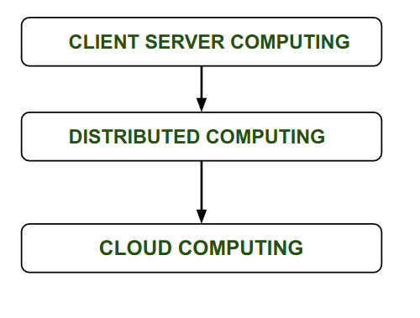Before cloud computing emerged, there was Client/Server computing which is basically a centralized storage in which all the software applications, all the data and all the controls are resided on the server side.

If a single user wants to access specific data or run a program, he/she need to connect to the server and then gain appropriate access, and then he/she can do his/her business.

Then after, distributed computing came into picture, where all the computers are networked together and share their resources when needed.

On the basis of above computing, cloud computing concepts emerged that were later implemented.

Cloud computing is not a modern technology. It has continued to evolve since the early 1950s. In 1955, John McCarthy created a time-sharing concept, enabling a group of users to use an expensive mainframe simultaneously. McCarthy’s theory of mainframe timesharing is said to have had a significant impact on the development of the internet.

With the evolution of technology, the concept of cloud computing took a giant leap in the mid-1960s, when an American computer scientist Joseph Carl Robnett Licklider described a theory of interconnected computing systems. This idea gave birth to the predecessor of the internet: ARPANET (Advanced Research Projects Agency Network).

Licklider’s contribution is considered to be the most valuable in the creation of cloud computation; thus, he is believed to be the father of cloud computing.

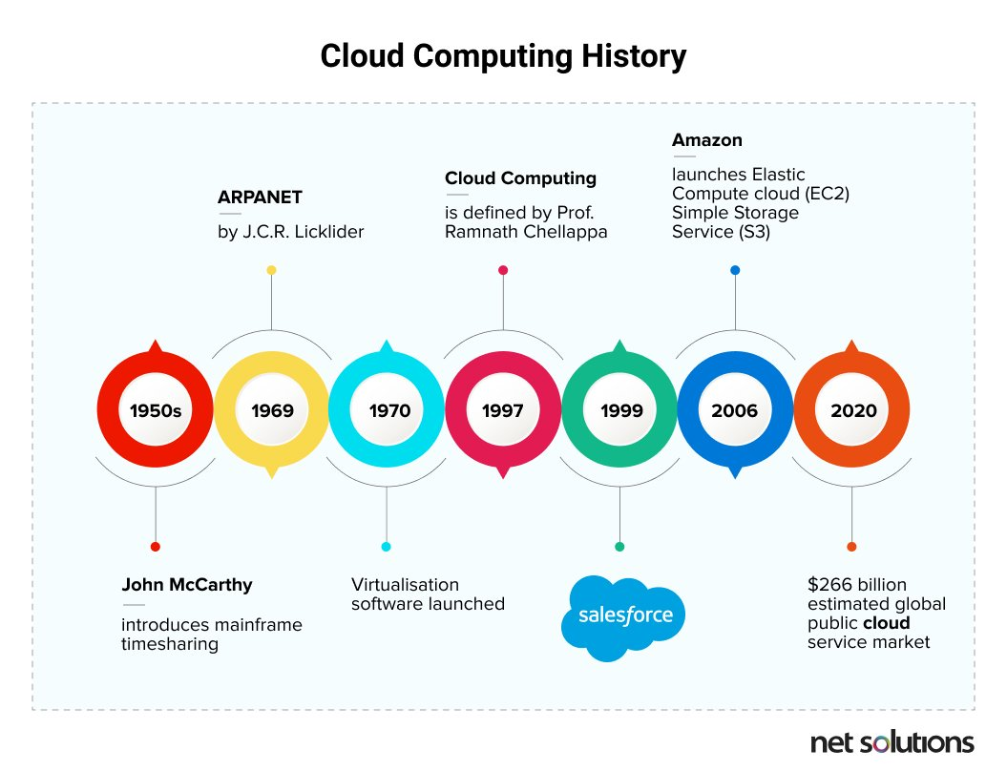

From the 1970s to the 1990s, cloud evolved at break-neck speed because of advancements in technology. In 1972, IBM released VM (Virtual Machine) operating system, exhibiting the behavior of dedicated hardware, giving users the same experience on a virtual machine. In the 1990s, telecommunications companies started offering “Virtualized” Private Networks (VPNs) as rentable services.

Professor Ramnath Chellapa of Emory University, in the year 1997, defined cloud computing as:

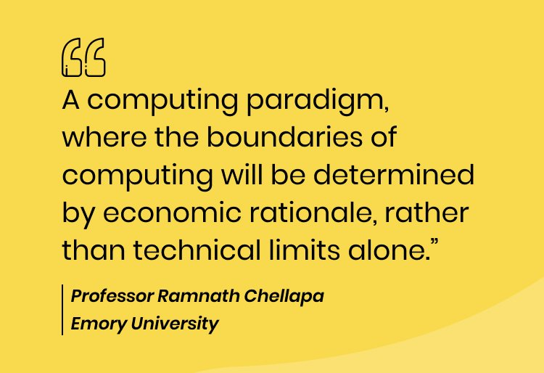

As businesses started gaining a better understanding of the term cloud, it gained popularity, and in 1999, Salesforce emerged as an ideal example of successful cloud computing adoption.

However, the term cloud computing became extremely popular in 2006 when Amazon released its Elastic Compute Cloud product.

# **Cloud Architecture**

Cloud architecture is the way technology components combine to build a cloud, in which resources are pooled through virtualization technology and shared across a network. Clouds are IT environments that abstract, pool, and share scalable resources across a network. Cloud architecture is how all the components and capabilities necessary to build a cloud are connected in order to deliver an online platform on which applications can run.

Cloud computing architecture is a combination of **service-oriented architecture** and **event-driven architecture**.

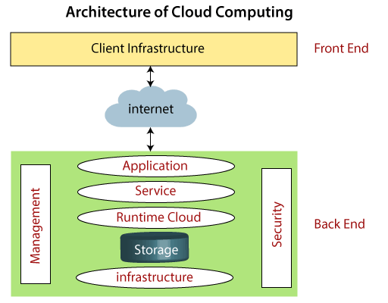Cloud computing architecture is divided into the following two parts -

* Front End
* Back End

The below diagram shows the architecture of cloud computing

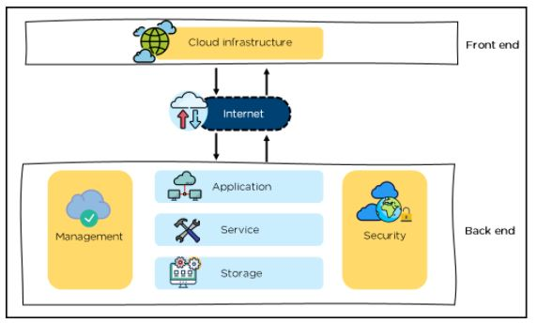

**Front End**

The front end is used by the client. It contains client-side interfaces and applications that are required to access the cloud computing platforms. The front end includes web servers (including Chrome, Firefox, internet explorer, etc.), thin & fat clients, tablets, and mobile devices.

**Back End**

The back end is used by the service provider. It manages all the resources that are required to provide cloud computing services. It includes a huge amount of data storage, security mechanism, virtual machines, deploying models, servers, traffic control mechanisms, etc.

Note: Both front end and back end are connected to others through a network, generally using the internet connection.

## **Components of Cloud Computing Architecture**

There are the following components of cloud computing architecture -

**1. Client Infrastructure**

Client Infrastructure is a Front end component. It provides GUI (Graphical User Interface) to interact with the cloud.

**2. Application**

The application may be any software or platform that a client wants to access.

**3. Service**

A Cloud Services manages that which type of service you access according to the client’s requirement.

Cloud computing offers the following three type of services:

**i. Software as a Service (SaaS) –**It is also known as **cloud application services**. Mostly, SaaS applications run directly through the web browser means we do not require to download and install these applications. Some important example of SaaS is given below –

**Example:** Google Apps, Salesforce Dropbox, Slack, Hubspot, Cisco WebEx.

**ii. Platform as a Service (PaaS) –** It is also known as **cloud platform** **services**. It is quite similar to SaaS, but the difference is that PaaS provides a platform for software creation, but using SaaS, we can access software over the internet without the need of any platform.

**Example:** Windows Azure, Force.com, Magento Commerce Cloud, OpenShift.

**iii. Infrastructure as a Service (IaaS) –**It is also known as **cloud infrastructure services**. It is responsible for managing applications data, middleware, and runtime environments.

**Example:** Amazon Web Services (AWS) EC2, Google Compute Engine (GCE), Cisco Metapod.

**4. Runtime Cloud**

Runtime Cloud provides the **execution and runtime environment** to the virtual machines.

**5. Storage**

Storage is one of the most important components of cloud computing. It provides a huge amount of storage capacity in the cloud to store and manage data.

**6. Infrastructure**

It provides services on the **host level**, **application level**, and **network level**. Cloud infrastructure includes hardware and software components such as servers, storage, network devices, virtualization software, and other storage resources that are needed to support the cloud computing model.

**7. Management**

Management is used to manage components such as application, service, runtime cloud, storage, infrastructure, and other security issues in the backend and establish coordination between them.

**8. Security**

Security is an in-built back end component of cloud computing. It implements a security mechanism in the back end.

**9. Internet**

The Internet is medium through which front end and back end can interact and communicate with each other.

Watch More: <https://www.youtube.com/watch?v=X43KVeWVkSY>

## **Public, private, hybrid, and multi-cloud architectures**

**Public cloud architecture**: A cloud environment created from resources not owned by the end user that can be redistributed to other tenants.

**Private cloud architecture**: Loosely defined as a cloud environment solely dedicated to the end user, usually within the user’s firewall and sometimes on premise.

**Hybrid cloud architecture**: Multiple cloud environments with some degree of workload portability, orchestration, and management among them.

**Multi-cloud architecture**: An IT system that includes more than 1 cloud—public or private—that may or may not be networked together.

# **Cloud Storage**

<https://aws.amazon.com/what-is-cloud-storage/>

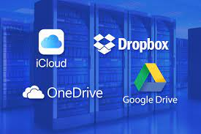Cloud storage is a cloud computing model that stores data on the Internet through a cloud computing provider who manages and operates data storage as a service. It’s delivered on demand with just-in-time capacity and costs, and eliminates buying and managing your own data storage infrastructure. This gives you agility, global scale and durability, with “anytime, anywhere” data access.

Cloud storage is purchased from a third party cloud vendor who owns and operates data storage capacity and delivers it over the Internet in a pay-as-you-go model. These cloud storage vendors manage capacity, security and durability to make data accessible to your applications all around the world.

Applications access cloud storage through traditional storage protocols or directly via an API. Many vendors offer complementary services designed to help collect, manage, secure and analyze data at massive scale.

## **Benefits of Cloud Storage**

* **Total Cost of Ownership**. With cloud storage, there is no hardware to purchase, storage to provision, or capital being used for "someday" scenarios. You can add or remove capacity on demand, quickly change performance and retention characteristics, and only pay for storage that you actually use. Less frequently accessed data can even be automatically moved to lower cost tiers in accordance with auditable rules, driving economies of scale.
* **Time to Deployment**. When development teams are ready to execute, infrastructure should never slow them down. Cloud storage allows IT to quickly deliver the exact amount of storage needed, right when it's needed. This allows IT to focus on solving complex application problems instead of having to manage storage systems.
* **Information Management**. Centralizing storage in the cloud creates a tremendous leverage point for new use cases. By using cloud storage lifecycle management policies, you can perform powerful information management tasks including automated tiering or locking down data in support of compliance requirements.

## **Requirements of Cloud Storage**

**Durability**. Data should be redundantly stored, ideally across multiple facilities and multiple devices in each facility. Natural disasters, human error, or mechanical faults should not result in data loss.

**Availability**. All data should be available when needed, but there is a difference between production data and archives. The ideal cloud storage will deliver the right balance of retrieval times and cost.

**Security**. All data is ideally encrypted, both at rest and in transit. Permissions and access controls should work just as well in the cloud as they do for on premises storage.

## **Types of Cloud Storage**

There are three types of cloud data storage: object storage, file storage, and block storage. Each offers their own advantages and have their own use cases:

**Object Storage** - Applications developed in the cloud often take advantage of object storage's vast scalablity and metadata characteristics. Object storage solutions like Amazon Simple Storage Service (S3) are ideal for building modern applications from scratch that require scale and flexibility, and can also be used to import existing data stores for analytics, backup, or archive.

**File Storage** - Some applications need to access shared files and require a file system. This type of storage is often supported with a Network Attached Storage (NAS) server. File storage solutions like Amazon Elastic File System (EFS) are ideal for use cases like large content repositories, development environments, media stores, or user home directories.

**Block Storage** - Other enterprise applications like databases or ERP systems often require dedicated, low latency storage for each host. This is analagous to direct-attached storage (DAS) or a Storage Area Network (SAN). Block-based cloud storage solutions like Amazon Elastic Block Store (EBS) are provisioned with each virtual server and offer the ultra low latency required for high performance workloads.

# **Advantages and Disadvantages of Cloud Computing**

<https://www.javatpoint.com/advantages-and-disadvantages-of-cloud-computing>

Cloud computing is a term referred to storing and accessing data over the internet. It doesn’t store any data on the hard disk of your personal computer. In cloud computing, you can access data from a remote server.

## **Advantages of Cloud Computing**

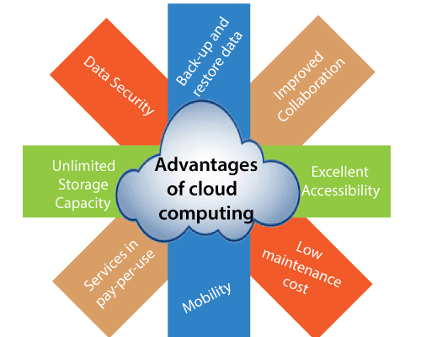

### **1) Back-up and restore data**

Once the data is stored in the cloud, it is easier to get back-up and restore that data using the cloud.

### **2) Improved collaboration**

Cloud applications improve collaboration by allowing groups of people to quickly and easily share information in the cloud via shared storage.

### **3) Excellent accessibility**

Cloud allows us to quickly and easily access store information anywhere, anytime in the whole world, using an internet connection. An internet cloud infrastructure increases organization productivity and efficiency by ensuring that our data is always accessible.

### **4) Low maintenance cost**

Cloud computing reduces both hardware and software maintenance costs for organizations.

### **5) Mobility**

Cloud computing allows us to easily access all cloud data via mobile.

### **6) IServices in the pay-per-use model**

Cloud computing offers Application Programming Interfaces (APIs) to the users for access services on the cloud and pays the charges as per the usage of service.

### **7) Unlimited storage capacity**

Cloud offers us a huge amount of storing capacity for storing our important data such as documents, images, audio, video, etc. in one place.

### **8) Data security**

Data security is one of the biggest advantages of cloud computing. Cloud offers many advanced features related to security and ensures that data is securely stored and handled.

## **Disadvantages of Cloud Computing**

<https://data-flair.training/blogs/advantages-and-disadvantages-of-cloud-computing/>

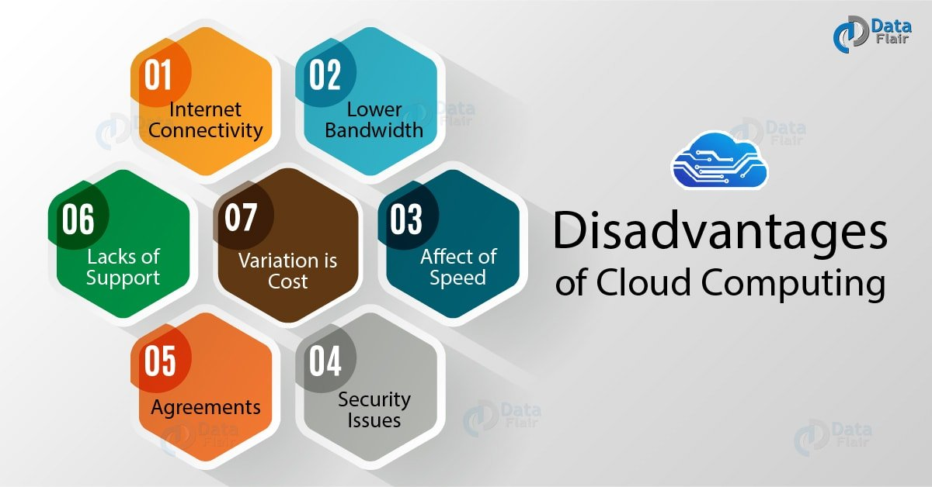

**Internet Connectivity**

Cloud Computing needs internet connectivity as if there will be no internet connection you won’t be able to access the cloud. Moreover, there is no other way to gather the data from the cloud.

**Lower Bandwidth**

Lower bandwidth reduces the benefits of the clouds such that it cannot use properly. A satellite connection can lead to quality disruption, due to higher latency or higher bandwidth.

**Effect of Speed**

If a client is using an internet which use by multiple users to download files such as music, documents, and many more. This will reduce the speed to use the Cloud.

**Security Issues**

As Cloud Computing is very secure but still it requires an IT consulting firm’s assistance and advice. Neglecting this can lead to the fact that the business will become vulnerable to the hackers and the threats.

**Agreements**

There are many vendors available which have agreements that are non-negotiable. It is one of the disadvantages for the companies.

**Lacks of Support**

Cloud Computing companies sometimes fail to provide proper support to the customers. Moreover, they want customers to depend fully on FAQs, which can be a tedious job.

**Variation is Cost**

Cloud Computing is an economical option, but if you will consider the installation of the software it can be costly. Installation can lead to some costly feature which can be non-beneficial in the future.

# **Why Cloud Computing Matters?**

<https://www.informit.com/articles/article.aspx?p=1321170&seqNum=5>

Cloud computing also enables new ways to access information, process and analyze data, and connect people and resources from any location anywhere in the world. In essence, it takes the lid off the box; with cloud computing, **developers** are no longer boxed in by physical constraints.

**For IT departments**, cloud computing offers more flexibility in computing power, often at lower costs. With cloud computing, IT departments don't have to engineer for peak-load capacity, because the peak load can be spread out among the external assets in the cloud. And, because additional cloud resources are always at the ready, companies no longer have to purchase assets (servers, workstations, and the like) for infrequent intensive computing tasks. If you need more processing power, it's always there in the cloud—and accessible on a cost-efficient basis.

**For end users**, cloud computing offers all these benefits and more. An individual using a web-based application isn't physically bound to a single PC, location, or network. His applications and documents can be accessed wherever he is, whenever he wants. Gone is the fear of losing data if a computer crashes. Documents hosted in the cloud always exist, no matter what happens to the user's machine. Users from around the world can collaborate on the same documents, applications, and projects, in real time. It's a whole new world of collaborative computing, all enabled by the notion of cloud computing.

**For everyone concerned**, cloud computing does all this at lower costs, because the cloud enables more efficient sharing of resources than does traditional network computing. When you tap into the power of the cloud, you get supercomputing power at PC prices—something that offers particular appeal to individuals and small businesses. And, with cloud computing, hardware doesn't have to be physically adjacent to a firm's office or data center; cloud infrastructure can be located anywhere, including and especially areas with lower real estate and electricity costs.

Bottom line? Cloud computing is set to change the way everyone uses computers. End users and organizations will be able to tap into more computing power at lower prices, and do their computing from any location in the world. Add to this the untold benefits of enhanced collaboration, and you see why cloud computing is set to be the "next big thing" in the computing world.

# **Companies in the Cloud Today**

<https://builtin.com/cloud-computing/cloud-computing-examples>

<https://data-flair.training/blogs/cloud-service-providers-companies/>

# **Cloud Services: Web-Based Application**

<https://financesonline.com/cloud-based-web-based-applications-a-comparison-of-features-key-aspects/>