Justin Melville and Steven Tong

EC413

Lab 3

4. introduced an error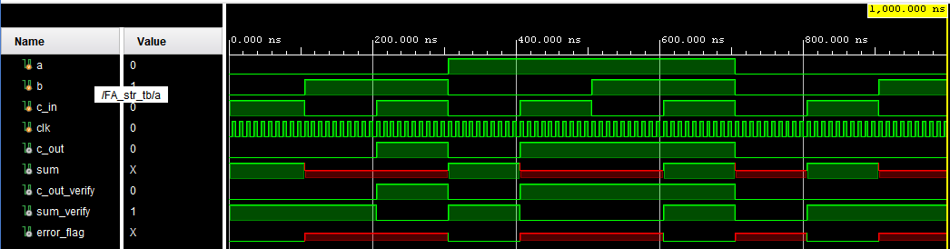

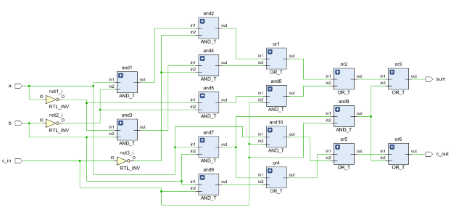

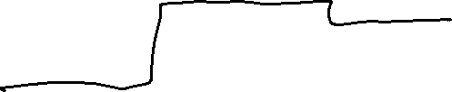

Longest path in this full adder is 5 gates, therefore for the 64-bit Ripple Carry Adder, the gate delay is 64x5 gates.

For the Two-stage Carry Select Adder, 3 32-bit RCAs run in parallel, and the mux can be considered to have no delay, therefore the gate delay is 32x5 gates.

With Delay

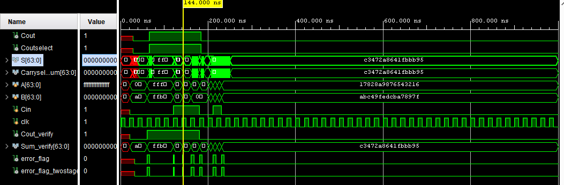

Without Delay

