# Creating a brach in github

* Go to <https://github.com/jem3523/BCEJ-Project01>
* Click the “Branch: master” tab.
* Select “develop”.
* Enter the name of your new branch. (For example, “**testBranch**”)
* Finally, click the clue button that confirms the name of your new branch and its parent.

**NOTE:** “New pull request” (purple arrow below) is used for merging later. It is not the same as the “pull” we do in class to refresh a repository on a local machine.

* When you then go to GitBash, enter the following:

git clone [git@github.com:jem3523/BCEJ-Project01.git](mailto:git@github.com:jem3523/BCEJ-Project01.git) -b **testBranch**

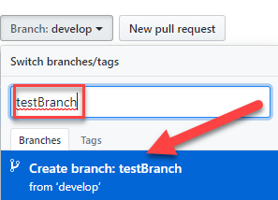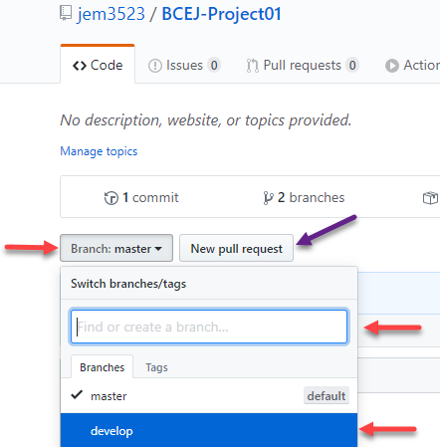

# Pushing a brach back into github

* Open gitbash
* Navigate to the branch directory (parent folder of the branch)
* Enter: *git add .*
* Enter: *git commit –a –m “* [insert a message here] *”*
* Enter both the parent branch and the branch you are uploading:

*git push –u develop testBranch*

# Merging a brach in github

* Go to <https://github.com/jem3523/BCEJ-Project01>
* Click the “Branch: master” tab.
* In the dropdown on the tab, select the branch you want to merge back into “develop”. (In this example, “**testBranch**”)
* Click “New pull request”.

**NOTE:** Once you select the branch you want to merge, that branch is no longer of use and should be deleted from your local machine.

