Research Framework Guide
A repeatable method for finding research on how supply shocks move through oil & aviation
Energy & aviation supply-resilience war game · July 10, 2026
What this is: a map of where to look when researching how any chokepoint or supply shock affects oil inventory and infrastructure — organized by the sources that answer each part of the question.
The cascade to follow: Trigger → crude → shipping & chokepoints → jet fuel → airfields. Each link leads or lags the others; the method is reading them in order and timing the gaps.

What We're Building — and How It Works
The end product is one living map that connects a political event to its effect on specific airfields and their fuel suppliers, anywhere in the world. Not a report about one crisis — a reusable model that absorbs each new event.
You build it one event at a time. Pick a real event and trace it down five layers. At each layer you pull a single number from a single open source, so every step is evidence, not a guess:
- Trigger — what happened, and where (GDELT / ACLED) →
- Crude — how far price and supply moved (EIA / OPEC) →
- Shipping — how much supply is physically at risk (IMF PortWatch + chokepoint data) →
- Jet fuel — the lagged price airfields actually pay (IATA) →
- Airfields — which runways feel the cost and supply strain (Flightradar24 / OurAirports)
Those figures land on a shared map that links every airfield to the chokepoints and suppliers it depends on — stitched together by three keys: country codes, dates, and coordinates. Run the next event through the same five layers and the map gets richer.
Why it's worth it: it turns scattered headlines into a system your team can explain (show the exact chain, not a hunch), anticipate (ask “if this closes, which airfields go dark first?”), and play (a realistic war-game board). It's a resilience and understanding tool built on open data — not a targeting tool.

Cascade Model — What to Watch
Layer | What you watch | Key indicator | Timing
1. Trigger | The event (strike, blockade, sanction) | Breaking news; policy briefings | Instant
2. Crude | First market reaction | Brent/WTI moves; supply balances | Minutes–hours
3. Shipping | Whether oil physically flows | Tanker transits; war-risk premiums | Hours–days
4. Jet fuel | Product that feeds airfields | Regional jet-fuel spot prices | Days–weeks
5. Airfields | Operational endpoint | Airport disruption indices | Days–weeks
Key habit: separate a real physical disruption from a risk premium. Prices spike on fear while oil still flows; the shipping layer tells you which you're seeing.

Oil Inventory — The Core
Inventory is the buffer between supply and demand; importers draw down while blocked exporters build up. Key metric: days of cover. Track three stock types — commercial crude, refined products (incl. jet fuel), and strategic reserves (SPR).
- EIA Weekly Petroleum Status Report — US stocks/flows/SPR, weekly (free)
- EIA Open Data API — programmatic access to all EIA series; free API key — pulls straight into Python
- JODI-Oil World Database — global stocks/production, 100 countries, free CSV
- JODI TableViewer (jodidb.org) — interactive data-table front end for browsing JODI series by country/flow
Reputable sources also publish ready-made visuals. JODI/IEF chart-of-the-week graphics, for example, track crude production across the 28 JODI-reporting countries against prior-year and five-year-average baselines:
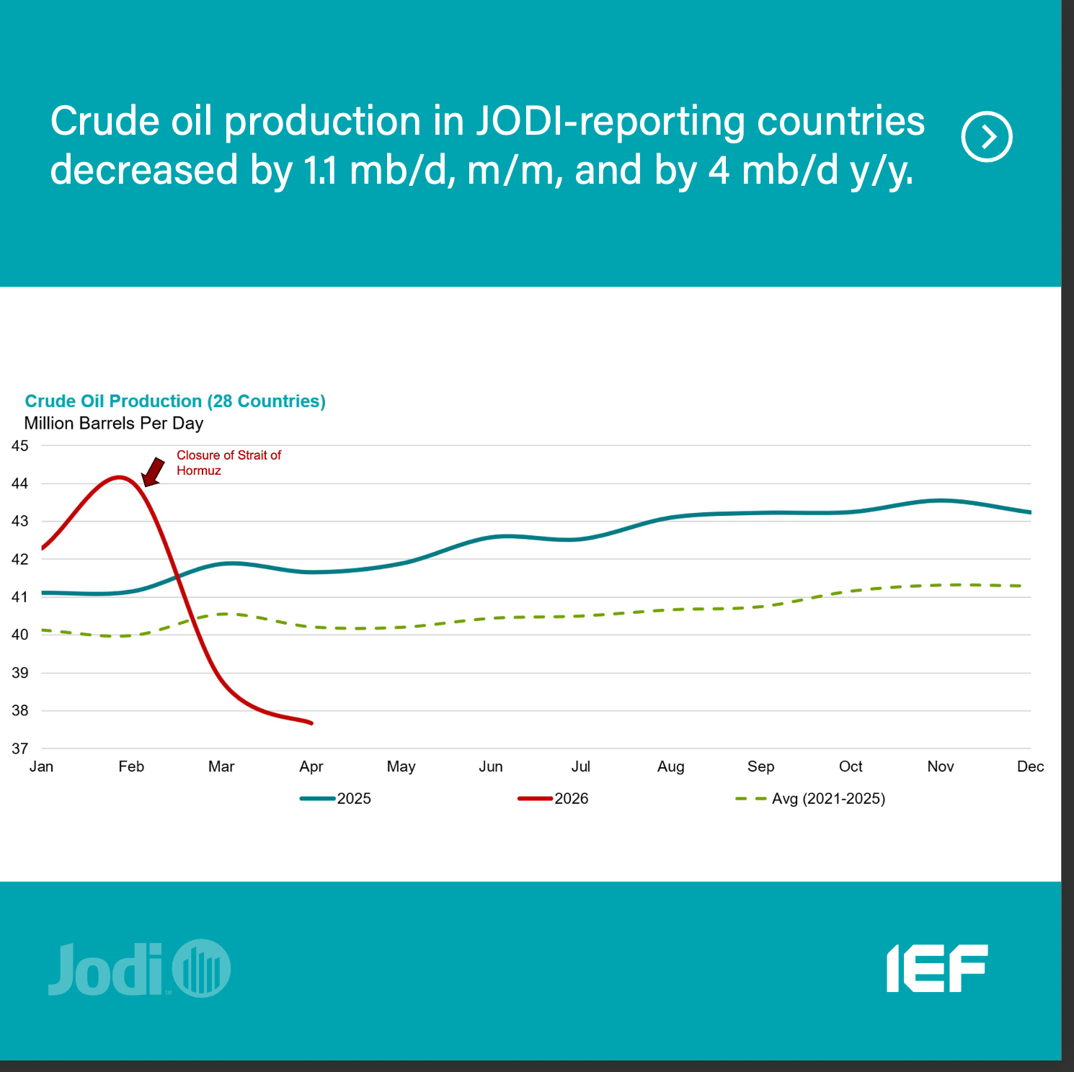
Source: JODI (Joint Organisations Data Initiative) / IEF.

Infrastructure — What Can Break
Trace a barrel from ground to wing and every vulnerable link appears.
Infrastructure link | Why it matters / vulnerability
Upstream (oil fields) | Supply originates here; attacks cut volume at the source.
Pipelines | Overland arteries; some bypass chokepoints (~4.7M bbl/d around Hormuz). Bypass capacity is a key resilience variable.
Export terminals / ports | Where crude loads onto tankers (Ras Tanura, Fujairah); single points of failure.
Shipping & chokepoints | Where a global flow becomes a local shortage (Hormuz, Malacca, Suez, Bab-el-Mandeb).
Refineries | Crude → jet-fuel link; regional refining bottlenecks bite harder than crude supply.
Storage terminals | The inventory buffer; draws down fast once flows stop.
Distribution | Last-mile trucks/pipelines to end users, including airfields.

Military vs. commercial: military airfields draw jet fuel from the same commercial refining/pipeline/storage network via defense contracts — so model “which commercial infrastructure does a base depend on?” Individual base arrangements aren’t public and aren’t needed for a realistic model.
- EIA World Oil Transit Chokepoints — chokepoint flow map
- Global Oil Infrastructure Tracker — asset-level pipeline/facility data

Source Quick-Reference
Reputability tiers: prefer official / IGO (EIA, OPEC, JODI, IMF PortWatch, IEA, UN, World Bank), then academic (UCDP, ACLED, SIPRI, GPR Index), then industry-standard commercial (Lloyd's List, Kpler, Argus/Platts — authoritative but paid). Treat crowd-sourced (OpenStreetMap, OurAirports) and aggregators (Trading Economics) as supplementary — verify against a primary source before publishing.
Source | Layer | Cadence | Access
EIA Weekly Petroleum Status | Inventory | Weekly | Free
EIA Open Data API | All / data | Real-time | Free (API key)
JODI-Oil World Database | Inventory | Monthly | Free (CSV)
JODI TableViewer | Inventory | Monthly | Free (browse)
IEF/JODI Oil & Gas Review | Inventory | Monthly | Free (PDF, charts)
OPEC Monthly Oil Market Report | Crude | Monthly | Free (full PDF)
EIA Short-Term Energy Outlook | Crude | Monthly | Free (+ API)
Trading Economics — Crude | Crude | Real-time | Free
EIA Oil Transit Chokepoints | Shipping | Periodic | Free (US gov)
IMF PortWatch | Shipping | Weekly | Free (IMF; CSV/API)
IEA ME Chokepoints Monitor | Shipping | Regular | Free (IEA tool)
Kpler / Vortexa | Shipping | Real-time | Paid (industry std.)
IATA Jet Fuel Monitor | Jet fuel | Weekly | Free
Flightradar24 Disruption | Airfields | Real-time | Freemium
OurAirports data | Airfields | Nightly | Free / public domain
Global Oil Infra. Tracker | Infrastructure | Periodic | Free

Source Directory — What Each One Gives You
Fuller notes on every source: what data it provides, how to access it, how it feeds the game, and how far to trust it.

Trigger & event data
GDELT — Machine-coded stream of world events (actor, location, date, plus a news-tone score) since 1979, 200M+ records. Fully open — raw CSV, BigQuery, and API, no login. Use it as your event clock and media-reaction proxy in the trigger layer; it's widely used but automated and noisy, so confirm specifics against ACLED/UCDP.
ACLED — Expert-verified political-violence and protest events with precise dates, locations, actors, and fatalities in 75+ languages. Free with registration, via dashboard or REST API. It's your accurate confirmation of what happened and where — the field's gold standard — though licensing is free only for non-commercial/research use.
UCDP — Uppsala University's rigorously curated conflict dataset, ideal for historical baselines. Open, free CSV/API. Use it to calibrate what a 'normal' vs. severe conflict level looks like; academic-grade but released with more lag than GDELT/ACLED.

Risk & market sentiment
Geopolitical Risk (GPR) Index — A daily/monthly index built from newspaper text, split into Threats vs. Acts. Free Excel/CSV download. It converts 'tension' into a single number for your risk-premium layer and has been shown to foreshadow investment and price effects; built by Federal Reserve economists and peer-reviewed, so highly credible — but it's a text-based proxy, not a direct measure.

Crude price & outlook
Trading Economics — Crude — Live Brent/WTI spot prices, charts, and history in one place. Free to view (API is paid). Use it for the instant price reaction in the crude layer; it's a reliable aggregator, but cite the underlying exchange or EIA for anything formal.
OPEC Monthly Oil Market Report — A ~90-page monthly report covering prices, world demand and supply, OPEC+ production by country, refining, tanker rates, OECD stocks, and the supply/demand balance. Free full PDF. It's your authoritative anchor for crude, demand, supply, and inventory fundamentals; a primary source, though written from OPEC's producer perspective, so pair with IEA/EIA on contested points.
EIA Short-Term Energy Outlook — Monthly short-term forecasts of Brent/WTI prices and global supply and demand. Free, with a data browser and API. Use it for the forward-looking view of where price and supply are headed; official US-government methodology, but remember these are projections.
Argus — Crude — Daily crude market news and analysis from one of the two pricing houses (with Platts) the industry prices off. Free news page; assessments are a paid product. A strong daily read for the crude layer — industry-standard and authoritative, but commercial.

Inventory
EIA Weekly Petroleum Status Report — Weekly US crude and product stocks, refinery runs, imports/exports, and the SPR. Free and precise. It's the buffer/days-of-cover reading for the US inventory layer; official and the gold standard for US data.
EIA Open Data API — Programmatic access to every EIA series — prices, stocks, production, and more — as JSON. Free API key. Use it to pull any EIA figure straight into Python for your model; it's the machine-readable backbone of the US data.
JODI-Oil World Database — Monthly oil production, demand, stocks, and trade for ~100 countries (about 90% of the market). Free CSV/Excel download. It gives you the global, country-keyed stock and production side of the inventory layer; a joint IGO initiative (IEA, OPEC, and others) so reputable, though data is self-reported by governments and can lag or have gaps.
JODI TableViewer — An interactive front end to browse JODI series by country, product, and flow without downloading whole files. Free, web-based. Handy for quick lookups; it's the same reputable JODI data in a browsable form.
IEF/JODI Monthly Oil & Gas Data Review — A free monthly ~25-page visual summary of the latest JODI data — crude production, product demand, stocks, trade, and refining — as ready-made, annotated charts. Free PDF. Use it for presentation-ready visuals and headline takeaways (it's the source of the crude-production chart in this guide); co-published by IEF, JODI, and OLADE, so reputable, though it summarizes JODI data that runs roughly two months lagged.

Shipping & chokepoints
EIA World Oil Transit Chokepoints — Reference analysis of how much oil flows through each major chokepoint (e.g., ~20% via Hormuz) and what bypass capacity exists. Free. It's the structural map of where flows can be pinched — the backbone of your chokepoint model; official EIA, drawing on Lloyd's List and UNCTAD.
IMF PortWatch — Real-time indicators for 2,065 ports and 28 chokepoints from satellite vessel data, plus a spillover simulator for hypothetical closures. Free, with CSV/API. Use the monitors for live flow status and the simulator as a ready-made scenario engine; IMF + Oxford, so strong provenance, but it's a beta and volumes are estimates.
IEA Middle East Chokepoints Monitor — A free tool tracking shipping flows through the Gulf chokepoints over time. Free, web-based. Use it for focused Gulf-chokepoint tracking; official IEA, built on IMF PortWatch data.
Kpler / Vortexa — Vessel-level tanker and cargo tracking in real time. Paid (some free public analyses and blogs). Gives granular 'is this specific cargo moving' detail beyond the aggregate monitors; industry-standard and used by traders and media — authoritative but commercial.

Jet fuel
IATA Jet Fuel Price Monitor — Weekly global and regional jet-fuel prices, powered by Platts. Free. It's the jet-fuel layer — the lagged, region-specific price airfields actually pay — and the best free indicator; an industry authority (IATA + Platts).

Airfields & operations
Flightradar24 — Airport Disruption — A live 0–5 disruption index for ~300 busy airports, based on delays and cancellations. Freemium web. Use it as the visible operational endpoint — strain showing up at airfields; the standard flight-tracking source, consumer-facing but widely trusted.
OurAirports — A public-domain CSV of 80,000+ airfields worldwide with coordinates, runways, and types, updated nightly. Free and public-domain. It's the base map — the airfield inventory you overlay everything else on; crowd-sourced, so excellent coverage but verify against official aeronautical data before publishing.

Infrastructure & actor context
Global Oil Infrastructure Tracker — Asset-level data on pipelines and facilities worldwide, with routes and status. Free download. Use it to map the infrastructure between chokepoints and end users; from Global Energy Monitor, a reputable NGO.
SIPRI databases — Free databases on military expenditure and arms transfers by country. Free Excel. Use them for actor-capability context — who can escalate a disruption and who arms whom; from a leading peace-research institute, highly reputable.
Further context sources (open, discussed for exposure and geography): UN Comtrade and World Bank Open Data for trade/economic exposure, OFAC for sanctions, and OpenStreetMap for supplementary infrastructure geography.

Methodology — RAND & CSIS
RAND for how to run a game (reusable frameworks like “Day-After,” “360”; has gamed Hormuz/Taiwan blockades). CSIS for content and how to present it (transparent, chart-heavy public games).
- RAND Wargaming · CSIS Hormuz in 8 Charts · CSIS Taiwan wargame

Key Terms
Term | Definition
Days of cover | Days current inventory lasts at current consumption — the headline resilience metric.
Commercial stocks | Crude/product held by refiners and traders; the first buffer drawn.
SPR | Government emergency crude stock, released to blunt shocks (~326M bbl, ~46% full).
Chokepoint | A narrow shipping passage with no easy alternative (Hormuz, Malacca, Suez).
War-risk premium | Surcharge to insure vessels in a conflict zone; throttles traffic without a closure.
Dark fleet | Tankers that hide AIS to evade sanctions; tracked by satellite.
Crack spread | Price gap between crude and refined products; why airfields feel shocks even when crude is steady.
Bypass capacity | Pipeline volume routing around a chokepoint (~4.7M bbl/d around Hormuz).
Disruption index | Flightradar24's 0–5 delay/cancellation score for ~300 airports.

Research Sequence
1) Learn stocks & days-of-cover (EIA + IEA). 2) Map the value chain (EIA Chokepoints + Infra Tracker). 3) Study RAND/CSIS method. 4) Trace each live event across all five layers with timestamps. 5) Encode the timing/magnitude as game rules; overlay OurAirports data to link airfields to chokepoints.
Open-data, energy-security framing, in the tradition of RAND/CSIS public exercises. Figures as of July 10, 2026 — refresh from the live sources above.

