Fiscal and Monetary Policy with Heterogeneous Agents
by Adrien Auclert Matthew Rognlie Ludwig Straub (2025)
Notes on the Model

A canonical HANK model

There is a continuum of households represented mathematically as a mass of 1. At birth, they all have the same preferences, opportunities, and expected lifetime. Nobody is born richer or poorer. As time goes on, households experience different shocks (good or bas labor income shocks). These shocks are idiosyncratic: they affect individuals, not everyone. These shocks are uninsurable: households cannot buy insurance to fully protect themselves.

At time 0, an unexpected shock hits the economy. From time 1 onward, everyone knows exactly what will happen (perfect foresight). So the only surprise is at time 0. After that, the path of the economy is deterministic. It makes the problem much easier than solving a fully stochastic model. But it still delivers the same linear impulse responses.

There are two kinds of heterogeneity here. The first one is the labor productivity shock eit. This is an earnings shock. At each time period, households draw a productivity level eit. If eit is high, this creates high earnings. Because these shocks are uninsurable, households need to save to protect themselves (precautionary savings).
The second one is a discount-factor shock. Households differ in how patient they are. A low beta type is more impation (consumes more today and accumulates less wealth). In real data, wealth inequality is much larger than what income shocks alon can generate, this is why we add beta heterogeneity.

A markov chain tells the probability of moving from one state to another between periods. The state of a household is (eit, betait). The markov chain gives probability like the chance of one’s labor productivity going from high to low the next period, or the chance of one staying patient next period. The markov chain describes the long-run distribution of households. Some households spend long periods being productive (accumulation of wealth) for example.

At every moment in time, the distribution of agents across states (e, b) is fixed at its long-run (stationary distribution). Though households jump aroun randomly, the aggregate distribution is constant. This way, the distribution of states does not need to be tracked over time. Only aggregate variables (output, interest rate, wages, taxes) move in response to shocks.

Productivity shocks do not depend on whether you are patient or impatient. This is to simplify computation. Productivity eit affects wages and output. It is simpler to say that, on average, an individual supplies 1 unit of productivity.

Households

Households have one asset they can hold: a mutual fund with return r. They cannot borrow ait > 0. Therefore, the only financial choice is how much to save.

Houshold earnings are (1−τ​)w e n, where:
wt = pre-tax real wage per unit of efficient labor.
eit = idiosyncratic labor productivity of household i. If productivity is high, households earn more.
nit = number of hours worked.
tt = labor-income tax rate.

Household preferences are: log(cit​)−v(nit​): utility increases with consumption and decreases with working more hours. Log utility means that poor households value consumption much more than rich households (because u’(c) = 1/c). Therefore, poor households have a high marginal propensity to consume (they consume a larger fraction of extra income).

The household’s lifetime problem is:
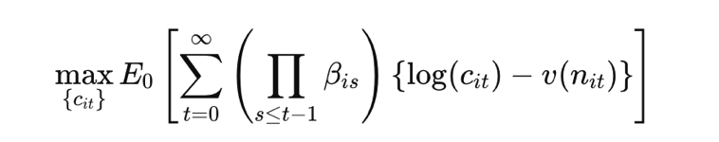
Expectation conditional on information at time 0: households do not know future shocks to productivity e or discount factor beta, but they understand the markov transition probabilities.

The discounting term is : βi0​ × βi1​ × ⋯ × βi,t−1​. Therefore, the effective discount factor up to time t depends on the sequence of idiosyncratic discount factors the household draws. If a household is patient in many periods, the betas will accumulate more weight on the future (higher savings).

The budget constraint the household faces is:
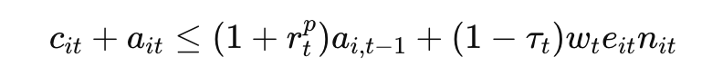
The left hand side are uses of funds for consumption cit and savings for the next period ait. The right hand side are sources of funds such as the return on assets (1+r)ait-1, after-tax labor income (1-tau)wen.

The borrowing constraint is ait > 0.

Households do not choose their own labor supply nit. Instead, hours are set by unions or an aggregate wage-setting institution. So individual households take nit = nt as given. This is a simplication because authors are interested in heterogeneity in income, but not heterogeneity in labor supply decisions.

Markets are incomplete because households cannot fully insure against their idiosyncratic risks thruogh arrow debreu securities.

Because households experience random income every period and cannot fully insure themselves, the only way to avoid starving during bad months is to save during good months. Households save as a buffer stock to protect themselves from bad income shocks in the future. Households aim for a target level of savings (target wealth). Households with low liquid wealth spend more than households with a lot of wealth. They have a higher marginal propensity to consume.

Firms

Firms produce with labor only. The production function is Yt = Nt (total effective labor). Every unit of effective labor produces one unit of output.
Effective labor is:
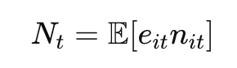
It is individual productivity times individual quantity of labor, aggregated across households.

Firms set their price at a constant markup mu over their nominal marginal cost, which equals the nominal wage. Hence:
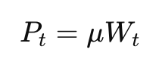
The real wage is:
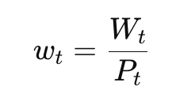
Because we know Pt, we end up with:
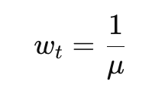
Firms’ dividends are taxed at the same rate tau as labor income. The real post tax dividends are therefore:
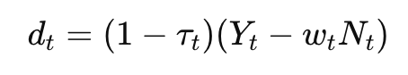
Through substitution of the real wage expression, we get:
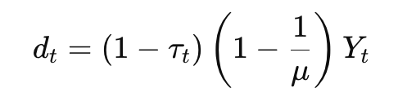
All firms together issue exactly 1 unit of equity. The price of this equity is pt. Households can hold this equity indirectly through the mutual fund. Firms are assumed to maximize shareholder value dt + pt.

Wages

In this model, wages are sticky. Because price is a function of wages, wage stickiness insures price stickiness. To generate sticky wages, the authors assume that labor is represented by unions, who set the nominal wage Wt. Unions face adjustment costs (like Calvo pricing). The union chooses the wage path to make workers as well off as possible by maximizing the utility of an agent with average consumption Ct discounted by the average discount factor. All workers supply the same number of hours. Hours may very at the aggregate level Nt, but not on the individual level. This results in a Phillips curve for wage inflation given by:
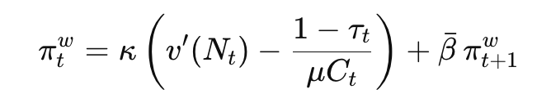
Wage inflation is how fast wages are growing:
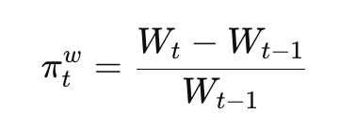
Because prices are a markup over wages, wage inflation results in price inflation.

- Kappa is a parameter capturing how flexible wages are. A high kapa means wages react strongly to labor market conditions. A low kapa means wages are very sticky.
- v’(Nt) is the marginal disutility of working.
- Wages are 1/mu. After wage taxes are (1- tau)/mu. Marginal utility of consumption is 1/Ct. Therefore,
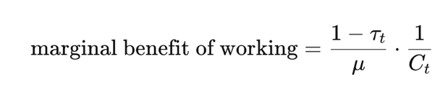
This is how much utility the worker gets from the extra income from working one more
hour.
- The bracket is the pain of working more minus the benefit of working more.
- The forward looking term means that wage setters care about future inflation when setting today’s wage.

Government

A government collects labor and corporate taxes, spends Gt, and must repay last period’s debt with a promised return. It can also issue new debt. Therefore, the government budget constraint is:
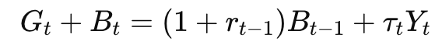
The left-hand side contains government spending and new debt issuance, the right-hand side contains tax revenue tau*Yt and the principal as well as the interest on last period’s debt issuance.

The government is assumed to set plans for Gt and tau t that are compatible with an intertemporal budget constraint.

Mutual Fund

The model uses a single mutual fund that receives household savings ait, and invests that money in government debt and firm equity. This eliminates household-level portfolio choice.

Government bonds pay a return of 1 + rt. Equity return is the future price and the dividend. To avoid arbitrage opportunities, both assets must give the same return:
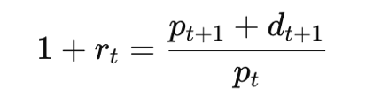
Total savings of households must equal total supply of assets in the economy. This is the asset market clearing condition. Household wealth = value of all shares + government debt. This holds every period:
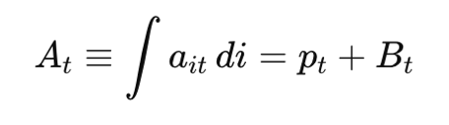
At: total household financial wealth in the economy, sum of all individual savings ait.
pt: total value of equity.
Bt: total outstanding real debt.

In equilibrium, the mutual fund return must equal the return on bonds. This is the no-arbitrage condition again. If the mutual fund had a higher return than government bonds, everyone would dump bonds. If it had a lower return, everyone would dump the fund. Hence:
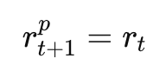
The mutual fund holds shares worth p0 and government bonds worth B. It receives dividends d0 this period. Government bonds pay (1+r)B next period.

Its total value to households must equal the value of their savings:
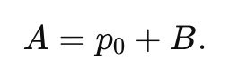
Now we consider one period return on the mutual fund. Households’ wealth next period is the value of all mutual fund assets after they pay out dividends and bond returns:
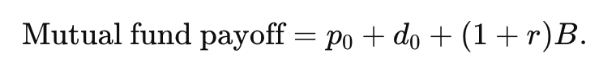
By definition, the mutual fund return satisfies:
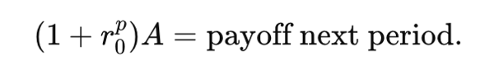
Therefore we get:
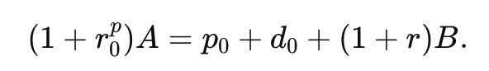
It means that the initial return on the mutual fund must equal the weighted average return of its stock and bond holdings.

Monetary policy sets the real interest rate rt on government bonds. This is because the central bank sets the nominal interest rate it, and the real interest rate is determined by the fischer equation:
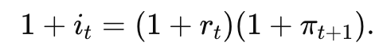
So monetary policy indirectly controls real rates.

Equilibrium

The equilibrium is a set of aggregate quantities (output, consumption, dividends, asset values), prices (wage, interest rate, stock price), household decisions (consumption, savings), a distribution of households over productivity, discount factor, and assets.

All must satisfy household optimization, government budget constraint, asset market clearing, goods market clearing.

The goods market clearing condition is:
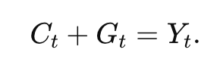
What households consume and what the government buys is the total production. There is no investment in this model.

A Representative Agent (RA) Model

Here, only one household exists. It faces no income risk (eit = 1), it faces no discount factor risk (beta it = beta). It faces no borrowing constraint. The RA household is thus perfectly insured, perfectly forward looking, fully unconstrained, identical to the average household.

The behavior of such a household is described by a standard intertemporal Euler equation with log utility:
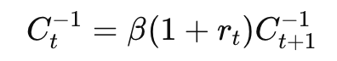
Today’s marginal utility of consumption Ct to the power of minus 1 equals the expected discounted marginal utility tomorrow. This is because a representative household smooths consumption perfectly over time.

A Two-Agent Model (TA or TANK)

In this model, households fall into two groups.

The first group are the unconstrained agents (share 1 – lambda). They behave like the RA household:
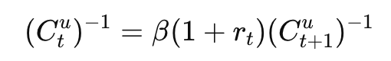
Cut is consumption of unconstrained agents.

They can save, smooth consumption, and solve an Euler equation. These agents are wealthy enough. They have access to financial markets to save.

The second group are the constrained or “hand-to-mouth” agents (share lambda). These agents cannot borrow or save. Their consumption is always equal to their post-tax labor income. Thus:
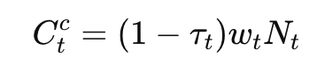
They consume their paycheck each period.

This is a simpler version of HANK. It includes heterogeneity but does not include income risk or a distribution of wealth.

Both types have the same idiosyncratic productivity eit = 1 and nit = Nt. This means no individual productivity differences, everyone works the same hours. This is to keep the model simple so that heterogeneity is only in access to financial markets (can save vs not save).`

Aggregate consumption in the TA model is:
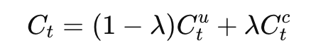
Total consumption is the mixture of the consumption of Euler equation agents (1-lambda unconstrained), and consumption of hand to mouth agents (lambda constrained).

Calibration

A HANK model contains many parameters. Calibration means choosing these parameters so that the model matches reality. They take the income process for eit from Kaplan et al. (2018). They want the model to match the size of total wealth in the US economy. They choose several targets.

A wealth-to-GDP ratio A/Y = 500%, meaning that total household wealth should be five times annual GDP to be consistent with US balance sheets.

Government debt-to-GDP ratio B/Y = 100%, meaning that public debt = GDP.

The real interest rate r = 2% annual to match long-run US real rates.

Government spending-to-GDP ratio G/Y = 20%, which is also standard.

Tax revenue must cover government spending (G) which is 20% of GDP (Y), as well as interest payments on debt (rB), which is 2% of GDP. Therefore, taxes T must be 22% of GDP.

Total household wealth is 500% of GDP. Debt to GDP is 100%. Since At = pt + Bt, the stock market value must be A – B, so 400% of GDP. Given the formula for dividends in the model, and the asset pricing condition formula for equity, we can solve for the markup mu such that the model’s steady-state stock market value mathces 400% of GDP. The result is for mu to be equal to 1.11. This means firms charge an 11% markup over marginal cost (quite realistic).

Beta differs for impatient households (beta L) and patient households (beta H). Impatient households accumulate little wealth. Patient households accumulate a lot.

With probability 99%, you stay the same type (beta), and with probability q = 1%, you become patient or impatient. This 1% is interpreted as generational turnover.

They choose values for Beta L, Beta H, and omega w (share of patient households) to match three targets: asset market clearing (wealth in the economy equals the supply of bonds and equity value), an empirical average MPC of 20% (meaning households spend about 20% of a temporary income gain in the first quarter), and the wealth distribution (Lorenz curve) of the 2019 US Survey of Consumer Finances.

Fiscal Policy

The authors study fiscal policy holding monetary policy constant, meaning that the real interest rate rt does not move and the central bank does not react to fiscal shocks.

Later in the paper, they allow monetary policy to react, but not for Figure 2.

They consider two types of fiscal shocks:
- A government spending shock dGt. An increase in public spending.
- A deficit-financed tax cut/tax shock dTt. Holding government spending constant, government should issue more debt to finance the tax cut.

The interest rate stays fixed for monetary policy not to offset fiscal changes.

Consumption changes and government spending changes should result in output changes according to the linearized version of the goods market clearing condition:
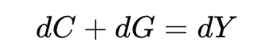
The authors then take the general household response equation, which in linear form says that consumption responds to changes in disposable income:
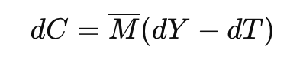
M bar is the aggregate marginal propensity to consume (MPC) out of a permanent change in income.
dY – dT is the change in after-tax labor income.

This equation is a log-linearized version of the aggregate Euler equation and budget constraint.

If output goes up, households earn more income so consumption rises. If taxes go up, disposable income falls, consumption falls. The strength of this effect is governed by M bar, the macro MPC.

As a reminder, for an individual household, the MPC is how much extra consumption results from 1 extra unit of income.

In HANK, M bar is large because of borrowing constraints, and high MPC households. In RA, M bar is tiny, which is why fiscal policy is weak in RA models.
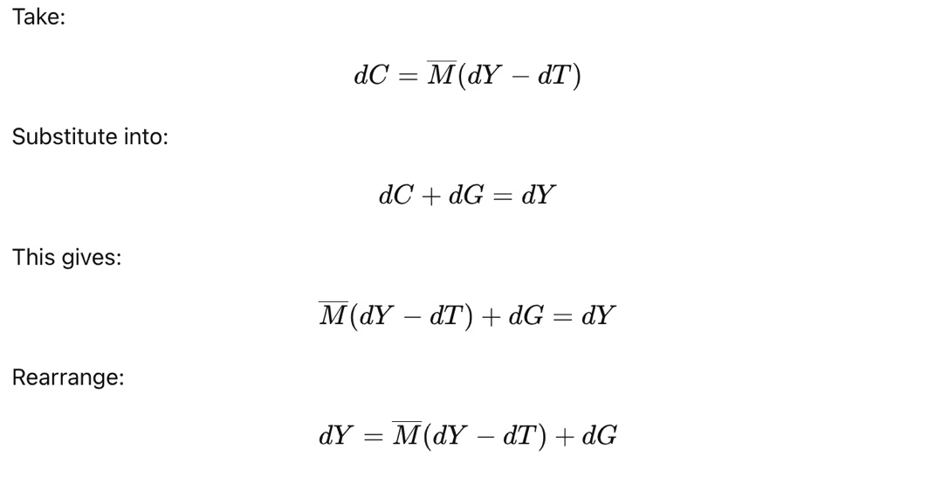
This gives equation (10) in the paper, called the “intertemporal Keynesian cross”:
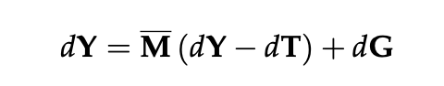
Output rises because government spending adds directly to demand. But output also rises indirectly via income feedback loops: If output increase, household income increases, and therefore household consumption increases by Mbar * dY. Taxes dampen this effect: higher taxes reduce disposable income, this reduces consumption and output.

When output increases, labor demand increases because the production function only uses labor as input. Therefore, wages paid to workers in total increase, household income rises, and households acquire more consumption power.

Output increases when government spending increases or taxes decrease, and the strength of this response is multiplied by households’ marginal propensity to consume out of income.

Reminder: the basic Keynesian cross is Y = C + G.

