JEMBEE PLAY
MASTER PROJECT PLAN
Reference Images + Product Requirements + Technical Roadmap
Version: 1.0 | Prepared: 09 November 2026 | Status: Requirements Blueprint (not an implementation audit)

0. इस दस्तावेज़ का उद्देश्य
यह JEMBEE PLAY का Master Requirements Blueprint है। इसमें उपलब्ध वास्तविक Reference Images, पहले तय की गई Product Requirements, मौजूदा Backend को सुरक्षित रखने के नियम, और Phase-wise Development/Test Plan शामिल हैं।
महत्वपूर्ण सीमा: इस पैक में उपलब्ध Shorts और Video UI reference images शामिल हैं। School Learning और Android TV/Google TV के सभी अंतिम स्क्रीनशॉट इस समय इस Library में नहीं मिले; इसलिए उनके लिए लिखित Functional/UI Requirements दी गई हैं। उन विभागों के exact pixel-level visual audit के लिए संबंधित reference screenshots अलग से जोड़ने होंगे।
यह दस्तावेज़ मौजूदा source code को verified घोषित नहीं करता। प्रत्येक feature को actual scripts, APIs, Firebase rules, storage flow और UI references के विरुद्ध audit करना होगा।

1. Product Vision और Scope
JEMBEE PLAY एक video-first platform होगा: long-form videos, Shorts, School Learning, Creators, Teachers, Sharers, admin-controlled advertisements, social features और earnings/settlement। Website, Android Mobile और Android TV/Google TV पर अनुभव उपलब्ध होगा।
- JembeeKart Shopping, Product Selling और MLM website इस project में शामिल नहीं होंगे; वे अलग product रहेंगे।
- पुराने JembeeKart source से केवल audited और उपयोगी Backend/Integration code सुरक्षित तरीके से reuse किया जाएगा।
- Mobile और TV apps केवल Video/Shorts/Learning experience के लिए होंगे; full shopping/MLM app नहीं।
- पुराने working features बिना audit और approval के हटाए या rewrite नहीं किए जाएँगे।

2. Reference Images – UI/UX Requirements
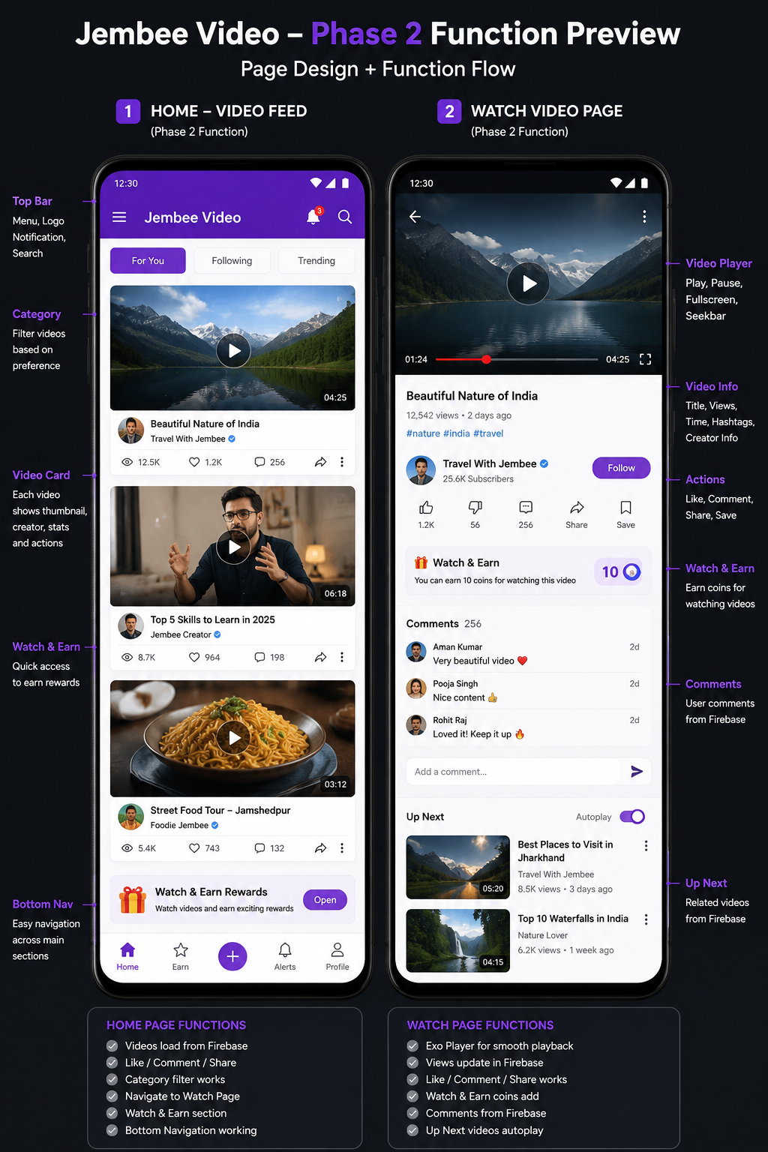
Reference 1 — Video Home Feed और Watch Page: category tabs, video cards, metadata, actions, Watch & Earn banner और bottom navigation.
- Home feed: thumbnail, duration, title, creator, views/likes/comments, share और overflow actions।
- Watch page: player, seekbar, title, views, creator/follow, like/comment/share/save और reward panel।
- Home navigation: Home, Earn, Upload, Alerts, Profile जैसे स्पष्ट destinations।
- Image में दिखाए गए sample counts/titles केवल design sample हैं; production data Firebase/API से आएगा।
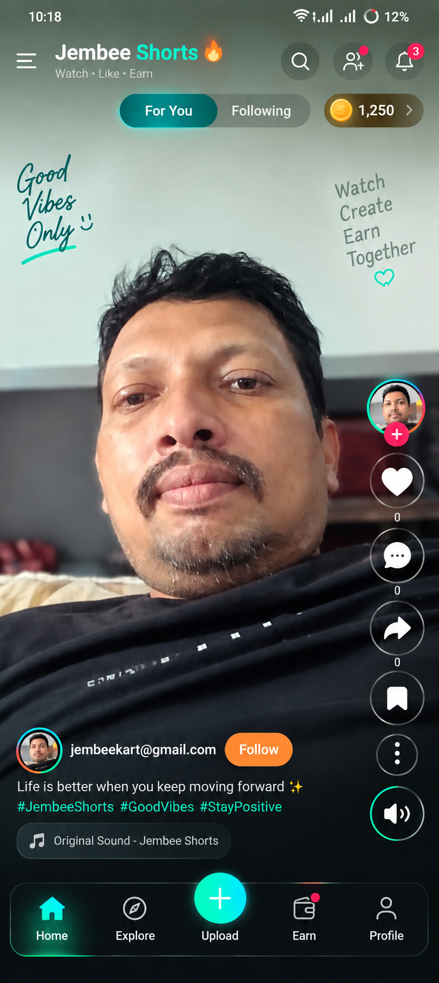
Reference 2 — Shorts Feed: For You/Following, coin indicator, vertical video, right-side actions, creator details और bottom navigation.
- Shorts feed में video viewport मुख्य रहेगा; header और action overlays स्पष्ट होंगे।
- Like, comment, share, bookmark, more-options, volume, follow और creator/caption metadata।
- For You/Following tabs तथा coin/reward entry तभी दिखे जब संबंधित backend function वास्तविक रूप से wired हो।
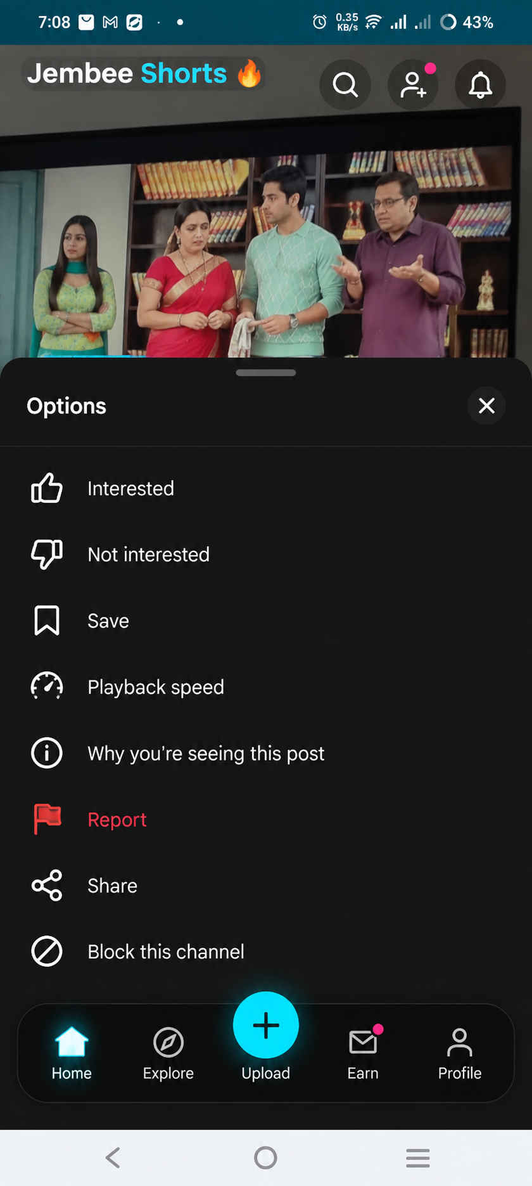
Reference 3 — Shorts 3-dot Options Sheet: Interested, Not interested, Save, Playback speed, Why this post, Report, Share और Block channel.
- 3-dot menu का options sheet रहना चाहिए और सभी actions वास्तविक कार्य करें।
- Report/Block moderation flow से जुड़े; Save user library से जुड़े; Playback speed player से जुड़े।
- Options sheet bottom navigation को गलत तरीके से permanently hide या duplicate न करे।
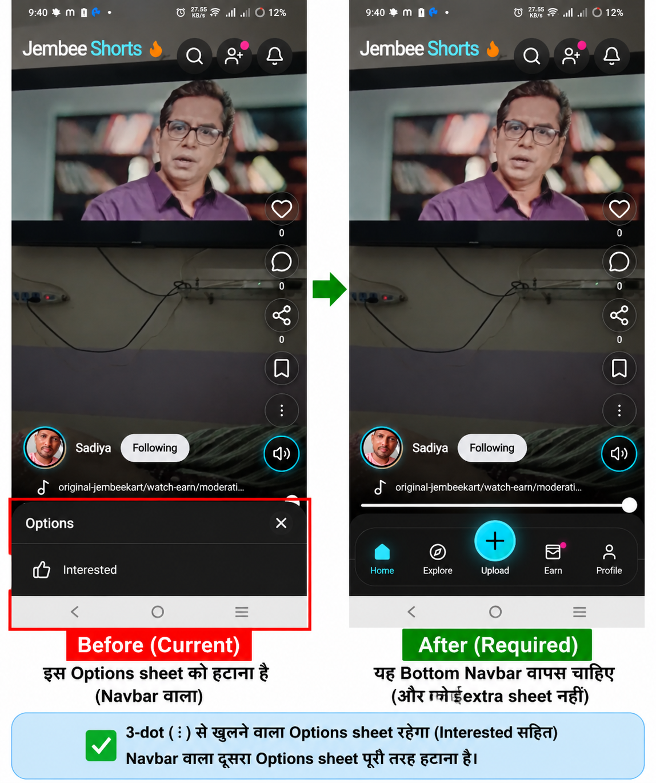
Reference 4 — Shorts Before/After: गलत bottom sheet हटाकर सही bottom navigation restore करने की अपेक्षा.
- Bottom navigation: Home, Explore, Upload (+), Earn/Rewards, Profile (approved final navigation labels के अनुसार)।
- अनचाहा दूसरा Options/Interested bottom sheet नहीं दिखना चाहिए।
- 3-dot से खुलने वाला legitimate Options sheet अलग रहेगा; दोनों UI patterns को confuse नहीं करना है।
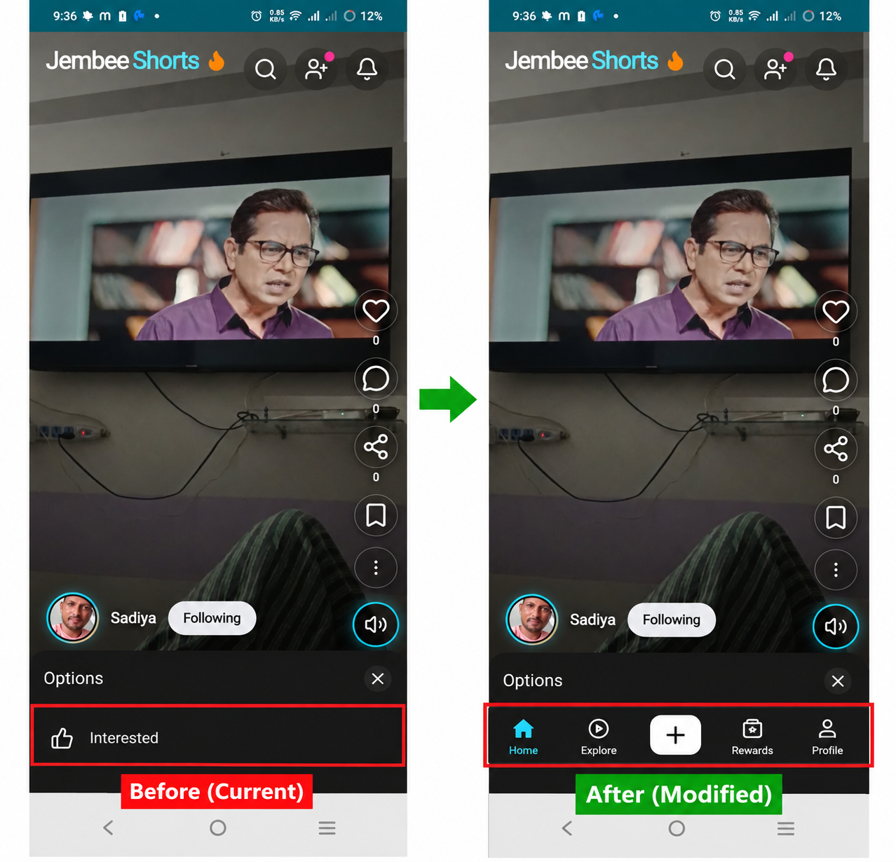
Reference 5 — Shorts Before/After: bottom navigation visibility और options-sheet behavior का दूसरा comparison.
Image Governance: हर screenshot को Reference ID दें। UI implementation के समय page/component, expected behavior और acceptance test उस Reference ID से map हों। यदि script और image में mismatch हो तो पहले discrepancy note बने; बिना approval अनुमान से code न बदले।

3. Main User Experience

3.1 Home / Video Feed
- Recommended, Trending, Latest, Popular, Continue Watching, Education, Creator/Teacher highlights और categories।
- Admin section order/visibility नियंत्रित कर सके।
- Search, filters, pagination/infinite loading और empty/error/loading states।

3.2 Video Player
- Play/Pause, seek, 10-second forward/back, volume, fullscreen, quality, playback speed, subtitles (जहाँ उपलब्ध), next/previous, related videos।
- Playback start fast हो; error/retry और network-aware quality handling।

3.3 Shorts
- Vertical swipe feed, autoplay policy, like/comment/share/save/follow/report/block, caption/audio metadata और 3-dot options।
- Feed में Approved Videos न हों तो black/empty area के बजाय proper empty state दिखे।

3.4 Account / Profile
- Login/Register, profile photo, username, bio, followers/following, uploads, saved videos, history, playlists, settings और eligible earnings/referral pages।
- Login के बाद originally requested page पर वापसी या video page पर redirect।

4. School Learning / Education Catalog
Education catalog hierarchical और admin-manageable होगा:
Board / Pattern → School → Class → Subject → Book → Chapter → Topic / Question → संबंधित Videos
- Board, School, Class, Subject, Book, Chapter, Topic और Question CRUD with validation.
- हर स्तर पर search, pagination, stable IDs, ordering और active/archive controls.
- एक Question/Topic के लिए कई Teachers के lessons दिख सकें।
- Teacher upload के समय Board/Class/Subject/Book/Chapter/Question mapping चुने।
- Free/Paid access, approved lesson status और teacher profile association।
- Demo/static catalog को production-ready नहीं मानना; Firebase/API-backed real data और admin CRUD आवश्यक।

5. Creator, Teacher और Sharer Roles
Role | मुख्य कार्य | मुख्य Dashboard
Viewer/User | Videos/Shorts देखना, social actions, playlist/history | Profile, History, Saved
Creator | Long video/Shorts upload, metadata, analytics | Uploads, Views, Watch time, Earnings
Teacher | Verified education lessons और topic mapping | Qualifications, Subjects, Lessons, Referral
Sharer | Approved video share और valid attribution | Referral links, attributed views, eligible earnings
Moderator | Reports और content review | Moderation queue, audit trail
Admin/Super Admin | पूरे platform का संचालन | Users, content, catalog, ads, finance, settings

6. Earnings, Referral और Settlement
निर्धारित proposed split: Creator 30%, Sharer 20%, Platform 50% (कुल 100%)। यह केवल defined Eligible Net Revenue Base पर लागू होगा; base, attribution window, invalid traffic, refunds, taxes/fees और eligibility rules को implementation से पहले स्पष्ट और versioned करना होगा।
Teacher Referral Commission: 2% अलग ledger और अलग report में। इसे Creator/Sharer split में silently mix या double-count नहीं करना है।
- हर earning event का immutable ledger entry, source, user, video, attribution और calculation snapshot।
- Duplicate commission, self-referral, bot/fake views और invalid traffic रोकना।
- Refund/chargeback/invalid traffic के लिए adjustment entries; पुराने ledger को overwrite न करना।
- Withdrawal request, admin review, payout status, transaction reference और reconciliation report।
- Live payouts बंद रहेंगे जब तक settlement implementation, automated tests और manual reconciliation verify न हों।

7. Advertisement System – Admin Controlled
- Admin placement slots configure करे: Home, Watch page, Shorts, category/search, Education, banner/sidebar आदि।
- हर slot में enable/disable, network, ad code/config, frequency cap, device/page targeting और reporting।
- Adsterra, AdSense या अन्य network का चयन current policies, approval, format restrictions और app rules verify करके ही।
- Pop-up, forced redirect, misleading ad या prohibited placement नहीं।
- Admin placement control का अर्थ network policy override नहीं; ad network की policy सर्वोपरि होगी।

8. Social, Notifications और Moderation
- Follow/unfollow, like, comment/reply, share, save, playlist, report, block।
- In-app/push notifications: follow, comment, approval, payment, earning, withdrawal और moderation status।
- Report queues, comment moderation, copyright process, spam/fraud detection और audit logs।

9. Video Storage, Cache और Playback Performance
- Latest/visible 4–5 videos के thumbnails और essential metadata cache हों ताकि cards black न दिखें।
- Tap पर video के शुरुआती segment का lightweight preload हो और playback जल्दी शुरू हो।
- पूरे videos auto-download/cache नहीं होंगे। Full offline download अलग opt-in action होगा।
- यह behavior Home feed, Shorts और School Learning video cards पर लागू होगा।
- Cache invalidation, stale metadata, low-memory devices और slow network tests शामिल हों।

10. Android Mobile, Android TV और Google TV

10.1 Mobile
- Video/Shorts/Learning-first navigation; upload, profile, search, notifications और eligible earnings।
- Android permissions केवल आवश्यक और स्पष्ट purpose के साथ माँगे जाएँ।
- Login redirect/return-to-origin behavior, deep links, offline download opt-in।

10.2 Android TV / Google TV
- TV-specific landscape UI, focus states, D-pad navigation और readable typography।
- Home, Videos, Shorts (TV-appropriate), Education, Search, Player, Continue Watching और account flows।
- Remote OK/Play/Pause, left/right seek, Back और volume mapping device capability के अनुसार।
- Paid playback entitlement TV पर भी server-verified हो।
- Chromecast/casting केवल supported secure flow में; paid content protection असफल हो तो casting disable।
- Android TV emulator और physical TV/Google TV पर test।
Exact TV visual references उपलब्ध नहीं हैं; TV screen designs को final करने से पहले user-approved TV screenshots/mockups जोड़े जाएँ।

11. Backend / Technical Architecture
- Existing Next.js + TypeScript web source का audit; current framework/version package files से confirm।
- Firebase Authentication, database, security rules और existing Google Drive storage integration का audit।
- API layer: auth, videos, shorts, education, creator/teacher/sharer, payments, settlement, ads, moderation।
- Role-based access control और server-side authorization; client UI hiding को security न मानें।
- Secrets केवल environment variables/secret manager में; .env.example template दें, वास्तविक secrets ZIP/Git में नहीं।
- Storage adapter/interface रखें ताकि Google Drive integration की limitations और future video/CDN needs अलग से assess हों।

12. Admin Panel
- Dashboard: users, active users, creators, teachers, sharers, videos, Shorts, views, watch time, revenue और pending queues।
- User/role/verification/suspension management।
- Creator/Teacher applications और qualifications review।
- Video/Shorts approval, rejection, takedown, copyright/report review।
- Education catalog management।
- Ad network/placement manager।
- Financial ledger, split reports, teacher referral, refunds, withdrawal और reconciliation।
- System settings, app settings, notifications, security events और audit log।

13. Security, Privacy and Compliance
- Firebase Security Rules and API authorization tests for every role.
- Rate limiting, upload validation, MIME/size checks, sanitization and abuse protection.
- Secure payment verification from server/provider webhook; never trust client success state.
- Paid content authorization on every playback/session request.
- Privacy policy, terms, copyright/takedown process, child safety and age-appropriate safeguards for education/kids content.
- No secret keys, service-account files, tokens or personal data in public source ZIP.

14. Phase-wise Delivery Roadmap
- Phase 1 — Source ZIP/GitHub audit: inventory, routes, APIs, Firebase, Drive, dependencies, env, tests, known defects.
- Phase 2 — Reference mapping: every screenshot to page/component/acceptance criteria; discrepancy register.
- Phase 3 — Architecture and cleanup: separate Jembee Play UI/routes from Shopping/MLM; preserve reusable backend.
- Phase 4 — Authentication, roles, profiles and navigation.
- Phase 5 — Home feed, video player, categories, search and watch history.
- Phase 6 — Shorts feed, options sheet, bottom navigation and moderation actions.
- Phase 7 — Video upload, thumbnail processing, cache, lightweight preload and playback.
- Phase 8 — School Learning hierarchy and Admin catalog CRUD.
- Phase 9 — Creator dashboard and analytics.
- Phase 10 — Teacher verification, lesson mapping and 2% referral ledger.
- Phase 11 — Sharer attribution and referral dashboard.
- Phase 12 — Settlement engine: 30/20/50, eligibility, ledger, refunds, tests; payouts remain disabled until verified.
- Phase 13 — Ad manager and approved network integrations.
- Phase 14 — Social features, notifications and moderation.
- Phase 15 — Admin control panel and audit logs.
- Phase 16 — Android Mobile app build and device testing.
- Phase 17 — Android TV/Google TV app, remote, focus and casting tests.
- Phase 18 — Security, performance, accessibility and regression tests.
- Phase 19 — Release packaging, deployment checklist, documentation and final source archive.

15. Definition of Done / Release Gate
- Production build succeeds; TypeScript and lint/test errors resolved or explicitly documented.
- All mapped UI reference criteria pass on supported screen sizes.
- Every visible button/action has a working backend/UI behavior; no dead controls.
- Firebase/API authorization tests pass for guest, user, creator, teacher, sharer, moderator and admin.
- 4–5 thumbnail/metadata cache and lightweight segment preload verified; no full auto-download.
- Education hierarchy CRUD/search/pagination works with real data, not demo-only data.
- Settlement calculation tests, ledger reconciliation and fraud/duplicate tests pass; payout remains disabled until sign-off.
- Ad placements comply with network policies and admin toggles work.
- Mobile and TV builds install and pass real-device/emulator test plans.
- ZIP contents scanned; no secrets; source, docs, test results and environment template included.

16. Phase Lock / Change Control
हर पूरी तरह tested phase को VERIFIED_LOCKED घोषित किया जाएगा। Lock के बाद उस phase में कोई बदलाव user permission, change note और affected regression tests के बिना नहीं होगा। हर release में phase status, commit/hash, test evidence और known limitations दर्ज होंगे।
Status | अर्थ
PLANNED | Scope तय है, implementation शुरू नहीं।
IN_PROGRESS | काम चल रहा है।
TESTING | Implementation complete; verification जारी।
VERIFIED_LOCKED | Tests pass और user-approved; बदलाव के लिए अनुमति + regression आवश्यक।
BLOCKED | Dependency, access या unresolved decision के कारण रुका।

17. Open Visual References / Required Inputs
- School Learning: Board → School → Class → Subject → Book → Chapter → Question screens के approved screenshots।
- Android TV/Google TV: Home, navigation focus, player, search, profile/login और remote behavior screenshots/mockups।
- Creator/Teacher/Sharer earnings dashboard के final visual references यदि पहले से तय हों।
- Admin ad placement और settlement screens के final visual references यदि उपलब्ध हों।
इन images के बिना functional requirements लागू की जा सकती हैं, लेकिन उन screens का exact image-by-image visual match verified नहीं कहा जाएगा।

18. Project Rules – Non-Negotiable
- JEMBEE PLAY video-first product है; JembeeKart shopping/MLM अलग रहेगा।
- Images और scripts दोनों के विरुद्ध audit होगा; mismatch report किए बिना अनुमान से बदलाव नहीं।
- Existing working backend और useful code सुरक्षित रखना है।
- Mobile तथा Android TV/Google TV scope में शुरू से शामिल हैं।
- School Learning production-backed hierarchy होगा; demo-only catalog स्वीकार नहीं।
- Creator 30%, Sharer 20%, Platform 50%; Teacher referral 2% अलग ledger में।
- Live payouts settlement verification और required tests से पहले enable नहीं होंगे।
- 4–5 thumbnail/metadata cache और limited initial-segment preload; full auto-download नहीं।
- Admin-controlled ads network policy के भीतर होंगे।
- हर fully tested phase VERIFIED_LOCKED होगा; बिना अनुमति बदलाव नहीं।

Appendix A — Available Image Pack
इस ZIP में उपलब्ध five original reference image files अलग /reference_images folder में भी रखे गए हैं। Word document में इन्हें inline भी शामिल किया गया है।
Note: इन reference images में UI sample names, faces, counts और ad content design examples हैं; इन्हें real production users, approved ads या live data न माना जाए।

