Work Experience setup on Lab Computers
You will need to install and setup the software to run the code and the Neural Network (NN) model you will be using. Please follow these steps:
- On your computer’s Desktop, right-click with the mouse and create a new folder. Give the folder the name “work_experience”. This will be the directory in which you keep all of your project’s files.
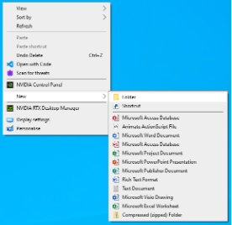
- You will need to download the digital notebooks that you will be using throughout the next two days. Open a web browser and go to:
https://github.com/jembennettuk/work_experience/tree/main/WorkSheets
Here, you can download the Jupyter Notebook called cnn_digit_classification.ipynb:
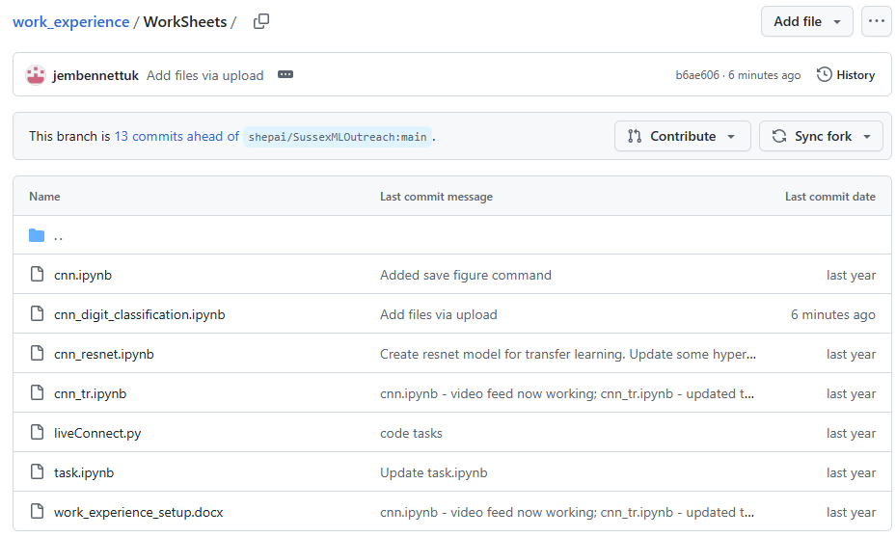

- On the Desktop, open the Software Hub link:
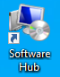
- Install Visual Studio Code: In the search bar, write Visual Studio Code. Click “Install” for the first option that appears.
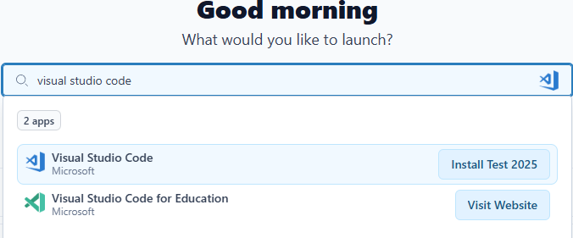
- Install Python 3:
  - In Software Hub, search for Python, and install Python 3.11.3.
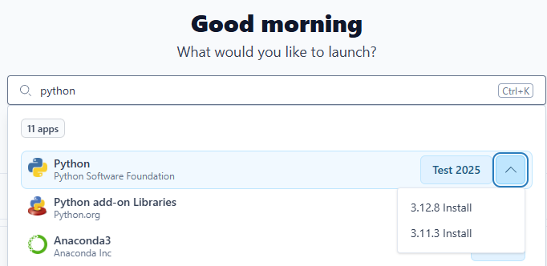
  - A new window should pop up, and a message to confirm that that Python can be launched through the start menu.
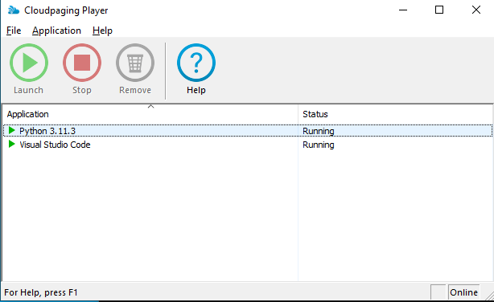
- Open Visual Studio Code (VSCode). Select “File > Open Folder”, and open the folder you created earlier for Lab files.
- On the left hand side of the window, you will see a list of the files in your folder. Click on the cnn_digit_classification.ipynb file to open it:
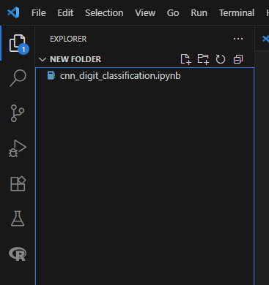
- In VSCode, you will need to install some extensions and other packages.
  - Click on this icon in the top left of the window: 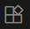
  - In the search bar, type “Python” and for the top option, click install:
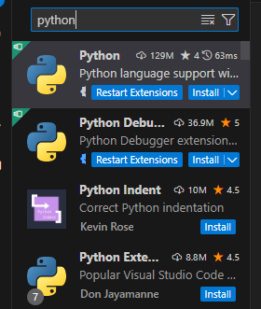
  - Search for “Jupyter” and select (BUT DON’T YET INSTALL) the top option:
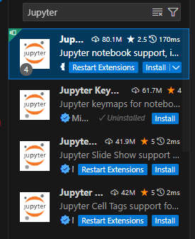
  - On the “Install” button, click the "settings" menu icon (a cog) and select “Install specific version”. Select the most recent version.

- We now need to install anaconda, which we use to create a virtual environment for python. This is standard practice in AI, as it allows us to install lots of packages and code libraries without interfering with (or being interfered by) similar versions of the same software installed elsewhere on the computer.
  - In Software Hub, search for anaconda, and install.
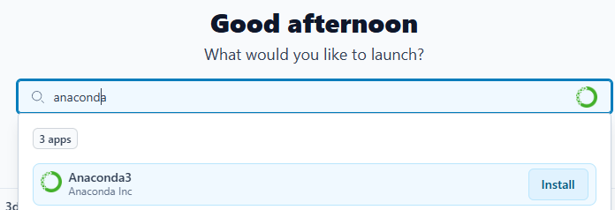
  - Once installed, use the Windows App Search to find Anaconda Prompt, and open it.
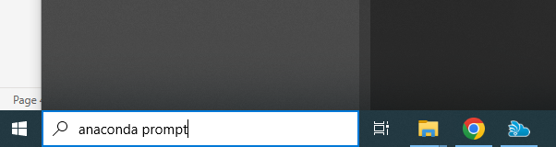
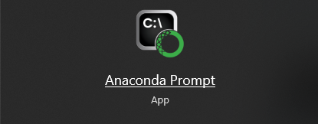
  - This provides a command line interface (CLI), i.e. an interface with which you can type and execute simple commands without the need of a graphical user interface (GUI). Enter and then execute the following command:
conda create -n wexenv python=3.12.8 pytorch torchvision opencv matplotlib-base pandas scikit-learn ipykernel pytorch-cuda=12.4 -c pytorch -c nvidia

This installs several helpful Python packages that we will use:
    - PyTorch – a library of very useful tools for building NNs and for deep learning
    - Pandas – a library for handling tabulated data.
    - Scikit-learn – a library with a wide variety of useful machine learning tools
    - Matplotlib – a library of plotting tools so that you can visualise the data and results of your experiments.
    - OpenCV – a library for very efficient processing of images and video.

  - Activate the virtual environment you created:
conda activate wexenv
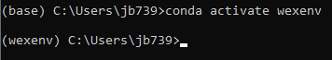
  - Install one last package:
conda install ipykernel
and type ‘y’, then hit enter
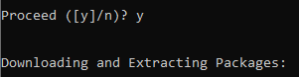
  - You can now close Anaconda Prompt, and go back to the “cnn_digit_classification.ipynnb” file you opened earlier in Visual Studio Code. You can select it from a tab at the top of the screen:
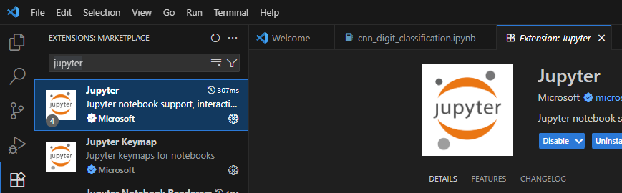
  - You now need to start up a Python kernel so that you can execute code in the notebook. You will be able to select this kernel for any ipynb file you want to work with in the future. First, you will need to activate the correct Python Interpreter. Use the keyboard shortcut:
ctrl+shft+p
to access VSCode’s command pallette. Type ‘Python: Select Interpreter’, and select the one corresponding to the virtual environment you created, e.g. ‘Python 3.14.4 (wexenv)’.

  - In the top right of the window, click on the tab with this icon . A popup in the centre of the window will appear: 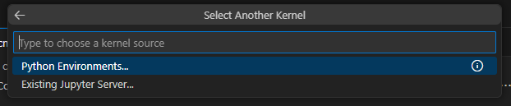
  - Select “Python Environments…” and then select “wexenv (Python 3.11.3)”
  - 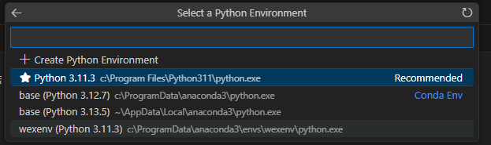
  - That’s it! You’re now ready to work through the Notebook and start training your Convolutional Neural Network!

On MacOS:
- Use Python3 to setup virtual environment: python3 –m venv .
- In venv, install pytorch etc using: pip install torch torchvision opencv-python matplotlib pandas scikit-learn ipykernel
- You may need to add certificates for MNIST dataset to be downloaded. If so, do this:
  - python -m pip install --upgrade certifi
  - python -c "import urllib.request; print(urllib.request.urlopen('https://ossci-datasets.s3.amazonaws.com/mnist/train-images-idx3-ubyte.gz').status)"
  - echo 'export SSL_CERT_FILE=$(python -c "import certifi; print(certifi.where())")' >> ~/Library/CloudStorage/OneDrive-UniversityofSussex/Desktop/openday/odenv/bin/activate
  - check using: python -c "import certifi; print(certifi.where())"
  - then restart vscode

