**REMOTE NETWORK CONFIGURATION (VNC Viewer)**

VNC stands for Virtual Network Computing, which allows remote access of another computer through the use Remote Frame Buffer protocol. There are several programs available to use for VNC, but in this case, we used the VNC Viewer from RealVNC. Therefore, to remotely access the Raspberry Pi from a computer, first install the VNC viewer.

But before we enabled the VNC, we first tried out the Raspberry Pi with a Waveshare 7-inch HDMI LCD, a mouse for the control, and also a keyboard.

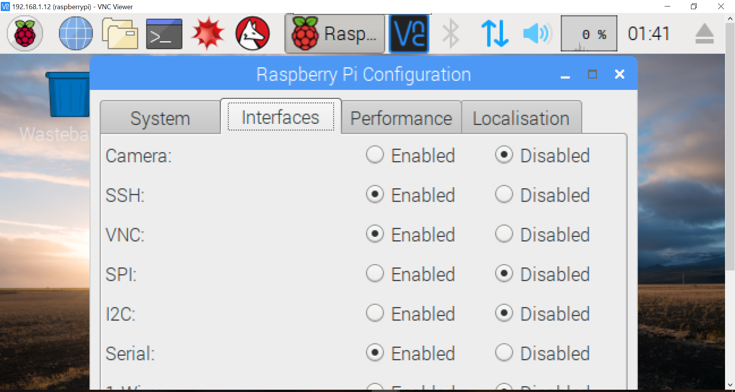

Once the Raspberry Pi finishes its installation and initialization process, first enable the SSH and VNC under Preferences.

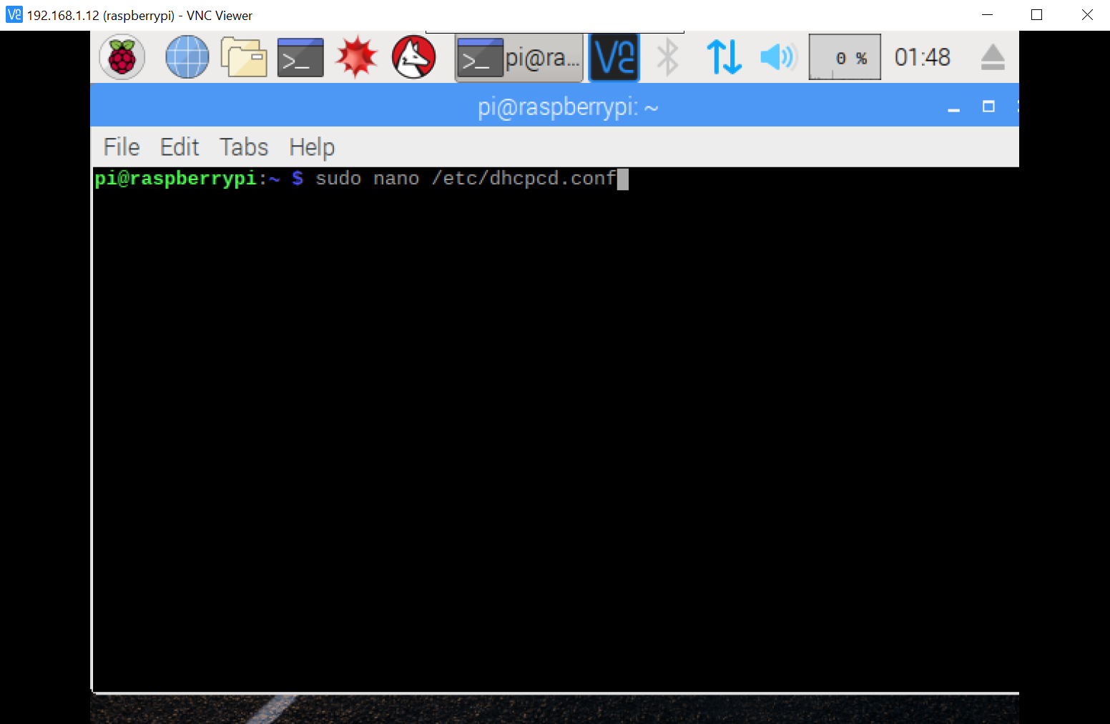

The next step is to open the Terminal. To edit with Network Configuration of the Raspberry Pi for the VNC, type in the codes ***sudo nano /etc/dhcpcd.conf***. dhcpcd.conf is the name of the file configuration, and is located under the directory etc.

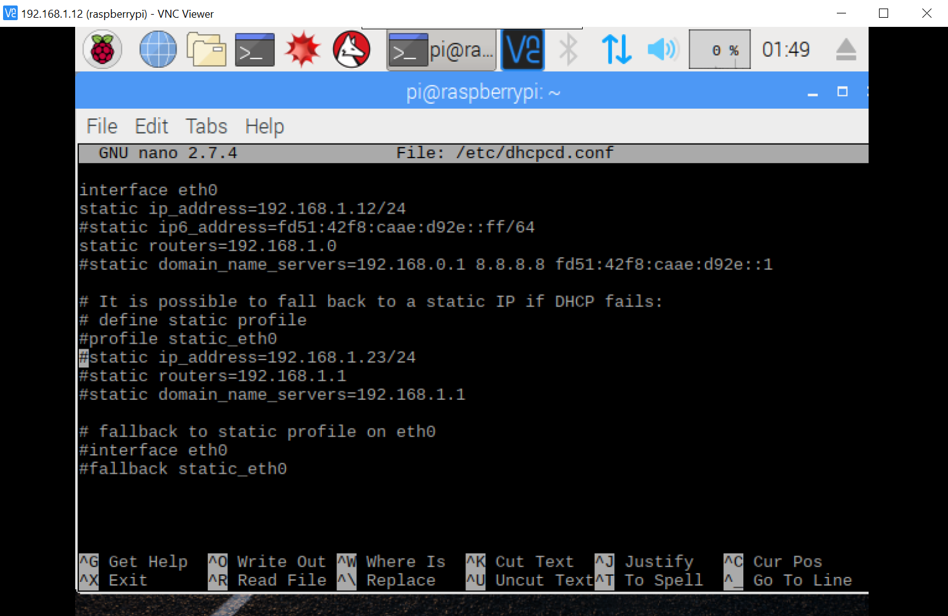

Once the codes are entered unto the command prompt, the terminal will then go to the Network Configuration of the Raspberry Pi. Now, uncomment the lines **interface eth0, static ip_address,** and **static routers**. Then, enter the IP address that you want to assign, which in our case, was the address 192.168.1.12. Once finished, hit **Ctrl + X** to exit, and save the configuration.

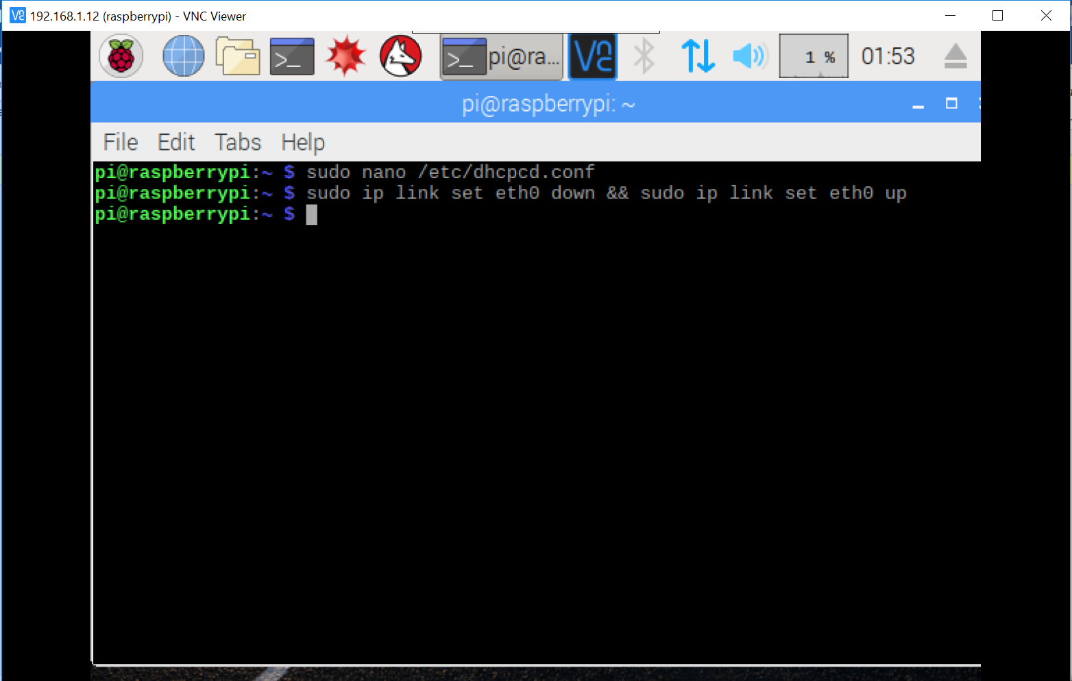

To disable and then enable the ethernet interface of the Raspberry Pi, type in the commands **sudo ip link set eth0 down && sudo ip link set eth0 up**.

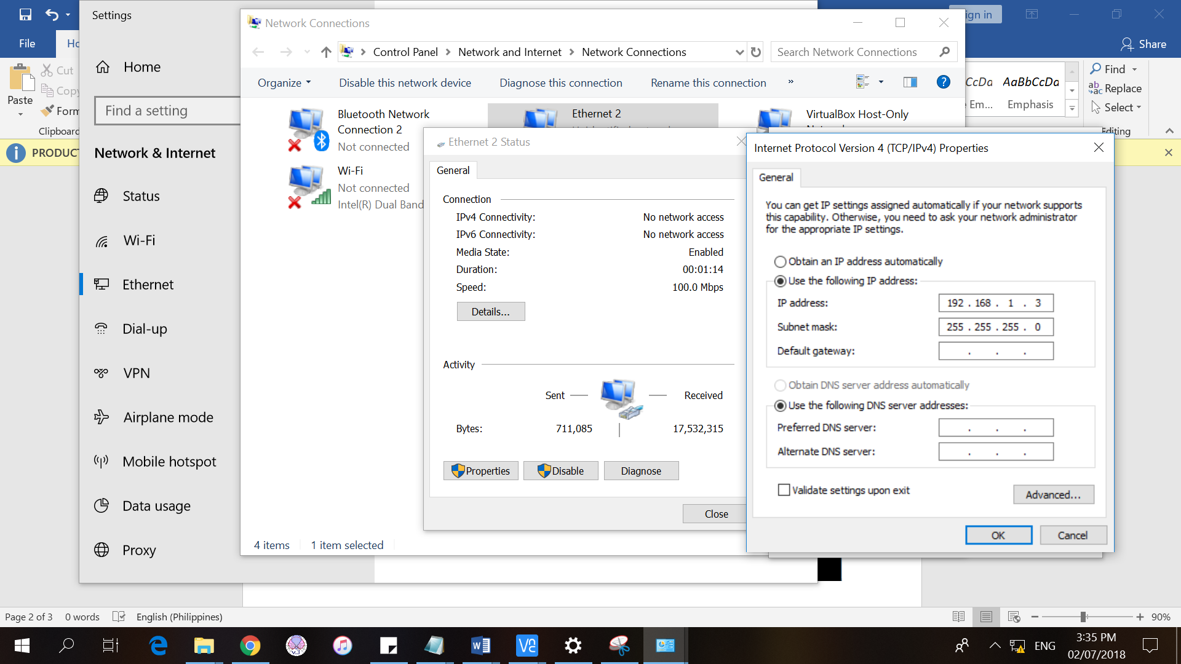

Now, go to the network adapter settings of the computer that will be used to remotely access the Raspberry Pi and change the IP address to 192.168.1.3.

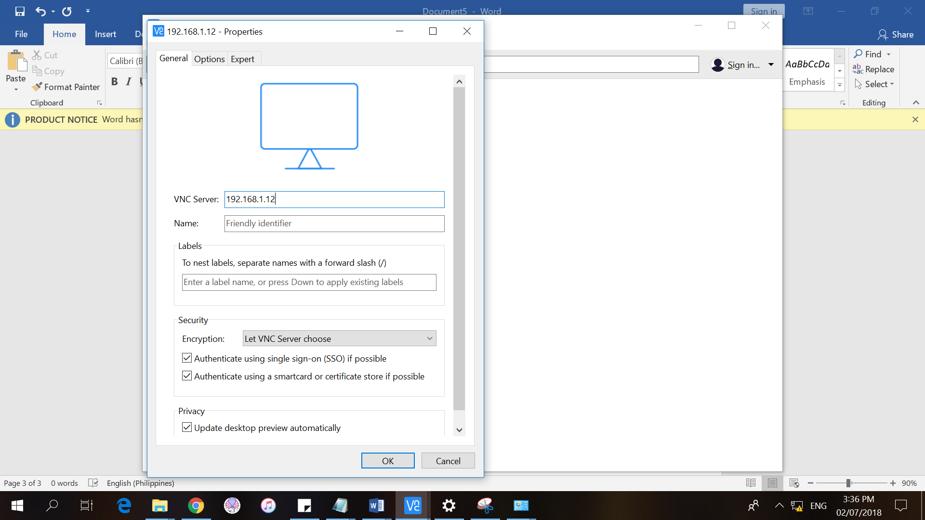

Then, go to VNC Viewer to set up a new connection. Type in the IP address of the Raspberry Pi that will serve as the VNC Server. A login window will appear. Just enter **pi** for the *Username* and **raspberry** for the *Password*. These are the default login preferences for the VNC Viewer of the Raspberry Pi.

**REMOTE NETWORK CONFIGURATION (Putty)**

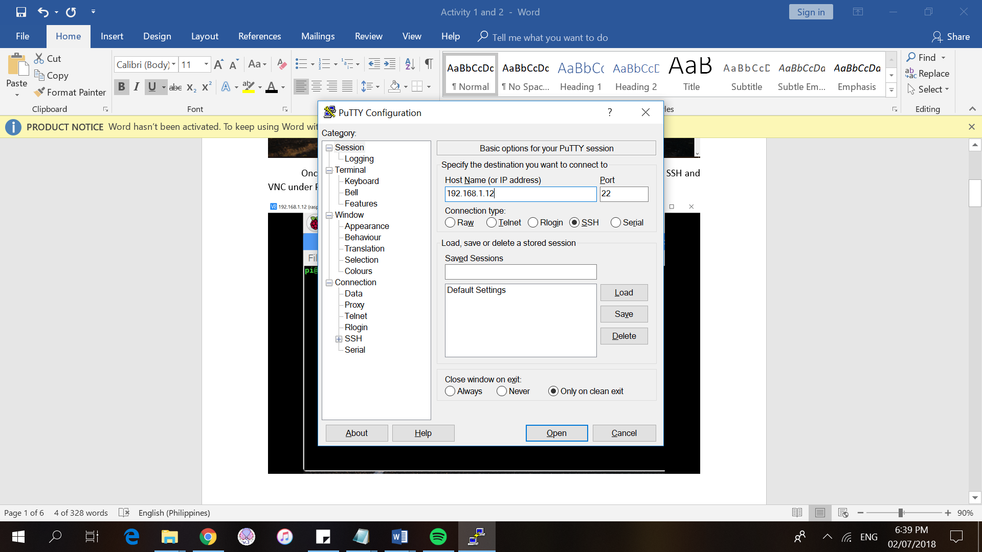

Remote access of the Raspberry Pi can also be done using SSH (Secure Shell) through PuTTY. On the Host Name, just type in the IP address of the Raspberry Pi, and check the **SSH** connection type. Then, press Enter.

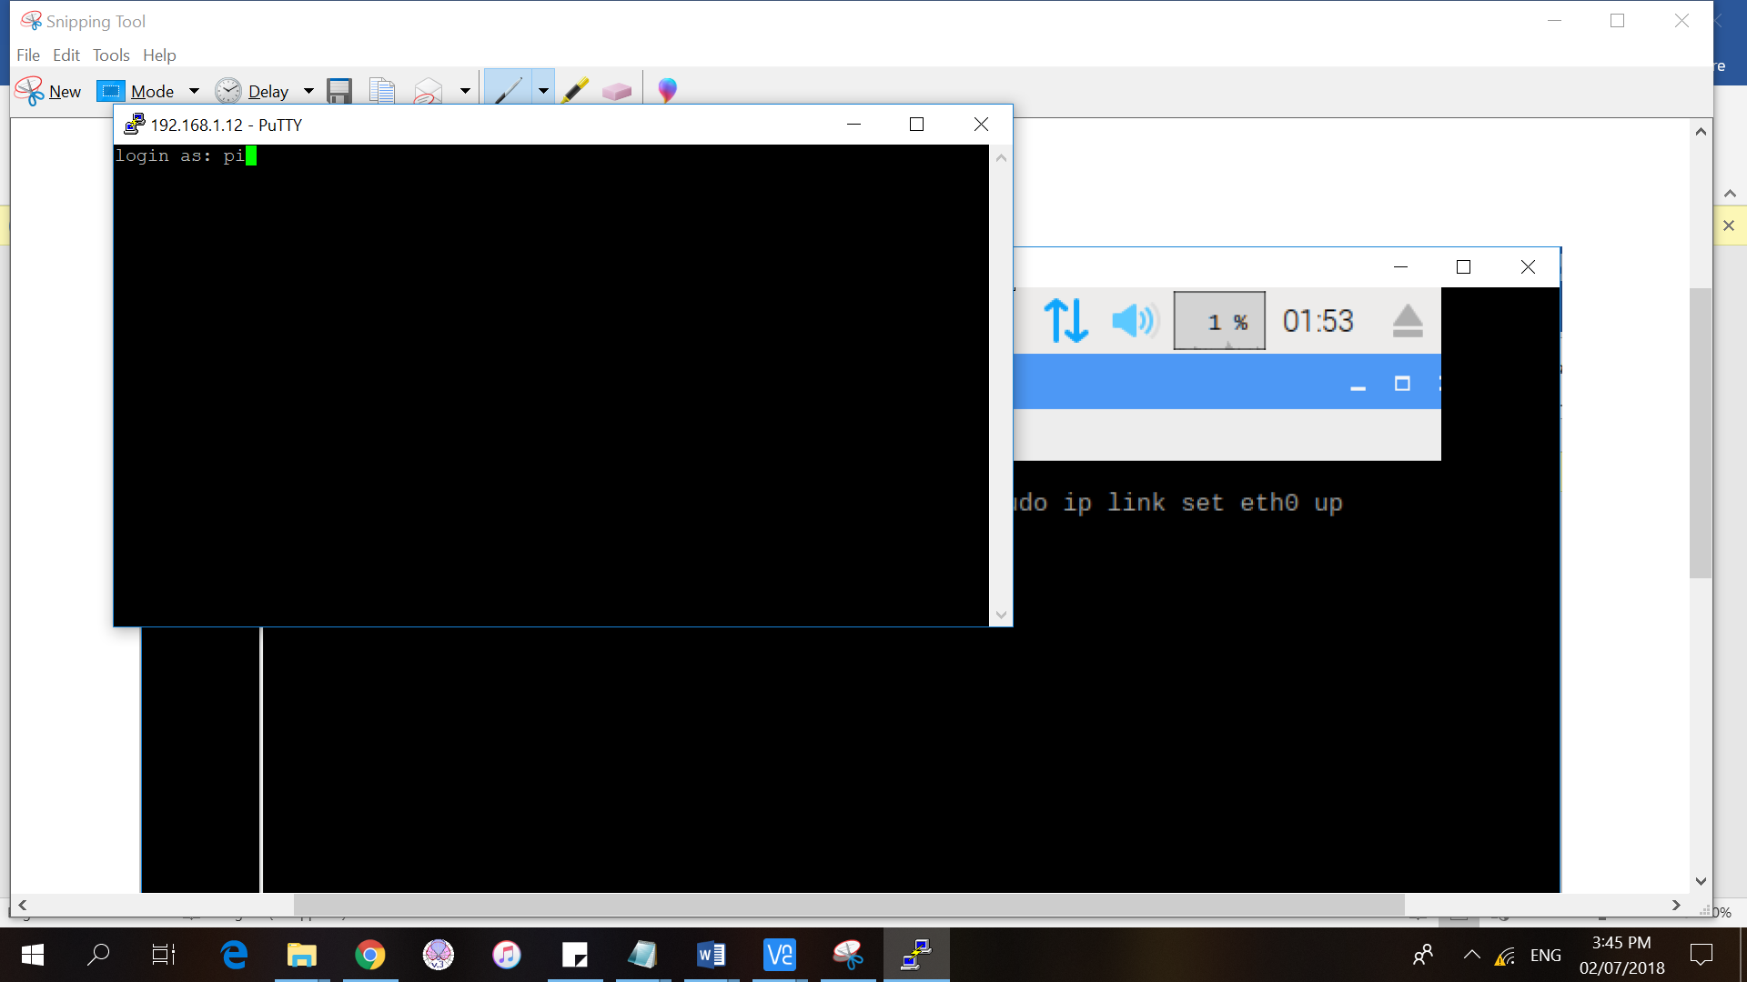

Then, a command prompt will appear on the screen and you will be asked to login. The login preferences is just the same as on the previous configuration.

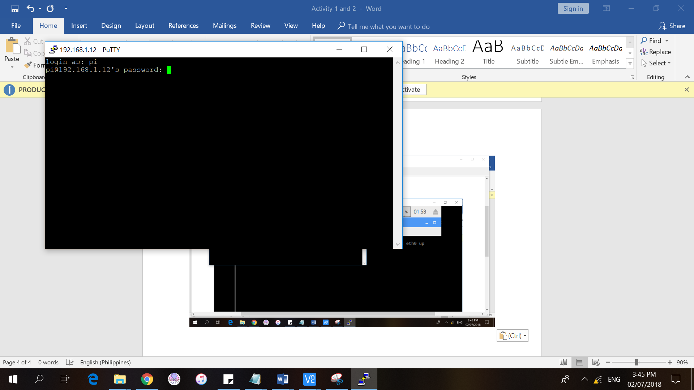

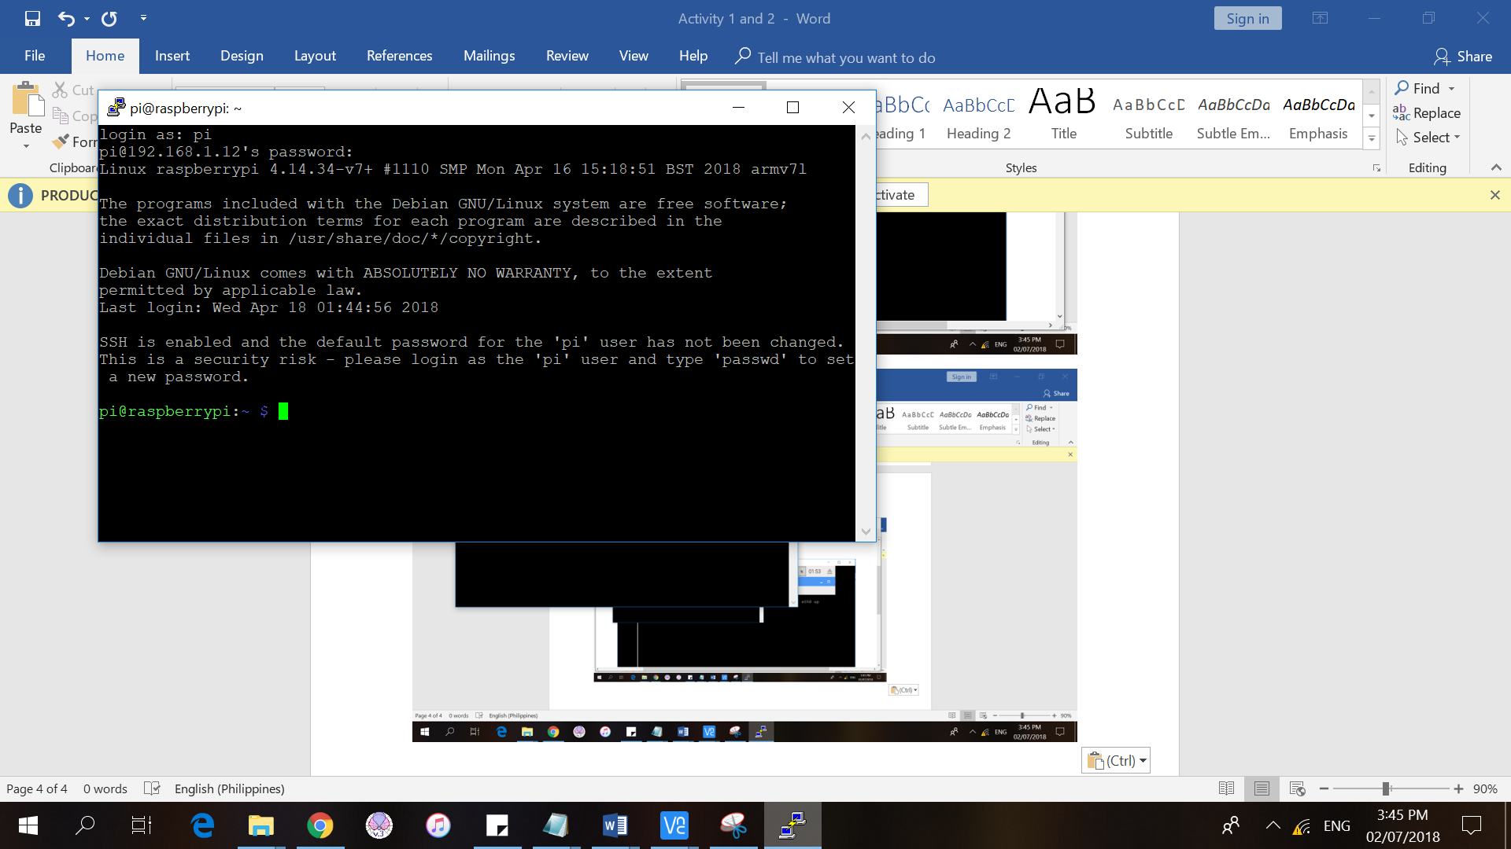

We could confirm that we successfully configured the remote access of the Raspberry Pi using SSH by checking if there is **pi@raspberrypi** at the command prompt, which means it is now ready for use.

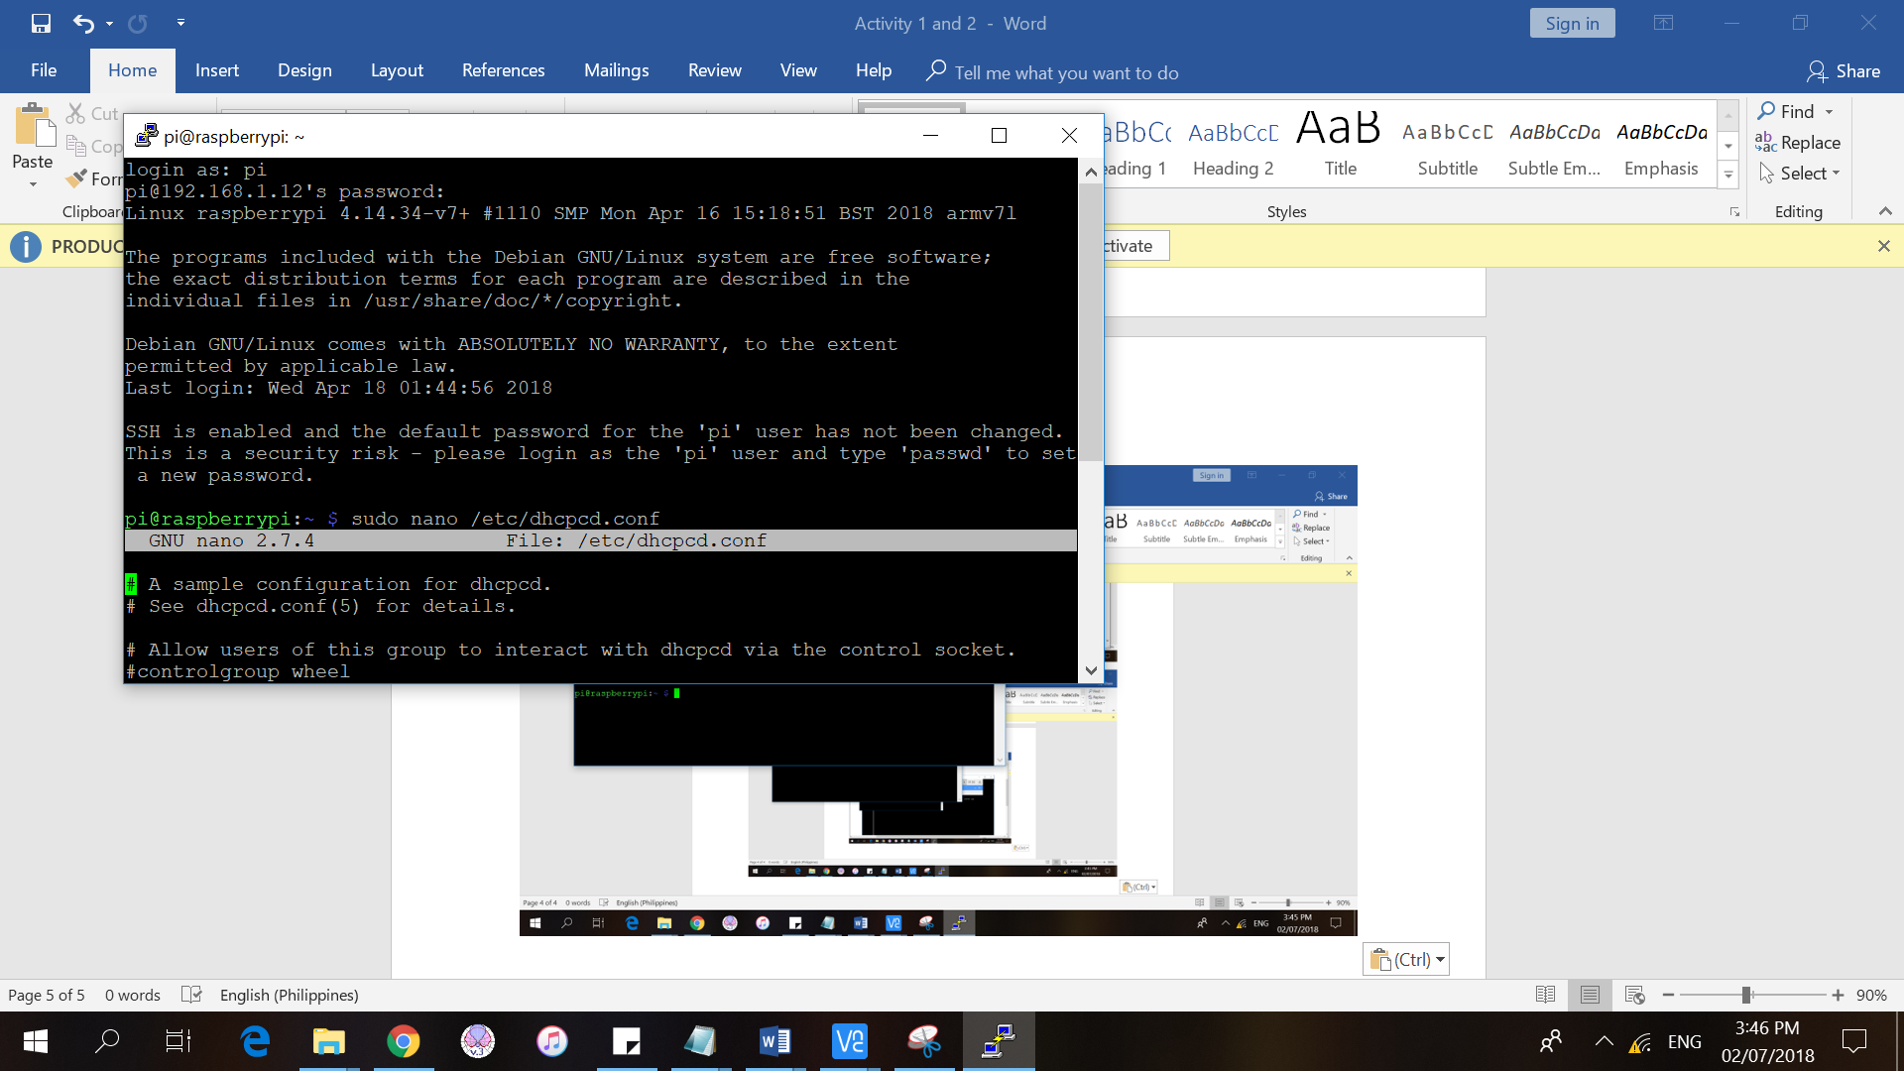

We checked out the details on the network configuration of the Raspberry Pi, and it’s the same as what we’ve configured before using the VNC.

