# Bug 1

Describe the bug

If the user were to enter year as a string instead of integer, the program breaks and is not able to handle invalid input. For ex: This program is expecting integer as input but, when a string is entered, the programs fails and crashes.

Program

CSC256PublicChangeDoc 09/30/2021 5:45:00 PM

Component

This is under the full_retirement_age_calculator_app.py, method def calculator

Error Type

Invalid literal for int() with base 10: 'year'

Severity

Fatal

Priority

TBD

## State

Working

To Reproduce

Steps to reproduce the behavior:

1. Run full_retirement_age_calculator_app.py
2. Enter year 2021 as a string and hit enter
3. Check the output

Expected behavior

When a string is entered instead of an integer, the program should recognize that it is not an integer and prompt the user to re-enter year in the expected format which in this case, it should be an integer.

Screenshots

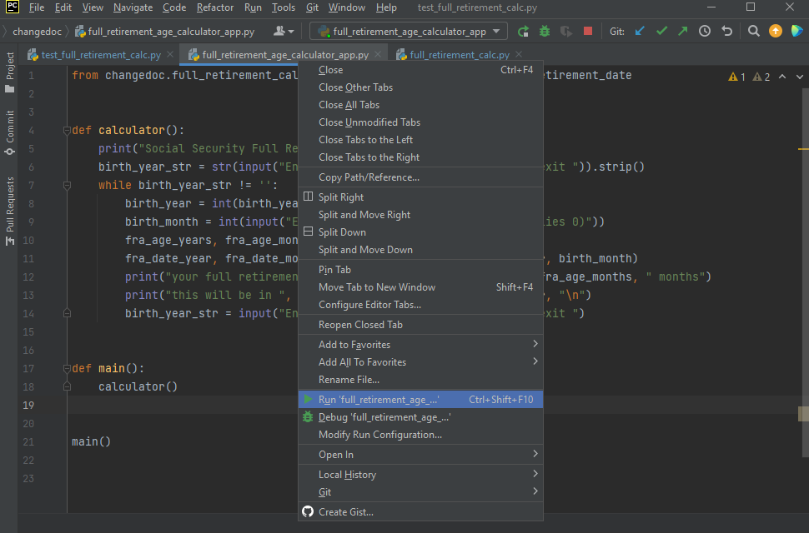

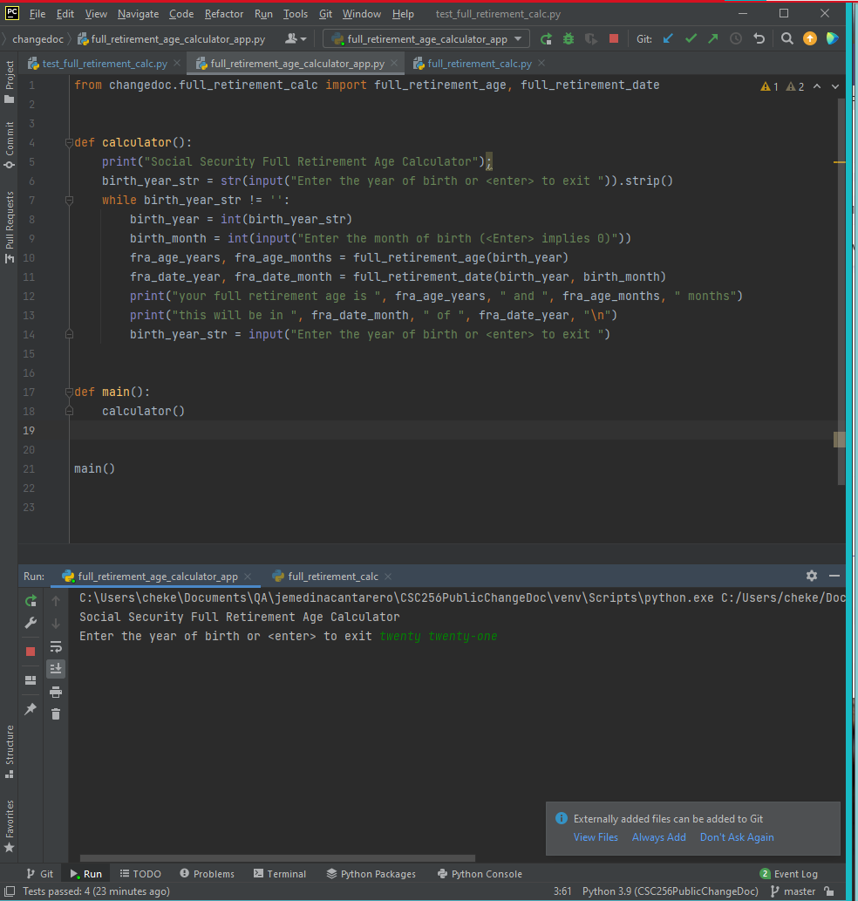

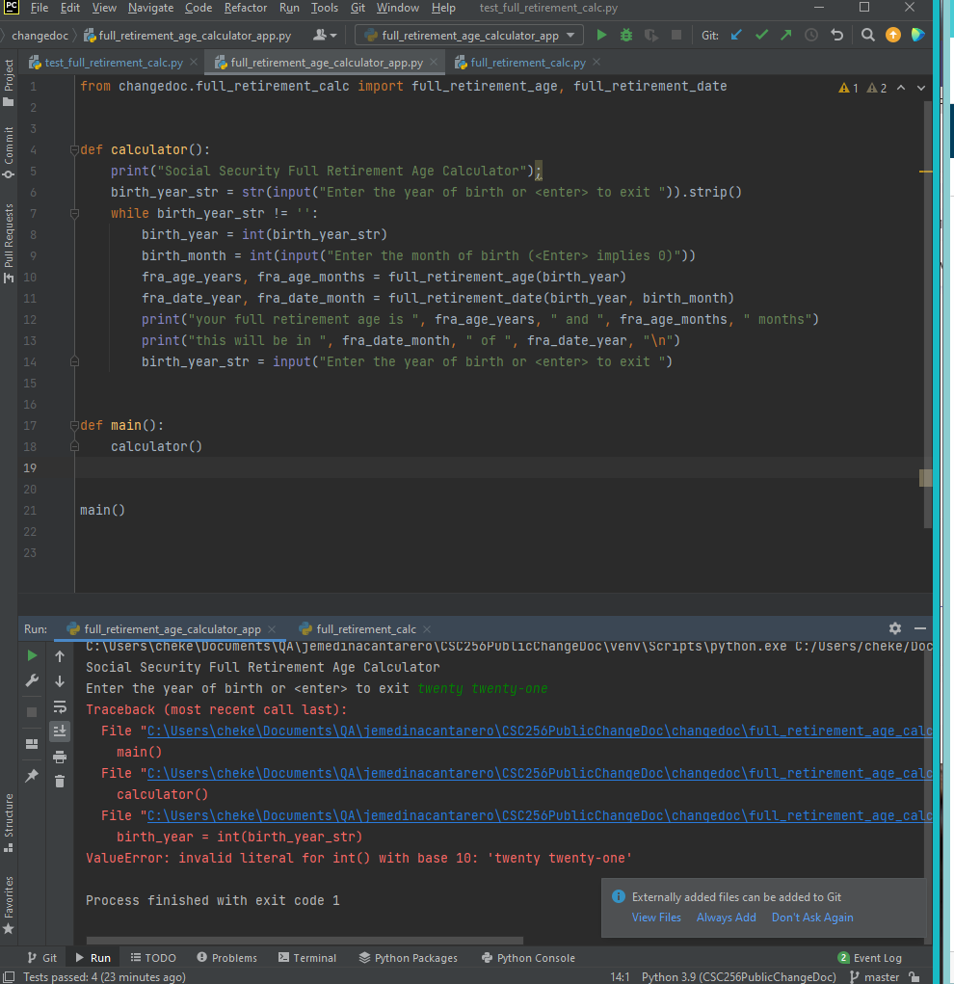

Desktop

Please complete the following information:

* OS: Windows 10 Version 21H1
* Browser : No Browser Required
* Version N/A

Additional context

I recommend addressing this issue ASAP since entering unexpected input will cause that app to break.

Assigned

Unassigned