# Bug 2

Describe the bug

When the user enters the current year as year of birth and enters birth month greater than 12, the programs outputs year of retirement and on the next line, it outputs invalid of -1. The correct output should not include the year of retirement due to bad input from the user.

Program

CSC256PublicChangeDoc 10/02/2021 11:51:00 PM

Component

APP: full_retirement_age_calculator_app.py Method: def full_retirement_date(birth_year, birth_month)

Error Type

Partial correct output

Severity

Minor

Priority

TBD

## State

Working

To Reproduce

Steps to reproduce the behavior:

1. Run full_retirement_age_calculator_app.py
2. Enter year 2021
3. Next, Enter 13 for month
4. Look the output

Expected behavior

When the user enters month greater than 12, the program should only display “this will be in invalid of -1” and not include “your full retirement age is 67 and 0 months”.

Screenshots

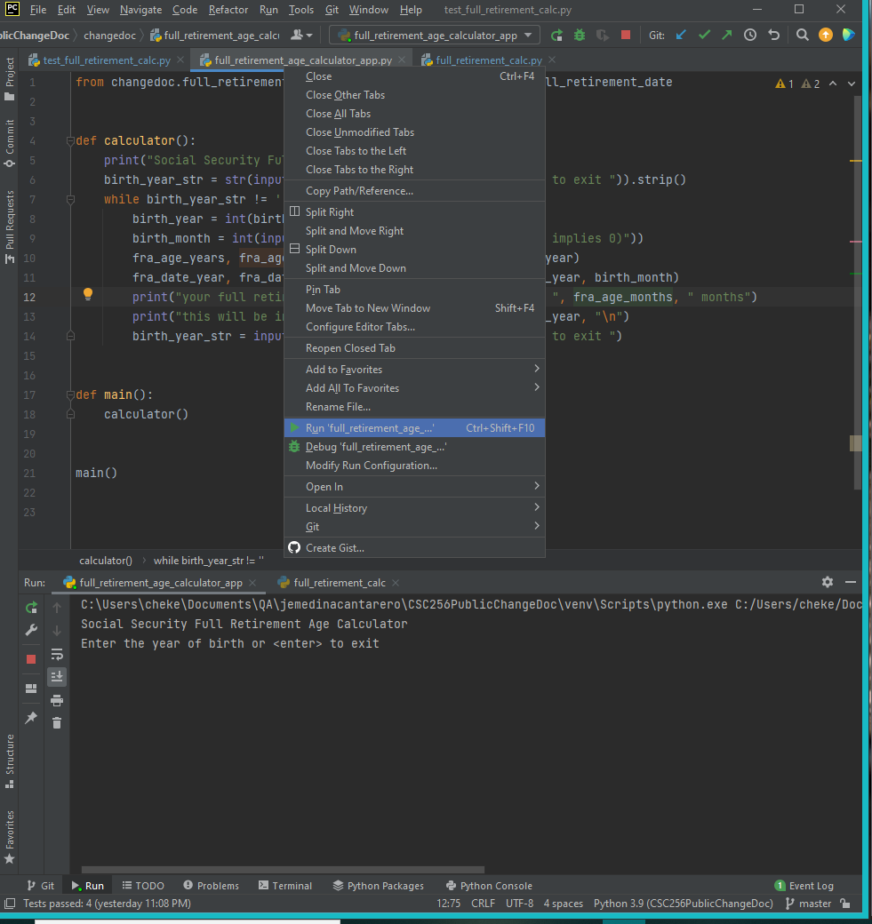

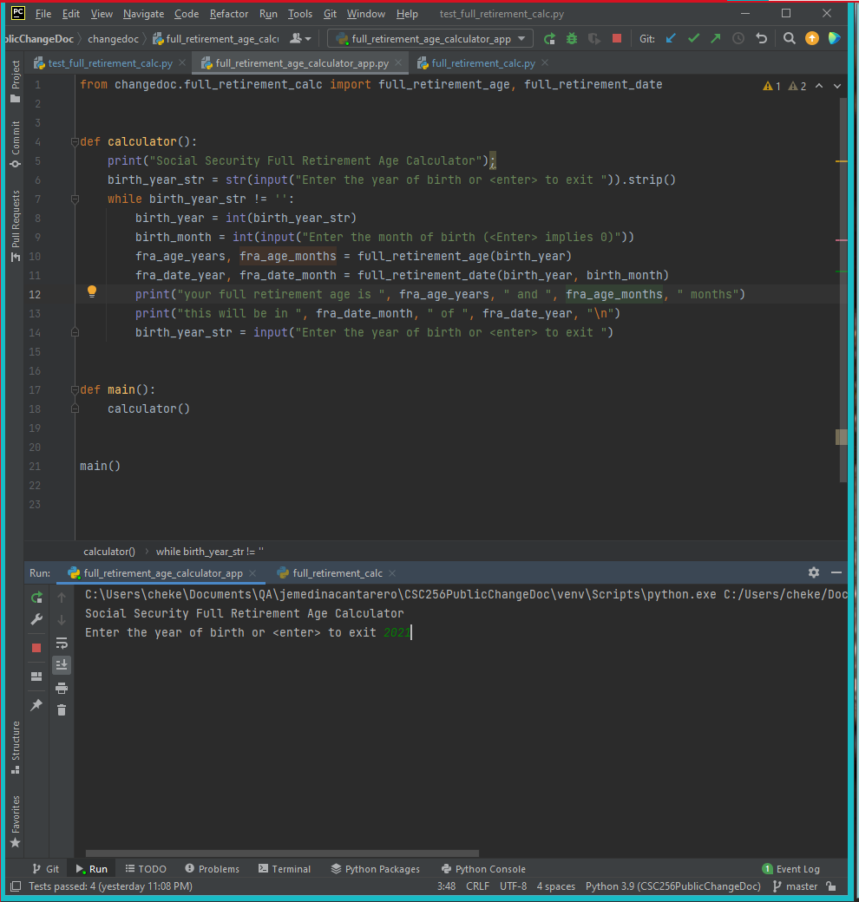

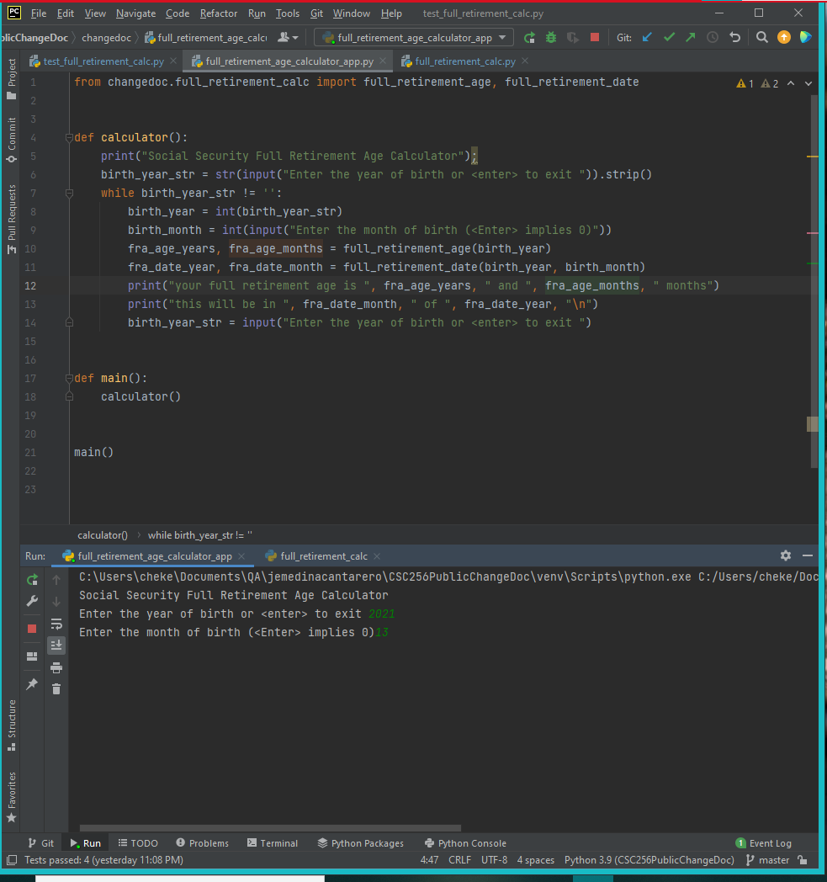

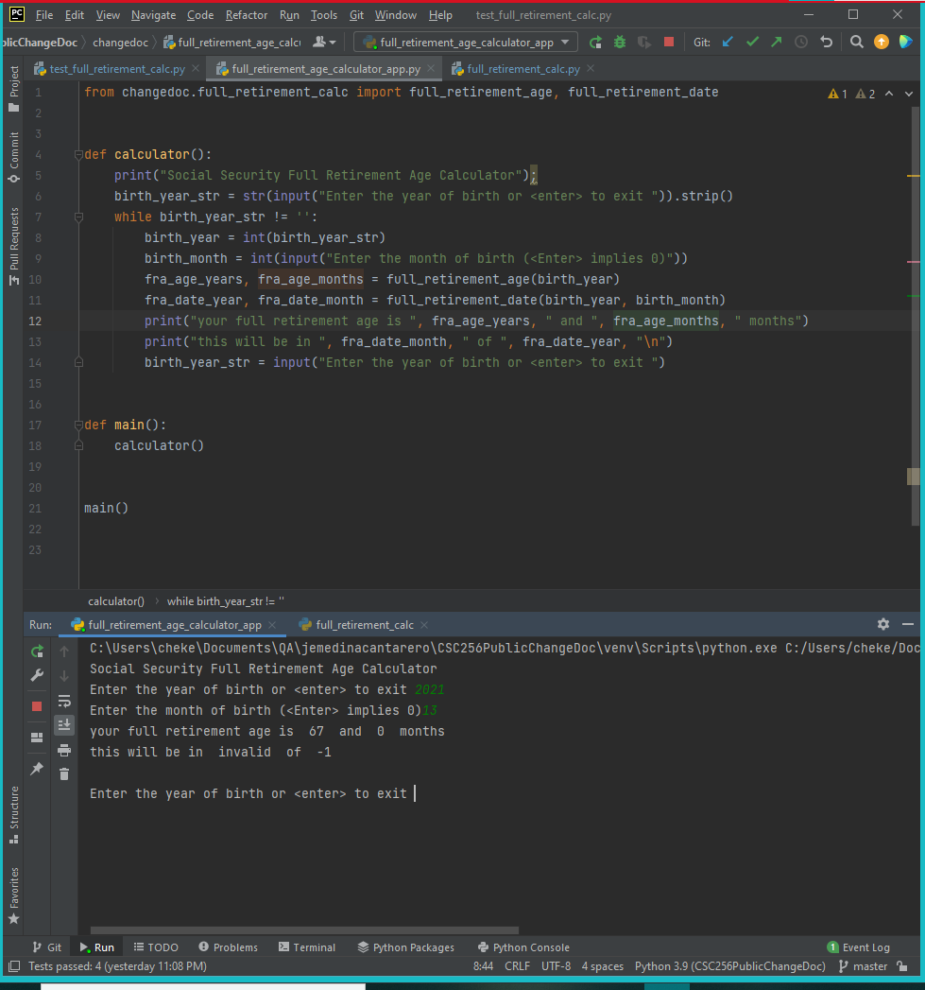

Desktop

Please complete the following information:

* OS: WINDOWS 10 21H1
* Browser N/A
* Version N/A

Additional context

No further suggestions.

Assigned

Unassigned