# Feature request 2

A Feature is a request for new function, and not related to something that must be "fixed."

Is your feature request related to a problem?

Please describe.

* Yes
* When running the Retirement Age Calculator, I noticed that when an input was entered that is a string instead of an integer, the system will crash and exit. This is a problem because, if a user were to enter a letter by accident, the system will crash without a warning.

Program

CSC256PublicChangeDoc 09/30/2021 5:45:00 PM

Component

App: full_retirement_age_calculator_app_py method: calculator()

Describe the solution you'd like

My proposed solution is to add some lines of code that will check that then input entered is and integer for example, is_digit() can be used to test that input entered is an integer. If it is integer, continue to next filter. If is not an integer, print out a statement that will tell the user that an invalid input was entered and initiate a while loop that will continue to prompt the user to try again. Give an example of an acceptable input. For example: “the input entered is incorrect, please try again” “Ex. Of an acceptable input, for year enter: 1993”

Describe alternatives you've considered

N/A

Additional context

This in example of what can be added to the full_retirement_age_cal

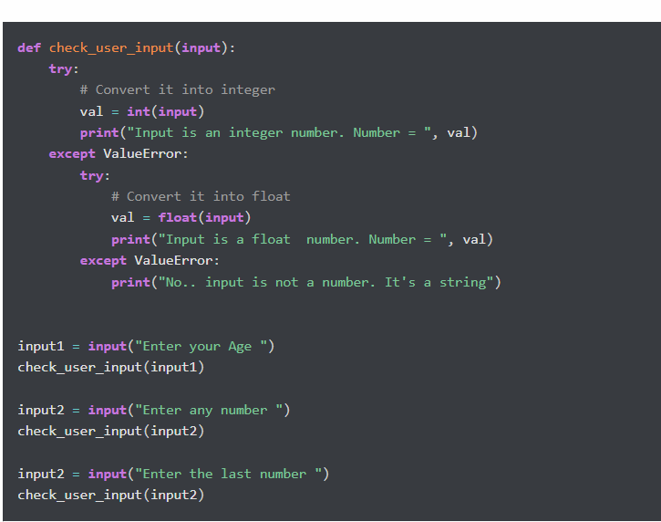

Priority

TBD

## State

Working

Assigned

Unassigned

Cost

TBD