**OPER20525A.A2019 - LOGISTICS**

Pedagogical note on warehousing

1. **Introduction:**

The role of a wholesaler on a supply network is to buy large quantities of products from multiple manufacturers and then re-distribute these products (in smaller quantities) to retailers. To achieve this goal, distributors rely on a network of what is commonly known as *distribution centers* (DCs). A DC is a facility where products are deconsolidated, temporarily stored, and then reconsolidated on their path between manufacturers and retailers in a supply network. The main function of a DC is to provide the wholesaler with:

1. High product availability (because there is often a lead time between the production and the consumption of a product)
2. Safeguards against product scarcity, and
3. Access to economies of scale

Distribution centers also provide value-added activities, such as kitting, custom labeling, and re-packing.

In practice, the terms *warehouse* and *distribution center* are used interchangeably. In theory, however, a warehouse is a facility where products are usually stored for a longer period of time (e.g., more than one year). Therefore, warehouses seek to maximize space utilization (i.e., store the largest possible quantity of products in the smallest possible space). On the other hand, DCs seek to maximize product turnover. As a direct consequence, for a given product, the *velocity* in warehouses and DCs is totally different. The velocity is the volume of activity associated to a product. It is usually measured as the quantity and frequency of the SKU picked over a designated period of time

Most DCs receive products by palettes and distribute them by cases. Retailers can then order any multiple of the case contents, but not a single unit of the product. For instance, if a case of a given product contains 12 units, then retailers can place orders for 12, 24, 36, … units, but cannot order only 6 units. There are, however, distribution centers that distribute products at the unit level. The latter are becoming more and more common every day, due to the phenomenal increase on e-commerce. Working at the unit level, usually increases the complexity of the operation and requires higher levels of automation. Figure 1 illustrates the three most common levels of product aggregation in DCs.

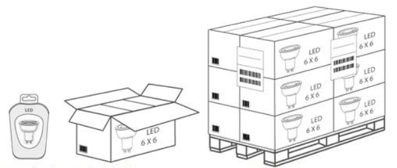

Figure 1: product aggregation levels on a DC.

Source: GS1 Sweden.

1. **The cycle of operations in a distribution center**

The four main operations in a distribution center are:

1. Reception
2. Storage,
3. Order preparation or picking and

(4) Shipping

The reception starts with the arrival of the trucks to the inbound docks. Then, DC associates unload the pallets or cases using forklifts or conveyors (see figure 2a). More details on this handle equipment are discussed in Section 3.1. Next, the associates inspect the shipment to make sure that the right product was delivered in the right quantities and conditions (see figure 2b). To achieve this goal, the associate compares the received products’ references and quantities to those stated in the purchase order.

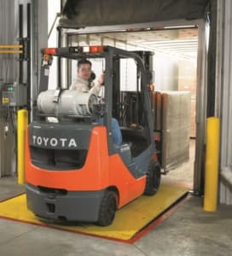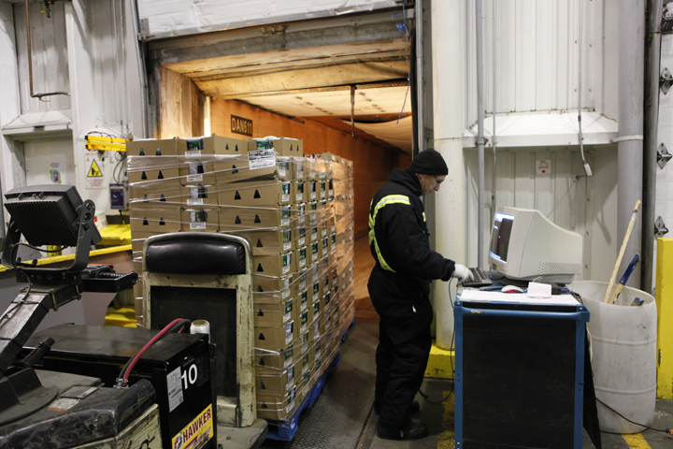

(a) (b)

Figure 2: product reception in a DC.

Sources: (a) Prolift, (b) picture taken by the author at Robert Transport

After cleared by the inspection the products are identified and put away for *storage*. This operation consists in driving the product to an empty storage position that is recorded and associated to the corresponding product for future retrieval. Depending on the DC’s level of automation, this operation may be carried by employees using lifts or by an automated system. To increase space utilization, the products are stored in specialized racks or shelves. The type of equipment best adapted to each product depends on factors that will be discussed in section 3.2.

In general, DCs exploit two types of storing positions: picking and reserve positions (see figure 3 for an example). The former store the products that are used to fulfil customer orders while, as the name suggest, the latter store the reserve inventory. When the level of stock at a picking position reaches a given threshold, fresh stock for the corresponding product is moved in from reserve locations. To simplify the operation and minimize the number of restocking movements, picking positions are usually located on the floor level of the racking systems while reserve positions the same product are located just above on the higher levels.

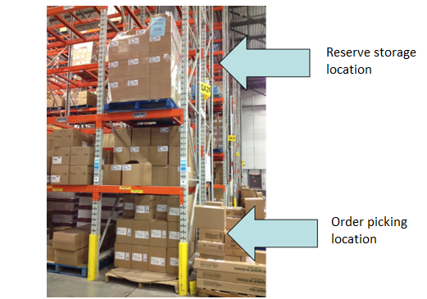

Figure 3: Example of picking and reserve storage locations in a pallet rack

Source: picture taken by the author at Novexco

The third operation in the cycle is the *picking*. This operation consists in retrieving the items composing a customer order from their corresponding positions and bringing those items to the packing or conditioning station. Depending on the *picking unit* (individual units or whole cases), the items composing an order are packed in boxes or pallets.

Picking systems can be split into three main categories: 1) picker-to-goods, 2) goods-to-picker, and 3) automated picking. Figure 4 illustrates the three categories. Picker-to-goods is, by far, the most common picking system. As the name suggest, in a picker-to-good system, the picker (i.e., the employee) moves around the DC to collects the items from the picking positions. Travel time represent about 50% of the overall order preparation time in picker-to-goods systems (Frazelle 2016). We will discuss in Section 4.3 some strategies that can be applied to minimize this time. On a goods-to-picker system, the goods “move” to a picking station where the picker waits to collect the items. The latter requires sophisticated equipment that will be discussed in Section 3.3. Finally, in an automated picking system, the whole picking process is carried by machines without the picker’s intervention.

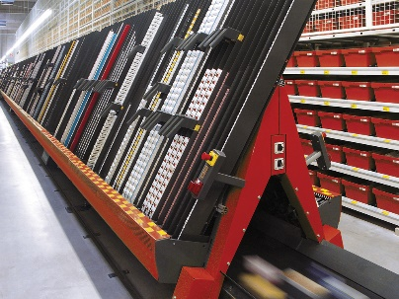

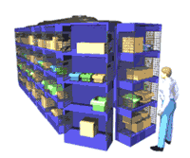

1. Picker-to-goods (2) Goods-to--Picker (3) Automated systems

Figure 4: The different picking systems

Sources: (1) Lucas systems, (2) Lomag-man.org, (3) Sam Technology Engineers

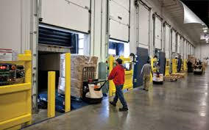The last operation in the cycle is *shipping*. As the name suggests, this operation consists in bringing all the boxes or pallets making up an order to the outbound docks, so they can be loaded in the corresponding truck. Figure 5 illustrates the shipping operation.

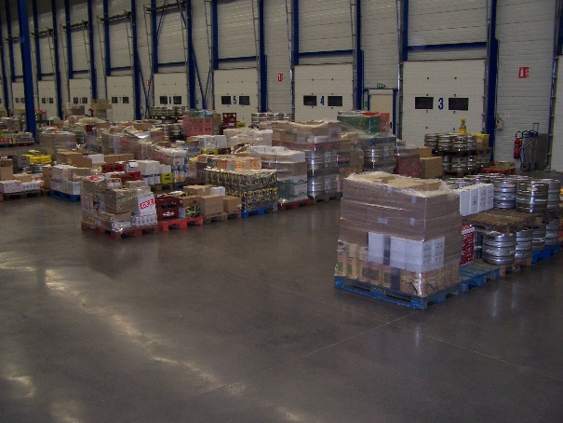

Figure 5 : Shipping dock and loading operations

References : (a) Arc-Isère, (b) SupplyChain 247

According to Tompkins et al. (2003), order preparation activities are responsible for 55% of the costs of a DC, followed by shipping (20%), storage (15%), and receiving activities (10%).

**3. Warehousing equipment**

There are multiple handling and storage equipment used in a distribution center. In some cases, parts of the operations in a distribution center are partially or fully automated. Thus, there are one or many storage systems being used. Finally, different technologies are normally put into place to alleviate employees’ tasks and to improve operational efficiency. We will do an overview of all these elements supporting the activities within a distribution center.

3.1 Handling equipment

There exist four major families of handling equipment that are frequently used in a distribution center. Firstly, a pallet is the main equipment that allows for the orderly storage and handling of products. The North American palette measures 48 in. wide and 40 in. deep (see figure 6).

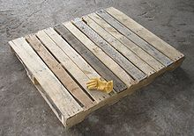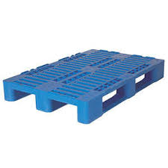

1. (b)

Figure 6: Standard North American wooden (a) or plastic pallet

Sources: (a) Wikipedia, (b) CHEP

Second, there is the pallet truck (or pallet Jack) family. These equipment can be motorized or not and they enable the movement of heavy ground level loads (one or two pallets). Figure 7 displays some examples.

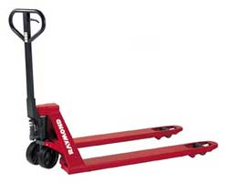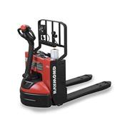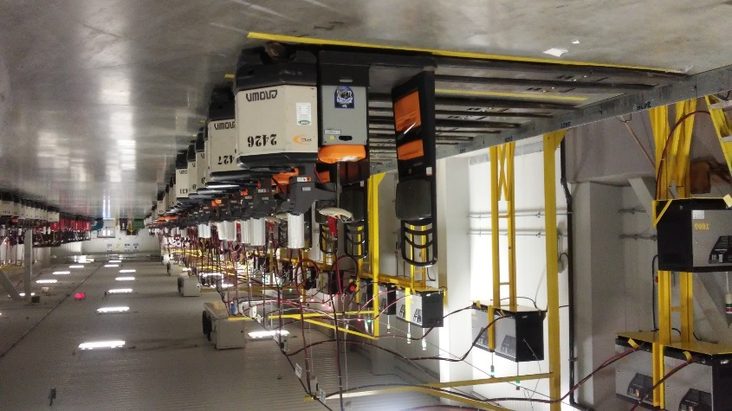

1. (b) (c)

Figure 7: (a) manual pallet Jack, (b) single motorized Jack, and (c) double motorized Jack

Sources: (a and b) Raymond équipements Johnston et (c) picture taken by the author at Metro

The third main family of handling equipment is forklifts. In comparison to pallet Jacks, forklifts are always motorized, and they can handle the stacking of heavy loads, as illustrated in figure 8.

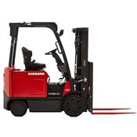

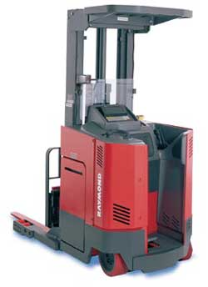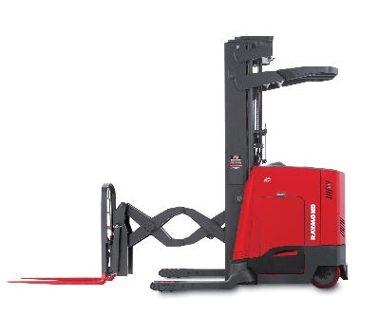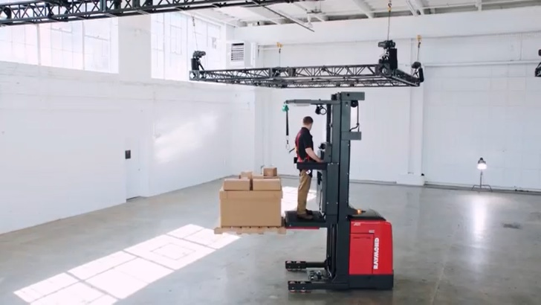

Reference:

(a) (b) (c) (d)

Figure 8: (a) Standard forklift, (b) counterbalance forklift, (c) double deep forklift, (d) order picker forklift or elevating forklift

Source: Raymond équipements Johnston

Last but not least, conveyors are frequently used to route cases or units of a product around the distribution center (see figure 9). Conveyors are generally equipped with a variety of sensors and scanners to identify the objects and orient their movements.

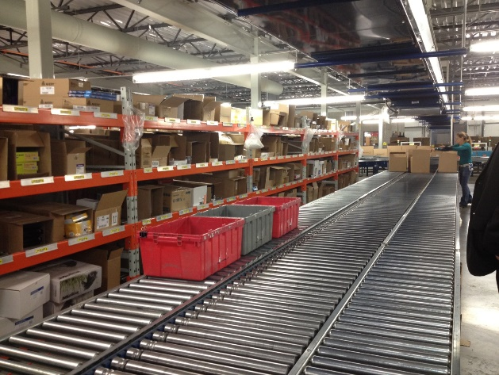

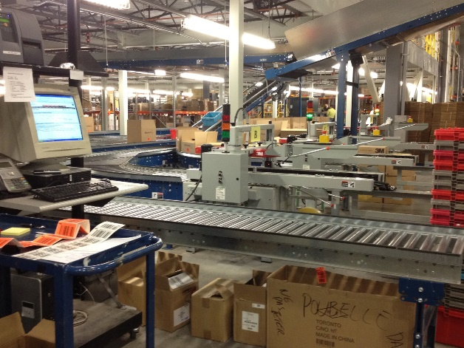 Figure 9: Examples of conveyors

Source: pictures taken by the author at Novexco

3.2 Storage equipment

There exist many types of storage equipment and they can be divided into two large families: pallet racks, that are used to store pallets, and shelves, that are used to store cases or units.

There exist different types of pallet racks as we can see in figure 10. The most common pallet racks are static single deep, double deep, drive-in or drive-thru pallet racks, as well as dynamic pallet flow or push-back pallet racks. The characteristics and specific selection criteria for these pallet racks are present in this video [*Les différents types de palettiers : comment s’y retrouver?*](https://tintin.hec.ca/audiovisuel/melies/visionnement_pb.cfm?version=17310) We strongly suggest watching this video and filling out the associated summary sheet.

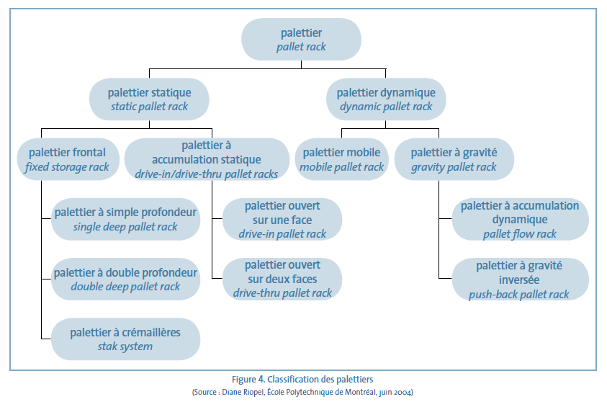

Figure 10 : Pallet rack classification

Reference: Riopel (2004)

There exist three different types of shelving to store cases or units of a products (see figure 11). The first type of shelving is carton flow shelves, which allows articles divided into cases with a strong velocity to be grouped in a single area, thus eliminating useless steps and simplifying stock reconfiguration. The second type of shelving are span-track shelves, which allows the rapid and low-cost conversion of pallet racks into racks with rollers that can accommodate cases. These shelves are thus directly integrated into the lower levels of the pallet racks, contrary to carton flow shelves that can be situated anywhere in the distribution center. They also offer important space savings at the ground level. Lastly, there are the standard shelves that are used for products with lower velocity.

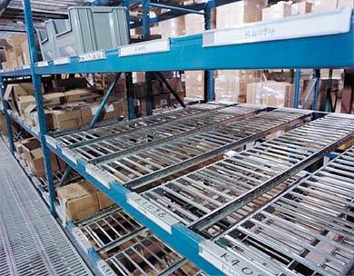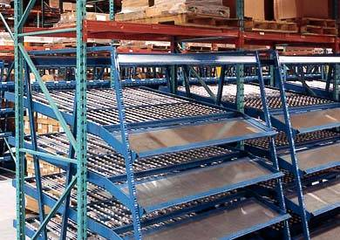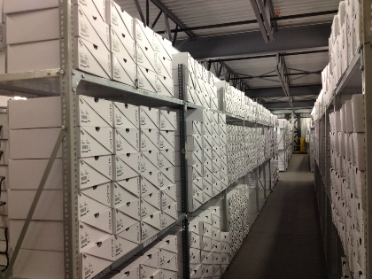

1. Carton flow shelves (b) Span-track shelves (c) standard shelves

Figure 11: Storage equipment for cases and units

Source: picture taken by the author at Aldo

3.3 Storage systems

Moving items from their storage locations to the picking stations in a goods-to-man system, requires an automatic or semi-automated storage system. There are four main types of semi-automated systems: automatic storage and retrieval systems (AS/RS), semi-automatic structural grid systems, vertical and horizontal carrousel systems, and automatic guided vehicle AGV-based systems. There exist a fifth type of system, known as the A-frame, which is fully automated, but much less flexible than the previous four. In the reminder of this sub-section we will discuss these five systems.

In AS/RSs, the items are stored inside a closed structure that is not accessible to the pickers. The items are collected at their storage locations and brought to the picking stations by robots. AS/RSs can be engineered and built to work at any aggregation level: individual units, cases, and pallets. When working at the unit level, the items are usually put in plastic baskets capable of storing between 4 and 8 different stock keeping units (SKUs). On the other hand, when working with cases, the items are usually stored in plastic trays containing a single SKU. Most AS/RSs store items at redundant positions to maximize throughput and to keep items accessible in case of a breakdown or a maintenance operation in one of the alleys. [This](https://www.youtube.com/watch?v=txOyIreIGgM&t=1s) video illustrates the operation of an AS/RS system on a DC working at the individual unit aggregation level. Figure 12 displays an AS/RS system.

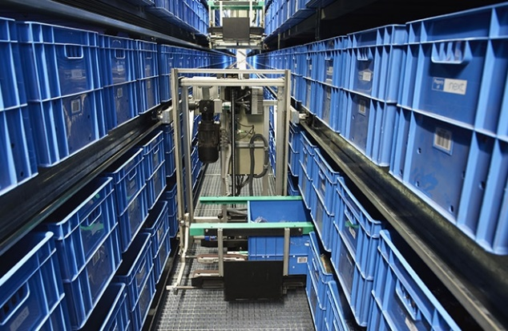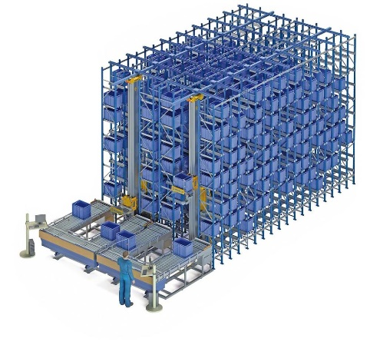

1. (b)

Figure 12: AS/RS system

Sources: (a) Mecalux, (b) Vanderlande

Carousels, on the other hand, are systems that contain cases or units of a products (see figure 13). They rotate in a horizontal or vertical manner which allows the products to be brought to a picking station. In fact, once the product needed for an order is facing the picking station, the carousel stops turning and waits for the order picker to pick the product. [This](https://www.youtube.com/watch?v=uueNp0eUf70) video shows a carrousel system in action. Figure 13 shows a vertical and a horizontal carrousel.

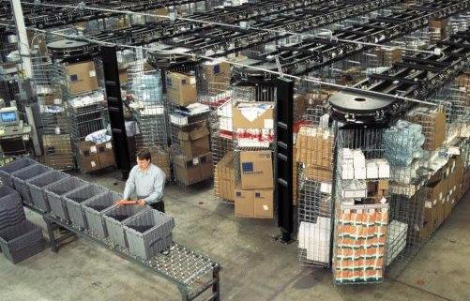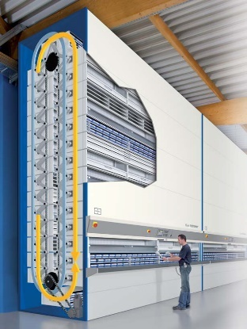

(a) (b)

Figure 13: Horizontal carrousel (a) et vertical carrousel (b)

Sources: (a) Southwest Solutions Group, (b) Les solutions spacesaver inc.

AGV-based systems are made up of two main components: mobile shelves and a fleet of AGV that move the shelves from the storage locations to the picking locations (see figure 14). After the picking operation, the AGVs move the shelves back to an empty storage location, following the instructions given by slotting algorithms. [This](https://www.youtube.com/watch?v=6KRjuuEVEZs) video shows Amazon’s Kiva system in operation.

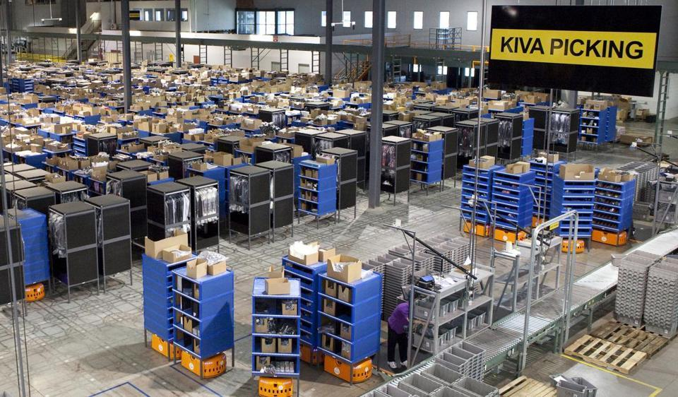

Figure 14: AGV-based system

In semi-automatic structural grid system, the items are store in plastic bins that are piled inside a multi-layer structural grid. Small robots retrieve the cases from the top of the structure and bring them to one of the sides, where vertical lifts take them down to the picking level (see figure 15). [This](https://www.youtube.com/watch?v=QP8fNXPscss) video shows Bastian Solutions’ semi-automatic structural grid system in operation at the DC of a e-retailer.

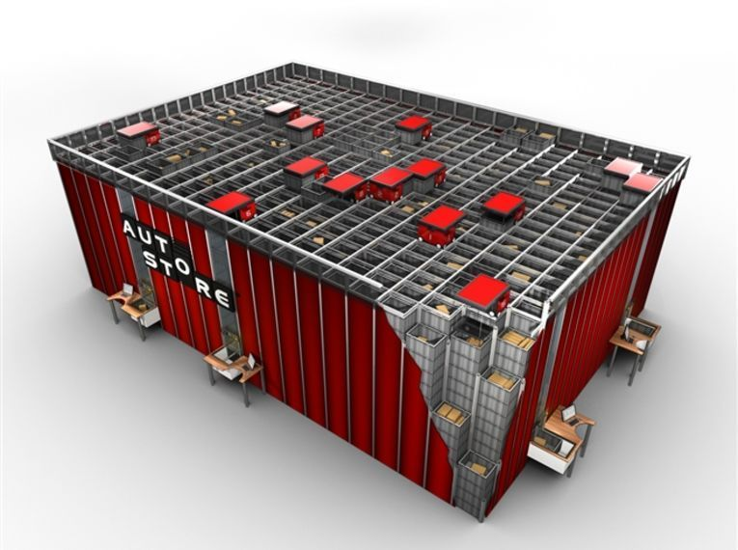

Figure 15: Semi-automated structural grid system

Sources: Digi.no

These picker-to-goods systems reduce or completely eliminate the space devoted to circulation aisles in a DC. They, however, require a significantly higher initial investment compared to that needed to set up a classical picker-to-goods systems. In addition, to take the best out of these technologies, companies must also invest on top-of-the-line information technology (IT) system that are able to optimize the systems’ operation.

Last but not least, A-frame system (see figure 16) are fully automated system that do not require the intervention of an order picker. These systems are typically work at the unit level of aggregation. They are less flexible than goods-to-picker systems, so their utilization is usually limited to small items with regular shapes (like medicines and cosmetic products). The items are arranged in columns on each side of the A-shaped system. A conveyor physically, or virtually, divided into slots corresponding to each order being prepared passes under the A structure. As the slot corresponding to a given order passes the position of one of the ordered items, the system pitches the number of required units to the conveyor. At the end of the “tunnel”, all items pitched to each of the slot are put together on a shipping box that is closed and moved to the dispatching area. [This](https://www.youtube.com/watch?v=lQDtp7d7cnA) video shows an A-frame system in operation at a cosmetic wholesaler.

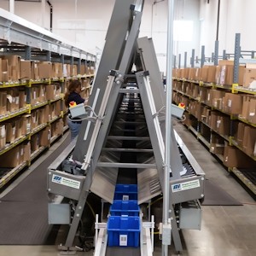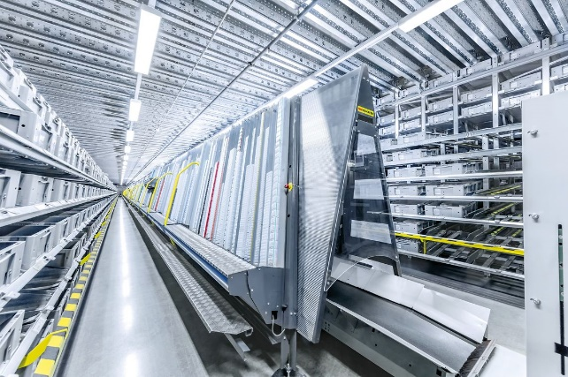

Figure 16 : Automated A-frame

Sources: (a) SI systems, (b) SSI Schafer

3.4 Technologies to support picking operations

We will now present four technologies that are used in a DC to support picking operations. The first two technologies are used to quickly and accurately identify products. Next, we will discuss two technologies that help the order picker increasing his or her picking speed and minimizing the picking errors.

Identification technologies

There exist two types of technologies that enable the identification of products in a distribution center: barcodes and radio frequency identification (RFID).

“A barcode is an image consisting of a series of parallel black and white lines that, when scanned, relay information about a product. Barcodes are read by optical devices such as a barcode reader or scanner”[1]. At less than 1 cent per tag, barcodes are probably the less expensive product identification technology.



Figure 17: Example of a one-dimensional barcode

Source: Bigstockphoto

As the name suggest, RFID technology use a radio frequency tag (see figure 18) that houses an antenna and an electronic chip. The chip contains an EPC (electronic product code) and can contain information about the product’s path on the supply chain. The cost of these tags is 10 to 50-fold that of a barcode. For this reason, this identification technology has not been as massively adopted as expectations let to believe in the first years following its invention. RFID tags have two main advantages over barcodes. First, they do not need to be aligned or in contact with the reader in order to be read, and second, multiple tags can be read on a single pass. These two features lead to considerable time savings during reception, storage, picking, and dispatching operations. [This](https://www.youtube.com/watch?v=4Zj7txoDxbE) video explains the RFID technology.



Figure 18: Example of a radio frequency tag

Source: Wikipedia

Technologies to support the picking operations

There exist three different types of technologies that support order preparation: hand-held terminals, light guided picking (pick-to-light), and voice guided picking (pick-to-voice). We will present them on after the other.

Wireless hand-held terminals enable barcodes reading and facilitate the picking of items in the distribution center. They can take many different forms (see figure 19). The order picker must hold the terminal in their hands to scan and enter information (figure 19a). To free their hands, order pickers usually carry the terminals on a belt specially designed for this purpose. Other terminals, commonly called “gladiators” (figure 19b), are attached to the picker’s wrist. The reader is carried on a ring in the picker’s finger. Finally, there are also portable terminal that are mounted to forklifts (figure 19c).

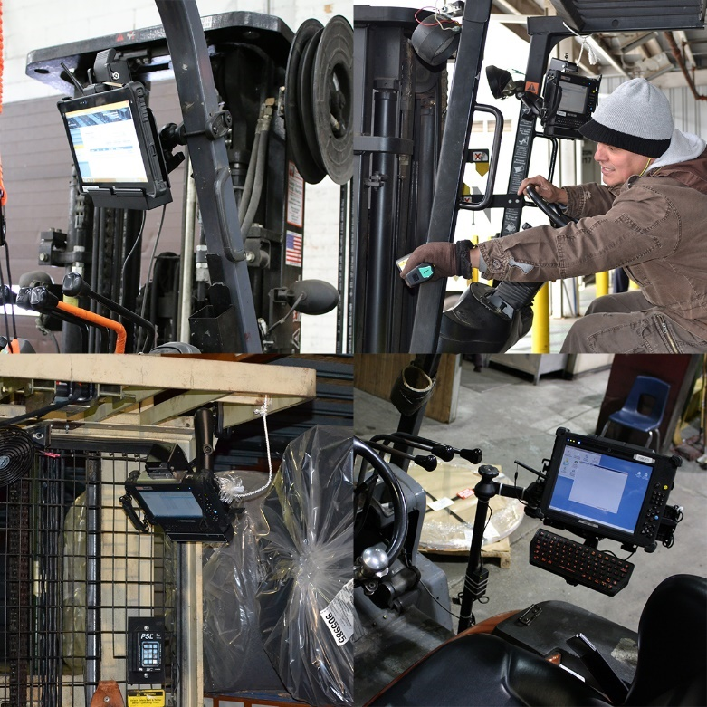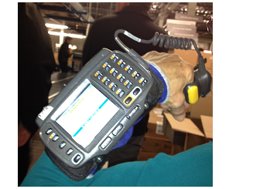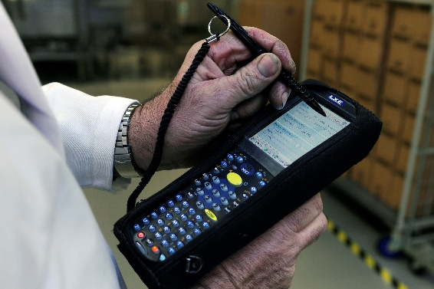 (a) (b) (c)

Figure 19: (a) Hand-held terminal, (b) Hands free terminal with scanner, (c) Terminal mounted on a forklift

Sources: (a) Breakaway staffing solutions, (b) personal picture, (c) Mobile demand

This type of technology is the most frequently used in a distribution center because they can be used under any circumstance and for any type of product. This is also the least expensive technology. The video [Ready to ship order picking system](http://www.youtube.com/watch?v=BcbhbGRXZRE) demonstrate how this technology is used. This technology allows a picker to pick between 50 to 190 lines per hour (MWPVL international, 2019). Productivity can be reduced if the barcodes are not well maintained or illegible. The use of the hand-held terminal can be cumbersome and reduce work ergonomics, which can increase the amount of work-related injuries. Lastly, the level of precision of this technology is between 99.3 % to 99.5%, which translates to 5 to 7 errors every 1000 picks (MWPVL, 2019).

Pick-to-light technology uses fixed light indicators at each storage location to help the order picker easily spot the location of the product and quantity to be picked. The video [Pick-to-light technology at Pepsico](https://tintin.hec.ca/audiovisuel/melies/description.cfm?version=17311) explains its functioning in more details. This technology is normally used for small products that are positioned on shelves with rollers. It can also be used in parallel with semi-automate storage systems like carousels or AS/RS to alleviate the order picker’s tasks. This technology allows a picker to pick between 110 to 350 lines per hour (MWPVL International, 2019). It requires little training and can be used by employees who do not necessarily speak the local language. Its level of precision is estimated between 99.5 % to 99.7%, which translates to 3 to 5 errors per 1000 picks (MWPVL International, 2019). Lastly, this technology is relatively expensive and is normally only implemented in a small area of the distribution center.

Pick to voice technology allows order pickers to determine the location of the product to be picked and quantity by listening to vocal commands given through a headset. The video [Voice Picking vs RF Scanning](http://www.youtube.com/watch?v=BcbhbGRXZRE) explains the operation of this technology and compares it to portable terminals. This technology can be used in any environment and for all types of products, but it is particularly interesting to use in frozen or refrigerated sections of a distribution center because employees do not have to remove their gloves to use it. This technology allows the picker to pick between 175 to 275 lines per hour and has a precision level estimate between 99.7% to 99.97%, which translate into 0.3 to 3 errors for 1000 picks (MWPVL International, 2019). Thus, this technology is the most precise. Furthermore, it is more expensive than hand-held terminal technology, but less expensive than the pick-to-light technology. Lastly, one disadvantage of this technology is that certain order pickers have difficulty working long hours wearing a headset because the voice being heard (synthetic voice) can quickly become irritating. On the other hand, this system allows for the easy translation of the directives in multiple languages which facilitates the hiring of a diverse workforce.

1. **Operation management decisions in a distribution center**

We will present the five main decisions that must be made by a distribution center manager. Many of these decisions are interrelated and can, with their synergy, allow for variating increases in the operational efficiency of the distribution center. These decisions greatly rely on the product manipulation characteristics, received order characteristics, the product volume that needs to be managed and the financial capabilities of the company.

4.1 Choosing the picking system

This is one of the most crucial and difficult decisions in a DC. The best picking system for a given situation, depends on criteria such as the volume of orders to pick on a day, the type of items and the product velocity. It is worth noting that first-in-class DCs usually combine two or more picking systems. For instance, it is usual to pick “very-fast movers” (i.e., items that are ordered very frequently) using a static picker-to-good system (i.e., on a single-and-short alley) and pick mid and slow movers using a goods-to-picker system. Table 1 provides some guidelines on the picking system that better fits difference situations.

|  |  |  |  |  |
| --- | --- | --- | --- | --- |
| Criterion | Picker-to-goods | Goods-to-picker | | A-frame system |
| Carrousel | ASRS |
| Order volume | Low to medium | Medium to high | Medium to high | High |
| Product type | All | Small | Small to medium | Small |
| Product velocity | Low to high | Low | Low to high | High |

4.2 Order preparation strategy selection

Description of order preparation strategies

There are two categories of order preparation strategies, picking one order at a time or picking multiple orders simultaneously. Starting from these two strategy categories, we can consider three possible order preparation strategies.

Strategy 1 – Discrete picking

This strategy aims to prepare a single order at a time. Each order picker takes care of a single order at a time. This is illustrated in figure 20.



Shipping zone

Products to be picked for order *i*

Figure 20: Discrete picking where each picker takes care of a single order at a time

Strategy 2 – Cluster picking

This strategy allows for multiple orders to be picked at the same time. Each picker retrieves the products and sorts them by order as they go (sort-while-picking). Thus, the integrity of each order is preserved. This strategy is illustrated in figure 21. This type of order preparation typically requires equipment or a container with separators in order to divide the products belonging to each order as illustrated in figure 22.



Shipping zone

Products to be picked for order *i*

Figure 21: Cluster picking strategy

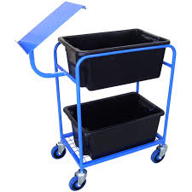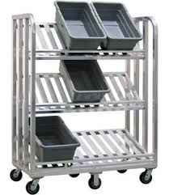

Figure 22: Example of carts used to preserve the integrity of orders during the whole order preparation process

Strategy 3 – Batch picking

This strategy allows for multiple orders to be picked at the same time. Each picker picks all the products from their assigned lists, then bring them to a sorting area where products for the same order are consolidated (pick-then-sort). This is illustrated in figure 23.



Sorting and shipping zone

Products to be picked for order *i*

*i*

Figure 23: Batch picking strategy

Advantages and disadvantages of these strategies

These 3 strategies offer different advantages and disadvantages. By using the discrete picking strategy, there is no dependencies among the pickers. If an order consists of a number of items, it would be more efficient to use this strategy because the time spent to consolidate and sort a number of items for different orders would be very long. However, it would not be efficient to use this strategy when the orders typically contain only a few items in each order and the locations of these items are spread out in the entire warehouse. In this case, all the workers would travel a long distance to pick up a few items for an order. Therefore, it is more efficient to consolidate and divide the tasks among different workers. If it is possible to sort while picking (i.e., using the cluster picking strategy), we can pick and complete the orders at the same time. However, it is not often the case that pickers can keep the order integrity when picking up the items because there must be enough partitions with sufficient capacity to keep each order separate. In this case, we can adopt the batch picking strategy to sort the items for orders after picking.

Determining the strategy to use

The method to choose the right picking strategy is to consider how many products and how many units for each product in an order. Table 2 shows how to choose the best picking strategy.

|  |  |  |  |  |
| --- | --- | --- | --- | --- |
|  |  | **Number of lines (products) per order** | | |
|  |  | **1-5** | **6-39** | **40+** |
| **Number of items per line** | **1-5** | Cluster  (sort-while-pick) | Batch  (pick-then-sort) | Discrete  (one order at a time) |
| **6-19** | Batch  (pick-then-sort) | Batch  (pick-then-sort) | Discrete  (one order at a time) |
| **20+** | Discrete  (one order at a time) | Discrete  (one order at a time) | Discrete  (one order at a time) |

Table 2: picking strategy selection guidelines

**Example 1**: Two orders are placed by two stores to a distribution center. The product list of these orders is given below. Which picking strategy should be used to prepare these orders?

|  |  |  |  |
| --- | --- | --- | --- |
| **Order**: A12009 | |  |  |
| **Ship to**: Dorval STORE 1229 | |  |  |
| **SKU** | **description** | **Unit** | **Quantity** |
| 55900 | DEHYDRATEUR 240 ML | cs | 4 |
| 74237 | KN PEAR BIO | cs | 2 |
| 19801 | NATURAL MINERAL WATER | cs | 12 |

|  |  |  |  |
| --- | --- | --- | --- |
| **Order**: A12010 | |  |  |
| **Ship to**: Montreal STORE 1106 | |  |  |
| **SKU** | **description** | **Unit** | **Quantity** |
| 55900 | DEHYDRATEUR 240 ML | cs | 2 |
| 74237 | KN PEAR BIO | cs | 2 |
| 66730 | VANILLA SOYA BIO | cs | 9 |
| 12880 | ORANGE JUICE BIO 250 ML | cs | 4 |
| 12883 | APPLE JUICE BIO 250 ML | cs | 2 |
| 19801 | NATURAL MINERAL WATER | cs | 15 |

We can see that the average number of lines is (3+6)/2 = 4.5 and the number of units (cases) per line is (4+2+12+2+2+9+4+2+15)/9 = 5.78 ≈ 6 cases per line. Therefore, the batch picking strategy (pick-then-sort) should be used. The list of products in these two orders must be consolidated and then the picker will pick all the items and sort after the picking is done.

4.4 The choice of technology to support order preparation

When choosing which technology to use in the distribution center it is important to consider the advantages and disadvantages of each option. It is also very important to consider the available budget for such a project.

4.5 Pallet racking selection

When trying to decide which type of pallet rack would best fit your company’s current situation, it can be useful to consider the number of pallets per product that need to be stored in the distribution center, as seen in table 3. The green boxes represent the best option and the yellow ones signify other potential options. To find this information, one can look at the historical amount of inventory stored. In addition, it is important to note that in a distribution center, multiple types of pallet racking systems can be used if the stored products have distinct characteristics.



Table 3: Choosing the best pallet racking system

* 1. Slotting

Slotting is the process of organizing inventory in a warehouse or DC. In the case of a DC, the slotting process typically seeks to minimize the picking time. To slot a distribution center, it is useful to carry out an ABC classification of the items, based on their velocity. A items (i.e., those ordered most frequently) are usually assigned to the picking positions (or slots) that are closest to the packing stations. C items, on the other hand, are typically located the far from the stations because they are seldom ordered.

**References**

Frazelle, E.H. (2016). *World-Class Warehousing and Material Handling, 2e edition,* New York, McGraw-Hill Education.

GS1 Sweden (2017) *Guideline Trade Item Information for lighting products.* Récupéré le 11 avril 2019 de <https://www.gs1.se/globalassets/artikelinformation/guideline-trade-item-information-for-lighting-products.pdf>

MWPVL International (2019) *Distribution center order picking technologies compared*. Récupéré le 14 mars 2019 de <http://www.mwpvl.com/html/order_pick_technologies.html>

Riopel, D. (2004) École Polytechnique de Montréal.

RFID Journal (2013) *What are the costs of passive, active, and semi-passive tags?* Récupéré le 11 avril 2019 de <https://www.rfidjournal.com/blogs/experts/entry?10744>

Tompkins, J.A., White, J.A., Bozer, Y.A. and Tanchoco, J.M.A. (2003). *Facilities Planning*, 3e édition, New Jersey, Wiley.

1. Taken from <https://www.investopedia.com/terms/b/barcode.asp>. Last accessed on Sep. 23, 2019.