**OPER20525A.A2019 - LOGISTICS**

Warehousing at Avril Supermarché

Practical exercises

**Context:**

“Avril Supermarché Santé is an independent Quebecer health food store chain. Just like a garden, Avril is a promise of freshness and abundance, bringing its customers closer to a healthier way of life. Avril stores are designed to be energy efficient and to provide its customers with a unique, satisfying shopping experience.

In Avril stores you will find:

* Natural and organic foods
* Organic vegetables and fruits, certified by Ecocert Canada
* Supplements and vitamins
* Natural cosmetics
* Organic meat products
* Gluten-free products
* Local products
* Fair-trade products
* Ecological products
* Herbal medicine, homeopathy and aromatherapy products
* Esthetics cabin care
* Bistro-type restaurant
* Qualified staff: naturopaths, homeopaths, herborists, cosmeticians
* Private consultations”[1]

Avril has stores in Brossard, Granby, and Longueuil and a distribution center (DC) located a few miles away from the Granby store. Figure 1 shows Avril’s network.

Avril does not accept any direct store delivery (DSD), meaning that every single product goes through the DC on its path between the manufacturers and the stores. Avril recently opened a store in Laval. They now want to move the DC closer to Montréal (but still in the south bank), to better serve the new Laval store. The DC manager wants your help to decide the type of pallet racking, the ideal picking system, and the best picking strategy for the new facility. To help you achieve this goal, the manager has provided you with a data base (file D.AVRIL_SUPER-MARCHE.XLS) holding information on products, transfers between the DC and the stores, and inventory levels for each product during a year.



Figure 1: Avril’s distribution network

**The database:**

The database is made up of three data sheets: product, transfer, and inventory. As the name suggests, the product sheet contains information about the products. Figure 2 describes the fields in the product table. The transfers sheet contains the details on the orders placed by the three stores to the DC between January and July 2019. Each row on the table corresponds to a *line* in an order. In the warehousing jargon, a line is simply a Stock Keeping Unit (SKU) included in an order. For instance, order 1 is made up of 21 lines (rows 3 to 22), meaning that the order includes 21 different SKUs. Figure 3 describes the fields in the transfers table. Finally, the inventory sheet holds “screen shots” of the inventory held at the DC the first day of each month between July 2018 and July 2019. Each row in this table shows the inventory (in units, cases, and pallets) held for a given SKU during the year. Figure 4 describes the fields in the inventory table.

|  |  |
| --- | --- |
| Field | Description |
| SKU ID | Unique identifier of the SKU on Avril’s ERP system. |
| Brand | Brand of the product. |
| Description | Name of the product associated to the SKU. Note that the same product can be sold as different SKUs (e.g., bottles of 500ml and bottles of 1L). |
| Size | Size of the product unit. For instance, if Size = 500ml, one unit of the SKU contains 500ml of the product (e.g., a bottle of 500ml). Similarly, if Size = 125gr, then one unit of the SKU contains of 125gr of the product (e.g., 1 package of 125gr). On the other hand, if Size = 4x125gr, then each unit of the SKU contains 4 units of 125gr of the product (e.g., 1 package of 4 units, each of 125gr). |
| Supplier | The name of the supplier of the product. |
| Category | Category of the product in the Avril classification. There are 9 categories: Canned; Honey, syrup and jam; Inedible; Juices and beverages; Oils, vinegar and seasonings; Pasta, bread and cereals; Snacks and sweets; Soups and broths; and Teas. |
| Class | The class of the product according to Avril’s ABC classification. |
| Nb units / case | Number of units of the SKU in a case. |
| Nb case / pallet | Number of cases of the SKU in a pallet. |
| Nb units / pallet | Number of units of the SKU in a pallet. |
| Weight | Weight classification: heavy, average, light. |
| Picking unit | The minimum aggregation unit in which the SKU may appear in an order. |
| Width (in) | Width of a case in inches. |
| Length (in) | Length of a case in inches. |
| Height (in) | Height of a case in inches. |
| Volume case (ft^3) | Volume of a case in cubic feet. |
| Volume case (in^3) | Volume of a case in cubic inches. |

Figure 2: description of the fields in the product table

|  |  |
| --- | --- |
| Field | Description |
| Order ID | Unique identifier of the order. |
| Line ID | Unique identifier of the line. |
| Customer | The store placing the order: BRD for Brossard, GBY for Granby, and LGL for Longueuil. |
| Date of TRF | Date of the transfer. |
| Day TRF | The day of the week corresponding to Date of TRF. |
| Month TRF | The month of the year corresponding to Date of TRF. |
| SKU ID | ID of the SKU in the line. |
| Description | Name of the product associated to the SKU (see Figure 2 for more details). |
| Qty (units) | Units of SKU shipped. |
| Qty (case) | Number of cases shipped. |
| Qty (pallet) | Number of pallets shipped. |

Figure 3: description of the fields in the transfers table

|  |  |
| --- | --- |
| Field | Description |
| SKU ID | ID of the SKU held in inventory. |
| Description | Name of the product associated to the SKU (see Figure 2 for more details). |
| Inventory in units | Snapshot of the inventory in units of the SKU the first day of every month between Jul-2018 and Jul-2019. The last two columns contain the average number of units held in inventory during the year and the maximum number of units held in inventory (considering only the values captured by the snapshot). |
| Inventory in cases | The same information presented in “Inventory in units” but in cases. |
| Inventory in pallets | The same information presented in “Inventory in units” but in pallets. |

Figure 4: description of the fields in the inventory table

**Practical exercises:**

**Exercises 1 to 6: basic database queries**

1. How many SKUs does Avril handle through the DC?

**Answer:** 657 SKUs.

**Solution:** this question can be answered using a pivot table. Select range A1:Q658 on the Product sheet. Click on the **PivotTable** icon on the **Insert** menu (see Fig. 5). On the popping up menu select **New Worksheet** and click on the **OK** button (see Fig. 6).

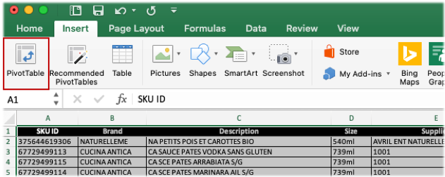

Figure 5: inserting a pivot table

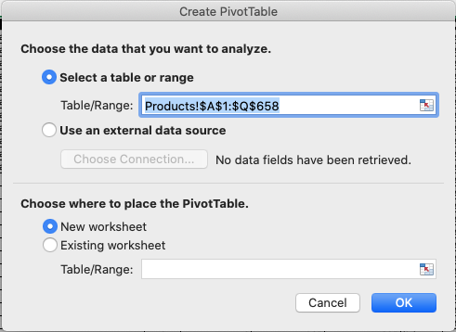

Figure 6: pivot table output parameters

Excel will create a new worksheet. The **PivotTableFields** menu will appear on the right side of the screen[2]. Drag and drop the **Description** field to the **Rows** combo-box and the **SKU ID** to the **Values** combo-box as shown in the right-most part of Figure 7. Right-click on the label **SKU ID** on the **Values** combo-box and select the **Field Settings** option. In the **Summarize by** menu, select **Count** and click on the **OK** button (see Fig. 8). The left-most part of Figure 7 shows the results. For each product (i.e., **Description**), the table shows the number of associated SKUs. The value in Cell B612 shows the sum of SKUs. Video **exercise1.mov** shows the whole procedure.

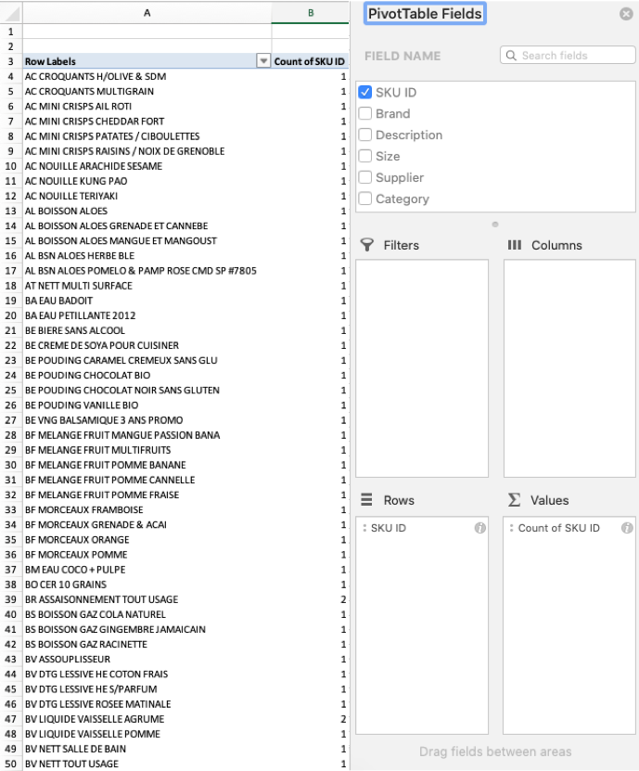

Figure 7: selecting fields on a pivot table

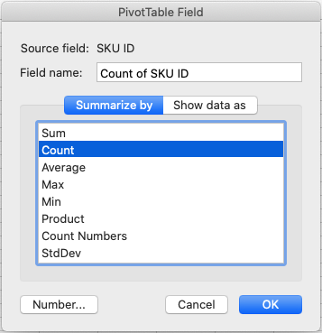

Figure 8: configuring fields on a pivot table

1. How many products?

**Answer:** 608 products.

**Solution:** There are different ways to find the answer to this question. The simplest one, is just to count the number of rows on the pivot table built to answer to Question 1. Note that each row in this table contains the name (i.e., description) of one product. Select the range A4:A611 and observe the count on the bottom right part of the screen. Video **exercise2.mov** shows the procedure.

1. How many suppliers deliver products to Avril’s DC?

**Answer:** 51 Suppliers.

**Solution:** There are different ways to find the answer to this question. The easiest one is to start from the pivot table built for Exercise 1. Right-click on the **Description** label on the **Rows** combo box and select the **Remove Field** option. Then, drag and drop the **Supplier** field into the **Rows** combo-box. The pivot table should now show the list of suppliers on Column A and the number of SKU supplied by each on Column B. To find the answer to the question, just count the number of suppliers in the table. To do this, select range A4:A54 and observe the count on the bottom right part of the screen. Video **exercise3.mov** shows the procedure.

1. What is the name of the supplier who provides the largest number of SKUs?

**Answer:** 1001 with 160 SKUs.

**Solution:** Select the range B4:A54 and sort the values on decreasing order. The supplier on the top of the list is the one supplying the largest number of SKUs to Avril. Video **exercise4.mov** shows the procedure.

1. What is the number of A, B, and C class SKUs?

**Answer:** A = 175, B = 210, and C = 272.

**Solution:** The solution to this exercise is quite similar to that shown in Exercise 3. Starting from the current pivot table, right-click on the **Supplier** label on the **Rows** combo-box and select the **Remove Field** option. Then, drag and drop the **Category** field into the **Rows** combo-box. The pivot table will be updated to show for each category (A, B, and C) the number of associated SKUs. Video **exercise5.mov** shows the procedure.

1. How many class-A SKUs are supplied by SATAU?

**Answer:** A = 25.

**Solution:** Starting from the pivot table built in Exercise 5, drag and drop the **Supplier** field into the **Rows** combo-box (place it on top of the **Class** field). The table will be updated to show for each supplier, the number of supplied A, B, and C class products. Video **exercise6.mov** shows the procedure.

**Exercises 7 to 11: Selecting a picking system**

1. What is the most common picking unit in Avril’s DC?

**Answer:** the case with 656 SKUs.

**Solution:** Starting from the pivot table built in Exercise 5, replace the **Class** field by the **Picking unit** field in the **Rows** combo-box. To achieve this goal, right-click the **Class** label on the **Rows** combo-box and select the **Delete Field** option. Then, drag and drop the **Picking unit** field into the **Rows** combo-box. The table will be updated to show the count of SKUs for each picking unit. As the results show, the most common picking unit is the case.

1. What is the average size of a case (in ft3)?

**Answer:** 0.7663ft3

**Solution:** Select range P2:P658 on the **Product** sheet and observe the average on the button right part of the screen.

1. What is the average and maximum number of orders in one month?

**Answer:** Average = 17.85 and Maximum = 21.

**Solution:** There are several ways to find the answer to this question, but most of them rely on rather advanced data handling functionalities. There is, however, a relatively easy way to dance around this limitation. In Cell M1 of the **Transfers** table, create a header called **Unique**. Set the value of Cell M2 to **TRUE**. Then, insert in Cell M3 the following formula: **=A3<>A2**. Extend the formula from Cell M3 to cell M5985. Figure 9 summarizes the procedure up to this point.

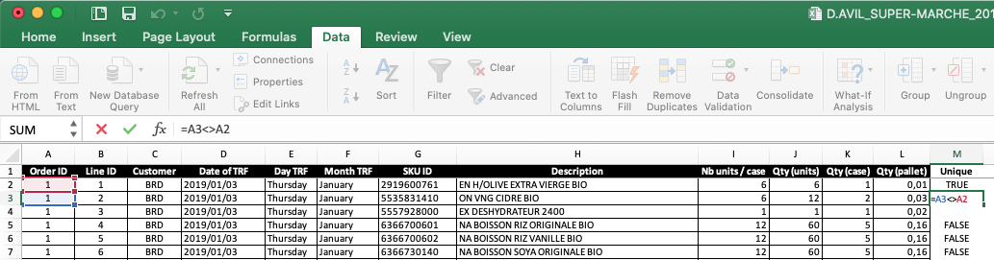

Figure 9: Finding unique order IDs. Steps 1 to 4.

Select column M, (see Fig. 10) and press the **CTRL+C** keys. Now right-click and select the **Paste Special** option. On the top menu of the popping up window, select **Values** and click on the **OK** button (see Fig. 11).

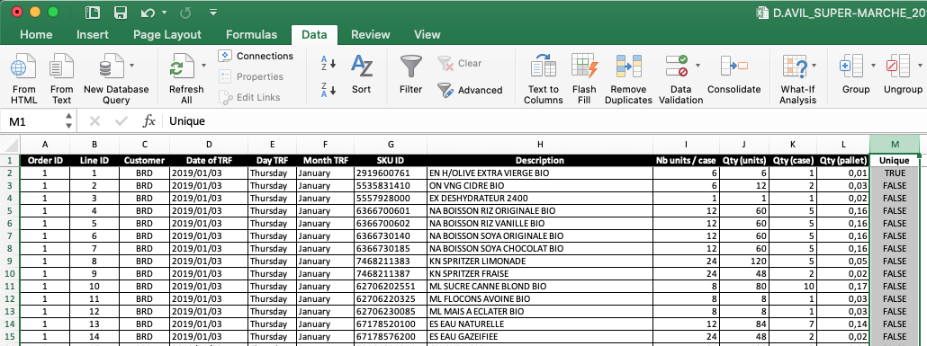

Figure 10: Finding unique order IDs. Steps 5.

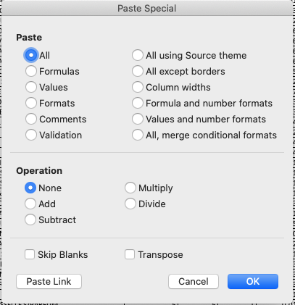

Figure 11: Paste Special window.

Now, select the range M2:A5985 and sort the range on the decreasing order of the values in Column M. Note that now, all the records with a value of **TRUE** in column M are at the top of the list. Note also that each of these records, corresponds to the first line of an order. For instance, Figure 12 shows the 20 first records, corresponding to **Order ID** 1 to 20. In other words, with this procedure we have obtain a sub-table, containing only record for the first line of each order. With this data, we can now proceed to find the answer to the question.

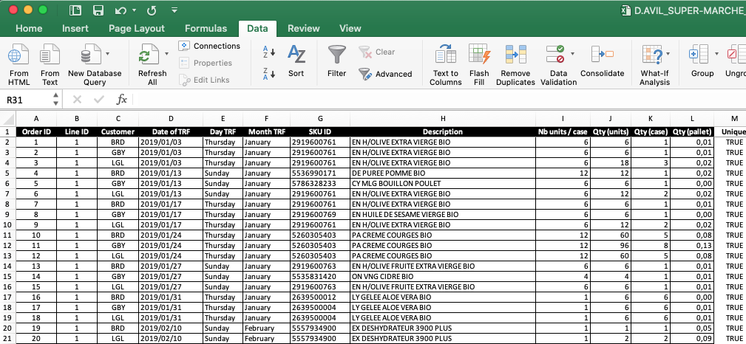

Figure 12: Finding unique order IDs. Steps 6.

Select range A2:M125 (i.e., the last record with a value of **TRUE** on Column M) on the **Transfers** sheet. Click on the **PivotTable** icon on the **Insert** menu (see Fig. 5). On the popping up menu select **New Worksheet** and click on the **OK** button (see Fig. 6). Excel will create a new worksheet. The **PivotTableFields** menu will appear on the right side of the screen. Drag and drop the **Month TRF** field into the **Rows** combo-box and the **Order ID** field into the **Values** combo-box. Right-click on the **Order ID** label in the **Values** combo-box and select the **Configure Field** option. Select **Count** and click on the **OK** button (see Fig. 8). The resulting pivot table will show the number of orders placed by the stores to the DC in each of the months (see Fig. 13). Select range B4:A10 and sort the range on decreasing order. The months on the top (May and June) are those with the maximum number of orders (21). Select the range B4:B10 and observe the metrics on the bottom right part to obtain the average number of orders (17.85). Video **exercise9.mov** shows the whole procedure.

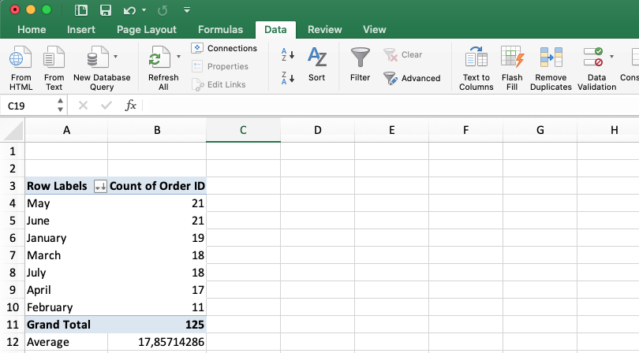

Figure 13: orders per month

1. What is the most frequently ordered SKU?

**Answer:** 306832016010 BA EAU BADOIT ordered 57 times.

**Solution:** Select range A2:L5985 on the **Transfers** sheet. Click on the **PivotTable** icon on the **Insert** menu (see Fig. 5). On the popping up menu select **New Worksheet** and click on the **OK** button (see Fig. 6). Excel will create a new worksheet. The **PivotTableFields** menu will appear on the right side of the screen. Drag and drop the **SKU ID** field into the **Rows** combo-box and the **Line ID** field into the **Values** combo-box. Right-click on the **Line ID** label in the **Values** combo-box and select the **Configure Field** option. Select **Count** and click on the **OK** button (see Fig. 8). The resulting pivot table will show for each SKU the number of times it was included in an order. Select range B4:A660 and sort the range in decreasing order. The SKU on the top of the list **306832016010** corresponds to the most frequently ordered SKU. Video **exercise10.mov** shows the procedure.

1. Based on your answers to questions 7, 8, 9, and 10, what picking system (goods-to man, man-to-goods, or automated system) would you recommend to the DC manager? Why?

**Answer:** Picker to goods.

**Solution:** The first hint comes from the size of the items picked. The most common picking unit is the case (656/657 SKUs) and the size of the boxes is relatively big (an average volume of 0.7663 ft3). The second hint comes from the number of orders that are prepared at the DC (an average of 17.85 per month with a maximum of 21). The last hint comes from the picking frequency of the most picking items. With only 57 picks during the year for the fastest moving product, we can safely assume that products in Avril’s DC do not move too fast. Following the picking system selection guidelines discussed in class (see Fig. 14), a picker-to-goods system seems to be the better fit for this situation.

|  |  |  |  |  |
| --- | --- | --- | --- | --- |
| **Criterion** | **Picker-to-goods** | **Goods-to-picker** | | **A-frame system** |
| **Carrousel** | **ASRS** |
| Order volume | Low to medium | Medium to high | Medium to high | High |
| Product type | All | Small | Small to medium | Small |
| Product velocity | Low to high | Low | Low to high | High |

Figure 14: picking system selection guidelines

**Exercise 12: Selecting a picking strategy**

1. According to the data in sheet “Transfers”, what picking strategy (cluster, batch, discrete) would you recommend to the manager?

**Answer:** Discrete Picking

**Solution:** We will answer this question following the guidelines discussed in class (see Fig. 15). To accomplish this goal, we first need to compute the number of orders made up of 1-5; 6-39; and 40+ lines. Starting from the pivot table built in Exercise 11, replace the **SKU ID** field on the **Rows** combo-box by the **Order ID** field. The resulting table shows the number of lines per order. Select range A3:B127 and copy the values pressing the **CTRL+C** (see Fig. 16). Create a new sheet. Right-click on Cell A1 and select the **Paste Special** option. On the top part of the popping up window, select **Values** and click on the **OK** button (see Fig. 11).

|  |  |  |  |  |
| --- | --- | --- | --- | --- |
|  |  | **Number of lines (products) per order** | | |
|  |  | **1-5** | **6-39** | **40+** |
| **Number of items per line** | **1-5** | Cluster  (sort-while-pick) | Batch  (pick-then-sort) | Discrete  (one order at a time) |
| **6-19** | Batch  (pick-then-sort) | Batch  (pick-then-sort) | Discrete  (one order at a time) |
| **20+** | Discrete  (one order at a time) | Discrete  (one order at a time) | Discrete  (one order at a time) |

Figure 15: picking strategy selection guidelines

Now we are going to build a frequency table, using the intervals suggested in the guidelines (columns in Figure 15). Build the template for the table as shown in Figure 17. Now, insert the following formula in Cell F3: **=FREQUENCY(B2:B125;E3:E5)**. The **frequency()** function takes as input a vector of data and the upper bounds of the frequency intervals and returns the frequency count for each interval. Note that contrary to most Excel functions, the output of the **frequency()** function is not a single value but an array of values (the frequency count for each interval). To deploy the array output, select the range F3:F5, enter the formula bar, and press **CTRL+SHIFT+ENTER** (see Fig. 18). Figure 19 shows the output.

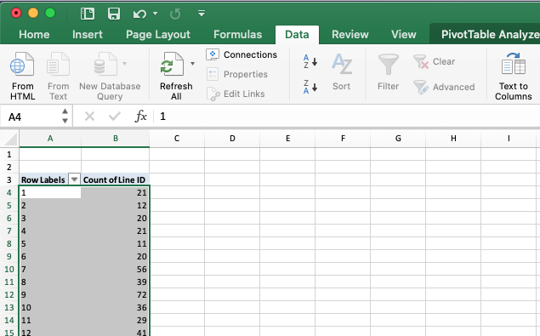

Figure 16: pivot table showing the number of lines per order

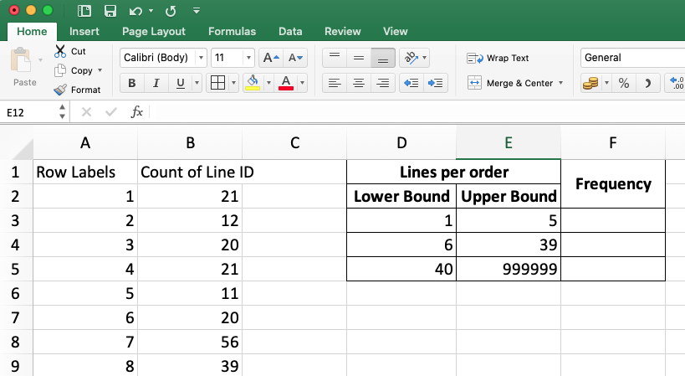

Figure 17: pivot table showing the number of lines per order

As the results in Table 19 show, most of the orders (60 out of 124) are made up of more than 40 lines. Following the guidelines in Figure 15, we select Discrete Picking as the preferred strategy (last column). Video **exercise12a.mov** shows the entire procedure. To confirm our recommendation, we can also compute number of units (cases) per line in the typical order.

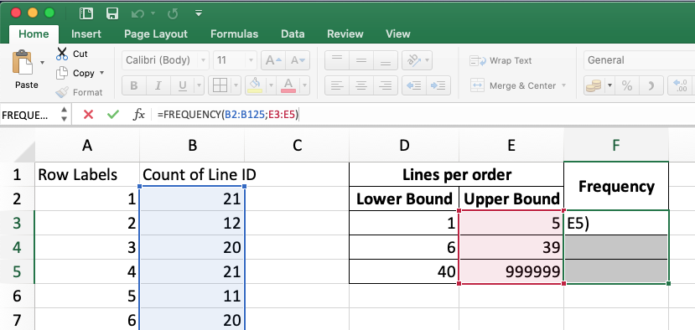

Figure 18: pivot table showing the number of lines per order

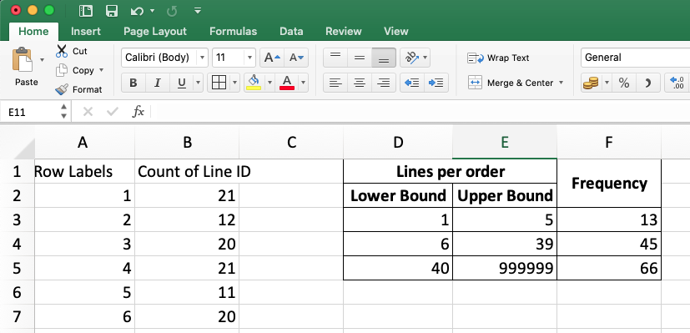

Figure 19: number of lines per order – frequency count

Starting from the pivot table built earlier in this exercise, replace the **Count of Line ID** field on the **Values** combo-box by the **Qty (case)** field. Right-click on the **Qty (case)** field on the **Values** combo-box and select the **Field Settings** option. On the top part of the popping up window, select **Average** and click on the **OK** button (see Fig.8). The resulting pivot table shows the average number of cases per line for each order. Select range A3:B127 and copy the values pressing the **CTRL+C**. Go to the sheet holding the frequency table that you created at the beginning of this exercise, right-click on Cell A1, and select the **Paste Special** option. On the top part of the popping up window, select **Values** and click on the **OK** button (see Fig. 11). Update the upper bounds of the frequency intervals in the frequency table and Excel will update the count. Figure 20 shows the resulting table. Video **exercise12b.mov** shows the entire procedure.

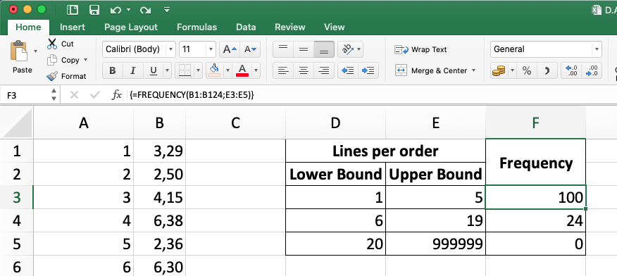

Figure 20: average number of cases per line – frequency count

**Exercises 13a to 13d: Selecting racking systems**

1. According to the data in sheet “Inventory”, what racking systems would you recommend for the following products?
   1. 67178550100 – Eska (ES EAU NATURELLE)

**Answer:** Double Deep

**Solution:** We will answer the question based on the racking system selection guidelines discussed in class and presented in Figure 20. We will first compute the frequency (i.e., number of months) at which the inventory (for this product) laid within the bounds of each of the intervals defined in the guidelines. Select and copy range AG2:AS2 in the **Inventory** sheet. Now, create a new worksheet and right-click on range A2. Select the **Paste Special** option. Select the **Values** and **Transpose** options in the top and bottom parts of the popping up window (see Fig. 11). Click on the **OK** button. Now return to the Inventory sheet and look for the row holding the information for product 67178550100 – Eska (ES EAU NATURELLE). An easy way to accomplish this task is to set a filter on the rows. Select the **Data** toolbar and click on the **Filter** icon (see Fig. 22 – Step 1). Click on the down arrow in Cell A1 (see Fig. 22 – Step 2). Use the search bar in the pop up menu to write the **SKU ID** of the product (i.e., 6717855010). Excel will filter out all the rows for which the value of **Column A** is not equal to the **SKU ID**. Select and copy range AG3:AS3. In the worksheet where you previously pasted the months, right-click on Cell B2 and select the **Paste Special** option. Select the **Values** and **Transpose** options in the top and bottom parts of the popping up window (see Fig. 11) and click on the **OK** button. The resulting table shows the number of pallets of the product held in inventory the first day of the month. Following the same procedure used to answer Question 12, build a frequency table using this time the intervals defined by the guidelines in Figure 21. Figure 23 shows the result. Video **exercise13.mov** shows the procedure.

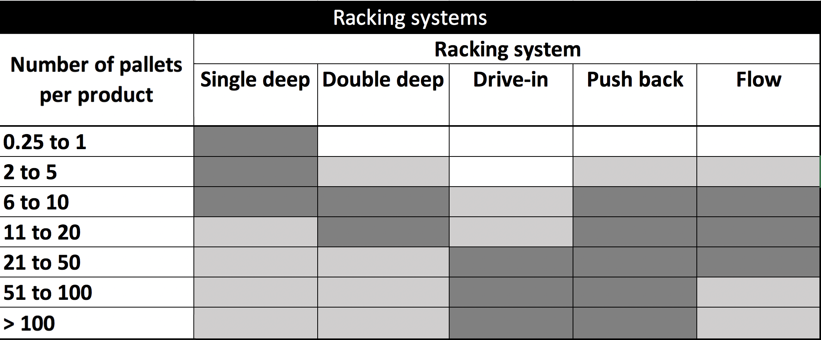

Figure 21: pallet racking selection guidelines.

Dark-grey indicates preferred options, light-grey indicates

possible options, and white boxes indicate misadvised options

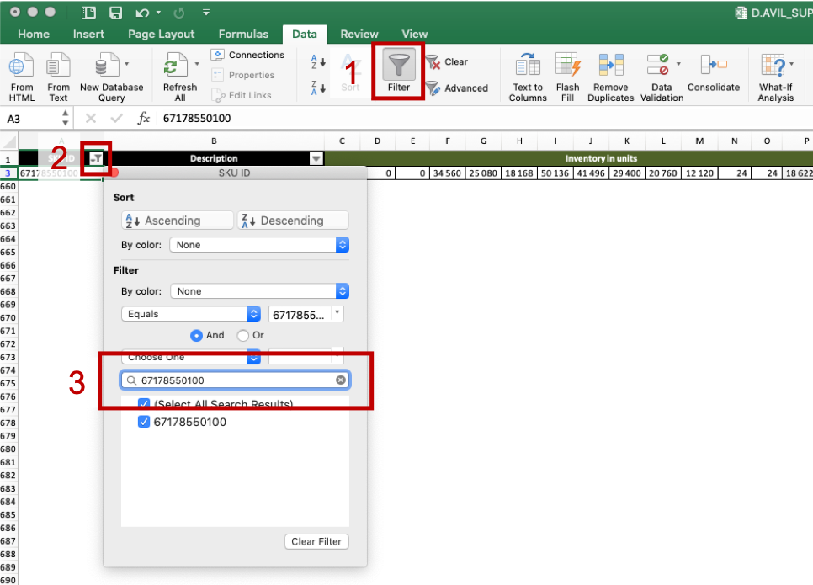

Figure 22: setting up filters in MS Excel.

As the frequency table shows, during most of the months (5 out of 12) the number of pallets in inventory laid between 11 and 20. A quick look at the value in Cell B14 in Figure 23, reveals that the average number of stored pallets, also falls within this interval. Following the guidelines, the candidate racking systems are then Double Deep, Push Back, and Pallet Flow. The typical number of pallets is close to the lower bound of the interval. Therefore, the higher density of the Pushback over the Double Deep is not needed. The former is also more expensive. Based on these two observations, we can safely eliminate the Pushback option. The product is perishable but usually has long expiration days (going from semesters to years). The FIFO property provided by the Pallet Flow system is therefore not needed. The latter is also more expensive than the Double Deep rack. Based on these two observations, we can also discard this option.

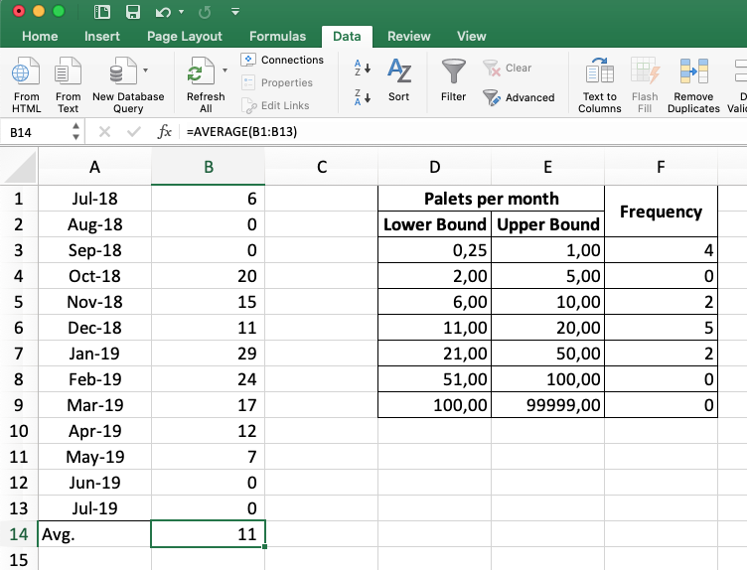

Figure 23: frequency count for the number of pallets in stock

The procedure to answer to questions 13b to 13d is exactly the same. These exercises are therefore leaved as an assignment for the reader.

* 1. 6366751100 – Boisson Soya non sucrée
  2. 3619212784 – Limonade à la mangue
  3. 62123490560 – Cubes bouillon de Poulet

1. Taken from: <https://www.avril.ca/en/about-us/>. Last access: September 28, 2019.
2. This may change depending on the MS Excel version or operating system platform. The menu should, however, have a similar look in every version.