
REPUBLIC OF THE PHILIPPINES DEPARTMENT OF LABOR AND EMPLOYMENT
Regional Office No. CAR PUBLIC EMPLOYMENT SERVICE OFFICE

SPES Form 2


City/Municipality/Province
SPECIAL PROGRAM FOR EMPLOYMENT OF STUDENTS
(RA 7323, as amended by RAs 9547 and 10917)
APPLICATION FORM Control No.:

SURNAME FIRST NAME MIDDLE NAME |  |  |  |  | GSIS BENEFICIARY/RELATIONSHIP |  |  |  |  |  |  |  | Passport Size Picture (3.5cm x 4.5 cm)
DATE OF BIRTH: (mm/dd/yyyy) |  | PLACE OF BIRTH: |  |  |  |  |  |  |  | CITIZENSHIP:
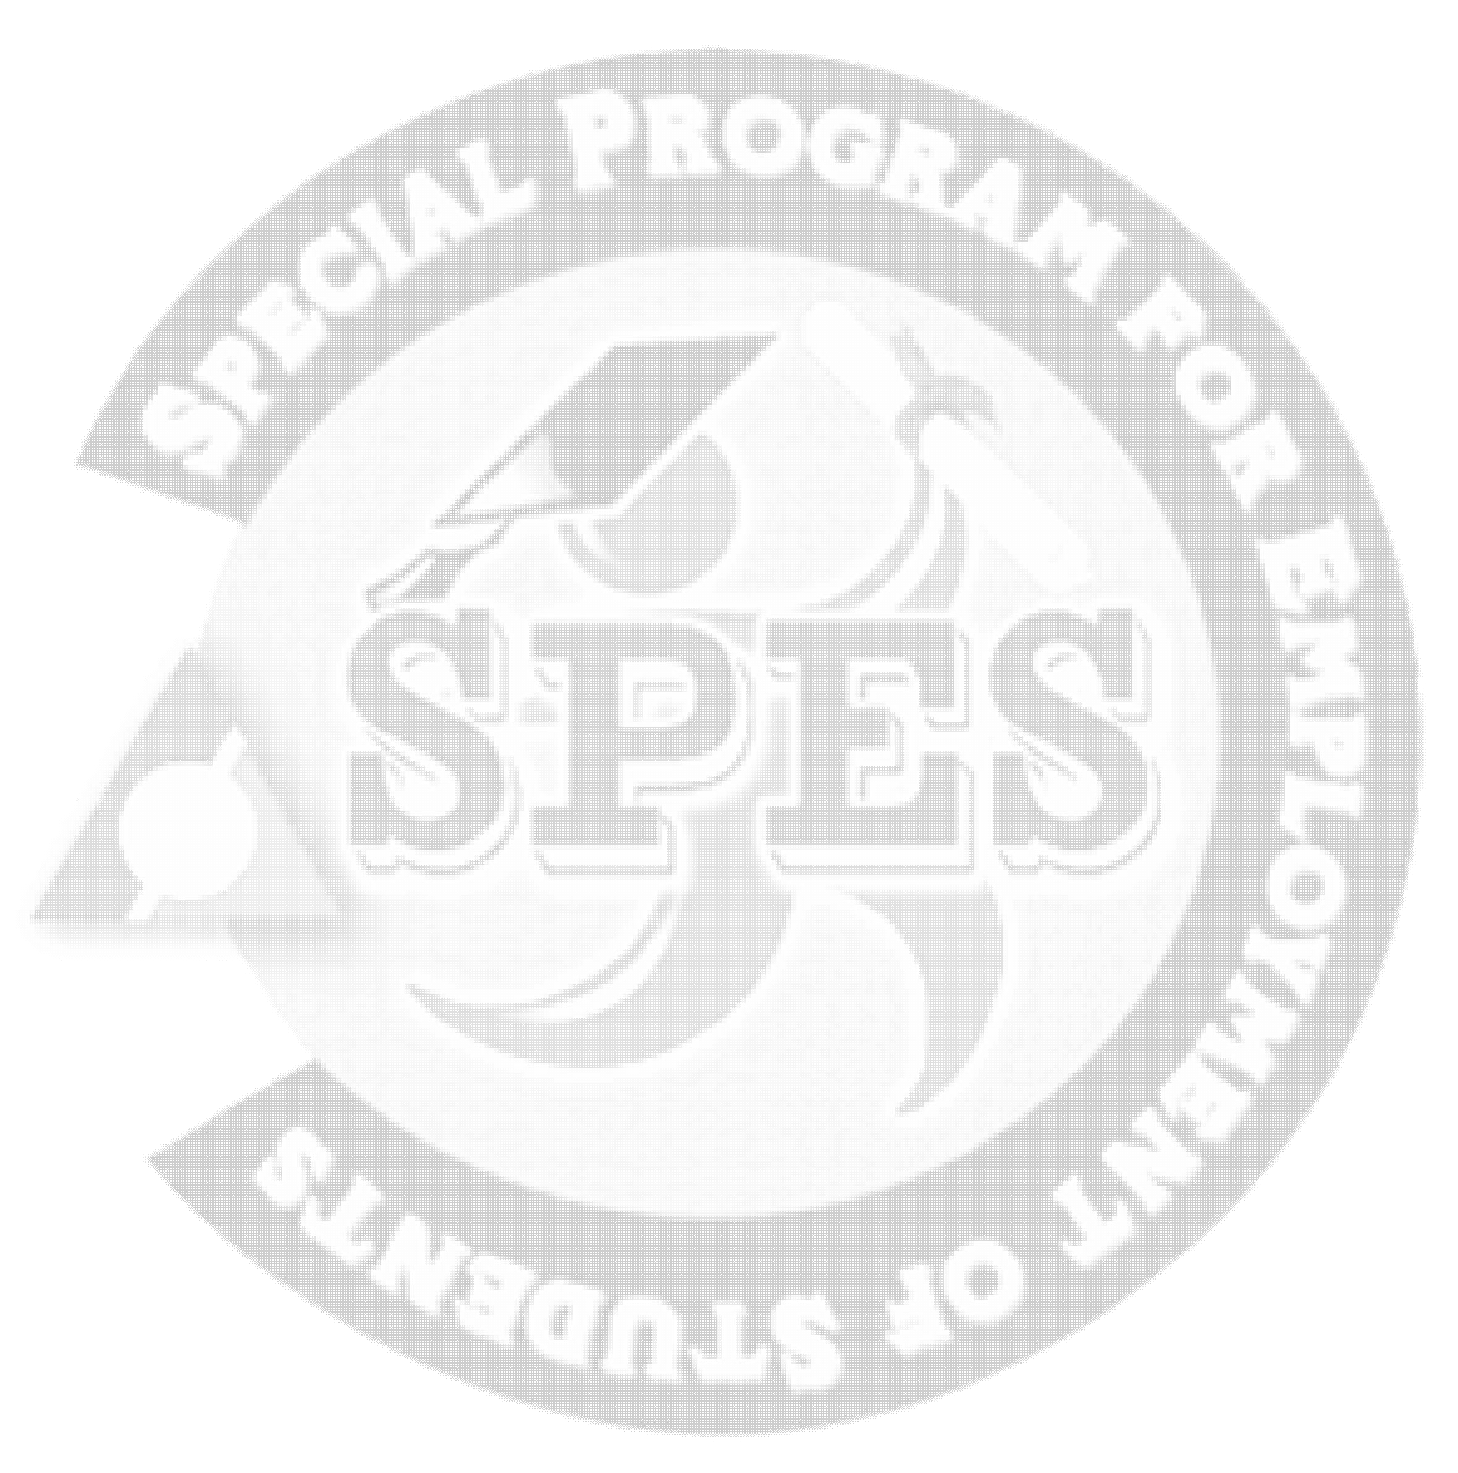  CONTACT DETAILS/CELPHONE NO.: |  |  | EMAIL ADDRESS:
SOCIAL MEDIA ACCOUNT (FACEBOOK, TWITTER, INSTAGRAM, ETC.)
STATUS   Single  Married  Widow/er  Separated |  |  |  | SEX   Male  Female |  |  |  | ❑ Student  ALS student   out-of-school (OSY)
CURRENT STATUS OF PARENTS:  Living together  Solo Parent  Separated  Person With Disability  Senior Citizen
❑ Sugar Plantation Worker  Indigenous People  Displaced Worker (1)  Local (2)  OFW
PRESENT ADDRESS:
PERMANENT ADDRESS:
FATHER’S NAME /CONTACT NO.: |  |  |  |  |  |  | MOTHER’S MAIDEN NAME/CONTACT NO.:
OCCUPATION: |  |  |  |  |  |  | OCCUPATION:
EDUCATION | NAME OF SCHOOL |  |  |  |  | DEGREE EARNED/COURSE |  |  |  |  | YEAR/LEVEL |  |  | DATE OF ATTENDANCE
Elementary
Secondary
Tertiary
Tech-Voc
DOCUMENTARY REQUIREMENTS:
(Original and other documents, when applicable, should be presented for validation)
[ ] 1) Photocopy of Birth Certificate or any official document indicating date of birth or age (age must be 15-30)
[ ] 2) Photocopy of the latest Income Tax Return (ITR) of parents/legal guardian OR certification issued by BIR that the Parents/guardians are exempted from payment of tax OR original Certificate of Indigence OR original Certificate of Low Income issued by the Barangay or DSWD/CSWD where the applicant resides; and
[ ] 3) For students, any of the following, in addition to requirements no. 1 and 2:
[ ] a) Photocopy of proof of average passing grade such as (1) class card or (2) Form 138 of the previous semester or year immediately preceding the application; OR
[ ] b) Original copy of Certification by the School Registrar as to passing grade immediately preceding semester/year if grades are not yet available
[ ] 4) For Out of School Youth (OSY), original copy of Certification as OSY issued by DSWD/CSWD or the authorized Barangay Official where the OSY resides, in addition to requirements no. 1 and 2.
SPECIAL SKILLS:
HISTORY of SPES Availment/ Name of Establishment |  |  |  |  |  |  |  |  | YEAR |  |  | SPES ID NO. (if applicable)
[ ] 1stAvailment
[ ] 2ndAvailment
[ ] 3rdAvailment
[ ] 4thAvailment
Other related information/ requests/ interventions from DOLE:
I hereby attest that the information above are true and correct to the best of my knowledge, including the attached documents / requirements which I also attest as to their veracity. I agree that any false statement would cause the automatic disqualification/ cancellation of the service/ contract/ grant and I shall refund amount received and/or pay damages to DOLE or comply with other sanctions in accordance with law. Any material change in my financial status may affect my eligibility to continue the program.

Signature of Applicant
BLE Revision as of December 2016

