

REPUBLIC OF THE PHILIPPINES
Department of Labor and Employment

REGIONAL OFFICE NO. CAR
Public Employment Service Office
SPES Form 4

SPECIAL PROGRAM FOR EMPLOYMENT OF STUDENTS

(RA 7323, as amended by RAs 9547 and 10917)

EMPLOYMENT CONTRACT
This Employment Contract is executed and entered into by and between:

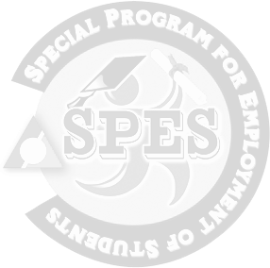
Name of Employer: Address:

and
Name of SPES Beneficiary : Date of Birth: Age: Civil Status: Address:

who voluntarily bind themselves to the following terms and conditions:

- That the Employer, in accordance with RA 10917 amending RA 9547 and 7323, hereby hires and employs the SPES beneficiary as for a period of days starting on until ;

- That the Employer shall pay the SPES beneficiary in cash the equivalent of 60% of the existing minimum wage in the area or sector or the approved % of the applicable hiring rate;

- That the employer shall observe its obligations, duties and responsibilities to the student as stipulated in the Implementing Rules and Regulations of RA 10917 amending RA 9547 and 7323; and

- That the SPES beneficiary, in consideration of the above conditions of employment, hereby binds him/her to perform the tasks/duties assigned to him/her and strictly adhere and observe the rules and regulations and/or company policies prescribed by the Employer.

IN WITNESS WHEREOF, the parties, having read the provisions of this contract, hereby affix their signatures this day of at , Philippines.

SPES Beneficiary Employer/Authorized Representative
(Signature over Printed Name) (Signature over Printed Name)

Consented:

Parent/Guardian
(Signature over Printed Name)

Witness/PESO Witness/DOLE FO/PO
(Signature over Printed Name) (Signature over Printed Name)

