SPES Form 2-A
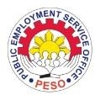
REPUBLIC OF THE PHILIPPINES

Department of Labor and Employment
REGIONAL OFFICE NO. CAR
Public Employment Service Office

SPECIAL PROGRAM FOR EMPLOYMENT OF STUDENTS
(RA 7323, as amended by RAs 9547 and 10917)

OATH OF UNDERTAKING

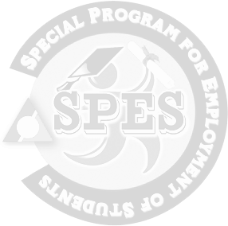
I, , years of age, resident of
, as a SPES beneficiary, do hereby agree and undertake to abide and be bound by the following conditions:
- That I will enroll in any educational or technical vocational (tech-voc) institution to pursue and continue my studies;
- That in the event that I would not be able to enroll, I will inform the DOLE Regional Office, through the Field or Provincial Office concerned, and submit a letter narrating and explaining the reason/s for not being able to enroll;

- That anytime, during and after my employment period, I vow to respect the implementers of SPES, and will not use any profane or disrespectful language/s to any PESO or DOLE staff and/or personnel relative to the program as beneficiary; and

- That any deviation of my oath and any fraud or dishonesty in any or all of my declaration in my application shall be a ground for my disqualification in the future availment of SPES.

Signed this day of , 20 , in the City/Municipality of .

SPES Beneficiary

Witnessed by: Noted by:

PESO Manager/staff (DOLE-FO staff name and position)

Date Date

