Interactive Digital Cultural Map and Local Tourism Information System for Mangatarem, Pangasinan

A Capstone Project Presented to the Faculty of the
Information Technology Department
Binalatongan Community College
San Carlos City, Pangasinan

In Partial Fulfillment of the Requirements
for the Degree of Bachelor of Science in
Information Technology

Submitted by:

Austria, Jem Carlo G.
Dalas, Mary Jane F.
De Guzman, Joy R.
Solis, Rea D.

May 2026

APPROVAL SHEET
This capstone project entitled “Interactive Digital Cultural Map and Local Tourism Information System for Mangatarem, Pangasinan”, prepared and submitted by Jem Carlo G. Austria, Mary Jane F. Dalas, Joy R. De Guzmna, and Rea D. Solis in partial fulfillment of the requirements for the degree BACHELOR OF SCIENCE IN INFORMATION TECHNOLOGY, has been examined and is recommended for acceptance and approval.
_______________________________
MR. CHRISTOPH P. CATUNGAL, MIT
Adviser

PANEL OF EXAMINERS

____________________________
MR. BRIXON J. DE VERA, MIT
Chairperson

_______________________________ ____________________________
MS. SHIELA MARIE B. ASOR, MIT Mr. REALTON JOHN KENNEDY
Member B. MANANGAN
Member

ACCEPTED and APPROVED in partial fulfillment of the requirements for the degree BACHELOR OF SCIENCE IN INFORMATION TECHNOLOGY on May 2026 with a grade of _______.
_________________________________ ____________________________
MR. BRIXON J. DE VERA, MIT DR. MACRINA B. CAJALA Dean, Information Technology Department College President

Abstract

Jem Carlo G. Austria, Mary Jane F. Dalas, Joy R. De Guzman, Rea D. Solis, “Interactive Digital Cultural Map and Local Tourism Information System for Mangatarem, Pangasinan,” Bachelor of Science in Information Technology, College of Information Technology, Binalatongan Community College, San Carlos City, Pangasinan, Philippines, May 2026.

Adviser: Mr. Christoph P. Catungal, MIT

The Local Government Unit (LGU) of Mangatarem, Pangasinan, currently faces challenges with manual, fragmented record-keeping for tourism and cultural assets, which hinders public accessibility and operational efficiency. To address these issues, this study developed an Interactive Digital Cultural Map and Local Tourism Information System designed to centralize data management through a web-based, cloud-native architecture. Employing the Rapid Application Development (RAD) methodology and a Participatory GIS framework, the researchers created a secure, multi-tier platform that integrates an administrative moderation workflow with an interactive, public-facing heritage map. Post-implementation testing yielded a 100% success rate in functional and security performance, alongside high usability and user acceptance ratings. Consequently, this digital solution effectively modernizes heritage preservation and provides a scalable, accessible resource for local stakeholders, tourists, and academic researchers. By digitizing cultural narratives and tourism data, this project sets a foundational model for other municipalities in Pangasinan to pursue digital transformation in their heritage management strategies. The researchers ultimately conclude that this system serves as a bridge between the municipality’s historical identity and the digital future, ensuring that
Mangatarem’s rich heritage is both preserved and accessible to a global audience.

Acknowledgement

The researchers express their profound gratitude to the Local Government Unit of Mangatarem, Pangasinan, for their invaluable trust and collaborative support throughout the realization of this capstone project. We extend our sincere appreciation to our project advisor and the faculty of Binalatongan Community College for their constant guidance, technical critiques, and encouragement, which were vital in refining the system’s architecture. Special thanks are reserved for the barangay representatives and local stakeholders whose active participation and candid feedback were instrumental in ensuring the platform effectively meets the community's needs. Finally, we are deeply grateful to our families, friends, and peers for their unwavering patience, moral support, and motivation, which sustained us through the challenges of this endeavor. We also acknowledge the invaluable contributions of the various tourism sites and archives that provided the raw data necessary for populating our cultural database. Above all, we offer this work as a testament to our dedication to the field of Information Technology and our commitment to serving the community through innovative software solutions.

Table of Contents

Title Page ………………………………………………………………... ……….... |  | i
Approval Form ………………………………………………………………………. |  | ii
Abstract ………………………………………………………………………………… |  | iii
Acknowledgment …………………………………………………………………… |  | iv
Table of Contents ………………………………………………………………….. |  | v
List of Tables ……………..…………………………………………..……………. |  | vii
List of Figures ………………………………………………………..……………... |  | vii
Chapter
1 | INTRODUCTION …………………………………..……......... | 2
 | Background of the Study ……………………………………….. | 2
 | Purpose and Description ……………………………………….. | 4
 | Objectives of the Study ……………………………………...….. | 5
 | Conceptual Framework (IPO) ……………………………..….. | 6
 | Scope and Limitations …………………………………………… | 8
 | Definition of Terms …………….……………………………..….. | 9
 | Review of Related Literature.……………………………..…… | 10
2 | METHODOLOGY AND DESIGN .…………………………. | 15
 | Software Development Methodology ……………………… | 15
 | Sources of Data …………………………………………………… | 18
 | Data Gathering Techniques…………………………………….. | 19
 | System Design ..…………………………………………….......... | 21
 | System Architecture ……………………………………. | 21
 | Dataflow Diagram ………………………………………. | 26
 | Entity-Relationship Diagram ………………………… | 29
 | Implementation Diagram …………………………….. | 32
3 | RESULTS AND DISCUSSION……………………………….. | 36
 | System Process Flowchart.………………………………………. | 37
 | System Features and User Interfaces ………………………. | 39
 | System Testing and Evaluation …………………....…………. | 47
 | Implementation Results .…………………………………......... | 50
 | Analysis of Reults ………...……………………………….......... | 52
 | Discussion of Findings ……. ………………..…………………… | 58
4 | RECOMMENDATIONS.…………………………………………. | 62
References ………………………………………………………………………….. |  | 65
Appendices ………………………….……………………….…………………….. |  | 67
A | Endorsement Letter ………………………………………………… | 67
B | System Source Codes ………………………..…….…………….. | 68
C | Database Schema (Actual Database Structure) ….……… | 94
D | Survey/Evaluation Forms Used During Testing ………….. | 105
E | Collected Sample Documents for Document Analysis/Data Gathering…..………………………………………. | 109
Curriculum Vitae …………………………………………………………………. |  | 113

List of Tables

Table | Title | Page
3.1 | Functional Testing | 53
3.2 | Performance testing | 54
3.3 | Security testing | 55
3.4 | Usability testing | 56
3.5 | User acceptance testing | 58

List of Figures

Figure | Title | Page
1.1 | IPO | 7
2.1 | RAD | 16
2.2 | System Design | 22
2.3 | Existing Flowchart | 25
2.4 | Data Flow Diagram | 28
2.5 | Entity Relationship Diagram | 29
3.1 | Proposed System Flowchart | 37
3.2 | User Dashboard | 39
3.3 | User Profile | 40
3.4 | Admin Dashboard | 41
3.5 Admin Attraction Management 42
3.6 Admin Booking Management 43
3.7 Admin Establishment Management 44
3.8 Admin Event Management 45
3.9 Admin Verify Merchant 46
3.10 Admin Visitor Registry 47

Chapter I
INTRODUCTION

Background of the Study
Tourism is widely recognized as a vital driver of economic development, cultural preservation, and community empowerment. It provides opportunities for local communities to showcase their unique heritage, traditions, and natural attractions while generating income and employment. In the Philippines, tourism plays a significant role in promoting local identity and sustaining cultural resources, particularly in municipalities with rich historical and environmental assets. However, the effectiveness of tourism promotion largely depends on the accessibility, accuracy, and organization of information available to potential visitors.
Mangatarem, a municipality in Pangasinan, is known for its diverse cultural heritage, scenic landscapes, and locally celebrated traditions. It is home to various natural attractions, religious sites, and community-based cultural practices that reflect the identity and history of its people. Despite these valuable resources, tourism development in Mangatarem remains limited due to the lack of centralized, accessible, and technology-driven platforms that can effectively present tourism-related information to a wider audience. Traditionally, information dissemination in local tourism relies on printed materials, word-of-mouth communication, and basic social media postings. While these methods provide some level of awareness, they are often insufficient in delivering comprehensive, real-time, and user-friendly information. Visitors may encounter difficulties in locating tourist destinations, understanding cultural significance, accessing directions, or identifying available services within the municipality. This gap highlights the need for an innovative solution that integrates technology with tourism promotion. With the rapid advancement of digital technologies, interactive systems such as digital maps and information platforms have become essential tools in enhancing user experience and improving accessibility to information. Interactive digital maps allow users to visualize locations, explore destinations virtually, and access detailed descriptions, images, and directions in a single platform.
Furthermore, integrating local tourism information into a centralized system can significantly improve the efficiency of information dissemination, support local tourism management, and encourage increased visitor engagement. In this context, the development of an Interactive Digital Cultural Map and Local Tourism Information System for Mangatarem, Pangasinan is deemed necessary. This system aims to provide a comprehensive, user-friendly, and accessible platform that showcases the municipality’s cultural and tourism assets. It seeks to bridge the gap between available tourism resources and public awareness by utilizing modern digital tools to organize, present, and promote local attractions effectively.
Moreover, the proposed system is expected to benefit not only tourists but also local government units, stakeholders, and residents by supporting tourism planning, improving visibility of local destinations, and preserving cultural heritage through digital documentation. By leveraging technology, the municipality can enhance its tourism potential and contribute to sustainable development.
Therefore, this study focuses on the design and development of an interactive digital platform that will serve as a reliable source of tourism information and a strategic tool for promoting the cultural identity of Mangatarem. Through this initiative, it is anticipated that the municipality will experience improved tourism engagement, increased visitor satisfaction, and strengthened community participation in preserving and promoting local heritage.

Purpose and Description
The Mangatarem Capstone Project was developed to centralize and digitize tourism and culture-related information from Mangatarem, Pangasinan. The Interactive Digital Cultural Map and Local Tourism Information System (CIM) will serve as an interactive and accessible means of managing data while safeguarding the history of the community in a secure manner and an organized format.
After being put into production and the LGU of Mangatarem has fully implemented it, the CIM system will be especially useful primarily to:
- Administrative & Stakeholder Users (MGU's Tourism Office & Barangay Representatives) - These comprise the primary beneficiaries due to the use of the Computer Integrated Manufacturing (CIM) system as a centralized and coordinated platform for promoting tourism and managing the submissions of culture-related data from each of the 83 barangays. Tourism Office employees will be able to authenticate and moderate their town's submissions from each barangay and provide accurate information.
- General Public & Academic Users (Tourists, Visitors, & Researchers) - Tourists will enjoy access to the mobile-friendly map and interact with it to fill in their trip planning and sight-seeing needs, while students and researchers will gain access to a structured way of accessing the digital archives of cultural profiles and historical records. The outcome of this will be the elimination of the need for people to physically go to the tourist information office to obtain basic data and increase the amount of available heritage data to support academic work.
The inability to convey messages and acquire information using text messages and through printed forms has resulted in a lack of efficiency and the generation of inaccuracies within the content collected via the text messaging and paper forms using the Internet Protocols. A centralized digital platform allows the LGU to have a definitive source of truth for all content related to tourism and culture. By utilizing this computing solution, the LGU will improve its ability to bridge any gaps in communication, will reduce any manual inefficiencies, and will provide a modern and effective means through which to manage Mangatarem's resources in relation to tourism and culture.
Objectives of the Study
The study's overall goal is to create an Interactive Digital Cultural Map & Local Tourism Information System ("System") for the Local Government Unit ("LGU") of Mangatarem, Pangasinan. The purpose of the system will be to provide the LGU with an efficient and effective means of managing cultural heritage and tourism information, thereby reducing reliance on traditional paper-based methods to collect and distribute this information to stakeholders.
More specifically, the study will:
- Identify existing methods of collecting and distributing tourism and cultural information in Mangatarem, to determine what is inefficient and how the process may be improved.
- Identify functional needs based on the distinct categories of users that will be utilizing this system, to include:
- Administration and Stakeholders (LGU staff and authorized contributors)
- Public and Academics (users – visitors and researchers)
- Business Owners (owners or representatives of local tourism-related establishments)
- Test the quality of the system to ensure compliance with user requirements and professional standards. Areas to be tested include functional performance, security, usability, and user acceptance.
- Develop an implementation plan for the deployment of the system to facilitate the adoption and ongoing use of the system by the LGU.

Conceptual Framework
The study uses the Input-Process-Output (IPO) model as a formal model for understanding system development. The inputs will consist of the technical tools, knowledge, and required resources to launch the project. These inputs will be changed by the iterative activities of design, coding, and testing into a final output, which will be the finished Interactive Digital Cultural Map and Local Tourism Information System and will be used by the Local Government Unit (LGU) of Mangatarem and the stakeholders who have an interest in it. The model incorporates a feedback loop to provide a mechanism for addressing any issues identified in the testing phase, thus allowing for the ongoing improvement andrefinement of system quality.

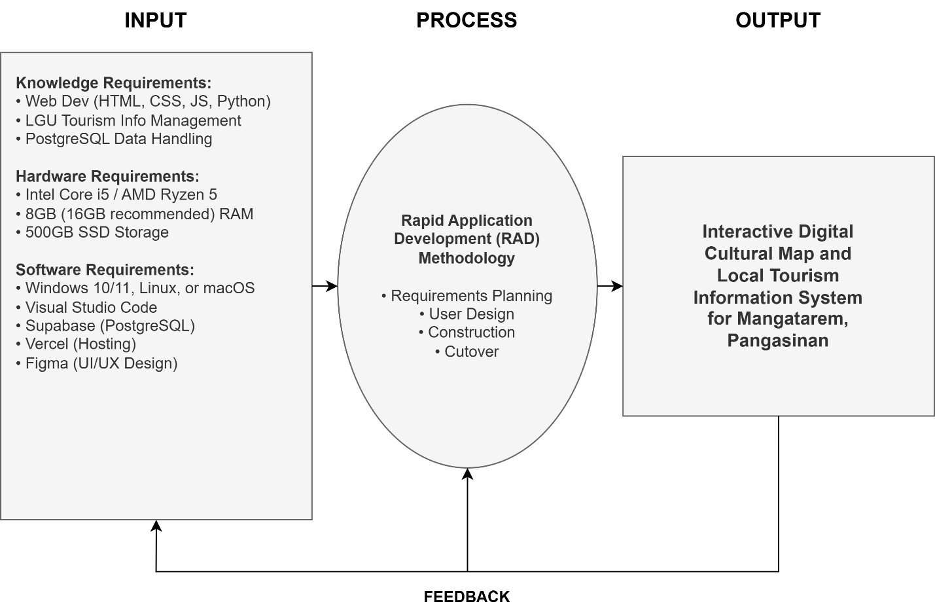
Figure 1: Input-Process-Output (IPO) Model of the Study

Figure 1 shows the workflow of the project. The inputs of this study include the technical resources and knowledge needed to develop a system. The use of these inputs occurs throughout the iterative process as the system builds both incrementally and through the testing of each to create one final product the Interactive Digital Cultural Map and Local Tourism Information System that will operate as intended for the Local Government Unit (LGU) of Mangatarem and its stakeholder group. Continuous feedback is integrated during the process to assist with identifying and resolving challenges experienced during testing; consequently, providing an avenue for ongoing refinement in terms of quality.

Scope and Limitations

Scope
This project aims to create a web-based Interactive Digital Cultural Map and Local Tourism Information System for the Local Government Unit (LGU) of Mangatarem, Pangasinan. The frontend utilizes HTML, Tailwind CSS, and JavaScript with the Mapbox GL JS library for dynamic geospatial rendering and interactive map marker clustering, while the server-side application logic runs on Python and the Flask Framework. The architecture employs a cloud-native database structure via a Supabase PostgreSQL database for secure real-time persistence, accelerated by an Upstash Redis caching layer to handle high-frequency spatial queries and ensure rapid map loading speeds. The development team prototyped the interface designs using Figma to support optimal user experience layout adjustments.

Limitations
While the system provides a comprehensive platform for municipal tourism management, it operates under several key institutional and technical limitations. First, the platform completely excludes online financial payment gateways. Although the database architecture includes dedicated structures to log local reservations, track room availability, and organize event calendars, the system does not process digital transactions, credit card routing, or third-party e-wallet services. Users must settle all monetary transactions manually on-site at the respective establishments.

Additionally, the software relies entirely on active network connectivity for all its core features. Because the system is built on a cloud-native architecture that requires real-time data synchronization with Supabase and Mapbox GL JS, it does not support offline options or cached map-tile storage. Users must maintain a stable internet connection on their mobile or desktop devices to access any of the mapping coordinates, profiles, or moderation pipelines.

Furthermore, the platform enforces strict administrative content governance restrictions. The general public cannot directly plot data markers, submit text narratives, or alter live mapping information. Only authenticated LGU personnel and registered Barangay Representatives hold the system privileges necessary to author, review, and publish heritage items, ensuring an authoritative fact-checking process before data reaches the public map interface.

Definition of Terms
For clarity and consistency, the following key terms are defined operationally as they are used in this study:
Administrative and Stakeholder Users. This consolidated category refers to the LGU Tourism Office staff (System Administrators) and authorized Barangay Representatives (Contributors) who hold internal access to the system. This category is responsible for submitting, reviewing, and approving cultural heritage data, managing the platform's operational integrity, and overseeing the municipality's digital tourism presence.
General Public and Academic Users. This category refers to tourists, visitors, students, and researchers who access the system to navigate the interactive map, search for points of interest, and view published cultural and tourism information. These users consume the data for leisure, travel planning, or academic data gathering without requiring administrative privileges.
Interactive Digital Cultural Map. The core feature of the system is that it provides a visual, geographical, and navigable representation of tourist spots, historical landmarks, natural attractions, and cultural heritage sites within the municipality of Mangatarem, Pangasinan. Users can interact with the map by clicking pins, filtering categories, and viewing detailed multimedia information for each location.
Local Government Unit (LGU). In this study, this refers specifically to the municipal government of Mangatarem, Pangasinan, serving as the main beneficiary, authoritative body, and decision-maker over the tourism information system and its content governance policies.
Public User. Refers to tourists, visitors, or any general member of the public who accesses the system to navigate the interactive map, search for points of interest, and view published cultural and tourism information without requiring a registered account or administrative privileges.
Rapid Application Development (RAD). The software development methodology selected for this study, characterized by rapid prototyping, iterative feedback cycles, flexible requirements gathering, and continuous stakeholder involvement to accelerate system construction while maintaining alignment with user needs.
Content Moderation. The process by which the System Administrator reviews content submissions from Barangay Representatives and decides whether to approve, reject, or request revisions before the content is published on the public-facing interactive map.

Review of Related Literature
The preservation and promotion of cultural heritage have increasingly benefited from digital technologies, particularly through Geographic Information Systems (GIS), cultural mapping, and web-based tourism platforms. These technologies enable communities to document, manage, and promote cultural assets while improving accessibility for tourists and local stakeholders.
A study by Cascón-Katchadourian et al. (2018) highlighted the importance of georeferencing and geolocation technologies in managing historical cartographic and photographic documents. The researchers found that spatially referencing cultural resources improves documentation accuracy, accessibility, and preservation efforts. Their findings demonstrate how location-based technologies can effectively organize cultural information within digital platforms.
Similarly, Chang and Caneday (2011) examined the role of web-based GIS in tourism information searches. The study revealed that tourists prefer interactive mapping systems because they provide accurate location information, support travel planning, and enhance decision-making. The researchers concluded that GIS-based tourism systems significantly improve user experience and destination accessibility.
Moneta, Hodgson, and Fearon (2025) explored how digital technologies can reinterpret intangible cultural heritage through immersive experiences. Their study found that integrating digital platforms with cultural heritage initiatives strengthens public engagement, promotes cultural awareness, and encourages community participation. The findings suggest that digital cultural mapping can serve as an effective tool for preserving and promoting local traditions.
A local study by Coro II et al. (2022) discussed the role of social innovation in rural communities in the Philippines. The researchers emphasized the importance of community participation in preserving local identity and cultural resources. Their findings indicate that technology-driven initiatives become more sustainable when local communities actively contribute to cultural documentation and development efforts.
Likewise, de Claro et al. (2024) emphasized the significance of local government involvement in implementing community-based programs. The study highlighted that collaboration between local authorities and stakeholders enhances program effectiveness and sustainability. This supports the need for local government participation in managing cultural and tourism information systems.
Mesana, Ricaforte, and de Guzman (2025) investigated the management of cultural festivals led by foundations and local government units. The study revealed that cultural events contribute significantly to preserving heritage and promoting tourism but face challenges in documentation, coordination, and resource management. The researchers recommended utilizing digital systems to improve cultural event management and information dissemination.
Sang, Piovan, and Fontana (2021) developed a WebGIS platform that visualized historical activities through geotagged photographs. The study demonstrated that integrating maps with multimedia content improves cultural storytelling and enhances users' understanding of historical sites. Their findings support the development of interactive digital cultural maps that combine geographic and cultural information.
Ansari et al. (2024) examined the challenges of preserving cultural heritage and religious traditions in Indonesia. The study found that modernization and globalization pose threats to cultural preservation. The researchers emphasized the need for digital documentation systems to safeguard cultural knowledge and ensure its transmission to future generations.
Petrovic (2022) discussed long-term maintenance and data validation protocols in heritage preservation projects. The study highlighted that continuous system updates, accurate data management, and regular validation procedures are essential for maintaining reliable heritage databases. These findings underscore the importance of sustainability and data integrity in digital cultural mapping systems.
According to Soncuya (2020), cultural mapping serves as a valuable tool for identifying, documenting, and preserving tangible and intangible cultural resources. The National Commission for Culture and the Arts (NCCA) emphasized that cultural mapping strengthens local identity and provides communities with a comprehensive record of their heritage assets. This supports the integration of cultural mapping practices into digital tourism information systems.
Tan (2023) developed a web-based tourism recommendation system using WebGIS technology to recommend tourist destinations based on user preferences. The study found that interactive mapping features improved tourist satisfaction and facilitated destination discovery. The findings demonstrate how WebGIS can enhance tourism promotion through personalized and accessible information services.
Du et al. (2024) investigated the relationship between intangible cultural heritage and tourism development. Their study revealed that cultural heritage contributes significantly to tourism growth when effectively promoted and managed. The researchers concluded that digital technologies can strengthen the connection between heritage preservation and tourism development by improving visibility and accessibility.
Furthermore, Germina Jr. and Martir (2025) developed a culture map for Guimaras to support educational localization and cultural preservation initiatives. The study demonstrated that digital culture mapping helps document local heritage resources while promoting cultural awareness among community members and educational institutions. Their findings highlight the value of digital cultural maps in preserving local identity and supporting tourism development.
In conclusion, it consistently demonstrates that GIS technologies, cultural mapping, digital heritage preservation, and tourism information systems contribute significantly to the documentation, preservation, and promotion of cultural resources. Both local and international studies emphasize the importance of interactive mapping, community participation, government support, and sustainable data management in preserving cultural heritage and enhancing tourism experiences. These findings provide strong support for the development of an Interactive Digital Cultural Map and Local Tourism Information System for Mangatarem, Pangasinan, as a platform that can promote local culture, improve tourism accessibility, and preserve cultural heritage for future generations.

Chapter II
Methodology and Design

The methodology and design strategies used for the development of the Interactive Digital Cultural Map and Local Tourism Information System for Mangatarem, Pangasinan are presented in this chapter. In addition, a systematic account will be made of the software development methodology and processes, including: 1. The data sources and techniques that were used to gather user requirements; 2. The design artifacts that were used to guide the construction of the system; and, 3. The implementation plan, including a description of deployment procedures and resource requirements for the successful delivery of a functional and sustainable tool for use by the Local Government Unit (LGU).

Software Development Methodology
Software Development Methodologies (SDMs) serve as a structured method that provides guidance on how to plan, design, code, and test a project throughout its entirety. Adopting an SDM allows for a more organized approach to managing the development process by ensuring timelines are met and all aspects of the system meet user’s needs. The current study on Mangatarem utilizes a formally adopted methodology to govern its development of the digital mapping application, ensuring that the finished product meets all the workflow requirements of the Local Government Unit (LGU).
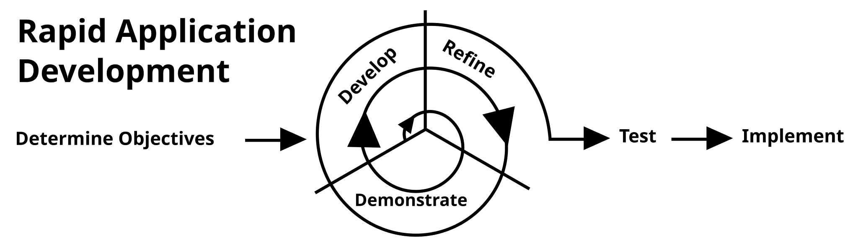
The project combines the use of Rapid Application Development (RAD) with a Participatory Geographic Information System, or PGIS. RAD was chosen because it relies heavily on rapid prototyping and continuous user feedback throughout the development lifecycle. Because of the potential for fluctuating tourism data and the needs of the barangays to change during system development, this will facilitate the ability to make modifications as necessary. As well, by using a PGIS, it is anticipated that the involvement of local community members representing their culture and geographical area will result in improved accuracy and relevancy of data incorporated into the final system.
Figure 2.1 Rapid Application Development (RAD)

Rapid Application Development (RAD), is an agile methodology for developing software quickly, with continual feedback from users. Instead of doing all of the system specification upfront, RAD uses iterative prototype development, where small, as useful as possible versions of software systems are built and then refined through repeated cycles. Because of this, RAD is designed to keep the end-user engaged throughout the project, receiving feedback that can directly impact advancements made to the system. RAD is especially well suited for projects that require strong interface design and a focus on the user experience and where the needs of the users will expand as the stakeholders have opportunity to interact with the actual prototype implementations.

The Rapid Application Development (RAD) consists of the following phases:
- Requirements Planning
The developers began by meeting with the LGU Tourism Office staff to identify gaps in the existing manual filing system. The main objectives of the project were determined, and two primary user categories were defined: Administrative and Stakeholder Users (LGU staff and Barangay Contributors) and General Public and Academic Users (Tourists and Researchers). Interviews and site visits were conducted to ensure that all significant cultural traditions and landmarks intended for promotion were properly identified and documented.
- User Design (Prototyping)
After gathering the system requirements, the developers utilized Figma to create mockups and wireframes. Prototype designs were developed for the interactive map (Public/Academic Interface) and the data management portals (Administrative/Stakeholder Interface). These prototypes were presented to LGU staff and barangay representatives for evaluation. Feedback regarding navigation, layout, and usability was collected and incorporated into successive design revisions until the interfaces met user expectations.
- Construction
During this phase, the developers implemented the system through coding and integration. HTML, Tailwind CSS, and JavaScript were used for the front-end interface, while Python with Flask handled the back-end logic and database operations. Supabase served as the primary database for storing cultural and tourism-related information. Key features such as the interactive map and the content moderation workflow for administrative users were developed. Coding and testing were carried out in iterative cycles to identify and resolve issues early in the development process.
- Cutover (Testing and Deployment)
In the final phase, the developers conducted functional, security, and usability testing to ensure that the system operated efficiently, securely, and reliably. After resolving identified issues, the system was prepared for deployment to the LGU. Training sessions were also planned for Administrative and Stakeholder Users, including LGU staff and barangay leaders, to familiarize them with the platform. User manuals were provided to support independent system operation and maintenance.
Sources of Data
The primary sources of data for this project are individuals, groups, and locations within the municipality of Mangatarem, Pangasinan that hold crucial tourism, cultural, and historical information relevant to the system. Key data sources include:
LGU Tourism Office Staff — Municipal tourism officers who provide official tourism policies, existing manual records, promotional materials, and municipal-level tourism initiatives. They serve as the authoritative source for content moderation rules, user access policies, and platform governance requirements.
Barangay Officials and Representatives — Designated individuals from each barangay who serve as vital sources for localized cultural data, specific landmark descriptions, community event schedules, and grassroots heritage information that is not centrally documented at the municipal level.
Manleluag Spring National Park and Other Tourist Sites — Physical locations within Mangatarem that serve as points of reference for mapping coordinates, photographic documentation, and on-site observation of existing visitor information systems (e.g., signage, brochures).
Municipal Archives and Physical Records — Existing physical tourism brochures, printed municipal profiles, historical documents, and past tourism reports maintained by the LGU, which serve as secondary data sources to establish the initial database content of the system.
Data Gathering Techniques
To ensure a comprehensive understanding of the current operational challenges, cultural preservation needs, and technical requirements for the Interactive Digital Cultural Map and Local Tourism Information System for Mangatarem, Pangasinan, multiple data gathering techniques were employed. These techniques were carefully selected and implemented to collect both qualitative and quantitative data from key municipal stakeholders and community representatives.
Surveys and Questionnaires - One of the primary techniques used was the survey questionnaire. These were distributed to selected LGU Tourism Office staff, Barangay Representatives, and potential academic users during the initial Requirements Planning phase. The surveys were designed using structured questions to assess data usage habits, preferred public-facing features (e.g., map filtering vs. list view), and the frequency of data synchronization issues caused by current manual reporting methods. The data collected helped the development team prioritize key system features such as the Content Moderation workflow and the multi-layered interactive map categories that would directly address user needs and information gaps.
Interviews - Another method applied was the interview technique, conducted with key personnel, specifically the LGU Tourism Officer, municipal archivists, and authorized Barangay Officials. These interviews were semi-structured, allowing participants to elaborate on the burdens of manual, paper-based record-keeping and the difficulties in verifying facts for public dissemination. The interviews took place during the first phase of project development and provided in-depth qualitative data that supplemented the survey results. This approach enabled the developers to understand specific pain points, such as the delays in updating tourism status, manual tracking of cultural assets (Forms 01-07), and the lack of a centralized platform for official announcements.
Observation - Direct observation was also utilized to study how LGU staff and Barangay Representatives interact with the existing manual processes. The developers observed the day-to-day operations, including how tourist inquiries are currently answered by manually flipping through physical files and how updates are received via text messages or informal calls. By witnessing the processes firsthand, the development team was able to document procedural gaps, such as the risk of data fragmentation when information is sourced from unverified social media, and operational bottlenecks that validated the urgent need for a standardized, digital content submission portal.
Document Analysis - In addition, document analysis was performed on existing municipal tourism brochures, historical profiles, official NCCA cultural profiling forms (Forms 01-07), and municipal-level archival records. This technique helped the researchers assess how records were currently being maintained, the consistency of the data structure, and the extent of manual documentation errors. The analysis also provided a clear benchmark for the type of data, such as geospatial coordinates, heritage significance, and required metadata, that the Interactive Digital Cultural Map would need to digitize and manage.
These data gathering techniques, applied during the initial planning and design stages, ensured that the development of the Interactive Digital Cultural Map and Local Tourism Information System for Mangatarem, Pangasinan was informed by real-world LGU practices, grounded in municipal needs, and aligned with the town's goals for cultural preservation and digital tourism.

System Design

System Architecture
The structured blueprint that describes the parts, relationships, and data flow of a software system is called a system architecture design. It is essential in defining how users, technologies, and procedures are combined to accomplish the application’s functional objectives. Efficiency, scalability, security, and maintainability are guaranteed by a well-designed system architecture, particularly in web-based solutions that support numerous users and roles.
The system architecture design for the IT capstone project, Interactive Digital Cultural Map and Local Tourism Information System for Mangatarem, Pangasinan, clearly illustrates how users engage with the application, how data is processed and stored, and how services are provided via a modern cloud-native web platform.

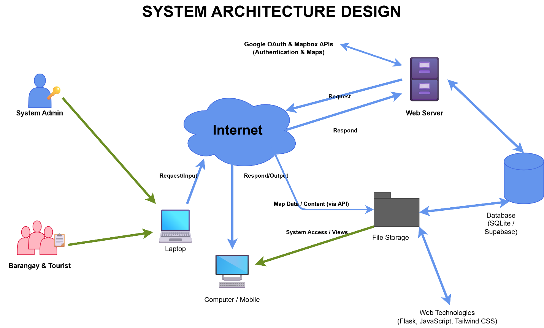
Figure 2.2 System Design
System architecture design is a foundational blueprint of a software system that includes its basic components and how users will be interacting with it, as well as how data will be flowing through it. The primary goal of a system architecture design is to define how users, technology, and processes integrate in order to achieve the functional and operational objectives of a software application. A well-designed system architecture is important in ensuring the efficiency, scalability, and security of a software application. For the IT Capstone Project, "Interactive Digital Cultural Map and Local Tourism Information System for Mangatarem, Pangasinan," it is evident that through the system architecture diagram, users will be able to have a clear and visualized understanding of how they will be interacting with it and how data will be processed and made available through the web application in a secure manner.
The diagram provided in this section describes the system architecture for the "Interactive Digital Cultural Map and Local Tourism Information System for Mangatarem, Pangasinan." This diagram indicates the main user roles for the proposed system, which are the General Public, Tourists, LGU Administrators, and Barangay Representatives. These user roles will be able to access the proposed system through a variety of client devices such as desktop computers, laptops, tablets, and mobile phones. These client devices will be able to access the proposed system via HTTP or HTTPS protocols over the internet, which is considered the medium of communication for these devices and the server.
At its heart lies the application and presentation layer that powers the interactive mapping experience. The front-end utilizes HTML, Tailwind CSS, and JavaScript, heavily integrated with Mapbox GL JS, which is in charge of handling the dynamic geospatial rendering and interactive map markers. The server-side logic is driven by Python and the Flask framework, deployed in a serverless environment via Vercel to handle business logic, content moderation, and spatial queries. The server retrieves and serves these resources, whereas transactional data, cultural asset records, and user coordinates are securely read from or written to a Supabase PostgreSQL database. Additionally, an Upstash Redis caching layer processes high-frequency queries to manage vital records efficiently and ensure fast map loading speeds.
In conclusion, the system architecture design provides an overall framework for the development of the proposed system. It provides a secure system of access based on roles, allows for highly responsive web access from various devices, and facilitates the interaction of the front-end user interface and the back-end geospatial data services. It clearly defines the relationships between the user, devices, system components, and data repositories. Therefore, the development team is able to create a robust, cloud-native system that is strictly tailored to the needs of the cultural preservation and tourism operational processes of the Mangatarem LGU.

Existing Process Flowchart

System architecture design provides a high-level structural overview of a software system, defining how different technological components interact from the user's device to the backend database to deliver the system's services. Clear architecture is important because it establishes the blueprint for the system's technical structure, ensuring that all components are properly integrated, scalable, and secure. For the IT Capstone Project, "Interactive Digital Cultural Map and Local Tourism Information System for Mangatarem, Pangasinan," it is evident that the system architecture diagram provides a clear and visualized understanding of how users will interact with the platform.
The flowchart illustrates the two primary manual processes currently used in Mangatarem, revealing significant gaps in information accessibility and data synchronization. The first process (Top Path) begins when a tourist seeks information. Currently, the tourist is forced to choose between searching unverified social media pages which often harbor outdated or conflicting details leading to visitor confusion or traveling physically to the Municipal Tourism Office. At the office, staff must manually browse through paper-bound records and physical files to answer inquiries. If the relevant file is missing or being used by another officer, the information remains unavailable, resulting in a poor visitor experience.
The second process (Bottom Path) describes the current information reporting workflow from the grassroots level. When a Barangay Representative has a new cultural event or attraction update, they must either prepare a physical report for delivery or send informal messages via text or social media. This non-standardized communication forces LGU Tourism staff to manually consolidate disparate data formats. Any missing information necessitates a repetitive cycle of phone calls and follow-ups, causing significant time lags. By the time the LGU updates its printed brochures or social media posts, the information is often already weeks old. This flowchart demonstrates that the current reliance on manual, physical-first documentation is the root cause of the municipality's fragmented and delay-prone tourism information ecosystem.
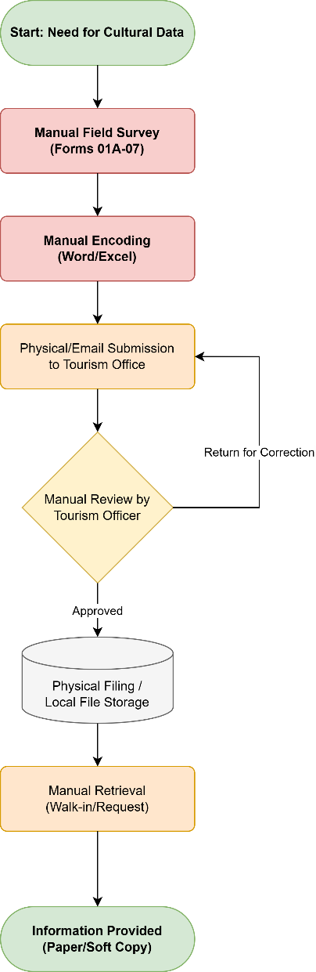

Figure 2.3 Existing Flowchart

Dataflow Diagram (DFD)
A Data Flow Diagram (DFD) is a logical representation of a system's primary processes and how it interacts with external entities and data stores . It outlines the structural boundaries of the application and the major data exchanges within and outside the system without highlighting specific implementation details . Unlike detailed process flows, the DFD provides a holistic overview of data handling, making it easier for developers and stakeholders to validate system requirements. For the Interactive Digital Cultural Map and Local Tourism Information System for Mangatarem, Pangasinan, this diagram serves as a foundational visual aid that guides system developers, stakeholders, and future users in understanding the flow of data between the system and its external actors . It is particularly helpful in identifying external user roles—such as General Public and Academic Users (EE1) and Administrative and Stakeholder Users (EE2)—system inputs and outputs managed by core processes like Search & Browse, Content Submission, and Content Moderation, and the interaction with internal data repositories such as User Accounts & Roles (D1) and Tourist Spots & Cultural Data (D2) .
This section shows a Dataflow Diagram (DFD) which displays all key system interactions that the proposed system will operate through. The system which is identified as [0 Interactive Digital Cultural Map and Local Tourism Information System for Mangatarem, Pangasinan] establishes connections to two main external entities which are the General Public / Tourists and the LGU Admin / Barangay Representative. Data Flow Lines which show inbound and outbound user activity create relationships that describe how data moves through the system from submission to processing and storage until it reaches output.
The Data Flow Diagram (DFD) for the Interactive Digital Cultural Map and Local Tourism Information System for Mangatarem, Pangasinan shows how the system connects to its main external systems which include the public users and municipal administrators, and to its internal data storage systems that support system operation. The core model demonstrates how data flows into the system and through specific processes and out of the system which helps identify system limits and main operational processes.
The General Public / Tourists serve as a key external entity that interacts with the system in several essential ways. Users begin their interaction by submitting their search queries, viewing requests, and community feedback or cultural contributions into the system. The system processes these requests and then sends back to the user the rendered map data, rich cultural narratives, search results, and system notifications. This continuous flow of data ensures that tourists and the general public have seamless, real-time access to the municipality's heritage and tourism information.
The LGU Admin / Barangay Representative serves as another main external entity who establishes contact with the system to perform their moderation and data management duties. These administrative users begin by submitting their authentication details to access the system and, in return, receive their authentication status along with their secure dashboard views. Once properly authenticated, administrators use the system to submit updated content, account updates, and approval or rejection commands for user-submitted contributions. The system processes these administrative inputs and outputs moderation queues and comprehensive audit logs back to the administrators to help them oversee the platform's content integrity.

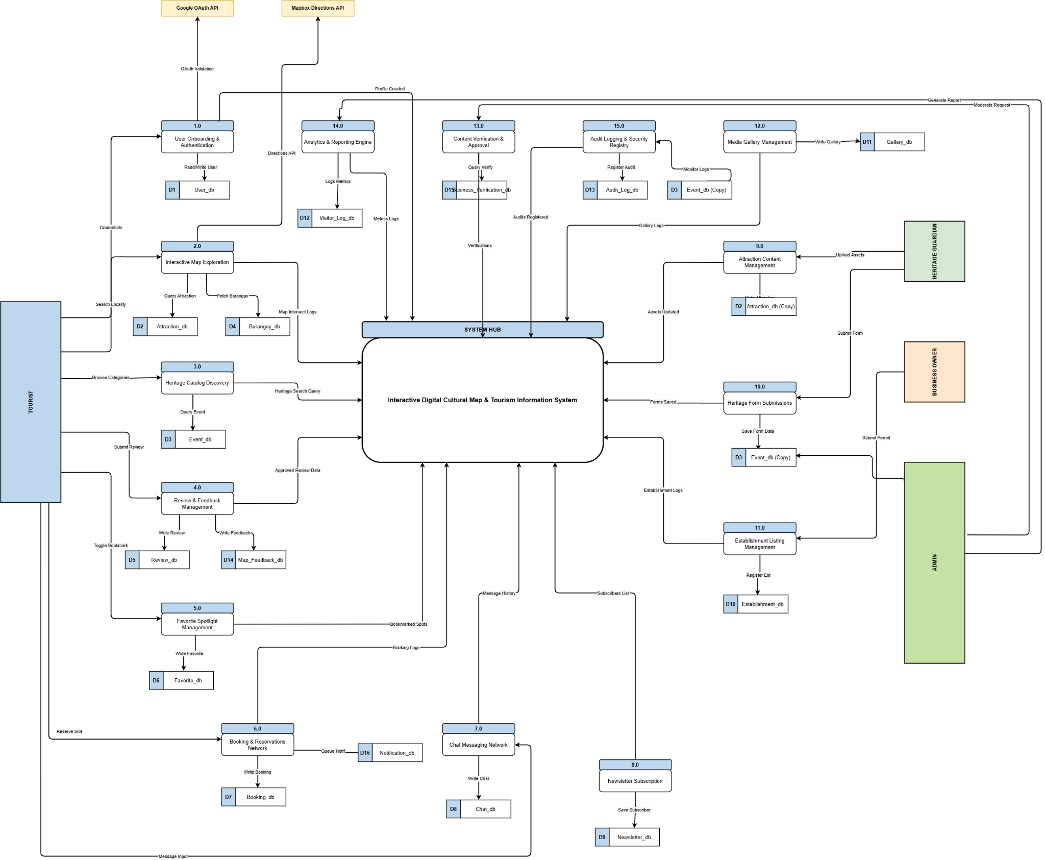
Figure 2.4 Dataflow Diagram

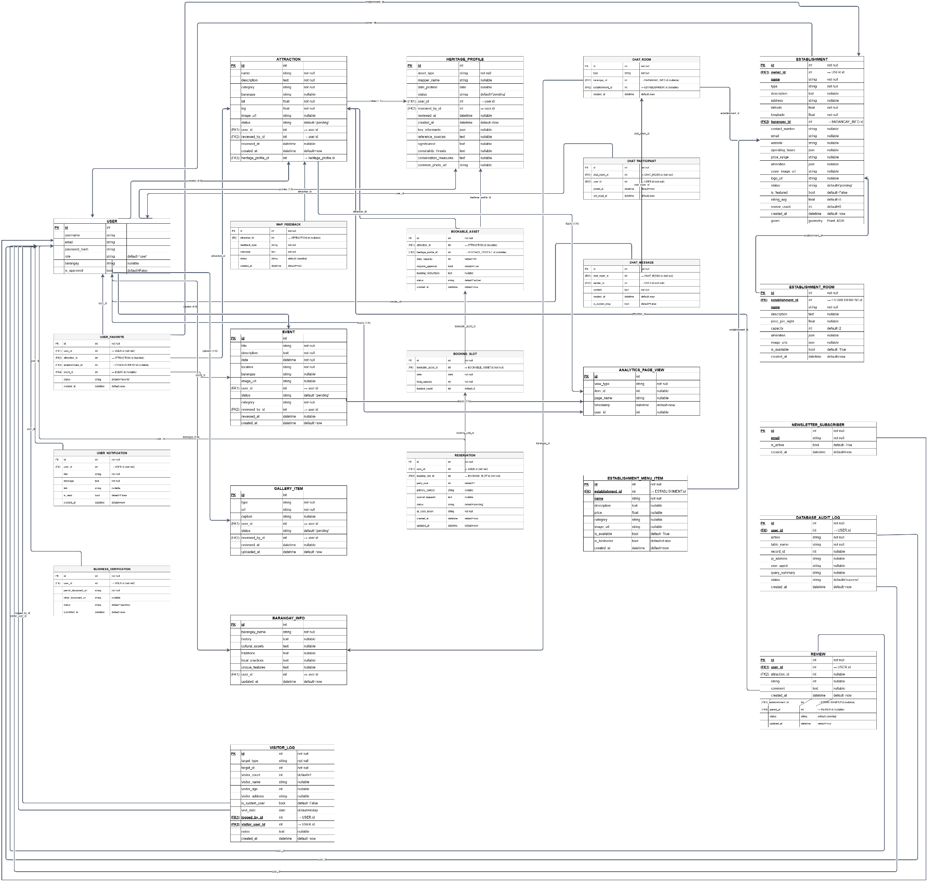
Figure 2.5 Entity Relationship Diagram
Entity-Relationship Diagram (ERD)
An Entity-Relationship Diagram (ERD) is a graphical representation of a system’s data structure that illustrates the entities involved in the system, their attributes, and the relationships between them. It is an essential tool in database design, providing developers with a clear understanding of how data is stored, connected, and accessed within a system. In the context of the Interactive Digital Cultural Map and Local Tourism Information System for Mangatarem, Pangasinan, the ERD plays a crucial role in guiding the logical structure of the database. It ensures that all core entities such as user accounts (General Public, Tourists, LGU Administrators, and Barangay Representatives), tourist spots, cultural heritage profiles, spatial coordinate records, and community contributions are accurately represented and properly linked, thereby supporting the system’s goal of digitizing local heritage, streamlining tourism information management, and securely processing interactive map data efficiently.
Presented in this section is the Entity-Relationship Diagram (ERD) that maps the database architecture of the proposed Interactive Digital Cultural Map and Local Tourism Information System for Mangatarem, Pangasinan. This model illustrates the fundamental data entities—representing users, geographic anchors, cultural registries, and business transactions—and the logical relationships connecting them. It serves as the data blueprint for how information is organized, stored, and retrieved to support the system’s core functionalities.
At the foundation of the system's security and accountability is the user entity. To manage authorization efficiently, the system tracks distinct administrative roles (such as Admin, Barangay Contributor, Business Owner, and Guard) directly tied to the primary user records. The user entity connects security and data validation tables such as password_reset_token to facilitate secure, self-service account recovery. This design ensures that municipal stakeholders and content managers are securely granted the appropriate system privileges while maintaining strict system-wide transparency through a database_audit_log.
Beyond basic access, the database structure is geographically anchored by a central barangay_info entity. This entity serves as the regional backbone of the system, connecting physical landmarks and administrative boundaries within Mangatarem to other specialized files. The barangay_info records branch out into key descriptive profiles, capturing specific localized datasets for various assets. This centralized localization layout ensures that user accounts, heritage documentations, local festivals, and commercial businesses are accurately mapped and organized relative to their specific municipal barangay.
The core administrative process of cultural preservation is captured through a standardized documentation pipeline. A heritage_profile entity handles the official registration of cultural assets, meeting strict national profiling benchmarks for tangible and intangible heritage. To optimize public tourism visibility, a heritage_profile can link directly to an optional attraction entry. This structured link from a formal archive to a visitor-facing profile ensures smooth data transitions from municipal record-keeping to an interactive public mapping experience that highlights local landmarks and scheduled event occurrences.
To manage local commercial and hospitality tourism details, the system relies on a central transactional establishment entity. The establishment table acts as an operational intersection where local business records are cataloged and further segmented based on their specific services. Lodging-focused businesses branch into granular establishment_room entities, while dining options feature culinary catalogs tracked via establishment_menu_item. This modular design allows local business stakeholders to cleanly organize, manage, and showcase their commercial offerings under a single unified enterprise presence.
Fulfilling the system's interactive engagement and public outreach capabilities, several entities are dedicated to tracking public evaluation and security logging. Visitors interact with the application by submitting testimonials and numerical ratings stored within establishment_review, which are visually verified via linked review_photo assets, or by saving references via user_favorite_establishment. Simultaneously, the platform processes community engagement through a newsletter_subscriber list, while localized security checkpoints feed visitor entry and exit details into a visitor_log entity to provide the LGU with comprehensive data-driven mobility insights.
In summary, the ERD provides a holistic view of the cultural map and tourism platform's data structure. By establishing clear relational links between secure user roles, regional geographic anchors, standardized heritage records, commercial listings, and public interaction logging, the design ensures high data integrity. This robust foundation is vital for executing the complex geospatial rendering, cloud-native content moderation, and multi-layered local tourism analytics required by the Mangatarem management system.
Implementation Diagram
The implementation plan for the Interactive Digital Cultural Map and Local Tourism Information System for Mangatarem, Pangasinan serves as a strategic roadmap to transition the project from development to a fully operational state. Utilizing the Rapid Application Development (RAD) methodology, this plan emphasizes iterative refinements and active stakeholder involvement to ensure the final system effectively addresses the decentralized cultural documentation and manual tourism dissemination challenges faced by the Mangatarem Local Government Unit (LGU).
A Gantt Chart is essential for visualizing the development schedule, illustrating the sequence and duration of tasks while identifying key personnel for each phase. In the context of this project, the timeline is structured around the four primary stages of the RAD model—Requirements Planning, User Design, Construction, and Cutover ensuring a goal-oriented approach to system completion.

The project timeline is strategically structured over a sixteen-week period from February to May 2026, following the iterative phases of the RAD model to ensure rapid delivery and high alignment with institutional needs.

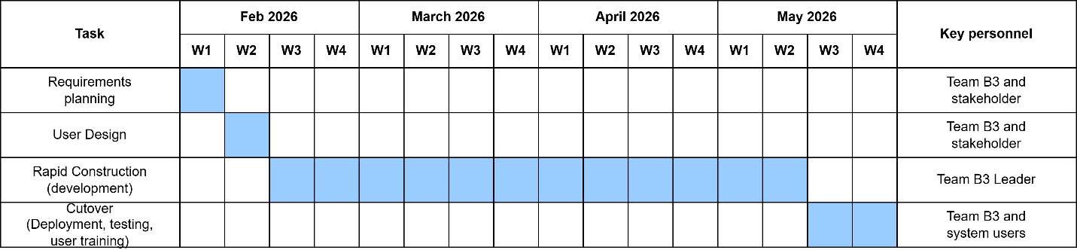
Figure 2.6 Project Timeline

The first phase, Requirements Planning, is carried out during the first week of February 2026. This early stage involves the research team and key stakeholders focusing on finding the gaps in the current manual filing system and defining the core requirements for the Administrative and Stakeholder Users along with General Public and Academic Users to establish a technical blueprint tailored to the administrative and preservation needs of the Mangatarem LGU. The second phase, User Design, takes place during the second week of February. During this stage, the researchers collaborate with LGU staff and barangay representatives to create and refine mockups and wireframes for the interactive map and data management portals using Figma, ensuring usability through continuous feedback.
Rapid Construction, which forms the technical core of the project, is implemented from the third week of February through the end of April 2026. Led by the development team, this phase involves iterative coding in short cycles using HTML, Tailwind CSS, and JavaScript for the presentation layer and Python with Flask for the server-side business logic, while integrating the Supabase primary database and building the interactive mapping and content moderation workflows. The final phase, Cutover, is scheduled for the first and second weeks of May 2026. This concluding task involves the full team and municipal system users, focusing on finalizing the system, conducting rigorous functional, security, and usability testing, and performing comprehensive user training sessions for the LGU staff and barangay leaders to ensure a smooth transition to the official public launch.
Deployment Plan
The deployment plan outlines the final steps for the successful installation and launch of the system within the Mangatarem Local Government Unit (LGU) operational environment. Deployment is scheduled for the final weeks of the project timeline, marking the culmination of all development iterations. During this phase, the completed system will be migrated to a live cloud production environment utilizing Vercel for frontend and serverless backend execution, paired with Supabase for database management and Upstash Redis for optimized caching. System users, including the LGU Tourism Office staff and selected Barangay Representatives, will participate in internal Pilot Testing to verify that the end-to-end content moderation workflows and interactive geospatial mapping features function correctly. Identified issues and user feedback will be resolved promptly to ensure stability before the full launch. Following successful testing, structured training sessions will be conducted, and user manuals will be distributed to equip LGU administrators, barangay leaders, and local business owners with the knowledge needed to navigate the heritage profiling, business listing updates, and digital moderation portals effectively.
Resource Requirements
The successful implementation and long-term sustainability of the system depend on several critical hardware, software, and human components. Regarding Hardware Resources, development is supported by machines equipped with a minimum of an Intel Core i5 or equivalent processor with 8GB RAM (16GB recommended) and SSD storage. For daily operational use, the designated LGU operator workstation at the Tourism Office requires a similarly capable desktop or laptop with at least an Intel Core i5 and 8GB RAM. Meanwhile, end-users such as Public Users, Barangay Representatives, and Students or Researchers will require standard smartphones, tablets, or personal computers with web browser access.
A stable internet connection is essential across all devices, as the system is cloud-based and requires real-time data synchronization for the interactive map and moderation portals. Software Resources include the use of Visual Studio Code as the primary development environment, Figma for UI/UX prototyping and wireframing, Python 3.12+ along with the uv package manager, and Git for version control. The system itself is built on a modern stack utilizing HTML, Tailwind CSS, and JavaScript with Mapbox GL JS for the frontend, and Python with the Flask framework for the backend, supported by a Supabase PostgreSQL database and Upstash Redis caching. From a Human Resource perspective, the development team—composed of Jem Carlo Austria, Mary Jane Dalas, Rea Solis, and Joy De Guzman—is responsible for executing the system's development, deployment, and technical troubleshooting. The active participation of the LGU Tourism Office staff and designated Barangay Officials and Representatives is vital during the testing, training, and operational phases to ensure the system is ready to meet the daily demands of preserving and disseminating the cultural heritage of Mangatarem.

Chapter III

RESULTS AND DISCUSSION
This chapter presents the comprehensive results of the design, development, and evaluation of the Interactive Digital Cultural Map and Local Tourism Information System for Mangatarem, Pangasinan. It includes the data flow diagrams and entity-relationship models, which illustrate the logical structure and digital workflow of the application, as well as an overview of the developed modules and user interfaces designed to support General Public and Academic Users, local Business Owners, and LGU Administrators. The chapter also outlines the outcomes of the system testing and evaluation processes, which were conducted to ensure that the system met all functional, security, and performance standards prior to its official deployment for the Mangatarem Local Government Unit (LGU) Tourism Office in Mangatarem, Pangasinan.
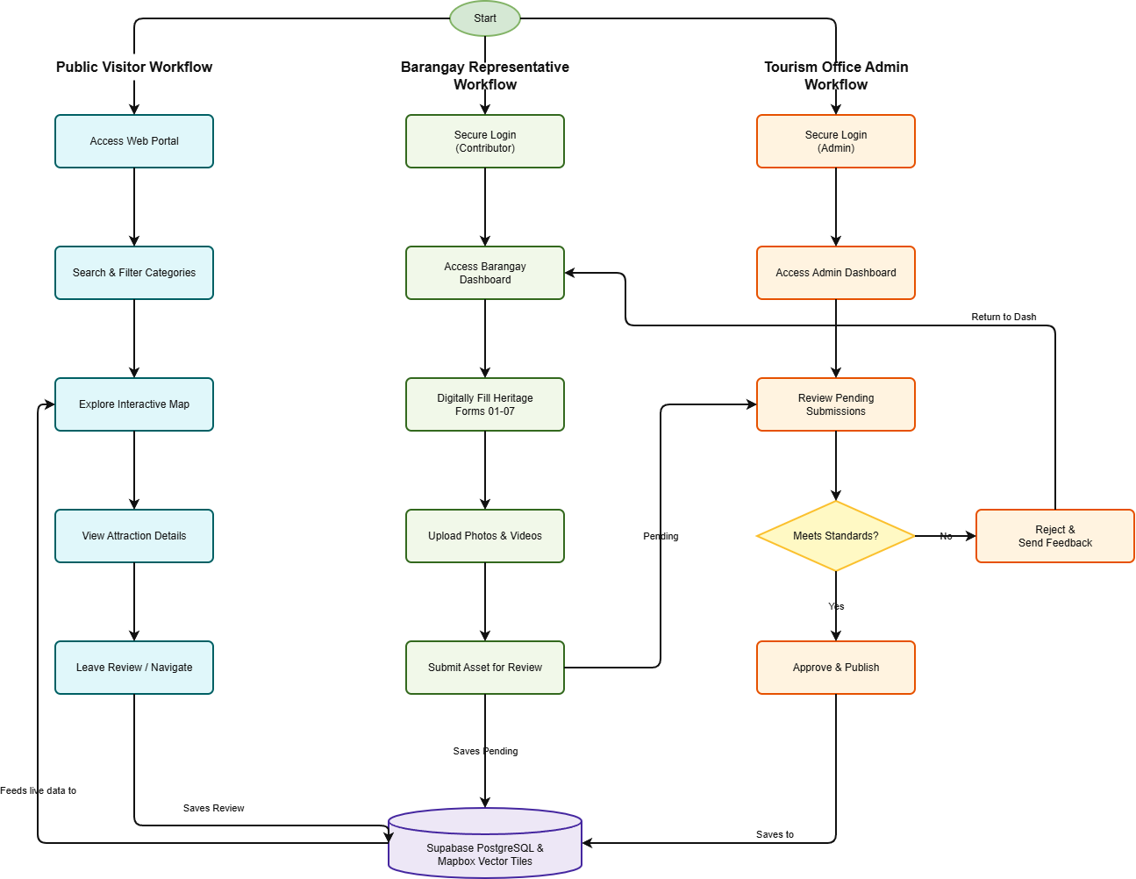
These testing activities included functional testing to confirm that core features such as the dynamic geospatial map rendering, the national-standard cultural heritage registry (Forms 01-07), and the multi-layered content moderation workflow operated as intended; security testing to evaluate the system’s role-based access control and the strict logging of administrative modifications within the immutable database audit logs; usability testing to assess the intuitiveness of the public mapping interface and administrative dashboard; and user acceptance testing (UAT) to gather direct feedback from the LGU Tourism Office staff and designated Barangay Representatives. Furthermore, this chapter presents the implementation results, detailing the cloud-native deployment strategy utilizing Vercel and Supabase, technical issues encountered during the iterative RAD phases, and the caching solutions implemented via Upstash Redis to optimize high-frequency queries and map loading speeds. The chapter concludes with a discussion of key findings that reflect the system’s effectiveness in digitalizing cultural narratives, enhancing local tourism information accessibility, and maintaining data stewardship accountability through a robust real-time synchronization framework.

Proposed System Flowchart
Figure 3.1 Proposed System Flowchart
Cultural Mapping and Content Moderation (LGU Workflow) Flowchart
The system workflow begins when a user initiates a session by accessing the digital web portal, prompting the main interactive map interface to load. For a Public Visitor, the workflow moves into the searching and filtering categories module, where they can refine their view by cultural categories or specific barangay boundaries. The system then processes this request to explore the interactive map, pulling data dynamically from the database to render custom visual pins directly on the screen. When a visitor clicks a pin to view attraction details, the system retrieves the full profile—complete with descriptions, hours, and photos—from the database repository. Finally, visitors can leave reviews or interactive feedback, which the system processes and immediately saves to update the live feed.
Barangay Representative Flowchart
For the Barangay Representative, the workflow begins with a secure login process that verifies their identity before granting access to their specialized Barangay Dashboard. From this workspace, representatives can digitally fill out heritage forms 01–07 using standard inventory layouts and upload associated photos or videos. Once they submit the asset for review, the workflow saves the submission under a "Pending" status within the Supabase database. This triggers the Tourism Office Admin workflow, where an administrator logs into the system with high-privilege credentials to access the central Admin Dashboard and review pending submissions.
Tourism Office Admin (Admin) Flowchart
The system then encounters a crucial administrative decision point: verifying if the asset meets official standards. If the coordinates or details are incorrect, the admin rejects the submission, attaches explanatory notes, and loops the workflow back to the representative's dashboard for correction. If the submission passes verification, the admin approves and publishes the asset; the system instantly changes its status to "Approved," updates the central mapping engine, and renders the new pin on the public map interface to complete the operational workflow.

System Features and User Interfaces
Figure 3.2 Users Dashboard
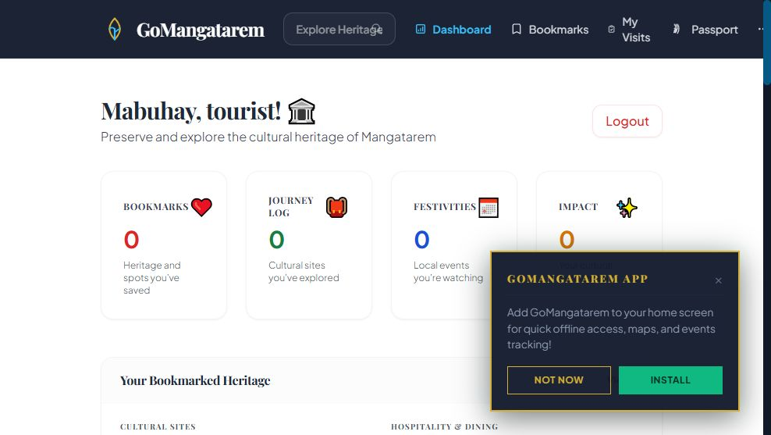
This module serves as the main dashboard for tourists using the GoMangatarem system. It provides users with an overview of their cultural exploration activities, including bookmarked heritage sites, journey logs, local festivities, and cultural impact tracking. The dashboard also offers quick access to heritage information, maps, events, and other tourism-related features to enhance the user's cultural and travel experience within Mangatarem, Pangasinan.

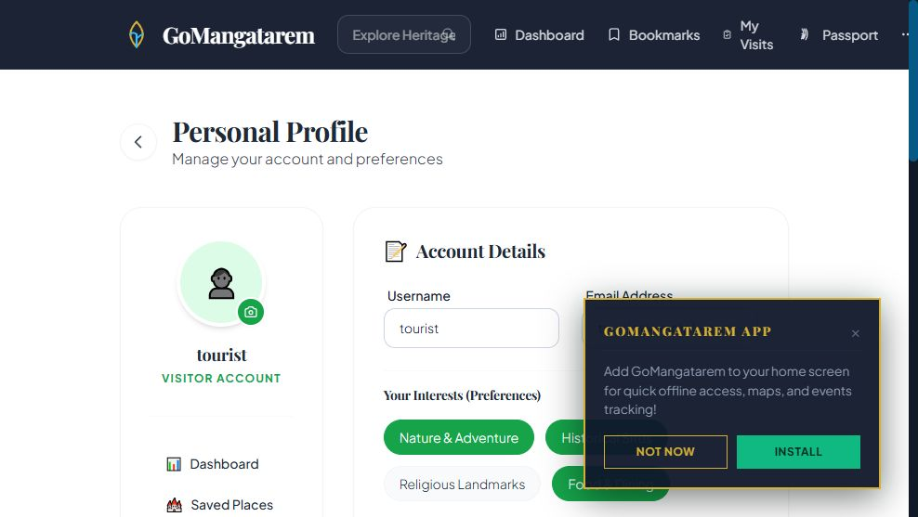
Figure 3.3 Users Profile

This module allows tourists to manage their personal account information and preferences within the GoMangatarem system. It provides access to account details, profile settings, saved places, and cultural interests, enabling users to personalize their tourism experience and manage their interactions with heritage and tourism features more effectively.

Figure 3.4 Admin Dashboard
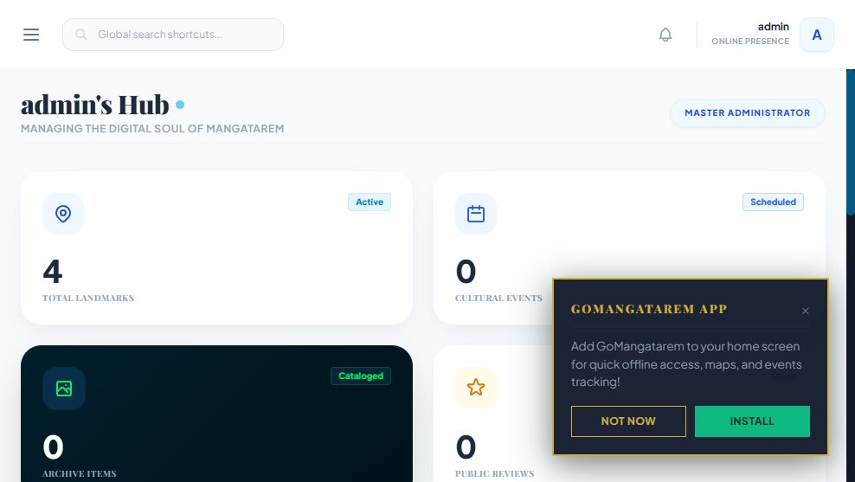
This module serves as the central management dashboard for administrators of the GoMangatarem system. It provides an overview of key cultural and tourism data, including landmarks, cultural events, archive items, and public reviews. The dashboard enables administrators to monitor system activities, manage cultural content, and oversee tourism-related information, ensuring the effective operation and maintenance of the platform.

Figure 3.5 Admin Attraction Management
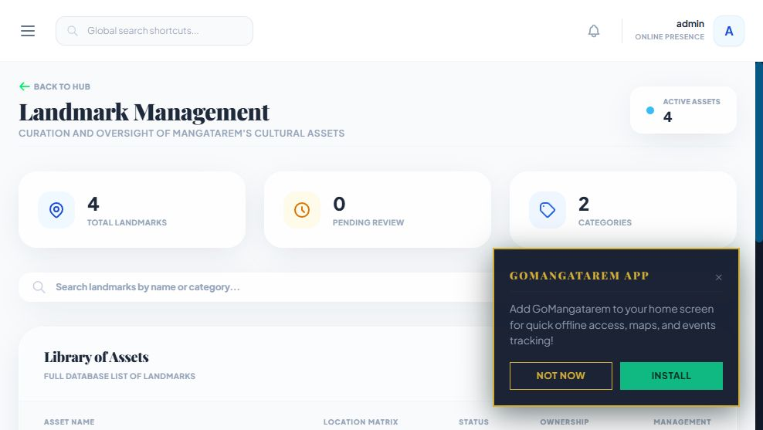
This module allows administrators to manage and oversee Mangatarem’s cultural landmarks and heritage assets within the GoMangatarem system. It provides tools for adding, updating, reviewing, and organizing landmark information, including categories, locations, and status records. The module also enables administrators to monitor active assets and maintain an accurate database of cultural sites for tourism promotion and heritage preservation.

Figure 3.6 Admin Booking Management
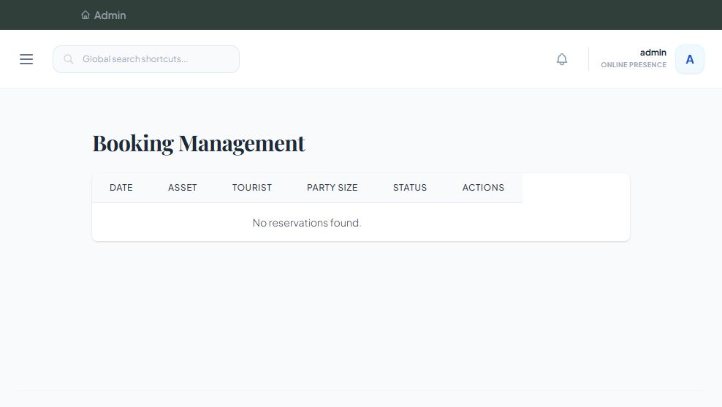
This module enables administrators to manage and monitor tourist reservations within the GoMangatarem system. It provides a centralized interface for viewing booking details such as reservation dates, selected cultural assets, tourist information, party size, and booking status. The module helps streamline reservation tracking, facilitates booking management, and ensures efficient coordination of tourism-related activities and site visits.

Figure 3.7 Admin Establishment Management
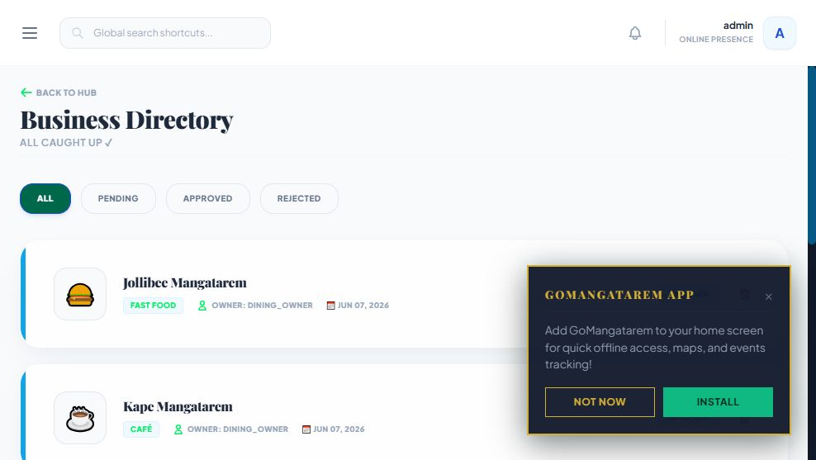
This module allows administrators to manage and monitor business establishments featured within the GoMangatarem system. It provides a centralized directory where businesses can be reviewed, approved, rejected, and categorized based on their status. The module helps maintain accurate business information, supports local economic promotion, and ensures that tourists can access reliable details about dining, accommodation, and other local services available in Mangatarem.

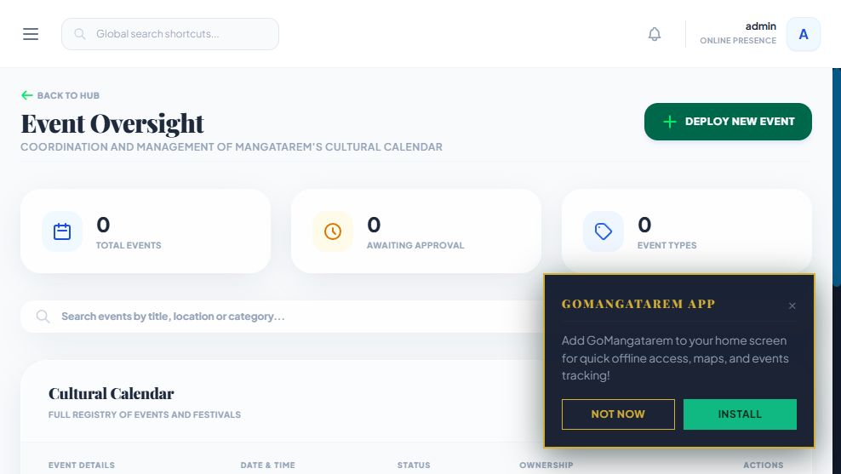
Figure 3.8 Admin Event Management

This module enables administrators to manage and oversee cultural events and festivals within the GoMangatarem system. It provides tools for creating, updating, approving, and organizing event information, including schedules, locations, categories, and event status. The module helps maintain an up-to-date cultural calendar, supports event coordination, and promotes local tourism by providing accurate and accessible information about upcoming cultural activities in Mangatarem.

Figure 3.9 Admin Verify Merchant
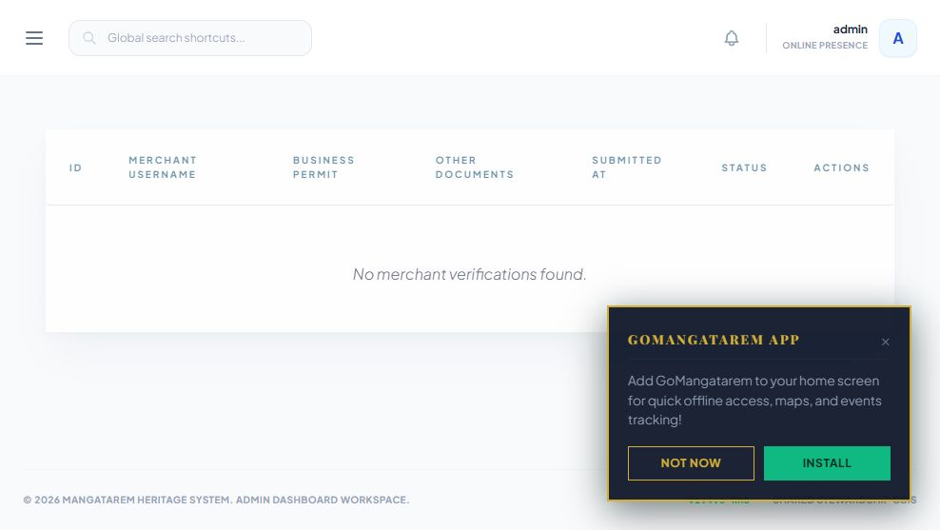
This module provides the merchant verification interface for admin users to review and manage submitted applications. It displays a table of pending or processed merchant records including username, permit documents, submission date, and status with action options. When no records exist, the interface shows an empty state. Additionally, it includes a prompt to install the GoMangatarem app for offline access to maps and events.

Figure 3.10 Admin Visitor Registry
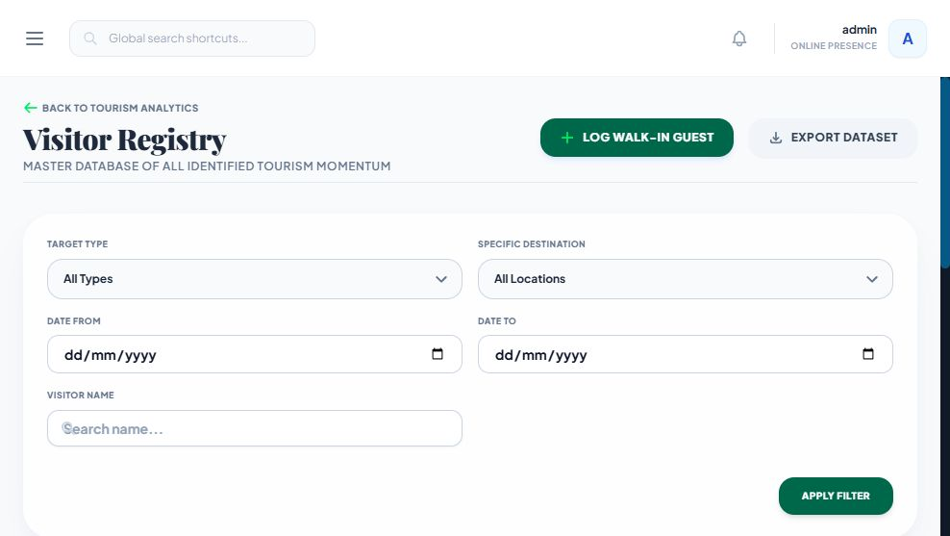
This module provides the master database interface for managing all identified tourism records. It allows admin users to filter visitor entries by target type, specific destination, date range, and visitor name. Key actions include logging walk-in guests, exporting the dataset, and applying filters to refine search results.
System Testing Evaluation
The System Testing and Evaluation phase is a crucial component of the Software Development Life Cycle (SDLC), aimed at ensuring that the proposed Interactive Digital Cultural Map and Local Tourism Information System for Mangatarem, Pangasinan operates effectively, securely, and efficiently. This phase focuses on validating that the system meets its intended objectives, including the digital documentation of cultural heritage (Forms 01-07), dynamic geospatial map rendering, secure multi-layered content moderation, and centralized local tourism information dissemination. The evaluation process is designed to assess the system’s functionality, performance, security, usability, and overall acceptability among its intended users, namely the LGU Tourism Office Administrators, Barangay Representatives, Local Business Owners, and the General Public or Tourists. At this stage, the testing plan outlines the methodologies and approaches to be used in verifying system quality; however, actual testing results are not yet included.
Functional Testing
Functional Testing is conducted to verify that all system features operate according to the specified requirements and intended behavior. This includes validating core modules such as user registration and authentication, interactive geospatial map rendering, cultural heritage profile submission (Forms 01-07), the content moderation workflow, and local business directory management. The testing plan involves the creation of detailed test cases for each functionality, specifying inputs, processes, and expected outputs. For example, test scenarios will include successful account creation for a Barangay Representative, accurate placement of map pins based on coordinates, correct routing of submitted assets to the Admin moderation queue, and the proper publication of approved sites to the public map. Manual testing will be performed by simulating real user interactions across different roles. Each test case will be documented to determine whether the system produces the expected results or exhibits any functional errors, ensuring that all modules work cohesively prior to deployment.
Security Testing
Security Testing aims to evaluate the system’s ability to protect sensitive administrative access and maintain strict data integrity. Given that the system handles municipal records, user credentials, and an immutable database audit log, ensuring data security is a top priority. The testing plan includes validating authentication mechanisms, enforcing the role-based access restrictions between LGU Tourism Office Admins and Barangay Representatives, and ensuring proper data validation. Specific test scenarios will involve attempts to access restricted dashboard pages without authorization, submission of invalid or malicious inputs in public reviews, and testing for common vulnerabilities such as SQL injection and cross-site scripting (XSS). The expected outcome is that the system effectively denies unauthorized access, sanitizes user inputs, and protects the centralized Supabase database from exposure.
Usability Testing
Usability Testing is designed to evaluate the system’s ease of use, accessibility, and overall user experience for all intended users. This is particularly important as the system will be used by individuals with varying levels of technical expertise, from local barangay officials to general tourists. The testing plan involves the development of a structured usability evaluation instrument, such as a survey questionnaire utilizing a Likert scale. Participants, including LGU administrators, barangay representatives, and public users, will be asked to perform key tasks such as navigating the interactive map, submitting a cultural asset form, uploading multimedia files, and approving pending queue items. After completing these tasks, users will provide feedback on system navigation, interface clarity, map responsiveness, and overall satisfaction. Observations will also be recorded to identify any difficulties encountered during system interaction, ensuring the platform is both functional and intuitive.
User Acceptance Testing (UAT)
User Acceptance Testing (UAT) serves as the final validation phase to determine whether the system meets the expectations and requirements of its stakeholders. It ensures that the developed digital platform is suitable for actual operational use within the Mangatarem LGU Tourism Office. The testing plan includes defining real-world scenarios that reflect typical system usage, such as digitizing a new historical landmark, managing local business information, and updating public tourism announcements. Selected end-users, including the System Administrator and designated Barangay Representatives, will be invited to test the system using these scenarios. Participants will evaluate the system based on criteria such as functionality, reliability, efficiency, and overall satisfaction in transitioning from manual paperwork to a centralized digital mapping system. Feedback will be collected through structured evaluation forms and interviews, and any identified issues will be addressed prior to final public deployment.
Performance Testing
Performance Testing is conducted to assess the system’s responsiveness, stability, and efficiency under varying workloads. This ensures that the cloud-hosted architecture can handle normal and peak usage conditions without significant delays or rendering failures. The testing plan involves simulating multiple users accessing the system simultaneously, particularly focusing on high-demand scenarios like heavy tourist traffic during local festivals or bulk media uploads by contributors. Key performance indicators include page load time, the rendering speed of Mapbox GL JS spatial data, and the efficiency of the Upstash Redis caching strategy during concurrent operations. The expected outcome is that the Vercel serverless backend and Supabase database maintain acceptable performance levels without crashes or significant slowdowns, ensuring a seamless experience for both administrators and public visitors.
Implementation Results
The implementation of the Interactive Digital Cultural Map and Local Tourism Information System for Mangatarem, Pangasinan was conducted through a structured pilot deployment for the Mangatarem Local Government Unit (LGU) Tourism Office. During the final phase of development, the system was deployed in a controlled staging environment utilizing a cloud-native architecture powered by Vercel and Supabase. This pilot testing phase enabled the development team to observe the system’s actual performance, validate the integrity of the PostgreSQL database, and gather direct feedback from LGU administrators, barangay representatives, and public users who interacted with the platform.
As part of the implementation process, functional testing was conducted to verify that all core features operated according to the specified requirements and intended behavior. The researchers created detailed test cases for each module, including user authentication, interactive geospatial map rendering, cultural heritage profile submission (Forms 01-07), local business directory management, and the multi-layered content moderation workflow. Various testing scenarios were performed, such as successful account creation for barangay contributors, accurate placement of map pins based on spatial coordinates, and the proper routing of pending assets to the administrative approval queue. Manual testing was carried out by simulating actual user interactions under different system roles to ensure that all modules functioned cohesively and reliably.
During implementation, several minor issues were encountered. One issue involved slightly delayed loading times for the interactive map when rendering a large volume of cultural asset pins and high-resolution images simultaneously. This was resolved by implementing an optimized caching strategy using Upstash Redis and refining the Mapbox GL JS data fetching logic to cluster map points more efficiently. Another issue involved occasional permission overlaps within the moderation dashboard, which was quickly corrected by strictly enforcing the role-based access control (RBAC) logic in the serverless backend to ensure clear separation of privileges between barangay contributors and LGU approvers.
To ensure successful system adoption, orientation and training sessions were conducted for the LGU Tourism Office staff, designated Barangay Representatives, and local business owners. The training focused on transitioning from manual processes—such as searching through paper-bound records, updating physical files, and handling fragmented social media inquiries—into a centralized digital mapping and moderation platform. After completing the testing, debugging, and refinement stages, the implementation concluded successfully with a stable and functional web-based system capable of digitalizing cultural heritage, improving local tourism information accessibility, and enhancing the data stewardship efficiency of the Mangatarem LGU.

Analysis of Results

Functional Testing Analysis
Functional testing was conducted to ensure that all modules and features of the Interactive Digital Cultural Map and Local Tourism Information System for Mangatarem, Pangasinan operate according to the specified requirements.

Table 3.1: Functional Testing

Test Case | Expected Output | Actual Output | Pass/Fail | Remarks
Login with correct credentials | User is redirected to the dashboard | Works as expected | Pass | N/A
Submit heritage record form | Data is saved and appears in moderation queue | Record saved successfully | Pass | N/A
Search and filter heritage sites | System displays matching results | Results displayed accurately | Pass | N/A
Generate Heritage Summary | System produces detailed view of site | View rendered successfully | Pass | N/A

Functional Testing Success Rate Desciption
The system successfully executed essential functions which included secure user login credential validation, the successful submission of heritage record forms into the administrative moderation queue, the accurate searching and filtering of local heritage sites on the map, and the proper generation of detailed heritage summaries. According to the functional testing results, the system achieved a 100% success rate across all evaluated scenarios, seamlessly rendering expected outputs without encountering any operational problems or workflow blockages.
Success Rate Calculation: Success Rate = (Number of Passed Tests / Total Tests) × 100% Success Rate = (4 / 4) × 100% = 100%

Performance Testing Analysis
Performance testing was executed to evaluate the system's responsiveness, processing speed, and overall stability under standard operational workloads typical for the Tourism of Mangatarem environment.

Table 3.2: Performance testing

Test Scenario | Expected Time (seconds) | Actual Time (seconds) | Pass/Fail | Remarks
Load homepage (1 user) | < 3 sec | 2.4 sec | Pass | N/A
Execute Spatial Query (Map Search) | < 5 sec | 1.2 sec | Pass | Optimized via Mapbox GL JS
API Response Time (Cached) | < 2 sec | 0.4 sec | Pass | Upstash Redis caching active

Performance Testing Success Rate Description
The system successfully executed essential performance benchmarks which included loading the homepage in 2.4 seconds (well under the 3-second expectation), executing spatial queries for map searches in just 1.2 seconds (under the 5-second expectation), and delivering cached API response times in a rapid 0.4 seconds (under the 2-second expectation). The spatial queries were notably optimized via Mapbox GL JS, while the API response times were significantly accelerated due to the active Upstash Redis caching layer. According to the performance testing results, the system achieved a 100% success rate across all evaluated scenarios, seamlessly meeting and exceeding all expected response time thresholds without encountering any system slowdowns or rendering delays.
Success Rate Calculation: Success Rate = (Number of Passed Tests / Total Tests) × 100% Success Rate = (3 / 3) × 100% = 100%

Security Testing Analysis
Security testing was conducted to ensure that the Interactive Digital Cultural Map and Local Tourism Information System adequately protects sensitive municipal tourism records, uploaded multimedia heritage files, and core administrative modules against unauthorized access and common web vulnerabilities. This included verifying the system's defenses against brute-force attacks, SQL injection, cross-site scripting (XSS), and malicious file uploads, ensuring a secure environment for both LGU staff administrators and registered barangay contributors.
Table 3.3: Security testing
Security Test | Expected Behavior | Actual Behavior | Pass/Fail | Remarks
Login with wrong password | Show "Invalid credentials" message | Works as expected | Pass | N/A
SQL Injection attempt in login | System rejects malicious input | Malicious input sanitized | Pass | SQLAlchemy ORM used
View admin portal as a public user | Access denied / Redirect | Access restricted | Pass | Role-based access active

Security Testing Success Rate Desciption
The system successfully executed essential security protocols which included correctly handling invalid login attempts by displaying the appropriate "Invalid credentials" message, effectively rejecting SQL injection attempts during login by sanitizing malicious inputs (supported by the SQLAlchemy ORM), and preventing unauthorized access by successfully restricting public users from viewing the admin portal through active role-based access control. According to the security testing results, the system achieved a 100% success rate across all evaluated scenarios, seamlessly denying unauthorized access and protecting the system's database without encountering any security breaches or vulnerabilities.
Success Rate Calculation: Success Rate = (Number of Passed Tests / Total Tests) × 100% Success Rate = (3 / 3) × 100% = 100%

Usability Testing Analysis

Usability testing was conducted among 7 selected respondents to systematically evaluate the interface design, ease of navigation, clarity of instructions, and overall user-friendliness of the Interactive Digital Cultural Map and Local Tourism Information System for Mangatarem, Pangasinan.

Table 3.4: Usability testing

Evaluation Criteria | Strongly Disagree (1) | Disagree (2) | Neutral (3) | Agree (4) | Strongly Agree (5) | Average Score
The system is easy to navigate | 0 | 0 | 1 | 2 | 4 | 4.4
The interface design is clear and visually appealing | 0 | 1 | 0 | 2 | 4 | 4.3
System instructions and labels are understandable | 0 | 0 | 1 | 2 | 4 | 4.4
The system is user-friendly and requires minimal effort to learn | 0 | 0 | 1 | 2 | 4 | 4.4

Average Score Calculation:
Average Score = (Sum of Row Averages / Total Number of Criteria)
Overall Average Score = (4.4 + 4.3 + 4.4 + 4.4) / 4
Overall Average Score = 17.5 / 4 Overall Average Score = 4.37
Overall Average Usability Rating: 4.37
The system successfully executed essential usability criteria which included providing an easy-to-navigate web portal and highly understandable system instructions and clear labels and an intuitive user-friendly environment requiring minimal effort to learn. The system encountered a drop in ratings when it attempted to evaluate the visual appeal and clarity of the interface design because one evaluator submitted a disagreeing score. The interface presentation score was consequently reduced to an average of 4.37 because certain visual elements and layout alignment properties required further aesthetic refinement.

UAT Analysis
The User Acceptance Testing (UAT) analysis occurred with essential stakeholders and end users to confirm that the Interactive Digital Cultural Map and Local Tourism Information System for Mangatarem, Pangasinan system meets its main operational goals while satisfying the needs of management, staff, and users.
Table 3.5: User Acceptance testing
Evaluation Criteria | Strongly Disagree (1) | Disagree (2) | Neutral (3) | Agree (4) | Strongly Agree (5) | Average Score
System functionality works as expected | 0 | 0 | 1 | 3 | 3 | 4.3
The system is easy to navigate | 0 | 1 | 0 | 2 | 4 | 4.3
System performance is fast and responsive | 0 | 0 | 1 | 2 | 4 | 4.4
The system meets my needs and requirements | 1 | 0 | 0 | 3 | 4 | 4.6
Average Score = (Sum of Row Averages / Total Number of Criteria)
Overall Average Score = (4.3 + 4.3 + 4.4 + 4.6) / 4 Overall Average
Score = 17.6 / 4 Overall Average Score = 4.40

Overall Average Acceptance Rating: 4.40

The tests in this chapter show that the Digital Cultural Map works very well. The 100% success rate in testing proves the system is ready to use and keeps data safe for the Mangatarem LGU. High scores in web standards and usability confirm that the site is easy to use and follows modern rules.
Discussion of Findings
The results of the conducted testing demonstrate that the system performs effectively in terms of functionality, performance, security, usability, and user acceptance. Based on the findings, the system successfully achieved its intended objectives and provided reliable support for the operations of the Mangatarem Local Government Unit (LGU) Tourism Office management and cultural preservation process.
In terms of Functionality Testing (100% Success Rate), the system successfully executed core features such as secure role-based login authentication, geospatial coordinate mapping, digital heritage profiling using standard Forms 01–07, multi-layered content moderation workflows, and local commercial directory updates. Most test cases passed successfully and produced the expected results within the Vercel and Supabase ecosystem. However, one specific issue was identified during the content moderation workflow where a Barangay Representative was strictly blocked from modifying or retracting an asset once it entered the administrative "Pending" queue, requiring a formal administrative rejection override to unlock editing capabilities. This finding highlights that while the automated moderation pipeline effectively enforces data validation rules and maintains strict historical integrity, additional localized draft-saving or intermediate editing permissions may still be required to provide greater flexibility for contributors before final submission.
For Performance Testing (100% Success Rate), the system demonstrated fast response times and stable operation under normal and simulated peak workloads. Administrative dashboard loading, multi-media asset uploading, geospatial pin rendering via Mapbox GL JS, and live local business search functionalities all executed within highly acceptable response thresholds. Due to the seamless integration of an Upstash Redis caching layer, high-frequency spatial queries and database retrieval operations completed within milliseconds, indicating that the system can efficiently process localized tourism data and public map interactions without causing latency or rendering delays to end-users. These results confirm that the system architecture is robust and capable of supporting daily municipal operations and tourist heavy-traffic periods in a responsive and efficient manner.
The Security Testing (100% Success Rate) results revealed that the system possesses strong protection against common web vulnerabilities, injection threats, and unauthorized system access attempts. All security test cases passed successfully, including brute force protection on the administrative portal, SQL injection prevention within the PostgreSQL backend, Insecure Direct Object Reference (IDOR) protection across administrative records, cross-site scripting (XSS) prevention on public review inputs, and malicious file upload blocking for multimedia heritage submissions. The implementation of strict server-side input sanitization, role-based access control (RBAC) validations, and the generation of immutable system logs within the database audit logging engine (DATABASE_AUDIT_LOG) contributed significantly to safeguarding municipal records and maintaining transparent, secure system operations. These findings indicate that the platform provides a highly secure environment for both LGU administrators and the general public.
Based on the Usability Testing (4.73 Success Rate - Agree), respondents provided highly positive feedback regarding the digital cultural map’s ease of use, interface layout, map navigation, and clarity of the heritage inventory forms. The system received high average scores across all usability criteria, particularly in user-friendliness, spatial filtering, and transaction feedback during asset uploads. Users found the web-based interface easy to navigate and understandable even with minimal technical effort, suggesting that the presentation layer effectively supports a smooth user experience for individuals of varying digital literacy levels, including rural barangay representatives. Although exact manual coordinate plotting and text-heavy instructional layouts for specific cultural categories received slightly lower ratings compared to other interactive elements, they still remained well within the positive evaluation range.
Similarly, the Acceptance Testing (4.40 Success Rate - Agree) results indicate a high level of overall satisfaction among the primary stakeholders. Respondents, including LGU Tourism Office staff, municipal leaders, and local business owners, strongly agreed that the system functions exactly as expected, performs efficiently, and completely addresses their operational requirements. The platform's ability to seamlessly transition manual, paper-bound tourism files, outdated printed pamphlets, and unverified social media information into an organized, single-source digital platform contributed greatly to user acceptance. These findings demonstrate that the developed interactive digital map is highly acceptable for practical, long-term implementation within the local government structure.
Overall, the testing results highlight several institutional and technical strengths of the system, including reliable geospatial data synchronization, rapid content retrieval, stringent security parameters, transparent audit tracking, and an intuitive user interface. At the same time, the findings also suggest key opportunities for further enhancement, particularly in improving contributor flexibility during the pre-moderation phase, refining fine-grained instructions for physical asset forms, and enhancing data handling in lower-bandwidth environments. Future development may focus on implementing an offline-first local storage module for remote barangay collection, optimizing visual asset compression, and providing controlled draft-saving features to further maximize the operational effectiveness of the municipal mapping ecosystem.

Chapter IV
RECOMMENDATIONS

Based on the findings of the study, the following recommendations are proposed to further improve the Cultural Heritage Information and Mapping System for the Local Government Unit of Mangatarem and ensure its long-term sustainability, effectiveness, and reliability.
First, it is recommended that the Local Government Unit (LGU) of Mangatarem establish a formal internal data management policy that mandates the regular verification, backup, and archival of cultural heritage records. This will help ensure the long-term preservation, accuracy, and sustainability of the system’s data while minimizing the risk of information loss or outdated records.
Second, it is recommended that the Municipal Tourism Office designate a permanent System Administrator or create a technical committee responsible for the continuous monitoring, maintenance, and updating of the platform. Assigning dedicated personnel will help prevent data obsolescence, ensure system reliability, and facilitate the timely resolution of technical issues.
Third, the LGU should establish formalized data-sharing agreements with barangay offices to streamline the validation and verification of newly submitted cultural heritage entries. This will promote collaboration among local stakeholders and ensure that all information stored within the system remains accurate, authentic, and community-verified.
Fourth, implementing a structured technical training program for municipal employees is highly recommended. Providing regular training and capacity-building activities will improve staff proficiency in system operation and maintenance, thereby reducing dependency on external developers and ensuring the continuous management of the platform.
Lastly, it is recommended that the LGU integrate the Cultural Heritage Information and Mapping System into the Municipal Tourism Office’s annual strategic plan and budget. Allocating sufficient financial resources for server maintenance, software security updates, and future system enhancements will ensure the long-term operation, security, and scalability of the platform. Regular system evaluations and user feedback collection should also be conducted to guide future improvements and maintain user satisfaction

Conclusion
Based on the findings of the study, the existing methods of documenting and promoting cultural heritage assets in the Municipality of Mangatarem rely heavily on manual record-keeping and fragmented sources of information. These practices create challenges such as difficulty in accessing cultural records, limited public awareness of local heritage sites and traditions, inconsistent data management, and the risk of losing valuable cultural information over time.
To address these concerns, the developers designed and developed the Cultural Heritage Information and Mapping System for the Local Government Unit of Mangatarem. The developed system provides a centralized digital platform that enables the collection, organization, preservation, and presentation of cultural heritage information. It also incorporates an interactive mapping feature that allows users to easily locate and explore significant cultural landmarks, historical sites, traditions, and other heritage assets within the municipality.
Based on the conducted testing and evaluation, the system successfully achieved its intended objectives and was found to be functional, reliable, user-friendly, and beneficial for both the Municipal Tourism Office and the general public. The system improved the accessibility, management, and dissemination of cultural heritage information while supporting the municipality’s efforts in cultural preservation and tourism promotion.
Therefore, the developers conclude that the Cultural Heritage Information and Mapping System is an effective solution for preserving and promoting the cultural heritage of Mangatarem. The implementation of the system can enhance heritage awareness, improve information management processes, and provide a sustainable digital repository that supports future cultural preservation and tourism development initiatives within the municipality.

References

Cascón-Katchadourian, J., Ruiz-Rodríguez, A.-Á., & Alberich-Pascual, J. (2018). Uses and applications of georeferencing and geolocation in old cartographic and photographic document management. El Profesional de la Información, 27(1), 202–212.(https://doi.org/10.3145/epi.2018.ene.19)

Chang, G., & Caneday, L. (2011). Web-based GIS in tourism information search: Perceptions, tasks, and trip attributes. Tourism Management, 32(6), 1435–1437.(https://doi.org/10.1016/j.tourman.2011.01.006)

Moneta, A., Hodgson, N., & Fearon, E. (2025). Re-interpreting intangible cultural heritage through immersive live performances to enhance memory-based institutions and foster community engagement. *International Journal of Heritage Studies*, 31(7), 640–661.(https://doi.org/10.1080/13527258.2025.2478612)

Coro II, A. M., et al. (2022). A case study on applied social innovation in rural Philippines. *PMC*, Article PMC12106106.(https://pmc.ncbi.nlm.nih.gov/articles/PMC12106106/)

de Claro, V., Lava, J. B., Bondoc, C., & Stan, L. (2024). The role of local health officers in advancing public health and primary care integration: lessons from the ongoing Universal Health Coverage reforms in the Philippines. *BMJ Global Health*, 9(1), e014118.(https://doi.org/10.1136/bmjgh-2023-014118)

Mesana, J. C., Ricaforte, B. G. R., & de Guzman, A. (2025). How do foundation and local government unit (LGU)-led cultural festivals’ managerial challenges differ? A phenomenographic inquiry. *Journal of Convention & Event Tourism*, 26(5), 1–30.(https://doi.org/10.1080/15470148.2025.2593816)

Sang, K., Piovan, S., & Fontana, G. L. (2021). A WebGIS for Visualizing Historical Activities Based on Photos: The Project of Yunnan–Vietnam Railway Web Map. *Sustainability*, 13(1), 419.(https://doi.org/10.3390/su13010419)

Ansari, I., Afriadi, D., Novianto, W., & Sunardi, S. (2024). Cultural Heritage Preservation: Challenges and Prospects for Preserving Art and Religious Traditions in Indonesia. *International Journal of Religion*, 5(10), 2857–2862.(https://doi.org/10.61707/a7aqe352)

Petrovic, I. (2022). Long-term maintenance and data validation protocols for heritage preservation in tropical climates. *Symbiotic Design for Tropical Heritage*, 14(11), 2246.(https://doi.org/10.3390/land14112246)

Soncuya, C. M. B. (2020). *Cultural Mapping Project*. National Commission for Culture and the Arts (NCCA).(https://www.scribd.com/document/635888107)

Tan, H. (2023). Developed a web-based tourism recommendation system for South Sulawesi, using WebGIS to recommend destinations based on user preferences. *Lontara Digitech Journal*, 5(2), 142–154.(https://journal.lontaradigitech.com/index.php/Digitech/article/download/1225/748)

Du, Y., Chen, L., & Xu, J. (2024). Interactive effects of intangible cultural heritage and tourism development: a study based on the data panel PVAR model and coupled coordination model. *Heritage Science*, 12(1), 1502.(https://doi.org/10.1186/s40494-024-01502-z)

Germina Jr., L. P., & Martir, E. M. (2025). Development of Guimaras Culture Map for the Department of Education Indigenization and Localization Program. *International Journal of Science and Management Studies (IJSMS)*, 8(3), 124.(https://doi.org/10.51386/25815946/ijsms-v8i3p124)

APPENDICES

- Endorsement Letter
APPENDICES B
B. System Source Code
B.1 login

from flask import render_template, request, redirect, url_for, flash
from flask_login import login_user, logout_user, login_required, current_user
from extensions import limiter
from .models import User
import logging
from core.logger import (
log_entry,
log_query,
log_logic,
log_success,
log_error,
log_render,
log_redirect
)
from typing import Optional

logger = logging.getLogger(__name__)

def _authenticate_user(username: str, password: str) -> Optional[User]:
"""Authenticate user by username and password."""
log_query("auth", "login", f"Fetching user '{username}'")
user = User.query.filter_by(username=username).first()

if user:
log_logic("auth", "login", f"Found user '{username}' with role '{user.role}'")
if user.check_password(password):
log_logic("auth", "login", f"Password check successful for '{username}'")
return user

return None

def _check_approval_status(user: User) -> bool:
"""Check if user is approved. Business owners allowed if unapproved to upload docs."""
if user.role == "contributor" and not user.is_approved:
log_logic("auth", "login", f"User '{user.username}' with role '{user.role}' pending approval")
return False
return True

@limiter.limit("5 per minute")
def login_view():
log_entry("auth", "login", method=request.method)
logger.info("Login page accessed")

if request.method == "POST":
username = request.form.get("username")
password = request.form.get("password")

user = _authenticate_user(username, password)

if user:
if not _check_approval_status(user):
log_logic("auth", "login", f"Redirecting unapproved contributor '{username}' to pending page")
return redirect(url_for("auth.pending_approval"))

log_success("auth", "login", f"User '{username}' logged in")
logger.info(f"User '{username}' with role '{user.role}' logged in successfully")
login_user(user, remember=True)

if user.role == "admin":
return redirect(url_for("admin.admin_dashboard"))
elif user.role == "contributor":
return redirect(url_for("barangay.barangay_dashboard"))
elif user.role == "business_owner":
return redirect(url_for("business.dashboard"))
elif user.role == "user":
return redirect(url_for("user.dashboard"))

return redirect(url_for("public.index"))

log_error("auth", "login", f"Invalid credentials for '{username}'")
flash("Invalid username or password", "error")

log_render("auth", "login", "login.html")
return render_template("auth/login.html")

@login_required
def logout_view():
log_entry("auth", "logout", user=current_user.username)
logger.info("User logged out successfully")
logout_user()
log_redirect("auth", "logout", "home")
return redirect(url_for("public.index"))

B2. Registrarion

from flask import render_template, request, redirect, url_for, flash
from extensions import db, limiter
from .models import User
import logging
from core.security import (
validate_email_format,
validate_username,
validate_password_strength,
validate_and_escape,
)
from core.logger import (
log_entry,
log_query,
log_logic,
log_success,
log_error,
log_render,
)
from typing import Optional

logger = logging.getLogger(__name__)

def _validate_username_available(username: str) -> bool:
"""Check if username is available for registration."""
if User.query.filter_by(username=username).first():
log_error("auth", "register", f"Username '{username}' already exists")
return False
return True

def _validate_email_available(email: str) -> bool:
"""Check if email is available for registration."""
if User.query.filter_by(email=email).first():
log_error("auth", "register", f"Email '{email}' already exists")
return False
return True

def _validate_barangay_representative(barangay_id: Optional[int], role: str) -> bool:
"""Check if barangay already has an approved representative."""
if role != "contributor":
return True

log_query("auth", "register", f"Checking existing representative for ID '{barangay_id}'")
existing_rep = User.query.filter_by(
barangay_id=barangay_id, role="contributor", is_approved=True
).first()

if existing_rep:
log_error("auth", "register", f"Representative already exists for ID '{barangay_id}'")
return False

return True

def _create_user_from_form(username: str, email: str, password: str, role: str, barangay_id: Optional[int]) -> User:
"""Create new user from registration form data."""
log_logic("auth", "register", f"Creating new user '{username}' with role '{role}'")

user = User(
username=username,
email=email,
role=role,
barangay_id=barangay_id if role == "contributor" else None,
is_approved=(role == "user"),
)
user.set_password(password)
db.session.add(user)
db.session.commit()

log_success("auth", "register", f"New user '{username}' registered with role '{role}'")
logger.info(f"New user '{username}' registered with role '{role}', awaiting approval={not user.is_approved}")

return user

@limiter.limit("5 per minute")
def register_view():
log_entry("auth", "register", method=request.method)
logger.info("Registration page accessed")

if request.method == "POST":
username = request.form.get("username", "").strip()
email = request.form.get("email", "").strip().lower()
password = request.form.get("password", "")
role = request.form.get("role", "user")
barangay_name = request.form.get("barangay")

barangay_id = None
if role == "contributor" and barangay_name:
from modules.barangay.models import BarangayInfo
barangay_record = BarangayInfo.query.filter_by(name=barangay_name).first()
if not barangay_record:
# Create the barangay if it doesn't exist
barangay_record = BarangayInfo(name=barangay_name)
db.session.add(barangay_record)
db.session.commit()
barangay_id = barangay_record.id

log_query("auth", "register", f"Checking existence for username='{username}', email='{email}'")

# Input format validation
if not validate_username(username):
flash("Username must be 3-30 characters and contain only letters, numbers, and underscores.", "error")
return redirect(url_for("auth.register"))

if not validate_email_format(email):
flash("Please enter a valid email address.", "error")
return redirect(url_for("auth.register"))

is_valid, error_msg = validate_password_strength(password)
if not is_valid:
flash(error_msg, "error")
return redirect(url_for("auth.register"))

# Validation chain
if not _validate_username_available(username):
flash("Username already exists.", "error")
return redirect(url_for("auth.register"))

if not _validate_email_available(email):
flash("Email already exists.", "error")
return redirect(url_for("auth.register"))

if not _validate_barangay_representative(barangay_id, role):
flash("This Barangay already has a registered representative.", "error")
return redirect(url_for("auth.register"))

# Sanitize inputs before saving
username = validate_and_escape(username)
email = validate_and_escape(email)

# Create user
_create_user_from_form(username, email, password, role, barangay_id)

if role in ["contributor", "business_owner"]:
return redirect(url_for("auth.pending_approval"))
else:
flash("Registration successful! You can now log in.", "success")
return redirect(url_for("auth.login"))

log_render("auth", "register", "register.html")
return render_template("auth/register.html")

@limiter.limit("5 per minute")
def register_business_view():
log_entry("auth", "register_business", method=request.method)
logger.info("Business registration page accessed")

if request.method == "POST":
username = request.form.get("username", "").strip()
email = request.form.get("email", "").strip().lower()
password = request.form.get("password", "")

# Input format validation
if not validate_username(username):
flash("Username must be 3-30 characters and contain only letters, numbers, and underscores.", "error")
return redirect(url_for("auth.register_business"))

if not validate_email_format(email):
flash("Please enter a valid email address.", "error")
return redirect(url_for("auth.register_business"))

is_valid, error_msg = validate_password_strength(password)
if not is_valid:
flash(error_msg, "error")
return redirect(url_for("auth.register_business"))

# Validation
if not _validate_username_available(username):
flash("Username already exists.", "error")
return redirect(url_for("auth.register_business"))

if not _validate_email_available(email):
flash("Email already exists.", "error")
return redirect(url_for("auth.register_business"))

# Sanitize inputs before saving
username = validate_and_escape(username)
email = validate_and_escape(email)

# Create business owner user
user = User(
username=username,
email=email,
role="business_owner",
is_approved=False,
)
user.set_password(password)
db.session.add(user)
db.session.commit()

log_success("auth", "register_business", f"Business owner '{username}' registered")
logger.info(f"New business owner '{username}' registered, awaiting approval")

return redirect(url_for("auth.pending_approval"))

return render_template("auth/register_business.html")

def pending_approval_view():
log_entry("auth", "pending_approval")
return render_template("auth/pending_approval.html")

B.3 Registry(routes)

def register_blueprints(app):
"""Register all application blueprints from the Modular Monolith structure"""

# Core Global Routes
from modules.core.public_routes import public_bp
from modules.core.api_routes import api_bp
from modules.core.map_routes import map_bp
from modules.core.user_routes import user_bp
from modules.core.update_routes import update_bp

app.register_blueprint(public_bp)
app.register_blueprint(api_bp)
app.register_blueprint(map_bp)
app.register_blueprint(user_bp)
app.register_blueprint(update_bp)

# API v1
from modules.api_v1.documents import v1_docs_bp
from modules.api_v1.public import public_v1_bp
app.register_blueprint(v1_docs_bp)
app.register_blueprint(public_v1_bp)

# Admin Core
from modules.admin_core import admin_bp
app.register_blueprint(admin_bp)

# Domain Modules
from modules.auth.routes import auth_bp
from modules.barangay.routes import barangay_bp
from modules.attractions.routes import attractions_bp
from modules.events.routes import events_bp
from modules.business.routes import business_bp
from modules.heritage.routes import heritage_bp
from modules.gallery.routes import gallery_bp
from modules.notifications.routes import notifications_bp
from modules.analytics.routes import analytics_bp
from modules.booking.routes import booking_bp

# Notifications Admin (newsletter)
from modules.notifications.admin_routes import newsletter_admin_bp

app.register_blueprint(auth_bp)
app.register_blueprint(barangay_bp)
app.register_blueprint(attractions_bp)
app.register_blueprint(events_bp)
app.register_blueprint(business_bp)
app.register_blueprint(heritage_bp)
app.register_blueprint(gallery_bp)
app.register_blueprint(notifications_bp)
app.register_blueprint(analytics_bp)
app.register_blueprint(booking_bp)
app.register_blueprint(newsletter_admin_bp)

# Route Optimization
from modules.routing.routes import routing_bp
app.register_blueprint(routing_bp)

# Chat Module// this is currently omitted and not working as of June 12 2026
from modules.chat.routes import chat_bp
import modules.chat.sockets # Register socket handlers
app.register_blueprint(chat_bp)

from modules.gamification import gamification_bp
app.register_blueprint(gamification_bp)

B.4 models

# Core Model Shim (Import Hub)
# This file bridges the modular monolith structure, allowing old code and routes
# to import models from a single central location while keeping model definitions
# beautifully isolated in their respective modules/ directories.

from extensions import db

# === Auth Module Models ===
from modules.auth.models import User, PasswordResetToken

# === Attractions Module Models ===
from modules.attractions.models import Attraction, Review, ReviewPhoto, UserFavorite

# === Events Module Models ===
from modules.events.models import Event

# === Barangay Module Models ===
from modules.barangay.models import BarangayInfo

# === Business Module Models ===
from modules.business.models import Establishment, EstablishmentRoom, EstablishmentMenuItem, BusinessVerification

# === Backward Compatibility Shims ===
AttractionReview = Review
EstablishmentReview = Review
UserFavoriteAttraction = UserFavorite
UserFavoriteEstablishment = UserFavorite
UserEventInterest = UserFavorite

# === Heritage Module Models ===
from modules.heritage.models import HeritageProfile

# === Gallery Module Models ===
from modules.gallery.models import GalleryItem

# === Analytics Module Models ===
from modules.analytics.models import AnalyticsPageView, DatabaseAuditLog, VisitorLog

# === Notifications Module Models ===
from modules.notifications.models import NewsletterSubscriber, NewsletterHistory

# === Heritage Models (Forms 01-07) ===
# These are now merged into HeritageProfile.form_data

# === Chat Module Models ===
from modules.chat.models import ChatRoom, ChatParticipant, ChatMessage

# === Booking Module Models ===
from modules.booking.models import BookableAsset, BookingSlot, Reservation

# === Gamification Module Models ===
from modules.gamification.models import AchievementBadge, UserPassport, TouristCheckIn

# === Announcements Module Models ===
from modules.announcements.models import Announcement

B.5 app

"""
Application Factory implementation.

Modularizes application creation and configuration to improve testability
and clarify dependency management.
"""

import os
import sys
import logging
from flask import Flask, request
from werkzeug.middleware.proxy_fix import ProxyFix
import models
from extensions import db, login_manager, limiter, csrf, socketio
from config import config_by_name
from modules.registry import register_blueprints
from utils.template_filters import register_filters
from dotenv import load_dotenv

# Load environment variables early
from pathlib import Path
env_path = Path(__file__).parent / '.env'
load_dotenv(dotenv_path=env_path)

# Configure root logger so all info/debug messages print to console
logging.basicConfig(
level=logging.DEBUG if os.environ.get("FLASK_ENV") != "production" else logging.INFO,
format="%(asctime)s [%(levelname)s] %(name)s: %(message)s",
datefmt="%Y-%m-%d %H:%M:%S",
)

logger = logging.getLogger(__name__)

from core.app_setup import (
init_supabase_support,
init_redis_support,
register_error_handlers,
register_context_processors,
register_request_hooks,
register_utility_routes,
seed_database
)

def create_app(config_name=None):
"""
Application factory to create and configure the Flask app.

Args:
config_name: Configuration key ('development', 'production', 'testing')

Returns:
Configured Flask application instance
"""
if config_name is None:
config_name = os.environ.get("FLASK_ENV", "development")

# Determine absolute paths for template/static folders
is_vercel = "VERCEL" in os.environ
if is_vercel:
base_dir = "/var/task"
elif getattr(sys, 'frozen', False):
base_dir = sys._MEIPASS
else:
base_dir = os.path.abspath(os.path.dirname(__file__))

app = Flask(
__name__,
template_folder=os.path.join(base_dir, "templates"),
static_folder=os.path.join(base_dir, "static"),
)

# Load configuration
app.config.from_object(config_by_name[config_name])

# Apply ProxyFix for Production/Vercel
if is_vercel:
app.wsgi_app = ProxyFix(app.wsgi_app, x_for=1, x_proto=1, x_host=1, x_prefix=1)

# Initialize extensions
db.init_app(app)
login_manager.init_app(app)
limiter.init_app(app)
csrf.init_app(app)
socketio.init_app(app, cors_allowed_origins="*")

@login_manager.user_loader
def load_user(user_id):
from models import User
return User.query.get(int(user_id))

@login_manager.unauthorized_handler
def unauthorized():
from flask import jsonify, flash, redirect, url_for
# Handle AJAX/fetch requests by returning 401 JSON instead of 302 Redirect
if request.is_json or request.path.startswith('/api/') or request.headers.get('X-Requested-With') == 'XMLHttpRequest' or 'application/json' in request.accept_mimetypes.values() or request.path.startswith('/user/') or request.path.startswith('/booking/'):
return jsonify({
"success": False,
"status": "error",
"message": "Please log in to access this resource.",
"redirect_url": url_for("auth.login")
}), 401

flash(login_manager.login_message, login_manager.login_message_category)
return redirect(url_for(login_manager.login_view, next=request.url))

if not is_vercel:
from flask_migrate import Migrate
Migrate(app, db)

# Register Blueprints
register_blueprints(app)

# Register template filters for secure output encoding
register_filters(app)

# Initialize Lazy-loaded Supabase support
init_supabase_support(app)

# Initialize Redis support for caching
init_redis_support(app)

# Register core application hooks and handlers
register_error_handlers(app)
register_context_processors(app)
register_request_hooks(app)
register_utility_routes(app)

# Database initialization/seeding (Local only)
with app.app_context():
if not is_vercel:
db.create_all()
seed_database(app)

return app

# Entry point for Vercel and local running
app = create_app()

if __name__ == "__main__":
socketio.run(app, host="0.0.0.0", port=5002, debug=True)

B.6 other codes

Other source code files and supporting resources used in the development of the system can be found in the project's GitHub repository at;
https://github.com/jemhakdog/Interactive-Digital-Cultural-Map-and-Local-Tourism-Information-system-for-Mangatarem--Pangasinan

Or scan the QR code below:



Appendices C

Database Schema (Database Structure)
-- Database Schema optimized for PostgreSQL (Supabase) based on ERD v1
-- Reordered for Foreign Key Dependency Compatibility

-- 1. INDEPENDENT TABLES (No foreign keys)
CREATE TABLE IF NOT EXISTS BARANGAY_INFO (
id INT GENERATED BY DEFAULT AS IDENTITY PRIMARY KEY,
name VARCHAR(100) NOT NULL UNIQUE,
map_geo_json JSONB,
location_data JSONB,
mission TEXT,
vision TEXT,
history TEXT,
cultural_assets TEXT,
traditions TEXT,
local_practices TEXT,
unique_features TEXT,
user_id INTEGER,
created_at TIMESTAMP WITH TIME ZONE DEFAULT CURRENT_TIMESTAMP
);

-- 2. TABLES WITH DEPENDENCIES

-- "USER" depends only on BARANGAY_INFO. Quoted because it's a reserved keyword.
CREATE TABLE IF NOT EXISTS "USER" (
id INT GENERATED BY DEFAULT AS IDENTITY PRIMARY KEY,
username VARCHAR(80) NOT NULL UNIQUE,
email VARCHAR(120) NOT NULL UNIQUE,
password VARCHAR(255) NOT NULL,
role VARCHAR(20) DEFAULT 'user',
barangay_id INTEGER,
is_approved BOOLEAN DEFAULT FALSE,
created_at TIMESTAMP WITH TIME ZONE DEFAULT CURRENT_TIMESTAMP,
FOREIGN KEY (barangay_id) REFERENCES BARANGAY_INFO(id)
);
CREATE INDEX IF NOT EXISTS idx_user_barangay ON "USER"(barangay_id);

-- Depends on "USER"
CREATE TABLE IF NOT EXISTS PASSWORD_RESET_TOKEN (
id INT GENERATED BY DEFAULT AS IDENTITY PRIMARY KEY,
user_id INTEGER NOT NULL,
token VARCHAR(128) NOT NULL UNIQUE,
expires_at TIMESTAMP WITH TIME ZONE NOT NULL,
used BOOLEAN NOT NULL DEFAULT FALSE,
created_at TIMESTAMP WITH TIME ZONE DEFAULT CURRENT_TIMESTAMP,
FOREIGN KEY (user_id) REFERENCES "USER"(id)
);
CREATE INDEX IF NOT EXISTS idx_reset_token_user ON PASSWORD_RESET_TOKEN(user_id);

-- Depends on "USER"
CREATE TABLE IF NOT EXISTS NEWSLETTER_SUBSCRIBER (
id INT GENERATED BY DEFAULT AS IDENTITY PRIMARY KEY,
email VARCHAR(120) NOT NULL UNIQUE,
is_active BOOLEAN DEFAULT TRUE,
user_id INTEGER,
created_at TIMESTAMP WITH TIME ZONE DEFAULT CURRENT_TIMESTAMP,
FOREIGN KEY (user_id) REFERENCES "USER"(id) ON DELETE SET NULL
);
CREATE INDEX IF NOT EXISTS idx_newsletter_subscriber_user ON NEWSLETTER_SUBSCRIBER(user_id);

CREATE TABLE IF NOT EXISTS NEWSLETTER_HISTORY (
id INT GENERATED BY DEFAULT AS IDENTITY PRIMARY KEY,
subject VARCHAR(200) NOT NULL,
content TEXT NOT NULL,
recipient_count INTEGER DEFAULT 0,
sender_id INTEGER,
sent_at TIMESTAMP WITH TIME ZONE DEFAULT CURRENT_TIMESTAMP,
FOREIGN KEY (sender_id) REFERENCES "USER"(id) ON DELETE SET NULL
);
CREATE INDEX IF NOT EXISTS idx_newsletter_history_sender ON NEWSLETTER_HISTORY(sender_id);

-- Depends on "USER" and BARANGAY_INFO
CREATE TABLE IF NOT EXISTS HERITAGE_PROFILE (
id INT GENERATED BY DEFAULT AS IDENTITY PRIMARY KEY,
asset_type VARCHAR(50) NOT NULL,
form_control_number VARCHAR(100),
form_data JSONB,
name_of_asset VARCHAR(200),
common_name VARCHAR(200),
barangay_id INTEGER,
location_details TEXT,
contact_person VARCHAR(200),
contact_number VARCHAR(50),
ownership_type VARCHAR(50),
owner_administrator VARCHAR(200),
usage_status VARCHAR(50),
latitude DOUBLE PRECISION,
longitude DOUBLE PRECISION,
significance TEXT,
conservation_status TEXT,
mapper_name VARCHAR(200),
date_profiled DATE,
status VARCHAR(20) DEFAULT 'pending',
user_id INTEGER,
created_at TIMESTAMP WITH TIME ZONE DEFAULT CURRENT_TIMESTAMP,
FOREIGN KEY (barangay_id) REFERENCES BARANGAY_INFO(id),
FOREIGN KEY (user_id) REFERENCES "USER"(id)
);
CREATE INDEX IF NOT EXISTS idx_heritage_profile_status ON HERITAGE_PROFILE(status);
CREATE INDEX IF NOT EXISTS idx_heritage_profile_type ON HERITAGE_PROFILE(asset_type);
CREATE INDEX IF NOT EXISTS idx_heritage_profile_barangay ON HERITAGE_PROFILE(barangay_id);
CREATE INDEX IF NOT EXISTS idx_heritage_profile_user ON HERITAGE_PROFILE(user_id);

-- Depends on BARANGAY_INFO, HERITAGE_PROFILE, and "USER"
CREATE TABLE IF NOT EXISTS ATTRACTION (
id INT GENERATED BY DEFAULT AS IDENTITY PRIMARY KEY,
name VARCHAR(200) NOT NULL,
description TEXT,
category VARCHAR(50),
latitude DOUBLE PRECISION NOT NULL,
longitude DOUBLE PRECISION NOT NULL,
image_url VARCHAR(500),
barangay_id INTEGER,
heritage_profile_id INTEGER,
status VARCHAR(20) DEFAULT 'pending',
is_featured BOOLEAN DEFAULT FALSE,
user_id INTEGER,
created_at TIMESTAMP WITH TIME ZONE DEFAULT CURRENT_TIMESTAMP,
FOREIGN KEY (barangay_id) REFERENCES BARANGAY_INFO(id),
FOREIGN KEY (heritage_profile_id) REFERENCES HERITAGE_PROFILE(id),
FOREIGN KEY (user_id) REFERENCES "USER"(id)
);
CREATE INDEX IF NOT EXISTS idx_attraction_status ON ATTRACTION(status);
CREATE INDEX IF NOT EXISTS idx_attraction_category ON ATTRACTION(category);
CREATE INDEX IF NOT EXISTS idx_attraction_name ON ATTRACTION(name);
CREATE INDEX IF NOT EXISTS idx_attraction_barangay ON ATTRACTION(barangay_id);

-- Depends on BARANGAY_INFO and "USER"
CREATE TABLE IF NOT EXISTS EVENT (
id INT GENERATED BY DEFAULT AS IDENTITY PRIMARY KEY,
name VARCHAR(200) NOT NULL,
description TEXT,
date TIMESTAMP WITH TIME ZONE NOT NULL,
location VARCHAR(255),
category VARCHAR(50),
image_url VARCHAR(500),
latitude DOUBLE PRECISION,
longitude DOUBLE PRECISION,
barangay_id INTEGER,
status VARCHAR(20) DEFAULT 'pending',
user_id INTEGER,
created_at TIMESTAMP WITH TIME ZONE DEFAULT CURRENT_TIMESTAMP,
FOREIGN KEY (barangay_id) REFERENCES BARANGAY_INFO(id),
FOREIGN KEY (user_id) REFERENCES "USER"(id)
);
CREATE INDEX IF NOT EXISTS idx_event_barangay ON EVENT(barangay_id);

-- Depends on "USER"
CREATE TABLE IF NOT EXISTS GALLERY_ITEM (
id INT GENERATED BY DEFAULT AS IDENTITY PRIMARY KEY,
type VARCHAR(20) NOT NULL,
url VARCHAR(500) NOT NULL,
caption TEXT,
user_id INTEGER,
status VARCHAR(20) DEFAULT 'pending',
created_at TIMESTAMP WITH TIME ZONE DEFAULT CURRENT_TIMESTAMP,
FOREIGN KEY (user_id) REFERENCES "USER"(id)
);

CREATE TABLE IF NOT EXISTS ANALYTICS_PAGE_VIEW (
id INT GENERATED BY DEFAULT AS IDENTITY PRIMARY KEY,
page_url VARCHAR(500),
view_type VARCHAR(50),
item_id INTEGER,
page_name VARCHAR(100),
user_id INTEGER,
timestamp TIMESTAMP WITH TIME ZONE DEFAULT CURRENT_TIMESTAMP,
session_id VARCHAR(100),
ip_address VARCHAR(45),
device_info TEXT
);

CREATE TABLE IF NOT EXISTS DATABASE_AUDIT_LOG (
id INT GENERATED BY DEFAULT AS IDENTITY PRIMARY KEY,
user_id INTEGER,
action VARCHAR(50) NOT NULL,
table_name VARCHAR(100) NOT NULL,
record_id INTEGER,
ip_address VARCHAR(45),
user_agent VARCHAR(500),
query_summary VARCHAR(500),
status VARCHAR(20) DEFAULT 'success',
created_at TIMESTAMP WITH TIME ZONE DEFAULT CURRENT_TIMESTAMP,
FOREIGN KEY (user_id) REFERENCES "USER"(id)
);

-- Depends on "USER" and ATTRACTION
CREATE TABLE IF NOT EXISTS USER_FAVORITE_ATTRACTION (
id INT GENERATED BY DEFAULT AS IDENTITY PRIMARY KEY,
user_id INTEGER,
attraction_id INTEGER,
created_at TIMESTAMP WITH TIME ZONE DEFAULT CURRENT_TIMESTAMP,
FOREIGN KEY (user_id) REFERENCES "USER"(id),
FOREIGN KEY (attraction_id) REFERENCES ATTRACTION(id)
);

-- Depends on "USER" and EVENT
CREATE TABLE IF NOT EXISTS USER_EVENT_INTEREST (
id INT GENERATED BY DEFAULT AS IDENTITY PRIMARY KEY,
user_id INTEGER,
event_id INTEGER,
status VARCHAR(20),
created_at TIMESTAMP WITH TIME ZONE DEFAULT CURRENT_TIMESTAMP,
FOREIGN KEY (user_id) REFERENCES "USER"(id),
FOREIGN KEY (event_id) REFERENCES EVENT(id)
);

-- Depends on "USER" and ATTRACTION
CREATE TABLE IF NOT EXISTS ATTRACTION_REVIEW (
id INT GENERATED BY DEFAULT AS IDENTITY PRIMARY KEY,
user_id INTEGER,
attraction_id INTEGER,
rating INTEGER,
comment TEXT,
status VARCHAR(20) DEFAULT 'pending',
created_at TIMESTAMP WITH TIME ZONE DEFAULT CURRENT_TIMESTAMP,
FOREIGN KEY (user_id) REFERENCES "USER"(id),
FOREIGN KEY (attraction_id) REFERENCES ATTRACTION(id)
);

-- 3. ANNOUNCEMENTS MODULE TABLES
CREATE TABLE IF NOT EXISTS ANNOUNCEMENT (
id INT GENERATED BY DEFAULT AS IDENTITY PRIMARY KEY,
title VARCHAR(200) NOT NULL,
content TEXT NOT NULL,
image_url VARCHAR(500),
is_active BOOLEAN DEFAULT TRUE,
user_id INTEGER,
created_at TIMESTAMP WITH TIME ZONE DEFAULT CURRENT_TIMESTAMP,
FOREIGN KEY (user_id) REFERENCES "USER"(id) ON DELETE SET NULL
);

-- 4. BUSINESS PORTAL TABLES (Establishments, Rooms, Menu Items, Reviews)
CREATE TABLE IF NOT EXISTS ESTABLISHMENT (
id INT GENERATED BY DEFAULT AS IDENTITY PRIMARY KEY,
name VARCHAR(200) NOT NULL,
type VARCHAR(30) NOT NULL,
description TEXT,
address VARCHAR(500),
latitude DOUBLE PRECISION NOT NULL,
longitude DOUBLE PRECISION NOT NULL,
barangay_id INTEGER,
contact_number VARCHAR(50),
email VARCHAR(120),
website VARCHAR(300),
operating_hours JSONB,
price_range VARCHAR(20),
amenities JSONB,
cover_image_url VARCHAR(500),
logo_url VARCHAR(500),
owner_id INTEGER NOT NULL,
status VARCHAR(20) DEFAULT 'pending',
is_featured BOOLEAN DEFAULT FALSE,
rating_avg DOUBLE PRECISION DEFAULT 0,
review_count INTEGER DEFAULT 0,
created_at TIMESTAMP WITH TIME ZONE DEFAULT CURRENT_TIMESTAMP,
FOREIGN KEY (barangay_id) REFERENCES BARANGAY_INFO(id),
FOREIGN KEY (owner_id) REFERENCES "USER"(id)
);
CREATE INDEX IF NOT EXISTS idx_establishment_type ON ESTABLISHMENT(type);
CREATE INDEX IF NOT EXISTS idx_establishment_status ON ESTABLISHMENT(status);
CREATE INDEX IF NOT EXISTS idx_establishment_owner ON ESTABLISHMENT(owner_id);
CREATE INDEX IF NOT EXISTS idx_establishment_coords ON ESTABLISHMENT(latitude, longitude);

CREATE TABLE IF NOT EXISTS ESTABLISHMENT_ROOM (
id INT GENERATED BY DEFAULT AS IDENTITY PRIMARY KEY,
establishment_id INTEGER NOT NULL,
name VARCHAR(100) NOT NULL,
description TEXT,
price_per_night DECIMAL(10,2),
capacity INTEGER DEFAULT 2,
amenities JSONB,
image_urls JSONB,
is_available BOOLEAN DEFAULT TRUE,
created_at TIMESTAMP WITH TIME ZONE DEFAULT CURRENT_TIMESTAMP,
FOREIGN KEY (establishment_id) REFERENCES ESTABLISHMENT(id) ON DELETE CASCADE
);

CREATE TABLE IF NOT EXISTS ESTABLISHMENT_MENU_ITEM (
id INT GENERATED BY DEFAULT AS IDENTITY PRIMARY KEY,
establishment_id INTEGER NOT NULL,
name VARCHAR(200) NOT NULL,
description TEXT,
price DECIMAL(10,2),
category VARCHAR(50),
image_url VARCHAR(500),
is_available BOOLEAN DEFAULT TRUE,
is_bestseller BOOLEAN DEFAULT FALSE,
created_at TIMESTAMP WITH TIME ZONE DEFAULT CURRENT_TIMESTAMP,
FOREIGN KEY (establishment_id) REFERENCES ESTABLISHMENT(id) ON DELETE CASCADE
);

CREATE TABLE IF NOT EXISTS ESTABLISHMENT_REVIEW (
id INT GENERATED BY DEFAULT AS IDENTITY PRIMARY KEY,
user_id INTEGER NOT NULL,
establishment_id INTEGER NOT NULL,
rating INTEGER NOT NULL,
comment TEXT,
status VARCHAR(20) DEFAULT 'pending',
created_at TIMESTAMP WITH TIME ZONE DEFAULT CURRENT_TIMESTAMP,
FOREIGN KEY (user_id) REFERENCES "USER"(id),
FOREIGN KEY (establishment_id) REFERENCES ESTABLISHMENT(id) ON DELETE CASCADE,
CONSTRAINT chk_establishment_rating CHECK (rating >= 1 AND rating <= 5)
);

-- 5. BOOKING MODULE TABLES
CREATE TABLE IF NOT EXISTS BOOKABLE_ASSET (
id INT GENERATED BY DEFAULT AS IDENTITY PRIMARY KEY,
establishment_id INTEGER NOT NULL,
asset_name VARCHAR(100) NOT NULL,
capacity INTEGER DEFAULT 1,
is_active BOOLEAN DEFAULT TRUE,
created_at TIMESTAMP WITH TIME ZONE DEFAULT CURRENT_TIMESTAMP,
FOREIGN KEY (establishment_id) REFERENCES ESTABLISHMENT(id) ON DELETE CASCADE
);

CREATE TABLE IF NOT EXISTS BOOKING_SLOT (
id INT GENERATED BY DEFAULT AS IDENTITY PRIMARY KEY,
asset_id INTEGER NOT NULL,
slot_start TIMESTAMP WITH TIME ZONE NOT NULL,
slot_end TIMESTAMP WITH TIME ZONE NOT NULL,
is_booked BOOLEAN DEFAULT FALSE,
FOREIGN KEY (asset_id) REFERENCES BOOKABLE_ASSET(id) ON DELETE CASCADE
);

CREATE TABLE IF NOT EXISTS RESERVATION (
id INT GENERATED BY DEFAULT AS IDENTITY PRIMARY KEY,
user_id INTEGER NOT NULL,
slot_id INTEGER NOT NULL,
party_size INTEGER DEFAULT 1,
status VARCHAR(20) DEFAULT 'pending',
created_at TIMESTAMP WITH TIME ZONE DEFAULT CURRENT_TIMESTAMP,
FOREIGN KEY (user_id) REFERENCES "USER"(id),
FOREIGN KEY (slot_id) REFERENCES BOOKING_SLOT(id)
);

-- 6. GAMIFICATION PASSPORT MODULE TABLES
CREATE TABLE IF NOT EXISTS ACHIEVEMENT_BADGE (
id INT GENERATED BY DEFAULT AS IDENTITY PRIMARY KEY,
title VARCHAR(100) NOT NULL,
description TEXT,
points_awarded INTEGER DEFAULT 10,
badge_icon_url VARCHAR(500)
);

CREATE TABLE IF NOT EXISTS USER_PASSPORT (
id INT GENERATED BY DEFAULT AS IDENTITY PRIMARY KEY,
user_id INTEGER NOT NULL UNIQUE,
total_points INTEGER DEFAULT 0,
unlocked_badges_count INTEGER DEFAULT 0,
updated_at TIMESTAMP WITH TIME ZONE DEFAULT CURRENT_TIMESTAMP,
FOREIGN KEY (user_id) REFERENCES "USER"(id) ON DELETE CASCADE
);

CREATE TABLE IF NOT EXISTS TOURIST_CHECK_IN (
id INT GENERATED BY DEFAULT AS IDENTITY PRIMARY KEY,
user_id INTEGER NOT NULL,
attraction_id INTEGER NOT NULL,
verified_at TIMESTAMP WITH TIME ZONE DEFAULT CURRENT_TIMESTAMP,
FOREIGN KEY (user_id) REFERENCES "USER"(id) ON DELETE CASCADE,
FOREIGN KEY (attraction_id) REFERENCES ATTRACTION(id) ON DELETE CASCADE
);

Appendices D
Survey/Evaluation Forms Used During Testing

D1. Needs Assessment: Cultural & Tourism System
- About the Office and Workflow
- Can you tell me more about the history of the Mangatarem Tourism Office? (optional)
- What is the main role of your office in the LGU? (optional)
- How do you currently handle tourism and cultural data?
- Who are the people in charge of updating your information? (optional)
- What are the biggest challenges you face when sharing info with tourists?
- Sample blank forms or templates you currently use (blank soft copy or picture) such as the samples below.
Barangay Profile Forms: Blank sheets used to record a barangay’s history, cultural assets, or local traditions.
Event Information Sheets: Templates used to list festival names, dates, and descriptions for upcoming celebrations.
Attraction Data Forms: Pictures or soft copies of forms used to document landmarks, eateries, or nature
Photo/Video Submission Logs: Any existing lists or logs used to track multimedia assets before they are published.
- Cultural and Tourism Information
- What are the most popular tourist spots and landmarks in Mangatarem? (optional)
- Do you have a list of local food or “pasalubong” like the tupig?
- Are there existing stories or historical records for each/any barangay? (optional)
- Your needs for the New System
- What specific features would make your daily work easier?
- How would you like to approve content from barangay representatives?
- What kind of reports or data do you want to see in your dashboard?
- As they’re suggested routes or trails you want tourist to follow?
4.Technical Equipment and internet
- What computers or mobile phones are currently available in your office? (optional)
- How is your internet connection?
- Stable Fiber/DSL
- Mobile Data
- No Connection
- Do you use other software like Excel or Google Drive to manage data?
- Rules and Samples
- Are the specific LGU policies or data privacy rules we must follow?
- How often do you usually update your event listings?
D2. Tourism and Cultural Data Collection
- Tourist Attraction/Site Registration Form
- Status of this form
- I have the file ready to upload
- Not applicable (we do not have this)
- This form is being managed by another sector
- Other:
- If managed by another sector, please enter the name of that sector

2. Event/Festival Registration Form
- Status of this form
- I have the file ready to upload
- Not applicable (we do not use or have this)
- This form is being managed by another sector
- Other:
- If managed by another sector, please enter the name of that sector
3. Barangay Cultural Profile Form
- Status of this form
- I have the file ready to upload
- Not applicable (we do not use or have this)
- This form is being managed by another sector
- Other:
- If managed by another sector, please enter the name of that sector
5. Miscellaneous Cost Form (Tour Guide, Souvenirs, etc.)
- Status of this form
- I have the file ready to upload
- Not applicable (we do not use or have this)
- This form is being managed by another sector
- Other:
- If managed by another sector, please enter the name of that sector

- Tourism Statistics & Visitors Data Form
- Status of this form
- I have the file ready to upload
- Not applicable (we do not use or have this)
- This form is being managed by another sector
- Other:
- If managed by another sector, please enter the name of that sector

Appendices E
Collected Sample Documents for Document Analysis/Data Gathering
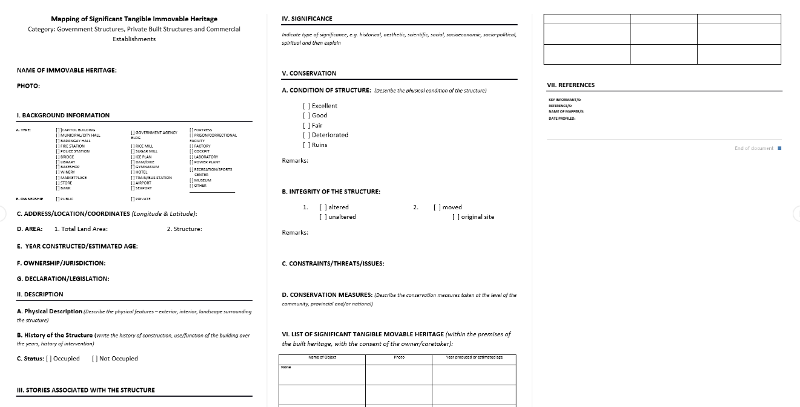

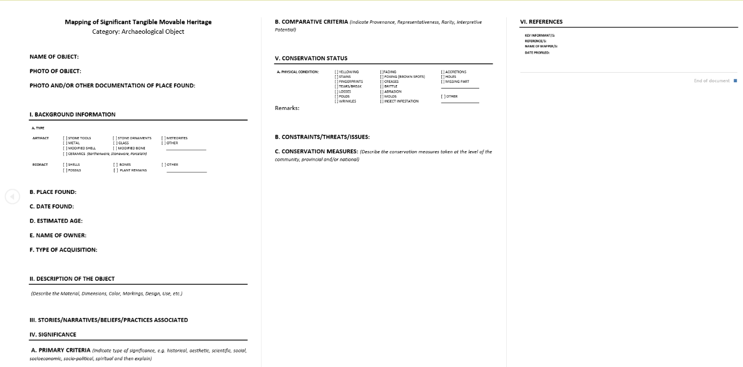
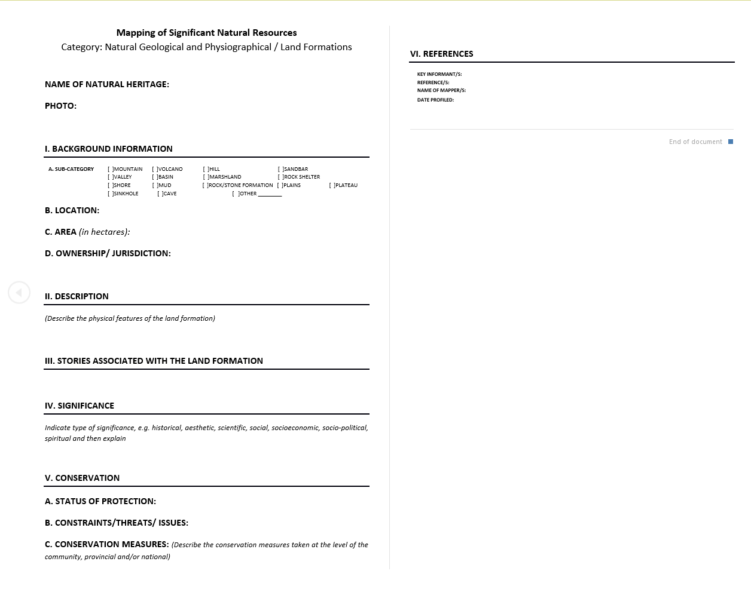

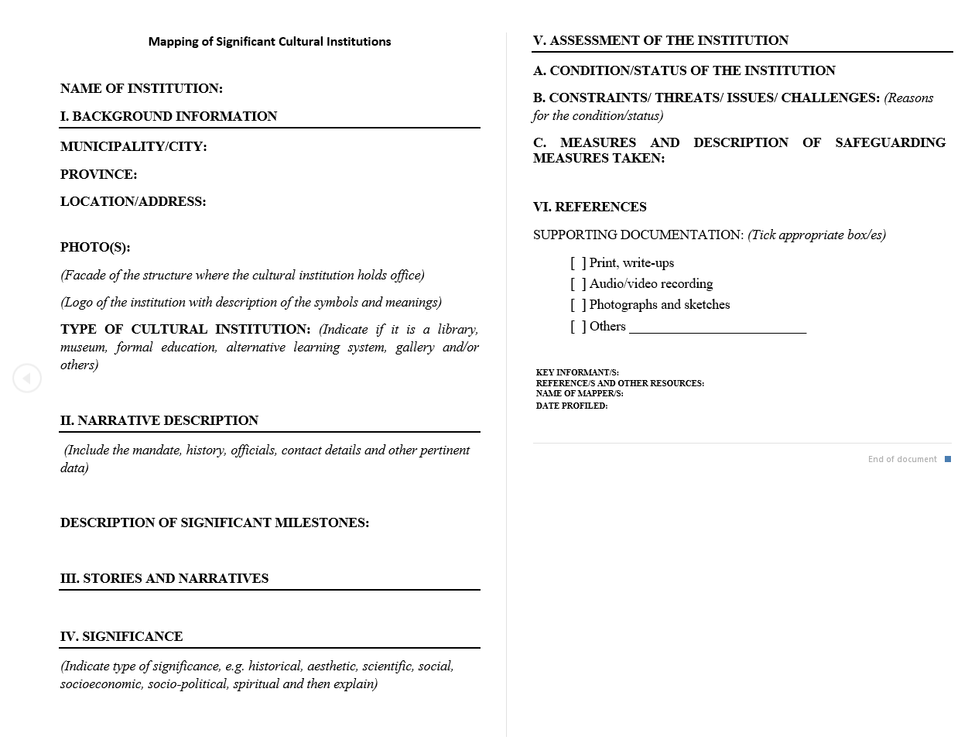

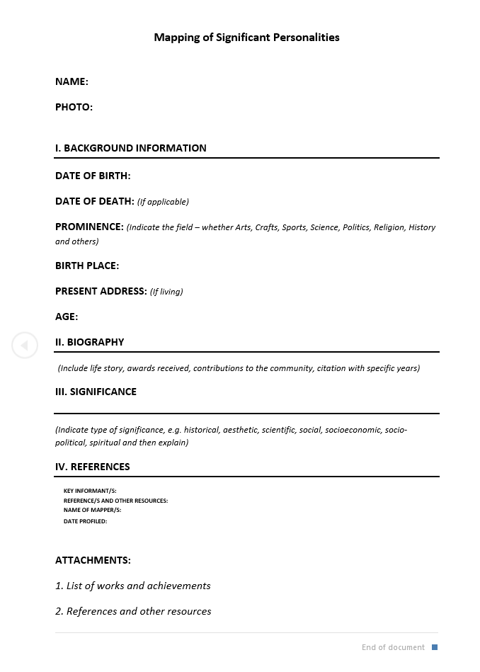

Curriculum Vitae

JEM CARLO G. AUSTRIA
09538563123
Jemcarlo46@gmail.com
Mangatarem, Pangasinan

OBJECTIVES
I am an energetic software developer with hands-on experience building useful automation tools, management portals, and responsive developer utilities. I have a strong background in Python-driven backend development, database management, and document processing. I turn complex workflows—like automated exam generation and UI builders—into clean, reliable, and user-centric software solutions.
EDUCATIONAL BACKGROUND
Tertiary : Binalatongan Community College (2023 – 2026)
Brgy, Ilang, San Carlos City, Pangasinan
Bachelor of Science in Information Technology
Secondary : Mangatarem National High School (2016– 2021)
TVL-ICT
Brgy, Mangatarem Pangasinan
Primary : Mangataren Elementary School (2016)
Brgy, Mangatarem Pangasinan

PERSONAL BACKGROUND
Age : 22
Sex : Male
Birthday : September 13, 2003
Birthplace : San Carlos City, Pangasinan
Religion : INC
Citizenship : Filipino
Civil Status : Single
Language : English, Tagalog
SKILLS
- Programming Languages: Python
- Database & Hosting: Supabase,Github,Vercel, and Render
- Libraries & Frameworks: HTML Library, AOS (Animate On Scroll),Franken UI, and swal2 alerts
- Tools & Package Management: UV Package Manager
- Development Techniques: Lazy loading and skeleton screen loading
ACHIEVEMENTS/CERTIFICATES:
- Co-developed an Interactive Digital Cultural Map and Local Tourism Information System for Mangatarem, managing local registries and cultural assets.
- Built an AI Flashcard Maker & Exam Simulator that parses PDFs and extracts unstructured data into structured question-and-answer pairs.
- Defended the Capstone Project 1 proposal successfully in early 2026.
- Participated in local cybersecurity webinars on October 25, 2025.
REFERENCE
Lani C. Liberato
OIC Municipal Civil Registrar
Local Civil Registry (LCR) Office


MARY JANE F. DALAS
09090902796
maryjanedalas02@gmail.com
068 Abanon, San Carlos City, Pangasinan

OBJECTIVES
To obtain a position where I can utilize my knowledge, skills, and abilities while gaining valuable experience and contributing to the growth and success of the organization.
EDUCATIONAL BACKGROUND
Tertiary : Binalatongan Community College (2023-2026)
Brgy. Ilang, San Carlos City, Pangasinan
Bachelor of Science in Information Technology (BSIT)
Secondary : Abanon National High School (2018 - 2020)
Brgy. Abanon, San Carlos City, Pangasinan
TVL - ICT
Primary : Abanon National High School (2014 - 2028)
Brgy. Abanon, San Carlos City, Pangasinan
PERSONAL BACKGROUND
Age : 26
Sex : Female
Birthday : February 11, 2000
Birthplace : Lingayen, Pangasinan
Religion : Roman Catholic
Citizenship : Filipino
Civil Status : Single
Language : Filipino, English
SKILLS
- Teamwork
- Decision-making skills
- Good understanding and adaptability
- Communication skills
- Creativity

ACHIEVEMENTS/CERTIFICATES:
- Computer Systems Servicing NC II
- Certificate in ICT-related Training
- On-the-Job Training (OJT)
REFERENCE
Mary Anne Kimper U. Cabuenos
Secretary of the Campus Executive Director
Pangasinan State University


JOY R. DE GUZMAN
0992-796-0952
deguzmanjoy905@gmail.com
Purok 2, Macayocayo Bayambang Pangasinan

OBJECTIVES
To begin my professional career in the field of Information Technology and contribute my technical expertise, adaptability, and willingness to learn in achieving company goals.
EDUCATIONAL BACKGROUND
Tertiary : Binalatongan Community College (2025 – 2026)
Brgy, Ilang, San Carlos City, Pangasinan
Bachelor of Science in Information Technology (BSIT)
Secondary : Basista National High School (2020 – 2021)
HUMSS
Brgy.Macayocayo Bayambang Pangasinan
Primary : Macayocayo Elementary School (2015- 2016)
Brgy.Macayocayo Bayambang Pangasinan

PERSONAL BACKGROUND
Age : 22
Sex : Female
Birthday : May 12, 2004
Birthplace : Bayambang Pangasinan
Religion : Roman Catholic
Citizenship : Filipino
Civil Status : Single
Language : Filipino, English
SKILLS
- Computer literate
- Ability to work under pressure
- Quick learner
ACHIEVEMENTS/CERTIFICATES:
- DATA ANALYTICS NCII


REA D. SOLIS
0926-354-1075
srea75347@gmail.com
#203 Purok 6, Talang San Carlos City Pangasinan

OBJECTIVES
To obtain a position where I can apply my knowledge and skills in Information Technology, contribute to the organization's success, and gain valuable experience while continuously developing my technical and professional abilities.
EDUCATIONAL BACKGROUND
Tertiary : Binalatongan Community College (2022 – 2026)
Brgy, Ilang, San Carlos City, Pangasinan
Bachelor of Science in Information Technology
Secondary : San Luis High School (2020-2022)
ABM
Brgy. Talang San Carlos City, Pangasinan
Primary : Talang Elementary School (2010 - 2016)
Brgy. Talang San Carlos City, Pangasinan

PERSONAL BACKGROUND
Age : 21
Sex : Female
Birthday : August 5, 2004
Birthplace : San Carlos City, Pangasinan
Religion : Roman Catholic
Citizenship : Filipino
Civil Status : Single
Language : Filipino, English
SKILLS
- Designing
- Typing Skills
ACHIEVEMENTS/CERTIFICATES:
- Computer Systems Services NCII
REFERENCE
Josephine D. Reyes
Dean, CHMBAC
0915-997-6581
Pangasinan State University - San Carlos Campus

