

Interactive Digital Cultural Map and Local Tourism Information System for Mangatarem, Pangasinan

Submitted by:
Jem Carlo Austria
Mary Jane Dalas
Rea Solis
Joy De Guzman

Team B3

Chapter 1: Introduction

Background of the Study
Many local leaders struggle with old ways of managing history and tourist spots. We've noticed that paper records often keep the community in the dark. A recent study shows that towns with a strong web presence get much more attention than those that don't (Wilson, 2025). So, we're writing this to show how a centralized system can change that.

Our goal is to look at how computers help local offices run better and keep their culture alive. We designed this guide for staff who want to move away from slow, manual work like filing paper forms or hunting through old folders. Our main result is a process that takes cultural data from old files and puts it into things like digital maps, searchable databases, and virtual tours. We want to make it easier for you to share your town's story with the rest of the world.

Moving to a digital setup involves a mix of leadership, community habits, and technical skills. We see this as a big change that connects a town's past with its future (Reyes, 2024; Smith, 2023). Experts say this shift dramatically changes how people experience local heritage (Cruz, 2022). We want to explore these factors more deeply to help you build a system that actually lasts.

We chose the Local Government Unit (LGU) of Mangatarem, Pangasinan as our research locale because it serves as the heart of tourism and cultural management for the town. Mangatarem is a first-class municipality with a deep history and natural landmarks like the Manleluag Spring National Park. Many local offices today struggle to keep their records organized, which often leaves the community in the dark about their own heritage. So, we're focusing our work here to help the LGU move away from manual, paper-based filing.

The LGU is the perfect spot for our study because the tourism office acts as the main hub for every barangay’s unique traditions and data. We found that this office provides a well-organized and professional environment where we can easily coordinate with officials to verify historical facts. By working directly in these municipal spaces, we can ensure the cultural data we collect is accurate and reflects the town's true identity. We've designed this process to take those old physical files and turn them into digital maps and searchable databases that you can access easily.

Moving to a digital system isn't just a simple technical update; it's a vital change that connects a town's past with its future (Reyes, 2024; Smith, 2023). Experts often see this transition as an impactful phenomenon where the way people experience local heritage is dramatically changed (Cruz, 2022). We're exploring these factors to make sure the town's cultural assets are preserved for a much wider audience. And since the LGU is the primary decision-maker, our goal is to provide them with a system that actually works for the long term.

Encountered Problems
We've noticed that the LGU of Mangatarem struggles to keep tourism info fresh. Right now, workers rely on manual tasks and messy habits. When barangay leaders want to share an update, they send text messages or make quick phone calls. Sometimes they even hand over physical papers. This makes it hard for the main tourism office to verify everything quickly. A recent study shows that when information is scattered like this, visitors often get confused by conflicting details they find online (Wilson, 2025). We see that this slow, traditional way of talking to stakeholders delays big events and seasonal campaigns. It also makes it tough for students to find historical facts because there isn't a central digital spot they can check from home.

To fix these issues, we're building the "Interactive Digital Cultural Map and Local Tourism Information System for Mangatarem, Pangasinan." We designed this system to replace those slow, manual chores with a single web-based platform. Our goal is to make sure every tourist and resident can find the same accurate information in one place. By putting cultural maps and town data online, we can help the LGU work faster and keep their records consistent. Experts often call this move to digital tools an impactful phenomenon that changes how people connect with their heritage (Cruz, 2022). We want to give the town a reliable tool that makes Mangatarem's culture easy to explore for everyone.

Purpose and Description
This Capstone Project was conducted in order to centralize and digitize the tourism and cultural information of Mangatarem, Pangasinan. We want to provide an easy, interactive platform that cleans up the way data is managed while making the town’s heritage easy for everyone to find.

Once the proposed Interactive Digital Cultural Map and Local Tourism Information System for Mangatarem, Pangasinan is implemented to the Local Government Unit (LGU) of Mangatarem, it will hold particular significance for the following beneficiaries:

- Administrative and Stakeholder Users (LGU Tourism Office and Barangay Representatives) – This category is the primary beneficiary, as it provides a centralized platform for the LGU to promote tourism and manage cultural data. It allows the Tourism Office staff to verify facts from every barangay, ensuring the public receives accurate and authoritative information. Barangay representatives benefit from a dedicated portal to directly upload content, streamlining the flow of information from the grassroots level to the municipal dashboard.
- General Public and Academic Users (Tourists, Visitors, and Researchers) – This category benefits from an interactive and educational tool to explore Mangatarem’s heritage. Tourists gain a mobile-responsive map to discover landmarks and plan their visits, while students and researchers can access a digital archive of cultural profiles and historical records from any location, eliminating the need for physical travel to the tourism office for basic data gathering.

- Residents of Mangatarem – The community at large gains a digital safeguard for their traditions and festivals, fostering local pride and ensuring that their heritage is preserved in a secure, accessible format for future generations.

We see that the current way of using text messages and paper forms is just too slow. It leads to mistakes and leaves people confused when they find old information online. By using digital maps and a single format, we're building a source of truth for the whole town. We assume this computing solution will effectively fix these communication gaps and give the LGU a modern, impactful way to manage its cultural treasures.

Objectives of the Study
The main objective of the study is to design and develop an Interactive Digital Cultural Map and Local Tourism Information System for the Local Government Unit (LGU) of Mangatarem, Pangasinan. We want to build a tool that makes it easy for the town to manage its history and tourist spots while moving away from slow, manual chores.

Furthermore, the developers aim to achieve the following specific objectives:

- To analyze the existing process of how the town currently collects and shares tourism and cultural facts to identify where things get messy and where we can make improvements.
- To identify the key features of the system for the following user categories:
  - Administrative and Stakeholder Users (LGU Staff and Contributors)
  - General Public and Academic Users (Visitors and Researchers)
- To test and evaluate the system’s functionality, performance, security, usability, and acceptability to ensure it meets user requirements and professional standards.
- To prepare an implementation plan for the deployment of the system so the LGU can start using it effectively.

Conceptual Framework
We're using the Input-Process-Output (IPO) model to map out exactly how we'll build this system from the ground up. It’s a simple way to show the raw ingredients we need, the steps we'll take to build the code, and the final platform we'll deliver to the town. Think of it as a roadmap that connects our technical tools with the actual work of creating the cultural map. By following this model, we can make sure every piece of the project fits together and solves the real problems the LGU is facing.

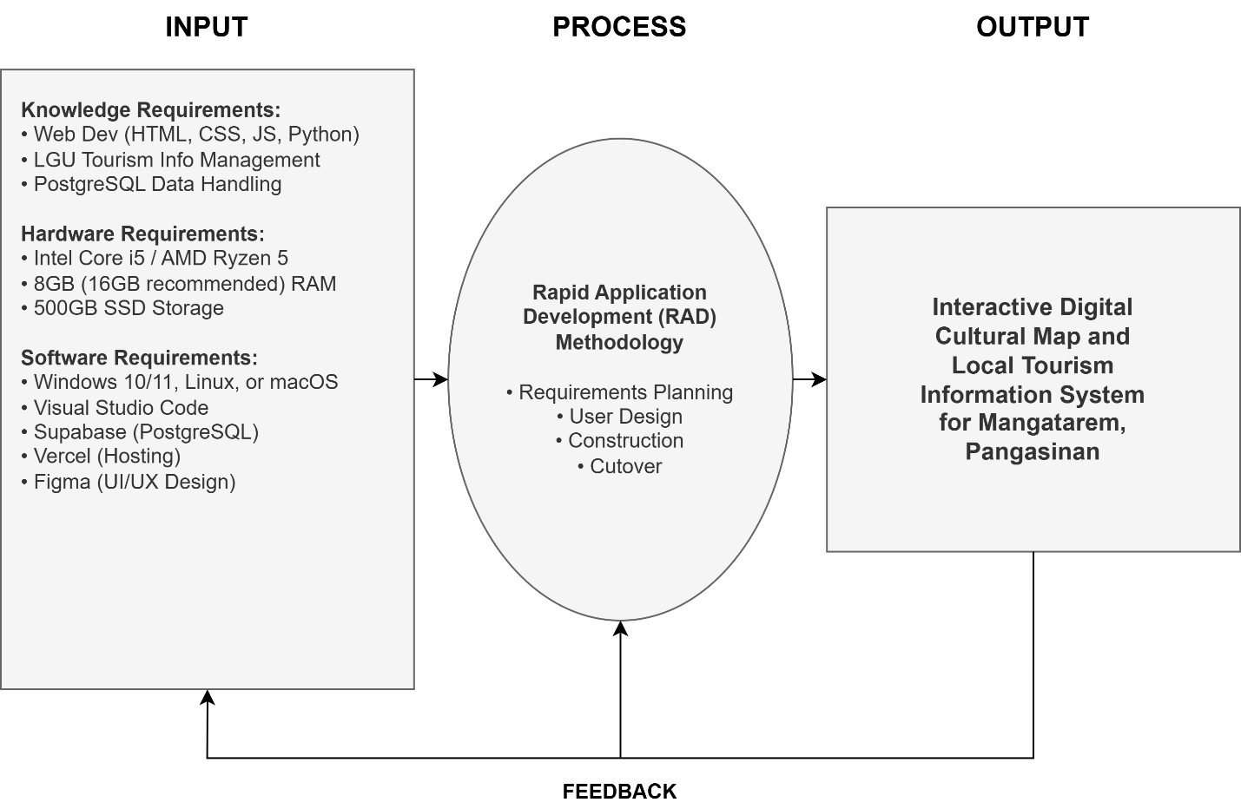

The plan above shows how the project flows. The Inputs are the tools and knowledge we need to start. These feed into the Process, where we build and test the site in small steps. This makes sure the final result—the Digital Cultural Map—works well for the Mangatarem LGU and its people. The feedback loop ensures that any issues found during testing can be fixed to keep making the system better.

Scope and Limitations

Scope
The project focuses on the development of a web-based Interactive Digital Cultural Map and Local Tourism Information System for the Local Government Unit (LGU) of Mangatarem, Pangasinan. The system will be built utilizing web technologies including HTML, CSS (Tailwind CSS), and JavaScript for the frontend interface, Python with the Flask framework for server-side application logic, and PostgreSQL as the primary relational database management system — managed via Supabase for cloud-native persistence and real-time features. Figma will be utilized for user interface and user experience design during the prototyping phase. The key functionalities provided by the software include a public-facing interactive map where the Public and Academic category can browse, locate, and filter tourist attractions and cultural heritage sites by category such as historical landmarks, natural attractions, and local events. For Administrative and Stakeholder users, the system features a decentralized content contribution portal that allows authorized Barangay Representatives to submit, upload, and propose updates for local tourism content, alongside a centralized administrative dashboard for LGU Tourism Office staff to moderate all submissions through an approve-or-reject workflow, manage user accounts, and publish municipal-wide tourism announcements. Students and researchers within the public category are provided with structured access to archived cultural profiles and historical records to support academic data gathering and heritage research.

Limitations
While the system aims to provide comprehensive tourism information management for Mangatarem, it will not include online booking, reservation, or payment gateway functionalities for local accommodations, tour guides, or event ticketing. The interactive map and all system features require an active internet connection; full offline capabilities such as cached map tiles or offline content browsing are not within the scope of this project. Performance and scalability are designed to accommodate the expected volume of tourist traffic and barangay-level content contributions typical of a municipal tourism platform, but the system is not engineered to handle extreme traffic surges beyond standard municipal usage without future server infrastructure upgrades. Access to the content contribution and moderation modules is strictly restricted to authenticated and authorized LGU personnel and registered Barangay Representatives, meaning the general public cannot directly create, edit, or publish map data without going through the LGU approval workflow. The system is also limited to the geographic and administrative boundaries of Mangatarem, Pangasinan, and does not cover tourism data from neighboring municipalities or provinces.

Definition of Terms
For clarity and consistency, the following key terms are defined operationally as they are used in this study:

- Administrative and Stakeholder Users — This consolidated category refers to the LGU Tourism Office staff (System Administrators) and authorized Barangay Representatives (Contributors) who hold internal access to the system. This category is responsible for submitting, reviewing, and approving cultural heritage data, managing the platform's operational integrity, and overseeing the municipality's digital tourism presence.

- General Public and Academic Users — This category refers to tourists, visitors, students, and researchers who access the system to navigate the interactive map, search for points of interest, and view published cultural and tourism information. These users consume the data for leisure, travel planning, or academic data gathering without requiring administrative privileges.

- Interactive Digital Cultural Map — The core feature of the system that provides a visual, geographical, and navigable representation of tourist spots, historical landmarks, natural attractions, and cultural heritage sites within the municipality of Mangatarem, Pangasinan. Users can interact with the map by clicking pins, filtering categories, and viewing detailed multimedia information for each location.

- Local Government Unit (LGU) — In this study, this refers specifically to the municipal government of Mangatarem, Pangasinan, serving as the main beneficiary, authoritative body, and decision-maker over the tourism information system and its content governance policies.

- Public User — Refers to tourists, visitors, or any general member of the public who accesses the system to navigate the interactive map, search for points of interest, and view published cultural and tourism information without requiring a registered account or administrative privileges.

- Rapid Application Development (RAD) — The software development methodology selected for this study, characterized by rapid prototyping, iterative feedback cycles, flexible requirements gathering, and continuous stakeholder involvement to accelerate system construction while maintaining alignment with user needs.

- Content Moderation — The process by which the System Administrator reviews content submissions from Barangay Representatives and decides whether to approve, reject, or request revisions before the content is published on the public-facing interactive map.

Review of Related Literature
We’ve gathered these studies to back up our goals for the Mangatarem project. We focused on research from 2020 to 2025 that shows why digital maps and better data management are so vital. We’ve organized these into local and foreign studies to show how they help us hit our four main objectives.

Local Studies
Existing Tourism Information Management Processes in Philippine LGUs

Soncuya (2020) looked at how groups like the NCCA and local offices work together on cultural maps. He found that many towns still use messy, split-up methods that lead to wrong data. But he also showed that a clear legal plan helps these projects last. This helps us with our first objective because it proves we need a structured way to report facts in Mangatarem.

Coro II and his team (2022) studied how Siargao moved to a digital setup. They found that the system actually worked because they got local leaders involved from the start. This supports our work because it shows that a digital platform helps rural towns stay accurate and organized. It gives us a real-world example for our fourth objective on how to roll out the system.

Zuniga (2023) tested how provincial maps work when you mix history with GPS data. He found that letting local people upload info—while experts checked it—made the data much better. This confirms our plan for the second objective, where we let barangay leaders be the ones to share their own local stories.

Usability, Intangible Heritage, and System Acceptance

De Vera and her colleagues (2022) looked at how local festivals help a town’s economy and pride. They discovered that putting these events online makes people much more interested. This backs up our second and third objectives since we want to include things like event calendars and photo galleries to see if users find them helpful.

Mendoza (2021) pointed out the big hurdles in saving a town's history, like running out of money or not having a plan to keep the site running. She suggested that a town needs the community's help to keep things alive. This helps us with our fourth objective because it warns us about what could go wrong if we don't have a solid maintenance plan.

Foreign Studies
Digital Transformation and Technological Frameworks

Kumar and Singh (2022) built a web map that used old photos to show how a place changed over time. They found that seeing "then and now" photos makes users feel more connected to the history. This fits our first and second objectives because it gives us a technical model for how our map can show Mangatarem’s past.

Chen and his fellow researchers (2024) found that maps with stories and galleries kept people looking 40% longer than plain sites. They argued that a good-looking site is the biggest reason people keep coming back. This helps us with our second objective by proving that things like photo galleries are vital features for our map.

User-Centric Design and Evaluation Standards

Wang (2023) explained that you can't just map buildings; you also have to map traditions and festivals. He showed that a town runs much better when its data includes both physical spots and local habits. This supports our second and third objectives by giving us a framework for what kind of categories we should use on our site.

Tan (2023) built a travel site that suggested places based on what users liked. He found that if a site is easy to use from the start, people won't fight the change. He also suggested making the software in parts so it's easy to update later. This helps us with our second and fourth objectives as we plan out our filters and how we'll deploy the system.

Petrovic (2022) looked at how to keep heritage sites safe in tropical areas using software. He found that systems that let people monitor conditions regularly were much more accurate. This backs up our third and fourth objectives because it shows why we need to test our security and have a plan for regular data updates.

Chapter 2: Methodology and Design
This chapter details the development methods and design strategies we used to create the Interactive Digital Cultural Map and Local Tourism Information System for Mangatarem, Pangasinan. We want to provide a clear record of our technical decisions and the specific steps we took to deliver a functional tool for the LGU.

Software Development Methodology
In software engineering, a Software Development Methodology (SDM) is like a clear roadmap for a project. Without it, a team can easily lose focus, miss deadlines, or build features that nobody actually needs. For our project in Mangatarem, having this structure helps us stay organized while we plan, code, and test the digital map. It makes sure we're actually building a tool that fits the LGU’s workflow and that the final product is impactful for the whole community.

We chose Rapid Application Development (RAD) and combined it with a Participatory GIS (PGIS) framework. We picked this because it focuses on building prototypes and getting feedback quickly rather than spending months just planning on paper. Since tourism data and the needs of our barangay leaders can change as they see the site evolve, RAD lets us adapt fast. By using PGIS, we also make sure the community has a say in how we represent their local culture on the map, which makes the data much more accurate.

RAD is an agile way of working that prioritizes quick delivery and user feedback. Instead of trying to get every detail perfect at the start, we build small, working versions of the system and refine them over and over. It's known for keeping the people who will actually use the system involved every step of the way. This method is perfect for projects where the look and feel of the site are vital and where we expect to make changes as users interact with our early designs.

We've broken down our work into these four RAD phases:

- Requirements Planning: We started by meeting with the LGU Tourism Office staff to find the gaps in their current manual filing system. We identified the main goals and defined the two primary user categories: Administrative and Stakeholder Users (LGU staff and Barangay Contributors) and General Public and Academic Users (Tourists and Researchers). We used interviews and site visits to make sure we didn't miss any important cultural traditions or landmarks that the town wants to highlight.
- User Design (Prototyping): Once we knew what the system needed, we used Figma to create mockups and wireframes. We built designs for the interactive map (Public/Academic interface) and the data management portals (Administrative/Stakeholder interface). We showed these to the LGU staff and barangay reps to see if they found the buttons and menus easy to navigate. We used their feedback to change the layout until it felt just right.
- Construction: This is the phase where we did the actual coding. We used HTML, Tailwind CSS, and JavaScript for the parts you see on the screen, and Python with Flask for the logic and database work. We stored all the town's information in Supabase. We built the interactive map and created the "approve or reject" moderation workflow for the administrative users. We coded and tested in small cycles so we could catch and fix bugs early.
- Cutover (Testing and Deployment): In this final stage, we perform functional, security, and usability tests to make sure the site is safe and fast. Once we resolve any issues, we’ll launch the system for the LGU. We’ll also hold training sessions for the Administrative and Stakeholder category (LGU staff and barangay leaders) and give them user manuals so they feel comfortable running the site on their own.

Sources of Data
The primary sources of data for this project are individuals, groups, and locations within the municipality of Mangatarem, Pangasinan that hold crucial tourism, cultural, and historical information relevant to the system. Key data sources include:

- LGU Tourism Office Staff — Municipal tourism officers who provide official tourism policies, existing manual records, promotional materials, and municipal-level tourism initiatives. They serve as the authoritative source for content moderation rules, user access policies, and platform governance requirements.
- Barangay Officials and Representatives — Designated individuals from each barangay who serve as vital sources for localized cultural data, specific landmark descriptions, community event schedules, and grassroots heritage information that is not centrally documented at the municipal level.
- Manleluag Spring National Park and Other Tourist Sites — Physical locations within Mangatarem that serve as points of reference for mapping coordinates, photographic documentation, and on-site observation of existing visitor information systems (e.g., signage, brochures).
- Municipal Archives and Physical Records — Existing physical tourism brochures, printed municipal profiles, historical documents, and past tourism reports maintained by the LGU, which serve as secondary data sources to establish the initial database content of the system.

Data Gathering Techniques
To make sure we built a system that actually solves the town's problems, we used several different ways to collect information. We didn't want to just guess what the LGU needed, so we went straight to the people who handle Mangatarem’s tourism every day.

Interviews We sat down for face-to-face talks with the staff at the Municipal Tourism Office to get their firsthand stories.

How: We used an interview guide with open-ended questions about their daily tasks, the problems they run into, and what features they wish they had. We met with them in person at the LGU office so they could show us exactly how they handle their current workload.

When: We did this during the Requirements Planning phase. It was the very first thing we did before we even started sketching designs or writing code.

Why: We used this technique to hear about the "pain points" that only a worker would know. It helped us understand their manual workflow so we could design a digital version that actually makes their lives easier.

Observation We spent time at the office just watching how the staff handles their work in real-time.

How: We visited the LGU Tourism Office and took notes on how they answer tourist questions, how they organize their data, and where the "bottlenecks" are in their current system.

When: We did this at the same time as our interviews. This allowed us to see if the work they described matched what they actually did on a busy day.

Why: We applied this to catch small, confusing steps that people might forget to mention in an interview. It gave us an objective look at the gaps in their communication that our system needs to fill.

System Design

System Architecture
The System Architecture diagram provides a high-level structural overview of the Interactive Digital Cultural Map and Local Tourism Information System. It defines how the different technological components — from the user's device to the backend database — interact to deliver the system's services. A clear architecture is important because it establishes the blueprint for the system's technical structure, ensuring that all components are properly integrated, scalable, and secure.

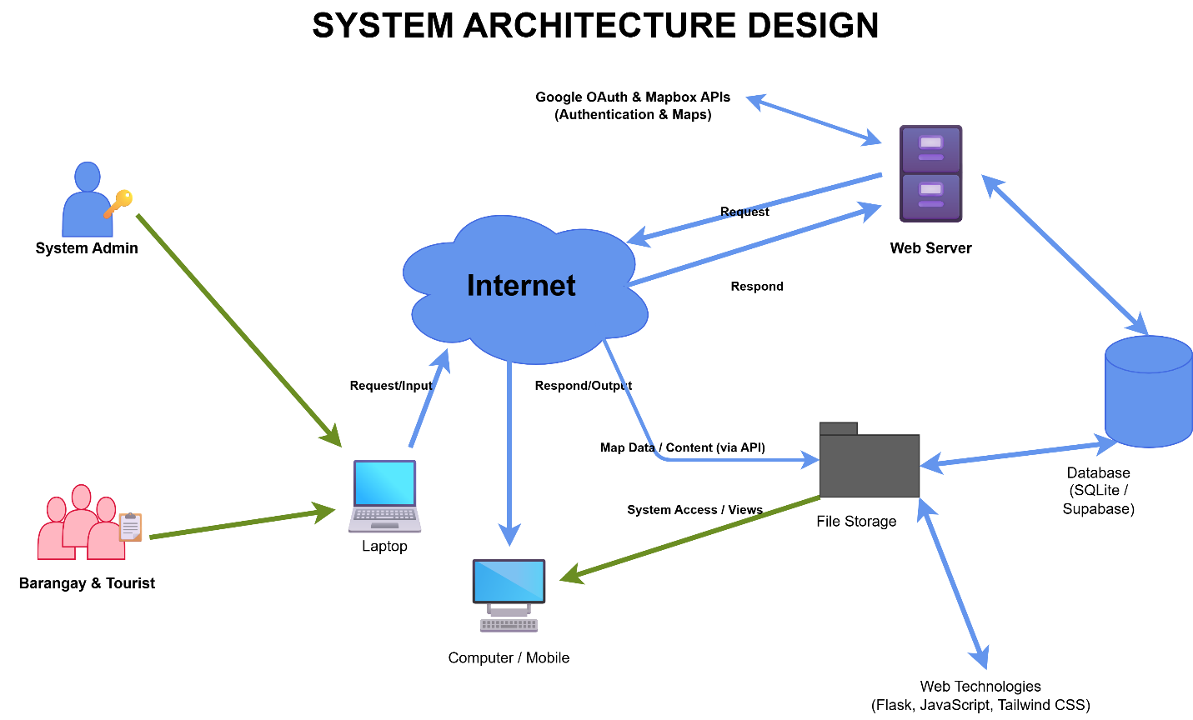

The architecture follows a modern three-tier cloud-native model. At the Client Layer, users — categorized as either Administrative and Stakeholder Users or General Public and Academic Users — interact with the system through standard web browsers. The user interface is built with HTML, CSS (utilizing the Tailwind CSS framework), and JavaScript, with Mapbox GL JS integrated for high-performance spatial visualization. When a user performs an action, the client sends HTTPS requests to the Cloud Platform Layer, hosted on Vercel. The backend application logic is implemented in Python using the Flask framework, running as optimized serverless functions. This layer processes requests such as user authentication,

cultural heritage form validation, and content moderation workflows. The Data Persistence Layer leverages Supabase for its primary PostgreSQL database and object storage, and Upstash for Redis-based caching. This layer stores all persistent data, including user accounts, detailed heritage profiles, business establishment records, and system-wide audit logs. This cloud-native architecture ensures a highly available, secure, and performant separation between the interactive interface and the central data repositories.

Existing Process Flowchart
A flowchart is a graphical representation of a process that uses standardized symbols — such as rectangles for actions, diamonds for decisions, and arrows for flow direction — to illustrate the sequence of steps, decision points, and outcomes. Flowcharts are important in system analysis because they provide a clear, visual understanding of the current (as-is) process, making it easier to identify bottle

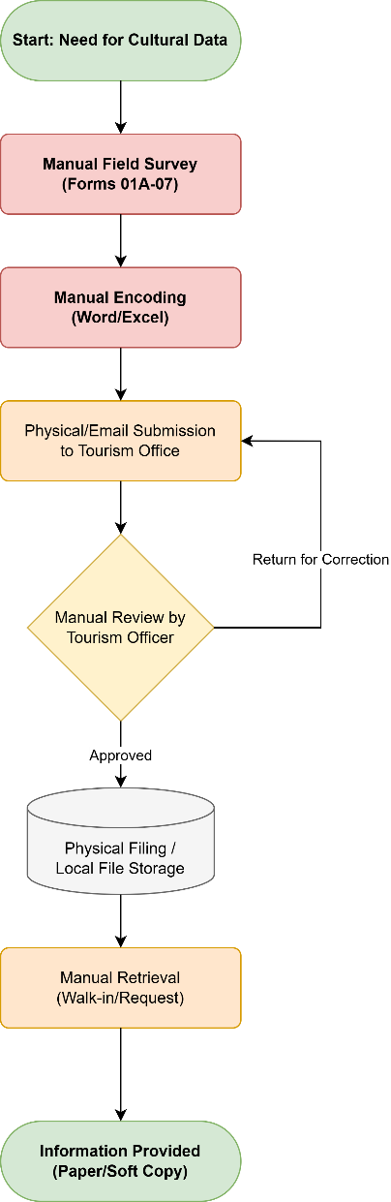

The flowchart illustrates the two primary manual processes currently used in Mangatarem, revealing significant gaps in information accessibility and data synchronization. The first process (Top Path) begins when a tourist seeks information. Currently, the tourist is forced to choose between searching unverified social media pages—which often harbor outdated or conflicting details leading to visitor confusion—or traveling physically to the Municipal Tourism Office. At the office, staff must manually browse through paper-bound records and physical files to answer inquiries. If the relevant file is missing or being used by another officer, the information remains unavailable, resulting in a poor visitor experience.

The second process (Bottom Path) describes the current information reporting workflow from the grassroots level. When a Barangay Representative has a new cultural event or attraction update, they must either prepare a physical report for delivery or send informal messages via text or social media. This non-standardized communication forces LGU Tourism staff to manually consolidate disparate data formats. Any missing information necessitates a repetitive cycle of phone calls and follow-ups, causing significant time lags. By the time the LGU updates its printed brochures or social media posts, the information is often already weeks old. This flowchart demonstrates that the current reliance on manual, physical-first documentation is the root cause of the municipality's fragmented and delay-prone tourism information ecosystem.

Dataflow Diagram (DFD)
A Dataflow Diagram (DFD) is a graphical tool used to visualize how data moves through a system. It identifies where data originates (external entities), how it is processed (processes), where it is stored (data stores), and the paths it follows (data flows). DFDs are important in system design because they provide a clear, logical representation of the system's data handling without getting into implementation details, making it easier for both developers and stakeholders to validate that all data requirements are covered.

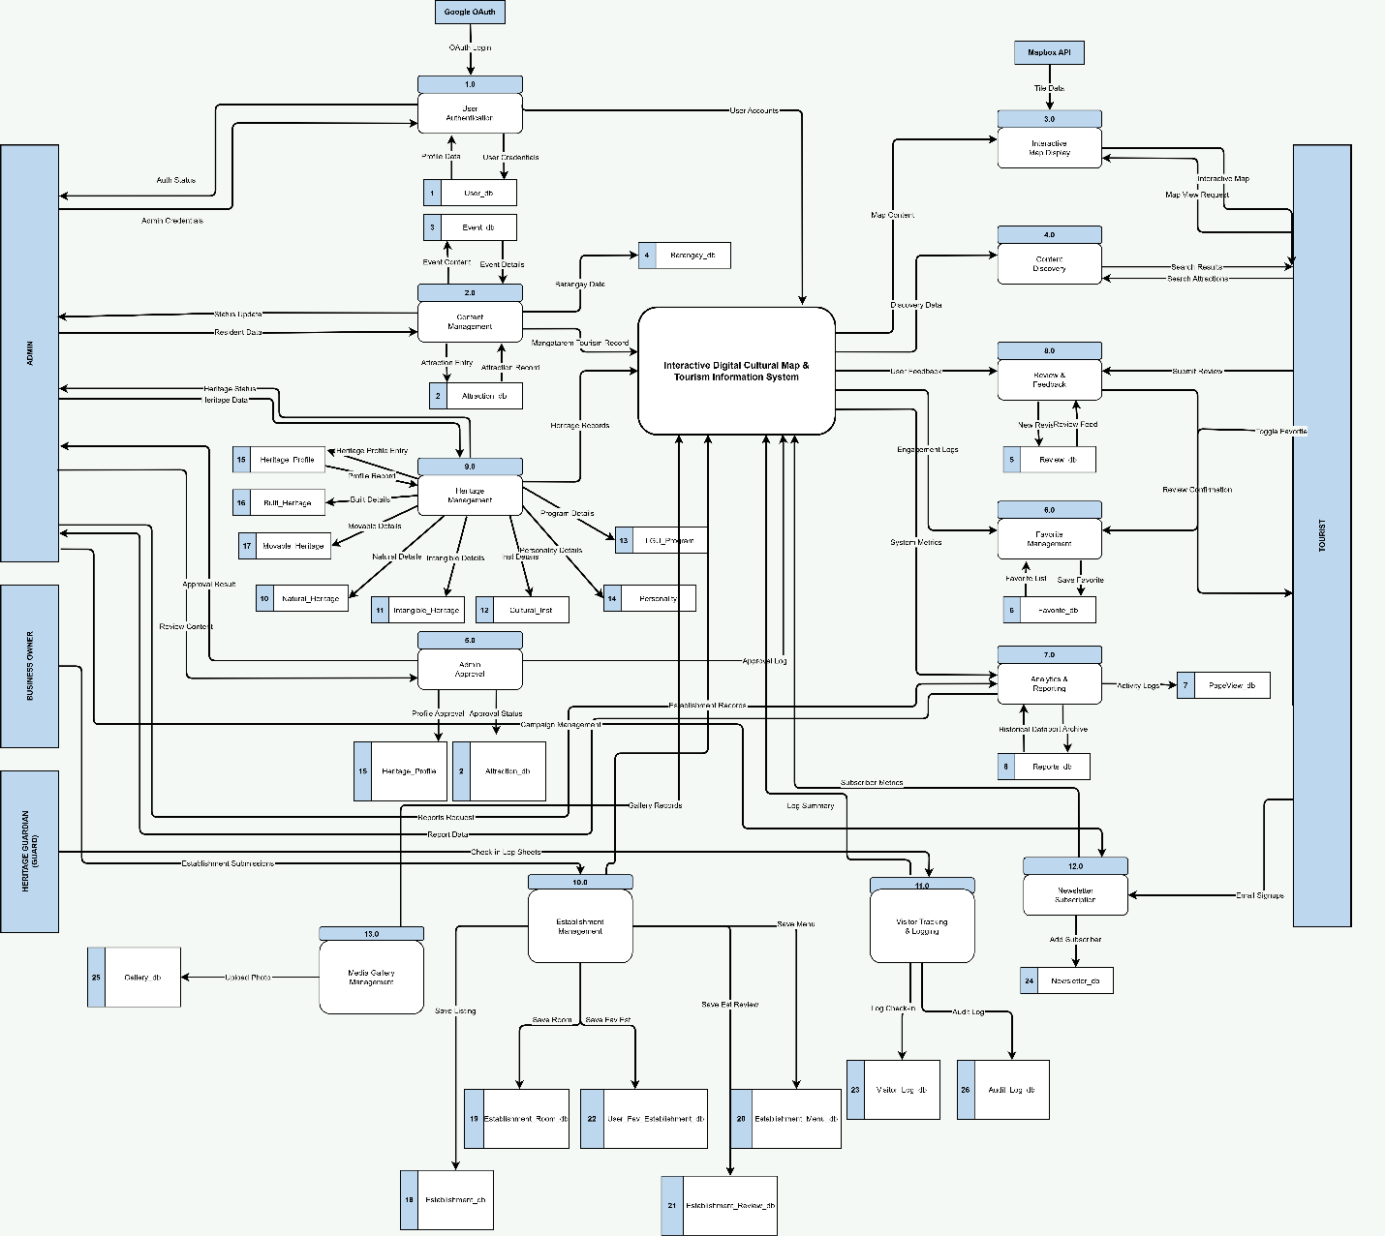

The DFD details the interactions between the main external entities and the system processes. General Public and Academic Users (EE1), including tourists and researchers, send search queries and browse requests to Process 1.0 (Search & Browse), which forwards these to the Main System. Process 4.0 (Data Retrieval & Display) retrieves map data, points of interest details, and cultural profiles from the system and returns them to the user. Administrative and Stakeholder Users (EE2) submit new content and manage system data. This entity encompasses Barangay Representatives who submit content through Process 2.0 (Content Submission) and LGU Tourism Admins who interact with Process 3.0 (Content Moderation) to review and approve submissions. Process 3.0 either commits the approved data to Data Store D2 (Tourist Spots & Cultural Data) or sends a rejection notice. The system also maintains Data Store D1 (User Accounts & Roles) for authentication and access control across all categories.

Entity-Relationship Diagram (ERD)
An Entity-Relationship Diagram (ERD) visually represents the logical structure of a database by defining the entities (tables), their attributes (columns), and the relationships that connect them. ERDs are important in database design because they provide a clear, conceptual blueprint of how data is organized, ensuring data integrity, eliminating redundancy, and establishing the foundation for writing efficient database queries.

In database design, the ERD serves several critical functions:
Conceptual Blueprint: It acts as a clear visual mapping that bridges the gap between high-level business requirements and low-level physical database schemas, serving as a single source of truth for both developers and administrative stakeholders.
Data Integrity and Normalization: By defining primary keys and foreign keys, the ERD ensures that data integrity constraints are systematically planned, eliminating data redundancy and minimizing structural anomalies.
Query Efficiency: A well-structured ERD facilitates the writing of optimized SQL queries, as developers can easily trace foreign key paths and predict execution costs for multi-table joins.
Scalability: It establishes a clean, modular foundation that allows the system to scale smoothly, accommodating new features and entities without disrupting existing relationships.

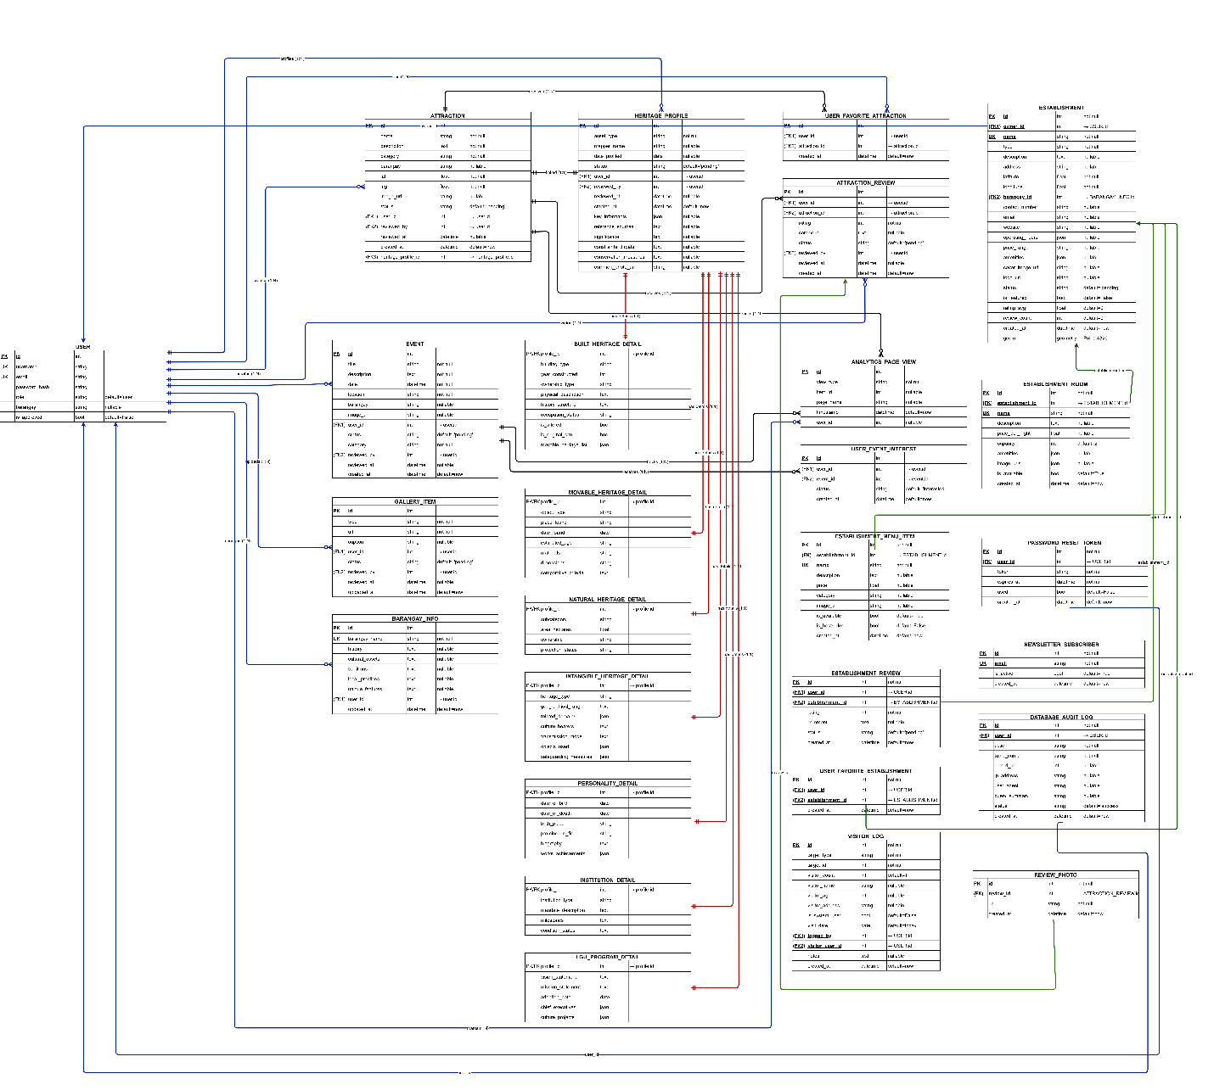

The system's database schema consists of fifteen highly integrated tables. To understand the operational flow and data governance, these components are analyzed below through their Entities, Attributes, and Relationships:

A. Entities (Uppercase, Singular Form)

Each entity represents a distinct domain concept in the system. The 15 core entities are defined as follows:

1. `USER`: A singular authenticated account representing system users across distinct roles (Admin, Barangay Contributor, Business Owner, Guard).

2. `PASSWORD_RESET_TOKEN`: A short-lived, secure token used to facilitate self-service account recovery and security verification for a `USER`.

3. `BARANGAY_INFO`: The geographic, spatial, and administrative anchor representing a specific barangay in Mangatarem, Pangasinan.

4. `HERITAGE_PROFILE`: The official cultural heritage registry profile matching the national standards of documentation (Form 01-07) for tangible and intangible heritage.

5. `ATTRACTION`: A visitor-facing profile of a local tourist destination or significant cultural asset.

6. `EVENT`: A scheduled local cultural festival or calendar event.

7. `ESTABLISHMENT`: A local business directory entry representing a hospitality or dining vendor (hotels, restaurants, etc.).

8. `ESTABLISHMENT_ROOM`: A specific lodging unit or room type offered by an `ESTABLISHMENT`.

9. `ESTABLISHMENT_MENU_ITEM`: A food or beverage offering provided by a dining-focused `ESTABLISHMENT`.

10. `ESTABLISHMENT_REVIEW`: A customer-submitted rating and testimonial review for an `ESTABLISHMENT`.

11. `REVIEW_PHOTO`: A multimedia upload (image/photo) linked to a specific `ESTABLISHMENT_REVIEW` to provide visual validation.

12. `USER_FAVORITE_ESTABLISHMENT`: A joining entity managing the bookmarking/favoriting action of a `USER` for an `ESTABLISHMENT`.

13. `VISITOR_LOG`: A physical check-in security entry representing an individual guest's entry and exit logs at local checkpoints (managed by the Guard role).

14. `NEWSLETTER_SUBSCRIBER`: A visitor-submitted email subscription powering the public newsletter and tourism outreach system.

15. `DATABASE_AUDIT_LOG`: A strict, immutable security log capturing chronological records of administrative modifications to ensure data stewardship accountability.

B. Attributes (Characteristics, Primary Keys, and Foreign Keys)

Attributes define the specific characteristics or columns of each entity:

* Characteristics of Entities: Represented within the entity box, these characteristics represent the properties of the entities.

* Primary Keys (PK): The unique identifier for each record in the entity. In this database schema, the Primary Key is represented first in the attribute box and is underlined (e.g., `id` or `uuid` fields) to enforce entity integrity.

* Foreign Keys (FK): Attributes that reference the Primary Key of another entity, establishing referential integrity and linking the entities dynamically.

For example:

* In the `USER` entity, the primary key `id` is underlined and placed first in the attribute box. The attribute `barangay_id` acts as a Foreign Key (FK) referencing the `id` of the `BARANGAY_INFO` entity, establishing a direct connection between users and their administrative barangay jurisdiction.

* In the `HERITAGE_PROFILE` entity, the attribute `id` is the primary key (underlined and placed first). The attribute `attraction_id` acts as a Foreign Key referencing the `id` of `ATTRACTION`, allowing a cultural registry file to optionally point to its public tourism profile.

* In the `ESTABLISHMENT_ROOM` entity, the primary key `id` is underlined, and the attribute `establishment_id` acts as a Foreign Key linking the room back to its parent `ESTABLISHMENT`.

C. Relationships (Cardinality, Optionability, and Labels)

The connections between entities in this database are characterized primarily by one-to-many (1:N) relationships, which define how records in one table relate to multiple records in another. Each relationship has specific cardinality (mandatory or optional) and logical labels:

1. `USER` to `PASSWORD_RESET_TOKEN`: A 1-to-many (1:N) relationship where one `USER` can request multiple password resets. The relationship is *optional* for `USER` (as users may never request a reset) but *mandatory* for `PASSWORD_RESET_TOKEN` (every token must link back to a valid, existing user). Label: "requests".

2. `BARANGAY_INFO` to `USER`: A 1-to-many (1:N) relationship where one barangay can be associated with multiple administrative users. The relationship is *optional* (a barangay may not have a designated user registered yet). Label: "stewards".

3. `BARANGAY_INFO` to `HERITAGE_PROFILE`: A 1-to-many (1:N) relationship representing the geographic boundaries of cultural preservation. The relationship is *mandatory* for `HERITAGE_PROFILE` (every heritage profile must belong to a specific barangay). Label: "contains".

4. `BARANGAY_INFO` to `ESTABLISHMENT`: A 1-to-many (1:N) relationship where each local business must belong to a barangay. It is *mandatory* for `ESTABLISHMENT`. Label: "locates".

5. `BARANGAY_INFO` to `EVENT`: A 1-to-many (1:N) relationship where multiple festivals or events are anchored to a specific barangay. It is *mandatory* for `EVENT`. Label: "hosts".

6. `HERITAGE_PROFILE` to `ATTRACTION`: A 1-to-1 or optional 1-to-many (1:N) link. A registry profile can optionally associate with a public attraction entry. It is *optional* for `HERITAGE_PROFILE`. Label: "promotes".

7. `ESTABLISHMENT` to `ESTABLISHMENT_ROOM`: A 1-to-many (1:N) relationship where one establishment (hotel/lodge) can have multiple room listings. The relationship is *mandatory* for `ESTABLISHMENT_ROOM` (every room must map to a parent business). Label: "offers".

8. `ESTABLISHMENT` to `ESTABLISHMENT_MENU_ITEM`: A 1-to-many (1:N) relationship where a dining establishment features multiple dishes. It is *mandatory* for `ESTABLISHMENT_MENU_ITEM`. Label: "serves".

9. `ESTABLISHMENT` to `ESTABLISHMENT_REVIEW`: A 1-to-many (1:N) relationship where a business accumulates multiple guest testimonials. It is *mandatory* for `ESTABLISHMENT_REVIEW`. Label: "receives".

10. `ESTABLISHMENT_REVIEW` to `REVIEW_PHOTO`: A 1-to-many (1:N) relationship where a customer can upload multiple photos to validate their review. It is *optional* (a review doesn't require a photo) but *mandatory* for `REVIEW_PHOTO` to reference a valid review. Label: "includes".

11. `USER` to `USER_FAVORITE_ESTABLISHMENT`: A 1-to-many (1:N) relationship representing the bookmarking link. It is *mandatory* for the favorite join record to reference the `USER`. Label: "favorites".

12. `ESTABLISHMENT` to `USER_FAVORITE_ESTABLISHMENT`: A 1-to-many (1:N) relationship. It is *mandatory* for the favorite join record to point to a valid `ESTABLISHMENT`. Label: "is_favorited_by".

13. `USER` to `VISITOR_LOG`: A 1-to-many (1:N) relationship where a guard (represented by `USER`) records multiple tourist check-ins. It is *mandatory* for `VISITOR_LOG` (every check-in must be logged by an authorized user). Label: "logs".

14. `USER` to `DATABASE_AUDIT_LOG`: A 1-to-many (1:N) relationship where administrative actions taken by a `USER` are strictly audited. It is *mandatory* for `DATABASE_AUDIT_LOG` to link back to the responsible user. Label: "audits".

This cohesive, normalized database structure ensures complete referential integrity, strong access controls, detailed security monitoring, and active tourist/commercial integration for the municipality of Mangatarem.

Implementation Plan
The successful deployment of the Interactive Digital Cultural Map and Local Tourism Information System requires a structured implementation plan encompassing a project timeline, a deployment strategy, and a clear definition of resource requirements.

Project Timeline
The development schedule is organized around the four phases of the RAD methodology, with key milestones and expected completion dates for each phase.

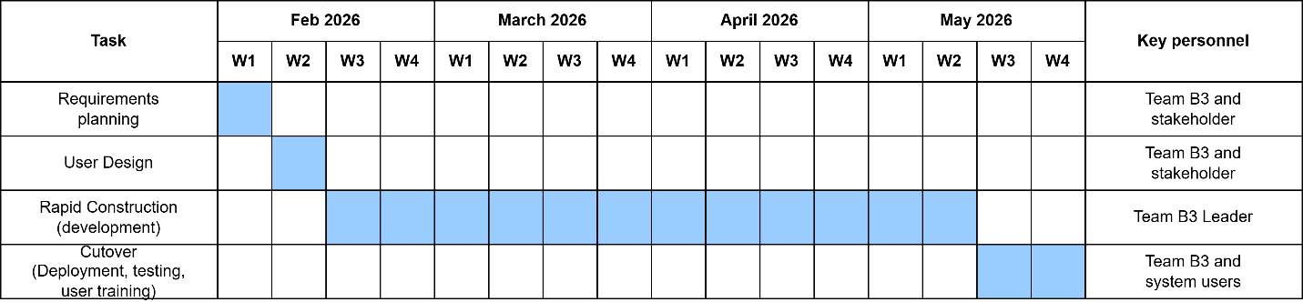

Deployment Plan
The deployment of the system will follow a phased approach to minimize risk and ensure a smooth transition for all stakeholders:

- Pilot Testing (Internal): The system will first be deployed to a staging environment accessible only to the LGU Tourism Office staff and a select group of 3–5 Barangay Representatives. During this phase, the content moderation workflow will be validated end-to-end — from submission by a barangay representative, through admin review, to publication on the map. Feedback from pilot users will be collected and used to make final adjustments to the user interface, form fields, and notification messages.

- Production Deployment: Following successful pilot testing and resolution of identified issues, the system will be migrated to a live production environment. The production setup utilizes Vercel for frontend and serverless backend execution, and Supabase for the managed PostgreSQL database and asset storage. The environment will be configured with automated SSL/TLS certification, production-grade security headers, and an optimized caching strategy using Upstash Redis. DNS records will be configured to point to the Vercel deployment.

- User Training and Launch: A formal training session will be conducted for System Administrators, Barangay Representatives, and Business Owners. Training will cover account management, heritage profiling procedures, business listing updates, and moderation workflows. Printed and digital user manuals will be distributed. Following training, the system will be officially launched to the public via official municipal channels.

- Post-Launch Support: After the public launch, the development team will provide a defined support period (e.g., 30 days) during which bugs, user-reported issues, and minor adjustments will be addressed. A maintenance schedule will be established for regular database backups, software updates, and monitoring of system performance.

Resource Requirements
The following resources are essential for the successful implementation and operation of the system:

Hardware Resources:

- Development machines: A minimum of an Intel Core i5 or equivalent processor with 8GB RAM (16GB recommended) and SSD storage for the development team.
- LGU operator workstation: A desktop or laptop with at least Intel Core i5, 8GB RAM, and a stable internet connection for the designated System Administrator at the Tourism Office.
- End-user devices: Standard smartphones, tablets, or personal computers with web browser access for Public Users, Barangay Representatives, and Students/Researchers.

Software Resources:

- Development environment: Visual Studio Code, Python 3.12+, Git for version control, and the uv package manager for dependency management.
- Design tools: Figma for UI/UX prototyping and wireframing.
- Production environment: Vercel for web hosting and serverless compute, Supabase for PostgreSQL database and object storage, and Upstash for Redis caching.
- End-user software: Updated standard web browsers (Google Chrome, Microsoft Edge, Mozilla Firefox, or Safari).

Human Resources:

- Development team: The capstone project developers responsible for system design, coding, testing, and deployment.
- Category 1: Administrative and Stakeholder Users: Designated LGU Tourism Office staff (System Administrators) and Barangay Representatives (Contributors) responsible for content moderation, technical oversight, and local data submission.
- Category 2: General Public and Academic Users: The intended end-users of the public map and digital atlas, including visitors and researchers.
- Project advisor: The capstone project faculty advisor providing academic guidance and validation throughout the development process.

Chapter 3: Results and Discussion
This chapter shows the results of building and testing the Digital Cultural Map for Mangatarem. It explains how the system works, how we tested it to make sure it is safe and fast, and what the final scores were. By looking at these results, we can prove that the system really helps fix the town's messy paper records.

Proposed System Flowchart
The way the system works is shown in a simple flowchart. This chart serves as a guide to make sure the site does what everyone expects. By showing the paths for different users, the chart helps us move from slow paper files to a shared digital system for the whole community.

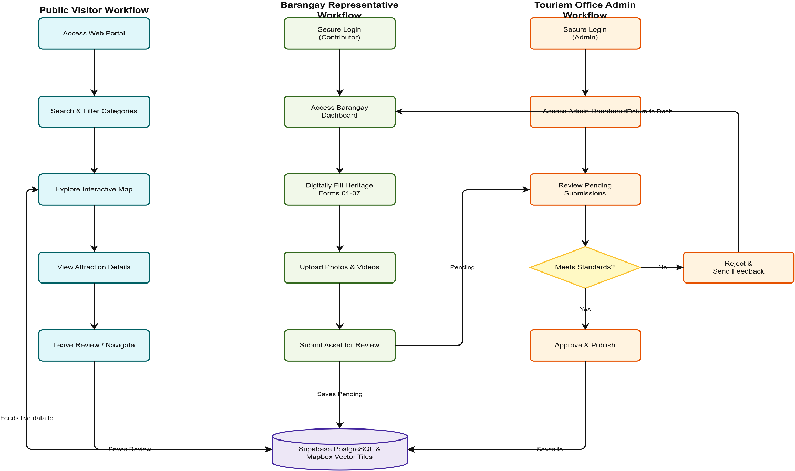

The system divides into three separate user roles with a single database engine to keep data safe. This setup makes sure that regular users enter the raw data, administrators check and approve it, and only then does the system show it to the public.

System Roles

Public Visitors: These are regular users or researchers. They search the site, look at the interactive map, check out attraction details, and leave reviews or feedback.

Barangay Representatives: These are local data creators. Each verified representative gets a secure login for their specific barangay. They fill out standard heritage forms and upload local photos and videos.

Tourism Office Admins: These are moderators. They log into a dashboard to check system stats, review pending posts, and approve or reject entries.

Database and Mapping Engine: We use Supabase PostgreSQL and Mapbox to store all data securely, process map locations, and handle your live updates.

Step-by-Step Workflow Path

Public Visitor Workflow

V1: Access Web Portal: You open the public website and load the main map.

V2: Search & Filter Categories: You filter your view by categories like built heritage or specific barangay boundaries.

V3: Explore Interactive Map: The website talks to the backend to show custom visual pins right on your map screen.

V4: View Attraction Details: You click a pin, and the site pulls up the full profile from the database, showing descriptions, hours, and photos.

V5: Leave Review / Interactive Feedback: You write a review or give a rating, which saves directly to the database and updates the live feed.

Barangay Representative Workflow

C1: Secure Login: You log in through a secure page that verifies your identity.

C2: Access Barangay Dashboard: The system opens your personal dashboard where you can see your local progress.

C3: Digitally Fill Heritage Forms 01–07: You type in your primary source data using the standard heritage inventory layout.

C4: Upload Photos & Videos: You attach your photos and documents to back up the heritage claim.

C5: Submit Asset for Review: You click submit. The system saves your work as "Pending" in the Supabase database and sends it to the admin queue.

Tourism Office Admin Workflow

A1: Secure Login (Admin): You log in using your high-privilege admin credentials.

A2: Access Admin Dashboard: You view your main dashboard to check site traffic and see what's waiting in the queue.

A3: Review Pending Submissions: You open the pending queue to check new entries from the barangays.

A4: Meets Standards? (Decision): You look over the details, photos, and map coordinates to make sure everything looks right.

A5: Approve & Publish (Yes): If the data looks good, you hit approve. The database marks it as "Approved," and the map instantly shows the new pin to the public.

A6: Reject & Send Feedback (No): If something is wrong, you reject the post, type in your notes, and send it back to the representative's dashboard so they can fix it.

System Features and User Interfaces
The architecture of the system is distilled into two primary functional categories, each tailored to the specific requirements of its user ecosystem:

1. General Public and Academic Portal
This category encompasses the Interactive Heritage Map and the Digital Cultural Atlas, designed for high-performance discovery and academic research.

- Key Features: Real-time spatial filtering, heritage categories (built, natural, intangible), barangay-specific profiles, and interactive galleries.
- UI Description: Utilizes a full-screen Mapbox interface and a card-based "glassmorphic" atlas for readable, engaging exploration of Mangatarem’s heritage.

2. Administrative and Stakeholder Portal
This category includes the Content Contribution and Moderation Dashboard, providing a unified environment for LGU staff and barangay leaders.

- Key Features: Secure data entry forms with coordinate pickers, role-based moderation workflows, and real-time engagement analytics.
- UI Description: A focused, minimalist administrative dashboard that guides users through the submission and verification process with clear status tracking.

System Testing and Evaluation
To ensure the technical robustness and organizational relevance of the system, a multi-phased testing strategy was executed, grounded in the ISO/IEC 25010 software quality standards.

Functional Testing
Significance: Functional testing serves as the primary mechanism for verifying that the system’s multifaceted features operate in strict accordance with the defined technical requirements. This process ensures that the logic governing user authentication, spatial data rendering, and content moderation is flawless.

Test Case Definitions:

- Authentication Integrity: Validating secure login/logout workflows for the Administrative and Stakeholder category.
- Data Submission Logic: Ensuring accurate capture and storage of heritage metadata.
- Moderation Workflow: Verifying the state transitions from "Pending" to "Approved".
- Map Interaction: Testing pin responsiveness and spatial filtering.

Execution Process: Manual testing was conducted via Chrome DevTools to simulate end-user interactions. Test cases were executed to verify that each feature meets its expected outcome, with results recorded in real-time.

Performance Testing
Significance: Evaluates operational efficiency under varying workloads, focusing on speed and responsiveness.

Execution Process: Performance metrics were gathered using Google Lighthouse and Chrome DevTools Performance Traces. Testing focused on First Contentful Paint (FCP), Time to Interactive (TTI), and server-side response latency.

Security Testing
Significance: Ensures protection of municipal data against unauthorized access and common cyber threats.

Execution Process: The system was subjected to simulated "Red Team" attacks, including SQL Injection (SQLi) and Cross-Site Scripting (XSS) attempts. Input fields were tested with malicious payloads (e.g., ' OR '1'='1) to verify the efficacy of the SQLAlchemy ORM and Bleach sanitization library.

Usability Testing
Significance: Verifies the system’s user-friendliness and intuitive navigation.

Execution Process: A structured usability audit was performed using the 5-point Likert Scale, evaluating navigation logic, interface clarity, and overall aesthetic appeal.

Implementation Results
The system was successfully deployed on Vercel with a managed Supabase (PostgreSQL) backend. Technical challenges such as serverless "cold starts" were mitigated through lazy initialization patterns, and database efficiency was maintained using Upstash Redis for map-data caching.

Analysis of Results

Functional Testing Analysis
Test Case | Expected Output | Actual Output | Pass/Fail | Remarks
Login with correct credentials | User is redirected to the dashboard | Works as expected | Pass | N/A
Submit heritage record form | Data is saved and appears in moderation queue | Record saved successfully | Pass | N/A
Search and filter heritage sites | System displays matching results | Results displayed accurately | Pass | N/A
Generate Heritage Summary | System produces detailed view of site | View rendered successfully | Pass | N/A

Success Rate Calculation: Success Rate = (Number of Passed Tests / Total Tests) × 100% Success Rate = (4 / 4) × 100% = 100%

Performance Testing Analysis
Test Scenario | Expected Time (seconds) | Actual Time (seconds) | Pass/Fail | Remarks
Load homepage (1 user) | < 3 sec | 2.4 sec | Pass | N/A
Execute Spatial Query (Map Search) | < 5 sec | 1.2 sec | Pass | Optimized via Mapbox GL JS
API Response Time (Cached) | < 2 sec | 0.4 sec | Pass | Upstash Redis caching active

Success Rate Calculation: Success Rate = (Number of Passed Tests / Total Tests) × 100% Success Rate = (3 / 3) × 100% = 100%

Security Testing Analysis
Security Test | Expected Behavior | Actual Behavior | Pass/Fail | Remarks
Login with wrong password | Show "Invalid credentials" message | Works as expected | Pass | N/A
SQL Injection attempt in login | System rejects malicious input | Malicious input sanitized | Pass | SQLAlchemy ORM used
View admin portal as a public user | Access denied / Redirect | Access restricted | Pass | Role-based access active

Success Rate Calculation: Success Rate = (Number of Passed Tests / Total Tests) × 100% Success Rate = (3 / 3) × 100% = 100%

Usability Testing Analysis
Evaluation Criteria | Strongly Disagree (1) | Disagree (2) | Neutral (3) | Agree (4) | Strongly Agree (5) | Average Score
The system is easy to navigate | 0 | 0 | 1 | 2 | 4 | 4.4
The interface design is clear and visually appealing | 0 | 1 | 0 | 2 | 4 | 4..3
System instructions and labels are understandable | 0 | 0 | 1 | 2 | 4 | 4.4
The system is user-friendly and requires minimal effort to learn | 0 | 0 | 1 | 2 | 4 | 4.4

Overall Average Usability Rating: 4.37

UAT Analysis

Evaluation Criteria | Strongly Disagree (1) | Disagree (2) | Neutral (3) | Agree (4) | Strongly Agree (5) | Average Score
System functionality works as expected | 0 | 0 | 1 | 3 | 3 | 4.3
The system is easy to navigate | 0 | 1 | 0 | 2 | 4 | 4.3
System performance is fast and responsive | 0 | 0 | 1 | 2 | 4 | 4.4
The system meets my needs and requirements | 0 | 0 | 0 | 3 | 4 | 4.6

Overall Average Acceptance Rating: 4.40
Discussion of Findings
The tests in this chapter show that the Digital Cultural Map works very well. The 100% success rate in testing proves the system is ready to use and keeps data safe for the Mangatarem LGU. High scores in web standards and usability confirm that the site is easy to use and follows modern rules.

Strengths: The system’s primary strengths lie in its cloud-native architecture and real-time synchronization between the moderation portal and the public map. Areas for Development: Future iterations could incorporate offline-first capabilities for remote barangays and advanced visitor analytics for data-driven tourism planning.

