URBIZTONDO WATER SERVICE CONSUMER INFORMATION AND BILLING MANAGEMENT SYSTEM

Members:

Diaz, John Lester
Lopez, Jillian
Muñoz, Katrina Jane
Regacho, King Melvin

Professor:
Mr. Brixon De vera, MIT

Chapter I
Introduction
The management of municipal water services is currently navigating a period of unprecedented transformation, driven by the intersecting pressures of rapid urbanization, climate-induced water scarcity, and the accelerating digitalization of public infrastructure. In the local setting, the Urbiztondo Water Services (UWS) operates as a vital utility managed by the Local Government Unit (LGU) of Urbiztondo, Pangasinan. Established in 2018 through Municipal Ordinance No. 8-2018, the UWS upholds its core mission of providing a safe, potable, and reliable water supply to the residents of 21 barangays. This mission remains a top priority under the current leadership of Water Services Supervisor William V. Gusto, as highlighted in the Municipality’s updated 2021 Citizen’s Charter, which defines the operational framework and service standards of the office.
In the modern era, the integration of digital solutions into public utility management has become a global standard for ensuring operational transparency. As argued by Hassan et al. (2022), the shift toward automated systems is no longer just an option but a necessity to minimize human error and safeguard data integrity. They emphasize that transitioning from traditional methods allows utilities to manage essential services like water and electricity with higher precision and sustainability.
Within the Philippine context, this transition is particularly visible in the evolution of Local Water Districts (LWDs). The Department of the Interior and Local Government (2021) has actively encouraged Local Government Units to embrace ICT-based solutions, noting that such digital interventions are key to enhancing public service delivery and ensuring financial accountability across all municipal levels. This national mandate serves as a roadmap for LGUs to move away from traditional, manual operations toward more data-driven systems.
The Municipality of Urbiztondo, a second-district municipality in Pangasinan with a population of approximately 56,349 as of the 2024 census data, represents a critical case for this technological upgrade. However, as the community expands, the existing reliance on manual recording—characterized by pen-and-paper meter reading and physical bill delivery—has become increasingly unsustainable. According to the study of Bautista and Reyes (2021), manual systems in rural water districts often lead to significant administrative bottlenecks and revenue leakage, ultimately hindering the utility's growth and efficiency. Thus, the implementation of an integrated Consumer Information and Billing Management System is not only timely but essential for the future of Urbiztondo.
Issues and Challenges Identified
Manual Record Keeping Consumer files are currently stored in physical folders, which makes data retrieval a labor-intensive and time-consuming process for the staff. This traditional filing method poses a high risk of document loss or damage due to physical wear, environmental factors, or misplacement, compromising the overall integrity of the agency's records.
Inefficient Monitoring The absence of a centralized database makes it difficult for management to perform real-time tracking of consumer accounts. There is no automated way to distinguish between active and disconnected accounts instantly, leading to administrative delays and inconsistencies in service monitoring across the 21 barangays.
Billing Errors Since consumption charges are computed using basic handheld calculators, the billing process is highly susceptible to human error. These frequent mathematical mistakes result in inaccurate Statements of Accounts (SOA), which not only causes confusion among consumers but also leads to potential revenue leakage for the LGU.
Delayed Reporting The generation of monthly financial reports is often delayed because the daily receipts and collections must be tallied manually. This manual consolidation of data is labor-intensive and prevents the management from accessing real-time financial insights, which are crucial for transparent and accountable governance (Bautista & Reyes, 2021).

Main Objective / Purpose of the System
The Urbiztondo Water Service Consumer Information and Billing Management System digitizes manual logbooks into a secure database to streamline record management and consumer profiling. By automating billing computations, it eliminates human mathematical errors while enabling real-time monitoring of active and disconnected accounts. This system is designed to strengthen financial oversight and enhance the overall efficiency and transparency of public service delivery in Urbiztondo.
Key Functions
- Digitize the consumer profiling process
- Replace the manual logbook with a secure database
- Automate billing computations
- Enable efficient monitoring of account statuses

Scope of the System
Consumer Information Management – The system covers the management of consumer data, allowing users to add new consumer profiles, update existing information, and search records using name, address, or meter number. This feature ensures faster and more efficient access to consumer information.
Billing & Ledger System – The system includes automated computation of the “Amount Due” to minimize human errors in billing. It also provides payment history tracking, enabling users to review past transactions and identify any remaining balances accurately.
Account Status Monitoring – The system provides real-time updates on account status, helping management easily monitor active and disconnected accounts. This supports better decision-making and efficient service management.
Admin Dashboard – The dashboard presents a visual summary of the total number of consumers and an overview of total collectibles. It also allows the generation of monthly reports, making reporting more organized and time-efficient.
Security – The system ensures data protection through secure admin login with authentication, OTP (One-Time Password) sent via email, and secure data storage to safeguard sensitive information.

Users of the System
Administrator – Has full control over the system, including configuration, user account management, and system security monitoring to ensure smooth and secure operations.
Billing Staff / Cashier – Responsible for encoding meter readings, posting payments, updating consumer accounts, and handling billing-related inquiries.

Stakeholders
Urbiztondo Water Service Management The management will benefit from improved operational efficiency through a centralized oversight of all water utility activities. The system ensures the maintenance of accurate financial records, providing the LGU with reliable data for better decision-making and long-term resource planning.
Billing Staff The staff will experience a significantly reduced workload by eliminating repetitive manual tasks. The automation of billing modules leads to the elimination of calculation errors, while the digitized database allows for faster customer information retrieval, enabling them to address consumer concerns with greater speed and precision.
Water Consumers The residents of Urbiztondo are the ultimate beneficiaries, as they will receive fair and accurate billing statements based on automated computations. This transition leads to better customer service, where disputes are minimized and billing inquiries are resolved more efficiently through the system's reliable data tracking.

Use Cases
Administrator (Full System Access) The Administrator holds the highest level of authority and is responsible for the overall management of the platform. This role involves Full Access to the database, including the ability to Create, View, Update, Edit, and Delete records as necessary. Beyond basic data entry, the Administrator is tasked with Reporting and Analytics, generating high-level monthly financial reports to assist the LGU in decision-making. Furthermore, the Admin ensures System Security by managing user credentials and performing regular data backups to prevent information loss.
Billing Staff (Operational Access) The Billing Staff is focused on the day-to-day frontline operations of the utility. Their primary function is Automated Billing, where they encode raw meter readings into the system for instant, error-free computation. For financial transactions, they are responsible for Payment Posting, which automatically updates consumer account balances and generates official electronic receipts. Lastly, the staff handles Consumer Inquiries by utilizing the system's search functionality to retrieve and view account information quickly, allowing for efficient resolution of billing disputes or customer questions.

Hardware, Software and Service Requirements
Hardware Requirements
- Processor: Core i5 or higher
- Memory: Minimum 8GB RAM
Software Requirements
- VS Code
- XAMPP
- Google Chrome
Programming Languages
- PHP
- JavaScript
- HTML5
- CSS3
- SQL
Network Requirements
- Local Area Network (LAN)
- Wi-Fi Router or Switch
- At least 3 client computers

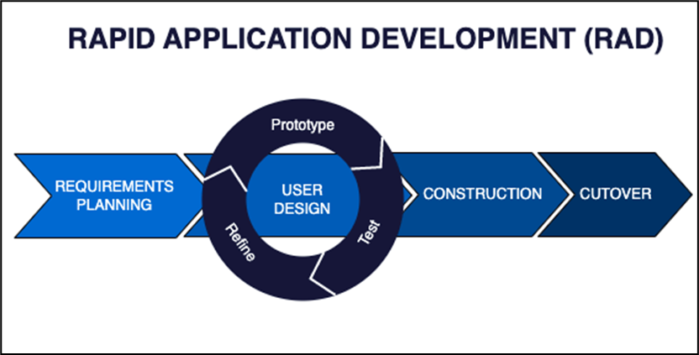
Methodology

The researchers adopted the Rapid Application Development (RAD) methodology to ensure the efficient and timely delivery of the Urbiztondo Water Service Consumer Information and Billing Management System. Unlike traditional linear models, RAD prioritizes rapid prototyping and continuous user feedback, which allows the researchers to refine the system’s features based on the actual operational needs of the Urbiztondo Water Services (UWS).
Requirements Planning The researchers began by gathering essential functional requirements through an interview with Mr. William V. Gusto, the Water Services Supervisor. This phase allowed the team to deeply understand the intricacies of the manual billing process and identify the specific data fields needed for the digital transition.
User Design During this phase, the researchers created visual prototypes of the Billing Ledger and the Management Dashboard. By involving the end-users in the design process, the team ensured that the interface was intuitive and directly addressed the staff's need for faster information retrieval.
Construction The researchers developed the core system using PHP and MySQL, focusing on building robust modules for auto-computation and secure data storage. This stage involved iterative coding and testing to ensure that the mathematical logic for billing was accurate and free from human-driven errors.
Cutover In the final phase, the researchers handled the system deployment to a local server. This included conducting comprehensive user training for the billing staff to ensure a smooth transition from the manual logbooks to the new digital platform.

Existing Process Flowchart

A flowchart diagram is a visual representation that illustrates the step-by-step flow of a specific process using standardized symbols such as ovals, rectangles, diamonds, and arrows. Its primary purpose is to map out complex workflows in a clear and structured manner, allowing stakeholders to easily understand task sequences, identify decision points, and analyze inefficiencies or redundancies in existing operations. In the development of the Urbiztondo Water Service Consumer Information and Billing Management System, these diagrams are essential in documenting current procedures related to service applications, meter reading, and billing collections. Understanding these manual processes in detail lays the groundwork for creating an automated solution that directly addresses the operational challenges and manual data handling currently faced by the office.
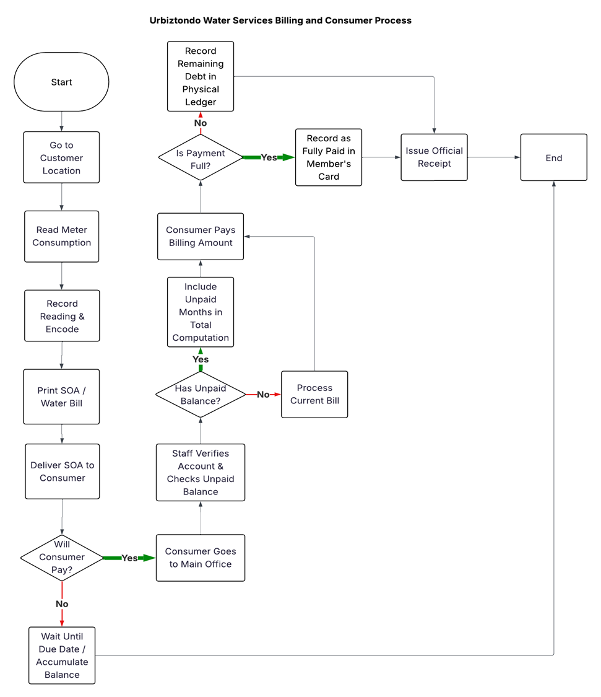The first diagram, titled “Urbiztondo Water Services Application Process,” illustrates the sequence of activities followed when a resident applies for a new water service connection. The process begins with the applicant visiting the main office to secure and fill out an application form. The staff then requests a valid government ID for verification. A critical decision point occurs regarding the completeness of documents; if requirements are lacking, the staff requests the missing ID, and the process ends prematurely. If documents are complete, the applicant proceeds to pay various charges, including application, inspection, meter, and service connection fees. Another decision point follows to verify if the payment is complete. If incomplete, the application is placed on hold. Once fully paid, the staff schedules an on-site inspection, followed by the actual installation of the water service by the technical team. This flowchart highlights the manual verification steps and the dependency on physical documentation and multiple payment categories.

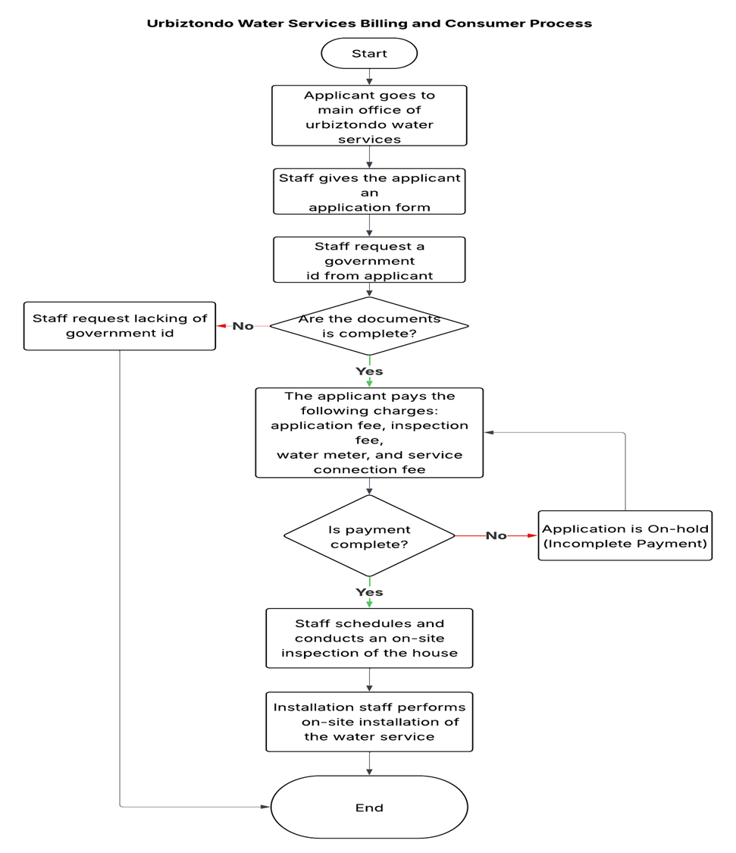

The second diagram, titled “Urbiztondo Water Services Billing and Consumer Process,” shows the workflow for monthly consumption monitoring and payment collection. The cycle starts with staff traveling to the customer’s location to manually read the water meter. The reading is recorded and later encoded into the records to generate and print a Statement of Account (SOA) or water bill, which is then delivered to the consumer. A decision point arises based on the consumer's intent to pay; if they choose not to pay immediately, the account waits until the due date, allowing the balance to accumulate. If the consumer chooses to pay, they must visit the main office where staff manually verifies the account and checks for any unpaid balances. If an arrears exists, it is included in the total computation; otherwise, the current bill is processed. After the consumer pays, the staff determines if the payment is in full. Full payments are recorded on a physical member’s card, while partial payments are recorded as remaining debt in a physical ledger. The process concludes with the issuance of an Official Receipt. This diagram underscores the heavy reliance on manual encoding, physical ledgers, and on-site visits, which are prone to human error and data fragmentation.

In conclusion, the flowchart diagrams serve as a comprehensive visual documentation of the existing manual processes currently followed by the Urbiztondo Water Service. By laying out each task and decision point, these diagrams expose procedural delays—such as the manual encoding of meter readings and the use of physical ledgers for debt tracking—and areas lacking centralized system support. This understanding is vital to the design and development of the proposed Urbiztondo Water Service Consumer Information and Billing Management System, as it ensures that the new system directly addresses these pain points, replaces manual ledgers with a digital database, and delivers tangible improvements in efficiency and data integrity for both the staff and the consumers.

Entity-Relationship Diagram (ERD)

An Entity-Relationship Diagram (ERD) is a graphical representation of a system’s data structure that illustrates the entities involved in the system, their attributes, and the relationships between them. It is an essential tool in database design, providing developers with a clear understanding of how data is stored, connected, and accessed within a system. In the context of the Urbiztondo Water Service Consumer Information and Billing Management System, the ERD plays a crucial role in guiding the logical structure of the database. It ensures that all core entities—such as consumers, accounts, and billing records—are accurately represented and properly linked, thereby supporting the system’s goal of streamlining water service management and billing accuracy.

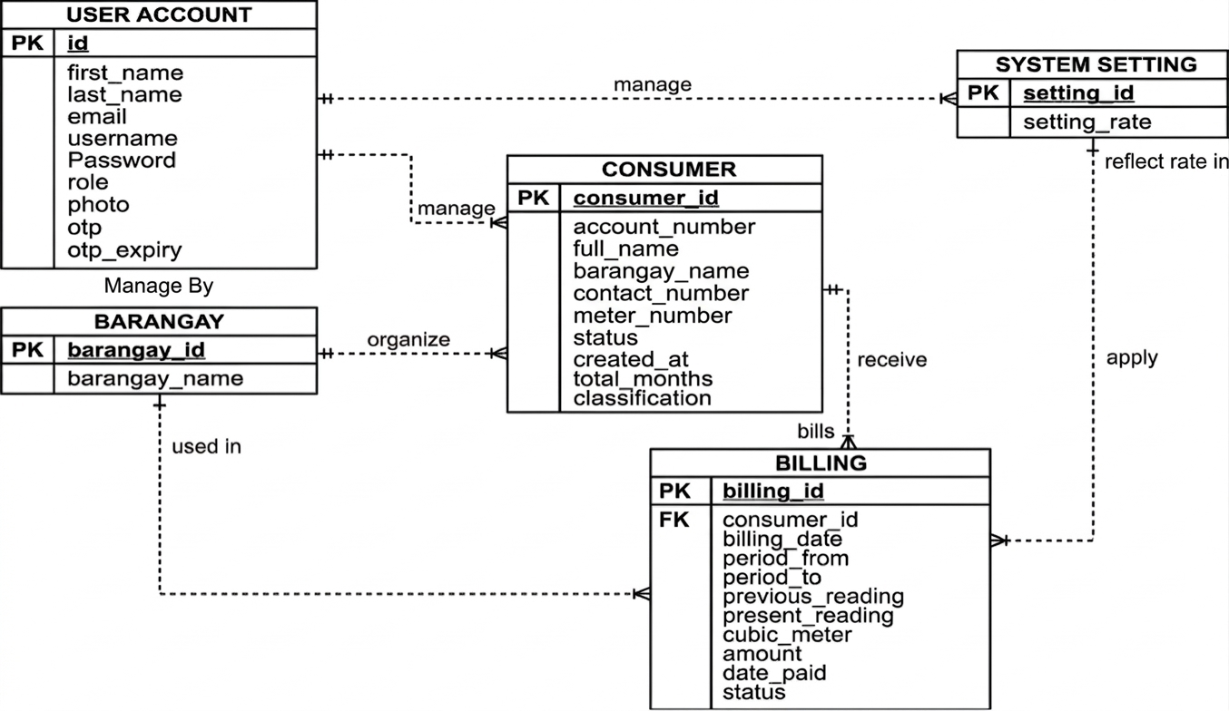
The ERD below presents the database structure for the proposed system, showcasing five core entities: User Account, Consumer, Barangay, Billing, and System Setting. Each entity includes specific attributes that reflect the information needed to support system functionalities, while the relationships between entities demonstrate how data flows and connects within the management system.
The User Account entity holds administrative and operational user details, including credentials, roles, and security attributes like OTP (One-Time Password) and its expiry for secure logins. One user account can manage multiple consumers and system settings, as indicated by the one-to-many relationships. This structure ensures that administrative actions and system-wide configurations are linked to specific authenticated users.
The Consumer entity contains the primary data for water service recipients, such as account numbers, meter numbers, and classifications. A consumer belongs to a specific Barangay, forming a one-to-many relationship where one barangay can organize many registered consumers. Furthermore, each consumer is linked to the Billing entity through a one-to-many relationship, as indicated by the receive connection, allowing a single consumer to accumulate multiple billing records over time.
The Billing entity is the central point of transaction, capturing essential data such as period dates, previous and present meter readings, total cubic meters consumed, and the total amount due. This entity applies rates from the System Setting entity, which stores global configurations like the setting_rate. Additionally, the Billing entity is linked to the Barangay entity, ensuring that consumption data is correctly associated with specific local areas. By linking billing to system settings, the organization can easily update rates or configurations without altering individual billing records.
In conclusion, the ERD provides a foundational structure for the successful development and implementation of the Urbiztondo Water Service Consumer Information and Billing Management System. By clearly defining entities and their relationships, the ERD ensures data consistency, system reliability, and operational efficiency. It supports the system’s primary objective of automating and improving the management of water services in Urbiztondo, ultimately enhancing service delivery and data integrity for both the administration and the community.

Data Flow Diagram (DFD)

1.0 & 2.0 Log in/Out
This process serves as the entry point for both the Admin and Staff members. To gain access, the user provides their Username and Password, which the system then verifies against the User_account data store. To enhance security, the system initiates a request for an authentication code through the Gmail API, which sends a unique verification code back to the user's registered email. Once the credentials and the code are validated, the system allows or denies entry.

1.1 View Dashboard
After a successful login, the Admin is directed to this process to monitor the overall status of the water service. This process retrieves real-time data from the Billing data store to display summaries like total collections or current billing trends. It is connected to the Admin entity as an output, providing a high-level overview of system activity before the Admin proceeds to more specific management tasks.

1.2 & 2.1 Manage Consumers
This process is shared by both the Admin (1.2) and Staff (2.1). It is responsible for handling the core information of the residents in Urbiztondo. It connects to the Consumers and Barangay data stores to save, retrieve, or update records such as names, meter numbers, and addresses. After managing consumer data, the user typically proceeds to billing or report generation.

1.3 Consumer Report
Exclusive to the Admin, this process organizes raw consumer data into readable statistical reports. It pulls information from the Consumers and Barangay data stores and generates "Consumer Statistical Data." This is used for auditing and decision-making, helping the Admin understand the growth or status of the water service across different areas.

1.4 User Management
In this process, the Admin manages the accounts of the system users (the Staff). It connects directly to the User_account data store to add, edit, or remove staff credentials and permissions. This ensures that only authorized personnel have specific access levels to the system's operational features.

1.5 & 2.2 Manage Payment History
This is the transactional core of the system where both Admin and Staff record payments. It connects to the Billing data store to track every "Collection record and Transaction log." After a consumer pays their bill, this process updates the database to reflect that the balance is cleared, ensuring that financial records are always up to date.

1.6 & 2.3 Identify Disconnections
This process identifies consumers who have failed to pay their bills on time. It connects to the Billing data store to filter out unpaid accounts and outputs a "verify disconnection need" notice to the Admin or Staff. This is a critical step for maintenance, as it triggers the physical disconnection of service for delinquent accounts.

1.7 System Setting
This process allows the Admin to configure the system's operational rules. It connects to the system_setting data store to save and retrieve values like Billing Rates. When the price of water per cubic meter changes, the Admin updates it here, which then dictates how the system calculates all future bills for the entire municipality.

System Architecture Design
System architecture design refers to the structured blueprint that outlines the components, interactions, and flow of data within a software system. It plays a crucial role in defining how users, technologies, and processes are integrated to achieve the functional goals of the application. A well-designed system architecture ensures efficiency, scalability, security, and maintainability, especially in web-based solutions that serve multiple users and roles. For the IT Capstone Project entitled Urbiztondo Water Service Consumer Information and Billing Management System, the system architecture design provides a clear understanding of how users interact with the application, how data is processed and stored, and how services are delivered through a secure web platform.
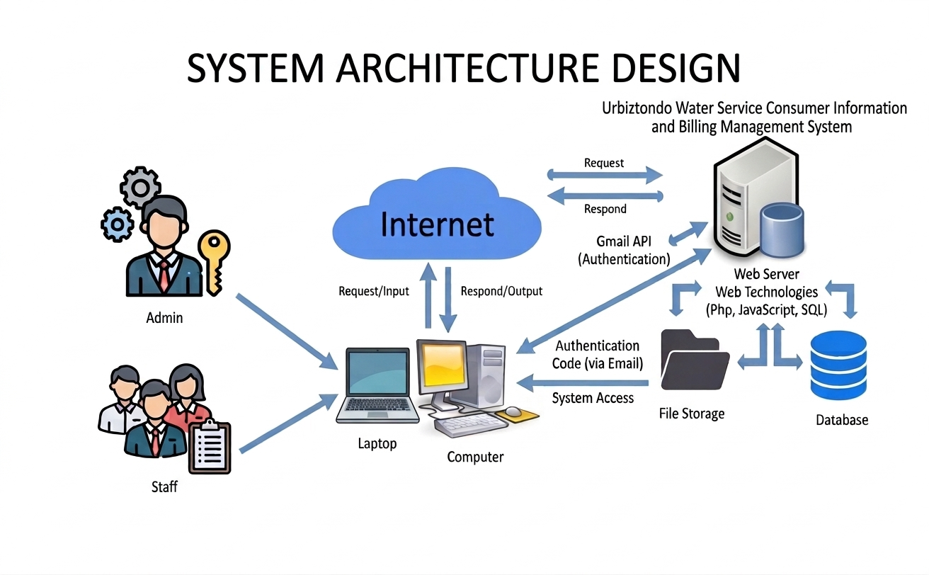
The diagram presented in this section illustrates the system architecture for the Urbiztondo Water Service Consumer Information and Billing Management System. It highlights two primary user roles: the Admin and the Staff. These users access the system through client devices, specifically laptops and desktop computers, using standard web browsers. All interactions with the system are facilitated via HTTP/HTTPS protocols over the Internet, which serves as the communication medium between client devices and the remote server. A key security feature of this architecture is the integration of the Gmail API, which handles Authentication. When a user attempts to log in, the system generates an Authentication Code sent via email; only upon entering this code is System Access granted, ensuring a robust layer of protection for sensitive consumer data.
At the core of the architecture is the Web Server, which functions as the application layer. It is powered by Web Technologies such as PHP and JavaScript, which handle the server-side business logic and dynamic user interactions. The server manages data through two distinct channels: File Storage for static resources and generated documents, and a Database powered by SQL for structured records. The SQL engine processes database queries to manage essential information, including consumer profiles, meter readings, billing history, and payment records.
In conclusion, the system architecture design provides a comprehensive and organized framework for the development and implementation of the proposed system. It establishes a secure, multi-factor authentication model, supports reliable web access, and ensures smooth interaction between the front-end user interface and the back-end data services. By clearly defining the relationships among users, devices, application components, and data repositories, this architecture enables the development of a robust and efficient system tailored to the operational needs of the Urbiztondo Water Service.

