Software Design & Modelling 5

# What is UML?

# Modelling Language Genealogy:

# UML Diagrams:

# Software Model:

# UML Class Diagram:

# Classes:

# Associations and Multiplicity:

# Many-To-One Associations:

# One-To-One Associations:

## A more complex example:

# Association Classes:

# Reflexive Associations:

# Directionality in Associations:

# Generalization:

## Avoid unnecessary generalization:

## Avoid instances change their type or class:

## Avoid having instances change class:

# Object Diagrams:

# Aggregation:

# Composition:

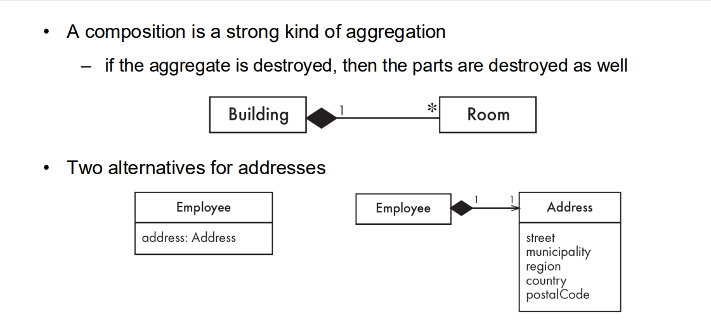

# Propagation:

# Interfaces:

# Notes and Descriptive Texts:

# Object Constraint Language (OCL):

## OCL Statements:

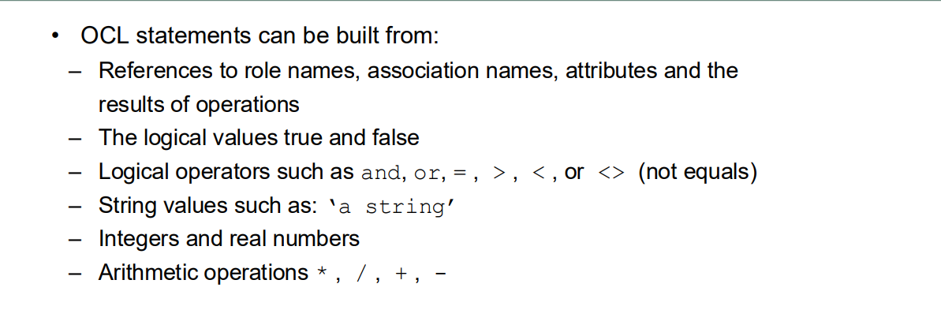

# Suggested Design Approach:

# Identifying Associations and Attributes:

