> cor(x$Height,x$Weight)

[1] 0.8294594

> cov(x$Height,x$Weight)

[1] 46.43183

> linearmodel=lm(Height~Weight,data=x)

> linearmodel

Call:

lm(formula = Height ~ Weight, data = x)

Coefficients:

(Intercept) Weight

-252.747 6.353

> plot(x=x$Height,y=x$Weight,main="Relationship between height and weight ",xlab="Height",ylab="Weight")

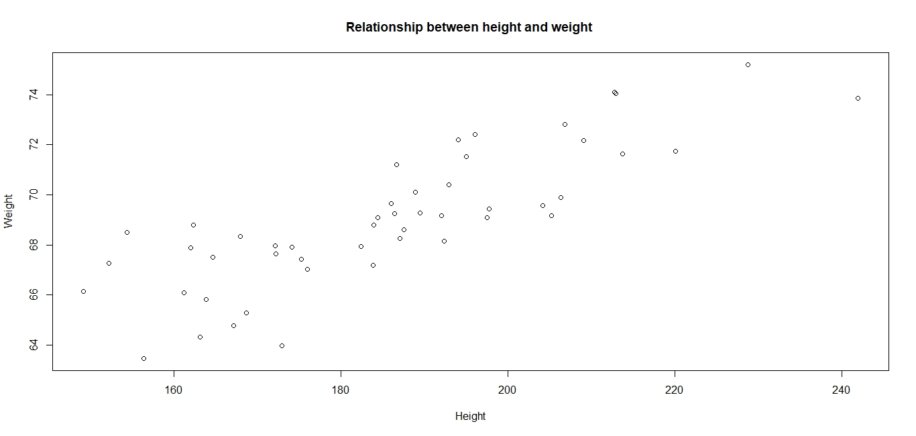

>scatter.smooth(x=x$Height,y=x$Weight,main="height-weight",xlab="height",ylab="weight",col=c("red"))

