Visualize Key Progress Indicators

This article shows how to create a view that shows Key Progress Indicators (KPIs). A Key Performance Indicator is a measurable value that shows how effectively a company is achieving key business objectives. At a high level, the procedure requires you to do the following:

The scenario uses the **Sample - Superstore** data source provided with Tableau Desktop to show how to build a KPI view that displays a green check mark for any sales figure over $25,000, and a red X for any sales figure under $25,000.

Create a view that includes the field you want to assess

In this case, that field is **Sales**.

1. Connect to the **Sample - Superstore** data source.
2. From the Dimensions area of the Data pane, drag **Sub-Category** to **Rows** and **Region** to **Columns**.
3. From the Measures area of the Data pane, drag **Sales** to **Text** on the Marks card.

Create a calculated field that establishes the threshold that demarcates success from failure

1. Choose **Analysis** > **Create Calculated Field** to open the calculation editor. Name the calculation KPI and type or paste the following in the formula area

IF SUM ([Sales]) > 25000 THEN "Above Benchmark" ELSE "Below Benchmark" END

1. Click **OK**.

Update the view to use KPI-specific shape marks

1. On the Marks card, select Shape from the drop-down list of views:

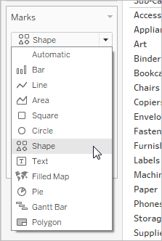

1. Drag the **KPI** field from the **Measures** area of the **Data** pane to **Shape** on the Marks card.
2. Click **Shape** on the Marks card to open the **Edit Shape** dialog box.
3. From the **Select Shape Palette** drop down list, choose **KPI**.

Now you are ready to associate specific values for the KPI field with specific shapes.

1. Click **Above Benchmark** under **Select Data Item** and then click the green check mark in the palette.
2. Click **Below Benchmark** under **Select Data Item** and then click the red X in the palette.

The Edit Shape dialog box should now look like this:

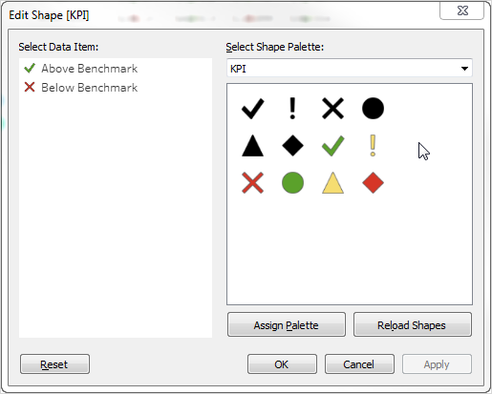

1. Click **OK** to close the Edit Shape dialog box.

The shapes in the view show the correct indicators. Now you just need to hide the sales numbers.

1. Drag **SUM(Sales)** on the Marks card to **Detail**.

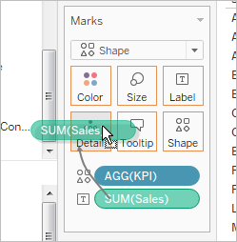

You now have a completed view that show how individual products (sub-categories) are performing across all four regions:

