**Dumbbell Chart in Tableau 10**

Dumbbell Chart in Tableau is effectively used to illustrate the change of data between two points. It is a dual axis chart with one marks type to be circle and the other marks type to be a line. Dumbbell chart if made vertically is also called as DNA chart.

Let’s move ahead make a dumbbell chart for a better understanding; and since all of us are quite comfortable with Sample Superstore xls. We’ll use the same for this chart type also.

**Step-1:**

Connect Tableau to the dataset i.e. Sample Superstore dataset and prepare a visualization with Sub Categories in Rows shelf and Sales in Columns Shelf. The result will be a Bar chart. From the Marks shelf change the marks from Automatic to Circle.

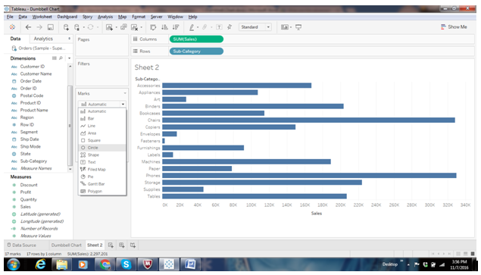

**Step-2:**

Drag the Order Date from the Data pane to the Colors marks Shelf. Drag again Order date from the data pane to the Filter Shelf this time and choose just the last two years of your dataset. In this case I have chosen 2014 and 2015. The viz will change from four colors circle view to two colors circle view for each Sub Categories. The Viz will look like the below:

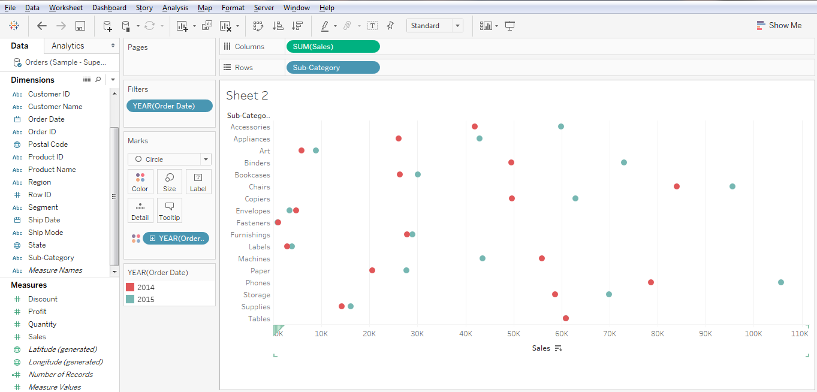

**Step-3:**

Drag another Sales Field from the data pane next to the previously used Sales field in the Rows Shelf. From the second Sales pill on the rows Shelf  Right Click to get the drop down and choose Dual Axis and from the marks shelf choose the marks type from Circle to Line for the second Sales. Now, the viz looks like below:

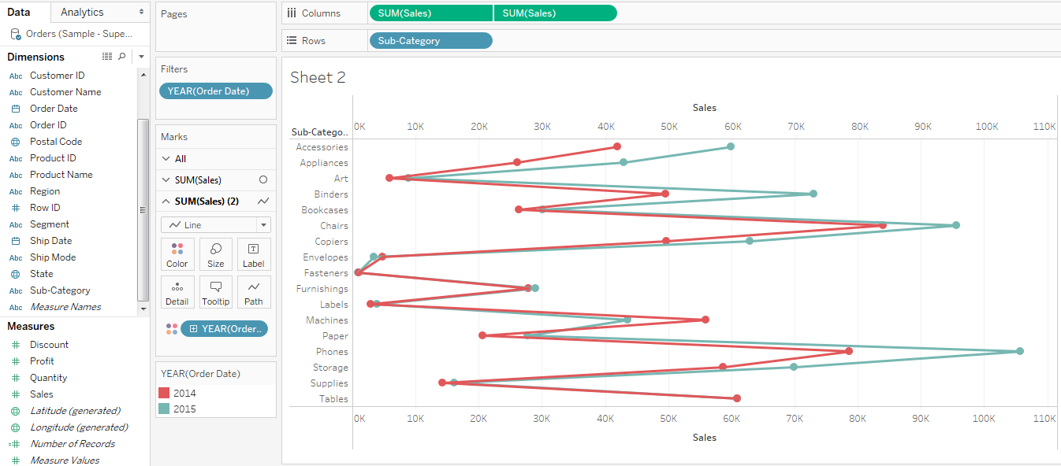

**Step-4:**

Now come the beautification part. You’ll notice that since you have a dual chart ready your chart has two axis for the Sales- one below and the other on the top. Click on the Top Sales axis and right click to one the drop down. Select Synchronize Axis and deselect the Show Header option. Now your Viz has a single Sales axis.

Moving ahead, notice that you have two sets of Marks card- one with Sales to be in Circle and the other one has Sales in Line. Navigate to the Sales with Line marks card and the Order date that was dropped earlier in the Color Shelf and now appears in the Marks Shelf has to be dragged into the Path Shelf.

Dumbbell Chart showing the Sales of various Sub Categories and their growth for the two years is ready.

