INTRODUCTION

INTRODUCTION

E-RepairMart is an online platformconnecting customers with skilled electronic device repair technicians forawiderangeofdevices,includingsmartphones,laptops,andhomeappliances.Theplatformoffersasimple interfacetocompareandselecttechniciansbasedonexpertise,pricing,andreviews,ensuringaffordabilityand transparency.
Customerscanbookservicesonline,chatwithtechnicians,and enjoy hassle-freerepairs fromhome.Admin features includemanagingtechnicianprofiles,categorizingrepairservices,andmonitoringcustomerrequests,ensuring efficientoperations.E-RepairMartfosterstrust and collaboration in the repairecosystemforcustomers,technicians, andadministrators.

PROBLEMSTATEMENT
Findingreliableandaffordableelectronic devicerepairservicescanbechallengingfor customers, oftenrequiring time-consuming searches and a lack of transparency in pricing and service quality. Similarly, skilled technicians struggle to reach potential customers effectively, limiting their business opportunities.
Themainproblemofexistingsystemare:
    - LackofAffordability
    - LackofTransparency
    - LimitedAccessibilityforTechnicians.

SCOPEANDRELEVANCEOFPROJECT
The E-RepairMart project aims to promoting affordability, transparency, and convenience, theplatformreduces the time and effort required for customers to find trustworthy services while providing technicians with increased
visibilityand businessopportunities.

OBJECTIVES
Theobjectivesofthisprojectare:
- Tominimizecostandtime
- Toprovideabetterplatformforelectronicrepairingitems.whichisbetterthantheexistingsystem.

SYSTEMANALYSIS

INTRODUCTION

System analysis is a structured method for identifying and solving problems. Analysis impliesbreakingsomethingintoitspartssothatthewholemaybeunderstood.Thedefinitionofsystemanalysis not onlyprocess analysisbutalsothatofsynthesis, whichimpliestheprocess ofputtingpartstogether toforma new whole .All activities relating to the life cycle phase must be performed managed and document. To design a system, we need requirements of the system and the specification document is prepared in this phase. The purpose of this document is to specify the functional requirement of the software that is to build .The specifications are intended to guide the activities, relationships and all other objectives.

EXISTINGSYSTEM

Thecurrent systemforelectronicdevicerepairservicesisfragmentedand inefficient,leadingtoseveral challenges for customers and technicians. Customers often rely on word-of-mouth recommendations, online searches, or physical visits to repair shops, which are time-consuming and lack transparency in pricing and service quality. There is no streamlined process to compare technicians based on their expertise or customer reviews, making it difficult to make informed decisions.

For technicians, the absence of an organized platform limits their ability to reach potential customers effectively,resulting inreducedbusinessopportunities.Additionally,existingsystemslackacentralized management structureto categorizerepairservices,monitorcustomerrequests,orensure prompt service delivery.

Overall,theexistingsystemfailsto provideaconvenient,transparent,andcollaborativeexperience for customers, technicians, and administrators, creating a demand for an integrated solution like E- RepairMart.

Drawbacksofexistingsystem
- Inefficient
- limitedaccesstoresourcesandbusinessopportunities.
- Doesnotprovideclearinformationaboutpricingandservicequality.
- Timeconsuming

PROPOSEDSYSTEM

The proposed system, eRepairMart, is a comprehensive online platform designed to streamline the processofconnectingcustomerswithskilledelectronicdevicerepairtechnicians.Theplatformcaters toawiderangeofdevices, includingsmartphones, laptops,homeappliances,andgadgets,offeringa user-friendly interface for browsing, comparing, and selecting technicians based on their expertise, pricing, and customer reviews.

eRepairMart prioritizes affordability and transparency, enabling customers to make informed decisions while promoting fair pricing. Customers can conveniently book repair services online, communicatedirectlywithtechnicianstodiscusstheirneeds,andenjoyhassle-freesolutionswithout leaving their homes.
Thesystemalso includesrobustadministrativetools,empoweringplatformadministratorstomanage technician profiles, categorize repair services, and monitor customer requests efficiently. This centralized management ensures timely resolutions and improves service quality.

FEASIBILITYSTUDY

Afeasibility study is made to see if the project on completion will serve the purpose of the organization for the amount ofwork, time and effort spent on it. Study lets the developer foresee the futureoftheproject and itsusefulness. Findingoutwhetheranewsystemisrequiredornot.Thestudyis carried out to the best systemthat meet performance requirements. This entails identification,description and evaluation of candidate systemand selection of the best system for the best system for the job. It simply identifies whether the proposed systemis feasible tothe organizationor not.Thereare three aspects in the feasibility study portion of the preliminary investigation

- Technicalfeasibility.
- Economicfeasibility.
- Operationalfeasibility.

TECHNICALFEASIBILITY

Atechnicalissue usuallyraised during the feasibilitystageoftheinvestigation includesthe following:

      - Doesthenecessarytechnologyexisttodowhatissuggested?
      - Dotheproposedequipmenthavethetechnicalcapacitytoholdthedatarequiredtousethenewsystem?
      - Willthe proposed systemprovide adequate response to inquiries regardless ofthe number oflocation of users?
      - Canthesystembeupgradedifdeveloped?
      - Arethetechnicalguaranteesofaccuracy,reliability, easeofaccessanddatasecurity?
      - Earlier no systemexists to cater to the needs of the Secure infrastructure implementation system, the current system developed is technically feasible.
      - Thedatabase’spurposeistocreate,establishandmaintainaworkflowamongvariousentitiesinorder tofacilitateallconcernedusers intheirvariouscapacitiesorrolesspecified.Therefore, it providesthe technical guarantee of accuracy reliability and security.

ECONOMICFEASIBILITY
Here an evaluation of development cost weighted against the ultimate income or benefit derived fromthedevelopedsystem.Thecost forthedevelopment oftheproject hasbeenevaluatedandwewant to check that the cost does not exceed. The economic and financial analysis is used for evaluating the effectiveness of the candidate system. This project also undergone economic feasibility study and found that it is feasible.

Fortheimplementationofthesoftwarerequiredacomputersystem,calculatethecostforasystem. Timerequiredfordevelopingthewebapplication,serveranddomainforthedeploymentoftheapplication, Cost for the server is calculated, So the cost of development, deployment does not exceed its beneficial cost. This brought to the conclusion that the system is economically feasible in this context.

OPERATIONALFEASIBILITY

Inoperationalfeasibilitytheentireapplicationischeckedto analyzewhetherthesystemwillbeused ifit isdevelopedandimplemented.Also,itischeckedwhethertherewillberesistancefromusersthat may undermine the possible application benefits. There is no barrier for implementing the system. The system alsohelpstoaccesstheinformationimmediatelyasneedarises,Thusthesystemisfoundtobeoperationally feasible
Here the system undergone operational feasibility study. The system is checked and it and user- friendlysoftware it canbe used bythe customerswho have limited computer knowledge.The systemwill help to access the information immediately whenever needed.

SOFTWAREENGINEERINGPARADIGMAPPLIED

The project follows Waterfall Model. The Waterfall Model was the first Process Model to be introduced.It isalso referredto asalinear-sequentiallife cycle model. It isverysimple to understand and use. In a waterfall model, each phase must be completed before the next phase can begin and there is no overlapping in the phases. The Waterfall model is the earliest SDLC approach that was used for software development.ThewaterfallModelillustratesthesoftwaredevelopmentprocessinalinearsequentialflow. Thismeansthatanyphaseinthedevelopmentprocessbeginsonlyifthepreviousphaseiscomplete.Inthis waterfall model, the phases do not overlap. The sequential phases in Waterfall model are:
- RequirementGatheringandanalysis−Allpossiblerequirementsofthesystemtobedeveloped are captured in this phase and documented in a requirement specification document.
- SystemDesign−Therequirement specificationsfromfirst phasearestudied inthisphaseand the system design is prepared. This system design helps in specifying hardware and system requirements and helps in defining the overall system architecture. Overall project planning Implementation − With inputs fromthe systemdesign, the system is first developed in small programscalledunits,whichareintegratedinthenextphase.Eachunitisdevelopedandtested for its functionality, which is referred to as Unit Testing.
- Integration and Testing − All the units developed in the implementation phase are integrated intoasystemaftertestingofeachunit.Postintegrationtheentiresystemistestedforanyfaults and failures.

- Deployment of system − Once the functional and non-functional testing is done; the product is deployed in the customer environment or released into the market.
- Maintenance− There are some issues which come up in the client environment.To fix those issues, patches are released, also to enhance the product some better versions are released. Maintenance is done to deliver these changes in the customer environment.

SYSTEM DESIGN

INTRODUCTION
Systemdesign is a process ofdeveloping specifications for a candidate systemthat meet the criteria established inthe systemanalysis.Majorstepsindesignarethepreparationofthe input formsandoutput reports ina formapplicable to user.The main objective ofthe systemdesign is to usethe package easily by any computer operator. System design is the creative act of invention, developing new inputs, a database, offline files, method, procedure and output for processing business to meet an organization objective. System design builds information gathered during the system analysis.

DATABASEDESIGN
Themostimportantaspectofbuildinganapplicationisthedesignoftablesorthedatabaseschema. Thedatastoredinthetablesmust beorganized insomemanner,whichismeaningful.Theoverallobjective in the process of table design has been to treat data as an organizational, resource and as an integrated whole. The organization of data in a database aim to achieve three major objectives, which are given below.
- Dataintegration.

- Dataabstraction.

- Dataindependence.

Several degrees of normalization have to be applied during the process of table design. The major aimof the process of normalization is to reduce data redundancy and prevent losing data integrity. Data integrity has to be converted at all levels. Pure normalization can access problem related to storage and retrievalofdata.Duringtheprocessofnormalization,dependence’scanbeidentifiedwhichcauseserious problems during deletion and updating. Normalizing also hope in simplifying the structure of table
Databasedesign isan important activityin design.Theefficiencyofthesystemlies intheefficiency ofthe database. The database design consists ofpredetermining number oftables that are to be used and fieldsthataretobeusedineachtable.Theefficiencyofthesystemtoretrievetheappropriatedatadepends on how the fields are specified and the coding mostly depends on format of the database. To group the givendataandtogivethemalogicalstructure,adatabasedesignisnecessary.Theoverallobjectiveinthe development ofthe database is to treat data as an organized resource and is an integrated whole.

Inthisprojectwearemainlyconcentratedintorelationaldatabase.Relationaldatabasestoresdataintable, which is turn, are composed ofrows also known as records, columns also known as fields. The fields in the relational models are.,
PRIMARY KEY-The key which uniquely identifies the records. They also known notify the not null constraint.
FOREIGNKEY-Thekeyreferencestheprimarykey, isthedatainsertedintheprimarykeycolumnofthe table.
The general theme is to handle information as an integrated whole with a minimum of redundancy and improved performance. Acomplete database management system separates definition of data from programs. The concept of data independence is one of the key advantages of a database management system. The choice ofa particular database system is complicated. Inthis project a relationaldata model is used because of many features it offers.
Data directoryspecifies the major element in the system, and care should be taken while designing, in order to avoid unnecessaryduplication ofdata. Severaltables are maintaining the systemto store data thosearerequiredforprocessingofvariousdataaswellstoringintermediateforthefinalprocessedresults. Different modules to meet their needs access these stored data.
Designing a database is complete task and the normalization theory is a useful aid in the design process. The process of normalization is concerned with transformation of conceptual schema into computer representation form. There will be need for most databases to grow by adding new attributes andnewrelations.Thedatawillbeusedinnewways.Tupleswillbeaddedanddeleted.Informationstored may undergo updating also. New association may also be added. In such situations the performance ofa database isentirelydepend upon itsdesign.Abad databasedesign maylead to certainundesirablethings like:

- Repetitionof information

- Inabilitytorepresentcertaininformation

- Lossofinformation

Tominimizetheseanomalies,Normalizationmaybeused.Ifthedatabaseis inanormalizedform, the data can be growing without, in most cases, forcing the rewriting application programs. This is

important because of the excessive and growing cost of maintaining an organization’s application programs and its data from the disrupting effects of database growth. As the quality of application programs increases, the cost of maintaining the without normalization will rise to prohibitive levels. A normalized database can also encompass many related activities of an organization thereby minimizing theneed forrewritingtheapplicationsofprograms.Thus, normalizationhelpsoneattainagooddatabase design and there by ensures continued efficiency of database.
Normalizationtheoryisbuiltaround theconceptofnormalforms.
Arelation is said to be in normal form if it satisfies a certain specified set ofconstraints. For example, a relation is said to be in first normalform(1NF) ifit satisfies the constraint that it contains atomic values only, thuseverynormalizedrelationis in1NF.Numerousnormalforms have beendefined. Codddefined the first three normal forms.

Allnormalized relations are in1NF, some 1NF relations are also in2NFand some 2NFrelations arealso in3NF.2NFrelationsaremoredesirablethan1Nfand3NFaremoredesirablethan2NF. Thatis, the database designer should prefer 3NFthan1NF or 2NF.Normalizationprocedure states that a relation that is in some given normal formcan be converted into a set of relations in a more desirable form. The successive reduction of a given collection of relations to some more desirable form. This procedure is reversible. That is, it is always possible to takethe output from the procedure
and convert them back into input. In this process, no information is lost. So, it is also called “no loss decompositions

FirstNormalForm
A relation is in first normal form (1NF) if and all its attributes are based on single domain. The objectiveofnormalizingatableistoremoveitsrepeatinggroupsandensurethatallentriesoftheresulting table have at most single value.
SecondNormalForm
Atableissaidto besecondNormalForm(2NF),whenit isin1NFandeveryattributeintherecordis functionallydependent uponthe whole key, and not just a part of the key.

TABLES

- Table Name: admin (ADMIN DETAILS) Aim:adminisusedforstoringadmindetails
FieldName | DataType | Description | Constraint
admin_id | Int | Primarykey | Adminid
admin_name | Varchar(30) | Notnull | Name
admin_email | Varchar(30) | Notnull | Email
admin_passwd | Varchar(20) | Notnull | Password

- Table Name: userregistration (USER DETAILS) Aim:userregistrationisusedforstoringuserdetails

FieldName | DataType | Description | Constraint
userid | int | Primaykey | Userid
uname | varchar(20) | Notnull | Username
ucontact | bigint | Notnull | Phone
uemail | varchar(30) | Notnull | Email
upasswd | varchar(20) | Notnull | Password
upincode | varchar(20) | Notnull | Pincode

TableName:techregistraction(TECHNICIANDETALS)
Aim:techregistractionisusedforstoringtechniciandetails

FieldName | DataType | Description | Constraint
tid | Int | Primarykey | TechnicianId
tname | Varchar(25) | Notnull | TechnicianName
temail | Varchar(25) | Notnull | Technicianemail
tpassword | Int | Notnull | Password
tstatus | Varchar(20) | Notnull | Status
tdescription | Varchar(20) | Notnull | Description
tphone | Int | Notnull | Phone
tphoto | Varchar(20) | Notnull | Technicianphoto

- TableName:repair_requ(REQUESTDETAILS) Aim:repair_requ is used for storing book details

FieldName | DataType | Description | Constraint
r_id | Int | Primarykey | Request id
customer_name | Varchar(30) | Notnull | Customername
Item_name | Varchar(20) | Notnull | Repairmentitemname
Category | Varchar(20) | Notnull | Repairmenitemcategory
Description | Varchar(400) | Notnull | Description
Phone_no | bigint | Notnull | Phonenumber
pincode | Int | Notnull | Pincode
address | Varchar(50) | Notnull | Addressofcustomer
Addr_type | Varchar(30) | Notnull | Addresstype
Status | Varchar(30) | Notnull | Status
tid | Int | Foreign key | Technician id

- Table Name: addr_type( CUSTOMER ADDRESS TYPE DETAILS) Aim:addr_type table is used forstore the type of address.

FieldName | DataType | Description | Constraint
add_id | Int | Primarykey | AddresstypeId
add_type | Varchar(20) | Notnull | Addresstype

- Table Name: category (CATEGORY DETAILS) Aim:tbl_categoryisusedforstoringcategorydetails

FieldName | DataType | Description | Constraint
cid | Int | Primarykey | CategoryId
cname | Varchar(50) | Notnull | CategoryName

1.7.TableName:place(PLACEDETAILS)
Aim:placetableisusedforstoringpincodewithplacedetails.

FieldName | DataType | Description | Constraint
Pin_id | Int | Primarykey | PlaceId
Pincode | Int | Notnull | Pincode
place | varchar(30) | Notnull | Place

  - OBJECTORIENTED DESIGN-UMLDIAGRAM

ACTIVITYDIAGRAM
Activity diagrams are graphical representation of workflows of stepwise activities and actions with support for choice, iteration and concurrency. UML, activity diagrams are intended to model both computational and organizational process. It shows the overall flow of control.

SymbolsinActivityDiagram
Action State: - It is an automatic state once it started execution. It will come to completion without any interruption at the middle of execution.

Transition: - When the action or activity state completes the flow of control passesimmediately to the next action or activity state. This is represented by using the solid lines.

Branching:-ItspecifiesthealternativepathsthataretakenbasedonsomeBooleanexpressions.

Initialnode:-Theinitialnodeisacontrolnode fromwheretheactivityis invoked.Anactivitymayhave more than one initial node.

Finalnode:-The finalnode showsthe endofthe activity.Anactivitycanhave morethanone finalnode but the first one reached will stop the activity.

ACTIVITYDIAGRAM
Admin eRepairMartshop Customer Technician

start

Nota user
No
yes
Registration

Login

AddTechnician
ViewTechnician

AddCategory
SendRequest ViewRequest

Addplace
Accept/Reject

View Request
No
Yes


Makepayment

logout

SEQUENCEDIAGRAM
Asequencediagramisaninteractiondiagramthatshowshowobjectsoperatewithoneanotherand in what order. It is a constant ofa message sequence chart.Asequence diagramshows object interactions arranged in time sequence. It depicts the objects and classes involved in the scenario and the sequence of messages exchanged between the objects needed to carry out the functionality of the scenario. Sequence diagrams are typically associated with use case realizations in the logical view of the system under development

SymbolsinSequenceDiagram
        - Life lines & life line boxes: -Active objects can be an object which is an instance ofa class and can be drawn with rectangular box called the life line box with its name is specified within the box. The long dashed line tailing the object is called life lines.
ACTIVEOBJECTNAME

        - Message: -It is used to illustrate the communication between different active objects. Each message between object is represented with a message, expressions and filled arrow solid lines from the calling active objects life line to the recipient life lines.
        - Synchronous:-Thistypeofmessageisusedwhenitisimportantthatamessageisreceived&completed before execution of control flow begins.

        - Return: -Return message shows that the control flow has return into the calling active objects and the synchronous messages are completed its operations.

        - Asynchronous: - This type of message is sent froman active object and waits for a responds. This type of message is used when control flow doesn’t lead to interrupted before complete the operation.

        - Flat: -Thistypeofmessage isusedwhenthere is no distinctionbetweenasynchronousandsynchronous messages

SEQUENCEDIAGRAM

Add Category
Add Technician
Login
|
|
|
|
|
|
|
|
|
|
System
Admin
Technician

<-------------------------------------------------------------------------------------------------------------------
Response
Response
Response
Manage Request
Payment
Send Request
Accept customer
Registration
<------------------------------------------------------------------------
<---------------------------------
<------------------------------
|
|
|
|
|
|
|
|
|
|
Customer


USECASEDIAGRAM

Themostimportantaspectistocapturethedynamicbehaviourwhenmodellingasystem.Dynamic means the behaviour of the system when it is operating. Use case diagram is one of the diagrams that describe the dynamic behaviour ofthe system. Use case diagrams are usedto gatherthe requirementsofa system including internal and external influences. These requirements are mostly design requirements. Hence,whenasystemanalysedtogatheritsfunctionalities,usecasesarepreparedandactorsareidentified. When the initial task is complete, use case diagrams are modelled to present the outside view.

      - SymbolsinUse-caseDiagram:

Anactorrepresentsacoherent setofrolesthatusersofasystemplaywheninteractingwiththeuse casesofthe system.Actorscanbe anything-humans, devices,other systems. One physicalobject canplay several roles and so can be modelled by several actors.

Use cases describe what a systemdoes, not howit does it.Ause case contains multiple scenarios, eachof whichdescribesaspecificflowofeventsthroughtheusecase.Usecasebehaviorisspecifiedbydescribing the scenarios clearly enough for outsiders to understand.

Connectionsymbolrepresenttheconnection betweenactorandusecases.

Include symbol include the relationship between use cases. One use case(base) includes the functionality of another (inclusion case).

AddTechnician

AddCategory

AddPincode
Admin

ViewRequests

Registration
ViewTechnician
Customer
SendRequest
MakePayment
ViewRequest
ManageRequest

Technician

INPUTDESIGN

Input design is the process of converting user-oriented input to a based format. Inaccurate input data are the most common cause of errors in data processing. Errors entered by data entry operatorscan be controlled by input design.
Thegoalofdesigning input dataisto makedataentryaseasy, logicaland free fromerrors.When weapproachinput datadesign;wedesignthedatasourcedocumentsthat capturethedataandthenselect the media used to enter them into the computer.
User –friendlyscreenformat canreducetheburdenonendusers, who arenothighlyproficient in computers.An important step in input design stage is a design of source document. Source document is the form in which the data are initially captured. The next step is the design of document layout. In the layout organizes the document by placing information, where it will be noticed and establishes the appropriate sequence of items.
Inour system, almost all inputs are being taken fromthe databases. To provide adequate inputs we have to select necessary values from the databases and arrange it to the appropriate controls
.

OUTPUTDESIGN

Computer Output is the most important and direct source of information to the user. It is the most important and direct source information to the user. Efficient and intelligent output design improves the system’s relationship and helps user decision-making.
In the output design it is determined how the implementation is to be played for immediate need and also the hard copy output.Amajor form of input is a hard copy from the printer. Printouts should be designed around the output requirements of the user. Printers, CRT screen display are the examples for providingcomputer-basedoutput.Theoutputdesignassociatedwiththesystemincludesthevariousreports of table generations and query executions.
Output design is one of the, most important features of the information system. The logical design of an informationsystemisanalogoustoanengineeringblueprintofanautomobile.Itshowsthemajor features and how theyare related to one another. The outputs, inputs and databases are designed in this phase.

SYSTEM ENVIRONMENT

INTRODUCTION

The unique technicaland operating characteristics ofanITsystemand its associated environment, including the hardware, software, firmware, communications capability, organization, and physical location. The system environment is primarily the set of variables that define or controlcertain aspectsof processexecution. Fromthe system-management point ofview, it is importantto ensure the user isset up with the correct values at log in. Most ofthese variables are set during system initialization.

SOFTWAREREQUIREMENTSPECIFICATION

Aftertheanalyst hascollectedalltherequired informationregardingthesoftwaretobedeveloped,and has removed all completeness, inconsistence, and anomalies from the specification, he starts to systematically organize the requirements in the formof an SRS document. The software developers refer totheSRSdocumenttomakesurethattheydevelopexactlywhatthecustomerrequires.TheSRSdocument helps the maintenance engineers to understand the functionality of the system. An SRS document should be clearly specify.
- Functionalrequirements
- Non-functionalrequirements
- Goals of implementation

SoftwareInterface
OperatingSystem:Windows10

HARDWAREREQUIREMENTSPECIFICATION
The most common set of requirements defined by anyoperating systemor software application is the physical computer resources, also known as hardware, A hardware requirements list is often accompanied by a hardware compatibility list.
Thehardwarecompatibilityliststested,compatible,andsometimesincompatiblehardwaredevices foraparticularoperatingsystemorapplication. Selectionofhardwareconfigurationisveryimportanttask related to the software development. The processor should be powerfulto handle all the operations.

The harddiskshouldhavethesufficientcapacitytosolvethedatabaseandtheapplication.Theminimum requirement for the implementation of the system is one machine and internet connection.
CPU:Intel(R)Core(TM)i3-6006UCPU@2.00GHz2.00GHz RAM: 4GB
KeyboardandMouse:Standard

TOOLS,PLATFORMS
    - PHP

ThePHPHypertextPre-processor(PHP)isaprogramminglanguagethatallowswebdevelopersto create dynamic content that interacts with databases. PHP is basically used for developing web based softwareapplications.Thistutorialhelpsyouto buildyour basewithPHP.PHPstartedoutasasmallopen sourceprojectthatevolvedasmoreandmorepeoplefoundouthowusefulitwas.RasmusLerdorfunleashed the first version of PHP way back in 1994.
      - PHPisarecursiveacronymfor"PHP:HypertextPre-processor".
      - PHPis a server-side scripting language that is embedded in HTML. It is used to manage dynamic content, databases, session tracking, even build entire e-commerce sites.
      - It is integrated with a number of popular databases, including MySQL,SQL, Oracle, Sybase, Informix, and Microsoft SQL Server.
      - PHP is pleasingly zippy in its execution, especially when compiled as anApache module on the Unix side. The MySQLserver, once started, executes even verycomplex queries with huge result sets in record-setting time.
      - PHP supports a large number of major protocols such as POP3, IMAP, and LDAP. PHP4 added support for Java and distributed object architectures (COM and CORBA), making n-tier development a possibility for the first time.
      - PHPisforgiving:PHPlanguagetriestobeasforgivingaspossible.

CommonusesofPHP

      - PHPperformssystemfunctions,i.e.fromfilesonasystemitcancreate,open,read,write,andclose them.
      - PHPcan handle forms, i.e. gather data from files, save data to a file, through email you can send data, return data to the user.

- Youadd,delete,modifyelementswithinyourdatabasethroughPHP.

      - Accesscookiesvariablesandsetcookies.
      - UsingPHP,youcanrestrictuserstoaccesssomepagesofyourwebsite.
      - Itcanencryptdata.

Characteristicsof PHP

Five importantcharacteristicsmakePHP'spracticalnaturepossible−
      - Simplicity
      - Efficiency
      - Security
      - Flexibility
      - Familiarity

    - MySQL

MySQL, the most popular Open Source SQL database management system, is developed, distributed, and supported byOracle Corporation. Ifthat is what you are looking for, you should give it a try. MySQL Server can run comfortably on a desktop or laptop, alongside your other applications, web servers, and so on, requiring little or no attention. If you dedicate an entire machine to MySQL, you can adjust the settings to take advantage of all the memory, CPU power, and I/O capacity available. MySQL canalso scale upto clustersofmachines, networkedtogether. MySQLServer was originallydevelopedto handle large databases much faster than existing solutions and has been successfully used in highly demanding production environments for several years. Although under constant development, MySQL Server today offers a rich and useful set of functions. Its connectivity, speed, and security make MySQL Server highly suited for accessing databases on the Internet.
FeaturesofMySQL
      - MySQLisreleasedunder anopen-sourcelicense.Soyouhavenothingtopaytouseit.
      - MySQL is a verypowerfulprogram in its own right. It handles a large subset ofthe functionality of the most expensive and powerful database packages.
      - MySQLusesastandardformofthewell-knownSQLdatalanguage.

SYSTEMIMPLEMENTATION

INTRODUCTION
An implementationplan is a document thatoutlinesthe steps yourteamshould taketo accomplish a shared goal or initiative. Implementation planning is the counterpart to a strategic plan. If the strategic plan details what strategies you will use to hit a specific goal, the implementation plan is the step-by-step guide for how those goals will be achieved. The purpose ofan implementation plan is to ensure that your teamcan answer who, what, when, how, and why ofa project before moving into the executionphase. In simple terms, it's the action plan that turns your strategy into specific tasks.

CODING
Coding, in simpler terms, is the language used by computers to understand our commands and, therefore,processourrequests.Itmeansusingtheprogramminglanguagetogetthecomputertobehaveas desired. Each line of the code is a set of instructions for the computer.Aset of codes form a script, and a set or dozens of sets, form a program.

CODINGSTANDARDS
A coding standard gives a uniform appearance to the codes written by different engineers. It improvesreadability,and maintainabilityofthecodeand it reducescomplexityalso.Ithelpsincodereuse and helps to detect error easily.

CODEVALIDATIONANDOPTIMIZATION

DEBUGGING

Debugging, in computer programming and engineering, is a multistep process that involves identifying a problem, isolating the source of the problem, and then either correcting the problem or determining a way to work around it. The final step of debugging is to test the correction or workaround and make sure it works.

SYSTEMTESTING

INTRODUCTION
Thepurposeofthesystemtesting isto identifyand correcterrorsinthecandidatesystem.Testing is an important element of the software quality assurance and represents the ultimate review of specification, design and coding. The increasing visibility of the software as a system element and the costs associated with a software failure are motivated forces for well-planned through testing. Software testing is a critical element of software quality assurance and represents the ultimate quality review of specifications, designandcodegeneration. Oncethesourcecodehasbeengenerated,theprogramshould be executed before the customer gets it with the specific intend of finding and removing all errors, test must be designed using disciplined techniques. Testing technique provides the systematic guidance for designing tests. To uncover the errors in the program behavior function and performance the following steps to be done:

- Executetheintegrallogicofthe software components.
- Executetheinputandoutputdomainsoftheprogramtouncovererrors.
- Duringtestingthesystemisusedexperimentallytoensurethatthesoftwaredoesnot fail, i.e., it willrun according to the specification and in the waythe user exports.
- Preparationoftest dataplays nvitalrule inthesystemtesting. Different setoftest data are generated and the system under study is tested using that data.
- Whiletestingusingtestdataerrorsareagainuncoveredandcorrectedusingdifferenttesting techniques.

System testing was conducted in order to detect errors and for comparing then the final system with the requirement specification report. That is, whether the system meets requirements. During testing the softwarewasexecutedwithasetoftestcasesandtheoutputoftheprogramforthetestcaseswasevaluated todetermine iftheprogramisperformingasit wasexpectedto.Testingpresents,aninterestingchallenge for the software engineer attends to hold software from an abstract concept to an acceptable implementation. In testing engineer creates a series of test cases that occurs when errors are uncovered. Testingistheprocessofexecutingaprogramforfindingerrors.Agoodtestisonethathashighprobability of finding an uncovered error. The turn error is used to refer the difference between the actual output of thesoftwaretofailtoperformitsrequiredfunction.Softwarereliabilityisdefinedastherequiredfunction.

Software reliabilityis defined as the probabilitythat the software will not undergo failure for a specified time under specified condition. Failure is the inabilityof a system or a component

toperformarequiredfunctionaccordingtoitsspecification.Differentlevelsoftestingwereemployedfor software to make an error free, fault free and reliable. Basically, in software testing three type oftesting methods are adopted.
- Unittesting
- Integrationtesting
- Systemtesting

TYPESOFTESTING

UNITTESTING

In unit testing the analysis tests the programs making a system. Unit testing gives stress on the modules independently of one another, to find errors. This helps the tester in detecting errors in coding andlogicthatarewithinthatmodulealone.Theerrorsresultingfromtheinteractionbetweenmodulesare initially avoided. Unit testing can be performed from the bottom up, starting with smallest and lowest- levelmodulesandproceedingoneatatime.Foreachmoduleinbottom-uptestingashortprogramisused toexecutethemoduleandprovidestheneededdata,sothatthemoduleisaskedtoperformthewayitwill when embedded within the larger system. Unit testing deals withtesting a unit testing a unit as a whole. Thiswould test the interactionofmany functions but confinethetest within oneunit.Theexact scopeof a unit is left to interpretation. Supporting test code, sometimes called scaffolding, may be necessary to support an individual test. This type of testing is driven by the architecture and implementation teams. This focus is also called back-box testing because only the details of the interface are visible to the test. Limits that are global to a unit are tested here.

Insoftwaretesting,oneparticulartestmayneedsomesupportingsoftware.Thissoftwareestablishedanenvironmentaroundthetest.Onlywhenthisenvironmentisestablishedcanacorrect evolutionofthetesttakeplace.Thescaffoldingsoftwaremayestablishstateandvaluesfordatastructures aswellasprovidingdummyexternalfunctionsforthetest.Differentscaffoldingsoftwarerarelyis consideredpartofthesystem.Sometimesthescaffoldingsoftwarebecomeslargerthanthesystem software being tested. Usually, the scaffolding software is notofthe same qualityas the systemsoftware and frequentlyisquite fragile.Asmallchange inthechange maymuchlargerchanges inthescaffolding. This testing level can be simply defined as integrating and then testing i.e., here, manyunit tested modulesarecombinedintosubsystems,which are then tested.Integrationtestingaimsatwhether the modulescanbeintegratedproperly.Hence,theemphasisison testinginterfacesbetweenmodules.This
testingactivitycanbeconsideredtesting thedesign.

SYSTEMTESTING
Theimportantandessentialpartofthesystemdevelopmentphase,afterdesigninganddeveloping the software is system testing. Theoretically, a newly designed system should have all the parts or sub systems are in working order, but in reality, each sub-system into one pooland test the whole system to determinewhetheritmeetstheuserrequirements.Thisisthelastchangetodetectandcorrecterrorsbefore thesystemisinstalled foruseracceptance testing.Thepurposetesting istoconsiderallthe likelyvariations to which it will be subjected and then push the system to its limits.

INTEGRATIONTESTING
This testing levelcan be simplydefined as integrating and thentesting i.e.,here, manyunit tested modules are combined into subsystems, which are then tested. Integration testing aims at whether the modules can be integrated properly. Hence, the emphasis is on testing interfaces between modules. This testing activity can be considered testing the design.

SYSTEM MAINTENANACE

INTRODUCTION
Systemmaintenanceisanumbrellatermthatencompassesvariousformsofcomputermaintenance needed to keep a system running. The two main components of system maintenance are preventive and corrective maintenance. Preventive maintenance involves taking measures to help keep the system functioning, whereas corrective maintenance involves the replacement or repair of a system or its components after they have already failed.

MAINTENANCE
Maintenance projects can be used for enhancement or defect fixing. Enhancement projects are related to implementing new developments. It is basically modifications of software after it has been delivered in order to correct errors, to improve performance or other properties of IT systems. The key problems of software maintenance in IT systems includeboth management and technical problems. Important management issues are: adjusting to customer priorities, appropriate system maintenance personnel, cost estimation. The key technical issues are limited understanding, impact analysis, testing, measuring system maintainability, and infrastructure maintenance. It iswellknownthat the guarantee of business survival is its continuous development and improvement of solutions, and thus also the continuous and adequate development of IT systems, combined with maintenance work carried out regularly on all components of the production environment.

FUTUREENHANCEMENTANDSCOPEFOR FURTHER DEVELOPMENT

INTRODUCTION
Customerscaneasilyfindskilledtechniciansonthiswebsitetoaddresstheir electronicrepair needs quickly and efficiently. The platform ensures quality service at a minimum charge ,making repairsboth affordable and reliable.

MeritsoftheSystem
    - Maintenanceiseasyandperformanceisgood
    - It iseasytouseandunderstand.
    - It reducesthetime complexity.

LimitationsoftheSystem
    - Ifthereispoorinternetconnectivityitwillaffectthe customers.
    - Therearenoreportscreens
    - No facilityforcustomerstoprovidefeedback

FUTUREENHANCEMENTOFTHESYSTEM

The system has been designed in such a way that it can be modified with very little effort when such needs arise in the future. New features can be added with slight modifications of software which make it easy to expand the scope ofthis project. Though the system is working on various assumptions, it can be modified easily to any kind of requirements.
    - Wecanaddskilledtechnicians.
    - Onlinebookingofelectronicdevicerepairmentservicebyusers.

CONCLUSION

9.1CONCLUSION

E-RepairMart serves as a comprehensive and user-friendly platform that bridges the gap between customers and skilled repair technicians for a wide range of electronic devices. By prioritizing convenience, transparency, and affordability, it empowers customers to make informed choicesandaccessreliablerepairserviceseffortlessly. Withrobust administrativetoolsandafocuson building trust, E-RepairMart fosters seamless collaboration among customers, technicians, and administrators, thereby revolutionizing the electronic device repair ecosystem.
The platform's design emphasizes user convenience, enabling customers to browse, compare, and selecttechniciansbasedonkeyfactorssuchasexpertise,pricing,andcustomerreviews. Thisensures that users can make well-informed decisions, promoting transparencyand fairness in pricing. The inclusionofonlinebookingandchat features further enhancestheuser experience, makingtherepair process accessible and hassle-free, all from the comfort of their homes.

BIBLIOGRAPHY

BIBLIOGRAPHY

• Database Management Systems, Raghu Ramakrishnan and Johannes Gehrke, Third Edition, McGraw Hill, 2003.
• Database Systems: Design, Implementation and Management, Peter Rob, Thomson Learning, 7Edn.
• Software Engineering A Practitioner's Approach, Roger S Pressman, McGrawhill International Edition, Sixth Edition. [Unit 1 and 4].
• Pankaj Jalote, An Integrated approach to Software Engineering, Narosa Publishing Company, Second Edition Pearson Education
• Object Oriented modeling and Design with UML, Michael Blaha, James Rumbaugh, Person, second edition.
• Web Programming, Chris Bates, 3 rd Edition; Pub: John Wiley & Sons
• The complete reference PHP, Holzner; 1st Edition McGraw Hill Education,

ANNEXURES

SCREENSHOTS

HOMEPAGE

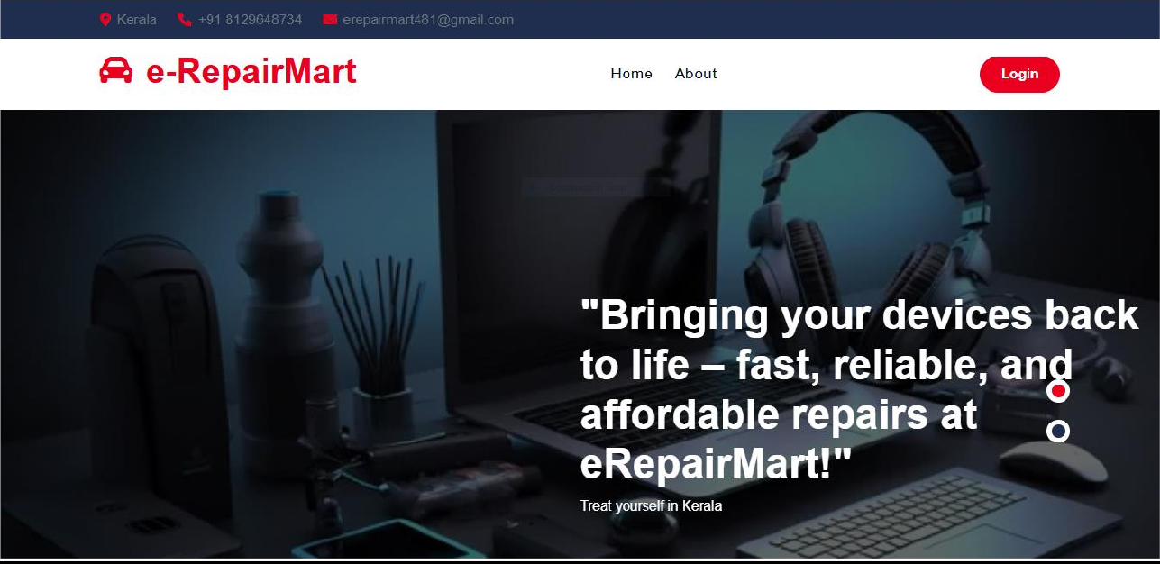

LOGIN FORM

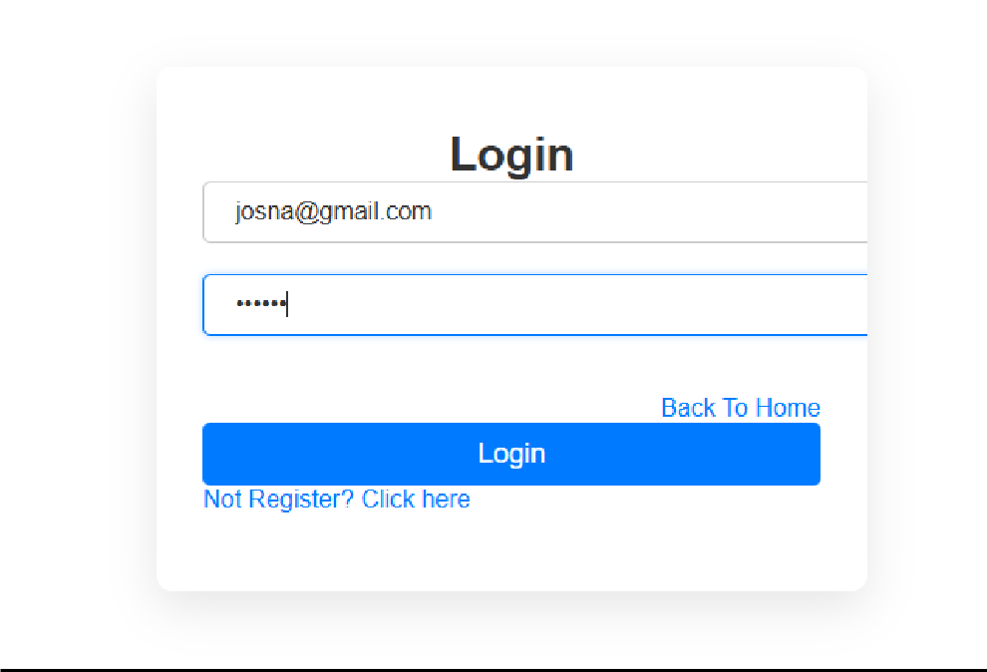

ADDTECHNICIANPAGE
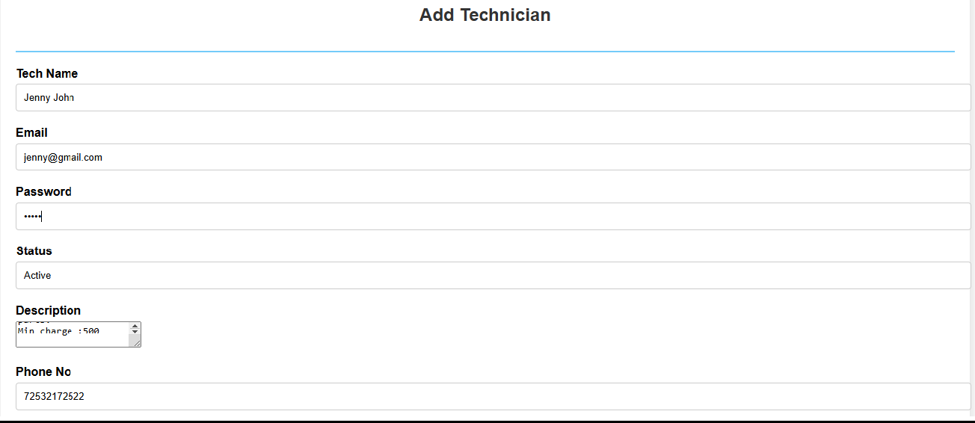
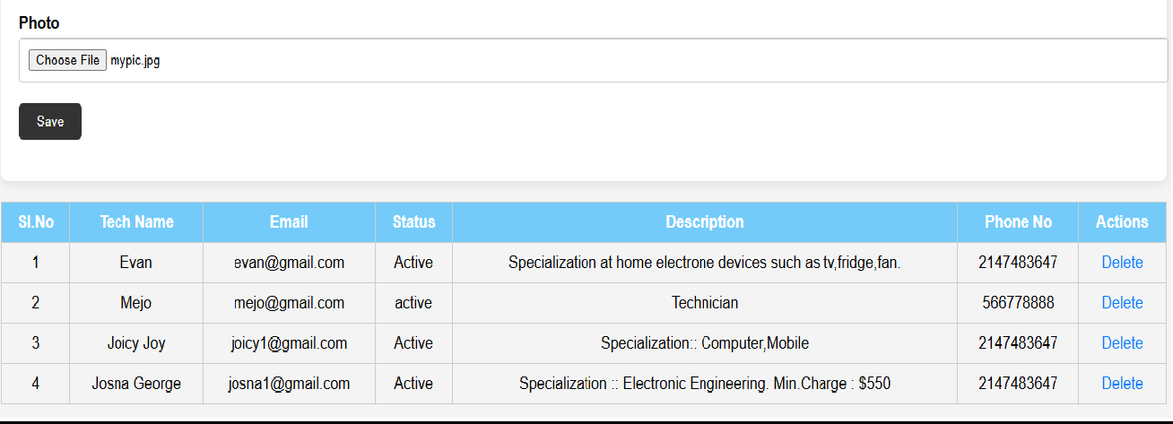

USERREGISTRATION
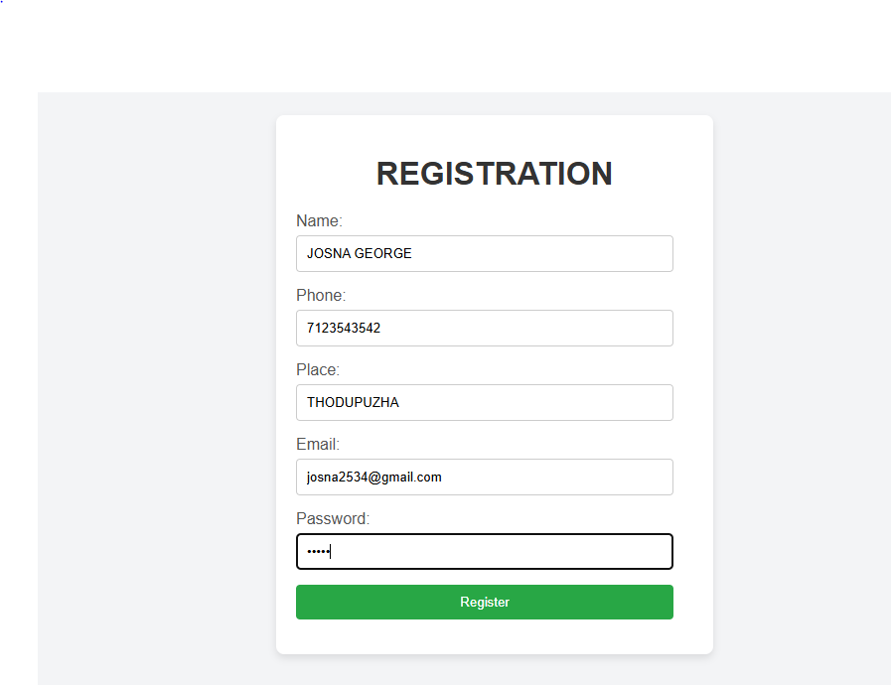

VIEWTECHNICIAN

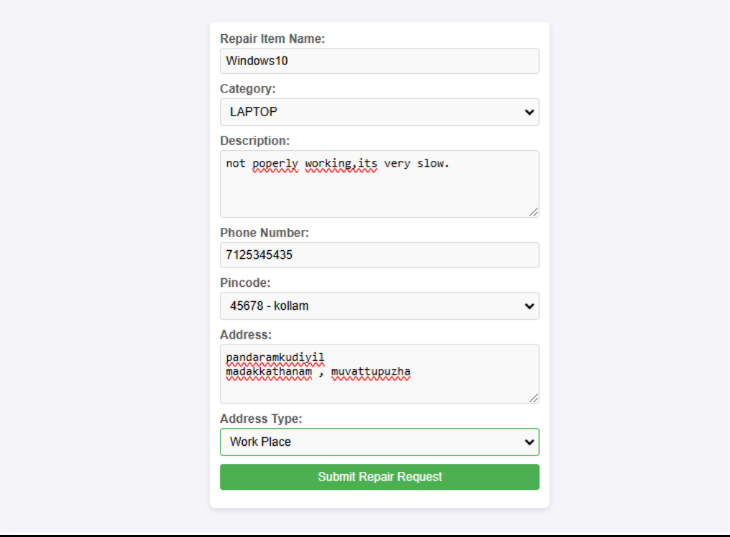
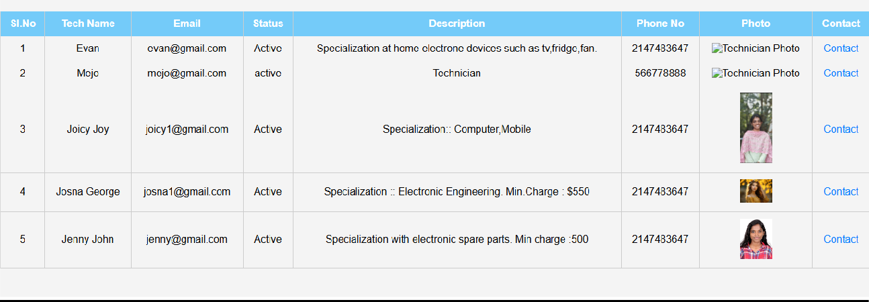
REPAIRMENTREQUESTFORM

CODING

LOGIN
<?php
//Includedatabaseconnectionfile include('../connection.php');
//Fetchcategoriesfrom'category'table
$categoryQuery="SELECT cid,cnameFROMcategory";
$categoryResult=$Conn->query($categoryQuery); if ($categoryResult === false) {
die("Errorfetchingcategories:". $Conn->error);
}

//Fetchpincodesfrom'place'table
$pincodeQuery="SELECTpin_id,pincode,place FROMplace";
$pincodeResult=$Conn->query($pincodeQuery); if ($pincodeResult === false) {
die("Errorfetchingpincodes:".$Conn->error);
}

//Fetchaddresstypesfrom'addr_type'table
$addrTypeQuery="SELECT add_id, add_typeFROMaddr_type";
$addrTypeResult=$Conn->query($addrTypeQuery); if ($addrTypeResult === false) {
die("Errorfetchingaddresstypes:". $Conn->error);
}
//Handleformsubmission
if($_SERVER['REQUEST_METHOD'] ==='POST') {
//Getformdata
$itemName=$_POST['item_name'];
$category= $_POST['category'];
$description=$_POST['description'];
$phoneNo=$_POST['phone_no'];
$pincode= $_POST['pincode'];
$address=$_POST['address'];
$addrType=$_POST['addr_type'];

//Prepareandexecutetheinsertstatement
$stmt=$Conn->prepare("INSERTINTOrepair_requ(item_name,category,description,phone_no, pincode, address, addr_type) VALUES (?, ?, ?, ?, ?, ?, ?)");
if($stmt===false){
die("Errorpreparingstatement:". $Conn->error);
}

$stmt->bind_param("sississ",$itemName,$category,$description,$phoneNo,$pincode,$address,
$addrType);

if($stmt->execute()){
echo"<script>alert('Repairrequestsubmittedsuccessfully!');</script>";
}else{
echo"<script>alert('Error:".htmlspecialchars($stmt->error)."');</script>";
}

$stmt->close();
}

// Fetchallrepairrequests
$repairRequestsQuery="SELECTrr.r_id,rr.item_name, c.cnameAScategory,rr.description, rr.phone_no, p.pincode, p.place, rr.address, at.add_type
FROMrepair_requrr
JOINcategorycONrr.category=c.cid JOINplacepONrr.pincode=p.pin_id
JOINaddr_typeatONrr.addr_type=at.add_id";
$repairRequestsResult=$Conn->query($repairRequestsQuery); if ($repairRequestsResult === false) {
die("Errorfetchingrepairrequests:".$Conn->error);
}
?>

<!DOCTYPE html>
<htmllang="en">
<head>
<metacharset="UTF-8">
<metaname="viewport"content="width=device-width,initial-scale=1.0">
<title>RepairRequestForm</title>
<linkrel="stylesheet"href="css/style.css"><!--Optional:LinktoyourCSSfile -->
</head>
<body>

<formmethod="post"action="">
<!--Formfieldsas inyouroriginalcode...-->

</form>

<!-- Displayallstoredrepair requests-->
<h2>AllRepairRequests</h2>
<tableborder="1">
<thead>
<tr>
<th>ID</th>
<th>ItemName</th>
<th>Category</th>
<th>Description</th>
<th>PhoneNumber</th>

<th>Pincode</th>
<th>Place</th>
<th>Address</th>
<th>AddressType</th>
</tr>
</thead>
<tbody>
<?phpwhile($row=$repairRequestsResult->fetch_assoc()): ?>
<tr>
<td><?=htmlspecialchars($row['r_id'])?></td>
<td><?=htmlspecialchars($row['item_name'])?></td>
<td><?=htmlspecialchars($row['category'])?></td>
<td><?=htmlspecialchars($row['description'])?></td>

s<td><?=htmlspecialchars($row['phone_no'])?></td>
<td><?=htmlspecialchars($row['pincode'])?></td>
<td><?=htmlspecialchars($row['place'])?></td>
<td><?=htmlspecialchars($row['address'])?></td>
<td><?=htmlspecialchars($row['add_type'])?></td>
</tr>

<?phpendwhile;?>
</tbody>
</table>

</body>
</html>

USERREGISTRATION

<?phperror_reporting(E_ALL); ini_set('display_errors', 1); require('../connection.php');

if(isset($_POST['submit'])){
$name=$_POST['uname'];
$password= $_POST['ucontact'];
$email=$_POST['uemail'];
$phone= $_POST['upasswd'];
$place=$_POST['uplace'];

$query="INSERTINTOuserregistration(uname,ucontact,uemail,upasswd,upincode)VALUES( '$name', '$phone', '$email', '$password', '$place')";
$result=$Conn->query($query); if ($result) {
echo "<script>alert('Registration Success');</script>"; echo"<script>window.open('login.php','_self')</script>";
}
}
?>

<!DOCTYPEhtml>
<htmllang="en">
<head>
<metacharset="UTF-8">
<metaname="viewport"content="width=device-width,initial-scale=1.0">
<title>RegistrationForm</title>
<linkrel="stylesheet"href="https://cdnjs.cloudflare.com/ajax/libs/font- awesome/5.15.4/css/all.min.css">
<style>
body{
display:flex;
justify-content:center; align-items: center; height: 100vh;
background-color:#f3f4f6; margin: 0;
font-family:Arial,sans-serif;
}
form{
background-color:#ffffff; border-radius: 8px;
box-shadow:04px8pxrgba(0,0,0,0.1); padding: 20px;
width:100%;
max-width:400px;
}
h1{
text-align: center; margin-bottom:20px; color: #333;
}
label{
display: block; margin-bottom:5px; color: #555;
}
input[type="text"],input[type="email"],input[type="password"],input[type="submit"]{ width: calc(100% - 20px);
padding: 10px; margin-bottom:15px;
border:1pxsolid#ccc; border-radius: 4px;
box-sizing:border-box;
}
input[type="submit"] { background-color:#28a745; color: #fff;
border: none; cursor:pointer;
transition:background-color0.3s;

}
input[type="submit"]:hover { background-color:#218838;
}
</style>
</head>
<body>
<formmethod="POST">
<h1>REGISTRATION</h1>
<labelfor="uname">Name:</label>
<inputtype="text"name="uname"required>

<labelfor="phone">Phone:</label>
<inputtype="text"name="ucontact"required>

<labelfor="place">Place:</label>
<inputtype="text"name="uplace"required>

<labelfor="email">Email:</label>
<inputtype="email"name="uemail"required>
<labelfor="password">Password:</label>
<inputtype="password"name="upasswd"required>
<inputtype="submit"name="submit"value="Register">
</form>
</body>
</html>

ADDTECHNICIAN

<!DOCTYPEhtml>
<htmllang="en">
<head>
<title>AddTechnician</title>
<linkrel="stylesheet"href="css/style.css">
</head>
<body>
<?php
include('../connection.php');//Ensurethisfilecontainsyourdatabaseconnectioncode

if(isset($_POST['btn_save'])){
$techname=$_POST['txt_name'];
$techemail=$_POST['txt_email'];
$techpasswd=$_POST['txt_password'];//Hashingthepassword
$techstatus=$_POST['txt_status'];
$techdesc=$_POST['txt_description'];
$techphone=$_POST['txt_phone'];

//Handlefileupload
if(isset($_FILES['txt_photo'])&&$_FILES['txt_photo']['error']==0){

$uploadDir='uploads/';//Directorytostoretheuploadedfiles
$uploadFile=$uploadDir.basename($_FILES['txt_photo']['name']);

if(move_uploaded_file($_FILES['txt_photo']['tmp_name'],$uploadFile)){
$techphoto=$uploadFile;
}else{
echo"<script>alert('Failedtouploadphoto.');</script>";
$techphoto='';
}
}else{
$techphoto='';
}

//Checkifthetechnicianalreadyexists
$stmt=$Conn->prepare("SELECTtemailFROMtechregistractionWHEREtemail=?");
$stmt->bind_param("s",$techemail);
$stmt->execute();
$result =$stmt->get_result();

if($result->num_rows===0){//Emaildoesnotexist
$ins="INSERTINTOtechregistraction(tname,temail,tpassword,tstatus,tdescription,tphone, tphoto) VALUES (?, ?, ?, ?, ?, ?, ?)";
$stmt=$Conn->prepare($ins);
$stmt->bind_param("sssssss",$techname,$techemail,$techpasswd,$techstatus,$techdesc,
$techphone,$techphoto);
if($stmt->execute()){
echo"<script>alert('Technicianaddedsuccessfully!');</script>";
}
}else{
echo"<script>alert('Technicianwiththisemailalreadyexists.');</script>";
}
}

// Deletetechnician
if(isset($_GET['id'])) {
$del="DELETE FROMtechregistractionWHEREtid=?";
$stmt=$Conn->prepare($del);
$stmt->bind_param("i",$_GET['id']); if ($stmt->execute()) {
header("Location:addtechnician.php"); exit;
}
}
?>

<sectionclass="main_contentdashboard_part">
<divclass="main_content_iner ">
<divclass="container-fluidp-0">
<divclass="rowjustify-content-center">

<divclass="col-12">
<divclass="QA_section">
<divclass="white_box">
<divclass="white_box_tittlelist_header">
<h3class="main-title">AddTechnician</h3>
</div>
<formmethod="post"enctype="multipart/form-data">
<divclass="form-group">
<labelfor="txt_name">TechName</label>
<inputrequiredtype="text"class="form-control"id="txt_name"name="txt_name"
autocomplete="off">
</div>

<divclass="form-group">
<labelfor="txt_email">Email</label>
<inputrequiredtype="text"class="form-control"id="txt_email"name="txt_email"
autocomplete="off">
</div>

<divclass="form-group">
<labelfor="txt_passwd">Password</label>
<inputrequiredtype="password"class="form-control"id="txt_passwd" name="txt_password" autocomplete="off">
</div>

<divclass="form-group">
<labelfor="txt_status">Status</label>
<inputrequiredtype="text"class="form-control"id="txt_status" name="txt_status" autocomplete="off">
</div>

<divclass="form-group">
<labelfor="txt_description">Description</label>
<textarearequiredclass="form-control"id="txt_description" name="txt_description" autocomplete="off"></textarea>
</div>

<divclass="form-group">
<labelfor="txt_phone">PhoneNo</label>
<inputrequiredtype="text"class="form-control"id="txt_phone" name="txt_phone" autocomplete="off">
</div>

accept="image/*">
<divclass="form-group">
<labelfor="txt_photo">Photo</label>
<inputrequiredtype="file"class="form-control"id="txt_photo"name="txt_photo"

</div>

<divclass="form-group">
<inputtype="submit"class="btn-dark"name="btn_save"value="Save">

</div>
</form>
</div>

<divclass="QA_tablemb_30">
<table>
<thead>
<tr>
<th>Sl.No</th>
<th>TechName</th>
<th>Email</th>

<th>Status</th>
<th>Description</th>
<th>PhoneNo</th>
<!--<th>Photo</th>-->
<th>Actions</th>
</tr>
</thead>
<tbody>

<?php
$i=0;
$selQry="SELECT*FROMtechregistraction";
$rs = $Conn->query($selQry);while($data=$rs->fetch_assoc()){
$i++;
?>

<tr>
<tdalign="center"><?phpecho$i;?></td>
<tdalign="center"><?phpechohtmlspecialchars($data["tname"]);?></td>
<tdalign="center"><?phpechohtmlspecialchars($data["temail"]);?></td>

<tdalign="center"><?phpechohtmlspecialchars($data["tstatus"]);?></td>
<tdalign="center"><?phpechohtmlspecialchars($data["tdescription"]);?></td>
<tdalign="center"><?phpechohtmlspecialchars($data["tphone"]);?></td>
<!--<td align="center"><imgsrc="../uploads/<?php echo htmlspecialchars($data["tphoto"]);?>"alt="TechnicianPhoto"width="50"></td>-->
<tdalign="center">
<ahref="addtechnician.php?id=<?phpecho$data["tid"];?>" class="status_btn">Delete</a>
</td>
</tr>
<?php}?>

</tbody>
</table>
</div>

</div>

</div>
</div>
</div>
</div>
</section>
</body>
</html>

