- What is a Collection?
A Collection is an object that stores multiple elements together.

Example:
list of employees
list of numbers

- Is an Array part of the Collection Framework?
arrays are not part of the Java Collection Framework.

- Arrays
Built into the Java language itself
Fixed size once created
Can store primitives and objects
Accessed with index syntax (arr[0])
Found in java.lang (no imports needed)

- Java Collection Framework
A set of classes and interfaces in java.util
Examples: List, Set, Queue, Map
Dynamic size (can grow/shrink)
Store objects only (not primitives directly)
Rich APIs for searching, sorting, iterating, etc.

- What is Java Collections Framework?
It is a set of classes + interfaces that helps to:

- Collection Hierarchy (Very Important)
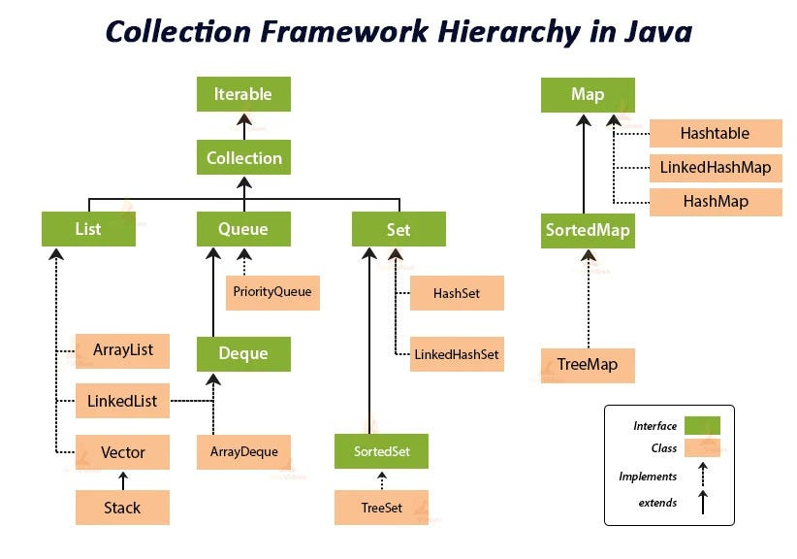

- Collection and Map are different

- Collection Interface
Collection is the root interface for List, Set, Queue.

Common methods:
add()
remove()
size()
isEmpty()
contains()

- List Interface (Most Used)
What is List?
Allows duplicate elements
Maintains insertion order
Index-based access

Implementations:
ArrayList
LinkedList
Vector (legacy)

ArrayList (Most Important)
Example:
import java.util.*;

public class Main {
public static void main(String[] args) {
List<String> list = new ArrayList<>();

list.add("Java");
list.add("Python");
list.add("Java"); // duplicate allowed

System.out.println(list);
}
}

Output:
[Java, Python, Java]

Feature -> ArrayList
Order -> Maintained
Duplicate -> Allowed
Access -> Fast (index-based)
Thread-safe -> No

Internal Working (Basic)
Uses dynamic array
When full → creates bigger array → copies elements

- Set Interface
What is Set?
No duplicates
Order not guaranteed (depends on implementation)

Implementations:
HashSet
LinkedHashSet
TreeSet

Example:
Set<Integer> set = new HashSet<>();
set.add(10);
set.add(20);
set.add(10); // duplicate ignored

System.out.println(set);

Output:
[10, 20]

- Map Interface (Very Important)
What is Map?
Stores data as key–value pairs
Keys are unique
Values can be duplicate

Implementations:
HashMap
LinkedHashMap
TreeMap

Example:
Map<Integer, String> map = new HashMap<>();
map.put(1, "Java");
map.put(2, "Python");
map.put(1, "C++"); // overwrites

System.out.println(map);

Output:
{1=C++, 2=Python}

Important Interview Point
- ❌ Map does NOT extend Collection
Because:
Map works with key–value, not single elements

- ArrayList vs LinkedList (deep + internal working)
- Basic Idea (Very Important)
- ArrayList
Uses dynamic array
Elements stored in continuous memory
Fast access using index

Think: Row of seats

- LinkedList
Uses doubly linked list

Each element is a node with:
data
previous reference
next reference

Memory is not continuous

Think: Chain of nodes

- Internal Working (This is the key part)
- How ArrayList works internally
ArrayList<String> list = new ArrayList<>();

Internally:
Object[] elementData;

Default capacity
Initial capacity = 10 (when first element is added)

Adding elements
list.add("A");
list.add("B");

Stored like:
[A][B][ ][ ][ ][ ][ ][ ][ ][ ]

When ArrayList is full
New array created with 1.5x capacity
Old elements copied to new array

Example:
Old size: 10
New size: 15

This copying is expensive

- How LinkedList works internally
Each element is a Node:

class Node {
Node prev;
Object data;
Node next;
}

Memory structure:
null <- [A] <-> [B] <-> [C] -> null

No resizing
No shifting
Uses extra memory for pointers

- Operation-wise Comparison (VERY IMPORTANT)
- 1. get(index)
- ArrayList
list.get(5);

Direct index access
Time Complexity: O(1)

- LinkedList
list.get(5);

Traverse from head/tail
Time Complexity: O(n)

Winner: ArrayList

- 2. add(element) at end
- ArrayList
O(1) normally
O(n) when resizing happens

- LinkedList
Just create new node
O(1)

- 3. add(index, element)
- ArrayList
list.add(2, "X");

Before:
[A][B][C][D]

After:
[A][B][X][C][D]

Elements shifted
Time Complexity: O(n)

- LinkedList
Travese to index → O(n)
Change links → O(1)

Overall:
Time Complexity: O(n)

Many think LinkedList is fast here — but traversal still costs time.

- 4. remove(index)
Same logic as add(index):
Operation | ArrayList | LinkedList
remove(index) | O(n) (shift) | O(n) (traverse)

- 5. Memory usage
- ArrayList
Stores only data
Less memory overhead

- LinkedList
Stores data + 2 references
More memory usage

✅ Winner: ArrayList

- ArrayList vs LinkedList (Deep Comparison Table)
Feature | ArrayList | LinkedList
Internal DS | Dynamic Array | Doubly Linked List
Memory layout | Continuous | Non-contiguous
get(index) | O(1) | O(n)
add at end | O(1)* | O(1)
add/remove middle | O(n) | O(n)
Memory usage | Less | More
Cache friendly | ✅ Yes | ❌ No
Random access | Fast | Slow

- Is LinkedList faster than ArrayList for insertion?
Not always — traversal cost makes it O(n).

- HashMap internal working (MOST IMPORTANT)

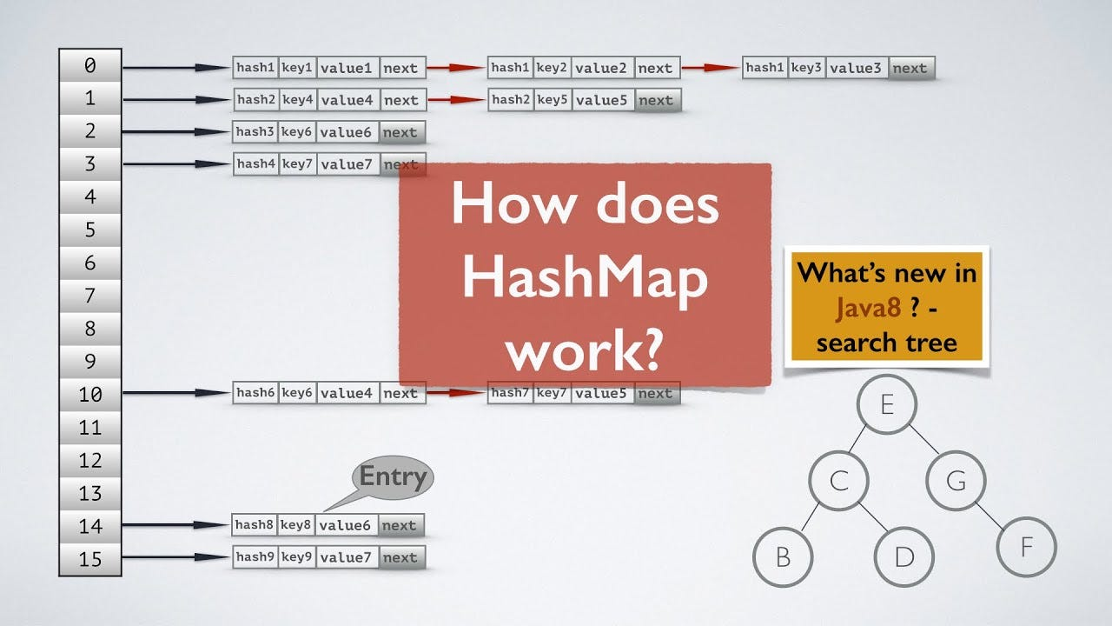

- What is HashMap?
Stores data as key–value pairs
Keys are unique
Values can be duplicate
Not thread-safe
Allows one null key and multiple null values

- Internal Structure of HashMap
Internally, HashMap uses:
Node<K, V>[] table;

Each index of this array is called a bucket.
Node structure:
class Node<K,V> {
int hash;
K key;
V value;
Node<K,V> next;
}

So each bucket contains:
null OR
a linked list OR
a red-black tree (Java 8+)

- How put(key, value) Works (Step by Step)
Let’s take this example:
HashMap<String, Integer> map = new HashMap<>();
map.put("Apple", 10);

- Step 1: Hashing the key
HashMap calls:
hash = key.hashCode();

For "Apple" → some integer value (example):
hashCode = 63257241

- Step 2: Calculate bucket index
Using formula:
index = (n - 1) & hash;

Where:
n = array size (default = 16)

Example:
index = (16 - 1) & hash
index = 15 & hash

This ensures index is always between 0–15.

- Step 3: Check bucket
If bucket is empty → store node directly
If bucket is not empty → collision happens

- Collision Handling (VERY IMPORTANT)
What is collision?
When two different keys map to the same bucket index.

Java 7 (and before)
Collision handled using:
👉 Linked List

Bucket[5] → (Apple,10) → (Orange,20) → null

Java 8+ (Improvement)
If:
Bucket size > 8
AND table size ≥ 64

Then:
- Linked List is converted into Red-Black Tree

Bucket[5] → Tree structure (balanced)

This improves performance from:
- O(n) → O(log n)

- Key Equality Check (equals method)
When inserting new key:
Compare hash
If hash matches → compare using:
key.equals(existingKey)

Cases:
If equals() returns true → value is replaced
If false → new node added

- Resizing (Rehashing) – Very Important
Default values:
Initial capacity = 16
Load factor = 0.75

Threshold:
threshold = capacity × loadFactor
threshold = 16 × 0.75 = 12

- When entries > 12 → resize happens

- What happens during resize?
Capacity doubles → 16 → 32
All existing entries are rehashed
New bucket index calculated

This is expensive operation

- Why only ONE null key?
Because:
HashMap treats null key as hash = 0

So only one bucket for null key
map.put(null, "A");
map.put(null, "B"); // replaces value

- Why HashMap key should be immutable (deep)
- What Happens If Key Is Mutable (Actual Problem)
❌ Mutable Key Example
class Employee {
int id;

Employee(int id) {
this.id = id;
}

@Override
public int hashCode() {
return id;
}

@Override
public boolean equals(Object o) {
Employee e = (Employee) o;
return this.id == e.id;
}
}

- Step 1: Put entry
Employee e = new Employee(1);
map.put(e, "Jemis");

hashCode() → 1
Stored in bucket for hash 1

- Step 2: Modify key (BIG MISTAKE)
e.id = 2; // 🔥 key changed

Now:
hashCode() → 2

- Step 3: Try to get value
map.get(e);

❌ HashMap:
looks in bucket for hash 2
but entry is in bucket for hash 1

Result: null (data lost)

- Is immutability mandatory for HashMap keys?
✅ Technically no, but
❌ Practically YES, otherwise HashMap behavior breaks.

- HashMap vs Hashtable vs ConcurrentHashMap (deep)
- Basic Idea (Start Simple)
Collection | Introduced | Thread-Safe | Used in
HashMap | Java 1.2 | ❌ No | Single-threaded
Hashtable | Java 1.0 | ✅ Yes | Legacy code
ConcurrentHashMap | Java 5 | ✅ Yes | High-concurrency

- HashMap
NOT thread-safe
Multiple threads can corrupt data
Can cause infinite loop during resize (old Java)

Map<Integer, String> map = new HashMap<>();

- HashMap Internal
No locking
Multiple threads can modify same bucket
Leads to data inconsistency

- Hashtable
Thread-safe

❌ Very slow
❌ Old legacy class

- Hashtable Internal (Why slow?)
Single lock on entire map

Only ONE thread can:
read
write
update

- ConcurrentHashMap
Thread-safe
Multiple threads can read/write concurrently

- ConcurrentHashMap Internal
Lock only the required bucket, not the entire map

Map<Integer, String> map = new ConcurrentHashMap<>();

✅ Best for multithreaded applications

- What is an Iterator?
An Iterator is used to traverse a collection safely.

Example:

Iterator<Integer> it = list.iterator();
while (it.hasNext()) {
System.out.println(it.next());
}

- Fail-Fast vs Fail-Safe Iterators (VERY IMPORTANT)
- Fail-Fast Iterator
- Meaning:
Fails immediately if the collection is modified while iterating
(except through iterator’s own remove() method).

- Used by:
ArrayList
HashMap
HashSet
LinkedList

- How Fail-Fast works internally?
Collections maintain a variable called:
modCount

Every structural modification (add, remove) increments modCount
Iterator stores expected value: expectedModCount

If they differ → ConcurrentModificationException

- Fail-Fast Example
import java.util.*;

public class Main {
public static void main(String[] args) {
List<Integer> list = new ArrayList<>();
list.add(1);
list.add(2);
list.add(3);

Iterator<Integer> it = list.iterator();

while (it.hasNext()) {
Integer val = it.next();
if (val == 2) {
list.remove(val); // ❌ modifying collection directly
}
}
}
}

❌ Output:
ConcurrentModificationException

- Correct way with Fail-Fast
Iterator<Integer> it = list.iterator();
while (it.hasNext()) {
Integer val = it.next();
if (val == 2) {
it.remove(); // ✅ allowed
}
}

- Fail-Safe Iterator
- Meaning:
Iterator does NOT fail if collection is modified during iteration.

- How?
👉 It iterates over a copy (snapshot) of the collection.

- Used by:
ConcurrentHashMap
CopyOnWriteArrayList
CopyOnWriteArraySet

- How Fail-Safe works internally?
Iterator works on a separate copy
Original collection can be modified safely
No ConcurrentModificationException

Trade-off:
Extra memory

Iterator may not reflect latest changes

- Fail-Safe Example
import java.util.concurrent.*;

public class Main {
public static void main(String[] args) {
CopyOnWriteArrayList<Integer> list =
new CopyOnWriteArrayList<>();

list.add(1);
list.add(2);
list.add(3);

for (Integer i : list) {
if (i == 2) {
list.remove(i); // ✅ no exception
}
System.out.println(i);
}

System.out.println("Final list: " + list);
}
}

Output:
1
2
3
Final list: [1, 3]

- HashSet internal working (relation with HashMap)
- What is HashSet?
HashSet is a collection that:
Stores unique elements
Does not maintain insertion order
Allows only one null
Is not thread-safe

- Example:
Set<String> set = new HashSet<>();
set.add("Java");
set.add("Java"); // duplicate ignored

- The BIG Secret (Most Important Interview Point)
- HashSet is internally backed by a HashMap
This is not theory — this is actual implementation.

Inside HashSet:
private transient HashMap<E, Object> map;

And it uses a dummy value:
private static final Object PRESENT = new Object();

HashSet stores elements as KEYS of a HashMap
The VALUE is a constant dummy object

- How HashSet.add() Works Internally

Let’s say:
HashSet<String> set = new HashSet<>();
set.add("Apple");

- Step-by-step:
- Step 1: Call HashMap.put()

Internally:
map.put("Apple", PRESENT);

Key → "Apple"
Value → dummy object

- Step 2: HashMap computes hash

Calls "Apple".hashCode()
Calculates bucket index
Stores entry in bucket

- Step 3: Duplicate check

If you do:
set.add("Apple");

Internally:
map.put("Apple", PRESENT);

But HashMap:
Finds same key using equals()
Replaces value (same dummy object)
Returns old value

So HashSet understands:
Element already exists → do not add

- Time Complexity
Operation | Complexity
add() | O(1) average
remove() | O(1) average
contains() | O(1) average

