- Spring MVC Internal Request Flow
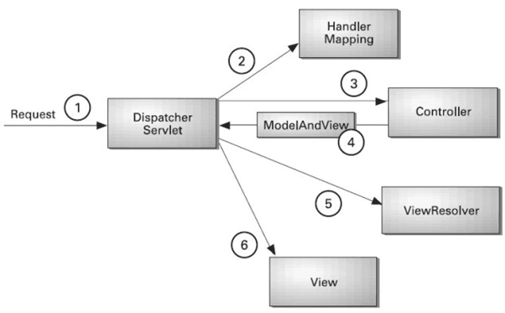
- Request Comes to Servlet Container

Tomcat receives HTTP request.
web.xml (or Java config) maps all requests to:

DispatcherServlet
This is the Front Controller.

- DispatcherServlet Receives Request
DispatcherServlet does NOT directly call your controller.
It asks:
“Which controller method should handle this request?”

So it calls:
HandlerMapping

- HandlerMapping:
Checks all @RequestMapping
Finds matching controller method

Example:
@GetMapping("/user/{id}")
public String getUser(@PathVariable int id)

Now Spring knows:
Controller class

Exact method to execute

- HandlerAdapter Executes Controller
Spring uses HandlerAdapter to:
Resolve method parameters
@PathVariable
@RequestParam
@ModelAttribute
Convert types (String → int)
Call controller method

Now your controller runs:
@GetMapping("/user/{id}")
public String getUser(@PathVariable int id, Model model) {
model.addAttribute("user", service.find(id));
return "userPage";
}

Controller returns:
"userPage"

- Controller Returns View Name + Model
Spring creates:
ModelAndView

Containing:
View name → "userPage"
Model data → user object

- ViewResolver Resolves Actual View
Spring now asks:
“Where is userPage?”

If configured:
prefix = /WEB-INF/views/
suffix = .jsp

It converts:
"userPage"
into:
/WEB-INF/views/userPage.jsp

- View Renders Response
JSP gets model data
HTML generated
Response sent back to browser

- If It Is REST Controller?

Example:

@RestController
@GetMapping("/api/user/10")
public User getUser() {
return user;
}

Flow changes slightly:
Instead of ViewResolver:

HttpMessageConverter converts object → JSON (Jackson)

Response:
{
"id": 10,
"name": "Jemis"
}

- Internal Components Summary
Component | Responsibility
DispatcherServlet | Front controller
HandlerMapping | Finds controller method
HandlerAdapter | Executes method
Controller | Business logic
ViewResolver | Maps logical view to JSP
HttpMessageConverter | Converts object to JSON

- Internal Flow in 10 Seconds (Interview Answer)
You can say:
In Spring MVC, the request first goes to DispatcherServlet. It uses HandlerMapping to find the appropriate controller method. Then HandlerAdapter invokes the method. The controller returns a view name and model data. ViewResolver resolves the view, and the response is rendered back to the client. For REST APIs, HttpMessageConverter converts objects into JSON instead of using a view.

- What is DispatcherServlet?
DispatcherServlet is the Front Controller in Spring MVC.

It:
Receives all incoming HTTP requests
Decides which controller should handle them
Coordinates the entire request lifecycle
Returns response to client

Without it → Spring MVC does not work.

then entire cycle of request handle by DispatcherServlet in spring mvc

- Core Spring MVC Annotations
- 1. @Controller
Marks a class as a web controller.

@Controller
public class UserController {
}

Used for returning views (JSP/HTML).

- 2. @RestController
Combination of:

@Controller + @ResponseBody

Used for REST APIs (returns JSON).

@RestController
public class UserApiController {
}

- 3. @RequestMapping
Maps URL to controller or method.

@RequestMapping("/users")

Can define:
path
method (GET, POST)
produces/consumes

- 4. @GetMapping, @PostMapping, @PutMapping, @DeleteMapping
Shortcut annotations (very common).

@GetMapping("/users")
@PostMapping("/users")

- 5. @PathVariable
Extracts value from URL.

@GetMapping("/users/{id}")
public String getUser(@PathVariable int id)

- 6. @RequestParam
Reads query parameters.

/users?id=10
@GetMapping("/users")
public String getUser(@RequestParam int id)

- 7. @ModelAttribute
Used for:
Form data binding
Adding data to model

@PostMapping("/save")
public String save(@ModelAttribute User user)

Spring automatically binds form fields → object.

- 8. @ResponseBody
Returns data directly instead of view.

@ResponseBody
@GetMapping("/hello")
public String hello() {
return "Hello";
}

Used internally by @RestController.

- 9. @RequestBody
Used in REST APIs to read JSON body.

@PostMapping("/users")
public User save(@RequestBody User user)

JSON → Java object conversion.

- 10. @Autowired
Dependency injection.

@Autowired
private UserService service;

(Prefer constructor injection)

- VERY IMPORTANT (Exception + Validation)
- 11. @ExceptionHandler
Handle exceptions inside controller.

@ExceptionHandler(Exception.class)
public String handleError() {
return "error";
}

- 12. @ControllerAdvice
Global exception handler.

@ControllerAdvice
public class GlobalExceptionHandler {
}

- 13. @Valid
Used for validation.

@PostMapping("/save")
public String save(@Valid @ModelAttribute User user, BindingResult result)

Works with:
@NotNull
@Size
@Email

- CONFIGURATION ANNOTATIONS (Since Not Using Boot)
- 14. @Configuration
Marks configuration class.

- 15. @EnableWebMvc
Enables Spring MVC.

- 16. @ComponentScan
Scans packages for beans.

- 17. @Component, @Service, @Repository
Stereotype annotations.
@Service
@Repository
@Component

- example combining all annotations
- Scenario: User Management Application

We will build:
JSP-based form submission (MVC)
REST API returning JSON
Validation
Global exception handling

- User Entity
import jakarta.validation.constraints.*;

public class User {

private int id;

@NotBlank(message = "Name is required")
private String name;

@Email(message = "Invalid email")
private String email;

// getters and setters
}

- Repository Layer
@Repository
public class UserRepository {

private Map<Integer, User> db = new HashMap<>();

public User save(User user) {
db.put(user.getId(), user);
return user;
}

public User findById(int id) {
if (!db.containsKey(id)) {
throw new RuntimeException("User not found");
}
return db.get(id);
}

public List<User> findAll() {
return new ArrayList<>(db.values());
}
}

- Service Layer
@Service
public class UserService {

@Autowired
private UserRepository repository;

public User save(User user) {
return repository.save(user);
}

public User getUser(int id) {
return repository.findById(id);
}

public List<User> getAll() {
return repository.findAll();
}
}

- MVC Controller (JSP Based)
@Controller
@RequestMapping("/users")
public class UserController {

@Autowired
private UserService service;

// Show form
@GetMapping("/form")
public String showForm(Model model) {
model.addAttribute("user", new User());
return "userForm";
}

// Handle form submit
@PostMapping("/save")
public String saveUser(@Valid @ModelAttribute User user,
BindingResult result) {

if (result.hasErrors()) {
return "userForm";
}

service.save(user);
return "success";
}

// Fetch user using query param
@GetMapping("/view")
public String viewUser(@RequestParam int id, Model model) {
model.addAttribute("user", service.getUser(id));
return "userView";
}
}
What we used here:
@Controller
@RequestMapping
@GetMapping
@PostMapping
@ModelAttribute
@RequestParam
@Valid
@Autowired

- REST Controller (JSON API)
@RestController
@RequestMapping("/api/users")
public class UserRestController {

@Autowired
private UserService service;

// Get user by path variable
@GetMapping("/{id}")
public User getUser(@PathVariable int id) {
return service.getUser(id);
}

// Create user via JSON
@PostMapping
public User createUser(@RequestBody User user) {
return service.save(user);
}

// Get all users
@GetMapping
public List<User> getAllUsers() {
return service.getAll();
}
}
Here we used:
@RestController
@PathVariable
@RequestBody
JSON conversion
@Autowired

- Global Exception Handling
@ControllerAdvice
public class GlobalExceptionHandler {

@ExceptionHandler(RuntimeException.class)
@ResponseBody
public String handleException(RuntimeException ex) {
return "Error: " + ex.getMessage();
}
}

Used:
@ControllerAdvice
@ExceptionHandler
@ResponseBody

- @ModelAttribute vs @RequestBody
Basic Difference (In One Line)

Annotation | Used For
@ModelAttribute | Binds form data / query parameters to object
@RequestBody | Binds JSON/XML request body to object

- How Data Comes to Server

- Form Submission (HTML Form)
<form action="/users/save" method="post">
<input name="name"/>
<input name="email"/>
</form>

This sends:
name=Jemis&email=jemis@gmail.com

This is form-urlencoded data

Here we use:
@PostMapping("/save")
public String save(@ModelAttribute User user) {
return "success";
}

- REST API (JSON)
Client sends:

{
"name": "Jemis",
"email": "jemis@gmail.com"
}

Content-Type:
application/json

Here we use:
@PostMapping("/users")
public User save(@RequestBody User user) {
return user;
}

- Internal Working Difference
- @ModelAttribute Internally
Uses DataBinder
Reads request parameters
Matches parameter names to object fields

Works with:
form-data
query params
URL parameters

Example:
/users/save?name=Jemis&email=abc@gmail.com

Spring binds:
name → user.name
email → user.email
No JSON parsing involved.

- @RequestBody Internally
Uses HttpMessageConverter
Reads raw HTTP body
Converts JSON → Java object
Uses Jackson library

- You can say:
@ModelAttribute binds form data and query parameters to a Java object using Spring's DataBinder. It is mainly used in traditional MVC applications.
@RequestBody binds JSON or XML request body to a Java object using HttpMessageConverter, typically in REST APIs.

- What is BindingResult?
- BindingResult is used to:
Capture validation errors after form binding.

It works with:
@Valid

- When Do You Need It?
When using:
@ModelAttribute + @Valid

Mostly in Spring MVC (JSP/Form-based apps).

- Basic Example (Most Important)
@PostMapping("/save")
public String saveUser(@Valid @ModelAttribute User user,
BindingResult result) {

if (result.hasErrors()) {
return "userForm"; // go back to form
}

service.save(user);
return "success";
}

- Important Rule (Very Important)
BindingResult must be placed immediately after the validated object.

- Correct:
public String save(@Valid @ModelAttribute User user,
BindingResult result)

- Wrong:
public String save(@Valid @ModelAttribute User user,
Model model,
BindingResult result) // ❌ error

If not placed immediately → Spring throws exception.

- What Happens Internally?
Spring binds form data → User object
Validation runs (@NotNull, @Email, etc.)
If errors occur → stored in BindingResult
You check result.hasErrors()

- Common Methods You Should Know
Method | Purpose
hasErrors() | Check if any validation errors
getAllErrors() | Get list of errors
getFieldError("name") | Get specific field error

You can say:
BindingResult is used in Spring MVC to capture validation errors after form data binding using @Valid. It must be placed immediately after the validated object in the method parameter. If validation fails, errors are stored inside BindingResult and can be checked using hasErrors().

- How Dependency Injection Works Internally Spring MVC?
- Spring Container Starts
When application starts:
DispatcherServlet loads
Spring creates ApplicationContext
It scans packages (@ComponentScan)

- Bean Creation
Spring finds:
@Repository
@Service
@Component
@Controller

It creates objects (beans) and stores them in:
IoC Container (ApplicationContext)

- Dependency Resolution
Spring sees:
@Autowired
private UserRepository repository;

It:
Checks container for matching bean
Finds UserRepository
Injects it

- View Resolver
Spring MVC does NOT automatically know where your JSP file is.

You must configure:
<bean class="org.springframework.web.servlet.view.InternalResourceViewResolver">
<property name="prefix" value="/WEB-INF/views/" />
<property name="suffix" value=".jsp" />
</bean>

Understand:
How logical view name → actual JSP file

- REST in Spring MVC
@RestController
@GetMapping("/api/users")
public List<User> getUsers() {
return service.getUsers();
}

- Bean configuration (XML + Java config)
- XML Configuration
<context:component-scan base-package="com.app"/>

- OR Java Config
@Configuration
@EnableWebMvc
@ComponentScan("com.app")

- What is an Interceptor?
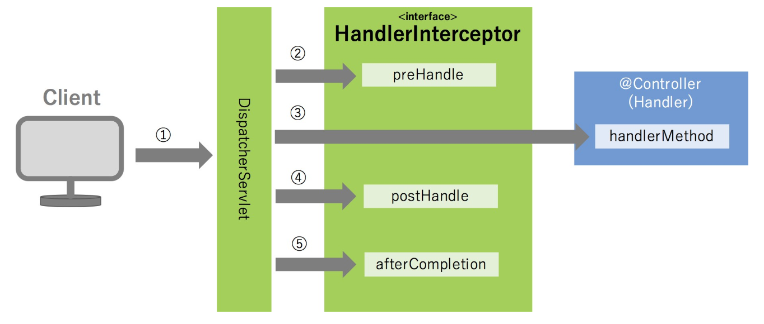
- An Interceptor in Spring MVC is:
A component that runs before and after a controller method executes.
It works at Spring MVC level (not Servlet level like Filters).

- Flow:
Client → DispatcherServlet → Interceptor (preHandle) → Controller →Interceptor (postHandle) → View →
Interceptor (afterCompletion) → Response

- Why Do We Use Interceptors?
Logging
Authentication check
Authorization
Measuring execution time
Adding common model attributes

- Core Interface
Spring provides:
org.springframework.web.servlet.HandlerInterceptor

- You implement it:
public class LoggingInterceptor implements HandlerInterceptor

- Three Important Methods (Must Know)
- preHandle()
Runs before controller execution

@Override
public boolean preHandle(HttpServletRequest request,
HttpServletResponse response,
Object handler) throws Exception {

System.out.println("Before Controller");
return true; // must return true to continue
}

If returns false → request stops here.

- postHandle()
Runs after controller, before view rendering.

@Override
public void postHandle(HttpServletRequest request,
HttpServletResponse response,
Object handler,
ModelAndView modelAndView) throws Exception {

System.out.println("After Controller, Before View");
}

- afterCompletion()
Runs after complete request processing.

@Override
public void afterCompletion(HttpServletRequest request,
HttpServletResponse response,
Object handler,
Exception ex) throws Exception {

System.out.println("After Complete Request");
}

- Example: Authentication Interceptor
public class AuthInterceptor implements HandlerInterceptor {

@Override
public boolean preHandle(HttpServletRequest request,
HttpServletResponse response,
Object handler) throws Exception {

String user = (String) request.getSession().getAttribute("user");

if (user == null) {
response.sendRedirect("/login");
return false;
}

return true;
}
}

- How to Register Interceptor (Non-Boot)
In Java config:

@Configuration
@EnableWebMvc
public class WebConfig implements WebMvcConfigurer {

@Override
public void addInterceptors(InterceptorRegistry registry) {
registry.addInterceptor(new AuthInterceptor())
.addPathPatterns("/users/**");
}
}

- Interceptor vs Filter (Interview Question)
Feature | Interceptor | Filter
Level | Spring MVC | Servlet
Works on | Controller level | All requests
Access to Controller | Yes | No
Part of | Spring | Servlet API

- You can say:
Interceptors in Spring MVC allow us to intercept requests before and after controller execution. They implement HandlerInterceptor and provide three methods: preHandle, postHandle, and afterCompletion. They are commonly used for logging, authentication, and request processing logic.

- when use model and modelAndView?
- Using Model (Most Common Way)
You return view name as String.

@GetMapping("/user")
public String getUser(Model model) {

model.addAttribute("name", "Jemis");

return "userPage";
}
- What happens internally?
You add data to Model
You return "userPage"
Spring creates ModelAndView internally

- Using ModelAndView
You return both data and view in one object.

@GetMapping("/user")
public ModelAndView getUser() {

ModelAndView mv = new ModelAndView();
mv.setViewName("userPage");
mv.addObject("name", "Jemis");

return mv;
}
use when you want to decide view dynamically

- Internally What Happens?
Even when you use Model:

Spring internally converts it into:
ModelAndView

Model is just a cleaner abstraction.

- You can say:
Model is used to pass data to the view when returning the view name as a String. ModelAndView is used when we want to return both the view and model data together in a single object. Internally, Spring converts Model into ModelAndView.

- Difference between Spring MVC and Servlet
- What is a Servlet?
Servlet is a Java API (javax.servlet / jakarta.servlet) used to handle HTTP requests.

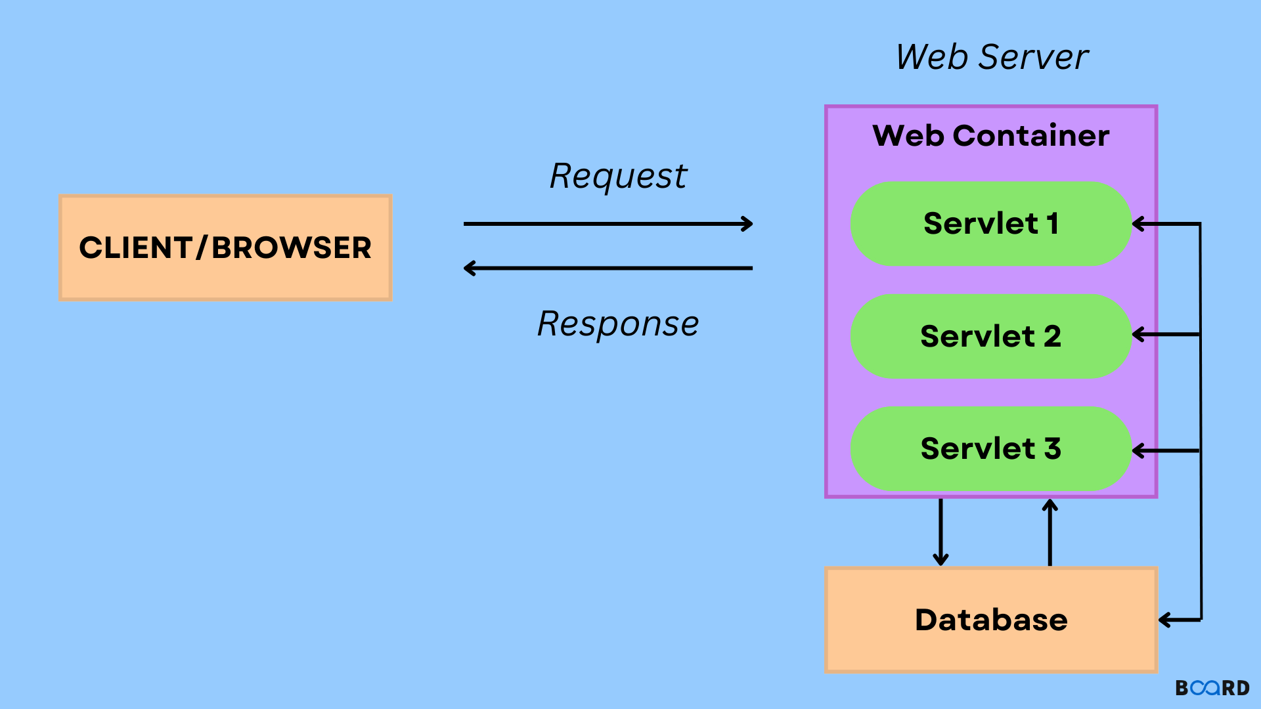

You manually write code like:
@WebServlet("/hello")
public class HelloServlet extends HttpServlet {

protected void doGet(HttpServletRequest request,
HttpServletResponse response)
throws IOException {

response.getWriter().println("Hello");
}
}

You handle everything manually.

- What is Spring MVC?
Spring MVC is a framework built on top of Servlet API.

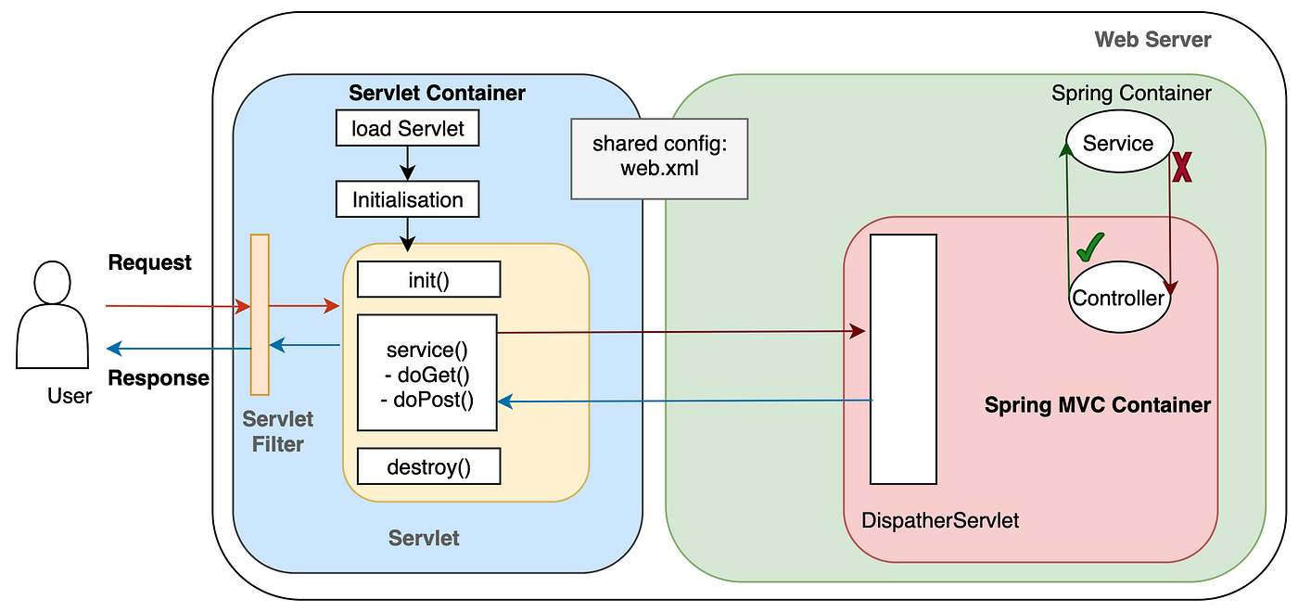

Instead of writing low-level servlet code, you write:
@Controller
public class HelloController {

@GetMapping("/hello")
public String hello() {
return "home";
}
}

Spring handles:
Request mapping
Object binding
Validation
View resolution
Exception handling

