- What is Java?
Java is a high-level, object-oriented, platform-independent programming language used to build:
Web applications
Enterprise systems
Mobile apps (Android)

Key features of Java:
Platform Independent (Write Once, Run Anywhere)
Object-Oriented
Secure
Robust
Multithreaded

Java code is compiled and interpreted

- How can we say that java is compiled and interpreted?
Because Java uses a two-step execution model:
- Compilation (once)
- Interpretation / Execution (every time you run)

- Step 1: Compilation (Source Code → Bytecode)

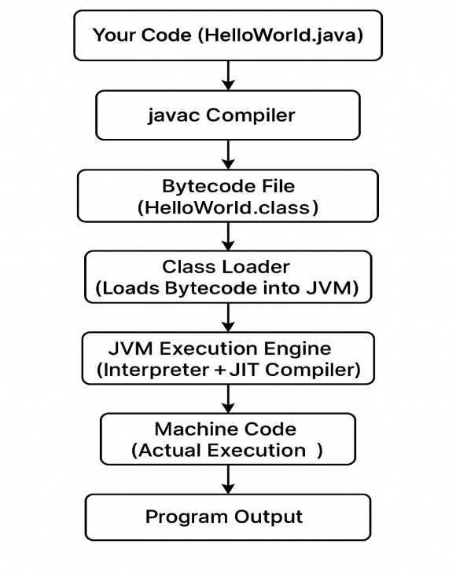

What happens?

You write Java code in a .java file
Java compiler (javac) compiles it
Output is a .class file (called bytecode)

- Important point:
Bytecode is NOT machine code
It is platform-independent
This is why Java is called compiled.

- Step 2: Interpretation / Execution (Bytecode → Machine Code)
What happens next?

When you run the program
JVM loads the .class file

JVM:
Verifies bytecode
Converts bytecode to machine code
Executes it

This execution is done by:
Interpreter (line by line)
JIT Compiler (Just-In-Time)

This is why Java is also interpreted.

- Role of JIT Compiler
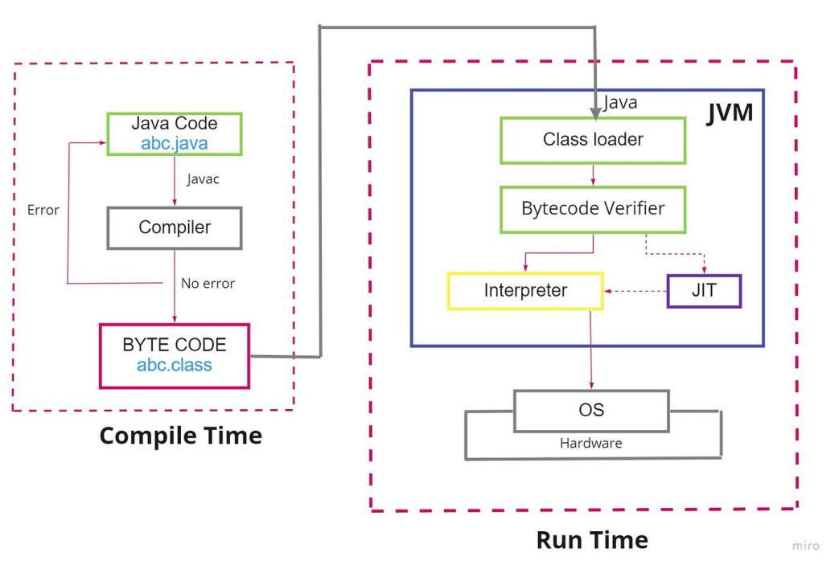
Why JIT?
Interpreting line-by-line is slow
JIT improves performance

How JIT works:
JVM detects frequently used code (hot code)
Compiles it into native machine code
Stores it for reuse

Result:
Java performance becomes close to C/C++

- Is Java fully interpreted like Python?
No, Java is hybrid.

- Is Java faster than interpreted languages?
Yes, because of JIT compilation.

- Why java does not compile directly to machine code?
Platform independence would be lost.

- Difference between Java & C++
- C++ Execution (Direct Machine Code)
C++ is compiled directly into machine code (native code).

Flow:
.cpp → C++ Compiler → .exe (Windows) / a.out (Linux) → Run directly on OS/CPU

Key points:
Output is platform dependent
Runs directly on hardware
Very fast execution

Example:
.exe created on Windows will not run on Linux.

- Java Execution (Bytecode + JVM)
Java is first compiled into bytecode, then executed by the JVM.

Flow:
.java → javac compiler → .class (bytecode) → JVM → Machine Code → Run

Key points:
Bytecode is platform independent
JVM converts bytecode into machine code
Java is portable: Write Once Run Anywhere

Example:
Same .class can run on Windows/Linux/Mac (only JVM needed).

- Main Differences (Interview Table)
Feature | Java Execution | C++ Execution
Compilation output | Bytecode (.class) | Native machine code (.exe)
Needs runtime | ✅ JVM required | ❌ Not required
Platform dependency | Bytecode: Independent, JVM: Dependent | Fully dependent
Speed | Slightly slower than C++ (but fast with JIT) | Usually faster
Memory management | Automatic (Garbage Collector) | Manual (new/delete)
Security | More secure (bytecode verification) | Less secure
Portability | ✅ High | ❌ Low

- Garbage Collection (Java) vs Manual Memory (C++)
- Java Memory Management (Garbage Collection)
In Java, you don’t manually delete objects.

Example:
Student s = new Student(); // object created in Heap
s = null; // now no reference
// GC will remove the object automatically

How it works?
Objects are created in Heap memory
When an object is no longer referenced, it becomes eligible for Garbage Collection
JVM’s Garbage Collector (GC) automatically frees that memory

- C++ Memory Management (Manual)
In C++, developer must manage memory manually.

Example:
Student* s = new Student(); // allocated in Heap
delete s; // developer must free memory

How it works?
Memory allocated using:
new (heap allocation)
malloc() (C-style)

Must be freed using:
delete
free()

- Simple Comparison Table
Feature | Java (Garbage Collection) | C++ (Manual Memory)
Who frees memory? | JVM (GC) | Developer
Risk of memory leaks | Low | High
Control | Less | Full control
Performance | Slight overhead due to GC | Faster (if coded properly)
Errors | Less | More (crashes possible)
Example | obj = null; | delete obj;

- What is Memory Leak in Java?
Memory leak in Java occurs when objects that are no longer required are still strongly referenced, preventing the Garbage Collector from freeing memory, which may finally cause OutOfMemoryError.

- How Garbage Collection Works Internally (Mark & Sweep)
- Step 1: Mark (Marking Phase)
GC starts from GC Roots and marks all reachable objects.

What are GC Roots?
These are references that are always considered “alive”, like:

Local variables in stack (method variables)
Active threads
Static variables
JNI references

Mark phase logic:
Start from GC Roots
Traverse object references like a graph
Mark all reachable objects as alive

- Step 2: Sweep (Sweeping Phase)
After marking is done:
Any object NOT marked is garbage
GC deletes those objects and frees heap memory

- Problem with Mark & Sweep
Even after sweep, heap memory becomes fragmented:

Example free spaces:
[Obj1][free][Obj2][free][free][Obj5]

This makes allocation slower.

That’s why JVM often also performs:
Compact Phase (Mark-Sweep-Compact)
Moves objects together and removes gaps

- what is JVM,JRE and JDK?
- JVM is a virtual machine that:
loads Java bytecode (.class)
converts bytecode into machine code
executes the program
manages memory (Heap/Stack) and Garbage Collection

JVM is platform dependent (different for Windows/Linux).

- JRE (Java Runtime Environment)
JRE is required to run Java applications.

It contains:
JVM
Java class libraries (API)

JRE = JVM + Libraries

- JDK (Java Development Kit)?
JDK is required to develop + run Java applications.

It contains:
JRE
Compiler (javac)
Development tools (jar, javadoc, etc.)

JDK = JRE + Development tools

- What is a Variable?
A variable is a container used to store data in memory.

- Rules for Variable Names
Allowed:
Letters, digits, _, $
Cannot start with digit

- Types of Variables in Java (Very Important)
- Local Variable
Declared inside a method.

void show() {
int x = 10;
}

- Instance Variable
Declared in class but outside method (per object).

class Student {
int id;
}

- Static Variable
Same for all objects (class level).

class Student {
static String schoolName = "ABC School";
}

- Default Values (Interview Question)
Only instance and static variables get default values.
Type | Default
int | 0
double | 0.0
boolean | false
char | '\u0000'
Object reference | null

Local variables have NO default value → must initialize before use.

- what is the Data Types?
Java has two types of data types:

- Primitive Data Types (8 types)
These store actual values directly.
Type | Size | Example
byte | 1 byte | byte b = 10;
short | 2 bytes | short s = 200;
int | 4 bytes | int x = 1000;
long | 8 bytes | long l = 999999L;
float | 4 bytes | float f = 10.5f;
double | 8 bytes | double d = 99.99;
char | 2 bytes | char c = 'A';
boolean | 1 bit (logical) | boolean ok = true;

- Non-Primitive Data Types (Reference Types)
These store reference/address, not actual value.

Examples:
String
Arrays
Class objects
Interfaces

- What does the Java equality operator (==) mean for primitives and objects
- == compares values for primitives
- == compares references for objects

