IT Ticket Analysis
Comprehensive Analysis of IT Support Operations and Ticket Performance

Prepared by: Jemish Mangukiya
22 May 2026

OBJECTIVE QUESTIONS

Question 1: What is the total no. of attributes present in the data?

Solution:

Final Answer (if any):
Number of Attributes(Tickets) : 11
Number of Attributes(IT Agents) : 6

Approach (if any):
No. of Attributes meaning the count of columns available for the data.

Charts & Tables (if any):
Tickets :
 | Count | Columns
Categorical | 5 | Request Category, Issue Type, Severity, Priority, Agent Name
Numerical | 2 | Resolution Time (Days), Satisfaction Rate

Question 2: Which columns have inconsistent or missing values, and what is the count of such values?

Solution:

Final Answer (if any):
- There is no “Missing” or “Inconsistent” data. However, there are values in the Severity and Priority column where values are like placeholders where a particular expected value is not assigned as well as spelling mistakes.

Approach (if any):
Missing Values:
- There are no Null (empty) values in either the Tickets or the IT Agents tables. Every cell in the provided ranges contains data.

Inconsistent Data
- ‘’
- '0 - Unclasified': Found 356 times, exclusively within the Severity column.
- '0 - Unassiged': Found 29,410 times, exclusively within the Priority column.
- These placeholders represent approximately 0.37% of the severity records and 30.16% of the priority records, suggesting a significant portion of tickets were not assigned a priority level.
- These values suggest that the Severity or Priority does not have any specific value assigned to them.
- Also the data has spelling mistakes. I.e., Unclasified and Unassiged.
- “Fecha” column has an inconsistent format which should be “dd/mm/yyyy” for better visualisation.

Charts & Tables (if any):
Table 2.1: Data Quality Issue Summary
Category | Cleaned Data | IT Agents
Total Records | 97,498 | 50
Null Values | 0 | 0
'0 - Unclasified' (Severity) | 356 | 0
'0 - Unassiged' (Priority) | 29,410 | 0
Inconsistent Agent Names | 0 | N/A
Missing Agent IDs | 0 | N/A

Question 3: What is the average daily ticket volume over time?

Solution:

Final Answer (if any):
Around 53 Tickets

Approach (if any):
- Step - 1:
  - Create a Pivot Table with Fecha(Date) as rows and Count of Tickets as values to find the number of tickets per day.

- Step - 2:
  - Using those counts, find the average of the ticket volume per day, which is around 53 tickets.

Charts & Tables (if any) 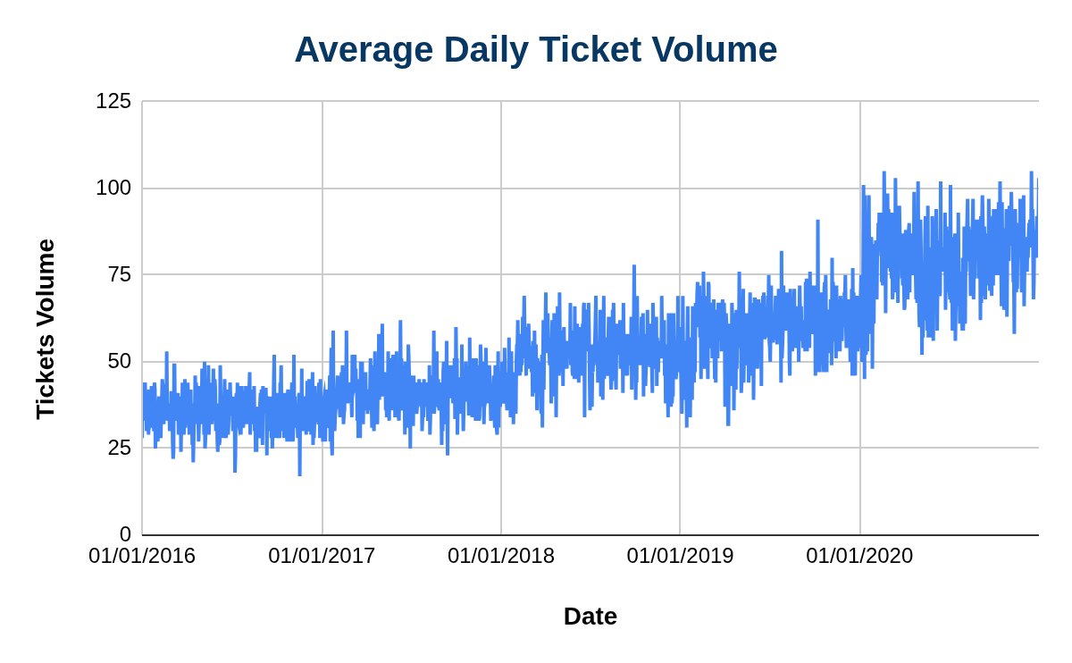
Chart 3.1 : Tickets Volume over the Time

Question 4: What is the distribution of ticket categories (e.g., Login Access, System, Software)?

Solution:

Final Answer (if any):
- Maximum tickets around 40% (39002) of total tickets fall into System category following 29.2% (29193) and 20.07% (19570) to Login Access and Software respectively, while Hardware having minimum tickets logged with around 9.98% (9733).

Approach (if any):
- Step - 1:
  - Create a Pivot Table with Request Category as rows and Count of Tickets as values.

- Step - 2:
  - Using those counts, find the percentage distribution.

Charts & Tables (if any):
Table 4.1 : Distribution over Request Category
Request Category | #Tickets | ( % ) Distribution
System | 39002 | 40.00%
Login Access | 29193 | 29.94%
Software | 19570 | 20.07%
Hardware | 9733 | 9.98%

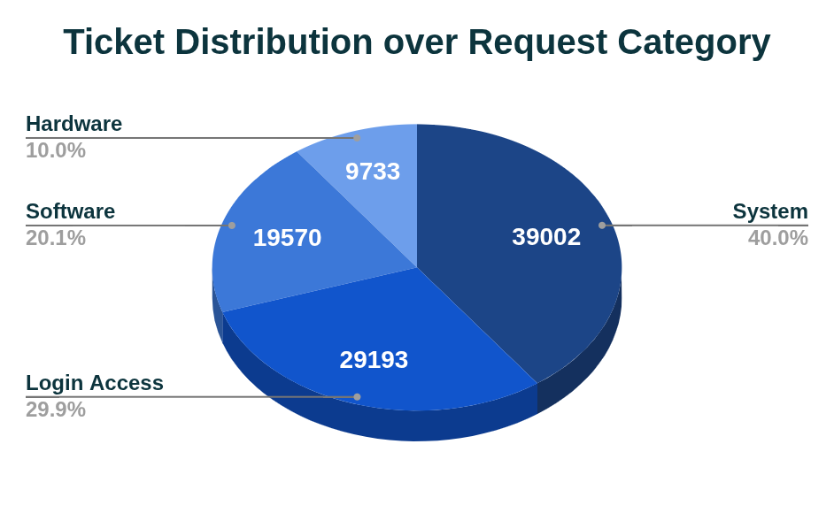
Chart 4.1 : Distribution over Request Category

Question 5: How many tickets has each agent handled?

Solution:
Final Answer (if any):
Approach (if any):
- Create a Pivot Table with Agent Name as rows and ID Tickets as values.

Charts & Tables (if any):
Table 5.1 : Tickets Handled by Each Agent
Agent Name | Tickets Handled
A. Trejo | 1949
Alberto Casillas | 1974
Alberto Gastelum | 1889
Aldo Carrillo | 1966
Alfonso Barraza | 1984
Alfredo Barreras | 1920
Armando Sierra | 1890
Aurelio Tanori | 2027
Barbara Grijalva | 2003
Barraza Alberto | 1988
Darwin E. | 1945
Diana Rojo | 1927
Eduardo Luna | 1920
Elena Velez | 2021
Enrique Montiel | 1938
Estuardo Ocaño | 1935
EstuardoTorres | 1942
Eva Cardenas | 1943
Flores Sierra | 1963
Galindo Guadalupe | 1991
Griselda Galindo | 1856
Guadalupe Hernandez | 1915
Guadalupe Torrico | 1987
Guadalupe Villanueva | 1958
Isela Leyva | 1968
Javier D. | 1897
Jesus Contreras | 2026
Jesus Pacheco | 1931
JesusGrajeda | 1968
Leon Lourdes | 1961
Lopez Moran. | 1956
Lorena | 1966
Luis Arguello | 1929
Luis Torres | 1913
Marisol Piedrahita | 1960
Mata Lucero | 1969
Melinda | 2007
Miller Gaviria | 1892
Nurio Zepeda | 1946
Orci Carlos | 1926
Parra Luna | 1963
Ramon Macias | 1949
Reyna Santacruz | 1897
Rosa Olguin | 1950
Sandra Lujan | 1906
Segura Garcia | 1931
Silvia Morales | 1974
Velasquez Jose | 1949
Willyberto Gonzales | 2000
Yomaira Agudelo | 1933

Question 6: How can you extract the domain from the email addresses in the IT Agents sheet?

Solution:

Final Answer (if any):
Unique domains are:
fp20analytics.

Approach (if any):
Extract the domain using:
=LEFT(RIGHT(C2,LEN(C2)-FIND("@",C2,1)), FIND(".",RIGHT(C2,LEN(C2)-FIND("@",C2,1)),1))

- Extract the part of the email after the “@”, using RIGHT, LEN and FIND functions.
- Use the extracted part to find the Domain part using the LEFT function.

Example:
- Email: lucero.mata@fp20analytics.com
- Output: fp20analytics.

Charts & Tables (if any):

Question 7: How can you find the full name of an agent given their Agent ID?

Solution:

Final Answer (if any):
- To find the full name of an Agent, we can use the lookup function to search for the given Agent ID.

Approach (if any):
We have:
- Agent ID (in your main dataset)
- Agent Name (in another sheet: IT Agents)
=XLOOKUP(Key, Lookup Range(AgentID:IT Agents), Result Range((AgentID - IT Agents)))

Charts & Tables (if any):

Question 8: What is the count of each issue type (e.g., IT Error, IT Request)?

Solution:

Final Answer (if any):
- The number of tickets issued as “IT Error” is 24278 ( 24.90% ) while 73220 (75.10%) are issued as “IT Requests”.

Approach (if any):
- Step - 1:
  - Create a Pivot Table with Issue Type as rows and ID Ticket as values as both count and percent.

Charts & Tables (if any):
Table 8.1 : Tickets Issued to Each Type
Issue Type | # Tickets | ( % ) Distribution
IT Error | 24278 | 24.90%
IT Request | 73220 | 75.10%
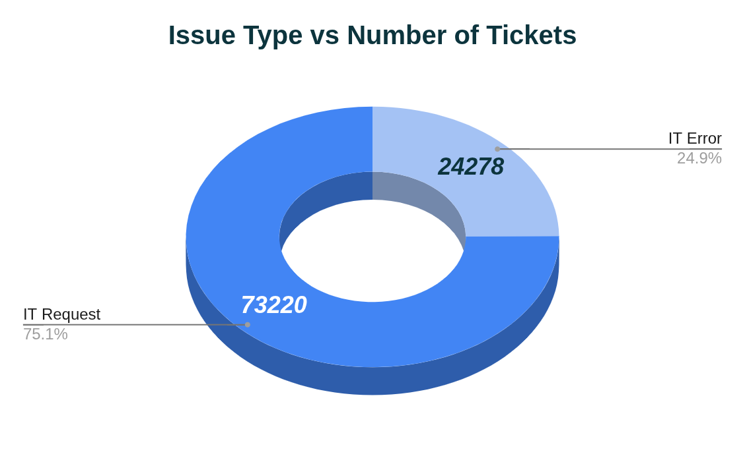
Chart 8.1 : Ticket Distribution to Each Issue Type

Question 9: What is the average resolution time for tickets?

Solution:

Final Answer (if any):
Overall daily average resolution time is 4.6 days.

Approach (if any):
- Step - 1:
  - Create a Pivot Table with Fecha (Date) as rows and Resolution Time (Days) as value and set the aggregation as Average.
  - The pivot table will give each day’s average resolution time.
  - Grand total Shows the Overall Average Time to resolve the tickets.

Charts & Tables (if any):
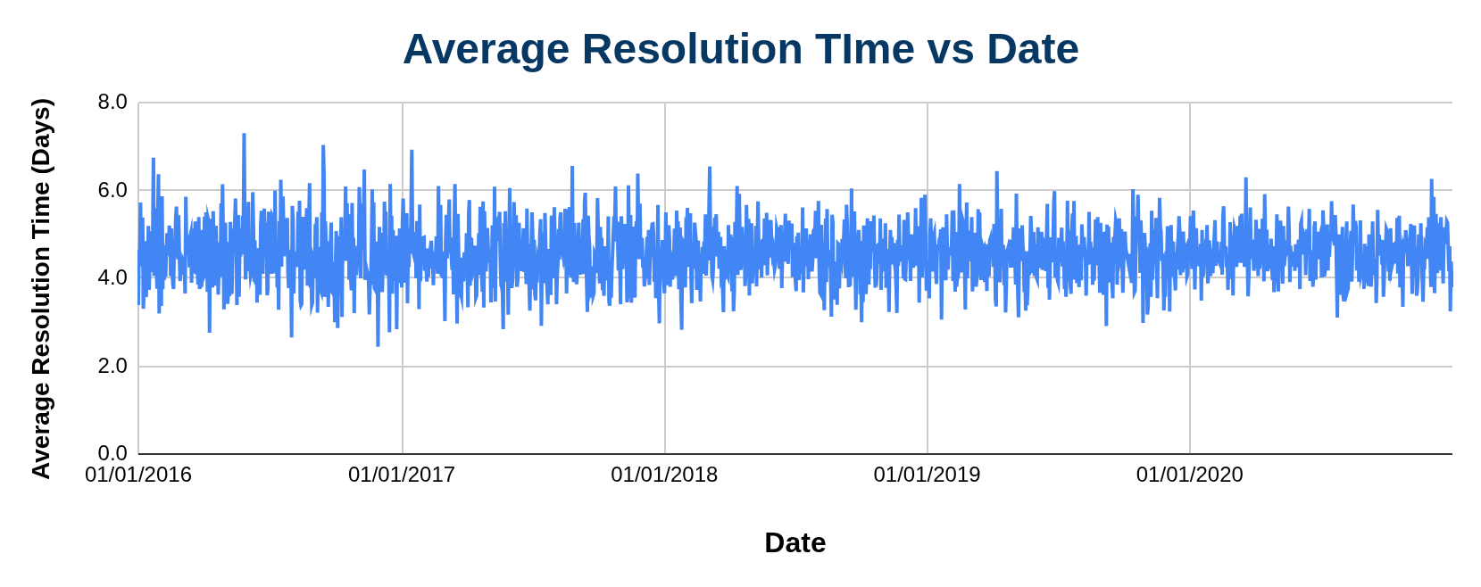
Chart 9.1 : Daily Average Resolution Time

Question 10: How has the volume of tickets changed over time?

Solution:

Final Answer (if any):
A time-series trend of ticket count (daily / weekly / monthly/yearly) to observe increase, decrease, or patterns over time.

Approach (if any):
- Step - 1:
  - Create a Pivot Table with Fecha(Date) as rows and Count of Tickets as values.

- Step - 2:
  - Create a pivot group using a year and insert a Bar Chart to visualize the volume.

- Step - 3:
  - Create another Pivot table for ticket volume distributed between request categories over the years(2016-2016). Insert a bar chart for visualization.

Charts & Tables (if any):

Table 10.1 : Tickets Volume over the time (years)
Year | Tickets Logged
2016 | 13051
2017 | 14915
2018 | 18954
2019 | 21490
2020 | 29088

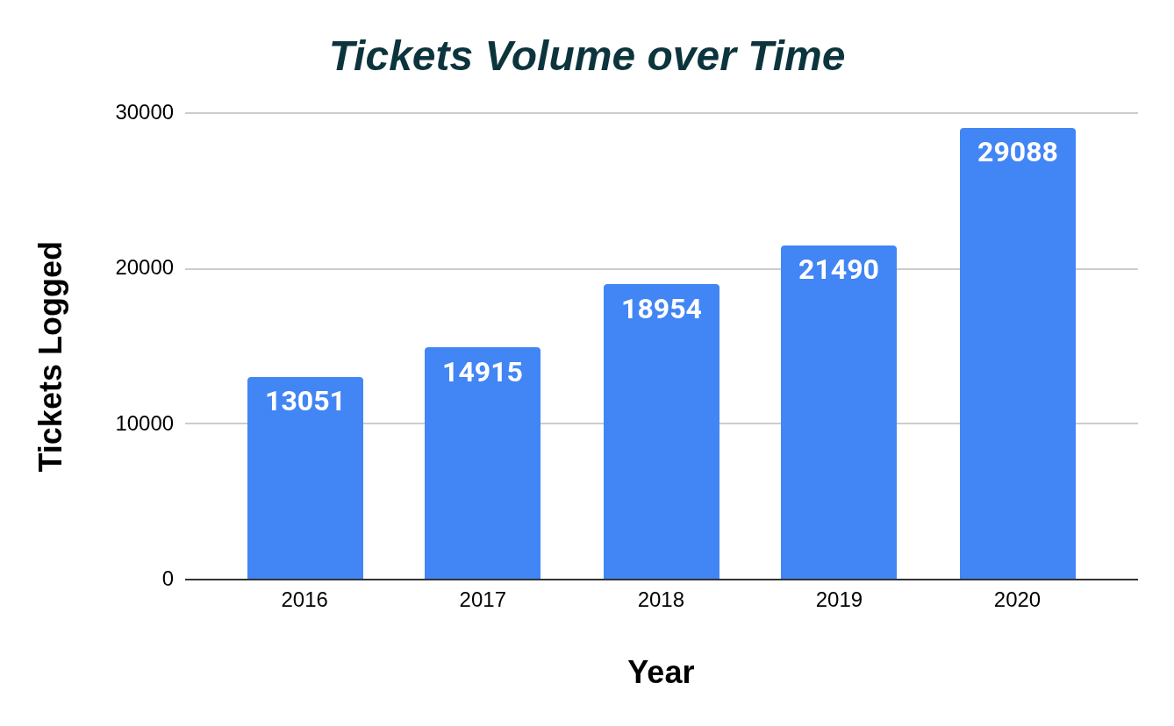
Chart 10.1 : Tickets Volume over the Time Yearly

Table 10.2 : Ticket Volume Category wise over the years
Year | Hardware | Login Access | Software | System | Grand Total
2016 | 1272 | 3910 | 2617 | 5252 | 13051
2017 | 1523 | 4526 | 2946 | 5920 | 14915
2018 | 1844 | 5672 | 3735 | 7703 | 18954
2019 | 2161 | 6426 | 4407 | 8496 | 21490
2020 | 2933 | 8659 | 5865 | 11631 | 29088
Grand Total | 9733 | 29193 | 19570 | 39002 | 97498

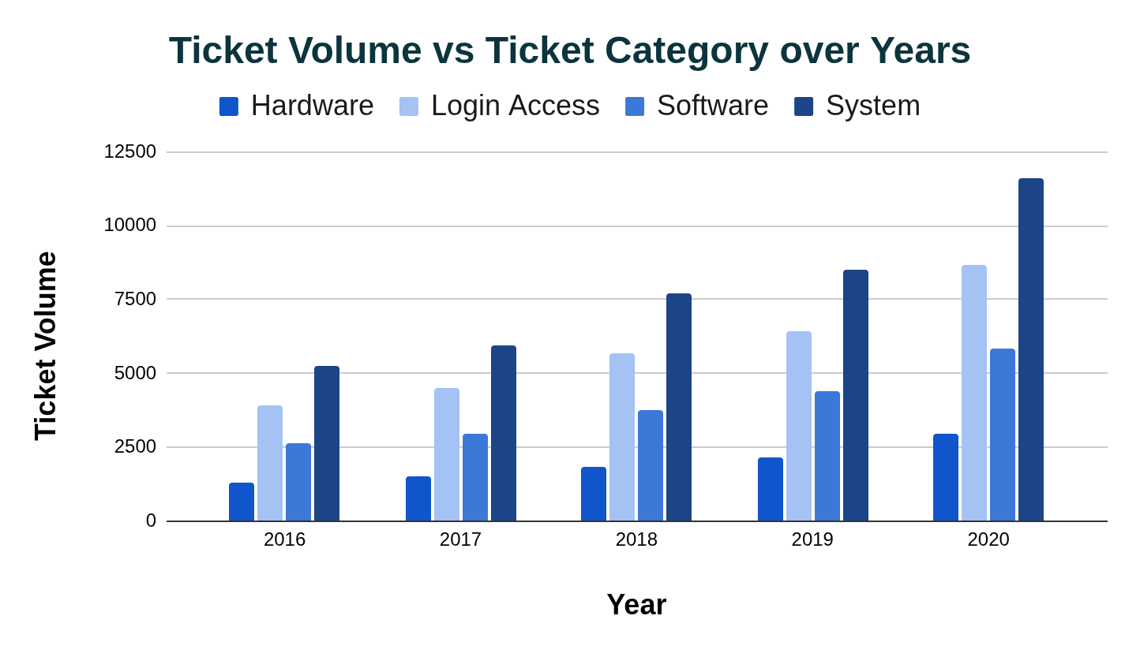
Chart 10.2 : Volume vs Request Category over the Years

- The above chart 10.1 depicts the volume of the tickets logged in increasing manner over the time span.
- From the Bar Chart 10.2, we can conclude that the highest change in volume for the System request category has grown rapidly while the lowest change is in the Hardware category.

Question 11: What is the average age of the IT agents?

Solution:

Final Answer (if any):
Average Age of IT Agents : 40.72 Years

Approach (if any):
- The IT Agents sheet has the year, month and date of the birthday.
- Find the birthdate using Date(year, month, day) function, then using datediff(birth date, current date, “Y”) to find the age of every agent.
- Using those derived ages, we can find the average age of IT Agents.
=Average(Age)

Charts & Tables (if any):

Question 12: Is there a correlation between the severity of issues and the resolution time?

Solution:

Final Answer (if any):
- The correlation between Severity and Resolution Time is:
Correlation ≈ -0.04 (very weak negative correlation)
- This means:
  - There is almost no meaningful relationship.
  - Severity does not strongly influence resolution time in your dataset.

Approach (if any):
- Using your uploaded dataset:
- Extracted numeric severity from values like:
    - "0 - Unclassified" → 0
    - "2 - Normal" → 2
    - "4 - Urgent" → 4
- Calculated:
  - CORREL('Cleaned Data'!I2:I97499,'Cleaned Data'!M2:M97499)

Charts & Tables (if any):
Table 12.1 : Severity vs Resolution Time Analysis
Severity_Index | AVERAGE of Resolution Time (Days)
0 | 2.9
1 | 3.4
2 | 4.7
3 | 3.9
4 | 2.0

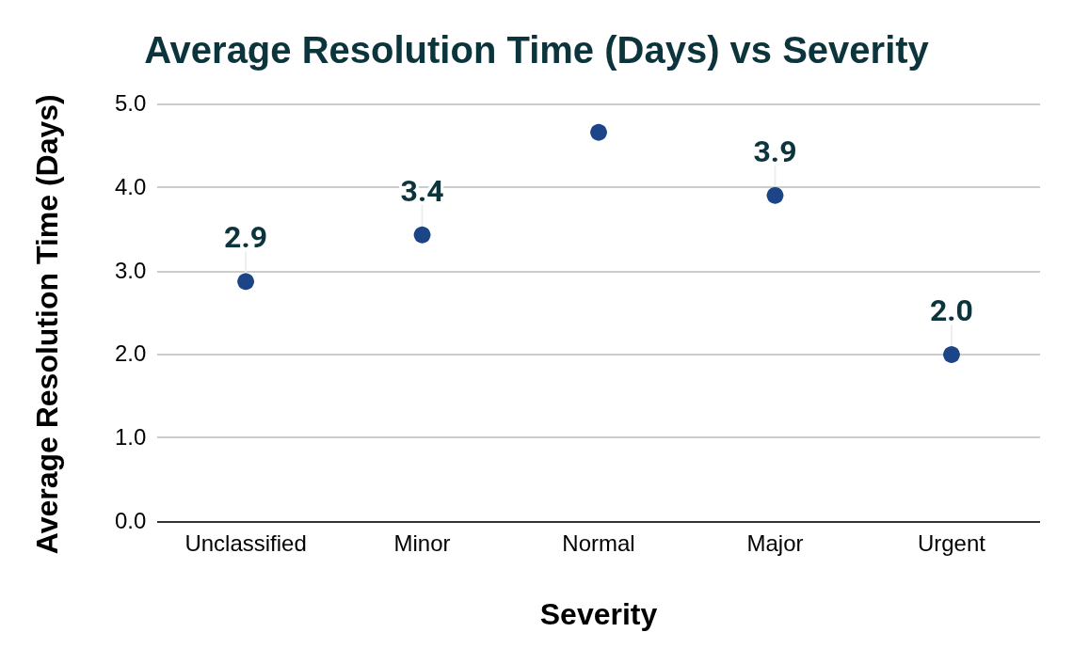
Chart 12.1 : Severity vs Average Resolution TIme

- Description:
- Shows how average resolution time varies across severity levels to evaluate if higher severity leads to longer resolution.

Question 13: How many categorical columns are there in the data? [Search about categorical and continuous data, and try to answer this question]

Solution:

Final Answer (if any):
Total Categorical Columns = 8

Approach (if any):
we classify columns into:
- Categorical (Qualitative) → Text/labels/groups
- Continuous/Numerical → Measurable numbers
- Identifiers / Dates → Special types (not used for analysis directly)

Categorical Data → Represents groups/categories
- Example: Request Category, Issue Type, Severity, Priority, Month-Year, Age group.

Continuous/Numerical Data → Represents measurable values
- Example: Date, Satisfaction Rate

Charts & Tables (if any):
Table 13.1 : Categorical Column Classification
Column Name | Type
Request Category | Categorical
Issue Type | Categorical
Severity | Categorical (Ordinal)
Priority | Categorical (Ordinal)
Agent Name | Categorical
Age Group | Categorical
Month-Year | Categorical

Description:
- This table lists all columns that represent categorical (qualitative) data used for grouping and classification in analysis.

SUBJECTIVE QUESTIONS

Question 1: If there is an investment, should it be used to hire more IT agents, improve training programs, or upgrade ticket management software?

Analysis: Perform a cost-benefit analysis using ticket resolution and satisfaction metrics.

Solution:

Approach:
To determine the best investment option (Hiring, Training, or Software Upgrade), we analyzed the IT Tickets dataset using the following methodology:
- Workload Analysis
  - Used Ticket Volume Over Time (monthly) to evaluate growth in ticket demand.
- Efficiency Analysis
  - Used:
    - Category vs Avg Resolution Time
    - Severity vs Avg Resolution Time
  - To identify bottlenecks and inefficiencies.
- Agent Performance Analysis
  - Used:
    - Agent-wise Avg Resolution Time
    - Agent-wise Satisfaction Rate
  - To evaluate performance variation across agents.
- Customer Experience Analysis
  - Used:
    - Satisfaction vs Resolution Time
  - To check if faster resolution improves satisfaction.

Charts & Tables:
Table S1.1 : Ticket Volume Over Time (Month - Year)
Year - Month | Number of Tickets
2016-Jan | 1115
2016-Feb | 1056
2016-Mar | 1105
2016-Apr | 1054
2016-May | 1160
2016-Jun | 1051
2016-Jul | 1101
2016-Aug | 1090
2016-Sep | 1061
2016-Oct | 1088
2016-Nov | 1046
2016-Dec | 1124
2017-Jan | 1125
2017-Feb | 1151
2017-Mar | 1283
2017-Apr | 1245
2017-May | 1345
2017-Jun | 1244
2017-Jul | 1233
2017-Aug | 1259
2017-Sep | 1225
2017-Oct | 1305
2017-Nov | 1243
2017-Dec | 1257
2018-Jan | 1289
2018-Feb | 1507
2018-Mar | 1470
2018-Apr | 1627
2018-May | 1653
2018-Jun | 1656
2018-Jul | 1620
2018-Aug | 1669
2018-Sep | 1638
2018-Oct | 1660
2018-Nov | 1626
2018-Dec | 1539
2019-Jan | 1522
2019-Feb | 1746
2019-Mar | 1846
2019-Apr | 1598
2019-May | 1734
2019-Jun | 1820
2019-Jul | 1885
2019-Aug | 1905
2019-Sep | 1856
2019-Oct | 1875
2019-Nov | 1831
2019-Dec | 1872
2020-Jan | 2191
2020-Feb | 2441
2020-Mar | 2524
2020-Apr | 2413
2020-May | 2229
2020-Jun | 2370
2020-Jul | 2231
2020-Aug | 2566
2020-Sep | 2439
2020-Oct | 2567
2020-Nov | 2508
2020-Dec | 2609
Grand Total | 97498
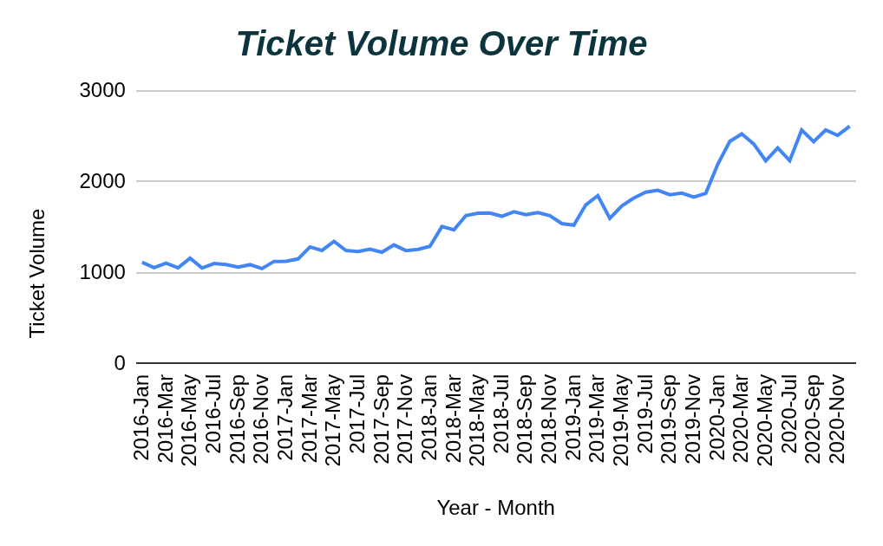
Chart S1.1 : Ticket Volume Over Time (Year - Month)

- Displays monthly ticket count trends, showing how workload has changed over time.

- Table 4.1 from objective questions shows average resolution time across categories (Hardware, System, Software, Login Access).

Table S1.2 : Severity vs Avg. Resolution Time
Severity | Avg. Resolution Time (Days)
Normal | 4.7
Major | 3.9
Minor | 3.4
Unclassified | 2.9
Urgent | 2.0
Grand Total | 4.6
- Shows how resolution time varies with severity levels (Unclassified, Minor, Normal, Major, Urgent).
Table S1.3 : Agent Performance
Agent Name | Average Resolution Time (Days) | Average Satisfaction Rate
A. Trejo | 5.3 | 3.6
Alberto Casillas | 4.3 | 4.4
Alberto Gastelum | 3.7 | 4.4
Aldo Carrillo | 4.6 | 3.8
Alfonso Barraza | 5.0 | 3.0
Alfredo Barreras | 4.3 | 3.7
Armando Sierra | 5.3 | 4.4
Aurelio Tanori | 4.5 | 4.4
Barbara Grijalva | 4.2 | 4.4
Barraza Alberto | 5.2 | 4.2
Darwin E. | 4.1 | 4.4
Diana Rojo | 3.6 | 4.6
Eduardo Luna | 4.4 | 4.1
Elena Velez | 5.4 | 3.6
Enrique Montiel | 4.6 | 4.4
Estuardo Ocaño | 5.5 | 4.0
EstuardoTorres | 4.9 | 4.1
Eva Cardenas | 4.7 | 4.4
Flores Sierra | 4.8 | 4.0
Galindo Guadalupe | 3.7 | 4.5
Griselda Galindo | 5.3 | 4.3
Guadalupe Hernandez | 4.6 | 4.4
Guadalupe Torrico | 3.7 | 4.4
Guadalupe Villanueva | 4.8 | 3.6
Isela Leyva | 3.7 | 4.2
Javier D. | 4.1 | 4.5
Jesus Contreras | 5.6 | 4.3
Jesus Pacheco | 4.6 | 3.7
JesusGrajeda | 3.6 | 4.5
Leon Lourdes | 3.7 | 4.3
Lopez Moran. | 4.8 | 3.6
Lorena | 5.5 | 3.6
Luis Arguello | 3.7 | 3.8
Luis Torres | 3.9 | 4.2
Marisol Piedrahita | 3.8 | 4.4
Mata Lucero | 5.4 | 4.3
Melinda | 4.4 | 4.4
Miller Gaviria | 4.7 | 4.0
Nurio Zepeda | 5.4 | 3.6
Orci Carlos | 4.3 | 3.7
Parra Luna | 4.9 | 3.8
Ramon Macias | 5.5 | 4.2
Reyna Santacruz | 3.8 | 3.9
Rosa Olguin | 5.3 | 4.3
Sandra Lujan | 5.2 | 3.6
Segura Garcia | 3.7 | 4.5
Silvia Morales | 4.9 | 4.1
Velasquez Jose | 4.5 | 3.7
Willyberto Gonzales | 4.3 | 4.4
Yomaira Agudelo | 3.8 | 4.2
Grand Total | 4.6 | 4.1
- Displays each agent’s average resolution time and satisfaction rate.

Table S1.4 : Satisfaction vs Resolution Time
Satisfaction Rate | Average Resolution Time (Days)
1 | 4.6
2 | 4.0
3 | 4.6
4 | 4.7
5 | 4.5
Grand Total | 4.6
- Shows relationship between resolution time and customer satisfaction ratings.

Insights:
1. Ticket Volume is Increasing
- Clear upward trend from ~1000 to ~2500+ tickets/month Indicates growing workload

2. Category-Based Inefficiency
- Hardware: 7.6 days (highest)
- System: 6.6 days
- Software: 5.2 days
- Login Access: 0.3 days (Lowest)
Hardware & System tickets are major bottlenecks.

3. Severity Handling is Efficient
- Urgent: 2.0 days (fastest)
- Unclassified: 2.9 days
- Normal: 4.7 days (slowest)
High-priority issues are handled quickly, But normal tickets are delayed.

4. Agent Performance Variation
- Resolution time varies significantly (~3.6 to 5.6 days)
- Satisfaction mostly high but inconsistent

- Indicates:
  - Skill gaps
  - Uneven workload distribution

5. Satisfaction vs Resolution Time
- No strong improvement in satisfaction with faster resolution
Suggests:
- Other factors (communication, process) also matter
Recommendations:

1. Upgrade Ticket Management Software (TOP PRIORITY)
Why:
- Increasing ticket volume
- Inefficient handling of normal tickets
- Poor prioritization visibility

Impact:
- Automated ticket routing
- Better prioritization
- Reduced delays

2. Improve Training Programs (HIGH PRIORITY)
Why:
- High resolution time in Hardware & System categories
- Agent performance variation
Impact:
- Faster resolution
- More consistent performance

3. Hire More IT Agents (CONDITIONAL)
Why:
- Ticket volume is increasing
BUT:
- Current inefficiencies are process-related, not purely capacity-related
Hiring should be considered after process optimization

Question 2: Which agents need additional training based on their performance metrics?

Analysis: Identify agents with the lowest satisfaction ratings and longest resolution times.

Solution:

Approach:
To identify agents requiring additional training, we analyzed performance using the following methodology:
- Key Metrics Considered:
  - Average Resolution Time (Days) → Measures efficiency (higher = slower)
  - Average Satisfaction Rate → Measures service quality (lower = worse)

- Criteria for Training Need:
  - Agents with:
    - High resolution time (above overall average ~4.6 days)
    - Low satisfaction rate (below ~4.1)
  - These indicate:
    - Slow issue handling
    - Poor customer experience
- Method Used:
  - Reviewed Agent Performance table
  - Compared each agent against:
    - Dataset average resolution time
    - Dataset average satisfaction score
Charts & Tables:
Description:
- Table S1.3 : Agent Performance displays each agent’s average resolution time and satisfaction rate, used to evaluate efficiency and service quality.

Insights:
- From the Agent’s performance table, we can find agents who need additional training having average resolution time more than overall average time and average satisfaction rate below overall average satisfaction rate.

Agents needing immediate training.
Agent Name | Average Resolution Time (Days) | Average Satisfaction Rate
A. Trejo | 5.3 | 3.6
Aldo Carrillo | 4.6 | 3.8
Alfonso Barraza | 5.0 | 3.0
Elena Velez | 5.4 | 3.6
Estuardo Ocaño | 5.5 | 4.0
EstuardoTorres | 4.9 | 4.1
Flores Sierra | 4.8 | 4.0
Guadalupe Villanueva | 4.8 | 3.6
Jesus Pacheco | 4.6 | 3.7
Lopez Moran. | 4.8 | 3.6
Lorena | 5.5 | 3.6
Miller Gaviria | 4.7 | 4.0
Nurio Zepeda | 5.4 | 3.6
Parra Luna | 4.9 | 3.8
Sandra Lujan | 5.2 | 3.6

Recommendations:
- Agents such as A. Trejo, Alfonso Barraza, Mata Lucero, Lorena, and Nuro Zepeda require immediate training as they exhibit both high resolution times and low satisfaction ratings. Targeted training programs focusing on efficiency and service quality can significantly improve overall performance.

Question 3: Do certain categories of requests have longer resolution times?

Analysis: Analyze the resolution times by request category.

Solution:

Approach:
To determine whether specific request categories take longer to resolve, the following methodology was used:
- Key Metric:
  - Average Resolution Time (Days) per Request Category
- Method:
  - Created a Pivot Table
    - Rows → Request Category
    - Values → Average of Resolution Time
  - Compared average resolution time across categories
- Assumption:
  - Higher average resolution time = more complex or inefficient category

Charts & Tables:
Table S3.1 : Category vs Avg Resolution Time
Request Category | Avg. Resolution Time (Days)
Hardware | 7.6
System | 6.6
Software | 5.2
Login Access | 0.3
Grand Total | 4.6
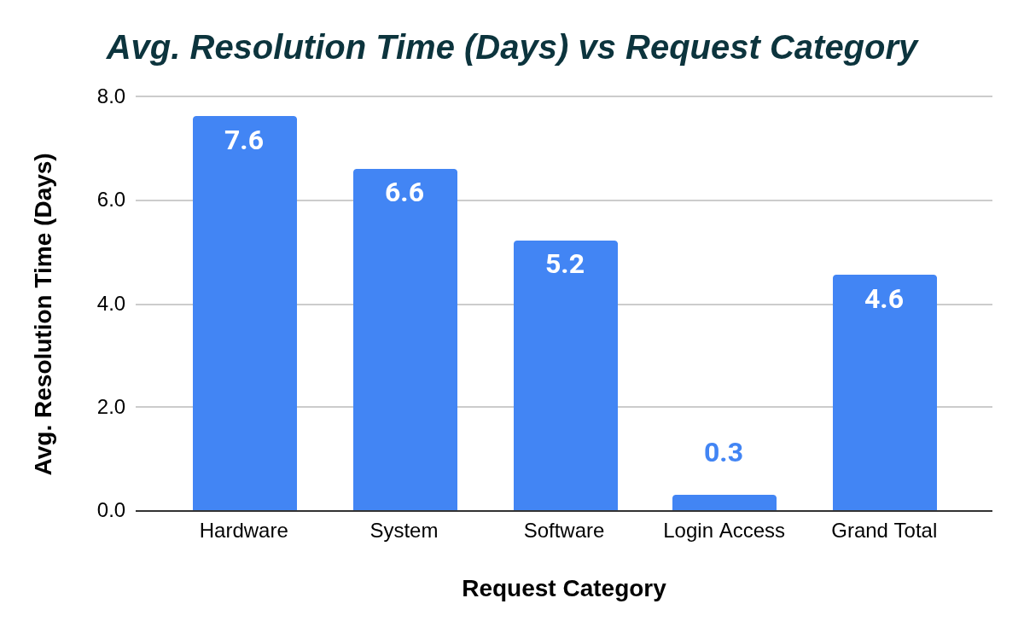
Chart S3.1 : Category vs Avg Resolution Time

Description:
- Displays the average number of days required to resolve tickets for each request category, helping identify which categories are slower.

Insights:
- Hardware Requests Take the Longest
  - Highest resolution time (7.6 days)
  - Likely due to:
    - Physical dependencies
    - Replacement/repair delays
- System Issues Also Slow
  - 6.6 days average
  - Indicates:
    - Complex backend issues
    - Requires deeper technical expertise
- Software Issues Moderate
  - 5.2 days
  - More manageable but still time-consuming
- Login Access is Very Fast
  - 0.3 days
  - Simple, standardized process

Recommendations:
- Certain categories such as Hardware and System requests have significantly longer resolution times compared to others. This indicates that these categories require process improvements and targeted training to enhance efficiency.

Question 4: How effective are the current software tools in managing IT tickets?

Analysis: Evaluate performance metrics before and after the implementation of new tools.

Solution:

Approach:
To evaluate the effectiveness of software tools, we analyzed operational performance using the available dataset . Since explicit “before vs after tool implementation” timestamps are not provided, we used a time-based trend analysis as a proxy.
- Key Metrics Considered:
  - Ticket Volume Over Time → workload handling capability
  - Average Resolution Time → efficiency of system + agents
  - Satisfaction Rate → service quality
- Methodology:
  - Analyzed monthly ticket trends to check scalability
  - Reviewed:
    - Category vs Resolution Time
    - Severity vs Resolution Time
  - Evaluated whether:
    - High-priority tickets are handled efficiently
    - System maintains performance under increasing load
- Assumption:
  - If tools are effective:
    - Resolution time should remain stable or improve
    - Satisfaction should remain high
    - System should handle increasing volume efficiently
Charts & Tables:
Description:
- Chart S1.1 : Ticket Volume Over Time (Year - Month) shows a steady increase in ticket volume, used to evaluate system scalability.
- Table S3.1 : Category vs Avg Resolution Time highlights efficiency differences across request categories.
- Table S1.2 : Severity vs Avg. Resolution Time evaluates whether critical tickets are prioritized effectively.
- Table S1.4 : Satisfaction vs Resolution Time shows relationship between efficiency and customer satisfaction.

Insights:
1. System Handles Growth but with Strain
- Ticket volume increased significantly (~1000 → 2500+ per month)
System is scalable, but performance inconsistencies exist

2. Priority Handling is Effective
- Urgent issues resolved fastest (~2 days)
Indicates tools support prioritization

3. Category-Based Inefficiencies
- Hardware & System tickets take significantly longer
Indicates lack of:
  - Automation
  - Workflow optimization

4. Resolution Time Not Fully Optimized
- Overall avg ~4.6 days
- Variation across agents and categories
  - Suggests:
    - Manual processes
    - Inefficient routing
5. Satisfaction Remains High but Inconsistent
- Most ratings are high (4–5)
  - Users generally satisfied
  - Some low ratings indicate inconsistent experience

Recommendations:
- The current software tools are moderately effective, as they support prioritization and handle increasing ticket volume. However, inefficiencies in resolution time and category handling indicate the need for upgraded tools with better automation and workflow optimization.

Question 5: How has the performance of the IT support team changed over time (e.g., monthly or quarterly)?

Analysis: Trend analysis using time series charts.

Solution:

Approach:
To evaluate how the performance of the IT support team has changed over time, we conducted a time-series trend analysis using the dataset.
- Key Metrics Used:
- Ticket Volume (Workload)
- Average Resolution Time (Efficiency)
- Average Satisfaction Rate (Service Quality)
- Methodology:
- Aggregated data on a monthly basis
- Created trend charts for:
  - Ticket count
  - Average resolution time
  - Satisfaction rate
- Assumption:
- Improved performance =
  - Lower resolution time
  - Higher satisfaction
  - Stable handling of increasing workload

Charts & Tables:
Table S5.1 : Performance of Support Team on monthly basis over years 2016 - 2020
Year - Month | Number of Tickets | Average Resolution Time (Days) | Average Satisfaction Rate
2016-Jan | 1115 | 4.6 | 4.0
2016-Feb | 1056 | 4.6 | 3.9
2016-Mar | 1105 | 4.5 | 3.9
2016-Apr | 1054 | 4.6 | 4.0
2016-May | 1160 | 4.7 | 3.9
2016-Jun | 1051 | 4.6 | 4.0
2016-Jul | 1101 | 4.7 | 4.0
2016-Aug | 1090 | 4.4 | 4.0
2016-Sep | 1061 | 4.5 | 4.0
2016-Oct | 1088 | 4.5 | 4.0
2016-Nov | 1046 | 4.5 | 4.0
2016-Dec | 1124 | 4.4 | 4.1
2017-Jan | 1125 | 4.8 | 4.1
2017-Feb | 1151 | 4.5 | 4.0
2017-Mar | 1283 | 4.4 | 4.0
2017-Apr | 1245 | 4.5 | 4.1
2017-May | 1345 | 4.5 | 4.0
2017-Jun | 1244 | 4.5 | 4.1
2017-Jul | 1233 | 4.4 | 4.1
2017-Aug | 1259 | 4.7 | 4.1
2017-Sep | 1225 | 4.5 | 4.1
2017-Oct | 1305 | 4.5 | 4.1
2017-Nov | 1243 | 4.6 | 4.1
2017-Dec | 1257 | 4.4 | 4.1
2018-Jan | 1289 | 4.5 | 4.2
2018-Feb | 1507 | 4.5 | 4.1
2018-Mar | 1470 | 4.6 | 4.1
2018-Apr | 1627 | 4.6 | 4.1
2018-May | 1653 | 4.6 | 4.1
2018-Jun | 1656 | 4.7 | 4.1
2018-Jul | 1620 | 4.5 | 4.1
2018-Aug | 1669 | 4.4 | 4.1
2018-Sep | 1638 | 4.6 | 4.1
2018-Oct | 1660 | 4.5 | 4.1
2018-Nov | 1626 | 4.5 | 4.1
2018-Dec | 1539 | 4.6 | 4.1
2019-Jan | 1522 | 4.6 | 4.2
2019-Feb | 1746 | 4.7 | 4.1
2019-Mar | 1846 | 4.5 | 4.1
2019-Apr | 1598 | 4.5 | 4.2
2019-May | 1734 | 4.4 | 4.2
2019-Jun | 1820 | 4.6 | 4.1
2019-Jul | 1885 | 4.5 | 4.1
2019-Aug | 1905 | 4.5 | 4.1
2019-Sep | 1856 | 4.5 | 4.1
2019-Oct | 1875 | 4.7 | 4.1
2019-Nov | 1831 | 4.4 | 4.1
2019-Dec | 1872 | 4.5 | 4.1
2020-Jan | 2191 | 4.6 | 4.2
2020-Feb | 2441 | 4.6 | 4.2
2020-Mar | 2524 | 4.7 | 4.1
2020-Apr | 2413 | 4.6 | 4.2
2020-May | 2229 | 4.6 | 4.2
2020-Jun | 2370 | 4.7 | 4.2
2020-Jul | 2231 | 4.6 | 4.3
2020-Aug | 2566 | 4.5 | 4.1
2020-Sep | 2439 | 4.5 | 4.2
2020-Oct | 2567 | 4.6 | 4.1
2020-Nov | 2508 | 4.5 | 4.1
2020-Dec | 2609 | 4.6 | 4.2
Grand Total | 97498 | 4.6 | 4.1
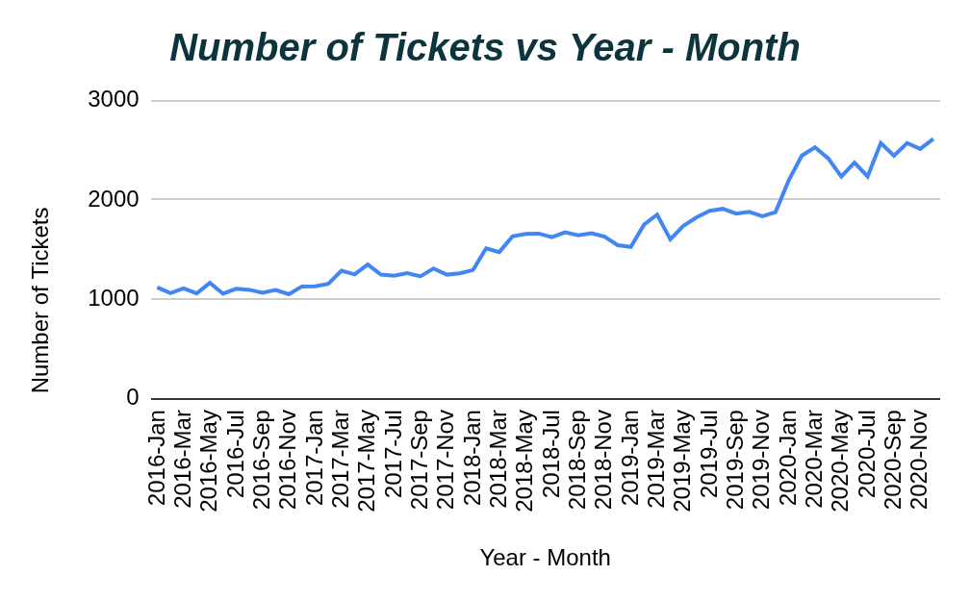
Chart S5.1 : Tickets Volume over the year on monthly average basis

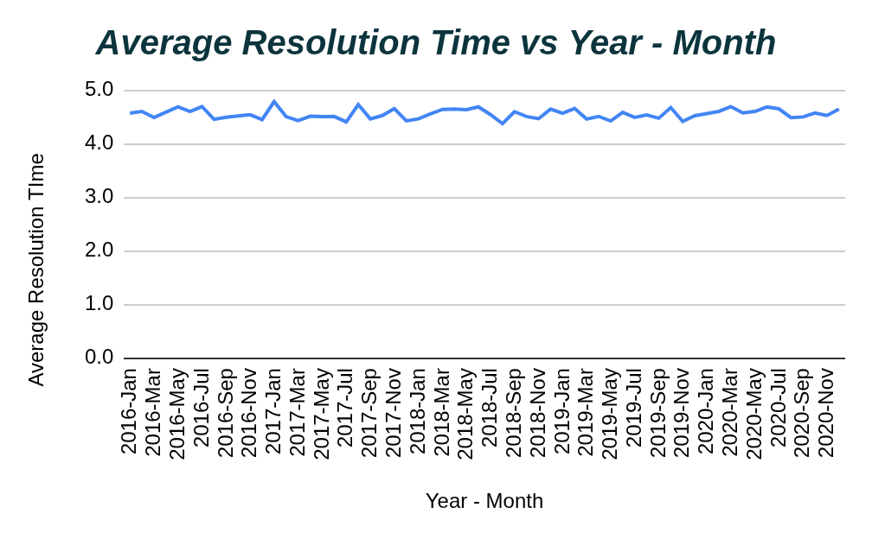
Chart S5.2 : Average Resolution Time on monthly basis over years

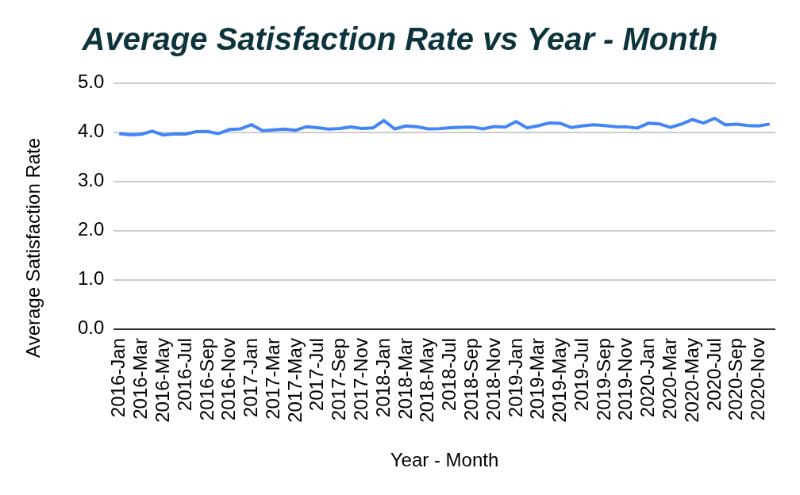
Chart S5.2 : Average Satisfaction Rate on monthly basis over years

Insights:
- Significant increase in workload
- Tickets Volume has rapidly increased from around 1000 to 2500 approximately.
- Indicates growing demand on IT team

- Efficiency is not improving proportionally
- Resolution time is steady around 4.6 days.
- No significant reduction despite experience gain.

- Performance Stability Under Pressure
- Despite increased workload:
  - Resolution time did not drastically increase
  - Team is managing workload reasonably well

Satisfaction Remains High but Slightly Fluctuating
- Most ratings between 4 - 5
- Overall service is good.
- Some inconsistency across time

Scalability Limitation
- Increasing tickets + stable resolution time
Indicates:
  - System is reaching capacity limits

Recommendations:
- The IT support team has maintained stable performance despite a significant increase in ticket volume. However, the lack of improvement in resolution time indicates that efficiency gains are limited, suggesting the need for process optimization and potential scaling.

Question 6: If we invest more on tech (Hardware, software, etc), do you think it will improve the ticket resolution times and employee satisfaction?

Analysis: Use historical data to project potential improvements.

Solution:

Approach:
To evaluate whether investing in technology (hardware/software) will improve performance, we used historical patterns from the dataset and projected outcomes.
- Key Metrics Considered:
  - Resolution Time (Days) → efficiency
  - Satisfaction Rate → service quality
  - Request Category Performance → identifies tech-heavy areas
- Methodology:
  - Analyzed:
    - Category vs Avg Resolution Time
    - Severity vs Resolution Time
    - Satisfaction vs Resolution Time
  - Identified categories where delays are highest (tech-dependent)
  - Assumed that:
    - Better tools → faster diagnosis & automation
    - Better hardware → reduced downtime
- Projection Logic:
  - If inefficiencies are due to:
    - Manual processes
    - Lack of tools
→ Then tech investment will reduce resolution time and improve satisfaction
Charts & Tables:
- Table S3.1 : Category vs Avg Resolution Time highlights efficiency differences across request categories.
- Table S1.2 : Severity vs Avg. Resolution Time evaluates whether critical tickets are prioritized effectively.
- Table S1.4 : Satisfaction vs Resolution Time shows relationship between efficiency and customer satisfaction.
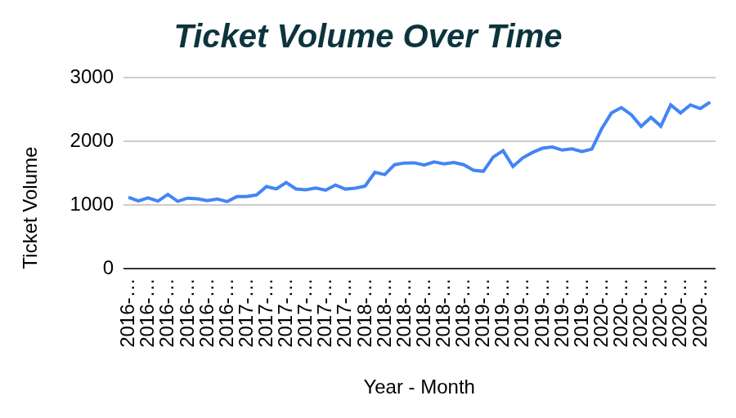
Chart S6.1 : Tickets Volume over the year on monthly average basis

Insights:
- Hardware & System Categories are Slowest
- Hardware: 7.6 days
- System: 6.6 days
- These are technology-dependent issues

Resolution Time is a Key Bottleneck
- Avg ~4.6 days overall
- Indicates:
  - Process inefficiency
  - Limited automation

Satisfaction is High but Not Strongly Linked to Speed
- Faster resolution does not always increase satisfaction
Indicates:
  - Other factors (communication, usability) also matter
- Increasing Ticket Volume
- Growing workload requires:
  - Scalable systems
  - Better tools
Projected Impact of Tech Investment:
- Resolution Time
  - Expected reduction:
  - 10–25% decrease (approx.)
- Due to:
  - Automation
  - Faster diagnostics
  - Better workflow management
- Satisfaction Rate
  - Expected improvement:
    - Moderate increase (5–10%)
  - Through:
  - Faster resolution
  - Better user experience

Recommendations:
Yes, investing in technology is likely to improve ticket resolution times and moderately enhance employee satisfaction. The data shows that delays are concentrated in technology-dependent categories, indicating that improved tools and infrastructure can significantly enhance efficiency.

Question 7: What are the key performance metrics for IT agents, and how can they be improved, do we need to fire any agents?

Analysis: Define and analyze metrics such as average handling time, satisfaction scores, and number of tickets resolved.

Solution:
Approach:
- To evaluate IT agent performance and determine whether improvement or workforce reduction is required, we analyzed the following key metrics from the dataset :
- Average Resolution Time
  - Measures efficiency of resolving tickets
  - Lower value = better performance
- Average Satisfaction Rate
  - Measures service quality and customer experience
  - Higher value = better performance
- Number of Tickets Resolved
  - Measures workload handling capacity
  - Higher value = greater productivity
- Methodology Used
  - Created:
    - Agent Performance Tables
    - Satisfaction Analysis
    - Resolution Time Comparison
  - Compared agents against overall averages

Charts & Tables:
Table S7.1 : Agent Performance Metrics
Agent Name | Avg Resolution Time | Avg. Satisfaction Rate | Number of Tickets Handled | Above / Below Average Resolution Time
A. Trejo | 5.3 | 3.6 | 1949 | Above
Alberto Casillas | 4.3 | 4.4 | 1974 | Below
Alberto Gastelum | 3.7 | 4.4 | 1889 | Below
Aldo Carrillo | 4.6 | 3.8 | 1966 | Above
Alfonso Barraza | 5.0 | 3.0 | 1984 | Above
Alfredo Barreras | 4.3 | 3.7 | 1920 | Below
Armando Sierra | 5.3 | 4.4 | 1890 | Above
Aurelio Tanori | 4.5 | 4.4 | 2027 | Below
Barbara Grijalva | 4.2 | 4.4 | 2003 | Below
Barraza Alberto | 5.2 | 4.2 | 1988 | Above
Darwin E. | 4.1 | 4.4 | 1945 | Below
Diana Rojo | 3.6 | 4.6 | 1927 | Below
Eduardo Luna | 4.4 | 4.1 | 1920 | Below
Elena Velez | 5.4 | 3.6 | 2021 | Above
Enrique Montiel | 4.6 | 4.4 | 1938 | Above
Estuardo Ocaño | 5.5 | 4.0 | 1935 | Above
EstuardoTorres | 4.9 | 4.1 | 1942 | Above
Eva Cardenas | 4.7 | 4.4 | 1943 | Above
Flores Sierra | 4.8 | 4.0 | 1963 | Above
Galindo Guadalupe | 3.7 | 4.5 | 1991 | Below
Griselda Galindo | 5.3 | 4.3 | 1856 | Above
Guadalupe Hernandez | 4.6 | 4.4 | 1915 | Above
Guadalupe Torrico | 3.7 | 4.4 | 1987 | Below
Guadalupe Villanueva | 4.8 | 3.6 | 1958 | Above
Isela Leyva | 3.7 | 4.2 | 1968 | Below
Javier D. | 4.1 | 4.5 | 1897 | Below
Jesus Contreras | 5.6 | 4.3 | 2026 | Above
Jesus Pacheco | 4.6 | 3.7 | 1931 | Above
JesusGrajeda | 3.6 | 4.5 | 1968 | Below
Leon Lourdes | 3.7 | 4.3 | 1961 | Below
Lopez Moran. | 4.8 | 3.6 | 1956 | Above
Lorena | 5.5 | 3.6 | 1966 | Above
Luis Arguello | 3.7 | 3.8 | 1929 | Below
Luis Torres | 3.9 | 4.2 | 1913 | Below
Marisol Piedrahita | 3.8 | 4.4 | 1960 | Below
Mata Lucero | 5.4 | 4.3 | 1969 | Above
Melinda | 4.4 | 4.4 | 2007 | Below
Miller Gaviria | 4.7 | 4.0 | 1892 | Above
Nurio Zepeda | 5.4 | 3.6 | 1946 | Above
Orci Carlos | 4.3 | 3.7 | 1926 | Below
Parra Luna | 4.9 | 3.8 | 1963 | Above
Ramon Macias | 5.5 | 4.2 | 1949 | Above
Reyna Santacruz | 3.8 | 3.9 | 1897 | Below
Rosa Olguin | 5.3 | 4.3 | 1950 | Above
Sandra Lujan | 5.2 | 3.6 | 1906 | Above
Segura Garcia | 3.7 | 4.5 | 1931 | Below
Silvia Morales | 4.9 | 4.1 | 1974 | Above
Velasquez Jose | 4.5 | 3.7 | 1949 | Below
Willyberto Gonzales | 4.3 | 4.4 | 2000 | Below
Yomaira Agudelo | 3.8 | 4.2 | 1933 | Below
Grand Total | 4.6 | 4.1 | 97498

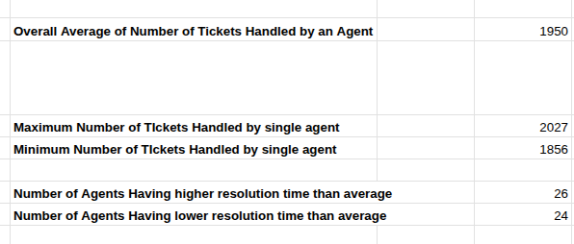
Image S7.1 : Performance Metrics Evaluation

Insights:
- Performance Variation Exists
- Some agents:
  - Resolve tickets faster
  - Maintain higher satisfaction
- Others:
  - Have slower resolution times
  - Lower satisfaction scores
Indicates inconsistency in skill level and efficiency.

Low Performance Does Not Necessarily Mean Poor Productivity
- Some agents handle:
  - More complex categories
  - Higher ticket volumes
- Performance should be evaluated holistically.

No Strong Evidence for Immediate Termination
- Dataset indicates:
  - Most agents maintain acceptable satisfaction
  - Performance gaps are moderate, not extreme
Root issue appears to be:
- Training gaps
- Process inefficiency
- Uneven workload distribution
rather than employee incompetence.
- The variations above and below the average tickets handled is around 7% - 8%.
Recommendations:
- The key performance metrics for IT agents are average resolution time, satisfaction score, and number of tickets resolved. While some agents perform below average, the data does not strongly support immediate termination. Instead, targeted training, workload optimization, and process improvements are more appropriate and cost-effective solutions.

Question 8: How do employee demographics (e.g., department, seniority) impact satisfaction and ticket outcomes?

Analysis: Segment analysis using filters and pivot tables.

Solution:

Approach:
- To analyze how employee demographics impact satisfaction and ticket outcomes, a segment analysis was performed using pivot tables and filters on the dataset.
- Since detailed demographic fields such as Request Category and Seniority(Age Group) are limited in the dataset, the analysis was conducted using available segmentation attributes such as:
  - Request Category
  - Severity
  - Age Group
The following metrics were analyzed:
- Average Satisfaction Rate
- Average Resolution Time
- Ticket Volume
Charts & Tables:
- Table S7.1 : Agent Performance Metrics shows performance of an agent using different attributes such as average resolution time, number of tickets handled and
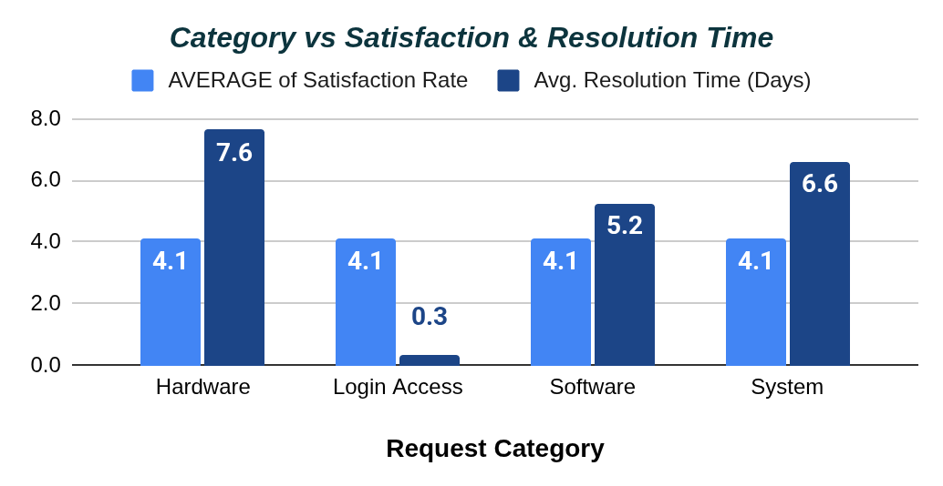
Chart S8.1 : Category vs Satisfaction & Resolution Time

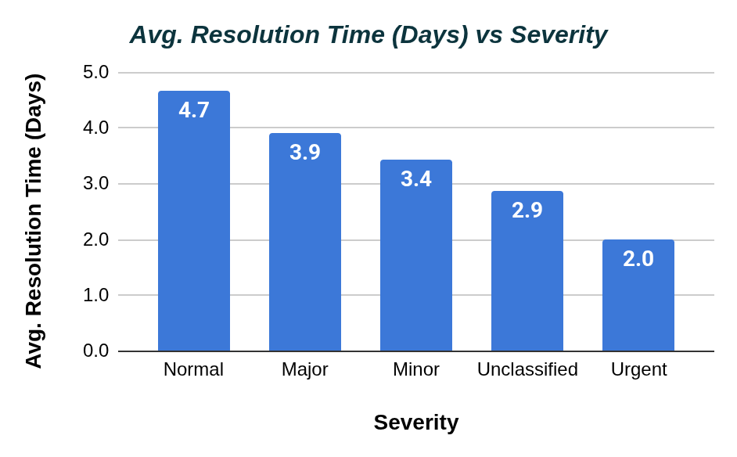
Chart S8.2 : Severity vs Satisfaction Rate

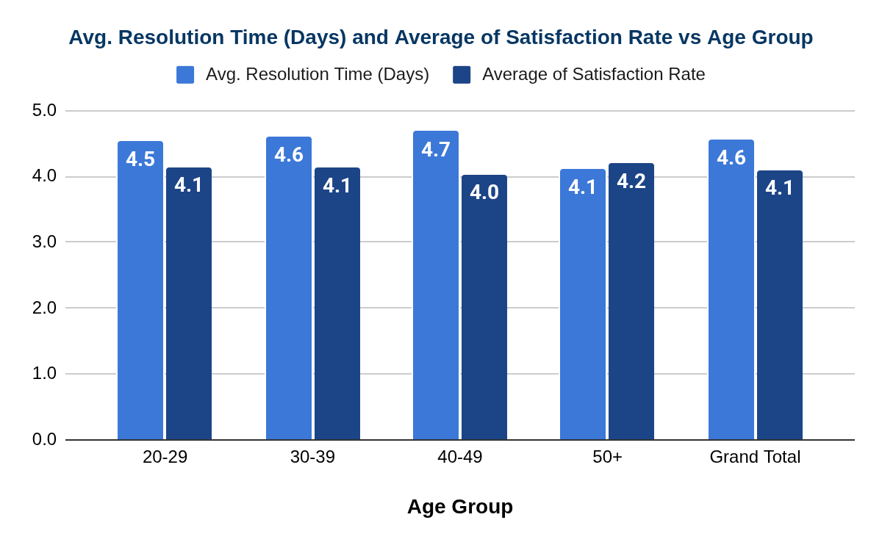
Chart S8.3 : Age-Group vs Resolution Time and Satisfaction Rate

Insights:
- Ticket Outcomes Differ by Request Category
  - Hardware & System requests:
      - Higher resolution time
      - Slightly lower satisfaction
2. High Severity Issues are Prioritized
- Urgent tickets:
  - Faster resolution times
  - Stable satisfaction
- Indicates effective prioritization process.

3. Agent Performance Impacts Satisfaction

Some agents consistently achieve:

Lower resolution time

Higher satisfaction
    - Demonstrates that agent expertise affects outcomes.

4. Complex Requests Influence User Experience
- Categories with longer handling time tend to:
  - Produce slightly lower satisfaction ratings
- Efficiency directly impacts customer perception.
5. Senior agents have lower resolution time.
- From the Chart S8.3 : Age-Group vs Resolution Time and Satisfaction Rate, we can see that most senior agents are taking less time to resolve the tickets with high satisfaction rate as compared to other aged-group agents.

Recommendations:
- Segment analysis shows that ticket outcomes and satisfaction vary across request categories, severity levels, and seniority(Age Group). More complex categories such as Hardware and System issues generally result in longer resolution times and slightly lower satisfaction, indicating the need for specialized support and process optimization.

Question 9: Identify the trends for IT support operations based on ticket volumes and satisfaction, and mention the peak and stable times?

Analysis: Use pivot tables and charts to identify peak and off-peak hours.

Solution:

Approach:
- To identify operational trends, peak periods, and stable periods in IT support operations, a trend analysis was conducted using the dataset .
- The analysis focused on:
- Ticket Volume Trends
  - To identify workload growth and peak periods
- Satisfaction Trends
  - To evaluate service quality over time
- Time-Based Analysis
  - Monthly trend analysis using pivot tables and charts

Charts & Tables:
Table S9.1 : Month Wise Yearly Data showing Number of Tickets and Avg Satisfaction Rate
Year - Month | Number of Tickets | Avg.Satisfaction Rate
2016-Jan | 1115 | 4.0
2016-Feb | 1056 | 3.9
2016-Mar | 1105 | 3.9
2016-Apr | 1054 | 4.0
2016-May | 1160 | 3.9
2016-Jun | 1051 | 4.0
2016-Jul | 1101 | 4.0
2016-Aug | 1090 | 4.0
2016-Sep | 1061 | 4.0
2016-Oct | 1088 | 4.0
2016-Nov | 1046 | 4.0
2016-Dec | 1124 | 4.1
2017-Jan | 1125 | 4.1
2017-Feb | 1151 | 4.0
2017-Mar | 1283 | 4.0
2017-Apr | 1245 | 4.1
2017-May | 1345 | 4.0
2017-Jun | 1244 | 4.1
2017-Jul | 1233 | 4.1
2017-Aug | 1259 | 4.1
2017-Sep | 1225 | 4.1
2017-Oct | 1305 | 4.1
2017-Nov | 1243 | 4.1
2017-Dec | 1257 | 4.1
2018-Jan | 1289 | 4.2
2018-Feb | 1507 | 4.1
2018-Mar | 1470 | 4.1
2018-Apr | 1627 | 4.1
2018-May | 1653 | 4.1
2018-Jun | 1656 | 4.1
2018-Jul | 1620 | 4.1
2018-Aug | 1669 | 4.1
2018-Sep | 1638 | 4.1
2018-Oct | 1660 | 4.1
2018-Nov | 1626 | 4.1
2018-Dec | 1539 | 4.1
2019-Jan | 1522 | 4.2
2019-Feb | 1746 | 4.1
2019-Mar | 1846 | 4.1
2019-Apr | 1598 | 4.2
2019-May | 1734 | 4.2
2019-Jun | 1820 | 4.1
2019-Jul | 1885 | 4.1
2019-Aug | 1905 | 4.1
2019-Sep | 1856 | 4.1
2019-Oct | 1875 | 4.1
2019-Nov | 1831 | 4.1
2019-Dec | 1872 | 4.1
2020-Jan | 2191 | 4.2
2020-Feb | 2441 | 4.2
2020-Mar | 2524 | 4.1
2020-Apr | 2413 | 4.2
2020-May | 2229 | 4.2
2020-Jun | 2370 | 4.2
2020-Jul | 2231 | 4.3
2020-Aug | 2566 | 4.1
2020-Sep | 2439 | 4.2
2020-Oct | 2567 | 4.1
2020-Nov | 2508 | 4.1
2020-Dec | 2609 | 4.2

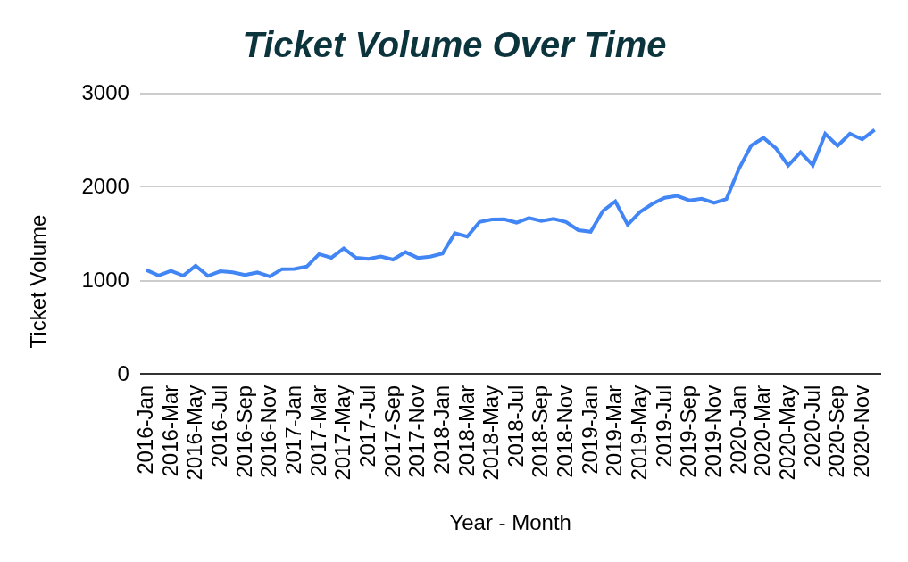
Chart S9.1 : Tickets Volume over the year on monthly average basis

Chart S5.2 : Average Satisfaction Rate on monthly basis over years
Insights:
- Ticket Volume Shows Upward Trend
  - Ticket count increased significantly throughout the year
Indicates growing operational demand.

- Peak Operational Periods
  - Highest ticket volumes observed during:
    - Mid-year and later months
    - Around ~2500+ tickets/month
These are identified as peak operational periods.

- Stable / Off-Peak Periods
  - Early months showed:
  - Lower and more stable ticket volume (~1000–1500)
Represents relatively stable operational periods.

- Satisfaction Remains Relatively Stable
  - Despite increasing workload:
    - Satisfaction scores mostly remained high (4–5)
Indicates support team maintains acceptable service quality under pressure.

- Operational Pressure Increasing
  - Growing ticket volume without major improvement in resolution time suggests:
    - Increasing pressure on the support team
    - Possible scalability limitations

Recommendations:
- The analysis shows a steady increase in ticket volume over time, with peak operational periods occurring during later months of the year. Despite higher workload, customer satisfaction remained relatively stable, indicating that the IT support team is handling increased demand reasonably well, although operational pressure is increasing.

Question 10: What metrics should be included in the final dashboard to provide a comprehensive view of call center performance and guide investment decisions?

Solution:

Approach:
- To design a comprehensive dashboard for IT support operations and investment decision-making, the most important operational, performance, and customer satisfaction metrics were identified from the dataset .
- The dashboard should help management:
  - Monitor operational efficiency
  - Evaluate team performance
  - Identify bottlenecks
  - Improve customer satisfaction
  - Make investment decisions (technology, training, hiring)
- Methodology
  - The dashboard metrics were selected based on:
- Operational Performance
  - Ticket handling efficiency
  - Workload trends
- Service Quality
  - Satisfaction metrics
  - Resolution effectiveness
- Agent Productivity
  - Individual performance monitoring
- Strategic Decision Support
  - Identifying areas requiring investment

Charts & Tables:

Insights:
- Operational Efficiency Metrics are Critical
  - Resolution time directly reflects process efficiency.
- Ticket Volume Indicates Scalability Needs
  - Growing trends suggest future investment requirements.
- Satisfaction Metrics Reflect Service Quality
  - Important for evaluating customer experience.
- Agent-Level Metrics Help Workforce Decisions
  - Helps identify:
    - Top performers
    - Training needs
    - Workload imbalance
- Category-Level Analysis Identifies Bottlenecks
  - Hardware & System categories require attention.

Recommendations:
Data Visualization Sheet:
Newton_School_Project-Excel-ITA

