Spreadsheet Project PPT - Sample Approach

Refer to the below manual to create a powerful and effective PowerPoint presentation to showcase your project to the audience

Slide 1: Title Slide
- Content: Project title, your name, and the presentation date.
- Guidelines:
  - Use a large, bold font for the title.
  - Keep the design clean and professional.
  - Optionally, include a relevant image or Zomato's logo for visual appeal.
Example:


Slide 2: Introduction and Objectives
- Content: Brief introduction to the project, its context, and the primary objectives.
- Guidelines:
  - Start with a hook, such as a surprising fact about the industry or market position.
  - Clearly state what the project aims to achieve - e.g., identifying potential areas for expansion, understanding market trends, etc.
  - Keep it concise but informative.
Example:
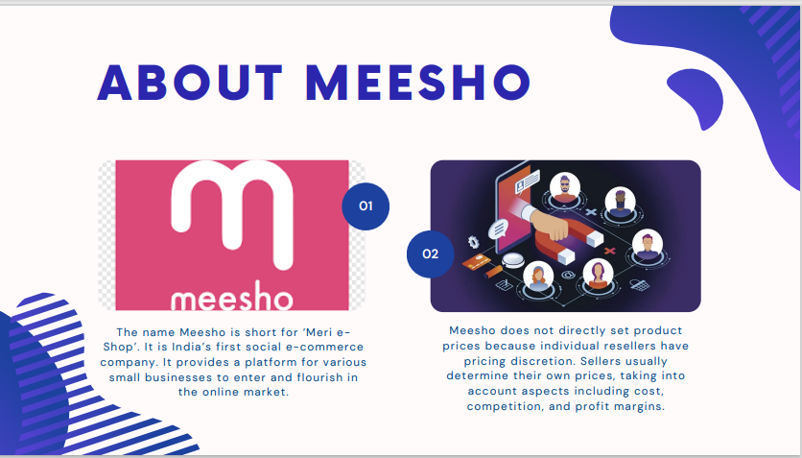
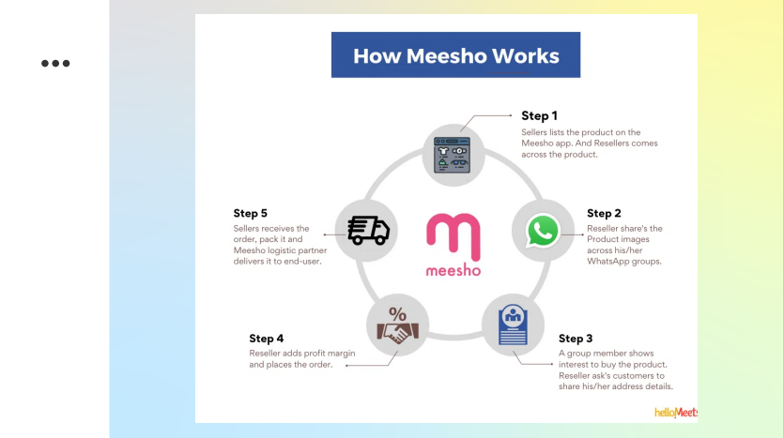

Slide 3: Data Overview
- Content: Summary of the dataset
- Guidelines:
  - Use bullet points or a small infographic to display key data points.
  - Mention any significant data cleaning or preprocessing steps undertaken.
  - Briefly explain why this data is critical for your analysis.
Example:
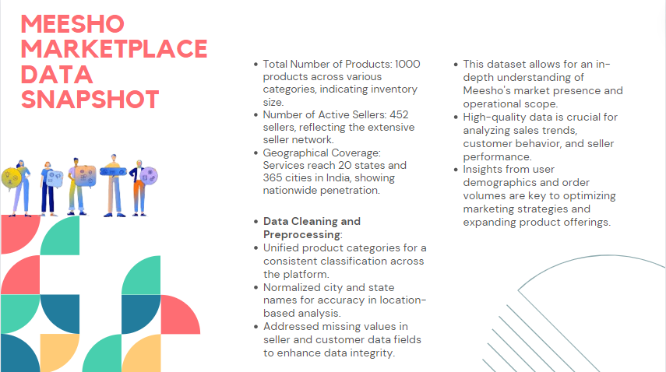

Slide 4: Methodology
- Content: Description of analytical methods and tools used.
- Guidelines:
  - Outline the steps taken in the analysis, like data cleaning, data enrichment, and the types of analysis conducted (e.g., statistical analysis, trend analysis).
  - Mention specific functions or features used (e.g., pivot tables, VLOOKUP).
  - Keep the technical jargon to a minimum to ensure clarity for all audience members.

Example:
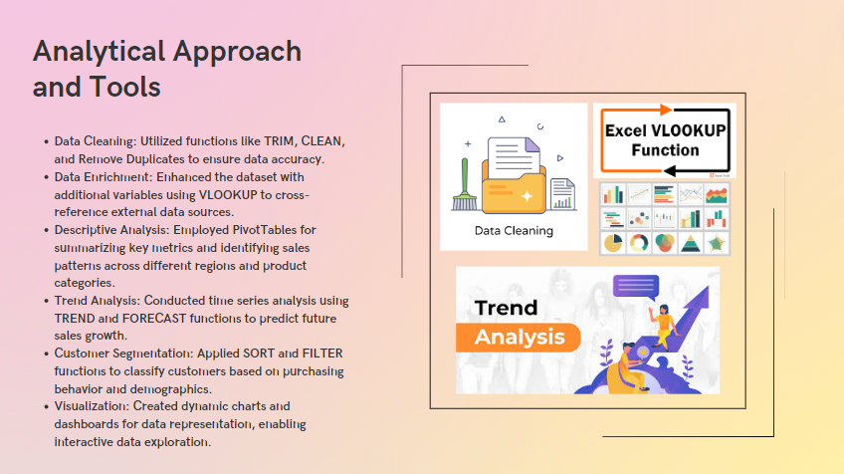

Slides 5-7: Analysis of Objective Questions
- Content: Detailed findings for each objective question.
- Guidelines:
  - Dedicate one slide to each major finding.
  - Use charts, graphs, or tables for visual representation.
  - Include brief bullet points to highlight key takeaways from each visual.
Example:
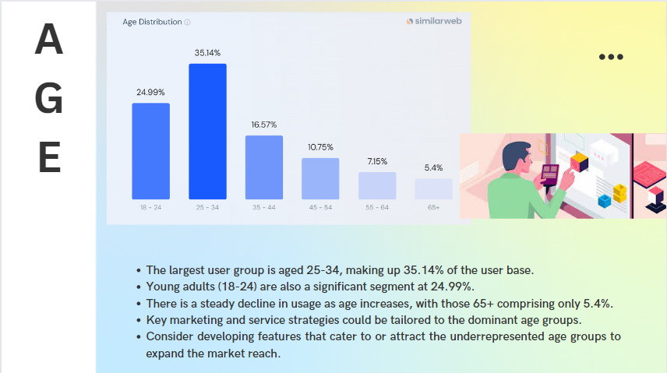

Slides 8-10: Insights from Subjective Questions
- Content: Analysis and insights related to subjective questions.
- Guidelines:
  - Explain the rationale behind each insight. For instance, if suggesting a new market for expansion, discuss the factors like market saturation, customer preferences, etc.
  - Use data visualizations to support your insights. For example, a heatmap for market saturation, pie charts for customer preference analysis.
  - Each slide should tell a story about what the data reveals and why it’s important.
Example:
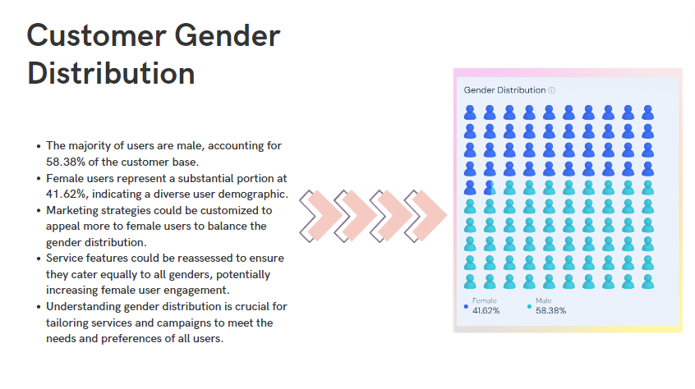
Slides 11-13: Strategic Recommendations
- Content: Specific recommendations based on your analysis.
- Guidelines:
  - Clearly state each recommendation and the data-driven reason behind it.
  - Use bullet points for clarity.
  - Discuss the expected impact of these recommendations, such as increased market share, improved customer satisfaction, etc.

Example:
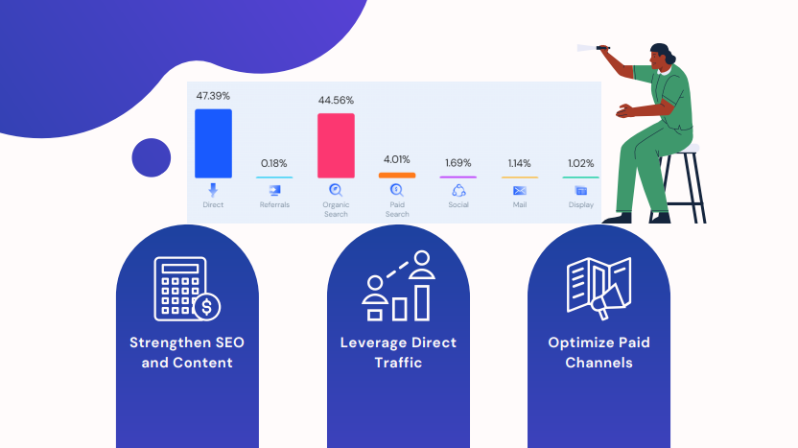
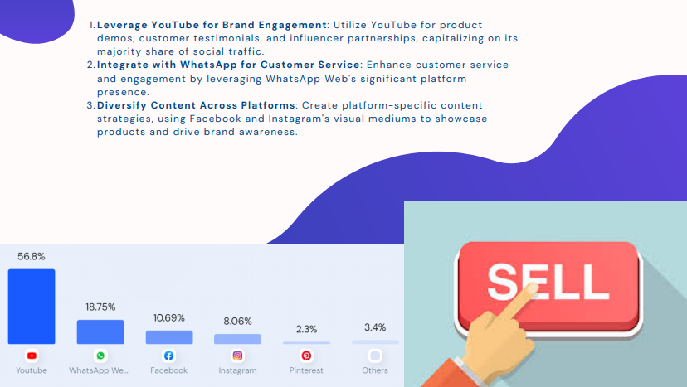

Slide 14: Dashboard and Visualizations
- Content: Showcase the dashboard or key visualizations created.
- Guidelines:
  - Use screenshots of your most impactful dashboards.
  - Briefly explain how to interpret them and their relevance to decision-making.
  - Highlight features like filters or slicers that add interactivity.

Example:
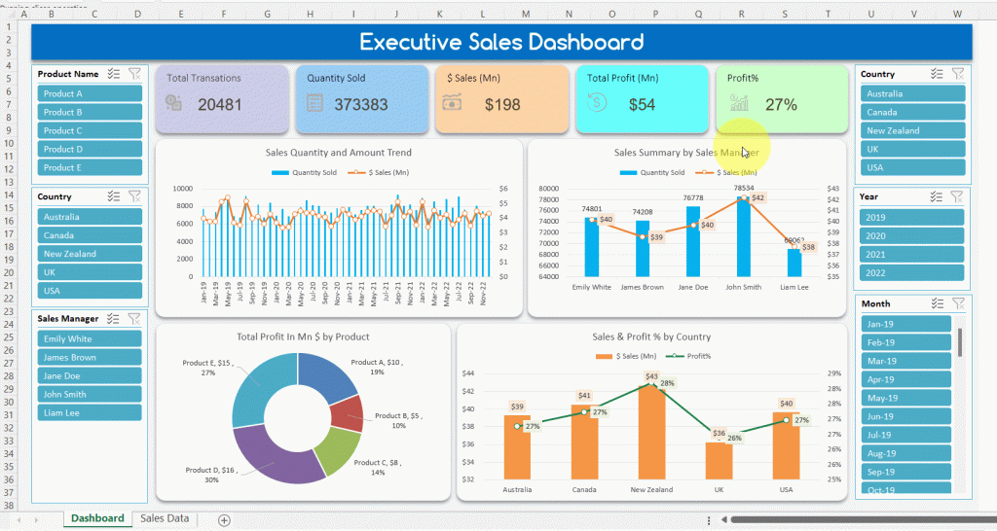

Slide 15: Conclusion
- Content: Summary of key findings and their implications.
- Guidelines:
  - Recap the main insights and recommendations.
  - End with a strong closing statement that reinforces the value of your analysis.
  - Keep it brief but powerful.
Example:
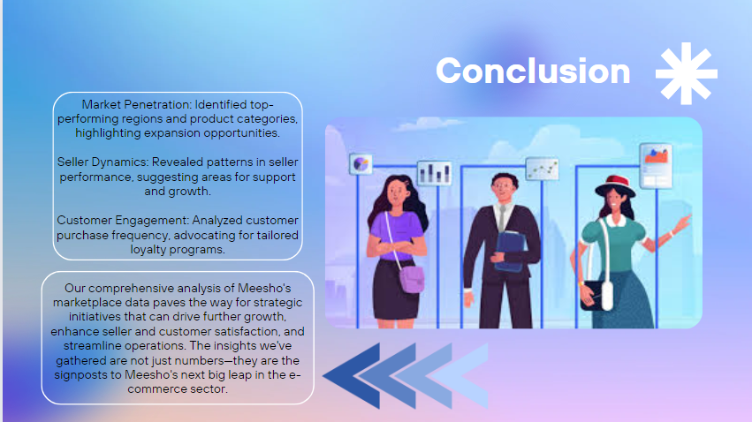
Slide 16: Acknowledgements and References
- Content: Credits for any external assistance or data sources.
- Guidelines:
  - List any sources in a small font.
  - Briefly acknowledge any significant contributions from team members or mentors.
Example:
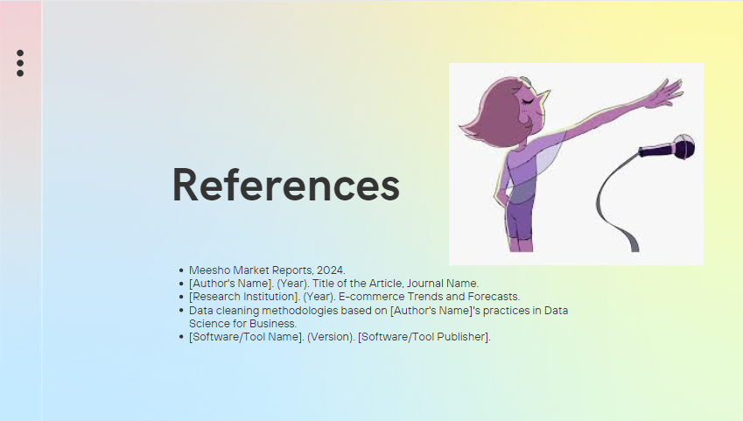
Note: The number of slides may vary as per different approaches.

Additional Tips for PPT:
1. Storytelling Approach
2. Use Visualizations to back your answer/insights
3. Clear and concise answers with exact reasons

Resources to check out:
- Cool article to do effective storytelling - check this out!
- How to do cool presentations - Check this out

Excel Project Documentation Guidelines

General Guidelines:

- Make sure to include the objective questions and the solutions in the documentation with the necessary explanations.
- The content guidelines have to be properly followed throughout the document. Failing to follow will result in a reduction in marks.
- The approach given under each subjective question is a sample. Please try to use your data insight with innovative approaches to solve the subjective questions.
- Include your dashboard in the document with relevant slicers and other components. Ensure to follow proper formatting and alignment throughout the entire document.

Content Guidelines for Questions:
1. Ensure brief Document Structure and Clarity
2. In-depth Analysis and Justification of Responses
- Provide a detailed examination of the project's context, using data from the Excel file to inform your insights.
- All responses must be justified with data or evidence from the project.
3. Reasoning for Strategic Recommendations
- When suggesting strategies or actions, outline the thought process and reasoning in a step-by-step manner.
- Recommendations should be tied back to the project's goals and supported by data-driven insights.
4. Scoring Considerations
- Aim for comprehensive and well-reasoned answers to meet the scoring criteria of at least 8 out of 10 for referral prioritization.
- Consider the scoring rubric while crafting responses, particularly focusing on areas of data cleaning, dashboarding, and visualization for the Excel file; exactness and reasoning for the Doc file; and storytelling and formatting for the Presentation file.

Sample for Objective and Subjective questions:
Objective Question:
1. What is the theater density per 100,000 people by region?

- Guidelines: Analyze the theater density and market saturation levels in the dataset. Make use of conditional aggregators and operators to approach the problem.
Visualization:
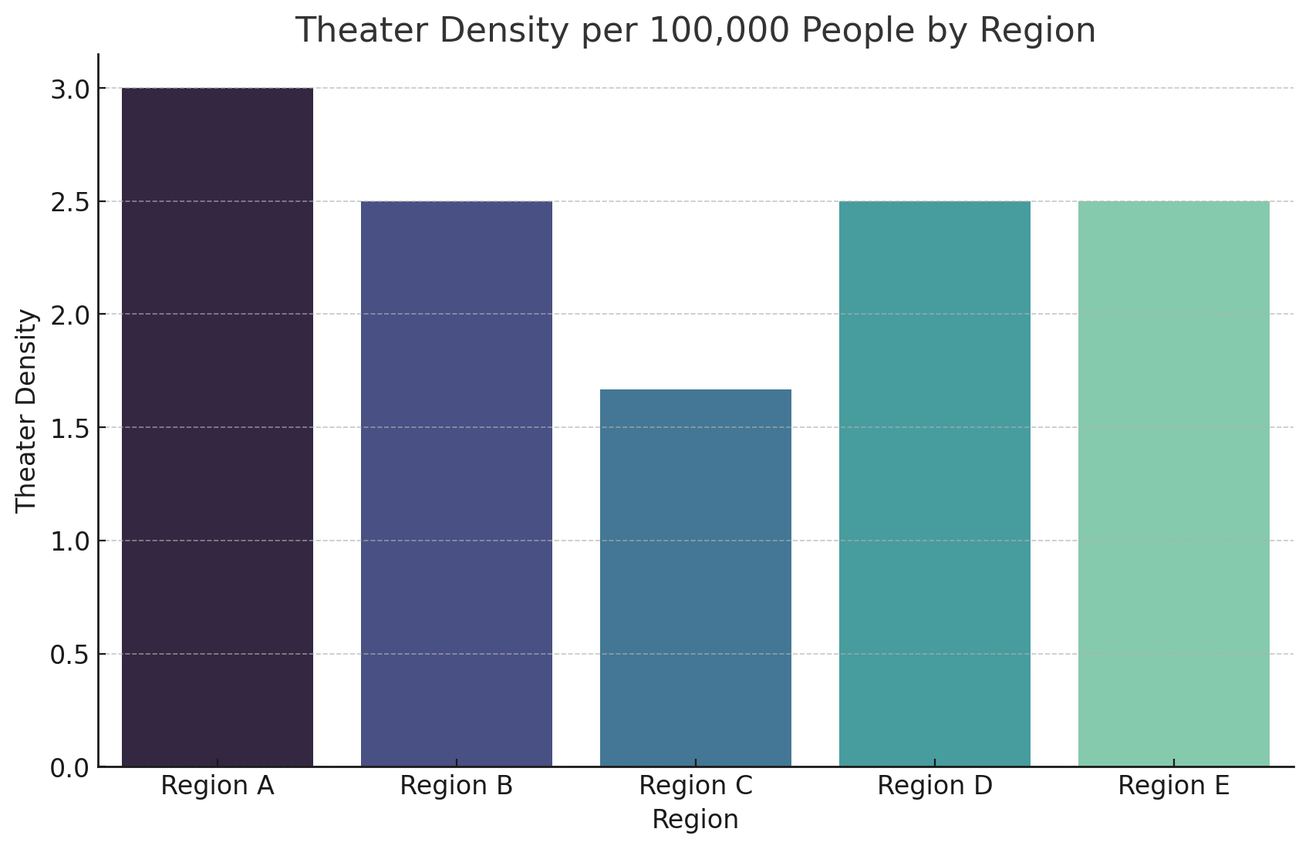
Observation:
Regions with fewer theaters: Regions with shorter bars, like Region C and Region E, indicate lower theater densities. These areas might be less saturated with theaters and could present opportunities for new theater openings.
Regions with more theaters: Conversely, a region like Region A, with a taller bar, suggests a higher theater density and possibly more competition.
Note: Follow the same procedure for all objective questions

Subjective Question:
1. Can you provide a comparison of theater ticket pricing across different countries?
- Guidelines: Use a pivot table to aggregate the number of theaters by ticket price range per country. Display the distribution with a histogram or bar chart, allowing for comparison across different markets.

Which could look like this:

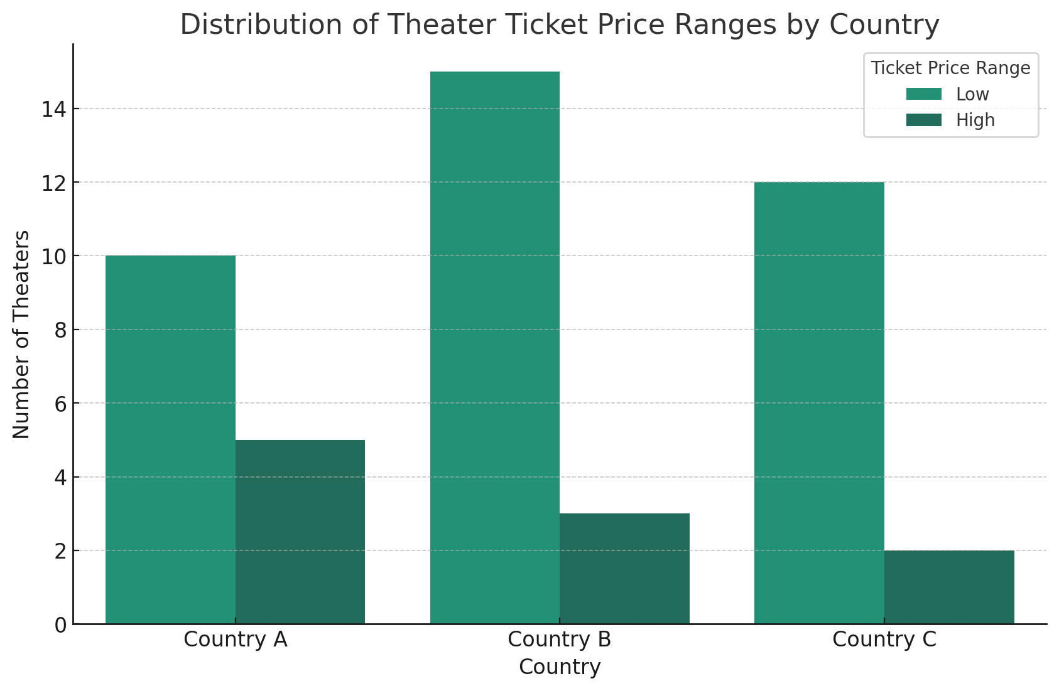
Insights:
- Price Range Preferences: Indicates which countries have more theaters in either the low or high ticket prices.
- Market Positioning: Helps in understanding how theaters are positioned in terms of pricing in different countries.
Recommendations:
- Market Strategy: In countries with a higher number of theaters in the high price range, consider premium offerings. In contrast, focus on affordability in countries with more low-priced theaters.
- Pricing Flexibility: Be adaptable in pricing strategies to cater to the prevalent market conditions in each country.
- Note: Follow the same procedure for all subjective questions

Spreadsheet Project Guidelines - Dashboard

Must haves for the .xlsx file

General Guidelines:

- Ensure all the pivot tables, charts, and dashboards are included in the file.
- The visualizations should be properly titled and formatted.
- Make use of conditional aggregation and operators wherever possible.
- The dashboard should have a title and should be formatted properly using a suitable color palette and slicers.
- Each slicer should be connected to the chart and should be dynamic.

Sample question and approach:

1. What percentage of records have missing values in the 'Product Price' column?
Sample Approach:
- Missing Value Treatment: Decide on a strategy for missing data, which might include:
  - Imputation: Replace missing values with the mean, median, or mode (for numerical data) or the most frequent category (for categorical data).
  - Deletion: Remove rows or columns with a high percentage of missing values.
- Inconsistency Correction: Identify and correct inconsistencies in data formats, units, or categories. For example, ensure that all dates are in the same format.
Your dashboard could look like this:
Resources to check out:
- Cool article to create effective dashboards - check this out!
- Building impressive dashboards
Note: Based on the mentioned details, you are required to create the pivot tables, and dashboard with relevant charts and slicers and ensure that everything is included in the report.

Project Submission on Platform
The submission UI can be changed for the newer learners, consider the following section.
Please submit your project link in the place indicated below screenshot (You can paste your drive link in the hosted project link)
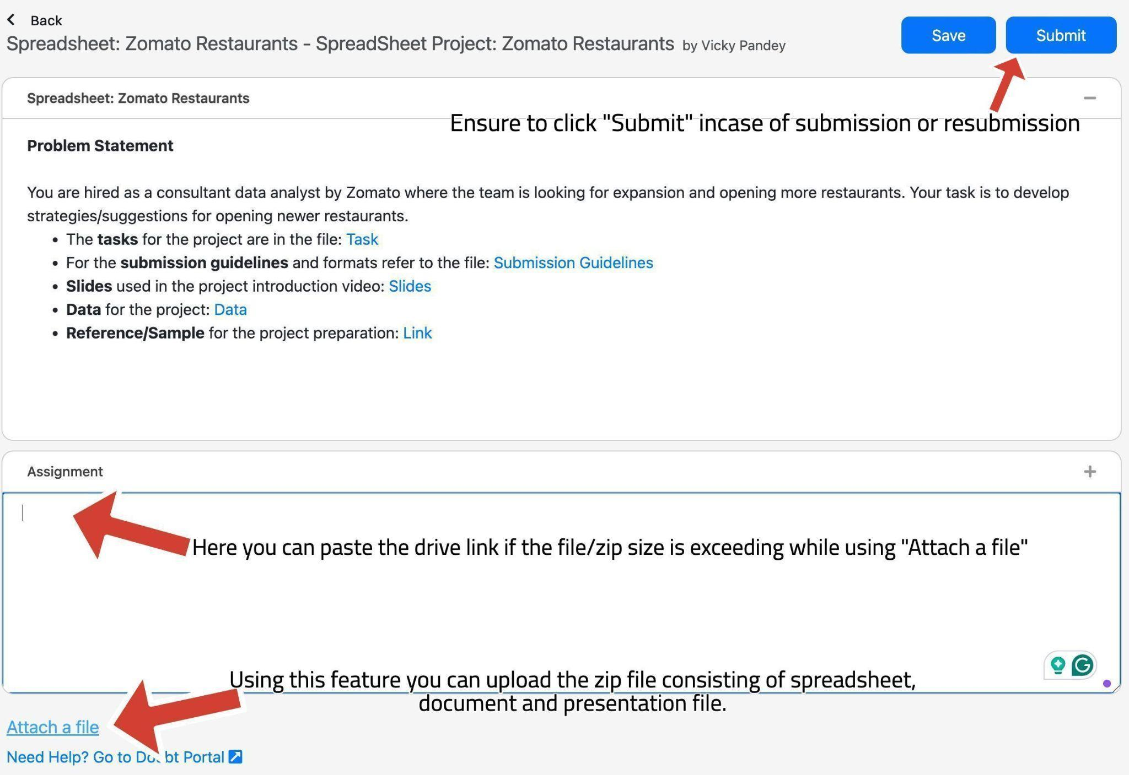
Look at the arrows and the comments to get familiar with the UI while submitting and uploading the files on the platform. There is a space to paste the drive link and upload the zip file.

