Document Format - Doc Template (IT Tickets)

Spreadsheet Template - Template (IT Tickets)

SUBMISSION FLOW

- The candidates are supposed to have the first submission for the project within the 10-day deadline.
- After the submission, candidates will receive feedback on their project, which they are supposed to incorporate and re-submit within 1 week of feedback.
- All the candidates are supposed to get a total of 8 marks to be prioritized in placements since it is necessary for Placements.
- The re-submissions after 3 weeks of launch in the batch will be de-prioritized during evaluations.
  - Candidates will have to give the reason for their delay, to make sure that the team picks up their evaluation through mail or PI request.
  - This will create backlogs as the project for the next module will also be released around the same time.
- So make sure to submit the project (with the requirements) within the timeline.

GUIDELINES

- Ensure that the project is submitted within the 10-day deadline.
- TA support won’t be answering any direct questions regarding the project.
- Plagiarism will be checked during the evaluation.
- Queries regarding submission should be asked to success champions.
- Candidates must score >=8 out of 10 to be picked for referrals.

COMPONENTS

All the components mentioned below hold significance while evaluation:

- Excel File:
  - Data Cleaning
  - Dashboarding
  - Proper formatting
  - The correct choice of visualization charts
  - Template (IT Tickets)

- Doc File:
  - Exact answers to the objective questions
  - Proper answers to the subjective questions with reasoning
  - Proper formatting
  - Doc Template (IT Tickets)

- Presentation File:
  - Proper storytelling
  - Proper formatting

EVALUATION

- The projects will be evaluated on 10 levels (Each learner will receive detailed feedback).
- On each level, learners will get a rating out of 5, if the rating is smaller than 4, they won’t be considered as passed at that level.
- Learners have to get >=4 (or passed) in at least 8 levels to get >=8 as the final rating in the project.
- In the final feedback, only the final feedback out of 10 will be considered.
- The ratings of level 9-10 will only be considered and included in the final feedback if someone is passing in all the Levels from 1 - 8. They (levels 1-8) are compulsory, in order to get passed in the final feedback.

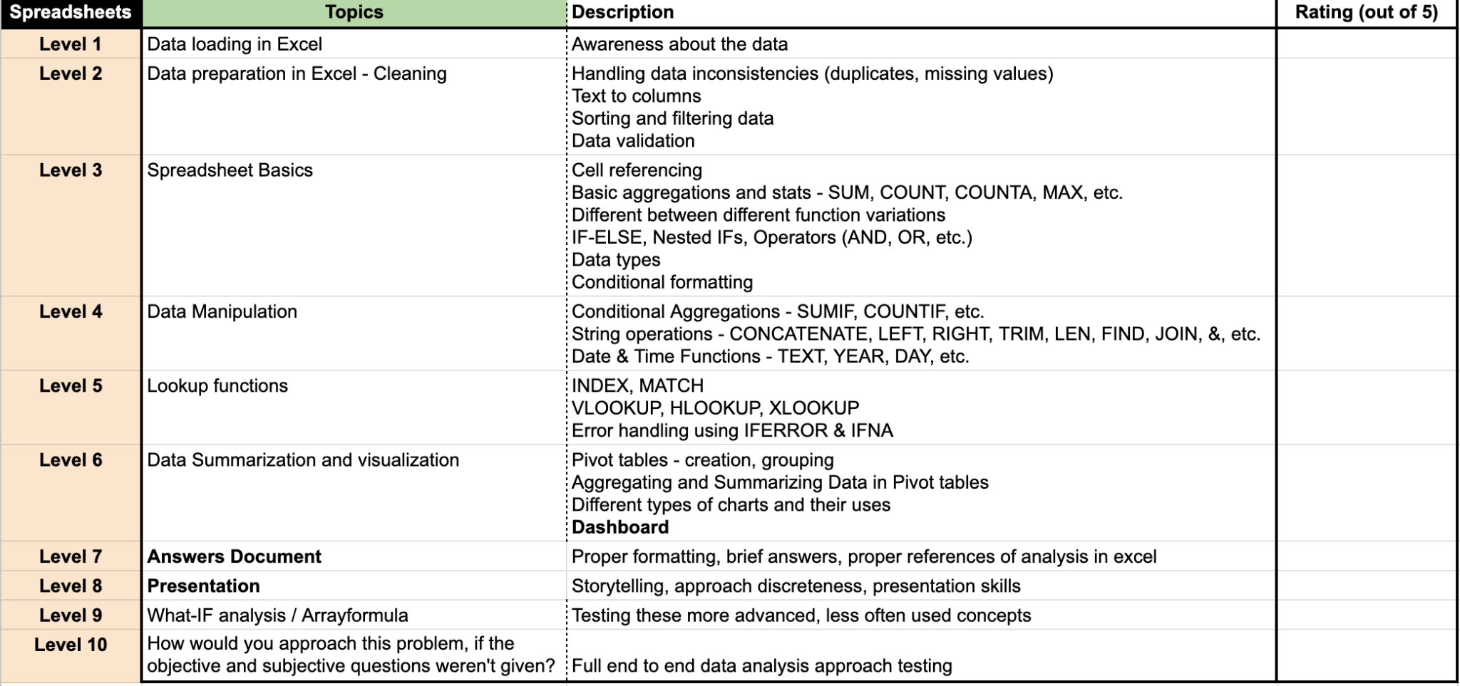

Feedback Form

- In the following feedback form, there is only one level (i.e. level 1) at which the candidate didn’t pass because he got rated <=4, that’s why he is given the feedback that his answer to Objective Question 1 is not correct.

- Due to this, only the candidate is rated 9 out of 10 in the final feedback.

Note: The following feedback form is just a sample it may differ across modules but the format remains the same.
