Useful Rreferances

Official Documentation
http://sailsjs.com/
https://digitaldrummerj.github.io/sails-tutorial/

Beginers guide
https://www.codementor.io/@codeforgeek/how-to-setup-sailsjs-tutorial-beginners-du107nl5i#installation-and-configuration

https://www.sitepoint.com/an-introduction-to-sails-js/

File image upload
https://jumpstartsails.blogspot.com/2015/10/fileimage-uploading-in-sailsjs.html

How to install sails on managed hosting
https://www.a2hosting.in/kb/installable-applications/manual-installations/installing-sails-js-on-managed-hosting-accounts#Step-2.3A-Install-Sails.js

knex js as node js (Data migration tool -web Development)
https://www.logisticinfotech.com/blog/use-of-knex-js-as-node-js-database-migration-tool/

send email
https://medium.com/@raj_adroit/sails-js-email-sending-using-sails-hook-email-and-mailgun-service-f6a8ab0e6d77
for sending mail
"nodemailer": "^4.7.0",
"nodemailer-ses-transport": "^1.5.1",
"nodemailer-smtp-transport": "^2.7.4",
job and queue
https://www.logisticinfotech.com/blog/easiest-way-to-create-job-queue-in-sails-with-sails-hook-job-queue/

https://www.npmjs.com/package/kue#queue-maintenance

open port check
https://askubuntu.com/questions/410218/how-to-close-an-open-port-in-ubuntu

kue npm for jobs
https://www.npmjs.com/package/kue#queue-maintenance
"kue": "^0.11.6",
kill specific port
sudo kill $(sudo lsof -t -i:1337)
show all open port list
sudo netstat -lnp
https://linuxize.com/post/check-listening-ports-linux/
show all tcp open port list
sudo netstat -tnlp
check specific port is open or not
sudo netstat -tnlp | grep :1337
kill specific port
sudo kill $(sudo lsof -t -i:1337)

Installation and Configuration
npm install -g sails
sails create projectName
npm install
run the project - sails lift
Visit localhost:1337 to view the app.

├── api
│ ├── controllers
│ ├── models
│ ├── policies
│ ├── responses
│ └── services
├── assets
│ ├── images
│ ├── js
│ │ └── dependencies
│ ├── styles
│ └── templates
├── config
│ ├── env
│ └── locales
├── node_modules
│ ├── ejs
│ ├── grunt
│ ├── grunt-contrib-clean
│ ├── rc
│ ├── sails
│ └── sails-disk
├── tasks
│ ├── config
│ └── register
└── views
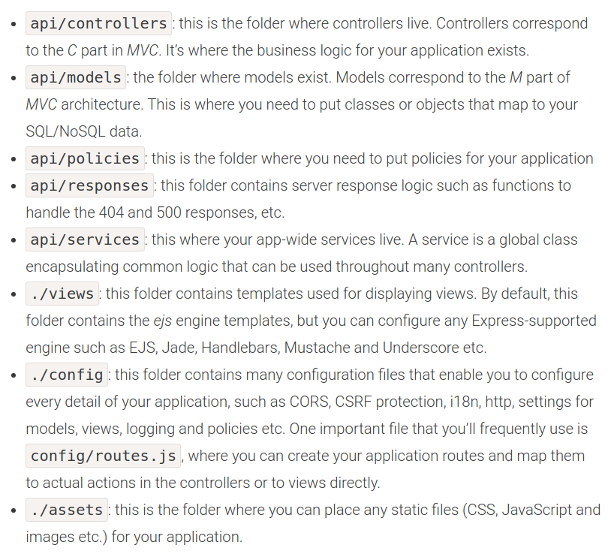

Configuring Your Database
npm install --save sails-mysql

config/connections.js changes related DB access

someMysqlServer: {
adapter: 'sails-mysql',
host: 'YOUR_MYSQL_SERVER_HOSTNAME_OR_IP_ADDRESS',
user: 'YOUR_MYSQL_USER',
password: 'YOUR_MYSQL_PASSWORD',
database: 'YOUR_MYSQL_DB'
}

Now to tell Sails to use it, open config/models.js file and change the driver.
connection: ‘someMysqlServer’,
migrate : ‘alter’

Creating an Auto-generated API
sails generate api testAPI. ——> api/controllers folder,
it will create a file called TestAPIController.js,
——> In the Model folder, it will create new file called testAPI.js.

Run this command :: sails lift

//create notification
notificationObj = {
sender_id: inputs.fromUserId,
reciever_id: adminId,
notification_type: 'CreatedChatByUser',
notification_data: chatsResult.id,
sender_type: 'app',
receiver_type: 'admin'
};

notificationResult = await Notifications.create(notificationObj).fetch();

1. sails new projectname
create empty application press 2
2.run sails project
sails lift
3.create api
sails new generate apiname
so it will create 2 files in controller and modal folder

4.now test our blueprint api (go to browser and type url )
localhost:1337/apiName
ite will show blank array []

5. lets add items in it using blueprint api
type”
localhost:1337/apiName/create?name =abc
6. go back
localhost:1337/apiName
it will show one record

this data is stored in localdiskDB (tmp/archive.db and tmp/apiName.db)

remove node modules
rm -rf node_modules/
You can scaffold a new Sails.js project without a front end with this:
sails new sailsdemo –no-frontend

Configuring Your Database
npm install --save sails-mysql

install radis servdr
brew install redis

#follow this link for knex update table
http://perkframework.com/v1/guides/database-migrations-knex.html

MIGRATION
npm install knex -g
knex migrate:make migration_file_nameMigration
knex migrate:latest

knex migrate:latest --env staging

All genereate cmd
action:: sails generate action <action file name>
helper:sails genereate helper <helpername>
create controller in api/controllers/<namecontroller.js>
sails generate controller product

create model in api/model/<modalname.js>
sails generate model <modalname>

Creating an Auto-generated API
sails generate api testAPI. ——> api/controllers folder,
it will create a file called TestAPIController.js,
——> In the Model folder, it will create new file called testAPI.js.

Create service and job
manually create folder in api/service or api/jobs

for sending mail npm package
"nodemailer": "^4.7.0",
"nodemailer-ses-transport": "^1.5.1",
"nodemailer-smtp-transport": "^2.7.4",
foe making job npm package
"kue": "^0.11.6",

# If got error related to ruby install
sudo apt install ruby-full rubygems autogen autoconf libtool make
sudo gem install sass

# for grunt error
sudo gem install sass
# if still issue try
sudo gem install clean

npm install grunt-sails-linker --save-dev --save-exact

grunt buildProd
grunt buildProd --build=prod --force

# for install grunt
sudo npm install -g grunt
#for install sass
sudo npm install -g sass
sudo npm install -g node-sass
#for permision
sudo chown -R $(whoami) $(npm config get prefix)/{lib/node_modules,bin,share}
sudo chown -R $USER:$GROUP ~/.npm
sudo chown -R $USER:$GROUP ~/.config

#remove cache for npm
sudo npm cache clean -f

#remove node modules
rm -rf /usr/local/lib/node_modules
sudo rm -rf /usr/local/lib/node_modules

#follow this link for knex update table
http://perkframework.com/v1/guides/database-migrations-knex.html

