1. **Please select essential data while system update. No need to select any extension (unchecked the Toggle all checkbox)**

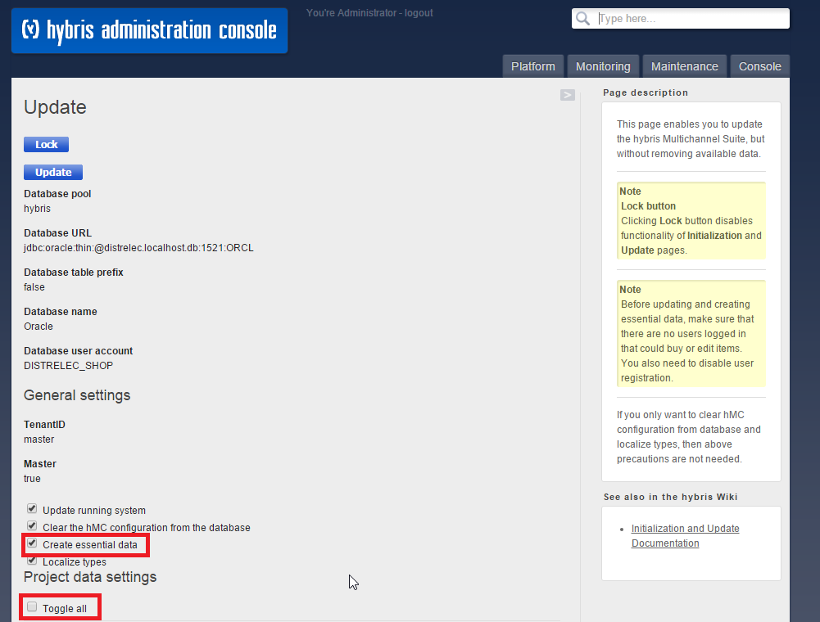

1. **After successfully system update, execute below command in hac - FlexibleSearch**

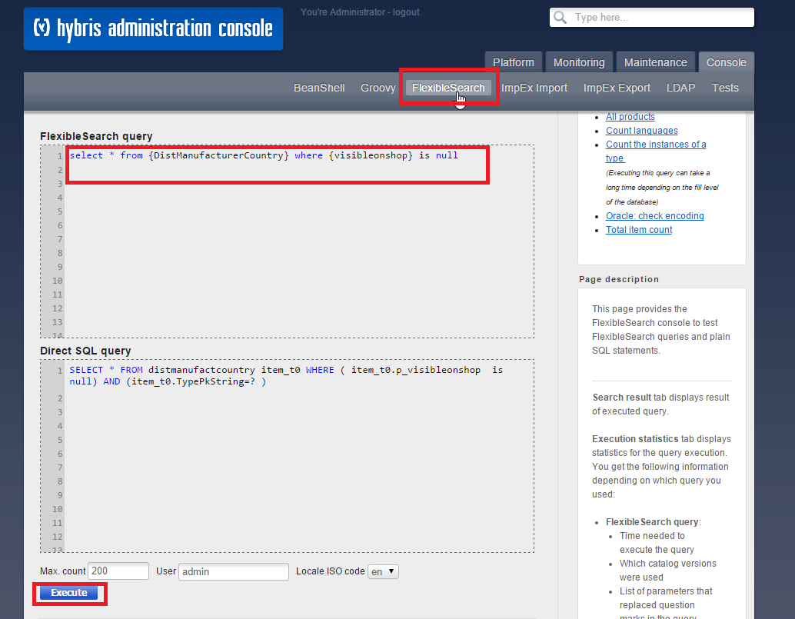

1. **If you found any records (>0) then please execute below query - because existing records will not be updated with default value - False**

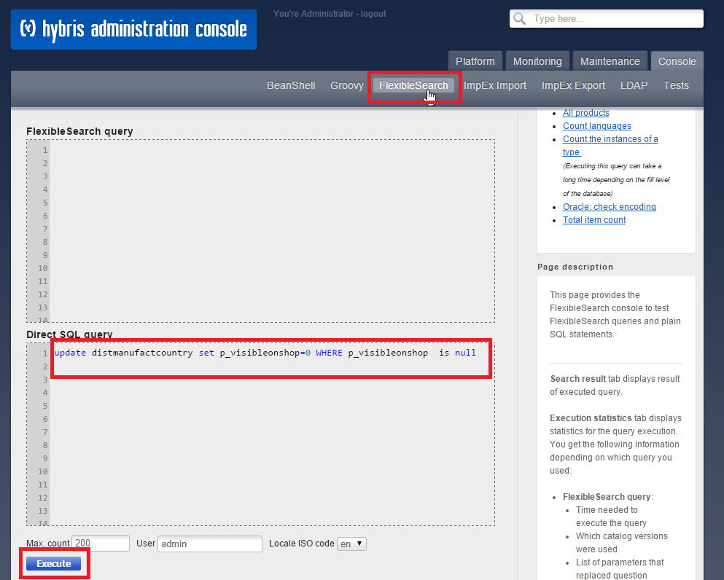

1. **Create new Cronjob for update Manufacturer Flag in Manufacturer Country Table**

**System > CronJobs > Create > Select ManufacturerFlagUpdateCronJob**

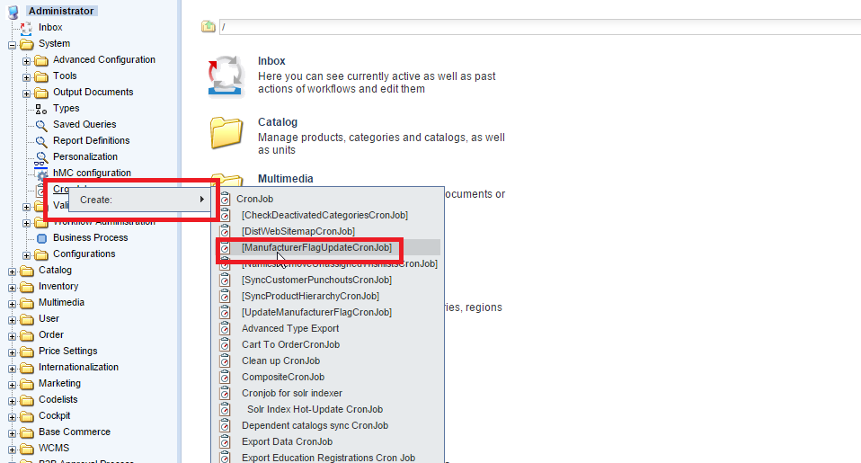

1. **Add the Job name and Select the manufacturerFlagUpdateJob as a job from Job list and click on Create button.**

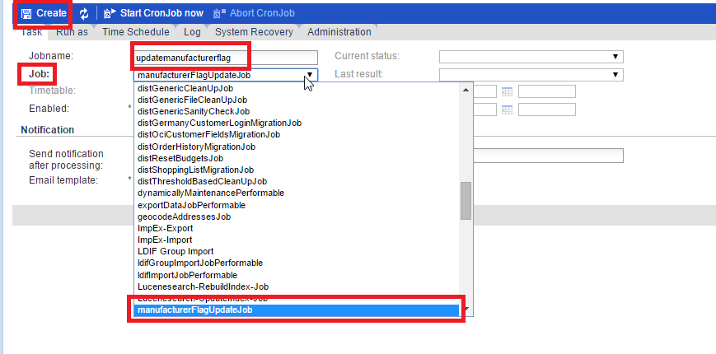

1. **Start the Cronjob**

