I am unable to record on my pc due to some error with my recording software but here are my screenshots of the emulator running and my development environment running.

Emulator and code running:

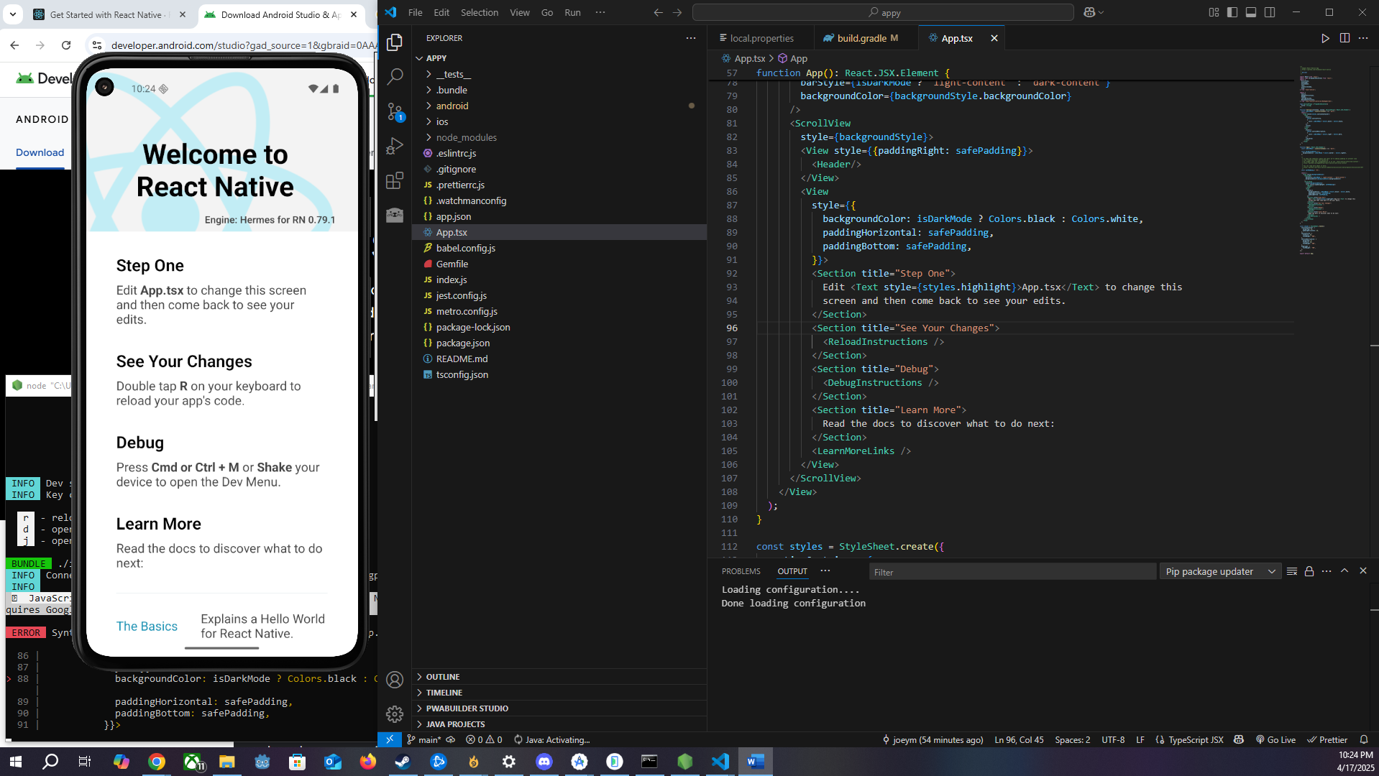

Change to background color showing up on emulator:

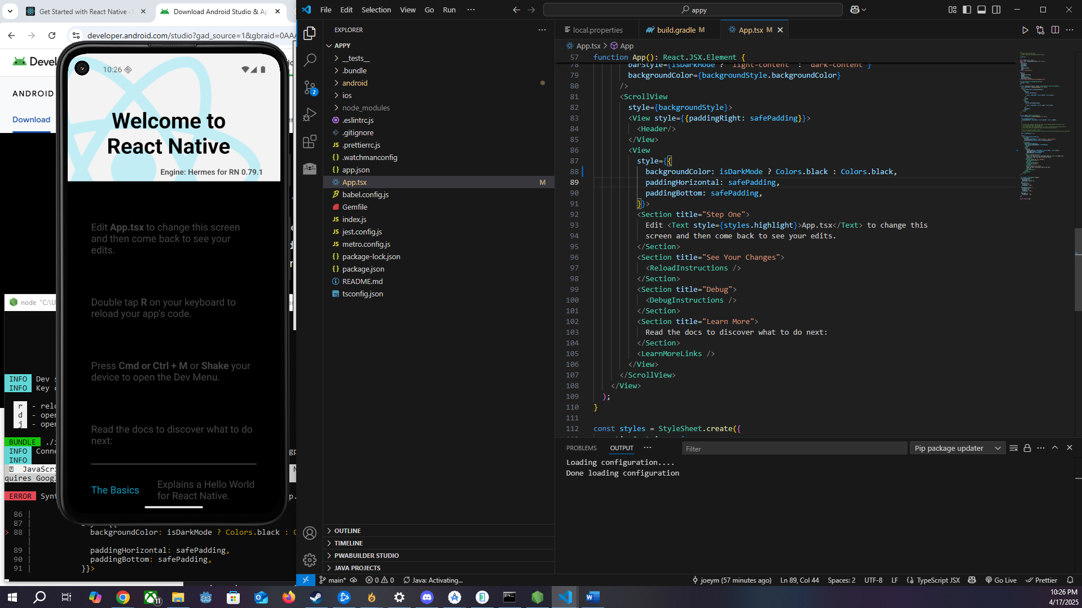

Command prompt and node screens:  
