# 1 Data Source and Collection

*The vulnerable dataset vs non-vulnerable dataset used in Section 3 is 10000:10000.

## Vulnerable

The vulnerable dataset has two main resources:

* From previous research provided. (**\*The results in Section 3 are from this dataset**)
* Newly fetched NVD data with 400+ more official data than the previous one. (**\*The *CVE SEVERITY* correlation analysis results in huge difference with new dataset than origin one**.)

*In the provided one, the origin research skipped/ignored some commits from security advisory or blob markdown.

## Non-vulnerable

The non-vulnerable dataset comes from latest Pytorch/Tensorflow GitHub repository. The latest version is considered to be non-vulnerable at this moment (**\*Need to be confirmed**)

# 2 Metric Process

Transfer the raw dataset/source to a metric-processed one with details.

## 2.1 Metric Definition

|  |  |  |
| --- | --- | --- |
| **Metrics** | **Description** | **Details** |
| ***Basic*** | | |
| URL | The URL link source | GitHub commit/pull request |
| Repo Name | The Repository name | GitHub repository name |
| Date | The time of the URL commit | The time that a vulnerability was solved |
| CVE ID | The CVE id | Official CVE ID from NVD |
| CVE Severity | The CVE severity | The latest CVE severity metric’s base score |
| Name | Component name | The component is the base unit |
| Component Type | Component type | File or Group. Group definition is based on the locality within the same CVE issues/commit |
| ***Code ownership*** | | |
| Ownership | The ownership | The highest ownership of a component |
| Num of Contributor | The sum of contributors | The sum of the contributors to a component |
| Num of Minor T% | The amount of the minor contributors | The total amount of the minor contributors to a component. Contributor with ownership under T% is Minor contributor.  (* T%: 5%, 10%, 20%, 50%) |
| Per of Minor T% | The proportion of the minor contributors | The proportion of the minor contributors over all the contributor amount |
| Avg of Minor Contri T% | The average of minor contributor’s ownership | The average value of the minor contributors’ ownership |
| ***Time/Release (See 2.2 for details)*** | | |
| Days Difference | The project existing time | The existing time of the project in GitHub repository till the **Date** |
| Age | The component lifetime | The component lifetime calculated based on Git Log info |
| Time Stage Numeric | Five Time stages | The five Time stages’ numerical value. Calculated by **Days Difference** |
| Time Stage Aged Numeric | Five Time stages Aged | The five Time stages’ numerical value. Calculated by **Age** |
| Oss Stage Numeric | Six Oss stages | The six Oss stages’ numerical value. Calculated by **Days Difference** |
| Oss Stage Aged Numeric | Six Oss stages Aged | The six Oss stages’ numerical value. Calculated by **Age** |
| Is Pre-release | Vulnerability found at pre-release | The release tag where the vulnerability found is pre-release |
| Is Post-release | Vulnerability found at post-release | The release tag where the vulnerability found is post-release |
| Release Amounts | Affected releases | The affected releases until the project latest time |
| Release Amounts Aged | Affected releases Aged | The affected releases within the lifetime of the vulnerability existing |
| ***Classic metrics*** | | |
| Code churn | NLOC | The number of lines changed = total added + total deleted |
| File Size | File Size | The number of lines for a component |
| Churn rate | Churn rate | = Code churn / File Size |

## 2.2 Time Stage + Oss Stage Metric

|  |  |  |
| --- | --- | --- |
| **Metric** | **Details** | **Numeric Value** |
| ***Time Stage*** | | |
| T1 | The given time period is in 0 to 7 days | 1 |
| T2 | The given time period is in 7 days to 3 months | 2 |
| T3 | The given time period is in 3 months to 9 months | 3 |
| T4 | The given time period is in 2 years to 3 years | 4 |
| T5 | The given time period is beyond 3 years | 5 |
| ***Oss Stage*** | | |
| SI | Success Initialisation. Has at least one successful release | 1 |
| TI | Tragedy Initialisation.  Within the given time period (>1year), no release | 2 |
| SG | Success Growth.  >= 3 releases AND >= 6 months between releases | 5 |
| TG | Tragedy Growth.  1 or 2 releases and >=1 year since the last release at the time of data collection | 6 |
| II | Indeterminate Initialisation.  0 releases and < 1 year since project registration | 3 |
| IG | Indeterminate Growth.  1 or 2 releases and < 1 year since the last release OR 3 releases and < 6 months between releases | 4 |

## 2.3 Vulnerable process + App interface

An application interface (vulnerable process) is created for processing the raw dataset to distilled one under the metric defined. This application interface defaults to calculate the provided dataset from Section 1. And it enables user to calculate the metric info with given commit/pull request URLs (CVE ID optional).

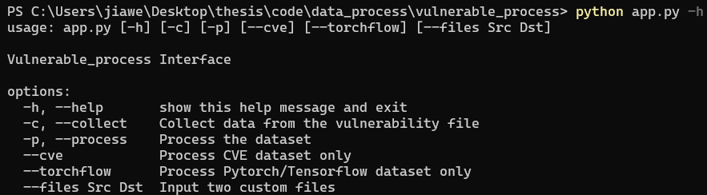

## 2.4 Non-vulnerable process + App interface

An application interface (non-vulnerable process) is created for calculate the metric info of a Git repository. The application interface defaults to process the local Git repo specified in settings, while also allows user to examine the repo with an external GitHub repo URL.

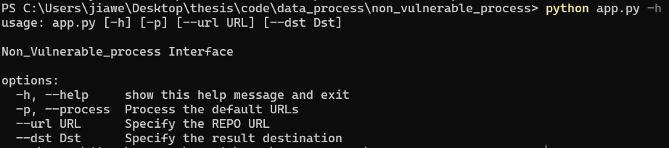

# 3 Result Analysis

## 3.1 Exploring Nature of Data

In summary, the dataset is not normally distributed.

### 3.1.1 Descriptive statistics

|  |  |  |  |  |  |  |
| --- | --- | --- | --- | --- | --- | --- |
| **Metrics** | **N** | **Min** | **Max** | **Mean** | | **Std. Dev.** |
| ***Statistics*** | ***Std. Error*** |
| CVE Severity | 658 | 3.3 | 9.9 | 6.465502 | 0.05183 | 1.329519 |
| Num of Contributor | 11491 | 1.0 | 364 | 13.997041 | 0.210087 | 22.520525 |
| Ownership | 11491 | 0.044088 | 1.00000 | 0.443906 | 0.0023718 | 0.254253 |
| Num of Minor 10% | 11491 | 0.0 | 364 | 11.495779 | 0.212516 | 22.780893 |
| Per of Minor 10% | 11491 | 0.000000 | 1.000000 | 0.499368 | 0.003641055 | 0.390307 |
| Avg of Minor Contri 10% | 11491 | 0.000000 | 0.100000 | 0.030714 | 0.0002789549 | 0.029903 |
| Days Difference | 11491 | 58 | 3962 | 1634.073275 | 5.91280283 | 633.829298 |
| Age | 11491 | 0.000000 | 2548 | 745.52884 | 6.4916690 | 695.881488 |
| Time Stage Aged Numeric | 11491 | 1.000000 | 5.000000 | 3.693325 | 0.011131 | 1.193224 |
| Oss Stage Aged Numeric | 11491 | 1.000000 | 6.000000 | 1.49195 | 0.01117426 | 1.197837 |
| File Size | 11491 | 0.000000 | 48295 | 621.776956 | 12.434681455 | 1332.949133 |
| Code churn | 11491 | 0.00000 | 8.137754e+06 | 2.659028e+03 | 709.30357 | 7.603456e+04 |
| Churn rate | 11491 | 0.000000 | 43785.714286 | 310.596780 | 12.22779542 | 1310.771761 |

### 3.1.2 Histogram, box plot, normal Q-Q plot

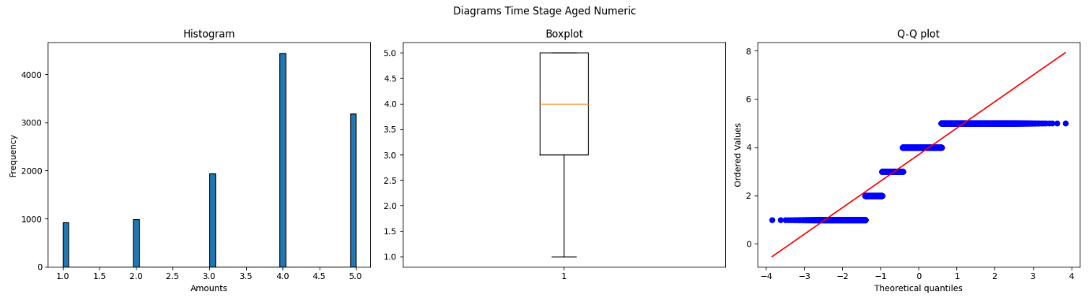

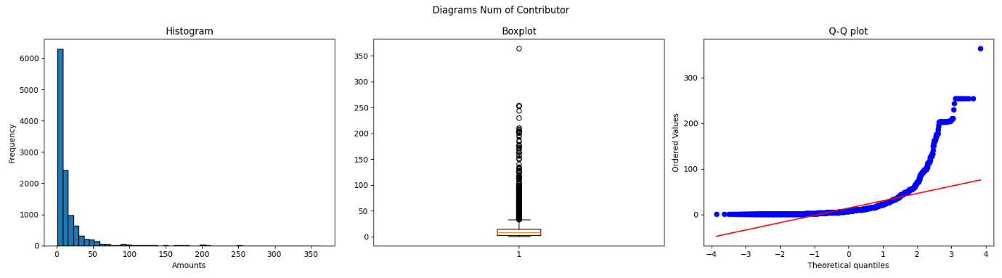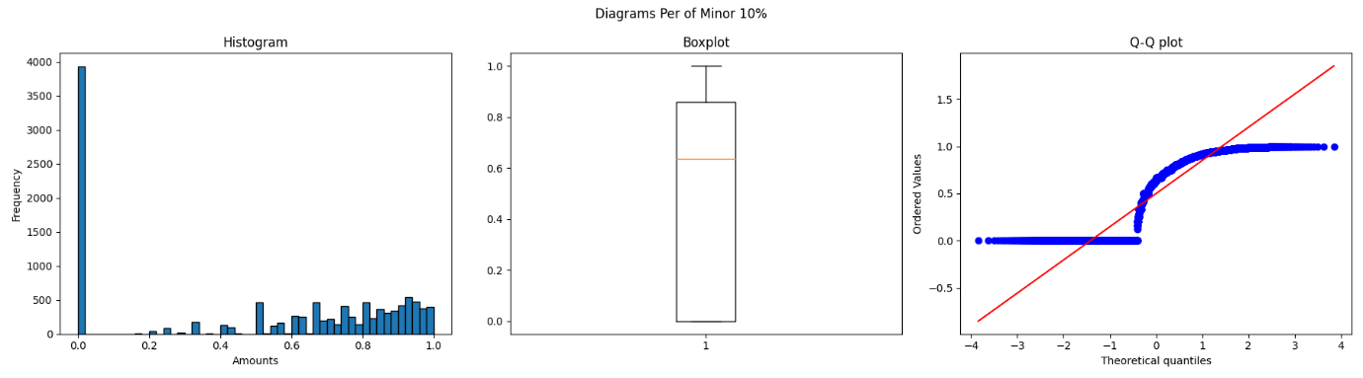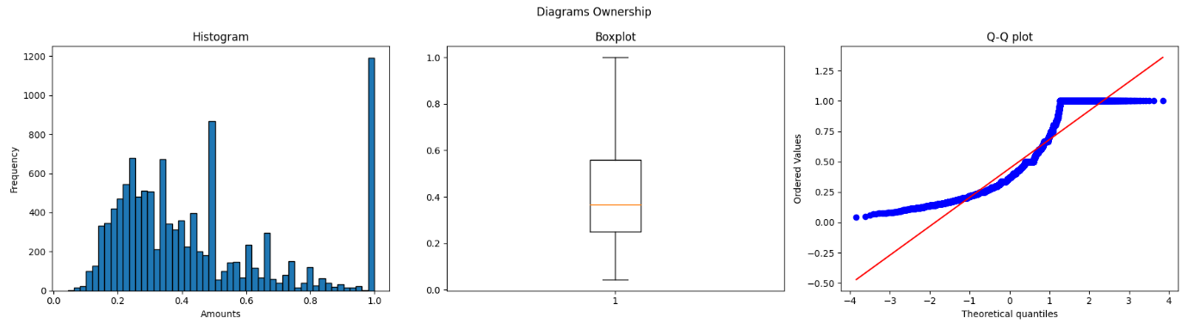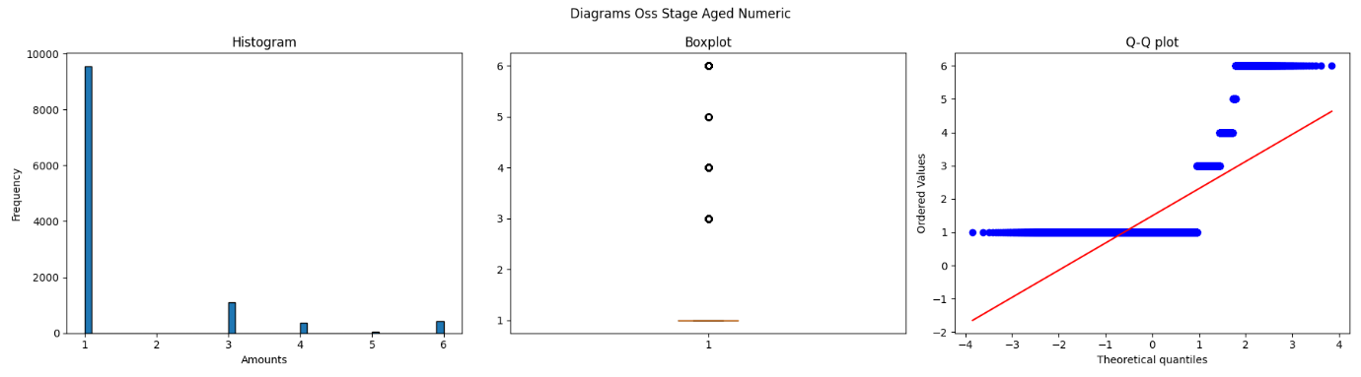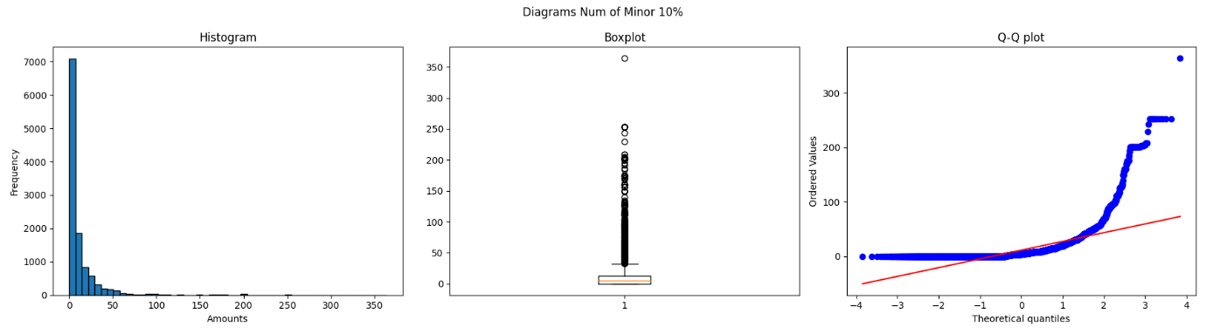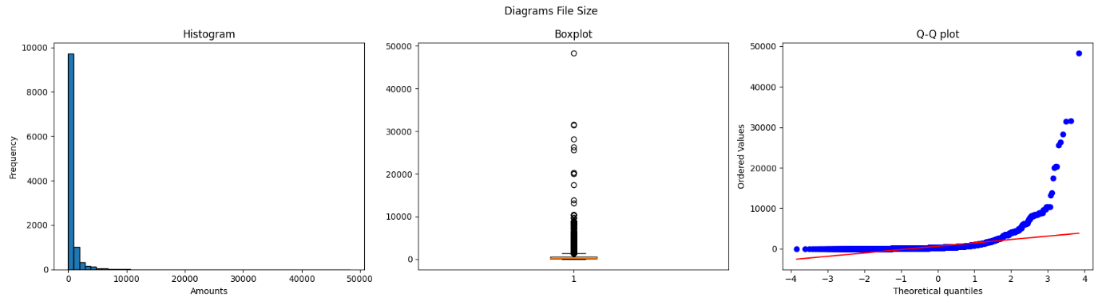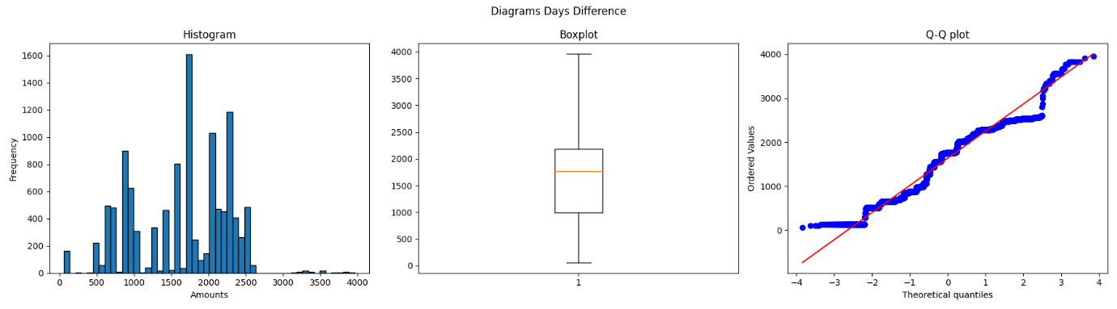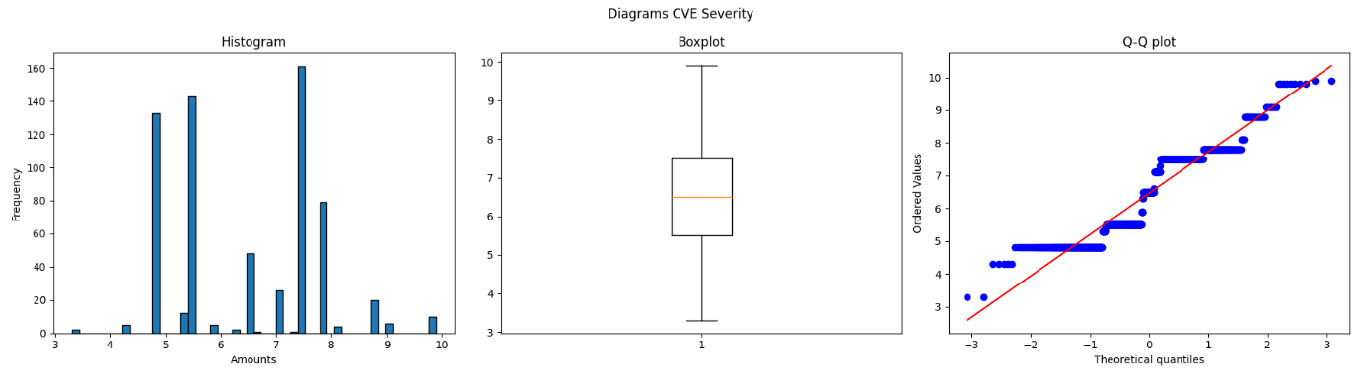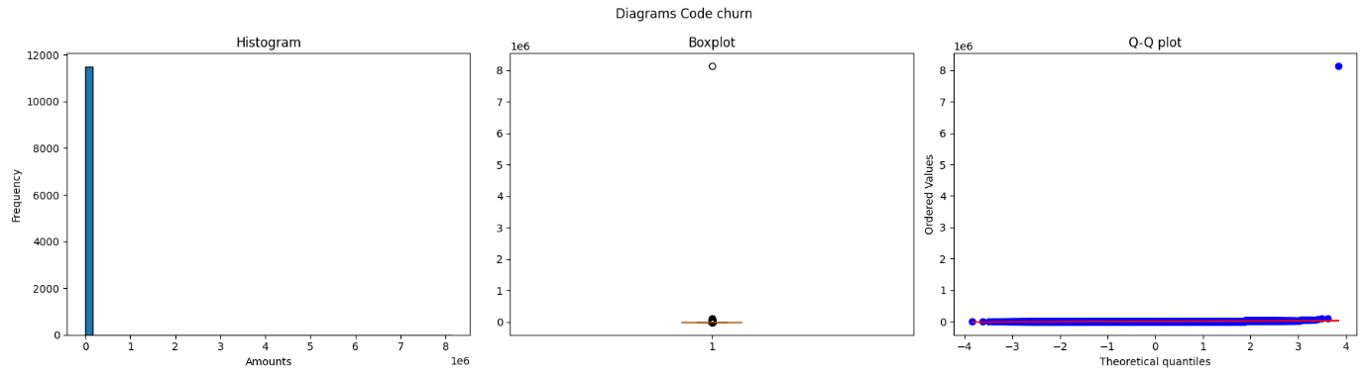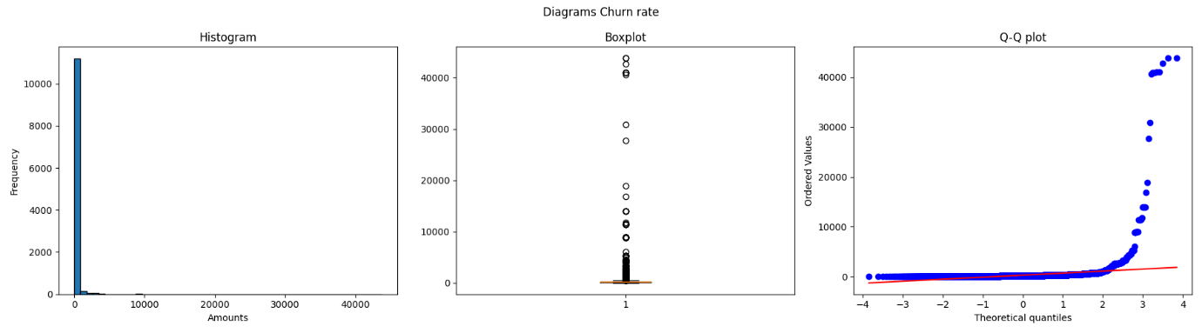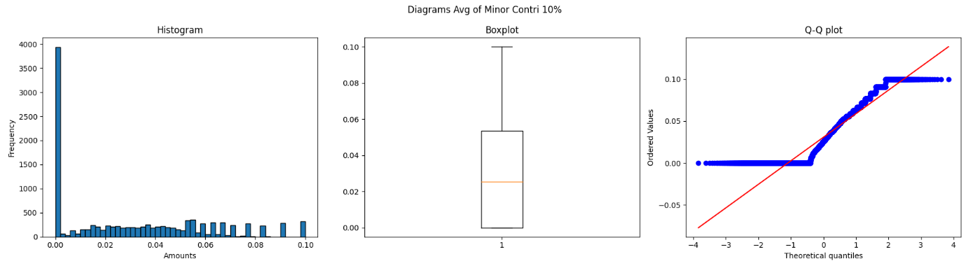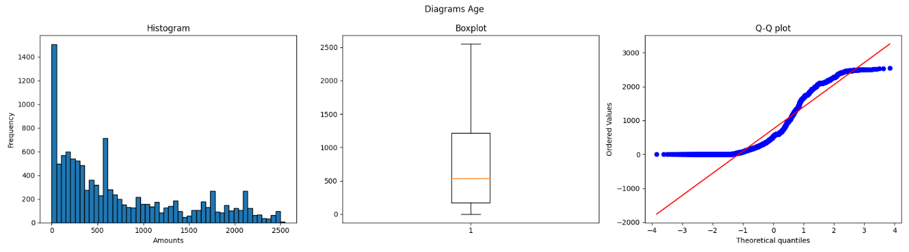

### 3.1.3 Skewness and Kurtosis check

|  |  |  |  |  |  |  |
| --- | --- | --- | --- | --- | --- | --- |
| **Metrics** | **Skewness** | | | **Kurtosis** | | |
| ***Statistics*** | ***Std. Error*** | ***z-value*** | ***Statistics*** | ***Std. Error*** | ***z-value*** |
| CVE Severity | 0.1659 | 0.0955 | 1.7373 | -1.0004 | 0.1910 | -5.2382 |
| Ownership | 0.9957 | 0.0229 | 43.5761 | -0.0209 | 0.0457 | -0.4567 |
| Num of Contributor | 5.3786 | 0.0229 | 232.7788 | 40.9957 | 0.0457 | 897.0388 |
| Num of Minor 10% | 5.3191 | 0.0229 | 232.7788 | 40.1170 | 0.0457 | 877.8117 |
| Per of Minor 10% | -0.2888 | 0.0229 | -12.6392 | -1.6201 | 0.0457 | -35.4499 |
| Avg of Minor Contri 10% | 0.5876 | 0.0229 | 25.7146 | -0.7820 | 0.0457 | -17.1108 |
| Days Difference | -0.2815 | 0.0229 | -12.3203 | -0.6759 | 0.0457 | -14.7900 |
| Age | 0.8587 | 0.0229 | 37.5774 | -0.4880 | 0.0457 | -10.6781 |
| Time Stage Aged Numeric | -0.8369 | 0.0229 | -36.6245 | -0.1359 | 0.0457 | -2.9747 |
| Oss Stage Aged Numeric | 2.5320 | 0.0229 | 110.8056 | 5.7030 | 0.0457 | 124.7880 |
| File Size | 11.2856 | 0.0229 | 493.8879 | 253.9972 | 0.0457 | 5557.7908 |
| Code churn | 106.6004 | 0.0229 | 4665.1112 | 11402.7559 | 0.0457 | 249507.2201 |
| Churn rate | 25.5640 | 0.0229 | 1118.7464 | 758.3895 | 0.0457 | 16594.5545 |

### 3.1.4 Shaprio-Wilk and Kologorow-Smirnow tests

|  |  |  |  |  |
| --- | --- | --- | --- | --- |
| **Metrics** | **Shaprio-Wilk** | | **Kolmogorov-Smirnov** | |
| ***Statistics*** | ***Sig.*** | ***Statistics*** | ***Sig.*** |
| CVE Severity | 0.8971 | 0.0000 | 0.9995 | 0.0000 |
| Ownership | 0.8746 | 0.0000 | 0.5380 | 0.0000 |
| Num of Contributor | 0.5084 | 0.0000 | 0.8737 | 0.0000 |
| Num of Minor 10% | 0.4976 | 0.0000 | 0.6089 | 0.0000 |
| Per of Minor 10% | 0.8113 | 0.0000 | 0.5000 | 0.0000 |
| Avg of Minor Contri 10% | 0.8807 | 0.0000 | 0.5000 | 0.0000 |
| Days Difference | 0.9497 | 0.0000 | 1.0000 | 0.0000 |
| Age | 0.8764 | 0.0000 | 0.9237 | 0.0000 |
| Time Stage Aged Numeric | 0.8495 | 0.0000 | 0.8966 | 0.0000 |
| Oss Stage Aged Numeric | 0.4640 | 0.0000 | 0.8413 | 0.0000 |
| File Size | 0.3893 | 0.0000 | 0.9453 | 0.0000 |
| Code churn | 0.0059 | 0.0000 | 0.9458 | 0.0000 |
| Churn rate | 0.0965 | 0.0000 | 0.8977 | 0.0000 |

## 3.2 Possible Distortion Check

In summary, vulnerability proportion/threshold/locality does not have significant influence on correlation heatmap.

### 3.2.1 Proportion influence

Sample the vulnerable dataset as 10% - 100% to the non-vulnerable dataset.

|  |  |  |  |  |  |  |  |  |  |  |
| --- | --- | --- | --- | --- | --- | --- | --- | --- | --- | --- |
| **Frobenius Norm of Matrix Differences** | | | | | | | | | | |
|  | 10% | 20% | 30% | 40% | 50% | 60% | 70% | 80% | 90% | 100% |
| 10% |  | 0.4925 | 0.6945 | 4.018 | 0.9668 | 1.1172 | 1.1963 | 1.2680 | 1.2731 | 1.4400 |
| 20% |  |  | 0.4184 | 3.92628 | 0.5968 | 0.8514 | 0.8653 | 0.9323 | 0.9202 | 1.1338 |
| 30% |  |  |  | 3.9246 | 0.4991 | 0.5551 | 0.7219 | 0.6567 | 0.7922 | 0.8971 |
| 40% |  |  |  |  | 3.9006 | 3.9386 | 3.918 | 3.9287 | 3.9318 | 3.9357 |
| 50% |  |  |  |  |  | 0.5065 | 0.4408 | 0.5102 | 0.4017 | 0.7171 |
| 60% |  |  |  |  |  |  | 0.4028 | 0.3812 | 0.5271 | 0.4660 |
| 70% |  |  |  |  |  |  |  | 0.4939 | 0.3026 | 0.4382 |
| 80% |  |  |  |  |  |  |  |  | 0.4273 | 0.4149 |
| 90% |  |  |  |  |  |  |  |  |  | 0.4637 |
| 100% |  |  |  |  |  |  |  |  |  |  |

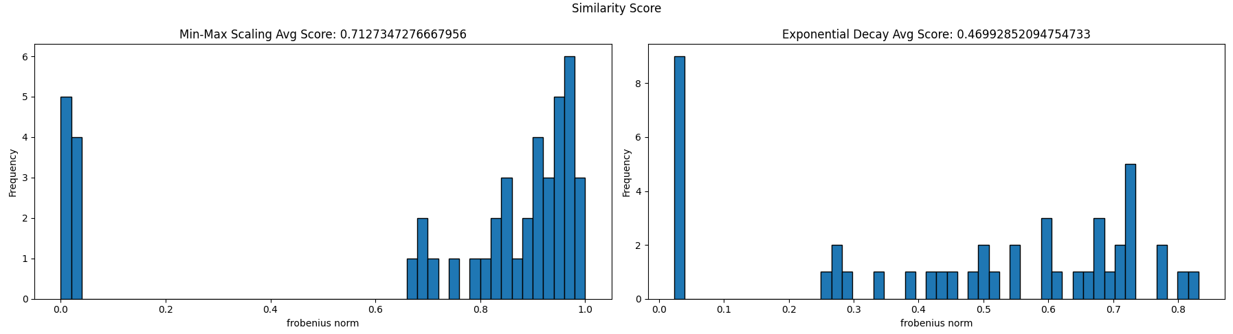

|  |  |  |  |  |  |  |  |  |  |  |
| --- | --- | --- | --- | --- | --- | --- | --- | --- | --- | --- |
| **Mantel Test** | | | | | | | | | | |
|  | 10% | 20% | 30% | 40% | 50% | 60% | 70% | 80% | 90% | 100% |
| 10% |  | 0.9326 | 0.9943 | 0.9885 | 0.9858 | 0.9827 | 0.9790 | 0.9752 | 0.9759 | 0.9736 |
| 20% |  |  | 0.9326 | 0.9316 | 0.9300 | 0.9303 | 0.9294 | 0.9323 | 0.9297 | 0.9258 |
| 30% |  |  |  | 0.9968 | 0.9949 | 0.9931 | 0.9905 | 0.9871 | 0.9886 | 0.9864 |
| 40% |  |  |  |  | 0.9973 | 0.9974 | 0.9963 | 0.9927 | 0.9935 | 0.9919 |
| 50% |  |  |  |  |  | 0.9977 | 0.9965 | 0.9959 | 0.9953 | 0.9953 |
| 60% |  |  |  |  |  |  | 0.9971 | 0.9980 | 0.9968 | 0.9977 |
| 70% |  |  |  |  |  |  |  | 0.9986 | 0.9974 | 0.9978 |
| 80% |  |  |  |  |  |  |  |  | 0.9977 | 0.9988 |
| 90% |  |  |  |  |  |  |  |  |  | 0.9993 |
| 100% |  |  |  |  |  |  |  |  |  |  |

### 3.2.2 Threshold influence

Check the similarity score between each threshold.

|  |  |  |  |  |  |  |  |  |  |  |  |  |
| --- | --- | --- | --- | --- | --- | --- | --- | --- | --- | --- | --- | --- |
| **Threshold vs Is_Defective** | | | | | | | | | | | | |
|  | 5% | | | 10% | | | 20% | | | 50% | | |
|  | Cosine Similarity | K-S Statistics | | Cosine Similarity | K-S Statistics | | Cosine Similarity | K-S Statistics | | Cosine Similarity | K-S Statistics | |
|  | Statistic | P-value | Statistic | P-value | Statistic | P-value | Statistic | P-value |
| 5% |  |  |  | 0.9196 | 0.0769 | 0.9765 | 0.7955 | 0.1282 | 0.5459 | 0.5715 | 0.1538 | 0.3159 |
| 10% |  |  |  |  |  |  | 0.9237 | 0.1025 | 0.8099 | 0.6818 | 0.1538 | 0.3159 |
| 20% |  |  |  |  |  |  |  |  |  | 0.8233 | 0.1282 | 0.5459 |
| 50% |  |  |  |  |  |  |  |  |  |  |  |  |

|  |  |  |  |  |  |  |  |  |  |  |  |  |
| --- | --- | --- | --- | --- | --- | --- | --- | --- | --- | --- | --- | --- |
| **Threshold Difference Check** | | | | | | | | | | | | |
| T | 5% | | | 10% | | | 20% | | | 50% | | |
|  | Cosine Similarity | K-S Statistics | | Cosine Similarity | K-S Statistics | | Cosine Similarity | K-S Statistics | | Cosine Similarity | K-S Statistics | |
|  | Statistic | P-value | Statistic | P-value | Statistic | P-value | Statistic | P-value |
| 5% |  |  |  | 0.9100 | 0.1282 | 0.5459 | 0.7651 | 0.1666 | 0.2296 | 0.5792 | 0.2179 | 0.0489 |
| 10% |  |  |  |  |  |  | 0.9136 | 0.1025 | 0.8099 | 0.7248 | 0.1410 | 0.4221 |
| 20% |  |  |  |  |  |  |  |  |  | 0.8851 | 0.1025 | 0.8099 |
| 50% |  |  |  |  |  |  |  |  |  |  |  |  |

|  |  |  |  |  |  |  |  |  |  |  |  |  |
| --- | --- | --- | --- | --- | --- | --- | --- | --- | --- | --- | --- | --- |
| **Threshold vs CVE Severity** | | | | | | | | | | | | |
|  | 5% | | | 10% | | | 20% | | | 50% | | |
|  | Cosine Similarity | K-S Statistics | | Cosine Similarity | K-S Statistics | | Cosine Similarity | K-S Statistics | | Cosine Similarity | K-S Statistics | |
|  | Statistic | P-value | Statistic | P-value | Statistic | P-value | Statistic | P-value |
| 5% |  |  |  | 0.8872 | 0.1282 | 0.5459 | 0.7028 | 0.1538 | 0.3159 | 0.5393 | 0.1794 | 0.1624 |
| 10% |  |  |  |  |  |  | 0.8906 | 0.1282 | 0.5459 | 0.7166 | 0.1666 | 0.2296 |
| 20% |  |  |  |  |  |  |  |  |  | 0.9090 | 0.1025 | 0.8099 |
| 50% |  |  |  |  |  |  |  |  |  |  |  |  |

### 3.2.3 Locality Clustering influence

Check the similarity between heatmap generated by file component and group component.

|  |  |  |
| --- | --- | --- |
| **Mantel Test** | | |
|  | Group Component | |
|  | Correlation | P-value |
| File Component | 0.8219009665635432 | 0.001 |

## 3.3 Correlation Check

In summary:

* **Check if is defective:** Days Difference, Age
* **Time Stage Aged Numeric**: Num/Per of Minor 10%, Oss Stage Aged Numeric
* **CVE Severity**: Days Difference, Pre-/Post- release, Release Amounts
* **Pre-/Post- vs Code ownership**: No correlation in this case

Between each metric, it seems like they are independent/robust with each other.

### 3.3.1 Correlation

|  |  |  |  |  |  |  |  |  |  |  |  |  |  |  |  |
| --- | --- | --- | --- | --- | --- | --- | --- | --- | --- | --- | --- | --- | --- | --- | --- |
| **Correlation** | | | | | | | | | | | | | | | |
|  | ***Is Defective*** | | | ***Time Stage Aged Numeric*** | | | ***CVE Severity*** | | | ***Pre-release*** | | | ***Post-release*** | | |
| ***P: Pearson***  ***S: Spearman***  ***K: Kendall*** | P | S | K | P | S | K | P | S | K | P | S | K | P | S | K |
| Ownership | -0.12 | -0.10 | -0.08 | -0.73 | -0.62 | -0.50 | -0.03 | -0.07 | -0.05 | 0.05 | 0.03 | 0.03 | -0.04 | -0.03 | -0.03 |
| Num of contributor | 0.16 | 0.22 | 0.19 | 0.38 | 0.70 | 0.58 | 0.11 | 0.08 | 0.06 | -0.06 | -0.06 | -0.05 | 0.04 | 0.07 | 0.05 |
| Num of Minor 10% | 0.16 | 0.23 | 0.20 | 0.36 | 0.64 | 0.53 | 0.12 | 0.09 | 0.06 | -0.06 | -0.06 | -0.05 | 0.04 | 0.07 | 0.06 |
| Per of Minor 10% | 0.23 | 0.23 | 0.20 | 0.64 | 0.63 | 0.52 | 0.06 | 0.07 | 0.05 | -0.09 | -0.06 | -0.05 | 0.07 | 0.07 | 0.06 |
| Avg of Minor Contri 10% | 0.13 | 0.17 | 0.15 | 0.36 | 0.38 | 0.29 | -0.01 | 0.01 | 0.01 | 0.04 | 0.03 | 0.03 | -0.02 | -0.01 | -0.01 |
| Days Difference | -0.81 | -0.92 | -0.82 | 0.22 | 0.32 | 0.25 | 0.45 | 0.44 | 0.35 | -0.63 | -0.69 | -0.58 | 0.66 | 0.72 | 0.61 |
| Age | -0.61 | -0.60 | -0.49 | 0.81 | 0.96 | 0.86 | 0.25 | 0.26 | 0.19 | -0.34 | -0.35 | -0.28 | 0.36 | 0.37 | 0.30 |
| Oss Stage Aged Numeric | 0.25 | 0.28 | 0.27 | -0.58 | -0.59 | -0.51 | -0.02 | -0.02 | -0.02 | 0.01 | -0.11 | -0.11 | -0.06 | -0.11 | -0.05 |
| File Size | 0.14 | 0.40 | 0.33 | 0.17 | 0.25 | 0.19 | 0.10 | 0.16 | 0.12 | 0.03 | 0.06 | 0.05 | 0.03 | 0.05 | 0.04 |
| Code churn | 0.01 | 0.36 | 0.30 | 0.02 | 0.49 | 0.38 | 0.12 | 0.14 | 0.10 | 0.03 | -0.07 | -0.06 | 0.04 | 0.07 | 0.05 |
| Churn rate | -0.01 | -0.00 | -0.00 | 0.09 | 0.45 | 0.36 | 0.06 | 0.01 | 0.01 | 0.04 | 0.01 | 0.00 | 0.04 | 0.03 | 0.03 |
| Is Pre-release | / | / | / | -0.18 | -0.23 | -0.22 | -0.41 | -0.32 | -0.28 | / | / | / | / | / | / |
| Is Post-release | / | / | / | 0.19 | 0.24 | 0.23 | 0.40 | 0.31 | 0.28 | / | / | / | / | / | / |
| Release Amounts | -0.84 | -1.00 | -0.98 | 0.28 | 0.45 | 0.37 | 0.43 | 0.43 | 0.34 | / | / | / | / | / | / |
| Release Amounts Aged | -0.23 | -0.23 | -0.19 | 0.82 | 0.85 | 0.74 | 0.27 | 0.29 | 0.21 | / | / | / | / | / | / |

### 3.3.2 Robustness

|  |  |  |  |  |  |  |
| --- | --- | --- | --- | --- | --- | --- |
| **Robustness (Multiple Linear Regression)** | | | | | | |
|  | R-squared | Adj. R2 | F-statistic | Coefficient | Std err | P-value |
| ***Is Defective*** | | | | | | |
| Days Difference | 0.659 | 0.659 | 4.582e+04 | -0.0005 | 2.51e-06 | 0.000 |
| Days Difference (controlled by Classic metrics) | 0.665 | 0.665 | 1.572e+04 | -0.0005 | 2.5e-06 | 0.000 |
| Age | 0.367 | 0.367 | 1.373e+04 | -0.0003 | 2.77e-06 | 0.000 |
| Age (controlled by Classic metrics) | 0.388 | 0.388 | 5020. | -0.0003 | 2.72e-06 | 0.000 |
| ***Time Stage Aged Numeric*** | | | | | | |
| Num of Minor 10% | 0.131 | 0.131 | 1734. | 0.0190 | 0.000 | 0.000 |
| Per of Minor 10% | 0.413 | 0.413 | 8099. | 1.9658 | 0.022 | 0.000 |
| Per of Minor 10%  (controlled by Classic metrics) | 0.416 | 0.415 | 2723. | 2.0164 | 0.023 | 0.000 |
| Oss Stage Aged Numeric | 0.332 | 0.332 | 5715. | -0.5741 | 0.008 | 0.000 |
| Oss Stage Aged Numeric  (controlled by Classic metrics) | 0.347 | 0.347 | 2033. | -0.5628 | 0.008 | 0.000 |
| Per of Minor 10% (combined with Oss Stage Aged Numeric) | 0.553 | 0.552 | 7093. | 1.1372 | 0.027 | 0.000 |
| ***CVE Severity*** | | | | | | |
| Days Difference | 0.202 | 0.201 | 222.7 | 0.0021 | 0.000 | 0.000 |
| Days Difference (controlled by Classic metrics) | 0.203 | 0.200 | 74.64 | 0.0020 | 0.000 | 0.000 |
| Age | 0.060 | 0.059 | 56.50 | 0.0005 | 6.06e-05 | 0.000 |
| Days Difference (controlled by Minor) | 0.202 | 0.200 | 111.4 | 0.0020 | 0.000 | 0.002 |

# 4 Problems and Further

## 4.1 Problems

* With the newly fetch data from NVD, when I move to the correlation analysis between metrics and CVE Severity, it shows that there is no correlation between CVE Severity and any metric, which is significant different from the results from origin dataset. While, only 400+ entries are updated in the new dataset (1200+ in total).
* The definition of the OSS Stage metric. I just randomly assign the stage with numeric value, but it seems like there are some correlations.
* Non-vulnerable dataset source and definition.
* Is there any point of the metric needed to be re-defined/added? Like adding `Major` attribute.

## 4.2 Further

* Prediction?
* The reasons that affect or cause minor?
* Correlation between metrics? (Paper: Effects of measurements on correlations of software code metrics)