檔名記得加上學號

Name: 陳冠軒

Student ID: 4107062045

* **Please show both the result of *find* and your program to prove the correctness. (refer to p.16 of the slide)**
* **Without the result of *find*, get no score.**

1. (35%) Snapshot of searching ‘*passwd*’ at root directory

* Your program

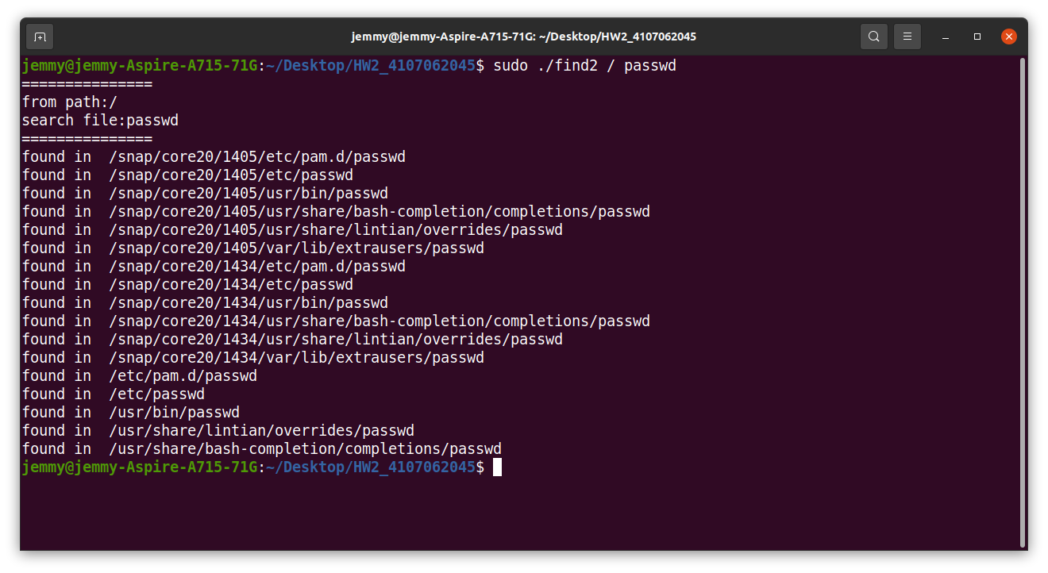

* By *find*

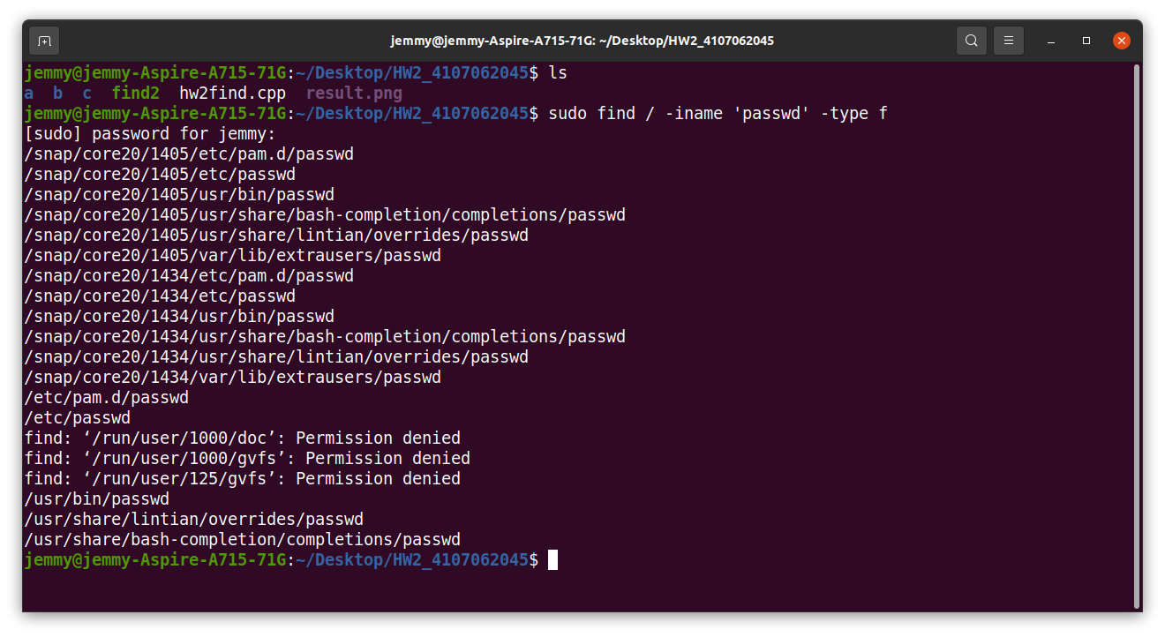

1. (35%) Snapshot of searching ‘*passwd’* at default directory (current directory)
   * Your program

* By *find*

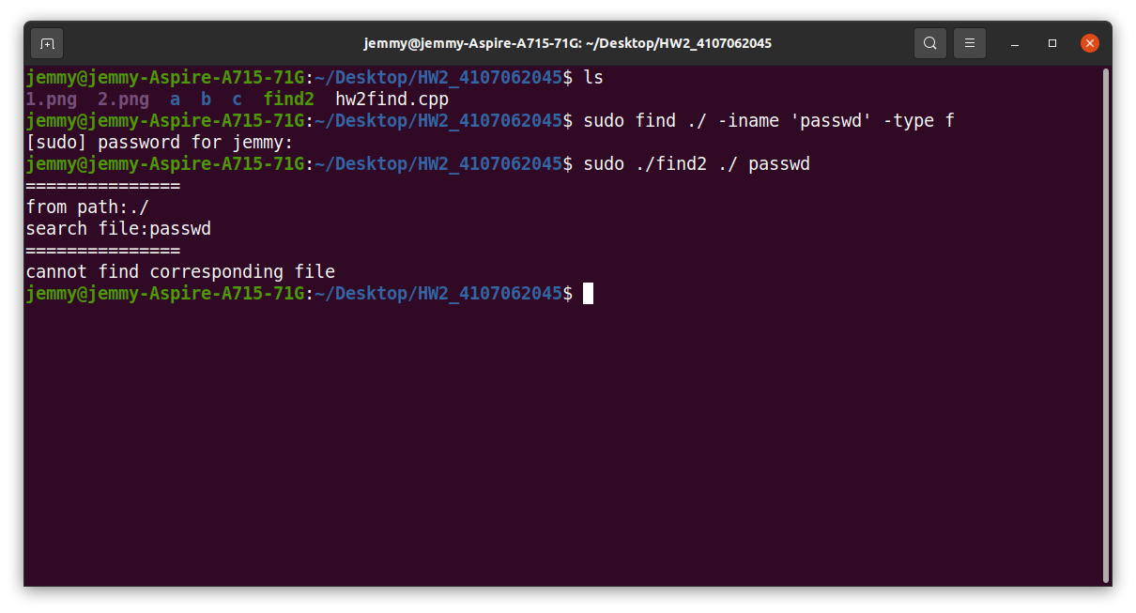

1. (30%) Briefly describe your design.