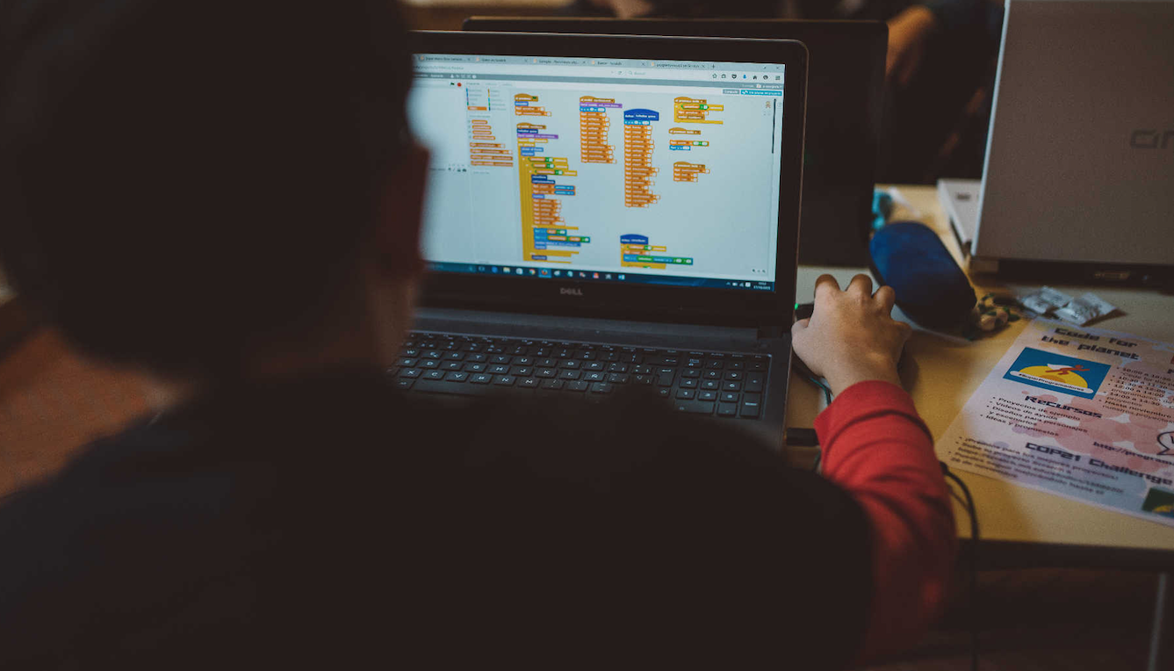
Call for Papers
FLOSS education and computational thinking workshop
@ OSS 2016
This workshop is co-located with the 12th International Conference on Open Source Systems, which will take place 30 May - 02 June 2016 in Gothenburg, Sweden's second biggest city.
Main Workshop Topics

The topics of interest of this workshop include but are not limited to:

- Teaching experiences with FLOSS/free content

- FLOSS in higher education

- FLOSS in K-12

- FLOSS practices in education

- FLOSS in the curriculum

- Computational thinking teaching and FLOSS

Important dates:

March 15 | Deadline for papers
April 05 | Notification of acceptance to authors
April 15 | Early bird registration for workshops
April 27 | Camera ready version due
June 02 | Workshop
More information at http://jemole.me/2016-OSSEduWorkshop/
Venue:

The conference venue is Lindholmen Conference Center, an internationally renowned Science Park in the fields of intelligent transport systems, mobile internet and media.
Submissions:

- Papers: 4 to 8 pages, comform to the Springer Formatting Guidelines (LNCS).
- All submissions will be peer-reviewed single blinded.
- Proceedings will be published in the website.
- Authors will keep the copyright of their work.

