**DATABASE SCHEMA OF TASK MANAGEMENT SYSTEM**

**USER TABLE**

user_id INT PK

fullname VARCHAR

address VARCHAR

username VARCHAR

password VARCHAR

department_id INT

usertype VARCHAR

**LOG TABLE**

log_id INT PK

user_id INT

logdetails VARCHAR

logdate VARCHAR

**DEPARTMENT TABLE**

department_id INT PK

departmentname VARCHAR

**ACTIVITY TABLE**

activity_id INT PK

user_id INT

activitydetails VARCHAR

activitydate VARCHAR

**TASK TABLE**

task_id INT PK

taskdetails VARCHAR

difficultylevel VARCHAR

prioritylevel VARCHAR

assigned_user_id INT

status VARCHAR

createdate VARCHAR

completiondate VARCHAR

**USER TABLE**

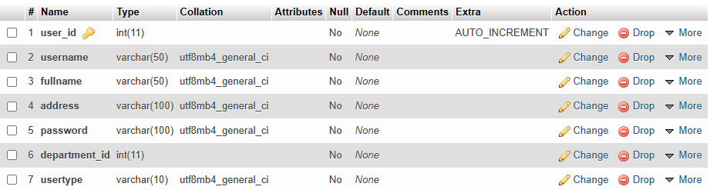

**TASK TABLE**

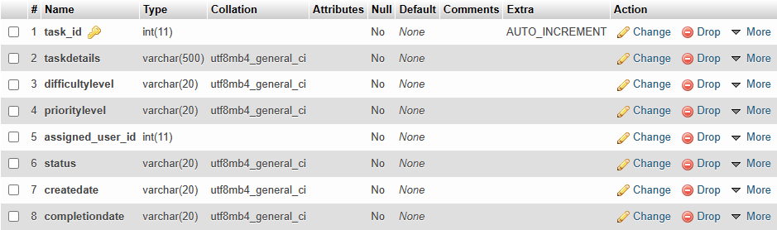

**ACTIVITY TABLE**

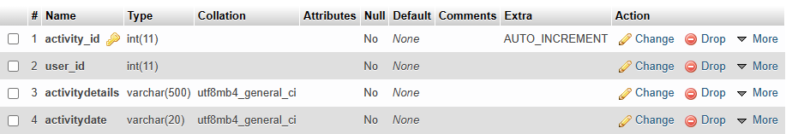

**LOG TABLE**

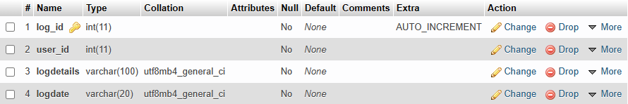

**DEPARTMENT TABLE**

