Testing the Atlassian Rovo MCP Server with MCP Inspector
A setup and verification manual for Jira and Confluence integrations in VS Code. Written for Windows with PowerShell. July 2026.
1. Purpose and scope
This manual covers running MCP Inspector, connecting it to the Atlassian Rovo MCP Server, and verifying Jira and Confluence tools before wiring the server into VS Code. The Rovo server is hosted by Atlassian, so there is nothing to install on the server side. Inspector acts as a stand-in MCP client: it speaks the same protocol VS Code will use, which makes it the right place to debug authentication, list tools, and exercise calls in isolation.
2. Prerequisites
Requirement | Detail
Node.js 22.7.5 or later | Current Inspector releases require it. Check with node --version in PowerShell.
Atlassian Cloud site | With Jira and Confluence enabled. The hosted server does not cover Data Center.
A browser | Completes the OAuth 2.1 consent flow against your Atlassian account.
Free ports 6274 and 6277 | Defaults for the Inspector web UI and its proxy. Both can be changed.
VS Code, current release | Native MCP client support, used in Part 5 once testing passes.

3. How the pieces fit
Inspector runs two local processes. A browser UI on port 6274 is where you work. A proxy on port 6277 holds the actual MCP session and forwards traffic to the Rovo endpoint over Streamable HTTP. The proxy can also spawn local server processes, which is why it authenticates every request with a session token and binds to localhost only. Never set DANGEROUSLY_OMIT_AUTH: a browser tab on a malicious page could otherwise reach the proxy and, through it, your machine (CVE-2025-49596).
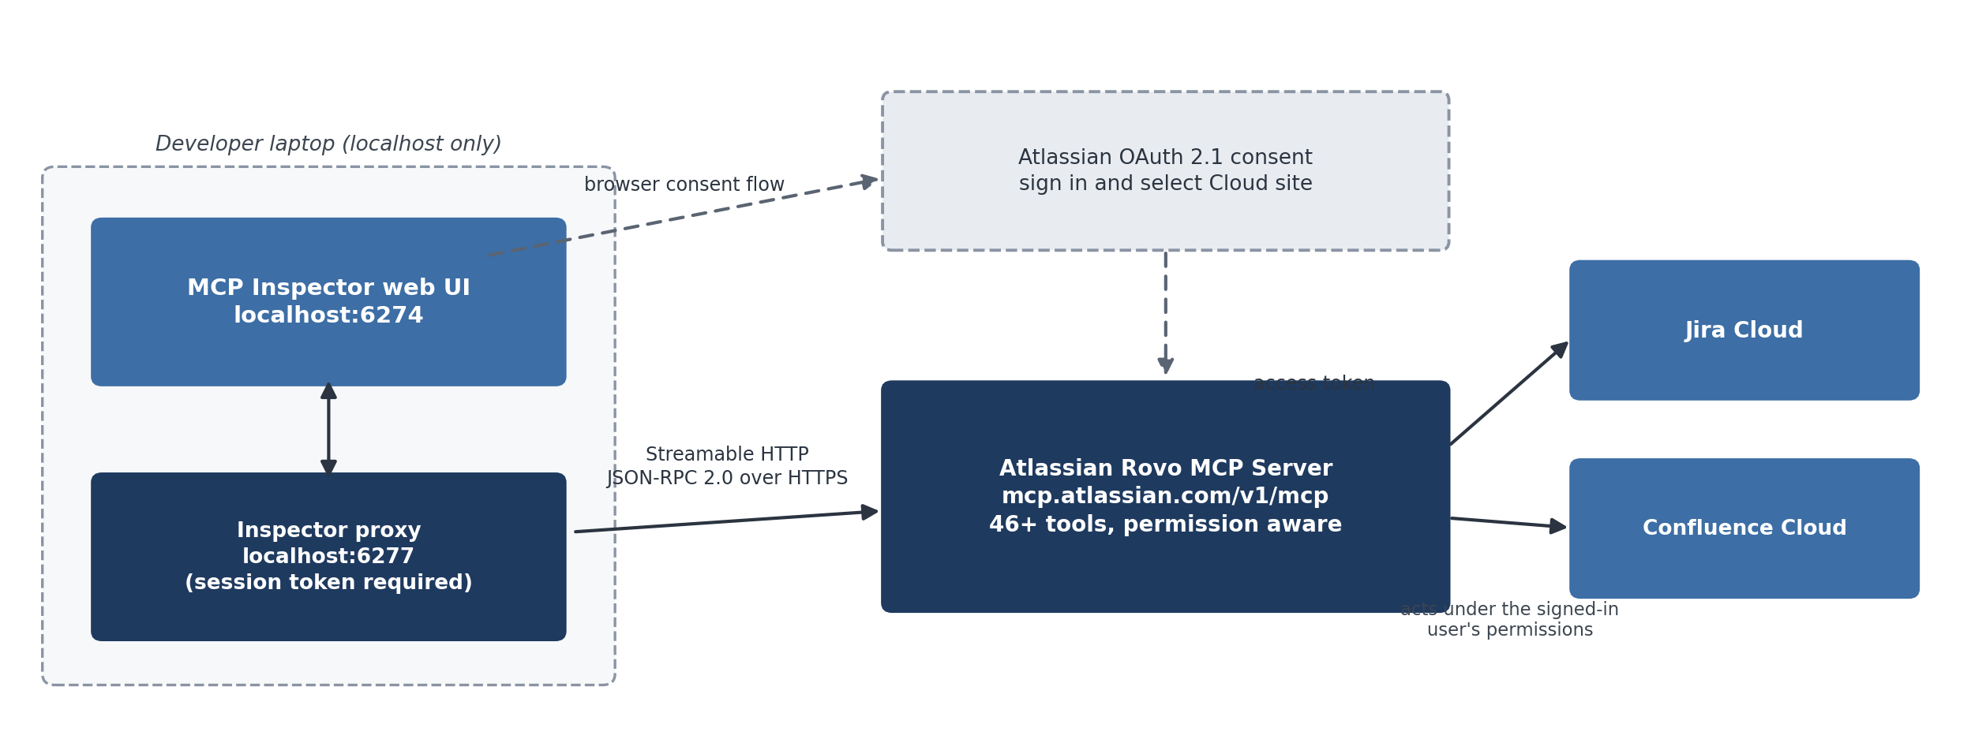
Figure 1. Test topology. The Inspector proxy holds the MCP session; Rovo enforces Atlassian permissions on every tool call.
4. Part 1: Launch MCP Inspector
There is no permanent install. From PowerShell:
npx @modelcontextprotocol/inspector
npx fetches the current release on first run and starts both processes. The console prints output similar to:
Starting MCP inspector...
Proxy server listening on 127.0.0.1:6277
Session token: 3a1c267fad21f7150b7d624c160b7f09b0b8c4f6...
Open inspector with token pre-filled:
http://localhost:6274/?MCP_PROXY_AUTH_TOKEN=3a1c267f...
Open the pre-filled link. If you open http://localhost:6274 without it, paste the token into the Configuration panel before connecting. If either port is taken, override both before launch:
$env:CLIENT_PORT="8080"; $env:SERVER_PORT="9000"; npx @modelcontextprotocol/inspector
5. Part 2: Connect to the Rovo server
- In the sidebar, set Transport Type to Streamable HTTP.
- Set the URL to https://mcp.atlassian.com/v1/mcp and select Connect. Do not use the older /v1/sse address; Atlassian retired that transport after June 30, 2026. Atlassian's OAuth guide now points custom clients at https://mcp.atlassian.com/v1/mcp/authv2, so if authorization stalls on the plain endpoint, retry with that URL.
- The server answers with an authentication challenge and Inspector opens the Atlassian consent screen in your browser. Sign in, pick the Cloud site that holds your Jira and Confluence content, and grant access. Tokens are scoped to that site, so selecting the wrong one is the most common reason later searches come back empty.
- Back in Inspector, the status turns Connected and the server capabilities appear in the sidebar.
Headless alternative. If your organization admin has enabled API token authentication, you can skip the consent screen: create a personal token at id.atlassian.com, base64 encode email:token, and supply an Authorization header of Basic <encoded> through the sidebar's authentication fields. In PowerShell:
[Convert]::ToBase64String([Text.Encoding]::UTF8.GetBytes("you@example.com:YOUR_API_TOKEN"))
Service account keys use Bearer <key> instead. The auth method changes the tool set: Jira Service Management and Bitbucket tools appear only with API tokens, while Compass tools require OAuth.
6. Part 3: Verify Jira and Confluence tools
- Open the Tools tab and select List Tools. Rovo exposes roughly 46 tools across Jira, Confluence, and related products; the exact set depends on your auth method, granted scopes, and the permission groups your admin enabled. Names follow a product-plus-verb pattern, for example searchJiraIssuesUsingJql.
- Start with a read. Select the JQL search tool, enter a query such as project = SAND ORDER BY created DESC with a small result cap, and run it. Confirm the response matches what the same query returns in Jira's own issue search. Repeat on the Confluence side with a page search or fetch.
- Inspect the wire format. The History pane keeps every JSON-RPC request and response; expand a call to see the exact parameter names and result schema your VS Code agent will receive. This is the fastest way to catch schema surprises before an agent hits them.
- Then one controlled write. Create a single issue in a sandbox project or a page in a personal space, verify it in the product, and confirm the matching entry in your organization's audit log if you have access. Rovo runs every call under your own Atlassian permissions, so a write your account cannot perform in the product will fail here too, which is the correct behavior.
- Check the other primitives. The Resources and Prompts tabs list whatever the server implements; an empty list there means the server does not publish that primitive and is not an error.
If long JQL queries time out, raise the request timeout under Configuration in the UI.
7. Part 4: Repeatable checks from the command line
Once the UI session works, freeze the connection details in a config file so a retest is one command. Save mcp-config.json:
{
"mcpServers": {
"atlassian": {
"type": "streamable-http",
"url": "https://mcp.atlassian.com/v1/mcp"
}
}
}
Launch the UI against it, or drop the UI entirely with CLI mode, which prints JSON and returns exit codes a CI runner can gate on:
npx @modelcontextprotocol/inspector --config mcp-config.json --server atlassian
npx @modelcontextprotocol/inspector --cli --config mcp-config.json --server atlassian --method tools/list
npx @modelcontextprotocol/inspector --cli --config mcp-config.json --server atlassian `
--method tools/call --tool-name <name> --tool-arg key=value
Interactive OAuth does not fit a headless run, so pair CLI mode with API token authentication, or keep OAuth testing in the UI. Flags change between releases; npx @modelcontextprotocol/inspector --help shows the current set.
8. Part 5: Wire the validated server into VS Code
Create .vscode/mcp.json in your workspace, or add the same block to your user-level MCP configuration to cover all workspaces:
{
"servers": {
"atlassian": {
"type": "http",
"url": "https://mcp.atlassian.com/v1/mcp"
}
}
}
Run MCP: List Servers from the Command Palette, start the atlassian entry, and complete the same Atlassian consent flow. The Jira and Confluence tools then show up in the agent mode tools picker in Copilot Chat. Atlassian also ships a gallery entry: searching @mcp Atlassian in the Extensions view installs the same server without a config file. Because Inspector already proved the endpoint, the auth flow, and the tool behavior, anything that fails at this stage is VS Code configuration rather than the server.
9. Troubleshooting
Symptom | Likely cause and fix
401 Unauthorized on connect or mid-session | OAuth token expired or was revoked; reconnect to repeat the consent flow. For Basic auth, confirm the admin has enabled API token authentication.
Errors mentioning /v1/sse or SSE | A leftover legacy configuration. That transport was retired after June 30, 2026; point everything at /v1/mcp.
UI loads but every action is rejected | Proxy session token missing. Reopen the token pre-filled URL printed in the console.
Port 6274 or 6277 already in use | Set $env:CLIENT_PORT and $env:SERVER_PORT before launching, as in Part 1.
An expected tool is missing from List Tools | Auth method or admin permission groups. JSM and Bitbucket need API tokens; Compass needs OAuth. List again after changing auth.
OAuth succeeds but tool calls fail from the office network | Rovo evaluates tool calls against your organization's Atlassian IP allowlists even when consent was granted elsewhere. Have the admin add the egress IP.
Verified against the MCP Inspector README and npm page (modelcontextprotocol/inspector) and Atlassian's Rovo MCP Server documentation: getting started, OAuth 2.1, API token authentication, and the SSE deprecation notice. Current as of July 14, 2026.

