Addendum 1: Architecture Diagrams
Monitoring and Observability for AI Workflows at CNB, Draft Architecture v0.1
Draft for discussion. Prepared by Muntaser Syed, September 16, 2026. Components, interfaces, and verification are as stated in the main document; this addendum adds the high level views for presentation and review.
Figure A1 is the one page view of the recommended architecture. It keeps the three bands of the main document (traffic classes, CNB control points, shared telemetry pipeline), places the RBC platform on the left as a black box, and shows the traffic that crosses the boundary today together with the four interfaces CNB requests from RBC.
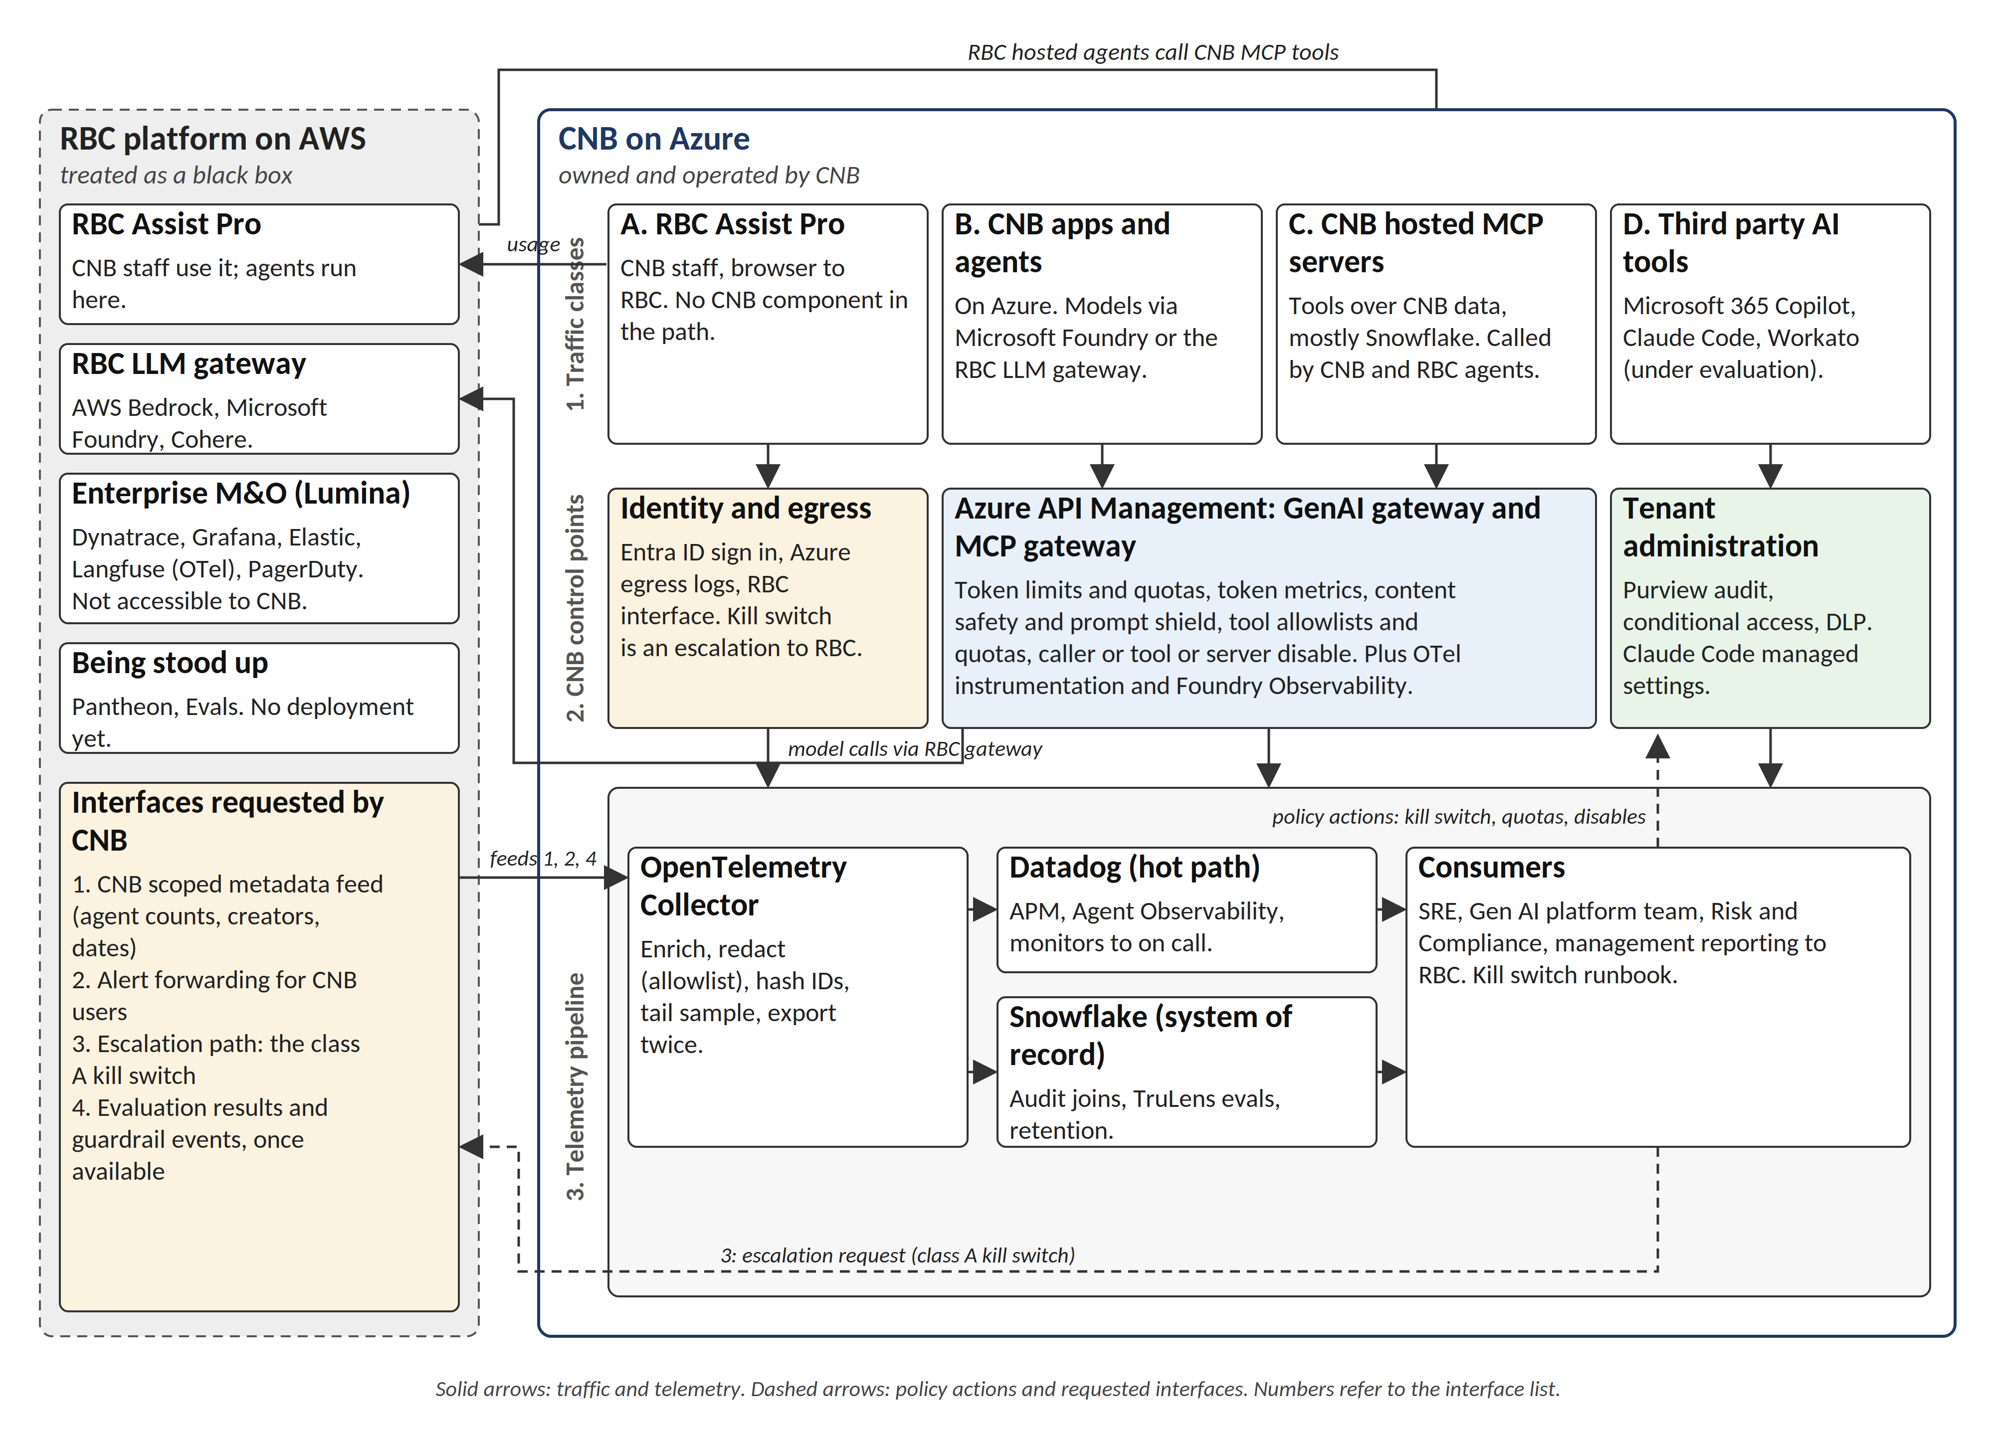
Figure A1. High level architecture: CNB owned control points and telemetry pipeline on Azure, the RBC platform on AWS as a black box, and the traffic and interface flows between them.

CNB to RBC interaction model
Figure A2 isolates the boundary. Rows pair the two sides where a direct relationship exists: CNB staff to RBC Assist Pro (usage), Azure API Management to the RBC LLM gateway (model calls), and, from RBC hosted agents, tool calls into the APIM MCP gateway in front of CNB tools. The dashed arrows are the four interfaces requested in section 3 of the main document; interface 3 is the only kill switch available for class A until the RBC operating model defines one. The two note boxes record the position established in discovery and should be revised as that operating model takes shape.
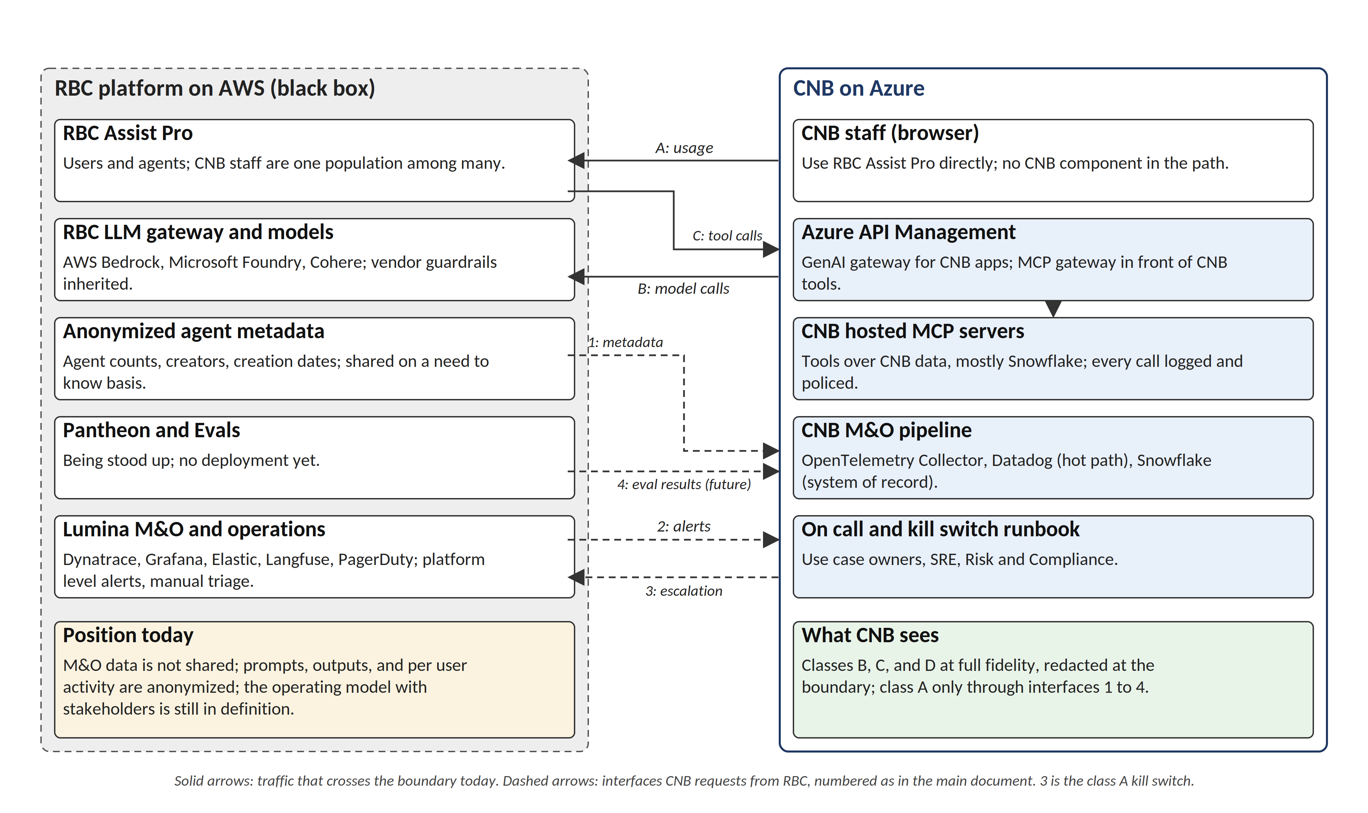
Figure A2. Interaction model: what crosses the CNB to RBC boundary today (solid) and what CNB requests (dashed), with each side's current position.

Policy loop and kill switch
Figure A3 shows the loop that turns monitoring into control. Steps 1, 2, and 5 run in the shared pipeline; step 3 is a human decision with a named authority and a reversal procedure; step 4 executes at the control point for the class. The loop is the same for every class and only step 4 differs. It can close in near real time for classes B, C, and D because CNB owns both the signals and the actions; for class A, step 4 is a request to RBC and the loop closes at the cadence RBC supports.
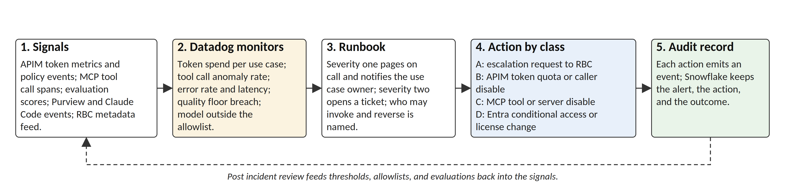
Figure A3. Policy loop: signals, monitors, runbook, action by class, and audit record, with post incident review feeding thresholds and evaluations back into the signals.

How the diagrams map to the main document
Figure | Shows | Main document sections
A1 | Recommended architecture on one page: traffic classes, control points, pipeline, RBC black box, interfaces. | 2 (principles), 3 (reference architecture), 5 (alternatives)
A2 | Boundary view: traffic crossing today, requested interfaces, current position on each side. | 1 (scope), 3 (RBC interfaces), 8 (assumptions)
A3 | Policy loop from signal to action to audit record; where the kill switch lives per class. | 4 (telemetry pipeline), 6 (operating model)

Use notes. A1 is the slide for leadership and RBC counterparts. A2 is the working diagram for the operating model discussion with the RBC AI Group and Khaled's team, since it names each request and the position it changes. A3 is the reference for the runbook drill in Phase 2. All three are generated from the same component list as the main document and will be regenerated with it.

