Monitoring and Observability for AI Workflows at CNB
Draft Architecture
Draft v0.1 for discussion. Prepared by Muntaser Syed, September 16, 2026. Scope: AI workflows originating from CNB. RBC platform components are treated as a black box.

1. Purpose and scope
This document proposes a CNB owned monitoring and observability (M&O) architecture for AI workflows that originate from CNB, whether as a direct model request, a Model Context Protocol (MCP) tool call, or an agentic request. It responds to the position established in discovery with the RBC AI Group: CNB cannot access or consume the enterprise M&O tooling that Lumina operates (Dynatrace, Grafana, and Elastic for monitoring, Langfuse on OpenTelemetry for observability, PagerDuty for alerting); RBC Assist data is anonymized so that only agent level metadata is visible; reports are provided on an as needed basis; and the operating model between the RBC team and its stakeholders is still being defined. Pantheon and Evals on the RBC side are being stood up, with no deployment yet. CNB therefore needs its own capability, built where CNB has control, with a defined interface to RBC for everything CNB cannot see.
Four workflow classes are in scope:
- A. RBC Assist Pro used by CNB staff.
- B. CNB built applications and agents on Azure that call models through Microsoft Foundry or through the RBC LLM gateway.
- C. MCP servers hosted by CNB and called by agents, whether those agents run at CNB or on the RBC platform.
- D. Third party AI tools used by CNB staff: Microsoft 365 Copilot, Claude Code, and Workato, which is under evaluation rather than adopted.
The requirements come from the problem statement recorded in the working session: different jurisdictional requirements between CNB and RBC; building only what the enterprise has not already built; monitoring the risk that comes with widespread deployment of RBC Assist Pro; proactive, near real time prompt observability; an agent kill switch; visibility into tool calling, including terminating a process when token consumption crosses a threshold; and a clear statement of CNB's own architecture and of the superset of risks CNB is subject to.
Out of scope: the internal design of RBC Assist Pro, the RBC LLM gateway, and the Lumina toolchain, which appear only as a black box with named interfaces; MLOps for classical models; replacement of enterprise incident processes; and an obligation by obligation regulatory mapping, produced separately with Risk and Compliance. The audience is CNB Gen AI leadership, the platform teams that would build the capability, Risk and Compliance, and the RBC counterparts who will define the interface.

2. Design principles
Observe what CNB owns, meter what CNB routes, contract for what CNB cannot see. Each workflow class is assigned one control point where policy is enforced and telemetry is emitted. Where CNB has no control point (class A), the design names the interface CNB asks RBC to provide instead of implying visibility into traffic CNB cannot reach.
Standards first. Instrumentation uses OpenTelemetry (OTel) and its Generative AI semantic conventions, so the same span shape describes a Bedrock call, an Azure OpenAI call, and a Cohere call, and so the hot path platform can change without re-instrumenting applications. The GenAI conventions are still marked Development rather than Stable, so instrumentation pins a convention version and the collector normalizes older attribute names.
Policy is telemetry. Every enforcement action (a token limit rejection, a blocked tool, a disabled agent) emits an event into the same pipeline as ordinary traces, so the audit trail records what the controls did and not only what the models did.
Redact at the boundary. Prompts and completions are not captured by default; the OTel conventions themselves default to not recording them. Where a use case justifies content capture, it is opted in per application, redacted and attribute allowlisted in the collector before export, and stored under restricted access with retention set by records policy rather than by tool defaults.
Reuse the estate. Azure services CNB already runs, Datadog for the operational hot path, and Snowflake as the system of record. A new vendor enters only through the alternatives in section 5 and only with a stated reason.
Black box RBC. RBC components appear once in the design, as a boundary with four interfaces: a CNB scoped metadata feed, alert forwarding, an escalation path, and eventual evaluation results. Nothing in the CNB architecture depends on RBC internals.

3. Reference architecture
Figure 1 shows the three bands of the design: where CNB AI traffic originates, the CNB control point for each class, and the shared telemetry pipeline that every class feeds. Table 1 summarizes what each control point can observe and enforce.
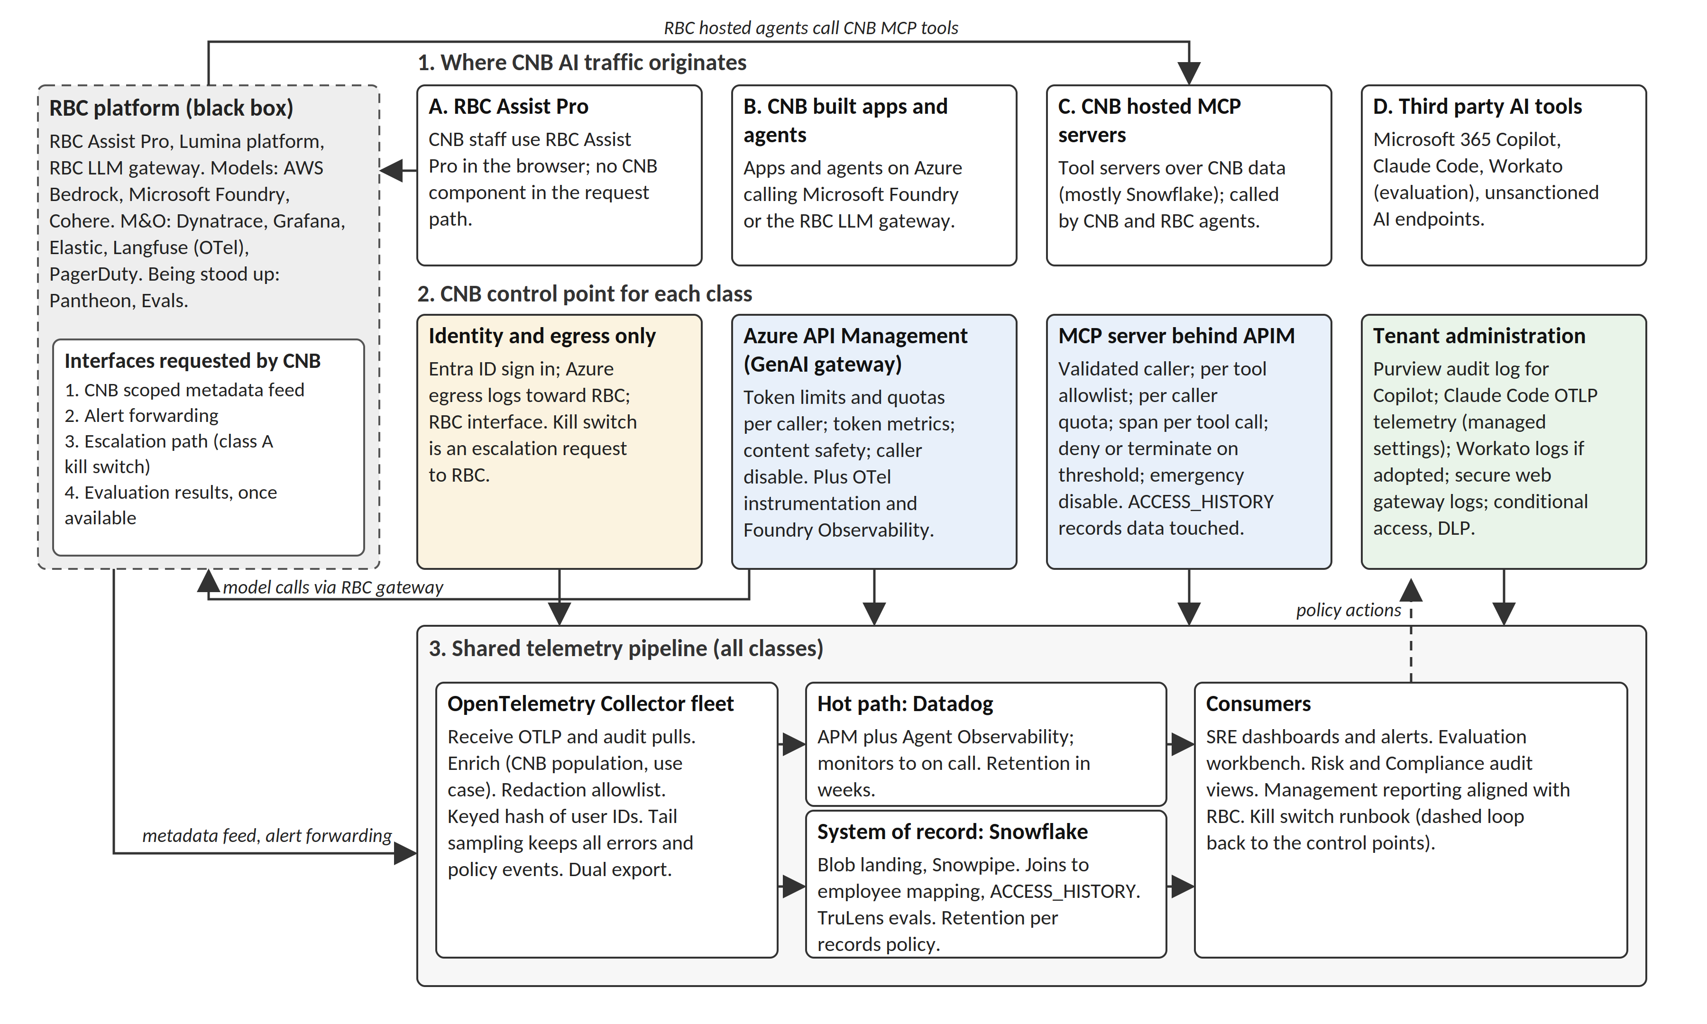
Figure 1. Reference architecture: traffic classes, CNB control points, shared pipeline, and the RBC black box with its four interfaces.
Class | CNB control point | Observable | Enforceable
A. RBC Assist Pro | None in the request path. Entra ID sign in, Azure network egress toward RBC, and the RBC interface. | RBC provided metadata (agent counts, creators, creation dates, usage counts); CNB egress flow volumes; who signed in and when. | Access control through identity. Escalation to RBC operations, which stands in for a kill switch until the RBC operating model defines one.
B. CNB built apps and agents | Azure API Management (APIM) as the GenAI gateway in front of Microsoft Foundry and the RBC gateway; OTel instrumentation in the application; Foundry Observability. | Full traces per request: model, provider, tokens, latency, errors, tool calls, cost. Prompts and completions only where opted in. | Token rate limits and quotas per caller (llm-token-limit), token metrics per consumer (llm-emit-token-metric), content safety and prompt shield checks (llm-content-safety), disable by application or agent identity, circuit breaker.
C. CNB hosted MCP servers | The MCP server itself, fronted by APIM, which exposes and governs MCP tool servers with authentication and rate limits. | Every tool invocation with caller identity, tool name, argument shape (redacted), result size, latency, and the Snowflake objects the call touched (ACCESS_HISTORY join). | Per tool allowlists, per caller quotas, content safety checks on tool call arguments and responses (llm-content-safety), deny and terminate on threshold, emergency disable of a tool or a server.
D. Third party tools | Tenant administration. | Copilot interactions from the Purview audit log (user, time, app, files touched with sensitivity labels); Claude Code metrics, events, and optional traces over OTLP; Workato job history and audit logs if adopted; secure web gateway logs for unsanctioned AI endpoints. | Conditional access, DLP and sensitivity labels, tenant policy, network blocks. Claude Code telemetry enforced centrally through managed settings distributed by MDM.
Table 1. Control tiers: what CNB can observe and enforce in each workflow class.
Band 3 is common to all classes. An OpenTelemetry Collector fleet on Azure (AKS or Container Apps, two or more instances behind an internal load balancer) receives OTLP from applications, APIM, MCP servers, and Claude Code, and applies the redaction, allowlisting, sampling, and enrichment processors described in section 4 before exporting twice: to Datadog for the hot path and to Azure Blob Storage for Snowflake. Batch records that are already structured, the Purview audit log and the RBC metadata feed, load to Snowflake directly.
Datadog is the operational hot path: APM for CNB services, Agent Observability (named LLM Observability in older documentation) for the GenAI spans, which Datadog maps from the OTel gen_ai attributes to its own schema for latency, tokens, cost, model, and provider, and monitors that route to the on call tool. Foundry Observability, which publishes evaluation results, traces, token usage, and quality metrics to Application Insights, stays the developer facing view for class B and the fallback hot path if Datadog coverage turns out thin (section 8).
Snowflake is the system of record. Telemetry lands in Azure Blob Storage and loads through Snowpipe, triggered by Event Grid notifications, into a dedicated observability schema. There it joins the CNB employee mapping (the population isolation already done once for RBC Assist), the use case registry, and Snowflake's own ACCESS_HISTORY view, which records per statement which tables and columns each user or service account read. That join answers a question no gateway can: which data an agent actually touched. Snowflake AI Observability, built on the TruLens SDK, stores traces and evaluation results in AI_OBSERVABILITY_EVENTS and provides batch LLM judge metrics such as groundedness and context relevance plus live runs for production monitoring, so CNB has an evaluation store now instead of waiting for RBC Evals. Unredacted fields in that table sit behind a dedicated account privilege, which matches the redact at the boundary principle.
The RBC black box sits at the left of Figure 1. Class A traffic flows into it from CNB browsers; class B traffic flows into it from APIM when the RBC gateway is the model provider; RBC hosted agents flow out of it into class C MCP servers. Four interfaces are requested from RBC, in order of value: (1) a CNB scoped metadata feed at a defined cadence, filtered by the CNB employee mapping and carrying at least the fields RBC already shares; (2) forwarding of platform alerts that affect CNB users into the CNB on call tool; (3) an escalation path with a named owner and a response target for disabling an agent or a user at CNB's request; (4) evaluation results and guardrail events once Pantheon and Evals are in production. Item 3 is what a kill switch means for class A today.

4. Telemetry pipeline
Figure 2 shows the pipeline from instrumentation to consumption, with the policy loop that closes it.
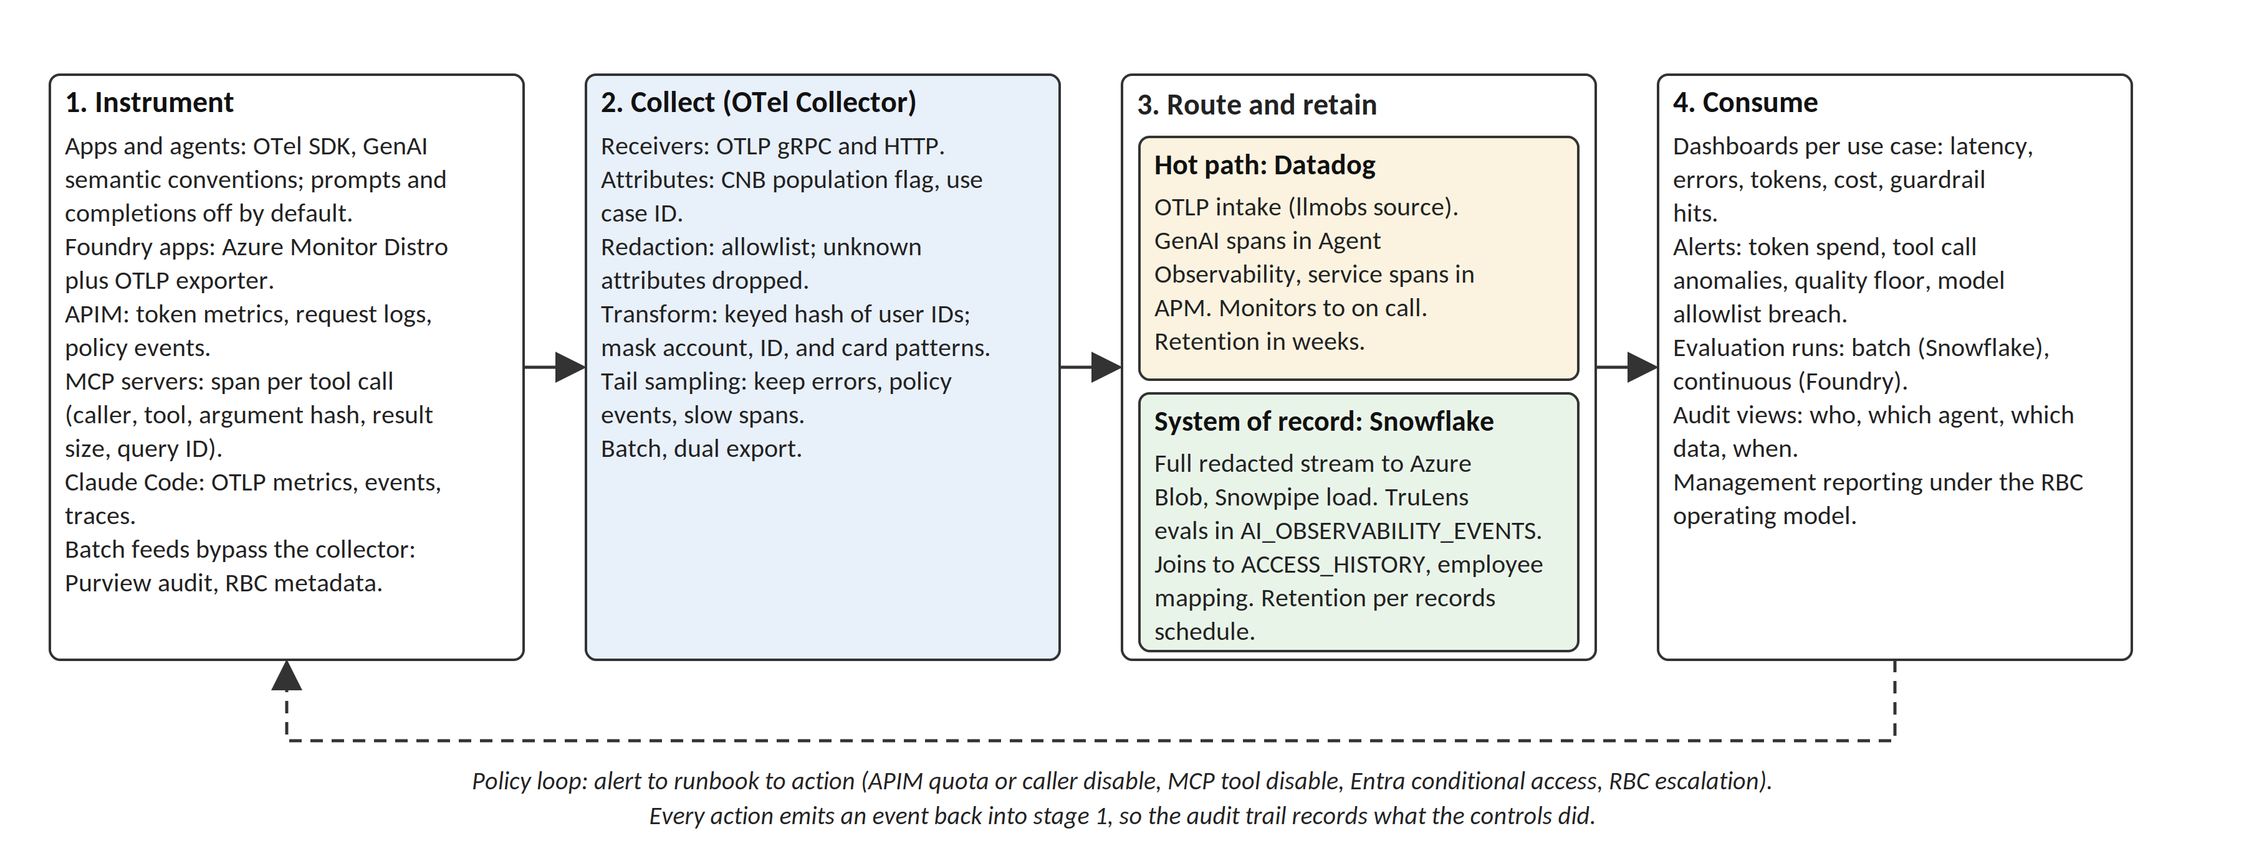
Figure 2. Telemetry pipeline: instrument, collect, route and retain, consume, and the policy loop back to the control points.
Instrument. Class B applications use the OTel SDK with the GenAI semantic conventions: one span per inference call carrying the operation name, provider, requested model, and token usage, and one span per tool execution. Applications built on Foundry use the Azure Monitor OpenTelemetry Distro to reach Application Insights and add an OTLP exporter for the collector, a dual export pattern the Azure Monitor configuration documents. APIM emits token metrics per consumer to Application Insights alongside its request logs. MCP servers emit one span per tool call carrying the caller identity APIM validated, the tool name, a hash of the argument payload, the result size, and the Snowflake query identifier where a query was issued, so the ACCESS_HISTORY join is exact. Claude Code exports metrics, events (prompt content redacted by default), and optional traces over OTLP, configured for every developer machine through the managed settings file.
Collect. The collector pipeline runs, in order: an attributes processor that inserts the CNB population flag and the use case identifier from a lookup; a redaction processor operating as an allowlist, so any attribute not explicitly permitted is dropped, including attributes a developer adds later; a transform processor that applies a keyed hash to user identifiers so joins stay possible without storing the identifier in the hot path; a tail sampling policy that keeps every span with an error, a policy event, or a latency above threshold and samples the remainder; and a batch processor. Prompt and completion attributes pass the allowlist only for applications on the opt in list, and only after pattern masking for account numbers, government identifiers, and card data.
Route and retain. The hot path receives the sampled stream through the Datadog OTLP intake with the llmobs source header set, so GenAI spans land in Agent Observability and service spans in APM. The cold path receives the full, unsampled, redacted stream as compressed files in Azure Blob Storage, loaded by Snowpipe within minutes. Hot retention follows the Datadog plan and is measured in weeks; cold retention follows the CNB records schedule, applied on the observability schema.
Policy loop. Datadog monitors fire on token spend per use case, tool call anomaly rate, error rate, latency, guardrail hit rate, and evaluation score floors. The kill switch runbook maps each alert class to an action and an owner: a token quota change or a caller disable in APIM (class B), a tool or server disable in the APIM MCP configuration (class C), a conditional access or license change in Entra (class D), or an escalation request to RBC (class A). Each action emits an event back into the pipeline. Near real time prompt observability is delivered for classes B and C at the granularity of the sampled hot path, and for class A only at the cadence of the RBC feed.

5. Alternatives considered
Azure native only. Application Insights and Foundry Observability as the hot path, Snowflake as the cold path, no Datadog. Fewer vendors and full coverage for class B, but weaker correlation with the rest of the CNB estate that Datadog already watches, and no single pane for classes C and D. This becomes the recommendation if the Datadog module audit in Phase 0 shows that Agent Observability is not licensed and will not be.
Specialist AI observability platform. Langfuse self hosted, or a commercial product such as Arize or Fiddler, on top of the same OTel instrumentation. Stronger prompt management and evaluation workflows, and Langfuse would match the RBC toolchain, which could ease a future data exchange. It adds a vendor and an operating burden for a capability that Snowflake AI Observability and Foundry already cover at the level CNB needs today. Revisit when evaluation volume justifies a dedicated workbench.
Wait for RBC. Consume Pantheon, Evals, and the RBC operating model once they exist. Rejected as the primary path: no deployment exists yet, no data is shared today, and the jurisdictional gap remains. Retained as the class A interface.
Datadog end to end. Skip Snowflake and keep long retention in Datadog. Rejected: audit grade retention in a hot path platform is expensive, the ACCESS_HISTORY and employee joins live in Snowflake, and Snowflake is where CNB's data already is.

6. Operating model
Ownership. The CNB AI platform team owns APIM policies, the MCP server platform, the collector fleet, and the Snowflake observability schema. Application teams own instrumentation of their own services against a published span checklist and do not ship to production without it. SRE and operations own Datadog monitors and the on call rotation. Risk and Compliance own the audit views and the retention schedule. One named liaison owns the RBC interface and represents CNB in the RBC operating model discussions.
Signals and floors. Each registered use case declares availability and latency objectives, a token budget per period, a quality floor from a named evaluation, and its approved model list. The model list is monitored, not only documented: the collector flags any requested model outside the approved set, which covers the enterprise decision that only whitelisted open weight models will be approved.
Alerting and the kill switch. Severity one alerts page the on call engineer and notify the use case owner; severity two alerts open a ticket. The kill switch runbook states who may invoke it (the use case owner, or the on call engineer for severity one), the reversal procedure, and the post incident review. Prompts, model versions, tool definitions, and APIM policies are versioned artifacts under change control, so a behavior change traces back to a change record.

7. Phased roadmap
Phases are sequenced by dependency, not dated.
- Phase 0, inventory and gap assessment. Fill the AI application inventory (Appendix A); audit the Datadog contract for APM and Agent Observability coverage; confirm the APIM tier and MCP server support; catalog existing MCP servers; refresh the CNB employee mapping; agree the RBC interface list with the RBC liaison.
- Phase 1, control points and pipeline. Stand up APIM as the GenAI gateway for class B with token metrics on; move MCP servers behind APIM; deploy the collector fleet with the redaction allowlist; land telemetry in Snowflake; publish the span checklist and instrument the first two use cases end to end.
- Phase 2, enforcement and alerting. Token quotas per caller; tool allowlists and per caller quotas on MCP; Datadog monitors and on call routing; the kill switch runbook exercised in a drill; model allowlist monitoring.
- Phase 3, evaluation. Batch evaluations in Snowflake AI Observability for each registered use case; sampled continuous evaluation in Foundry for class B; quality floors wired to alerts; a drift review cadence.
- Phase 4, third party and RBC integration. Purview Copilot audit load; Claude Code telemetry through managed settings; Workato job and audit logs if adopted; secure web gateway feed for unsanctioned endpoints; the RBC metadata feed and alert forwarding once the operating model allows; management reporting aligned with RBC's central reporting.

8. Assumptions and open questions
- Datadog. Licensed modules and current coverage at CNB are unknown. Phase 0 resolves this; the Azure native alternative is the fallback.
- APIM. Assumed available, or provisionable, at a tier that supports MCP servers and the LLM policies; the RBC gateway is assumed reachable from APIM as an ordinary HTTP backend.
- Class A. Assumed to run browser to RBC with no CNB component in the request path. If a CNB proxy exists on that path, class A gains a control point and section 3 changes.
- RBC interfaces. Subject to the RBC operating model, which is still being defined. Pantheon and Evals are not deployed and are not assumed.
- Workato. Evaluation only; appears in class D as a candidate, not a dependency.
- Regulatory mapping. Jurisdictional differences are treated here as a design driver; the obligation by obligation mapping is a separate deliverable with Risk and Compliance.
- Pantheon and Evals naming. The vendor scan addendum dated September 1, 2026 identified these as pantheon.io and OpenAI Evals; the discovery notes indicate they are RBC internal capabilities. The addendum should be corrected once confirmed.

Appendix A. AI application inventory template
Use case or application | Owner | Class | Provider and models | Entry point | Data touched | Telemetry today | Control point status
 |  | A / B / C / D |  | UI, API, MCP, agent

References (verified September 16, 2026)
Azure API Management, llm-token-limit policy. https://learn.microsoft.com/en-us/azure/api-management/llm-token-limit-policy
Azure API Management, llm-emit-token-metric policy. https://learn.microsoft.com/en-us/azure/api-management/llm-emit-token-metric-policy
Azure API Management, expose and govern an existing MCP server. https://learn.microsoft.com/en-us/azure/api-management/expose-existing-mcp-server
Azure API Management, llm-content-safety policy. https://learn.microsoft.com/en-us/azure/api-management/llm-content-safety-policy
Microsoft Foundry, observability in generative AI. https://learn.microsoft.com/en-us/azure/foundry/concepts/observability
Azure Monitor, configuring OpenTelemetry in Application Insights (dual export). https://learn.microsoft.com/en-us/azure/azure-monitor/app/opentelemetry-configuration
OpenTelemetry, semantic conventions for GenAI client spans. https://opentelemetry.io/docs/specs/semconv/gen-ai/gen-ai-spans/
OpenTelemetry, handling sensitive data in the Collector. https://opentelemetry.io/docs/security/handling-sensitive-data/
Datadog, OpenTelemetry instrumentation for Agent Observability. https://docs.datadoghq.com/llm_observability/instrumentation/otel_instrumentation/
Snowflake, trace and monitor applications with TruLens (AI Observability). https://docs.snowflake.com/en/user-guide/snowflake-cortex/ai-observability/trace-applications-trulens
Snowflake, Access History. https://docs.snowflake.com/en/user-guide/access-history
Snowflake, automating Snowpipe for Azure Blob Storage. https://docs.snowflake.com/en/user-guide/data-load-snowpipe-auto-azure
Microsoft Purview, audit logs for Copilot and AI applications. https://learn.microsoft.com/en-us/purview/audit-copilot
Claude Code, monitoring usage with OpenTelemetry. https://code.claude.com/docs/en/monitoring-usage

